WOXSEN UNIVERSITY
B.Tech Artificial Intelligence and Machine Learning | Database Management Systems
HackerRank Profile
Name | Student ID | Platform / username | Profile link
D. Ritheek (Ritheek Yadav) | 25WU0102057 | HackerRank / ritheekyadav01 | hackerrank.com/profile/ritheekyadav01

1. Profile login screenshot
HackerRank profile, logged in as Ritheek Yadav (@ritheekyadav01). Badges shown: Problem Solving (3 stars) and SQL (1 star).
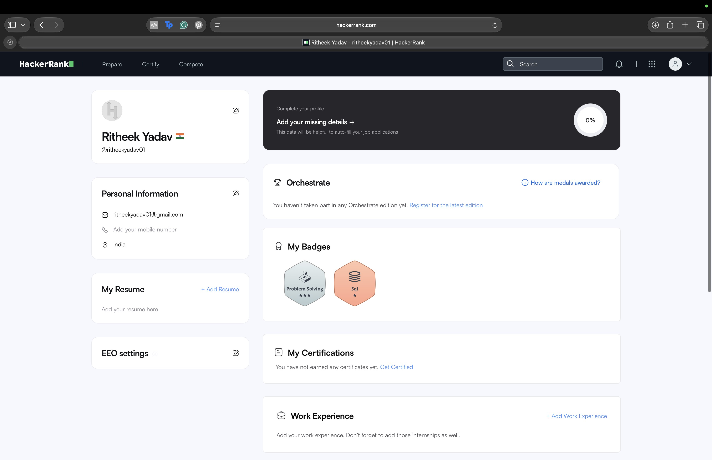

2. Problems solved (10)
All ten problems below show Result: Accepted in the submissions list. Score is the points awarded by HackerRank.
No. | Problem name | Topic | Language | Result | Score
1 | Revising the Select Query I | SELECT with WHERE | MySQL | Accepted | 10.0
2 | Select All | SELECT * | MySQL | Accepted | 10.0
3 | Select By ID | WHERE (equality) | MySQL | Accepted | 10.0
4 | Japanese Cities' Attributes | WHERE (string match) | MySQL | Accepted | 10.0
5 | Japanese Cities' Names | SELECT column + WHERE | MySQL | Accepted | 10.0
6 | Weather Observation Station 1 | SELECT columns | MySQL | Accepted | 15.0
7 | Weather Observation Station 3 | DISTINCT, MOD | MySQL | Accepted | 10.0
8 | Weather Observation Station 4 | COUNT, DISTINCT | MySQL | Accepted | 10.0
9 | Weather Observation Station 5 | ORDER BY, LENGTH, LIMIT | MySQL | Accepted | 30.0
10 | Revising the Select Query II | SELECT with WHERE | MySQL | Accepted | 10.0

3. Submissions screenshot
Submissions list: ten SQL problems solved in MySQL, all Accepted.
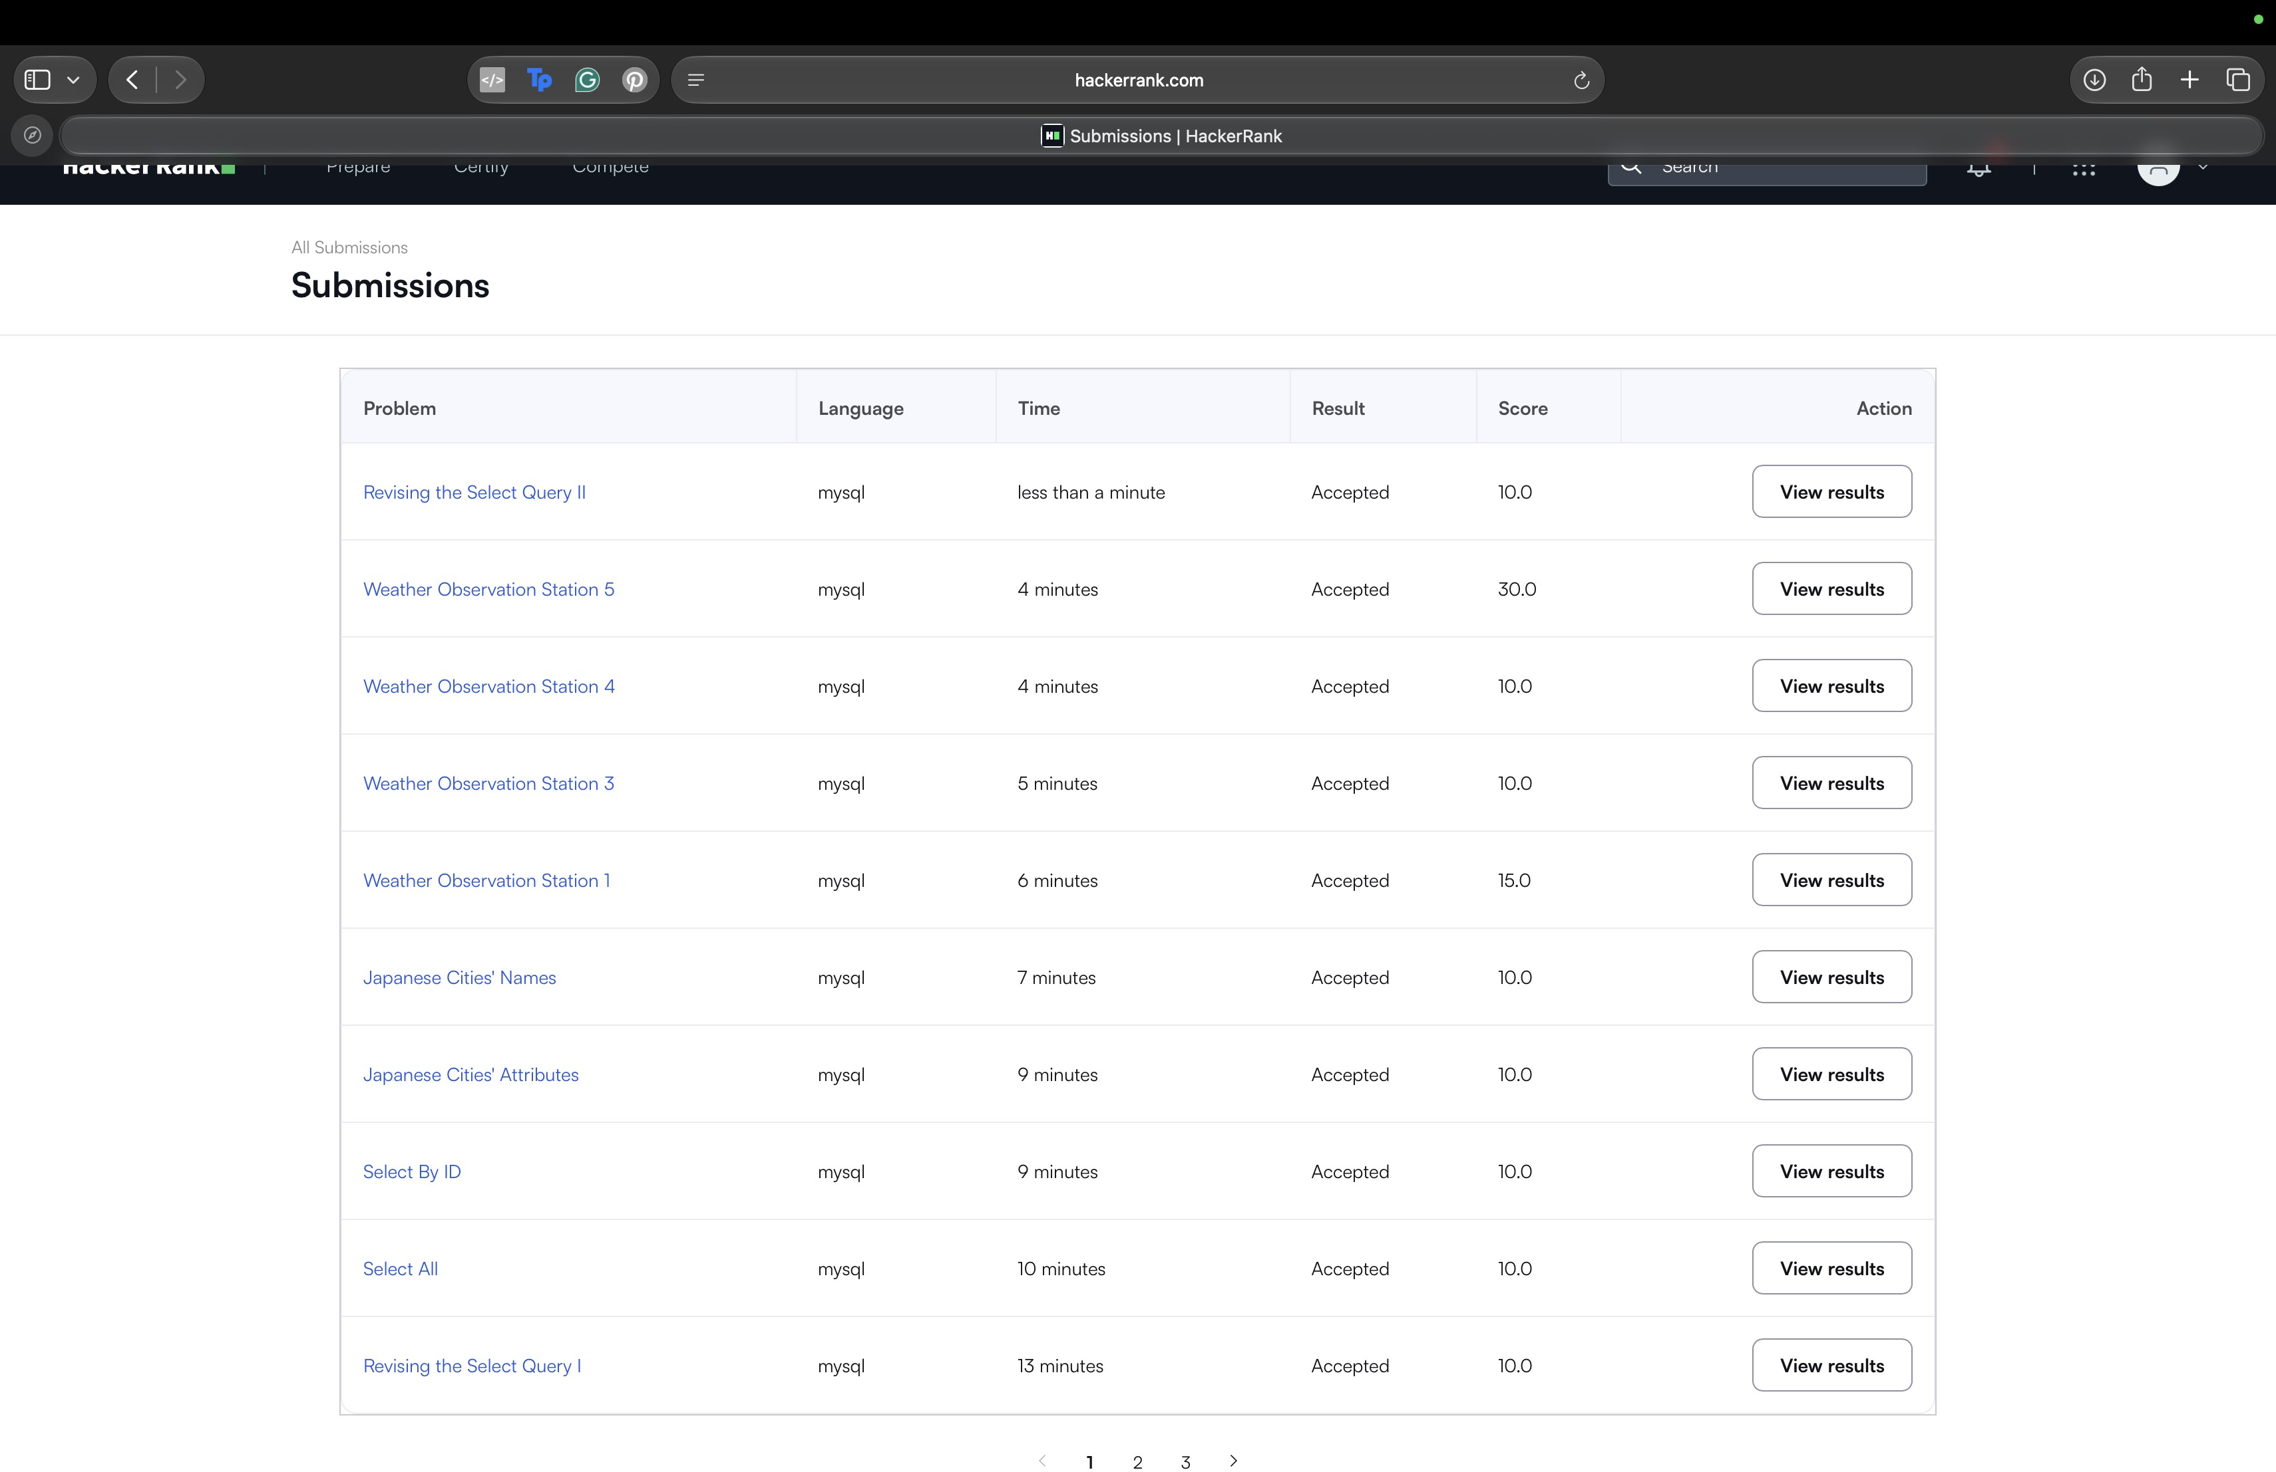

4. Badges and certificates
Badges earned: Problem Solving (3 stars) and SQL (1 star). No HackerRank certificate has been earned yet.

