WOXSEN UNIVERSITY
B.Tech Artificial Intelligence and Machine Learning | Database Management Systems
LeetCode Profile
Name | Student ID | Platform / username | Profile link
D. Ritheek | 25WU0102057 | LeetCode / ritheekyadav | leetcode.com/u/ritheekyadav

1. Profile login screenshot
LeetCode profile of ritheekyadav: 25 problems solved (13 Easy, 11 Medium, 1 Hard). 10 of them are SQL problems solved in MySQL for DBMS.
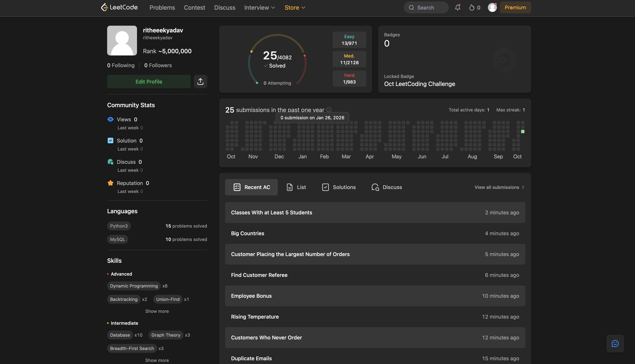

2. Problems solved (10)
Every problem below shows Accepted on LeetCode. Each screenshot is in section 3, in the same order.
No. | Problem name | Difficulty | Topic / technique | Language
1 | Combine Two Tables | Easy | LEFT JOIN | MySQL
2 | Employees Earning More Than Their Managers | Easy | Self join | MySQL
3 | Duplicate Emails | Easy | GROUP BY / HAVING | MySQL
4 | Customers Who Never Order | Easy | LEFT JOIN + IS NULL | MySQL
5 | Rising Temperature | Easy | Self join + DATEDIFF | MySQL
6 | Employee Bonus | Easy | LEFT JOIN + NULL handling | MySQL
7 | Find Customer Referee | Easy | NULL handling / WHERE | MySQL
8 | Customer Placing the Largest Number of Orders | Easy | GROUP BY / ORDER BY / LIMIT | MySQL
9 | Big Countries | Easy | WHERE with OR | MySQL
10 | Classes More Than 5 Students | Easy | GROUP BY / HAVING (DISTINCT) | MySQL

3. Accepted submission screenshots
1. Combine Two Tables (Easy) - Accepted
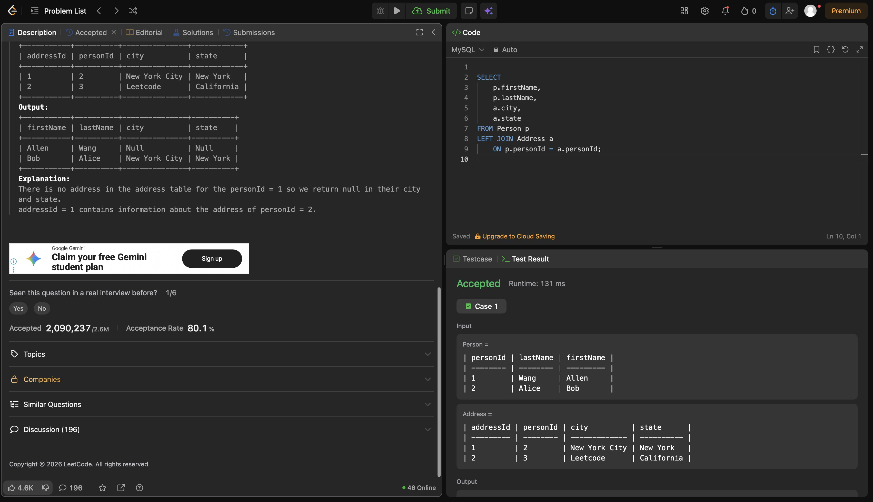
2. Employees Earning More Than Their Managers (Easy) - Accepted
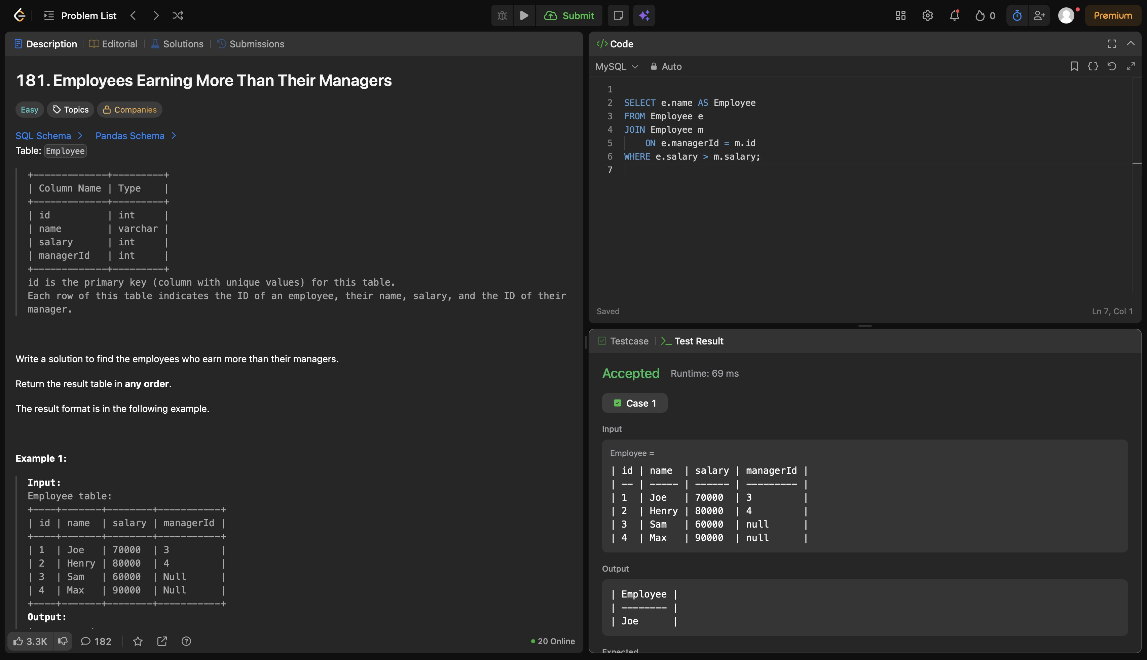
3. Duplicate Emails (Easy) - Accepted
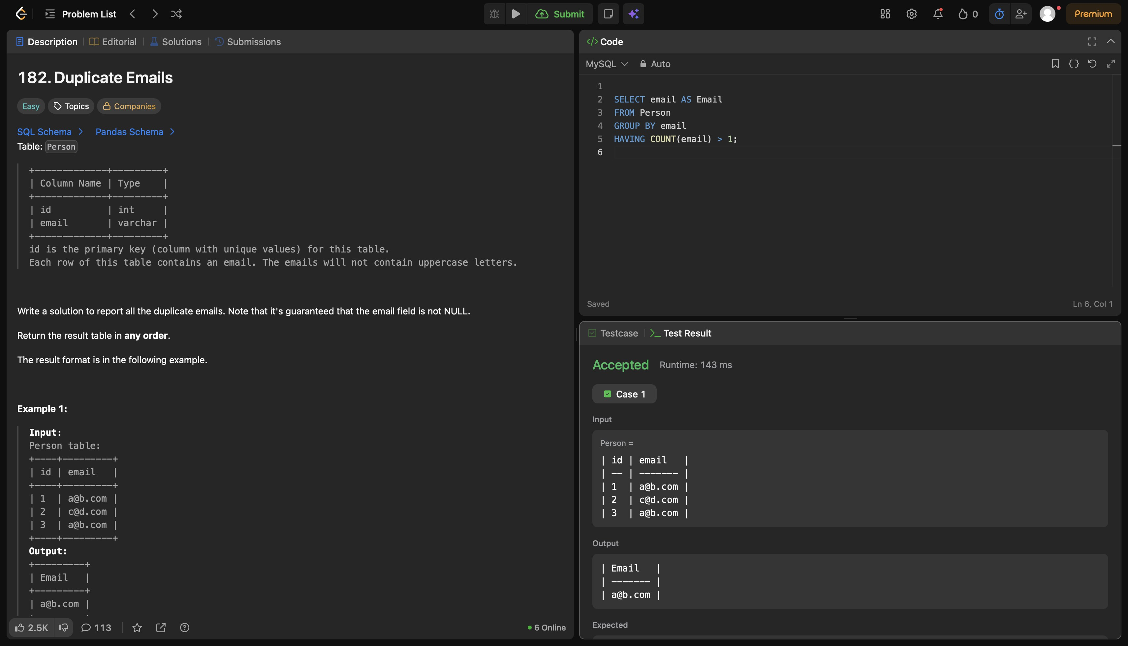
4. Customers Who Never Order (Easy) - Accepted
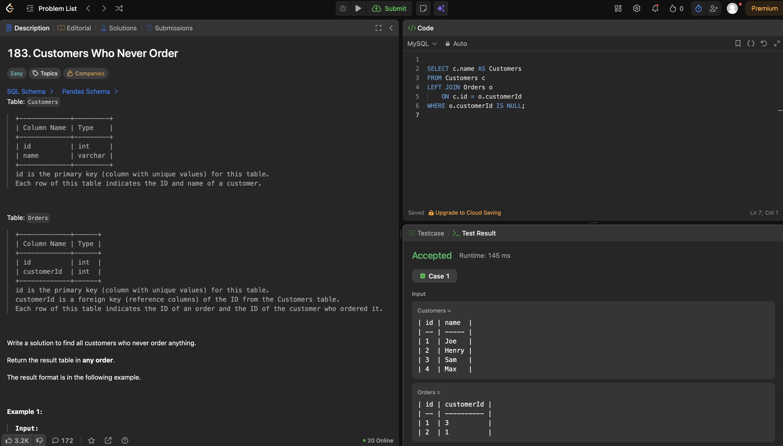
5. Rising Temperature (Easy) - Accepted
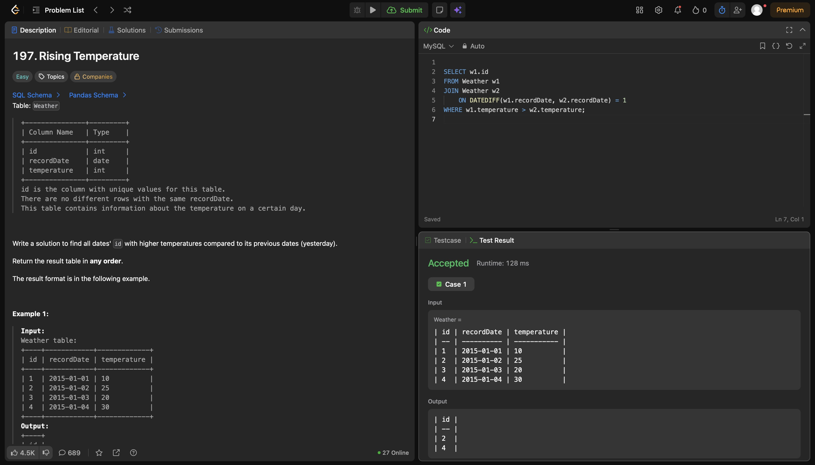
6. Employee Bonus (Easy) - Accepted
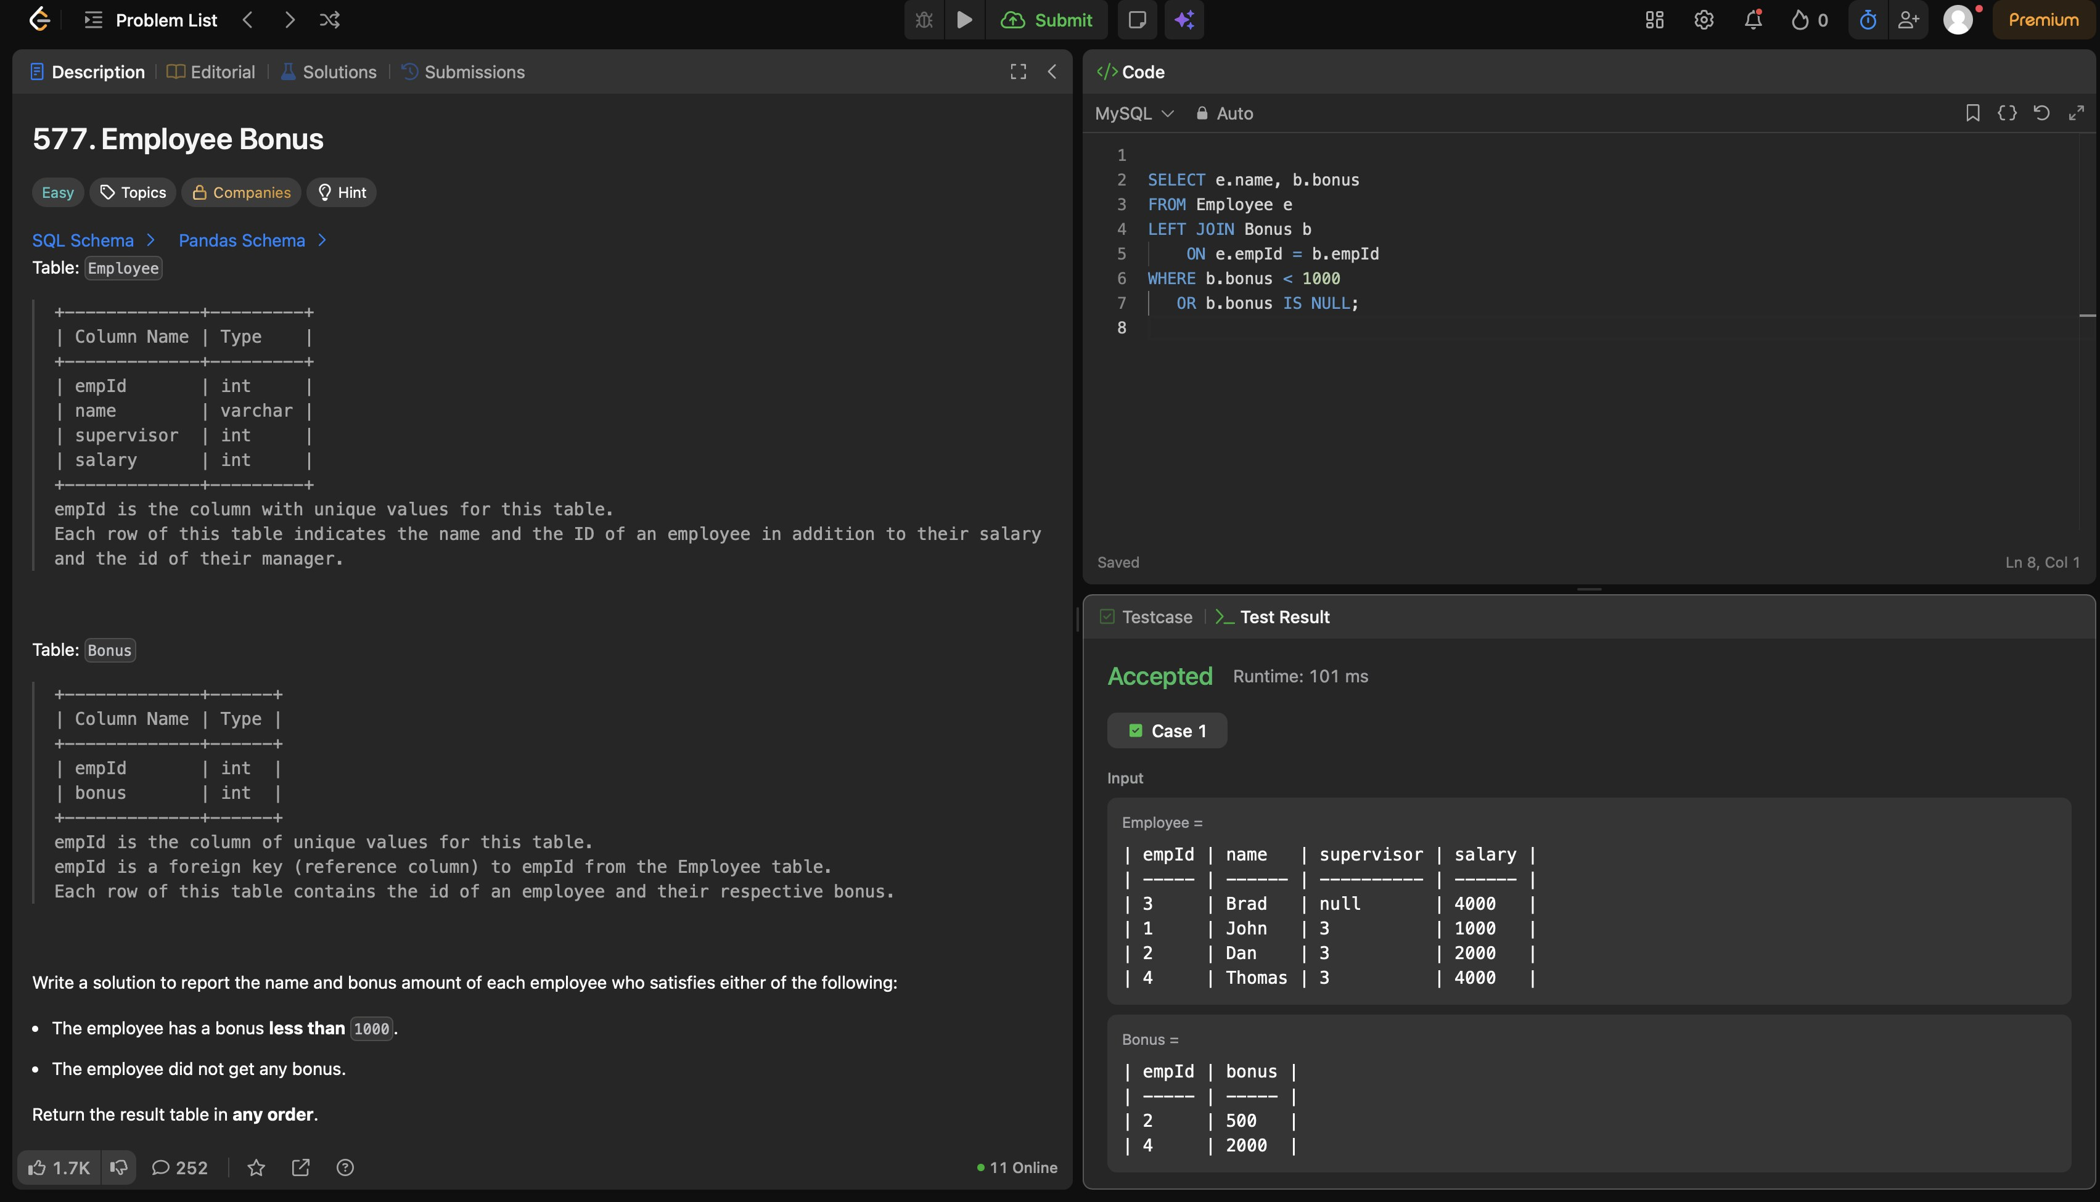
7. Find Customer Referee (Easy) - Accepted
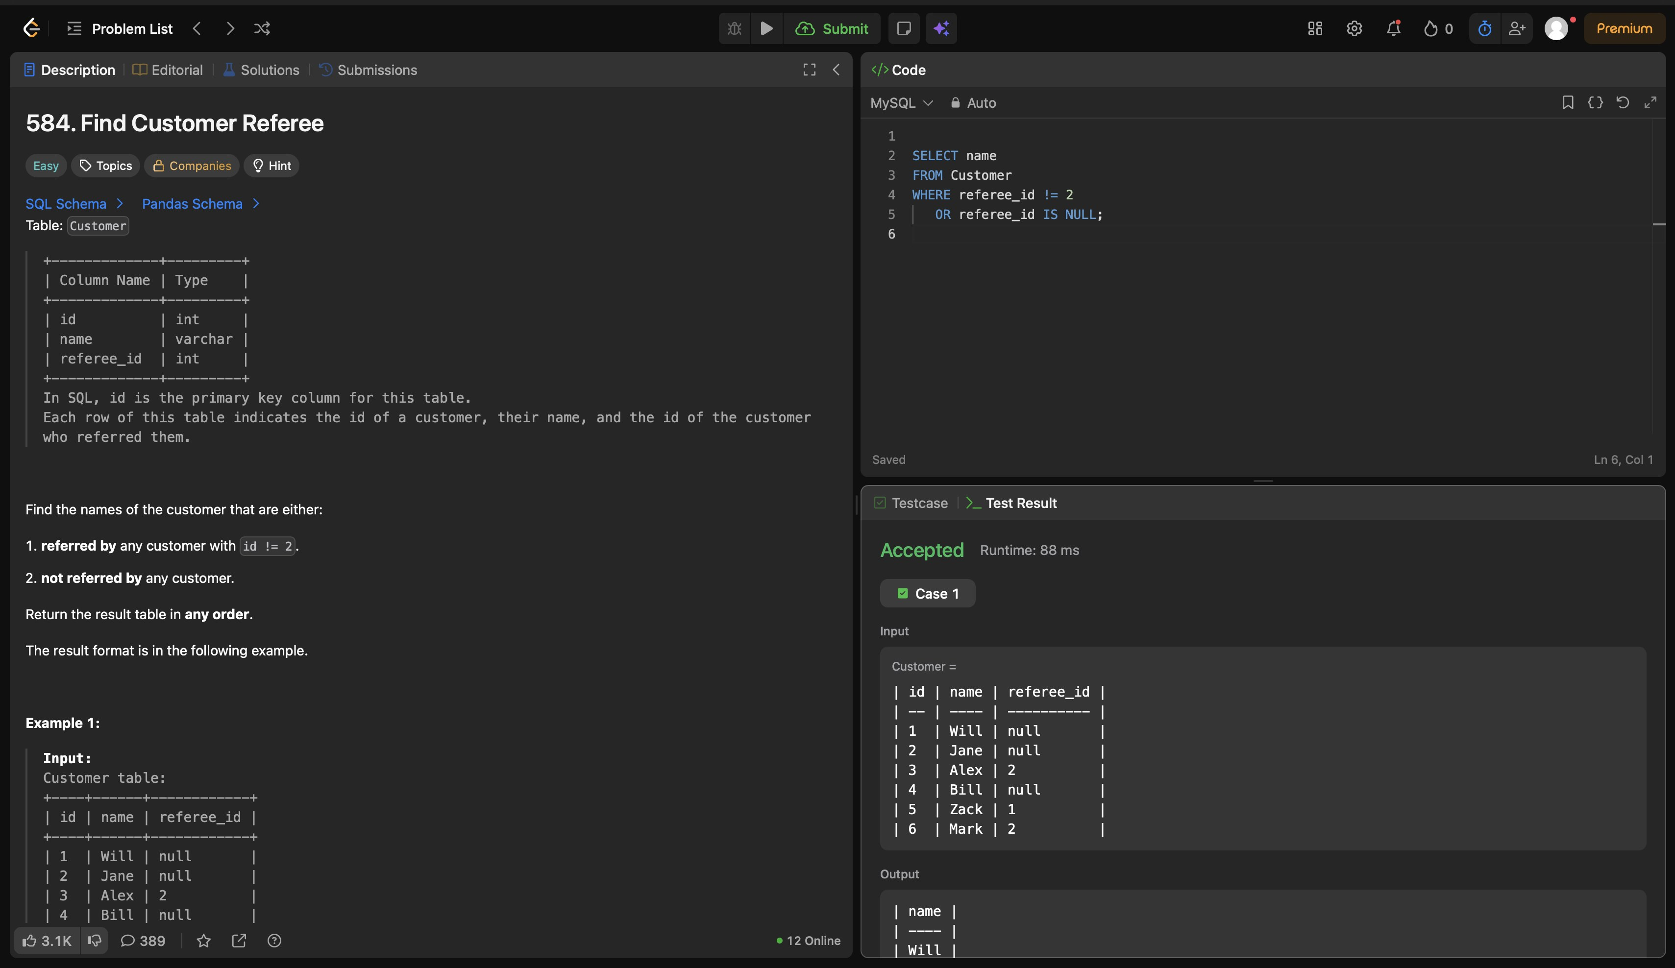
8. Customer Placing the Largest Number of Orders (Easy) - Accepted
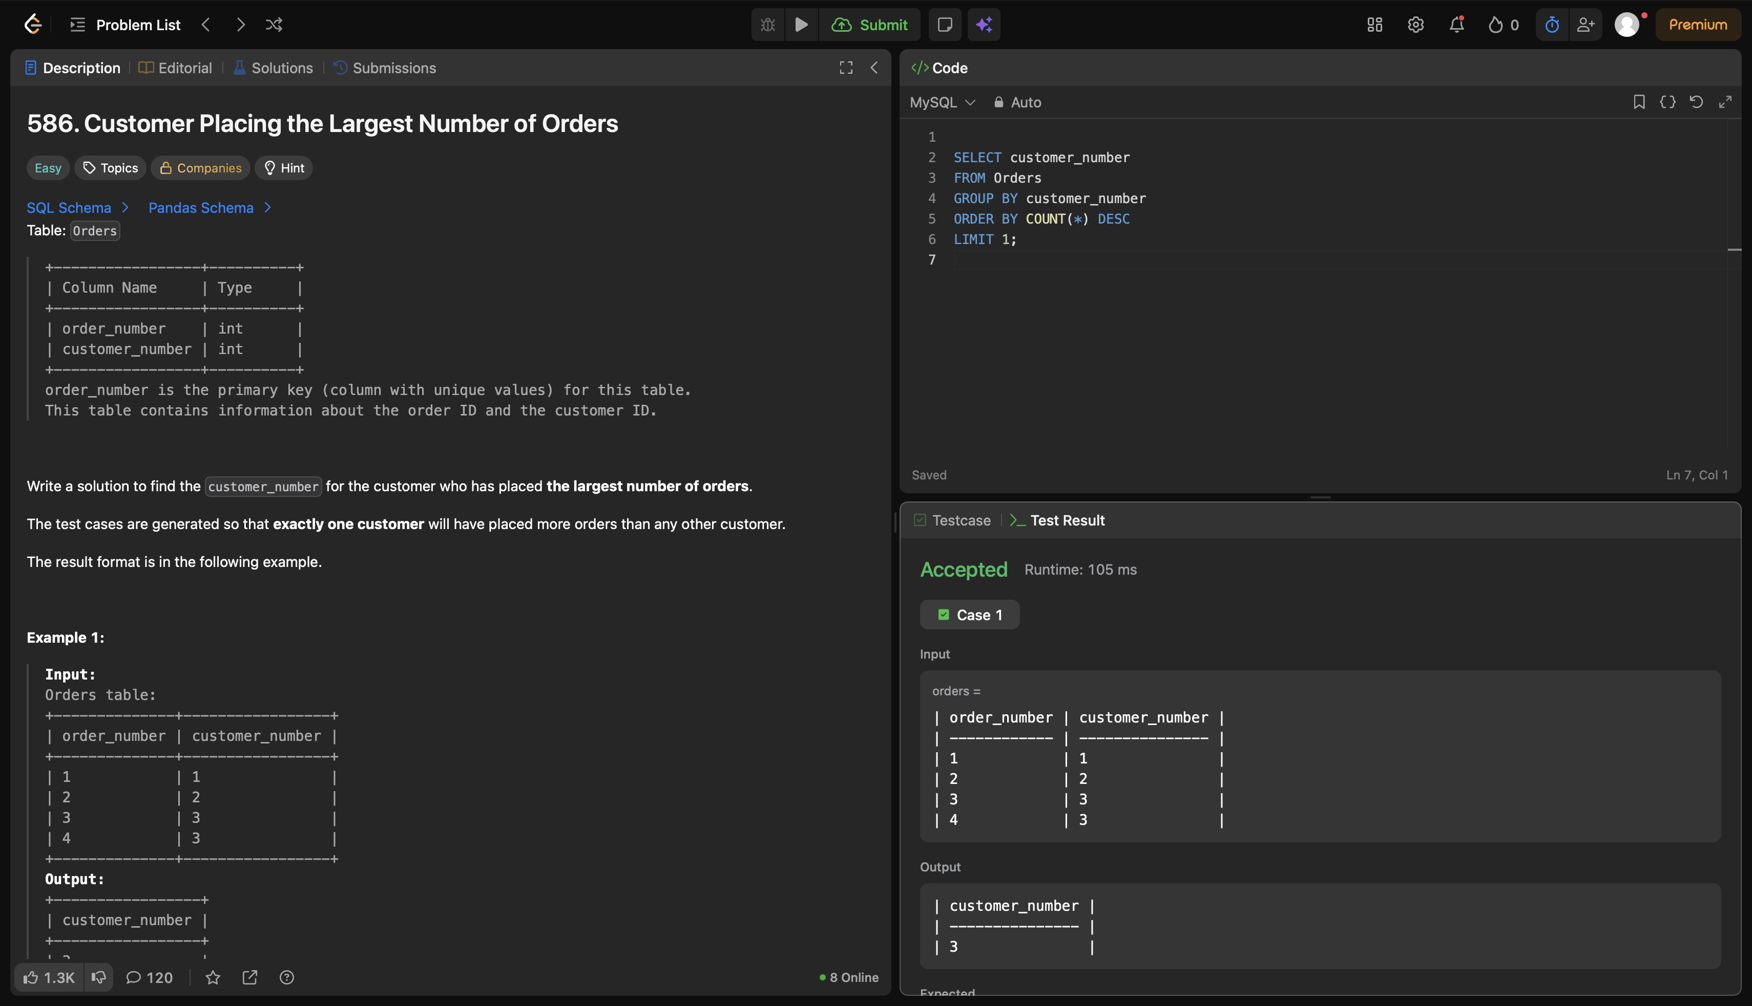
9. Big Countries (Easy) - Accepted
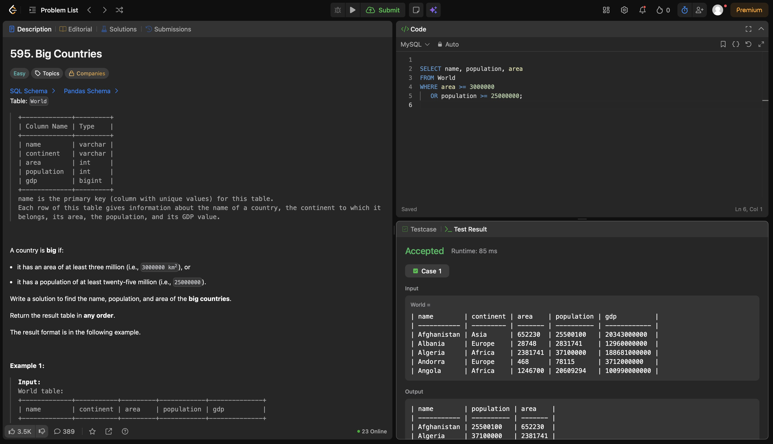
10. Classes More Than 5 Students (Easy) - Accepted
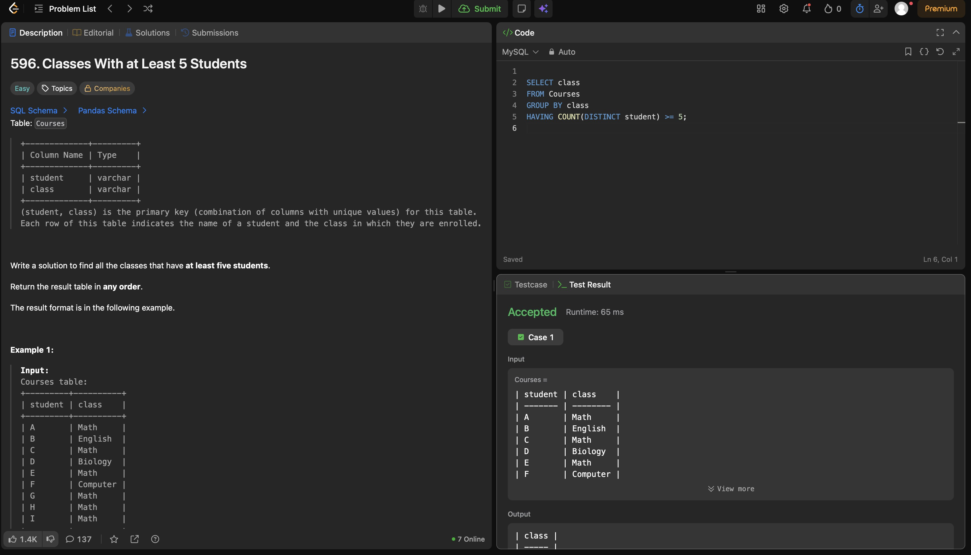

4. Certificates
No LeetCode certificate or badge earned yet.

