PROJECT 12
Design and Implementation of a Database Management System for Hotel Reservation and Guest Services Management System
DBMS Project-Based Learning (PBL) — Review 1
Ritheek | Woxsen University | Student ID: 25WU0102057

1. Problem Identification
Hotels manage an interconnected set of resources — rooms, rates, guests, reservations, in-house stays, guest services, housekeeping, and billing. When these are tracked through uncoordinated spreadsheets or disconnected tools, rooms can be double-booked, guest charges can be missed or duplicated, housekeeping status goes untracked, and invoices end up incorrect. This project designs and implements a single relational database — with a small Java/Python front end — that keeps room availability, guest stays, service billing, and housekeeping consistent with each other at all times.

2. Scope
In scope:
- Room type and room inventory management (with per-type occupancy limits)
- Rate plan management, linked to room type and validity period
- Guest registration and reservation booking with availability search
- Check-in / check-out, tracked as a Stay against a Reservation
- In-stay service requests (e.g. room service, laundry) and their charges
- Housekeeping task assignment and status tracking, per room and staff member
- Invoice generation (room charges + service charges) and payment recording
- Operational reports: occupancy, vacancy, cancellations, housekeeping status, guest history, service revenue, total revenue
Out of scope (for this semester project):
- Multi-property / hotel-chain management
- Staff HR, payroll, and shift scheduling
- Third-party OTA (Online Travel Agency) integration and online guest self-booking portal

3. Objectives
- Model the hotel domain as a conceptual ER diagram covering room types, rooms, rate plans, guests, reservations, stays, service requests, housekeeping tasks, service charges, invoices, and payments.
- Convert the ER model into a relational schema, normalized up to 3NF, with primary/foreign keys and integrity constraints (UNIQUE, NOT NULL, CHECK, DEFAULT).
- Enforce core business rules at the database level: no overlapping room stays, valid check-in/check-out dates, room-capacity control, non-negative charges and payments.
- Build a Java or Python application performing CRUD operations — availability search, reservation, check-in/out, service posting, housekeeping assignment, billing, and payment.
- Produce meaningful SQL reports using joins, nested queries, aggregation, and views.

4. Users / Actors
Actor | Interacts with
Front Desk / Receptionist | Availability search, Reservation, Stay (check-in/out), Invoice
Housekeeping Staff / Supervisor | HousekeepingTask (assign, update status)
Service Staff (room service, concierge, etc.) | ServiceRequest, ServiceCharge
Billing / Accounts Staff | Invoice, Payment
Hotel Manager / Admin | RoomType, RatePlan, reports (occupancy, revenue, cancellations)
Guest | Source of Guest and Reservation data (captured by front desk)

5. Functional Requirements
ID | Requirement
FR1 | Search room availability by date range and room type.
FR2 | Create, modify, or cancel a reservation for a guest.
FR3 | Check in a reservation (creates a Stay) and check out (closes it).
FR4 | Log a service request against an active stay and generate its service charge.
FR5 | Assign and track housekeeping tasks per room and staff member.
FR6 | Generate an invoice combining room charges and service charges for a stay.
FR7 | Record one or more payments against an invoice.
FR8 | Generate reports: occupancy, vacancy, cancellations, housekeeping status, guest history, service revenue, total revenue.
FR9 | Validate data: no overlapping stays per room, check-out date after check-in date, non-negative charge and payment amounts.

6. Conceptual Design — ER Diagram
The model has 13 entities grouped into four areas: inventory & pricing (RoomType, Room, RatePlan), guest activity (Guest, Reservation, Stay), in-stay services (Service, ServiceRequest, ServiceCharge, HousekeepingTask, Staff), and billing (Invoice, Payment). This extends the 6-table hotel_booking schema built in Experiment 1 (Guest, Room, Reservation, Payment, Staff, Amenities) by splitting bookings into Reservation vs. Stay, replacing the flat Amenities table with a proper Service/ServiceRequest/ServiceCharge chain, and adding RoomType, RatePlan, HousekeepingTask, and Invoice as first-class entities.
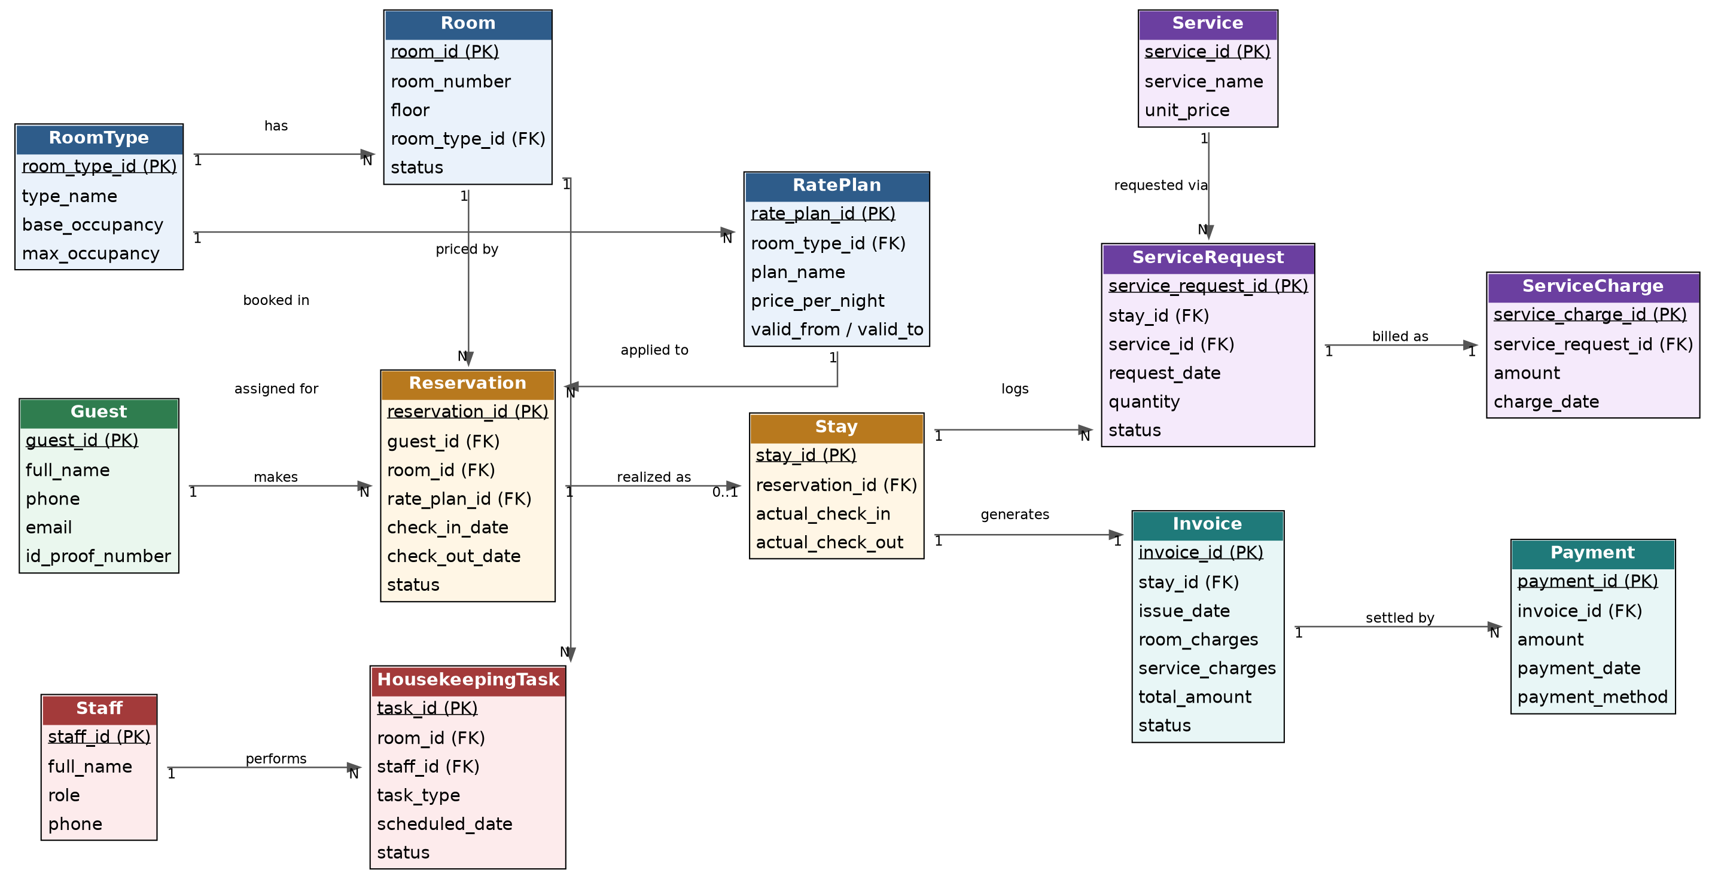
Legend: rectangles are entities with primary keys underlined; arrows point from the “one” side to the “many” side of each relationship, labelled with cardinality and a short verb phrase.

7. Initial Relational Schema
Proposed tables, primary keys, and foreign keys (to be normalized to 3NF with full DDL and constraints in Review 2):
Table | Primary Key | Foreign Keys → References
RoomType | room_type_id | —
Room | room_id | room_type_id → RoomType
RatePlan | rate_plan_id | room_type_id → RoomType
Guest | guest_id | —
Reservation | reservation_id | guest_id → Guest, room_id → Room, rate_plan_id → RatePlan
Stay | stay_id | reservation_id → Reservation
Service | service_id | —
ServiceRequest | service_request_id | stay_id → Stay, service_id → Service
ServiceCharge | service_charge_id | service_request_id → ServiceRequest
Staff | staff_id | —
HousekeepingTask | task_id | room_id → Room, staff_id → Staff
Invoice | invoice_id | stay_id → Stay
Payment | payment_id | invoice_id → Invoice
Key relationships and cardinalities:
- RoomType 1–N Room, RoomType 1–N RatePlan
- Guest 1–N Reservation; Room 1–N Reservation; RatePlan 1–N Reservation
- Reservation 1–0..1 Stay (a Stay is created only once the guest actually checks in)
- Stay 1–N ServiceRequest; Service 1–N ServiceRequest; ServiceRequest 1–1 ServiceCharge
- Room 1–N HousekeepingTask; Staff 1–N HousekeepingTask
- Stay 1–1 Invoice; Invoice 1–N Payment

8. Next Steps (Review 2)
- Write functional dependencies and a data dictionary for each table.
- Produce DDL scripts with UNIQUE, NOT NULL, CHECK, and DEFAULT constraints enforcing the business rules above.
- Populate sample data and write SQL for joins, subqueries, aggregation, and views for the required reports.

