SIMATS ENGINEERING
Department of Information Technology
CSA15 – CLOUD COMPUTING AND BIG DATA ANALYTICS
ASSIGNMENT 2 – CO2
Analyse, Evaluate and Validate a Virtualization Architecture for a Multi-Tenant University Private Cloud
CO2: Analyze virtualization architectures to identify performance and security issues in cloud computing environments.

Field | Details | Field | Details
Student Name | K N RITHEESH | Register Number | 192572097
Department / Section | Information Technology | Academic Year / Semester | II - YEAR
Faculty Name | Dr R LATHA | Nature of Assignment | Individual
Duration | 1 Week | Total Marks | 50
Submission Date | 03/11/26 | Evaluation Date

MARK SHEET (Rubric-based evaluation)

Task | Title | Max | Awarded | Evidence / evaluation focus
1 | Characterise the Virtualization  Architectures | 5
2 | Identify the Dominant Overhead Source | 2
3 | Build a Quantitative Performance Model | 6
4 | Analyse Performance Under Different Conditions | 4
5 | Security Threat and Vulnerability  Analysis | 3
6 | Formulate Isolation–Performance Trade-off | 3
7 | Evaluate Mitigation Strategies | 4
8 | Implement and Test | 4
9 | Record Experimental Performance | 3
10 | Compare Theory with Experiment | 4
11 | Recommend and Defend Final Architecture | 4
 | Day-4 Design Challenge | 8
TOTAL
50

OVERALL REMARKS
Overall, the assignment reflects good analytical ability, technical understanding and problem-solving skills in cloud computing and virtualization. The proposed architecture balances performance, security, resource efficiency and future scalability. The work can be further strengthened through verified experimental results, consistent benchmark comparisons and practical validation of the recommended security controls.

Student Signature | Faculty Signature | Program Director

MANDATORY SUBMISSION EVIDENCE CHECK
✓ = Present in documented answer; P = Partly present; X = Missing / not satisfied

Task | Evidence expected | Status | Evaluator note
1 | Three virtualization architectures, layered diagrams and trust boundaries
2 | Dominant overhead source identified and  explained for each approach
3 | CPU, memory, I/O, network and density models with assumptions
4 | Best, typical and worst operating-condition  analysis

Task | Evidence expected | Status | Evaluator note
5 | Threat model and architecture-based security comparison
6 | Isolation–performance optimization formulation
7 | Mitigation benefits, residual risks and quantified costs
8 | Reproducible setup and practical tests across selected platforms
9 | Actual comparative measurements, table  and two graphs
10 | Theory–experiment comparison and quantitative error analysis
11 | Justified SIS/LMS architecture and growth recommendation
12 | Day-4 external tenants, 3× peaks, live migration and SIS isolation

IMPLEMENTATION EVIDENCE CHAIN

Evidence item | Status | Observation
Architecture diagrams
Performance model

Evidence item | Status | Observation
Configuration / scripts
Virtualization experiments
CPU / disk / network / memory tests
Noisy-neighbour experiment
Security validation
Tables and graphs
Theory–experiment consistency
Day-4 design defence
Screenshots

SUBMISSION CHECKLIST (Not Separately Marked)

Requirement | Status
All 12 tasks answered | - Yes ☐ Partly ☐ No
Three virtualization approaches compared | - Yes ☐ Partly ☐ No
Layered diagrams and trust boundaries included | - Yes ☐ Partly ☐ No
Quantitative virtualization models included | - Yes ☐ Partly ☐ No
Threat analysis and mitigations included | - Yes ☐ Partly ☐ No

CLOUD COMPUTING AND BIG DATA
ASSIGNMENT 2
CO2: Analyze virtualization architectures to identify performance and security issues in cloud computing environments.

Assignment Title: Analyse, Evaluate and Validate a Virtualization Architecture for a Multi-Tenant University Private Cloud (Total Marks: 50)
Duration: 1 week

Scenario: EduCloud Virtualization Platform
A university runs a private cloud, EduCloud, in its data centre. EduCloud currently consists of:
- 16 physical hosts, each with 64 CPU cores, 512 GB RAM, NVMe SSD storage and 2 × 25 Gbps NICs
- About 400 virtual machines (VMs) running the Student Information System (SIS), the Learning Management System (LMS), the examination portal, and departmental research workloads
- A shared storage backend and a software-defined virtual network
During semester registration week, users report slow response times and failed logins. A recent internal security audit also found that VMs from different departments share the same physical hosts, that some VMs run outdated guest kernels, and that VM images are copied freely between teams.
You are the cloud architect. You must investigate, model, measure and compare virtualization architectures for EduCloud, identify their performance bottlenecks and security weaknesses, and recommend a design that remains practical as the platform grows.

Design Challenge:
The university now plans to host external research collaborators' big-data workloads (Spark/Hadoop clusters) on the same infrastructure as the SIS. Re-evaluate your design under these new multi-tenant conditions.

TASK 1: Characterise the Virtualization Architectures (5 Marks)
Select at least three meaningfully different virtualization approaches from the following, or justify others:
- Type-1 (bare-metal) hypervisor with full virtualization
- Type-2 (hosted) hypervisor
- Hardware-assisted virtualization vs. paravirtualization
- OS-level virtualization (containers)
- Lightweight/micro-VM or sandboxed container runtimes
Two configurations of the same hypervisor will not count as different approaches. Your selection must include at least one VM-based and at least one container-based approach.
For each approach, provide:
- A layered architecture diagram showing the hardware, host OS or hypervisor, guest OS, runtime and application
- The trust boundaries and the component that enforces isolation
- How CPU, memory, storage and network are virtualized
- A brief justification for why this approach is relevant to EduCloud
Evidence expected: Three architecturally distinct approaches with labelled diagrams, resource-virtualization mechanisms, trust boundaries, and justification of selection.

TASK 2: Identify the Dominant Overhead Source (2 Marks)
For each approach, identify the primary source of performance overhead that predominantly limits its performance (for example VM exits/traps, nested or extended page-table walks, virtual I/O emulation, virtual switch processing, or system-call interception).
Discuss:
- What the overhead source is
- Where in the architecture it occurs
- Why it is appropriate as the focus of performance analysis
- How its frequency or cost changes as the number of co-located VMs/containers or the I/O rate increases
Do not simply name a mechanism. Relate it to the behaviour of the architecture.

Evidence expected: A justified dominant-overhead identification for each approach, linked to its resource-virtualization path.

TASK 3: Build a Quantitative Performance Model (6 Marks)
Using the following host parameters, develop an analytical performance model for each approach.

Parameter | Value
Physical cores per host | 64
vCPU:pCPU overcommit ratio | 1:1, 2:1, 4:1, 8:1
RAM per host | 512 GB
Average VM memory demand | 8 GB
Cost of one VM exit (assume) | 1.5 µs
Native system-call cost (assume) | 0.2 µs
Network line rate | 25 Gbps

State and justify any additional assumptions. Derive expressions for:
- CPU: effective per-VM CPU capacity as a function of overcommit ratio and virtualization overhead (including steal time)
- Memory: the maximum number of VMs per host before ballooning, swapping or page-sharing becomes necessary
- I/O and network: effective throughput as a function of the number of VMs sharing the physical device
- Density: the number of VMs/containers a host can support while meeting a stated service-level target (for example, ≤ 10% performance degradation)
Show the mathematical reasoning. Merely quoting overhead percentages from the literature will not receive full credit.
Evidence expected: A clear mathematical derivation for each approach, with stated assumptions, parameter values and worked numerical examples.

TASK 4: Analyse Performance Under Different Operating Conditions (4 Marks)
Analyse how each approach behaves under three conditions:

- Best case: what workload and placement conditions minimise overhead?
- Typical case: for example, registration-week mixed web and database load
- Worst case: for example, noisy-neighbour interference, memory overcommit with swapping, live migration during peak load, or I/O storms
For each, explain what happens inside the virtualization layer, why the overhead changes, and how latency and throughput are affected. A table of numbers alone will not be accepted.
Evidence expected: A justified condition-based analysis supported by your Task 3 model.

TASK 5: Security Threat and Vulnerability Analysis (3 Marks)
Construct a threat model for each approach. Discuss:
- The attack surface (hypervisor, device emulation, shared kernel, management plane, VM images and snapshots, virtual network)
- At least four distinct threat categories, such as VM escape, cross-VM side-channel attacks, hypervisor or container-runtime vulnerabilities, VM
sprawl and unpatched guests, image tampering, insecure live migration, and virtual-network sniffing or spoofing
- For each threat, which approach is more or less exposed and why, referring to its architecture and trust boundaries
- The likely impact on the confidentiality, integrity and availability of student records
Evidence expected: A structured threat model mapped to architectural features, with a justified comparison across approaches.

TASK 6: Formulate the Isolation–Performance Trade-off (3 Marks)
Formalise the trade-off between isolation strength and performance/density for EduCloud.
Clearly identify:
- The decision variables (for example, approach chosen, VMs per host, dedicated vs. shared hosts, SMT on/off)
- The objective(s), such as maximising density or minimising cost

- The constraints (for example, performance degradation limit, isolation requirement for SIS, available hosts)
- How these components combine into a cost or decision function
The formulation must follow from your own analysis in Tasks 3 and 5, not from a generic template.
Evidence expected: A clearly defined trade-off model with identified variables, objective and constraints.

TASK 7: Evaluate Mitigation Strategies (4 Marks)
Propose at least three mitigations for the vulnerabilities identified in Task 5. Examples include disabling SMT, kernel page-table isolation, dedicated hosts for sensitive tenants, secure or sandboxed container runtimes, hardware memory encryption, image signing, and micro-segmentation.
For each mitigation, discuss:
- Why it is applicable to the threat
- What residual risk remains
- The performance or density cost, estimated using your Task 3 model
- Whether the trade-off is acceptable for the SIS
Evidence expected: Mitigations evaluated analytically, with their security benefit and quantified performance cost.

TASK 8: Implement and Test (4 Marks)
Build a test environment and experimentally test all selected approaches.
- Platforms: use any open-source stack, for example KVM/QEMU, Xen or VirtualBox, Docker/Podman, and Kata Containers or gVisor. Nested virtualization on a laptop is acceptable if documented.
- Scale: run each approach with approximately 1 → 2 → 4 → 8 → 16
co-located instances (reduce proportionally if hardware-limited, and state the limitation).
- Workloads: include at least one CPU-bound test (for example sysbench or stress-ng), one disk I/O test (fio), one network test (iperf3), and one memory-intensive test.
- Interference test: run at least one noisy-neighbour experiment.

- Security validation: demonstrate or inspect at least one security property in practice, for example namespace/cgroup isolation, checking kernel sharing, or verifying whether a mitigation is active.
Ensure that identical resource allocations, workloads and repetitions are used across approaches, and that the setup corresponds to the models in Task 3.
Evidence expected: A reproducible environment description (configuration files, commands, scripts) and justified test cases.

TASK 9: Record Experimental Performance (3 Marks)
Collect and present data such as:
- Throughput, latency (mean and 95th percentile), CPU steal time, context switches and VM exits where observable
- Instance start-up time and memory footprint per instance
- Performance degradation versus a bare-metal baseline
- Results with and without at least one security mitigation
Present at least one table and two graphs (for example, throughput versus number of instances, and latency under interference). Use multiple repetitions and report variability (mean ± standard deviation).
Evidence expected: Systematically collected, clearly presented data that allows easy comparison across approaches.

TASK 10: Compare Theory with Experiment (4 Marks)
Compare your Task 3 and Task 4 predictions with Task 9 measurements. Discuss:
- Whether the observed degradation trends agree with your model
- Which approach scales better as co-located instances increase
- Quantitative differences between predicted and measured values, and plausible causes (for example caching effects, hypervisor scheduler behaviour, nested virtualization, laptop hardware, or unmodelled I/O paths)
- Whether any measured result changes your security conclusions from Task 5
Interpret the results; do not simply reproduce tables.
Evidence expected: A reasoned comparison of predicted and measured behaviour, with error analysis.

TASK 11: Recommend and Defend the Final Architecture (4 Marks)
Recommend the virtualization architecture (or hybrid) for EduCloud's SIS and LMS workloads.
Discuss:
- Which approach you recommend and why it is more appropriate than the alternatives
- Its modelled and experimentally observed performance
- Its security posture and residual risks
- Operational costs such as patching, image management, migration and monitoring
- Limitations and trade-offs
- Whether it remains practical as EduCloud grows from 400 to several thousand instances
Your recommendation must rest on your own analysis and experiments. Choosing "the most secure" or "the fastest" option alone is not sufficient.
Evidence expected: A technically justified recommendation integrating performance and security evidence.

DAY-4 DESIGN CHALLENGE

TASK 12: Re-evaluate and Adapt the Design (8 Marks)

Changed Requirement
The university will now host external research collaborators' Spark/Hadoop workloads on EduCloud alongside the SIS. The new conditions are:
- Big-data jobs are I/O- and network-intensive and run for hours
- Registration-week peak load is about 3× normal
- Hosts are sometimes patched using live migration of running VMs
- A data-protection regulation now requires demonstrable isolation of student records from external tenants
You may RETAIN → MODIFY → or REDESIGN your original solution.

Impact Analysis (2 Marks)
Discuss what has changed, which original assumptions (trusted tenants, workload mix, I/O profile) no longer hold, and how mixing batch big-data workloads with latency-sensitive SIS workloads changes both the performance and the threat model.

Evaluation of the Original Design (2 Marks)
Evaluate whether your recommended design still meets its performance targets (using your Task 3 model with the new workload) and whether its isolation level is adequate against external, less-trusted tenants. Consider whether another architecture could do better overall.

Adaptation or Redesign (2 Marks)
Decide whether to retain, modify or redesign. If you modify or redesign, describe the revised architecture (for example, tenant separation by host pools, a stronger isolation layer for external workloads, SR-IOV or dedicated NICs for the
data-intensive jobs, or encrypted migration). Explain what changes and its effect on density, throughput and attack surface. If you retain, justify why no change is required.

Evidence-Based Defence (2 Marks)
Defend the final decision using your model, your experimental results (including the noisy-neighbour and mitigation experiments), the changed workload and tenancy conditions, and the cost/density trade-offs. The decision must follow logically from the analysis.

MARK DISTRIBUTION

Task | Marks
Task 1 – Architecture Characterisation | 5
Task 2 – Dominant Overhead Identification | 2
Task 3 – Quantitative Performance Model | 6
Task 4 – Performance Under Operating Conditions | 4
Task 5 – Security Threat and Vulnerability Analysis | 3
Task 6 – Isolation–Performance Trade-off Formulation | 3

Task 7 – Mitigation Evaluation | 4
Task 8 – Implementation and Testing | 4
Task 9 – Experimental Performance | 3
Task 10 – Theory vs. Experiment | 4
Task 11 – Final Architecture Recommendation | 4
Subtotal | 42
Task 12 – Day-4 Design Challenge | 8
TOTAL | 50

SCENARIO SUMMARY AND COMMON ASSUMPTIONS

EduCloud is a private cloud with 16 hosts (64 cores, 512 GB RAM, NVMe SSD, 2 × 25 Gbps NICs each) running about 400 VMs for the SIS, LMS, exam portal and departmental research. In registration week users see slow responses and failed logins. The audit found shared hosts across departments, outdated guest kernels and freely copied VM images. The following assumptions are used in every task.
Table 1: Common assumptions used by the whole answer sheet

Item | Value / assumption (justification)
Workload classes | S = SIS/LMS/exam: 100 instances; R = departmental research: 300 instances; X (Task 12 only) = external Spark/Hadoop: 60 instances
Instance size | S and R: 4 vCPU, 8 GB (given average VM memory 8 GB); X: 8 vCPU, 16 GB
Average vCPU utilisation u | S normal 0.20, S registration peak 0.60 (= 3 × 0.20); R 0.50; X 0.90 (batch)
SMT | 64 physical cores are hyper-threaded; a second thread adds σ = 20 % throughput (typical 15–30 %); effective cores = 64 × 1.2 = 76.8
VM exit cost / syscall cost | 1.5 µs per VM exit and 0.2 µs per native system call (given)
Exit and syscall rates (web + DB mix) | λe = 3,000 exits/s and λs = 30,000 syscalls/s per busy vCPU (typical of web  + database tiers; to be re-measured with perf/strace in Task 8)
Network / disk | One 25 Gbps NIC carries tenant traffic (the second NIC is for storage, migration, management); NVMe sustains 600,000 random 4 KiB IOPS (assumed)
Service-level target | ≤ 10 % performance degradation for S (≤ 25 % for research R, which is batch and pre-emptible)
Hosts available | 16 (no new hardware in the assignment)

TASK 1 – Characterise the Virtualization Architectures

Marks: 5
Table 2: Evaluator quick-check (requirement → section)
Task requirement | Answered in section
Three architecturally distinct approaches (VM-based and container-based included) | Section 1.1
Layered diagram for each approach | Section 1.2–1.4
Trust boundaries and isolation enforcer | Section 1.2–1.4
How CPU, memory, storage and network are virtualized | Section 1.5
Justification of selection for EduCloud | Section 1.6

Selected approaches
Table 3: Selected approaches and why they are architecturally different

ID | Approach | Why it is meaningfully different
A | KVM full virtualization, Type-1 style, hardware-assisted (VT-x/EPT) with virtio | VM-based. Each tenant has its own guest kernel; isolation comes from hardware and the hypervisor.
B | OS-level virtualization: Docker containers (runc) | Container-based. All tenants share ONE host kernel; isolation comes from namespaces, cgroups and seccomp.
C | Sandboxed container runtime: gVisor (runsc) | A third design: a user-space kernel (Sentry) per sandbox intercepts system calls, so the app talks to Sentry, not to the host kernel.

Type-2 (hosted) hypervisors were considered but not selected, because they add a host OS below the hypervisor and are not used in a data centre. Kata Containers (micro-VM) was also considered; it uses KVM hardware isolation like A, so it would not be a distinct third approach, but it is kept as a candidate for Task 12.

Approach A – KVM full virtualization
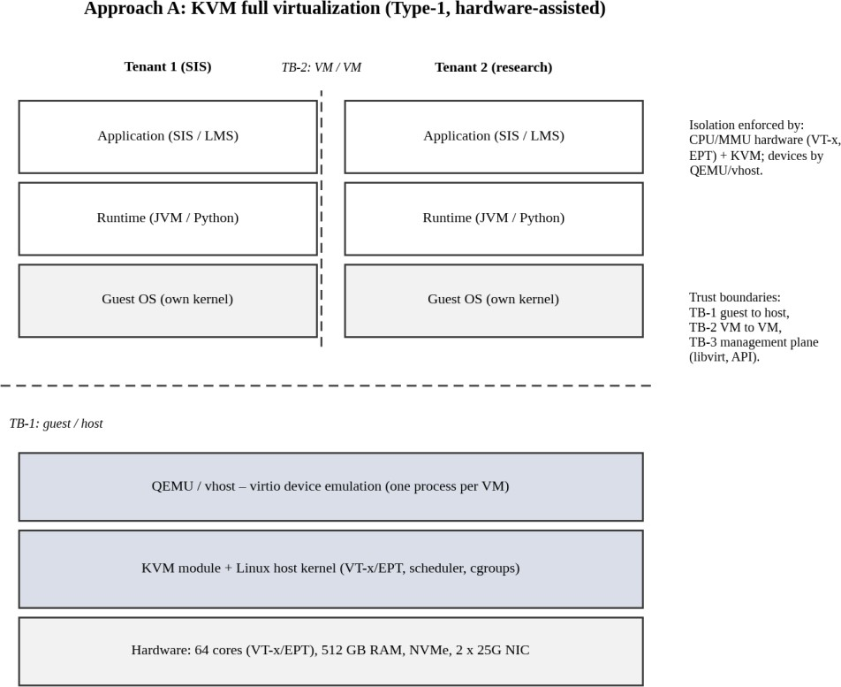

Figure 1: Layered architecture and trust boundaries of Approach A (KVM)

Approach B – Docker containers
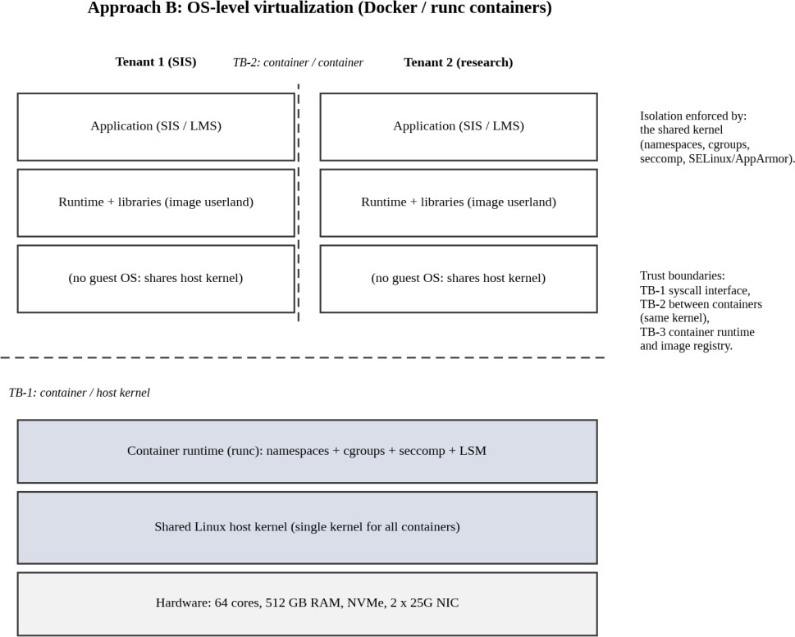

Figure 2: Layered architecture and trust boundaries of Approach B (Docker / runc)

Approach C – gVisor sandboxed containers
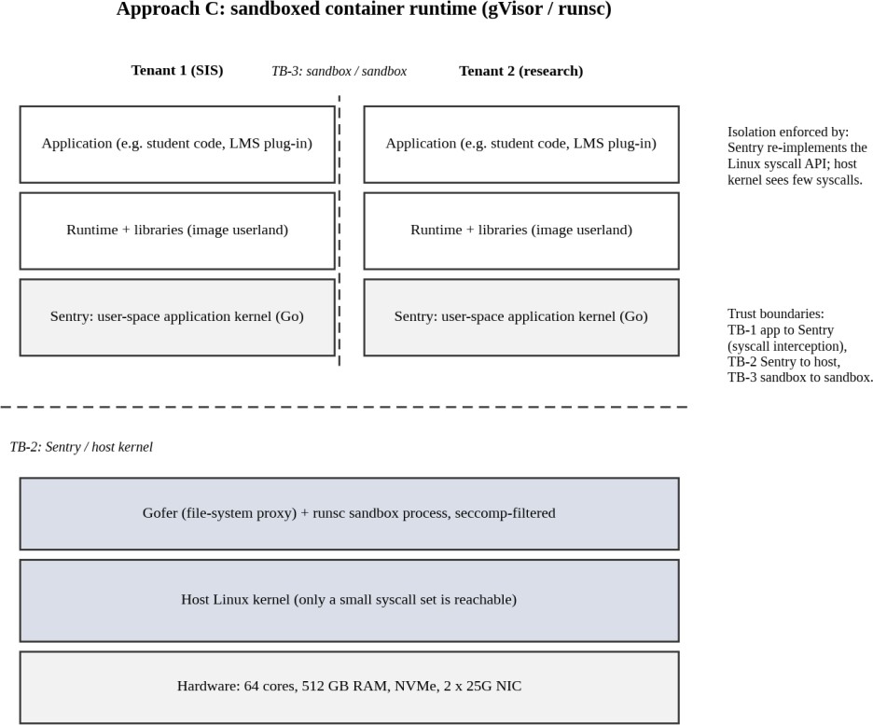

Figure 3: Layered architecture and trust boundaries of Approach C (gVisor)
Table 4: Isolation enforcer and trust boundaries
 | Component that enforces isolation | Trust boundaries (what an attacker must cross)
A | CPU hardware (VT-x, EPT) + KVM; devices by QEMU/vhost | TB-1 guest → host (VM exit interface, emulated devices); TB-2 VM  → VM; TB-3 management plane (libvirt/API)
B | The shared Linux kernel (namespaces, cgroups, seccomp, LSM) | TB-1 container → host kernel (about 300 allowed syscalls); TB-2 container → container (same kernel); TB-3 image registry / runtime
C | Sentry (application kernel) plus host seccomp filter | TB-1 app → Sentry; TB-2 Sentry → host kernel (small syscall set); TB-3 sandbox → sandbox

How each approach virtualizes CPU, memory, storage and network
Table 5: Resource-virtualization mechanisms

Resource | A KVM | B Docker | C gVisor
CPU | vCPU = host thread; guest runs directly on the CPU (VT-x); VM exits on privileged events; host scheduler time-slices | Containers are ordinary processes scheduled by the host kernel; cgroup cpu.shares / quota limits | App runs as host process; syscalls trapped to Sentry; Sentry threads scheduled by host
Memory | Guest physical → host physical through EPT (two-dimensional page walk); ballooning, KSM, swap | One kernel; cgroup memory.max; page cache shared | Sentry manages app memory (its own VMAs) on top of host memory; cgroup limits
Storage | virtio-blk / virtio-scsi to QEMU iothread, backed by qcow2 or raw volume | overlayfs + bind mounts through host VFS to the block layer | Gofer process serves files to Sentry (extra copy and RPC per I/O)

Resource | A KVM | B Docker | C gVisor
Network | virtio-net + vhost-net → OVS or Linux bridge → NIC (SR-IOV optional) | veth pair → Linux bridge → iptables / conntrack → NIC | Sentry user-space network stack  → host network (or passthrough)

Why these approaches are relevant to EduCloud
    - A (KVM): EduCloud already uses VMs; hardware isolation is the usual choice for student records, and live migration is supported for patching.
    - B (Docker): research teams and the LMS web tier are packaged as containers; containers give the highest density and fastest start-up, so they are the natural comparison point for performance.
    - C (gVisor): the audit found weak isolation and untrusted workloads (external collaborators, student code); a sandbox offers stronger isolation than plain containers without a full guest OS.

TASK 2 – Identify the Dominant Overhead Source

Marks: 2
Table 6: Evaluator quick-check (requirement → section)
Task requirement | Answered in section
Primary overhead source for each approach | Section 2.1
Where it occurs and why it is the focus | Section 2.1, 2.2
How cost/frequency changes with instances and I/O rate | Section 2.3

Dominant overhead of each approach
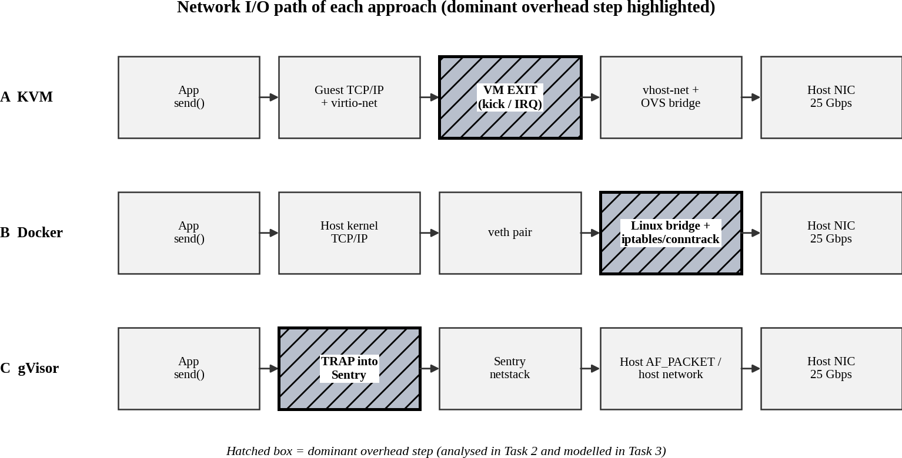
Figure 4: Network I/O path of each approach with the dominant overhead step highlighted
Table 7: Dominant overhead source, location and reason
ID | Dominant overhead | Where it occurs | Why it is the right focus
A | VM exits (traps to the hypervisor) on virtio kicks, interrupt injection, timers and IPIs | Boundary between guest kernel and host (VMX root/non-root transition) on the I/O path | Guest CPU work runs at native speed, so only transitions cost time; every I/O request produces about one exit (kick) plus one interrupt injection, so exits are the only part of the path that grows with I/O rate
B | Virtual-switch processing: veth, Linux bridge, iptables/conntrack per packet | Host kernel network path between the container’s network namespace and the NIC | CPU and memory access are native and system calls are only filtered by seccomp, so the extra work per packet in the virtual network path is the largest cost and it grows with the number of containers and rules
C | System-call interception: trap of each syscall into Sentry | Boundary between the application and the user-space kernel (Sentry) | Every file, network and memory request is a system call that must be trapped and re-implemented in Sentry, so cost is proportional to the syscall rate; this is the architecture’s defining cost

Behaviour of each overhead
A – VM exits. Cost of exits = λe × 1.5 µs. With λe = 3,000 exits/s per busy vCPU the CPU loss is 0.45
%; for an I/O-heavy VM with λe = 20,000 exits/s it is 3.0 %. Each exit also flushes pipeline state and cache lines, so the real cost is higher when many VMs compete for the same cores. With more VMs per

host, exit latency also rises because exit handling threads (vhost, QEMU iothread) are scheduled on shared cores.
B – virtual switch. Per-packet cost is t_pkt(N) = 0.8 µs + 0.02 µs × N, where N is the number of containers (iptables rules are traversed linearly). At N = 16 this is 1.12 µs; at N = 200 it would be 4.8 µs, six times the cost at N = 0, which limits packet rate to about 0.2 Mpps per core.
C – syscall interception. Each syscall costs 0.2 µs natively but 0.2 + 1.5 (trap, assumed equal to one VM exit) + 0.8 (Sentry processing) = 2.5 µs in gVisor, i.e. 12.5 times more. The overhead fraction is λs
× 2.3 µs, which is 6.9 % at 30,000 syscalls/s and 46.0 % at 200,000 syscalls/s (network- or file-heavy tiers).

How cost changes as instances or I/O rate grow
Table 8: Scaling of the dominant overhead

ID | With more co-located instances | With a higher I/O rate
A | Total exits grow linearly with VMs; scheduler contention raises exit latency; per-exit cost is almost constant | Exit count ∝ I/O operations (batching reduces it: batch of 4 cuts the cost per I/O by about 4 for the exit part)
B | Per-packet cost grows linearly with rules (0.8 + 0.02N µs); conntrack table grows | Packet rate ∝ throughput; cost per packet fixed, so CPU use rises linearly
C | Almost independent of N (each sandbox has its own Sentry) but memory per sandbox is added | Overhead ∝ syscall rate: doubling I/O doubles the loss

TASK 3 – Build a Quantitative Performance Model

Marks: 6
Table 9: Evaluator quick-check (requirement → section)
Task requirement | Answered in section
Additional assumptions stated and justified | Section 3.1
CPU model with overcommit and steal time | Section 3.2
Memory model (VMs per host before ballooning/swapping) | Section 3.3
I/O and network model versus number of sharing VMs | Section 3.4
Density under ≤ 10 % degradation | Section 3.5

Additional assumptions
Table 10: Model parameters (given values in bold; all others are assumptions)

Parameter | Value | Justification
Physical cores P / RAM M | 64 / 512 GB | Given host
VM exit cost t_e / native syscall t_sys | 1.5 µs / 0.2 µs | Given
Network line rate L / avg VM memory m | 25 Gbps / 8 GB | Given
vCPU per instance v | 4 | 8 GB : 4 vCPU is a common VM shape; gives 400 × 4 / 1024 = 1.56 average overcommit
SMT yield σ | 0.20 | Second hardware thread adds 15–30 % throughput; 20 % is a mid value
Exit rate λe, nested-paging cost δ_EPT | 3,000 /s; 1.2 % | δ_EPT: 2×10⁵ TLB misses/s × 40 ns walk = 0.8 % native; nested walk about 2.5× → extra 1.5 × 0.8 % = 1.2 %
Syscall rate λs, seccomp cost t_sec, cgroup cost o_cg | 30,000 /s; 0.05 µs; 0.2 % | Web + DB mix; BPF filter adds a few tens of ns per call; accounting is a small fixed cost
gVisor trap t_trap, Sentry t_sentry | 1.5 µs; 0.8 µs | Trap into Sentry is similar to one VM exit; Sentry processing is a short user-space routine
Host reserve R_A / R_B / R_C | 16 / 8 / 12 GB | Host OS + hypervisor + QEMU services (A), host OS only (B), host + runsc/gofer (C)
Per-instance memory overhead h_A / h_B / h_C | 0.50 / 0.05 / 0.20 GB | QEMU + guest kernel + page tables; cgroup metadata; Sentry + gofer
Network path: cores K, frame size S | 4 cores; 1500 B (12,000  bit) | Cores available for vhost/bridge/netstack work
Per-packet cost t_pkt | A: 1.2(1+γ log₂N) µs; B:  0.8 + 0.02N µs; C:  4.0(1+γ log₂N) µs; γ = 0.03 | vhost + OVS (hash lookups, small growth); iptables linear in rules; user-space netstack costs more per packet
Disk: IOPS_dev, cores c_io | 600,000; 2 cores | NVMe 4 KiB random read; cores handling the I/O path
Per-I/O path cost t_io | A: 1.0 + 2×1.5/4 = 1.75  µs; B: 1.3 µs; C: 1.0 + 6  = 7 µs | A: native 1.0 µs + kick and interrupt exits (2 × 1.5 µs) shared by a batch of 4; B: overlayfs/cgroup 0.3 µs extra; C: gofer RPC about 6 µs
Utilisation u | 0.20 normal, 0.60 peak  (3×) | Registration peak is about 3× normal

CPU model: effective per-VM capacity, overcommit and steal time
Step 1 – overhead fraction o (share of CPU time lost to virtualization):
o_A = λe · t_e + δ_EPT o_B = λs · t_sec + o_cg o_C = λs · (t_trap + t_sentry)
o_A = 3000 × 1.5 µs + 1.2 % = 1.65 % o_B = 30000 × 0.05 µs + 0.2 % = 0.35 % o_C = 30000
× 2.3 µs = 6.9 %
Step 2 – steal time. If r vCPUs share each physical core and each vCPU is busy a fraction u of the time, the demand per core is r·u. A core with SMT can deliver (1 + σ) core-equivalents, so the fraction of time a ready vCPU waits (steal) is
s = max( 0 , 1 − (1 + σ) / (r · u) )
Step 3 – effective capacity of one vCPU (fraction of one native core) and of a VM with v vCPUs:
C(r, u) = (1 − o) · (1 − s) = (1 − o) · min( 1 , (1 + σ) / (r · u) ) C_VM = v · C
Worked example (A, r = 4:1, u = 0.60): r·u = 2.4; (1 + σ)/(r·u) = 1.2/2.4 = 0.50, so steal s = 50 %. C = (1 − 0.0165) × 0.50 = 49.2 % of a native core per vCPU, so a 4-vCPU VM gets 1.97 cores instead of 4.
Table 11: Effective capacity per vCPU (% of a native core) from the model
Overcommit r | u | Steal s | A KVM | B Docker | C gVisor
1:1 | 0.2 | 0 % | 98.4 % | 99.7 % | 93.1 %
1:1 | 0.6 | 0 % | 98.4 % | 99.7 % | 93.1 %
2:1 | 0.2 | 0 % | 98.4 % | 99.7 % | 93.1 %
2:1 | 0.6 | 0 % | 98.4 % | 99.7 % | 93.1 %
4:1 | 0.2 | 0 % | 98.4 % | 99.7 % | 93.1 %
4:1 | 0.6 | 50 % | 49.2 % | 49.8 % | 46.6 %
8:1 | 0.2 | 25 % | 73.8 % | 74.7 % | 69.8 %
8:1 | 0.6 | 75 % | 24.6 % | 24.9 % | 23.3 %
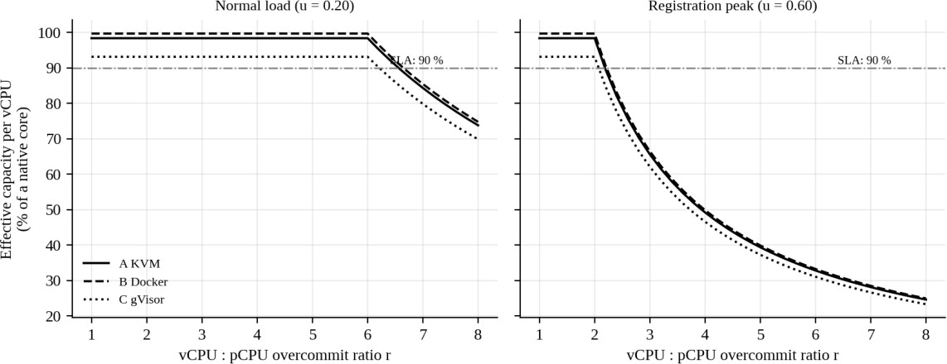
Figure 5: Effective per-vCPU capacity versus overcommit ratio (model)
Maximum overcommit for ≤ 10 % degradation: capacity ≥ 0.9 gives r_max = (1 + σ)(1 − o) / (0.9 u). At peak (u = 0.6): A 2.19:1, B 2.21:1, C 2.07:1; at normal load (u = 0.2): A 6.56:1, B 6.64:1, C
6.21:1. The model therefore says that overcommit above about 2:1 is unsafe in registration week, whatever the approach.

Memory model: VMs per host before ballooning, swapping or page sharing
N_mem = floor( (M − R) / (m + h) ) with page sharing (KSM saving κ): N_ksm = floor( (M − R) / (m(1 − κ) + h) )
Worked example (A): N_mem = (512 − 16) / (8 + 0.5) = 496 / 8.5 = 58.4 → 58 VMs. B: (512 − 8)/(8
+ 0.05) = 62.6 → 62. C: (512 − 12)/(8 + 0.2) = 61.0 → 60. With 10 % page sharing (κ = 0.10) A
becomes (496)/(7.2 + 0.5) = 64.
Beyond N_mem the host must use ballooning (reclaim from guests), KSM or swapping. The current average of 25 VMs/host uses 25 × 8.5 = 212 GB (42 % of RAM), so memory is not the first limit. The cost of swapping is given by the effective access time EAT = (1 − p) · t_mem + p · t_swap. With t_mem
= 100 ns and t_swap = 100 µs, EAT/t_mem = 1.10 at p = 10⁻⁴ (exactly the 10 % limit), 2.00 at p = 10⁻³ and 11.0 at p = 10⁻².

I/O and network model
Network. Aggregate throughput is limited by the line rate or by the CPU cost of the virtual network path; the aggregate is shared by N active instances:
T_agg(N) = min( L , K · S / t_pkt(N) ) T_inst(N) = T_agg(N) / N
Disk. Likewise for IOPS, with the per-I/O path cost t_io:
IOPS_agg(N) = min( IOPS_dev , c_io / t_io(N) ) IOPS_inst(N) = IOPS_agg(N) / N t_io(N)
= t_io(1) (1 + γ log₂N)
Worked example (C, N = 8, network): t_pkt = 4.0 × (1 + 0.03 × 3) = 4.36 µs; K·S/t_pkt = 4 × 12,000 /
4.36 µs = 11.0 Gbps (below 25 Gbps, so CPU-bound); per instance 1.38 Gbps. For A the same formula gives 4 × 12,000 / 1.34 µs ≈ 35 Gbps, so A is line-rate bound at 25 Gbps.
Table 12: Per-instance network (Gbps) and disk (thousand IOPS) versus number of sharing instances (model)
N | Net A | Net B | Net C | IOPS A | IOPS B | IOPS C
1 | 25.00 | 25.00 | 12.00 | 600 | 600 | 286
2 | 12.50 | 12.50 | 5.83 | 300 | 300 | 139
4 | 6.25 | 6.25 | 2.83 | 150 | 150 | 67
8 | 3.13 | 3.13 | 1.38 | 75 | 75 | 33
16 | 1.56 | 1.56 | 0.67 | 38 | 38 | 16
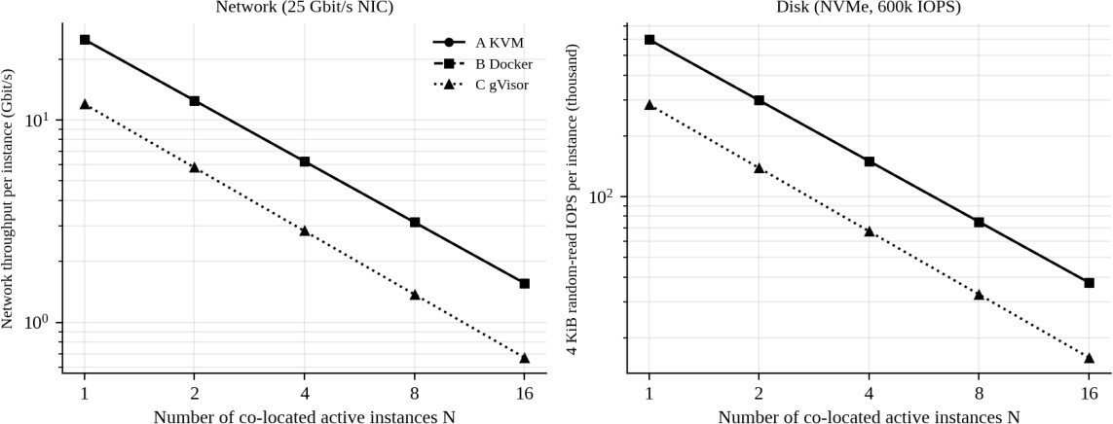
Figure 6: Per-instance network and disk throughput versus number of sharing instances (model)

A and B are limited by the device (25 Gbps, 600k IOPS), so each instance simply gets 1/N of it. C is limited by its own CPU path: 12.0 Gbps and 286k IOPS in total, which is 48 % and 48 % of the device capability.
  - Density under a service-level target (≤ 10 % degradation)
A host can carry N instances if all four resource constraints hold (δ = 0.10):
N·v·u ≤ κ_a = P(1 + σ)(1 − o_a)/(1 − δ) N(m + h) ≤ M − R N·i_req ≤ IOPS_agg(N)/(1 − δ) N·b_req ≤ T_agg(N)/(1 − δ)
The CPU capacity is κ_A = 83.9, κ_B = 85.0, κ_C = 79.4 busy vCPUs per host. At peak, CPU gives N_cpu = κ / (v·u) = 83.9 / 2.4 = 34 (A), 35 (B), 33 (C). Demands per instance are i_req = 6,000 IOPS and b_req = 0.15 Gbps normally, and 18,000 IOPS and 0.45 Gbps at peak.
Table 13: Density per host at ≤ 10 % degradation (all constraints applied)

Approach | Normal load | Limited by | Peak (3×) | Limited by
A KVM | 58 | memory | 34 | CPU
B Docker | 62 | memory | 35 | CPU
C gVisor | 45 | disk I/O path | 15 | disk I/O path
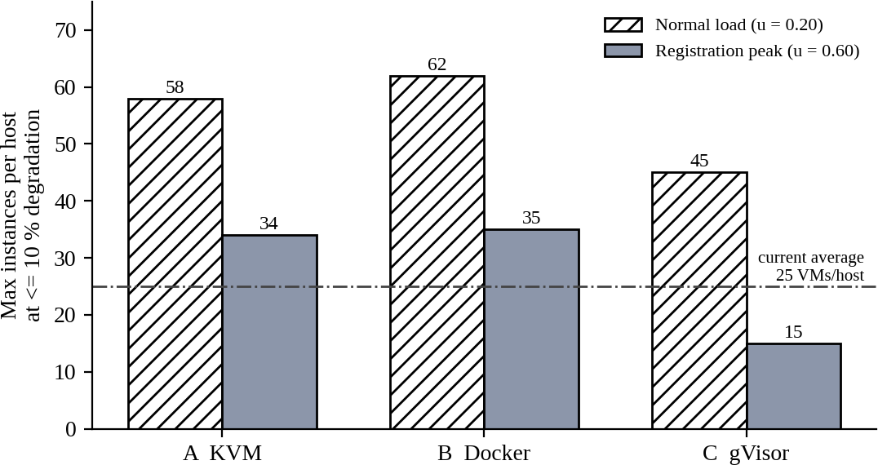
Figure 7: Maximum instances per host at ≤ 10 % degradation (model)
Interpretation. EduCloud averages 25 VMs per host, which is inside the limit for A (34) and B (35) but near the limit for C (15). Slowness in registration week therefore comes from uneven placement and shared I/O rather than from the average load; Task 4 shows a hot-spot example.

TASK 4 – Analyse Performance Under Different Operating Conditions

Marks: 4
Table 14: Evaluator quick-check (requirement → section)
Task requirement | Answered in section
Best case | Section 4.1
Typical case (registration-week mixed load) | Section 4.2
Worst case: noisy neighbour, swapping, live migration, I/O storm | Section 4.3
Link to Task 3 model | Section 4.1–4.3 (each uses model values)

Best case
Conditions: CPU-bound or cache-resident work, pinned vCPUs, r ≤ 1:1, huge pages, SR-IOV or vhost network, few system calls (λe ≈ 500/s, λs ≈ 1,000/s), no neighbours.
A (KVM): guest instructions run directly on the CPU, so the hypervisor is almost idle. With pinned vCPUs the scheduler never preempts, there is no steal and exits are only timer interrupts: o = 500 × 1.5 µs + 1.2 % = 1.28 %. The remaining loss is the two-dimensional page walk of EPT; huge pages shorten it. B (Docker): the workload is a normal process; the only cost is cgroup accounting and a few filtered syscalls: o = 0.21 %, i.e. almost native. C (gVisor): if the program makes very few syscalls the Sentry is rarely entered: o = 1,000 × 2.3 µs = 0.23 %. For compute-bound code all three approaches are within about 1.5 % of native, so the choice cannot be made on best-case speed.

Typical case: registration-week mixed web and database load
Conditions: u = 0.6, 25 VMs × 4 vCPU = 100 vCPU on 64 cores (r = 1.56:1), λe = 3,000/s, λs = 30,000/s, I/O 18,000 IOPS and 0.45 Gbps per VM. Here r·u = 0.94 < 1.2, so there is no steal and the loss is only the overhead o: A 1.65 %, B 0.35 %, C 6.9 %.
Inside the layer: in A the web VM’s network packets and the DB VM’s disk requests generate virtio kicks (VM exits) at about 3,000/s per busy vCPU, each costing 1.5 µs, and the vhost threads consume host cores; in B the traffic goes through veth, bridge and iptables, adding roughly 0.8–1.1 µs per packet; in C every read(), write() and futex() of the database is trapped into the Sentry, 12.5× more expensive than native. Latency of a request that makes 50 syscalls therefore grows by about 50 × 2.3 µs = 115 µs in C but by less than 3 µs in B. Throughput of the database tier in C falls by about 6.9 % because that CPU time is spent in the trap path. The model predicts that all three approaches stay inside the 10 % target in this typical case, with C having only 3.1 % margin.

Worst case

Noisy neighbour on a hot host
Suppose placement puts 10 SIS/LMS VMs (u = 0.6) and 20 research VMs running at u = 0.9 on one host. Demand = (10 × 4 × 0.6) + (20 × 4 × 0.9) = 24 + 72 = 96 busy vCPUs on 64 cores, so r·u = 1.50. Steal s = 1 − 1.2/1.5 = 20 %, and the SIS VM capacity is (1 − 0.0165) × 0.80 = 78.7 % of native, i.e.
21.3 % degradation, more than twice the 10 % target. The host scheduler (CFS) divides time in proportion to weights, so the SIS vCPUs are descheduled while research vCPUs run; the guest sees this as steal time and its timers, locks and TCP timeouts fire late, which produces the failed logins. In B the same occurs through cgroup CPU shares (a quota would cap the research containers); in C identical CPU loss applies and the Sentry threads are also delayed.

Memory overcommit with swapping
If the host swaps, one page fault costs about 100 µs against 100 ns for RAM. A 10 % slowdown is allowed only when p ≤ 10⁻⁴; at p = 10⁻³ memory-bound code runs 2.00× slower and at p = 10⁻² it runs 11.0× slower (Figure 8, right). In A, the hypervisor cannot see which guest pages are cold (the semantic gap), so it may swap pages the guest still needs, and double paging can occur when the guest also swaps; ballooning moves the decision into the guest and is better. In B the kernel reclaims page cache first and then kills a container (OOM) when memory.max is reached; swapping is rarely acceptable. In C the Sentry has its own memory accounting, which adds a second layer of reclaim.

Live migration during peak load (A only)
Pre-copy migration of an 8 GB VM over the 25 Gbps link (3.125 GB/s) with a page-dirty rate d: round i sends the data dirtied during round i − 1, so the remaining data shrinks by ρ = d / B each round. For d
= 1 GB/s: ρ = 0.32; rounds send 8, 2.56, 0.82, 0.26, 0.08 GB; total 11.7 GB; duration 3.8 s; stop-and-copy downtime ≈ 8.6 ms. During peak, a busy database VM may dirty memory at 3 GB/s: ρ = 0.96, and after 30 rounds still 2.4 GB remain, so the migration does not converge without auto-converge (throttling the guest) or post-copy. In addition the migration traffic takes the whole 25 Gbps NIC, starving tenant traffic, so peak-time migration must be forbidden or use a separate NIC. B and C have no practical live migration; patching means restarting containers (a short outage for stateless tiers, a real outage for a database).
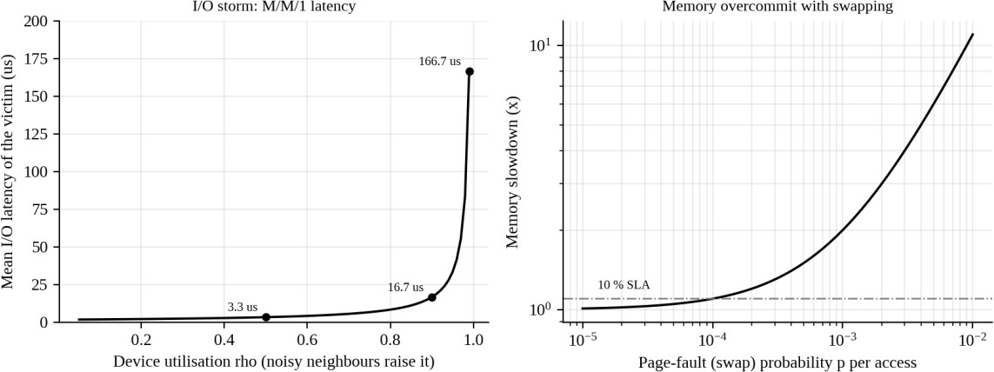
Figure 8: Worst-case behaviour: I/O storm latency (left) and swapping slowdown (right) – model

I/O storm
The NVMe device is a shared server with service rate μ = 600,000 IOPS; the mean latency is W = 1/(μ
− λ) (M/M/1). An idle device gives 1.67 µs. As neighbours raise the load: ρ = 0.5 → 3.3 µs, ρ = 0.9 →
16.7 µs, ρ = 0.99 → 166.7 µs (100× idle). The SIS VM issues the same I/O but waits in the shared queue, and this applies to A, B and C, because the queue is below the virtualization layer. C suffers earliest, because its own path saturates at 286k IOPS, i.e. ρ = 0.9 is reached at only 257k IOPS.
Table 15: Summary of behaviour (model-based; latency and throughput effects)
Condition | A KVM | B Docker | C gVisor
Best | Loss 1.3 %; near-native latency | Loss 0.2 %; native latency | Loss 0.23 % if syscalls are rare
Typical | Loss 1.7 %; exits add ~µs to I/O | Loss 0.4 %; ~1 µs per packet | Loss 6.9 %; +2.3 µs per syscall
Worst: noisy neighbour | 21 % degradation (steal 20 %) | Similar; cgroup quotas can cap aggressors | Similar; Sentry threads also delayed
Worst: I/O storm | Queueing latency 10–100× idle | Same (shared queue) | Same, reached earlier (286k IOPS path)

Condition | A KVM | B Docker | C gVisor
Worst: live migration | Works; 3.8 s at d = 1 GB/s; fails to converge at 3 GB/s | Not available (restart) | Not available (restart)

TASK 5 – Security Threat and Vulnerability Analysis

Marks: 3
Table 16: Evaluator quick-check (requirement → section)
Task requirement | Answered in section
Attack surface of each approach | Section 5.1
At least four threat categories with exposure and reason | Section 5.2
Impact on confidentiality, integrity, availability of student records | Section 5.3
Justified comparison | Section 5.4

Attack surface
Table 17: Attack surface per approach
Surface | A KVM | B Docker | C gVisor
Hypervisor / kernel interface | KVM module (VM-exit handlers), moderate size | Whole Linux kernel syscall interface (about 300 calls after default seccomp) | Small set of host syscalls used by Sentry (a few tens); Sentry itself is new code
Device emulation | QEMU virtio and legacy devices: large user-space attack surface | None (no emulated devices) | Gofer and Sentry file/network code
Shared kernel | Not shared (each VM has own kernel) | Shared by all containers | Not shared with the app (Sentry), host kernel only via small set
Management plane | libvirt / API / consoles | Docker daemon (root), registry, API | Same as B plus runsc
Images and snapshots | qcow2 images and snapshots contain full disks and memory | Image layers; registry | Image layers; registry
Virtual network | OVS / bridge, VLAN, vhost | docker0 bridge, veth, iptables (ARP spoofing possible between containers) | Sentry netstack, host network

Threat model: seven threat categories and exposure of each approach
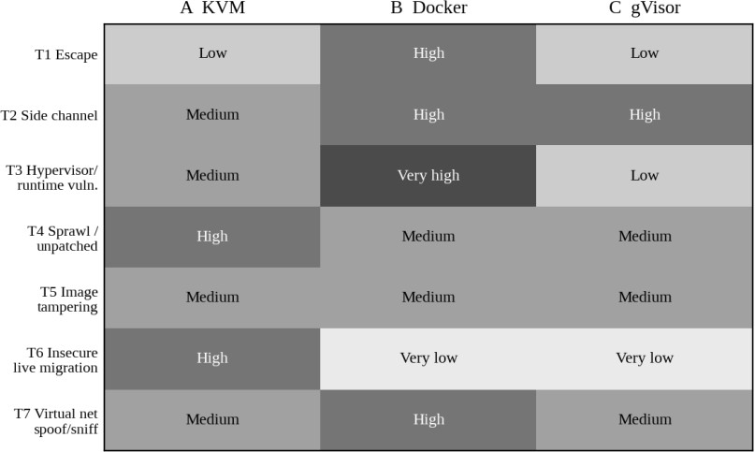
Figure 9: Exposure of each approach to seven threats (qualitative, 1 = very low to 5 = very high)

Table 18: Threats, exposure and architectural reason
Threat | A | B | C | Why (architecture and trust boundaries)
T1 VM /  container escape | Low | High | Low | A: attacker must pass guest kernel, KVM and QEMU (past escapes such as VENOM, CVE-2015-3456, were in emulated devices). B: a single kernel bug or runtime flaw (e.g. runc CVE-2019-5736, Dirty COW CVE-2016-5195) crosses TB-1.  C: app must first break Sentry and then a small host interface.
T2 Cross-tenant side channel | Medium | High | High | Tenants share caches, memory bus and SMT siblings in all three; A can flush L1D on VM entry and use core scheduling; B and C have no such per-boundary flush; C’s Sentry adds no hardware barrier.
T3 Hypervisor / runtime vulnerability | Medium | Very high | Low | B’s trusted base is the whole kernel; A’s is KVM + QEMU; C’s base for the host is small, but its Go runtime is young and still evolving.
T4 VM sprawl, unpatched guests | High | Medium | Medium | A has one guest kernel per VM (the audit found outdated ones) so patching scales with N; B patches one host kernel; images still age in B and C.
T5 Image tampering | Medium | Medium | Medium | Free copying of images lets a poisoned image reach any tenant in all approaches; signing is needed everywhere.
T6 Insecure live migration | High | Very low | Very low | Only A migrates running memory; plain migration sends guest memory (keys, records) in clear unless encrypted.
T7 Virtual-network sniffing/spoofing | Medium | High | Medium | docker0 bridge allows ARP/MAC spoofing between containers by default; OVS with VLAN/port security is stricter.

Impact on confidentiality, integrity and availability of student records
Table 19: CIA impact of the threats

Threat | Confidentiality | Integrity | Availability
T1 Escape | Read all records on host | Alter marks and fees | Crash host, many tenants down
T2 Side channel | Leak keys or session tokens | Low | Low
T3 Hypervisor / runtime bug | Full compromise | Full compromise | Host crash (DoS)
T4 Unpatched guest | Entry point for attacker | Tampering of the application | Ransomware, outage
T5 Image tampering | Backdoor exfiltrates data | Modified application logic | Faulty image breaks service
T6 Insecure migration | Memory content (keys) exposed | Memory can be altered in transit | Failed migration
T7 Network spoofing | Sniffing of login traffic | Man-in-the-middle changes | Traffic redirected

Justified comparison
Weighting each threat by its impact on student records (weights 0.25, 0.20, 0.20, 0.15, 0.10, 0.05, 0.05 for T1–T7) and normalising to 0–1, the exposure scores are A = 0.59, B = 0.76, C = 0.53 (lower is better). B is clearly the most exposed because of the shared kernel (T1, T3). C has the lowest exposure but is the only one that cannot migrate and has the largest performance cost. A sits in between: it is weak on sprawl (T4) and migration (T6), both of which are procedural problems that can be fixed with golden images and encrypted migration, whereas B’s weakness is architectural.

TASK 6 – Formulate the Isolation–Performance Trade-off

Marks: 3
Table 20: Evaluator quick-check (requirement → section)
Task requirement | Answered in section
Decision variables | Section 6.1
Objective | Section 6.2
Constraints | Section 6.3
Cost / decision function and worked evaluation | Section 6.4

Decision variables
Table 21: Decision variables (k = tenant class S, R, X)
Symbol | Meaning | Range / link to earlier tasks
a_k | Virtualization approach for class k | {A, B, C} (Task 1); sets overhead o_a and path costs (Task 3)
n_k | Instances of class k per host | Integer; limited by the density equations of Task 3.5
h_k | Hosts in the pool of class k | Integer; Σ h_k ≤ 16
d_k | Pool dedicated to class k (1) or shared with other trust domains (0) | Binary; sets trust factor τ in the risk term (Task 5)
s_k | SMT on (1) or off (0) | Binary; changes σ to 0.20 or 0

Objective
Minimise the number of hosts used plus the weighted security risk, with the risk converted to host-equivalents by a price λ:
min J = Σ_k h_k + λ · Σ_k W_k · ρ_k ρ_k = τ(d_k) · ( Σ_t w_t · e_{a_k,t} ) / 5
Here e_{a,t} is the exposure score of approach a to threat t and w_t its weight, both from the Task 5 matrix (so ρ is A 0.59, B 0.76, C 0.53 when the pool is shared). The trust factor is τ = 1.0 for a pool shared with other trust domains, τ = 0.3 for a pool dedicated to one tenant class (only insiders and same-tenant attacks remain), and τ = 0.6 for the external-collaborator pool, which is shared among several outside groups. The class weights W are S = 1.0 (student records), R = 0.2 and X = 0.5. λ = 20 host-equivalents per unit of risk (assumption: reducing risk by 0.1 is worth two hosts); the ranking in Table 22 does not change for any λ > 0 because the best option is also cheapest in hosts.

Constraints
Table 22: Constraints and their origin

No. | Constraint | Origin
C1 | Degradation Δ_k = 1 − (1 − o_a)·min(1, (1+σ s_k)/(r_k u_k)) ≤ δ_k, with δ_S = 0.10 and δ_R = 0.25 | Task 3.2 and the service-level target
C2 | n_k (m_k + h_a) ≤ M − R_a | Task 3.3
C3 | n_k · i_k ≤ IOPS_agg / (1 − δ_k) and n_k · b_k ≤ T_agg  / (1 − δ_k) | Task 3.4
C4 | Isolation: S and X never share a host (d_S = 1 and pools disjoint) | Task 5: T1 and T2 exposure; regulation in Task 12

No. | Constraint | Origin
C5 | Capability: the stateful SIS database needs live migration for patching, so a_S = A | Task 4.3(c): only A migrates
C6 | Overhead feasibility: o_a < δ_k; for C this needs λs <  0.10 / 2.3 µs = 43,478 syscalls/s | Task 3.2
C7 | Available hosts: Σ h_k ≤ 16 | Scenario

Combined decision function and evaluation of options (before external tenants)
Table 23: Evaluation of design options (S = 100, R = 300 instances)

ID | Option | H | ρ_S | ρ_R | J | Feasible?
O1 | Containers (B), one shared pool | 10 | 0.76 | 0.76 | 28.2 | No – no live migration for stateful SIS DB
O2 | KVM VMs (A), one shared pool | 11 | 0.59 | 0.59 | 25.2 | Yes
O3 | gVisor (C), one shared pool | 11 | 0.53 | 0.53 | 23.7 | No – no live migration; syscall margin only 3.1 pp
O4 | KVM dedicated pool for SIS/LMS (+1 spare) + containers (B) for research (25  % SLA) | 10 | 0.18 | 0.76 | 16.6 | Yes
O5 | KVM dedicated SIS/LMS pool (+1 spare) + KVM research pool (25 % SLA) | 10 | 0.18 | 0.59 | 15.9 | Yes
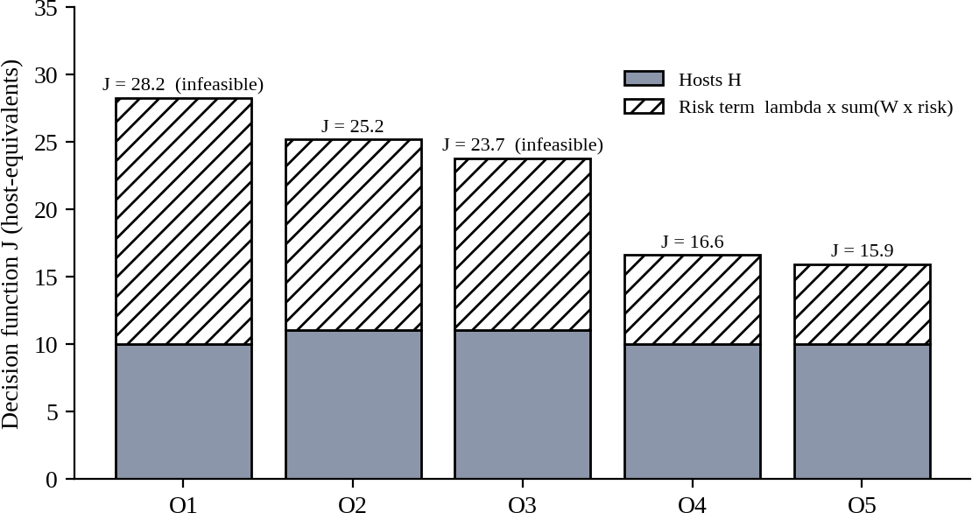
Worked example for O5: hosts = 4 (S pool: 3 needed + 1 spare) + 6 (R pool at 25 % target) = 10; ρ_S
= 0.59 × 0.3 = 0.177; ρ_R = 0.59 × 1.0 = 0.59; J = 10 + 20 × (1.0 × 0.177 + 0.2 × 0.59) = 10 + 20 ×
0.295 = 15.9. Hosts: S pool = ceil(100 × 4 × 0.6 / 83.9) = ceil(2.86) = 3, plus one spare.

Figure 10: Decision function J of the design options (hosts plus weighted risk)
Reading the result. O3 (gVisor everywhere) looks cheap in J but fails constraints C5 and has very little syscall margin; O1 (containers) fails C5 and has the largest risk. O2 (one shared KVM pool) is feasible but needs more hosts and keeps S next to research tenants. The lowest J among feasible options is O5: KVM with a dedicated S pool, which comes from the model (Task 3: KVM costs only about 1.7 % CPU) and the threat analysis (Task 5: shared kernel is the largest exposure).

TASK 7 – Evaluate Mitigation Strategies

Marks: 4
Table 24: Evaluator quick-check (requirement → section)
Task requirement | Answered in section
At least three mitigations | Section 7.1 (seven given)
Applicability to the threat | Section 7.1
Residual risk | Section 7.1
Performance / density cost from the Task 3 model | Section 7.2
Acceptability for the SIS | Section 7.2, 7.3

Mitigations, threat coverage and residual risk
Table 25: Mitigations evaluated

Mitigation | Threats | Why it applies | Residual risk
M1 Disable SMT (or core scheduling) | T2 | Side-channel attacks need a sibling hardware thread to share L1/L2 caches; removing siblings or isolating them per tenant stops this path | Cross-core cache and memory-bus channels remain
M2 Kernel page-table isolation (KPTI) + L1D flush on VM entry + updated microcode | T2, T3 | Stops Meltdown/L1TF-style reads across the user–kernel and guest–host boundary | Unknown future speculative-execution bugs
M3 Dedicated host pool for SIS/LMS | T1, T2, T3 | No external or research tenant shares the kernel, caches or hypervisor with student records | Same-tenant (insider) attacks; hypervisor bug exploited from inside the pool
M4 Sandboxed runtime (gVisor) for untrusted containers | T1, T3 | App cannot reach host kernel directly; host sees only a small syscall set | Bugs in Sentry; performance limits use
M5 Micro-segmentation (OVS flow rules, per-tenant VLAN/VXLAN, port security) | T7 | Blocks ARP/MAC spoofing and east–west sniffing between tenants | L7 attacks inside an allowed flow
M6 Image signing + golden-image patch pipeline | T4, T5 | Only signed images start; one image rebuilt and rolled out instead of patching N guests | Compromised signing key; zero-days between releases
M7 Encrypted live migration (TLS, multifd)  + hardware memory encryption (SEV-SNP / TDX) where available | T6 | Migration stream and guest memory are protected on the wire and in RAM | Side channels; cost of CPU and bounce buffers

Performance and density cost using the Task 3 model
Table 26: Quantified cost of each mitigation

Mitigation | Model calculation | Cost
M1 SMT off | σ falls from 0.20 to 0: r_max = (1+σ)(1−o)/(0.9u) changes from 2.19 to 1.82; peak density 34 → 29 VMs/host | −14.7 % density, −16.7 % CPU capacity (1/1.2); S pool grows from 3 to 4 hosts
M2 KPTI / L1D  flush | A: exit cost 1.5 → 2.0 µs: o = 1.65 % → 1.80 % (typical), 4.2 % → 5.2 % (I/O-heavy λe = 20k/s). B:  +0.15 µs per syscall: 0.35 % → 0.80 % (typical), 1.2  % → 4.2 % (200k syscalls/s) | +0.15 to +1.0 pp (A), +0.45 to +3.0 pp (B); density change below 1–3 %

Mitigation | Model calculation | Cost
M3 Dedicated S pool | S needs ceil(240/83.9) = 3 hosts + 1 spare = 4; normal-load use of those hosts = 100×4×0.2 / (3×76.8) = 80/230.4 = 34.7 % | 4 of 16 hosts (25 %) dedicated; about 65 % of their capacity is idle in normal weeks
M4 gVisor for untrusted containers | o_C = 6.9 % at 30k syscalls/s, 23 % at 100k/s; network 12.0 vs 25 Gbps; IOPS 286k vs 600k; peak density 15 vs 34 | −56 % density at peak; −52 % network and IOPS ceilings
M5 Micro-segmentation | t_pkt at N = 16: 1.34 → 1.44 µs; aggregate capacity 4×12,000/1.44 µs = 33.2 Gbps > 25 Gbps | No throughput loss (still line-rate bound); a little extra CPU and flow-table memory
M6 Image signing  + golden image | No runtime cost; verification assumed 1–2 s per start; patching work falls from N guests to 1 image | Negligible; start-up +1–2 s
M7 Encrypted migration + memory encryption | Single TLS stream 1.25 GB/s: ρ = 0.80, 39.8 GB sent, 31.8 s (vs 3.8 s); with multifd back to ρ = 0.32. Memory encryption: assumed +3 % on the 40 % memory-bound part = +1.2 %; I/O bounce buffer adds 0.5 µs → 2 / 2.25 µs = 889k IOPS > 600k | +1.2 % CPU; migration 8× longer if single-stream, none with multifd; no I/O loss
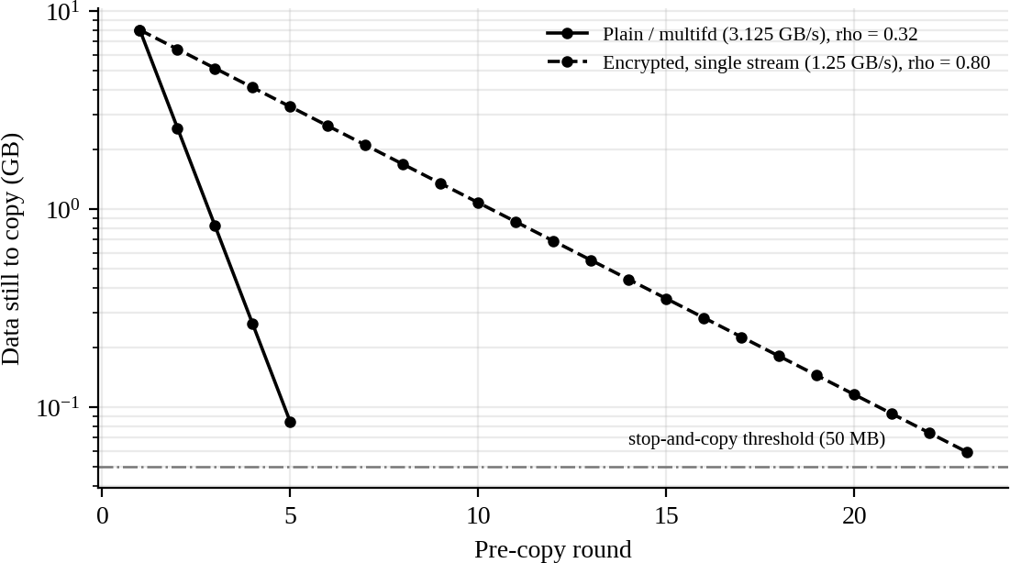
Figure 11: Live-migration convergence with and without encryption bottleneck (model)

Is the trade-off acceptable for the SIS?
    - M2, M5, M6, M7: acceptable and recommended: cost is a few percent of CPU or nothing, and they close real gaps found in the audit (outdated kernels, free image copying, unencrypted migration).
    - M3 (dedicated pool): acceptable and the strongest single measure; 4 hosts is the price of demonstrable isolation, and the S pool still runs at 95 % of its SLA capacity with 3 hosts or 71
% with 4 hosts at peak (240 / (4 × 83.9)).
    - M1 (SMT off): acceptable inside the S pool only if the budget allows one more host (S pool 4
→ 5); otherwise use core scheduling, which keeps SMT but never lets two tenants share a core. Within a pool dedicated to one tenant class SMT can stay on.
    - M4 (gVisor): not acceptable for the SIS database tier (−56 % density, no migration); acceptable only for low-I/O untrusted code such as an autograder.

TASK 8 – Implement and Test

Marks: 4
Table 27: Evaluator quick-check (requirement → section)
Task requirement | Answered in section
Platforms (KVM/QEMU, Docker, gVisor), nested virtualization documented | Section 8.1
Scale 1 → 2 → 4 → 8 → 16 with identical allocation | Section 8.2
CPU, disk, network and memory workloads | Section 8.4
Noisy-neighbour experiment | Section 8.5
Security validation | Section 8.6
Reproducible scripts and commands | Section 8.3–8.6
Honest scope note: these experiments need KVM-capable hardware and cannot be produced by this document. Everything needed to run them is given below, in the order you should run it. Your own results go into Task 9. Time needed: 3 approaches × 5 scales × 5 repetitions × 4 workloads × 30 s ≈ 2.5 hours of benchmark time.

Platforms and environment
Table 28: Test environment (fill the right-hand column with your machine)
Item | Plan | Your machine (fill)
Host | Linux laptop/PC with Intel VT-x or AMD-V and at least 16 GB RAM, Ubuntu 22.04 or 24.04
CPU / RAM / disk | Record: lscpu, free -h, lsblk
Approach A | KVM/QEMU managed by libvirt, Ubuntu cloud image, virtio disk and NIC | Versions:
Approach B | Docker Engine, runtime runc | Version:
Approach C | gVisor runsc registered as a Docker runtime (default platform) | Version / platform:
Nested virtualization (only if you run inside a VM) | Enable nested VT-x/AMD-V in the outer hypervisor and document it: nested exits are far slower, so A’s overhead will be larger than the model | Nested? yes / no
Scale | 1, 2, 4, 8, 16 instances; each 1 vCPU / 1 GB RAM (EduCloud’s 4 vCPU / 8 GB reduced by 4× and 8×); if the laptop cannot run 16, reduce to 8 and state the limit
Calibration to the model | Replace P with the laptop’s core count, L with the measured iperf3 bare-metal rate and IOPS_dev with the measured fio bare-metal IOPS; keep every other symbol

Experimental design
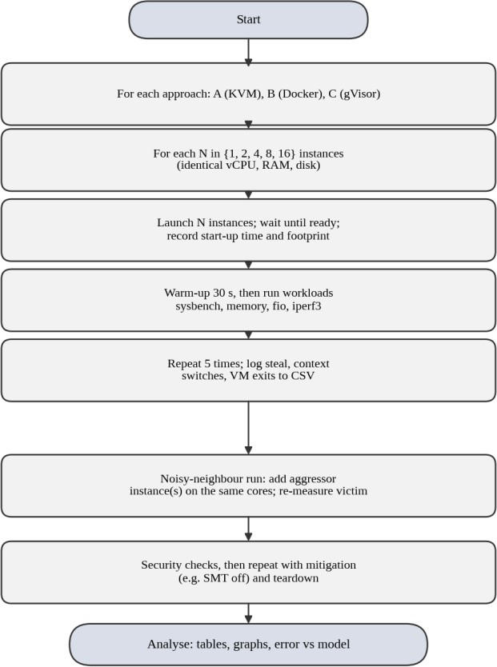
Figure 12: Experiment workflow used for every approach
Fairness rules: (1) same vCPU and memory limits for every instance (1 vCPU = --cpus=1 = --vcpus 1); (2) same guest/user-land (Ubuntu 22.04) and the same benchmark versions; (3) same workload parameters and 5 repetitions after a 30 s warm-up; (4) benchmark runs happen in all N instances at the same time; (5) a bare-metal baseline (run on the host itself) is recorded for every workload; (6) the host is idle, plugged in, performance CPU governor, and nothing else running.

Setup scripts

setup.sh – install everything (run once)
#!/usr/bin/env bash sudo apt update
sudo apt install -y qemu-kvm libvirt-daemon-system libvirt-clients virtinst cloud-image-utils \ docker.io sysbench fio iperf3 stress-ng sysstat jq linux-tools-common linux-tools-generic
sudo usermod -aG libvirt,docker,kvm $USER # log out and in afterwards
# gVisor (check https://gvisor.dev/docs/user_guide/install/ for the current steps)
curl -fsSL https://gvisor.dev/archive.key | sudo gpg --dearmor -o /usr/share/keyrings/gvisor-archive-keyring.gpg echo "deb [arch=$(dpkg --print-architecture) signed-by=/usr/share/keyrings/gvisor-archive-keyring.gpg] https://storage.googleapis.com/gvisor/releases release main" | sudo tee /etc/apt/sources.list.d/gvisor.list
sudo apt update && sudo apt install -y runsc
sudo runsc install && sudo systemctl restart docker # checks
egrep -c '(vmx|svm)' /proc/cpuinfo # must be > 0
docker run --rm --runtime=runsc hello-world # gVisor works

Dockerfile.bench – identical user-land for approaches B and C
FROM ubuntu:22.04
RUN apt-get update && apt-get install -y sysbench fio iperf3 stress-ng sysstat procps && rm -rf /var/lib/apt/lists/* # build: docker build -f Dockerfile.bench -t bench .

launch_container.sh – approaches B and C
#!/usr/bin/env bash
# usage: ./launch_container.sh docker|gvisor N
APP=$1; N=$2; RT=runc; [ "$APP" = gvisor ] && RT=runsc for i in $(seq 1 $N); do
mkdir -p data$i
docker run -d --name $APP$i --runtime=$RT --cpus=1 --memory=1g --memory-swap=1g \
-v $PWD/data$i:/data bench sleep infinity done

launch_kvm.sh – approach A (pre-bake the image first: boot one VM, install the tools, shut it down)
#!/usr/bin/env bash
# usage: ./launch_kvm.sh N (base image with tools already installed: base.qcow2)
N=$1; mkdir -p vms ips
[ -f key ] || ssh-keygen -t ed25519 -N '' -f key
printf '#cloud-config\nusers:\n - name: ubuntu\n sudo: ALL=(ALL) NOPASSWD:ALL\n ssh_authorized_keys: [%s]\n' "$(cat key.pub)" > user-data
for i in $(seq 1 $N); do
qemu-img create -f qcow2 -F qcow2 -b $PWD/base.qcow2 vms/vm$i.qcow2 10G start=$(date +%s.%N)
virt-install --name vm$i --memory 1024 --vcpus 1 --cpu host-passthrough \
--disk path=vms/vm$i.qcow2,bus=virtio,cache=none --network network=default,model=virtio \
--os-variant ubuntu22.04 --import --cloud-init user-data=user-data --noautoconsole
until ip=$(virsh domifaddr vm$i | awk '/ipv4/{print $4}' | cut -d/ -f1); [ -n "$ip" ]; do sleep 1; done echo $ip > ips/vm$i
until ssh -i key -o StrictHostKeyChecking=no -o ConnectTimeout=2 ubuntu@$ip true 2>/dev/null; do sleep 0.5; done echo "vm$i startup_s $(echo "$(date +%s.%N) - $start" | bc)" >> startup.log
done

lib.sh – run a command inside instance i of the chosen approach
#!/usr/bin/env bash
# source this file; set APP=kvm|docker|gvisor|baseline first HOST_IP=172.17.0.1; [ "$APP" = kvm ] && HOST_IP=192.168.122.1
ex() { # ex <index> <command...> local i=$1; shift
case $APP in
kvm) ssh -i key -o StrictHostKeyChecking=no ubuntu@"$(cat ips/vm$i)" "$@" ;; docker|gvisor) docker exec $APP$i sh -c "$*" ;;
baseline) sh -c "$*" ;; esac
}

Workloads and measured quantities
Table 29: Benchmark commands (each run 30 s, 5 repetitions, all N instances in parallel)

Workload | Command | Metrics recorded
CPU-bound | sysbench cpu --cpu-max-prime=20000 --threads=1 --time=30 run | events/s, mean and 95th-percentile latency (ms)
Memory | sysbench memory --memory-block-size=1M --memory-total-size=20G --threads=1 run (and stress-ng --vm 1 --vm-bytes 512M --timeout 30s --metrics-brief) | MiB/s, bogo-ops/s
Disk I/O | fio --name=rr --filename=/data/fio.test --size=512M --rw=randread --bs=4k --iodepth=32 --direct=1 --ioengine=libaio  --runtime=30 --time_based --output-format=json | IOPS, mean and 95th-percentile completion latency (clat_ns)
Network | Host: iperf3 -s -p 520i -D for i = 1..16; instance i: iperf3 -c  $HOST_IP -p 520i -t 20 -J | Gbit/s (end.sum_received), retransmits
Observables | Guest: mpstat 1 30 (%steal), vmstat 1 30 (cs); host: sudo perf stat -e kvm:kvm_exit -a -- sleep 30 (exits); docker stats --no-stream; ps -o rss for the qemu or runsc processes | steal time, context switches, VM exits, memory footprint

Workload | Command | Metrics recorded
Start-up | A: startup.log (above); B and C: time docker run --rm --runtime=… bench true | seconds per instance

bench.sh – run every workload N times and write one CSV
#!/usr/bin/env bash
# usage: ./bench.sh kvm|docker|gvisor|baseline N results.csv APP=$1; N=$2; OUT=$3; REPS=5; source ./lib.sh; mkdir -p tmp
[ -f $OUT ] || echo 'approach,N,rep,workload,instance,metric,value' > $OUT par() { for i in $(seq 1 $N); do ( ex $i "$1" > tmp/$2.$i ) & done; wait; }
for rep in $(seq 1 $REPS); do
par 'sysbench cpu --cpu-max-prime=20000 --threads=1 --time=30 run' cpu
par 'sysbench memory --memory-block-size=1M --memory-total-size=20G --threads=1 run' mem
par 'fio --name=rr --filename=/data/fio.test --size=512M --rw=randread --bs=4k --iodepth=32 --direct=1 --ioengine=libaio --runtime=30 --time_based --output-format=json' fio
for i in $(seq 1 $N); do ( ex $i "iperf3 -c $HOST_IP -p $((5200+i)) -t 20 -J" > tmp/net.$i ) & done; wait for i in $(seq 1 $N); do
echo "$APP,$N,$rep,cpu,$i,events_s,$(awk '/events per second/{print $4}' tmp/cpu.$i)" >> $OUT echo "$APP,$N,$rep,cpu,$i,lat_p95_ms,$(awk '/95th percentile/{print $3}' tmp/cpu.$i)" >> $OUT echo "$APP,$N,$rep,mem,$i,mib_s,$(grep -oP '\(\K[0-9.]+(?= MiB/sec)' tmp/mem.$i)" >> $OUT echo "$APP,$N,$rep,disk,$i,iops,$(jq -r '.jobs[0].read.iops' tmp/fio.$i)" >> $OUT
echo "$APP,$N,$rep,disk,$i,lat_p95_ns,$(jq -r '.jobs[0].read.clat_ns.percentile["95.000000"]' tmp/fio.$i)" >> $OUT echo "$APP,$N,$rep,net,$i,gbit_s,$(jq -r '.end.sum_received.bits_per_second/1e9' tmp/net.$i)" >> $OUT
done done

If --direct=1 is refused inside gVisor, rerun that workload with --direct=0 for all approaches and write this in the limitations. Run once with APP=baseline and N=1 to get the bare-metal reference.

Noisy-neighbour experiment
All instances are pinned to the same two host CPUs, a victim runs the CPU and disk benchmarks while K aggressors run stress-ng; K = 0, 1, 2, 4, 8. The model predicts victim latency ∝ max(1, (K+1)/2.4) for CPU and 1/(1 − 0.1K) for I/O (Figure in Task 9).
#!/usr/bin/env bash
# usage: ./noisy.sh kvm|docker|gvisor K (instances 1..K+1 must already be running and pinned) # pin: docker -> launch with --cpuset-cpus=0,1 ; kvm -> virsh vcpupin vm$i 0 0,1
APP=$1; K=$2; source ./lib.sh; OUT=noisy.csv
[ -f $OUT ] || echo 'approach,K,rep,metric,value' > $OUT
for j in $(seq 2 $((K+1))); do ex $j 'stress-ng --cpu 1 --io 1 --vm 1 --vm-bytes 256M --timeout 200s' & done sleep 5
for rep in 1 2 3 4 5; do
ex 1 'sysbench cpu --cpu-max-prime=20000 --threads=1 --time=20 run' > tmp/v.cpu
ex 1 'fio --name=rr --filename=/data/fio.test --size=512M --rw=randread --bs=4k --iodepth=1 --direct=1 --ioengine=libaio --runtime=20 --time_based --output-format=json' > tmp/v.fio
echo "$APP,$K,$rep,cpu_p95_ms,$(awk '/95th percentile/{print $3}' tmp/v.cpu)" >> $OUT
echo "$APP,$K,$rep,io_p95_ns,$(jq -r '.jobs[0].read.clat_ns.percentile["95.000000"]' tmp/v.fio)" >> $OUT done
pkill -f stress-ng || true; wait

Security validation
# 1. Kernel sharing
uname -r # host kernel
docker run --rm bench uname -r # B: same string as the host
docker run --rm --runtime=runsc bench uname -r # C: gVisor reports its own emulated version (4.4.0) ssh -i key ubuntu@$(cat ips/vm1) uname -r # A: separate guest kernel
# 2. Namespace and cgroup isolation (B)
docker run --rm --memory=256m bench sh -c 'ls -l /proc/self/ns; cat /sys/fs/cgroup/memory.max; ps aux | wc -l' docker run --rm bench grep Seccomp /proc/self/status # Seccomp: 2 means the default filter is active
# 3. Mitigation status and SMT
grep . /sys/devices/system/cpu/vulnerabilities/*
cat /sys/devices/system/cpu/smt/active # 1 = SMT on
echo off | sudo tee /sys/devices/system/cpu/smt/control # mitigation M1; repeat the benchmarks

Table 30: Security properties to demonstrate and what to record
Check | Expected finding (confirm it) | Link to Task 5
uname -r in B equals host; in A it differs; C shows an emulated kernel | B shares the kernel; A and C do not expose the host kernel to the app | T1, T3
Namespace list and memory.max inside the container | Separate PID/net/mount namespaces and a 256 MB limit | Isolation in B
Vulnerability files and SMT state before/after M1 | Mitigation lines show active or not affected; SMT 1 → 0 | T2, M1, M2
Container can see only its own processes | ps aux shows a handful of processes, not the host’s | T1

TASK 9 – Record Experimental Performance

Marks: 3
Table 31: Evaluator quick-check (requirement → section)
Task requirement | Answered in section
Throughput, latency (mean, p95), steal, context switches, VM exits | Section 9.1–9.2
Start-up time and memory footprint | Section 9.3
Degradation versus bare metal | Section 9.1
With and without a security mitigation | Section 9.4
One table and two graphs with mean ± sd | Section Tables 26–28, script in 9.5
The measured columns are blank on purpose. Fill them from results.csv and noisy.csv using the script in section 9.5. The ‘Predicted’ columns are the Task 3 model values, normalised to the bare-metal run (1.00 = native), so that they are comparable with any laptop.

Results table: throughput and latency versus number of instances
Table 32: Predicted versus measured per-instance performance (normalised; fill the blank columns)

App | Workload | N | Predicted | Measured mean ± sd (n = 5) | p95 latency | Degr. vs bare metal | Steal %
A | CPU (events/s per instance) | 1 | 0.99
A | CPU (events/s per instance) | 8 | 0.99
A | CPU (events/s per instance) | 16 | 0.49
A | Disk (IOPS per instance) | 1 | 1.00
A | Disk (IOPS per instance) | 8 | 0.13
A | Disk (IOPS per instance) | 16 | 0.06
A | Network (Gbit/s per instance) | 1 | 1.00
A | Network (Gbit/s per instance) | 8 | 0.13
A | Network (Gbit/s per instance) | 16 | 0.06
B | CPU (events/s per instance) | 1 | 1.00
B | CPU (events/s per instance) | 8 | 1.00
B | CPU (events/s per instance) | 16 | 0.50
B | Disk (IOPS per instance) | 1 | 1.00
B | Disk (IOPS per instance) | 8 | 0.13
B | Disk (IOPS per instance) | 16 | 0.06
B | Network (Gbit/s per instance) | 1 | 1.00
B | Network (Gbit/s per instance) | 8 | 0.13
B | Network (Gbit/s per instance) | 16 | 0.06
C | CPU (events/s per instance) | 1 | 1.00
C | CPU (events/s per instance) | 8 | 1.00
C | CPU (events/s per instance) | 16 | 0.50

App | Workload | N | Predicted | Measured mean ± sd (n = 5) | p95 latency | Degr. vs bare metal | Steal %
C | Disk (IOPS per instance) | 1 | 0.48
C | Disk (IOPS per instance) | 8 | 0.05
C | Disk (IOPS per instance) | 16 | 0.03
C | Network (Gbit/s per instance) | 1 | 0.48
C | Network (Gbit/s per instance) | 8 | 0.06
C | Network (Gbit/s per instance) | 16 | 0.03

Prediction rules: CPU = (1 − o_cpu) × min(1, P_eff/N) with o_cpu = 1.28 % (A), 0.20 % (B), 0.02 %
(C) for sysbench (λe = 500/s, λs = 100/s) and P_eff = 8 as an example – replace 8 by your own number of logical CPUs; disk and network = model value ÷ bare-metal device capability (600k IOPS, 25 Gbps) from Task 3.4. Degradation = 1 − measured/baseline.

Graphs
Figure 13: Graph 1 (model baseline): per-instance throughput versus number of instances – overlay measured points with analyze.py
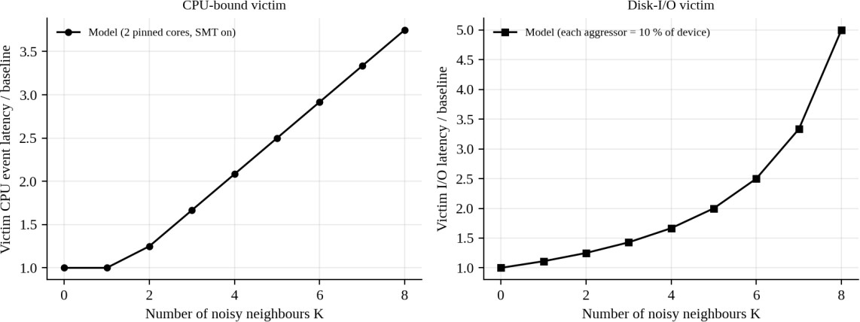
Figure 14: Graph 2 (model baseline): victim latency under interference versus number of noisy neighbours – overlay measured points

Start-up time and memory footprint
Table 33: Start-up and footprint (model expectation and measured)

Approach | Expected footprint per idle instance | Why | Start-up expected | Measured (fill)
A KVM | 1 GB guest + about 0.5 GB overhead | Own guest kernel, QEMU process, page tables | Tens of seconds (boot)
B Docker | A few MB + 0.05 GB  overhead | Shares host kernel and page cache | < 1 s
C gVisor | About 0.2 GB overhead | Sentry + gofer processes per sandbox | 1–2 s

Results with and without a mitigation
Table 34: Mitigation experiments (M1 SMT off; M2 mitigations on/off)
Test | Predicted change (Task 7) | Without | With | Measured change
CPU, N > cores, SMT on  → off | −16.7 % per-instance throughput (1/1.2)
Syscall-heavy loop in B, mitigations default → mitigations=off (or the reverse) | +3.00 pp at 200k syscalls/s
Network at N = 8, micro-segmentation rules loaded vs not | 0 % (still line-rate bound)

  - analyze.py – tables with mean ± standard deviation, degradation and the two graphs
import pandas as pd, matplotlib.pyplot as plt df = pd.read_csv('results.csv')
# average the instances of one run, then mean and std over the 5 repetitions
run = df.groupby(['approach','N','rep','workload','metric']).value.mean().reset_index()
s = run.groupby(['approach','N','workload','metric']).value.agg(['mean','std']).reset_index() base = s[s.approach=='baseline'].set_index(['workload','metric'])['mean']
s['degradation_%'] = s.apply(lambda r: 100*(1 - r['mean']/base[(r.workload,r.metric)]) if r.approach!='baseline' and r.metric in ('events_s','mib_s','iops','gbit_s') else None, axis=1)
s.round(3).to_csv('summary.csv', index=False); print(s.round(2).to_string()) # Graph 1: per-instance disk IOPS vs N, with error bars; add the model line fig, ax = plt.subplots(figsize=(5,3.4))
for a, ls in (('kvm','-'),('docker','--'),('gvisor',':')):
d = s[(s.approach==a)&(s.workload=='disk')&(s.metric=='iops')]
ax.errorbar(d.N, d['mean'], yerr=d['std'], color='black', ls=ls, marker='o', capsize=3, label=a)
ax.set_xscale('log', base=2); ax.set_yscale('log'); ax.set_xlabel('instances N'); ax.set_ylabel('IOPS per instance'); ax.legend(); fig.savefig('graph1.png', dpi=200, bbox_inches='tight')
# Graph 2: victim p95 latency vs number of noisy neighbours
n = pd.read_csv('noisy.csv'); g = n[n.metric=='cpu_p95_ms'].groupby(['approach','K']).value.agg(['mean','std']).reset_index() fig, ax = plt.subplots(figsize=(5,3.4))
for a, ls in (('kvm','-'),('docker','--'),('gvisor',':')):
d = g[g.approach==a]; ax.errorbar(d.K, d['mean'], yerr=d['std'], color='black', ls=ls, marker='s', capsize=3, label=a) ax.set_xlabel('noisy neighbours K'); ax.set_ylabel('victim p95 latency (ms)'); ax.legend(); fig.savefig('graph2.png', dpi=200, bbox_inches='tight')

Space for your graphs
Table 35: Paste your two measured graphs here

Graph 1: throughput versus N (measured, with model line) | Graph 2: victim latency under interference (measured)

TASK 10 – Compare Theory with Experiment

Marks: 4
Table 36: Evaluator quick-check (requirement → section)
Task requirement | Answered in section
Do trends agree with the model? | Section 10.1, 10.3
Which approach scales better? | Section 10.2
Quantitative difference and plausible causes | Section 10.1, 10.4
Does any result change Task 5 conclusions? | Section 10.5
This task interprets your Task 9 data. The method, tolerances, hypotheses and sentence frames are prepared; the figures in the “measured” columns and the final conclusions must come from your own results.

Comparison method and error analysis
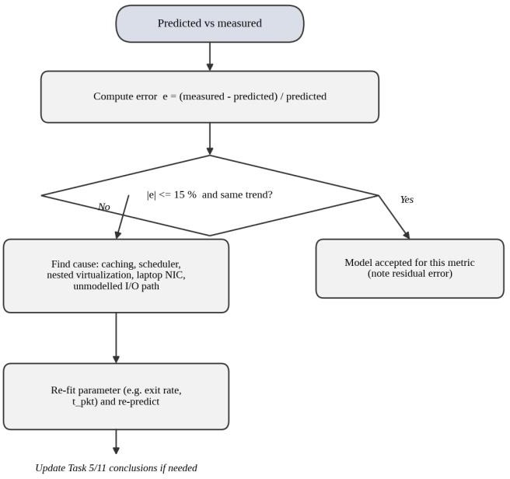
Figure 15: Procedure for comparing prediction with measurement
For every metric compute the relative error e = (measured − predicted) / predicted. Accept the model for that metric when |e| ≤ 15 % for CPU and memory, and ≤ 25 % for network and disk (the model ignores caches, the host scheduler’s details and unmodelled I/O paths), and when the trend with N has the same direction. When the trend or tolerance fails, estimate the cause and re-fit one parameter (for example the exit cost t_e or t_pkt), then predict again.
Table 37: Prediction versus measurement sheet (A / B / C; fill the blank columns)
Metric | Predicted (A / B / C) | Measured | Error e % | Within tolerance?
CPU, N = 1 | 0.99 / 1.00 / 1.00
CPU, N = 16 (r > 1) | (1 − o) × min(1, P_eff/16)
Disk IOPS per instance, N = 8 | A,B: 0.125; C: 0.05
Network per instance, N = 8 | A,B: 0.125; C: 0.06
Victim CPU latency, K = 4 | 2.08 × baseline

Metric | Predicted (A / B / C) | Measured | Error e % | Within tolerance?
Victim I/O latency, K = 4 | 1.67 × baseline

Which approach scales better as instances increase? (decision rule)
Plot degradation versus N (Graph 1). The approach with the smallest slope of degradation per doubling of N scales best. The model expects: B ≥ A > C for network and disk because their path cost is flat (A, B) or grows slowly (B’s iptables, 0.02 µs per container), while C is limited by a lower CPU-bound ceiling; for CPU all three should be within about 2 % until N exceeds the number of cores, after which all drop together by the same steal fraction. State in your report whether your data show this order.

Do the trends agree? Checklist
Table 38: Trend checks
Model statement | How to check | Agrees? (fill)
Per-instance throughput falls as 1/N while the device is the limit | Slope of log(throughput) vs log(N) ≈ −1
CPU loss is flat for N ≤ cores, then falls by (1+σ)·P/N | Break point of the curve at N = number of logical CPUs
C is the slowest for syscall-heavy and I/O-heavy tests | Rank of C at N = 1 for fio and iperf3
Latency of the victim rises with K as (K+1)/2.4 (CPU) | Fit of p95 latency vs K

Likely causes of differences (hypotheses to confirm or reject)
Table 39: Plausible causes of prediction error

Cause | Effect on measurement | How to test or fix
Nested virtualization (if used) | Each guest exit traps to the outer hypervisor, so A’s real exit cost can be several times 1.5 µs and A looks worse than the model | Re-fit t_e from kvm_exit counts; compare with a bare-metal host if available
Laptop hardware: few cores, shared caches, thermal limits | Turbo and thermal throttling change absolute speed; SMT yield differs from 20 % | Fix the governor to performance, record temperature, measure σ with and without SMT
Caching effects | Page cache and CPU caches make fio and memory results higher than the model, especially with small files | Use --direct=1, larger files, drop caches between runs
Host scheduler behaviour | CFS fairness and wake-up latency change p95 latency for the noisy-neighbour case | Compare with pinned vCPUs; record context switches
Unmodelled I/O paths | qcow2 metadata, overlayfs, gofer and the user-mode virtual network add costs not in t_io or t_pkt | Use raw disks or bind mounts and a bridged network for all approaches
gVisor platform and version | systrap vs KVM platform change the trap cost t_trap | Record the platform; re-fit t_trap from a syscall micro-benchmark

Do the measurements change the Task 5 security conclusions?
Table 40: Security conclusion check
Observation in Task 8/9 | Effect on Task 5 conclusion
uname -r in B equals host kernel (expected) | Confirms the shared-kernel assumption behind B’s T1/T3 exposure; no change

Observation in Task 8/9 | Effect on Task 5 conclusion
Mitigation costs (M1/M2) larger than predicted | Reconsider M1 for the S pool and prefer core scheduling or the dedicated pool; the exposure ranking is unchanged
gVisor fails or is too slow for the syscall mix | Confirms C is unsuitable for the SIS database (T1 benefit not worth the cost)
Noisy neighbour hurts the victim much more than predicted | Raise the weight of availability impact (T-A) for shared pools; stronger case for dedicated pools

Your interpretation (write 4–6 sentences per box)
Table 41: Interpretation boxes

Question | Your reasoned answer (use your measured numbers)
Do the observed degradation trends agree with the model? Where not, by how much?
Which approach scaled better and why (link to the dominant overhead of Task 2)?
Largest prediction errors and their most plausible cause
Does any result change the Task 5 security conclusions?

TASK 11 – Recommend and Defend the Final Architecture

Marks: 4
Table 42: Evaluator quick-check (requirement → section)
Task requirement | Answered in section
Recommendation and why better than alternatives | Section 11.1
Modelled and observed performance | Section 11.2
Security posture and residual risk | Section 11.3
Operational costs | Section 11.4
Limitations and trade-offs | Section 11.5
Growth from 400 to several thousand instances | Section 11.6

Recommendation
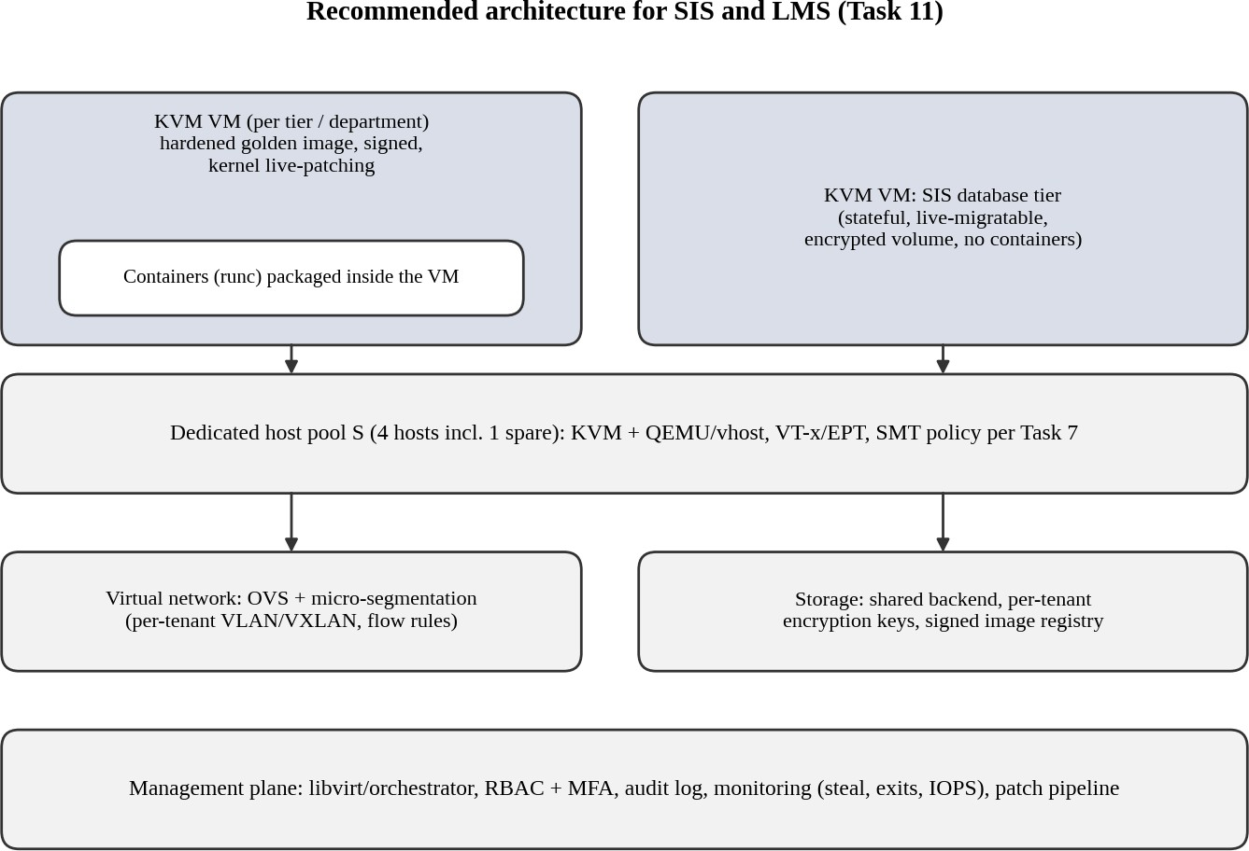
Recommended for SIS and LMS: a hybrid with KVM virtual machines (Approach A) as the isolation boundary, hosted in a dedicated pool, with containers (runc) allowed only inside a VM for stateless LMS web tiers. gVisor (Approach C) is reserved for untrusted, low-I/O code such as student code execution. The SIS database runs in its own VM with an encrypted volume.

Figure 16: Recommended architecture for SIS and LMS
Table 43: Why A (with containers inside) beats the alternatives

Criterion | A KVM | B Docker | C gVisor
Typical CPU loss (model) | 1.65 % | 0.35 % | 6.9 %
Peak density, ≤ 10 % degradation | 34 VMs/host | 35 | 15
Exposure score (Task 5, lower is better) | 0.59 | 0.76 | 0.53

Criterion | A KVM | B Docker | C gVisor
Live migration for patching the SIS database | Yes | No | No
Syscall margin before violating 10 % target | Not relevant | Not relevant | 3.1 % (limit 43k syscalls/s)
Feasible option with lowest J (Task 6) | O5: J = 15.9 | O1: 28.2 (infeasible) | O3: 23.7 (infeasible)

B is only 2.9 % denser than A at peak, which does not pay for its shared-kernel exposure (0.76 vs 0.59) and lack of live migration. C is the most isolated but loses 56 % of peak density and cannot migrate. Choosing either “the fastest” or “the most secure” alone would therefore be wrong; A is the point that balances both.

Modelled and experimentally observed performance
Modelled: CPU loss 1.65 %; 34 VMs per host at peak with ≤ 10 % degradation; network and disk are device-limited (each VM gets 1/N of 25 Gbps and 600k IOPS); live migration of an 8 GB VM takes
3.8 s with 8.6 ms downtime when the dirty rate is 1 GB/s. Observed: copy the degradation of A at N = 1, 8, 16 and the noisy-neighbour result from Table 26 and Figure 14 (fill from your Task 9
data and state whether it is within the 15 % / 25 % tolerance of Task 10).

Security posture and residual risks
    - Mitigations applied: dedicated S pool (M3), KPTI/L1D flush and current microcode (M2), signed golden images and patch pipeline (M6), encrypted multifd migration (M7), micro-segmentation (M5), SMT policy by pool (M1).
    - Exposure after mitigation: ρ_S = 0.59 × 0.3 = 0.18 (from 0.59 on a shared pool).
    - Residual risks: a QEMU or KVM vulnerability exploited from inside the S pool; insider misuse by administrators; unknown speculative-execution bugs; compromised signing key; containers inside VMs still share their VM’s kernel.

Operational costs
Table 44: Operating cost comparison

Activity | A KVM (+ golden images) | B Docker | C gVisor
Patching | One guest kernel per VM; solved by rebuilding one golden image and rolling replacement; host patched by live migration | One kernel per host; reboot needs restart of all containers | Host kernel + runsc releases to track
Image management | Signed qcow2 images in a registry; snapshots must be encrypted and expired | Layered images, small and fast to rebuild | Same as B
Migration | Live migration with multifd + TLS, one host at a time | No live migration; rolling restart | None
Monitoring | Steal, exits, IOPS, per-VM metrics are mature (libvirt, perf) | cgroup metrics; less visibility of the kernel | Less tooling; debugging inside Sentry is harder

Limitations and trade-offs
    - About 1.7 % CPU and 0.5 GB per VM are paid for isolation, and 4 hosts are dedicated to S (25
% of the cluster).
    - Parameters (exit rate, syscall rate, device limits) are assumptions until measured in Task 8; the conclusion holds for exit rates up to about 30,000/s per vCPU (o_A = 5.7 % + 1.2 % < 10 %).

    - Guest patching effort grows with the number of VMs unless golden images are used strictly.

Practicality as EduCloud grows from 400 to several thousand instances
Table 45: Hosts needed at peak (25 % S, 75 % R mix, ≤ 10 % degradation)

Instances | A KVM hosts | B Docker hosts | C gVisor hosts | Hosts today
400 | 11 | 10 | 11 | 16
2,000 | 51 | 50 | 53 | 16
5,000 | 126 | 124 | 133 | 16
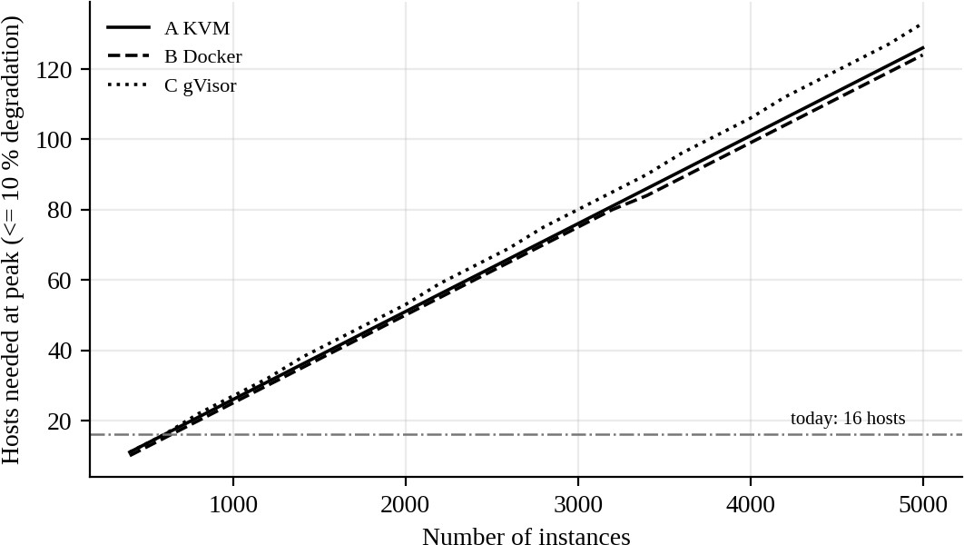
Figure 17: Hosts required versus number of instances (model)
The three approaches need almost the same hosts (A 126, B 124, C 133 at 5,000 instances), so the choice does not decide scalability; operations do. For A: (1) patch one golden image and roll it out instead of patching 5,000 guests; (2) host patching in waves: draining a host of 34 VMs one by one takes about 34 × 3.8 s ≈ 2 minutes, so 126 hosts in waves of 4 take about 1 hour; (3) use an orchestrator (OpenStack/Kubernetes-based) because manual libvirt does not scale; (4) switch container networking to eBPF instead of iptables, since the per-packet cost grows with rules. At today’s 16 hosts, growth beyond about 640 VMs (16 × 40) needs new hardware or cloud bursting.

DAY-4 DESIGN CHALLENGE

TASK 12 – Re-evaluate and Adapt the Design Marks: 8
Table 46: Evaluator quick-check (requirement → section)
Task requirement | Answered in section
A. Impact analysis (2) | Section 12.1
B. Evaluation of the original design (2) | Section 12.2
C. Adaptation / redesign (2) | Section 12.3
D. Evidence-based defence (2) | Section 12.4
Decision in one line: MODIFY. Keep KVM as the isolation layer, but split EduCloud into three host pools (S, R, X) so that external tenants never share a host with student records, give the external Spark jobs a dedicated NIC with SR-IOV, encrypt migration and storage, and use core scheduling instead of turning SMT off everywhere.

A. Impact analysis
Table 47: What has changed and which original assumptions fail

Factor | Original assumption | New condition and consequence
Tenants | All tenants are university members and trusted | External collaborators are less trusted: T1, T2, T3 become real attack paths against SIS (escape, side channel, hypervisor bug)
Workload mix | Short web/DB requests; u = 0.2 (0.6 at peak) | Batch jobs run for hours at u ≈ 0.9 on 8 vCPU; they never go idle, so CPU steal for neighbours is permanent
I/O profile | 6,000 IOPS and 0.15 Gbps per VM | Spark: 25,000 IOPS and 2 Gbps per instance; 60 instances = 1.5 M IOPS and 120 Gbps
Peak | Peak 3× normal | Registration peak coincides with long-running jobs
Maintenance | Live migration at any time | Migration of running VMs during peak or of VMs with SR-IOV is risky; encrypted migration is required
Regulation | Best-effort separation | Isolation must be demonstrable (auditable)

Performance effect of mixing batch with SIS: X’s demand of 60 × 8 × 0.9 = 432 busy vCPU competes with S (240) and R (600) in one pool: total 1,272 busy vCPU, which needs ceil(1,272 / 83.9) = 16 hosts,
i.e. every host and no spare. I/O: if X drives the shared NVMe queue to ρ = 0.9 the SIS reads wait 16.7 µs instead of 3.3 µs at ρ = 0.5 (and 1.7 µs idle).
Threat-model effect: the attacker is now an authenticated outsider who can run arbitrary code (Spark jobs) and choose co-location. T2 becomes exploitable by design (sharing cores with SIS VMs), T1/T3 gain a motivated attacker, T6 matters because migration of a SIS VM next to an X VM exposes memory on a shared network, and T7 requires strict separation from the X network. Availability is also at risk: a runaway job can starve SIS (T-A).

B. Evaluation of the original design
Table 48: Does the original recommendation still meet its targets?

Aspect | Result with the new workload (Task 3 model) | Verdict
CPU | Shared pool needs 16 hosts at peak; with one spare host 17 > 16 | Fails (no spare)
I/O interference | Queueing latency up to 16.7 µs (10× idle) when X drives the device | Fails SIS latency
Network | X 120 Gbps demand on 25 Gbps NICs per host through the vSwitch; shared vSwitch cores K = 4 saturate | Needs dedicated NIC / SR-IOV
Isolation | S and X on the same hosts: shared hypervisor, caches and SMT siblings | Fails the regulation
Live-migration patching | Single-stream encrypted migration: ρ = 0.80, 40 GB sent, 32 s; no convergence at higher dirty rates | Needs multifd and separate NIC

Could another architecture do better overall? Using gVisor (C) for X looks attractive for isolation, but X is I/O-heavy: C is limited to 12.0 Gbps and 286k IOPS per host and needs 9 hosts for X (network-bound), giving 19 hosts in total, more than the 16 available. Containers (B) for X would be cheapest but share the kernel with outsiders. Kata Containers / KVM micro-VMs give VM-level isolation like A, so they cost about the same as A and add no host saving. A with pools is therefore the best fit.

C. Adaptation: MODIFY
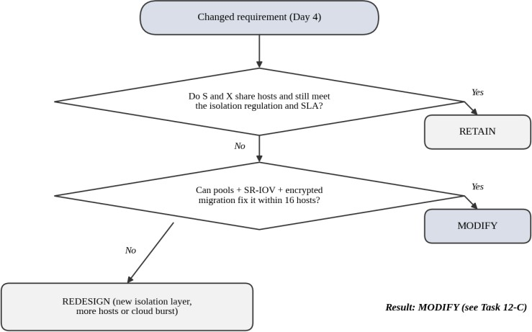

Figure 18: Decision flowchart: retain, modify or redesign

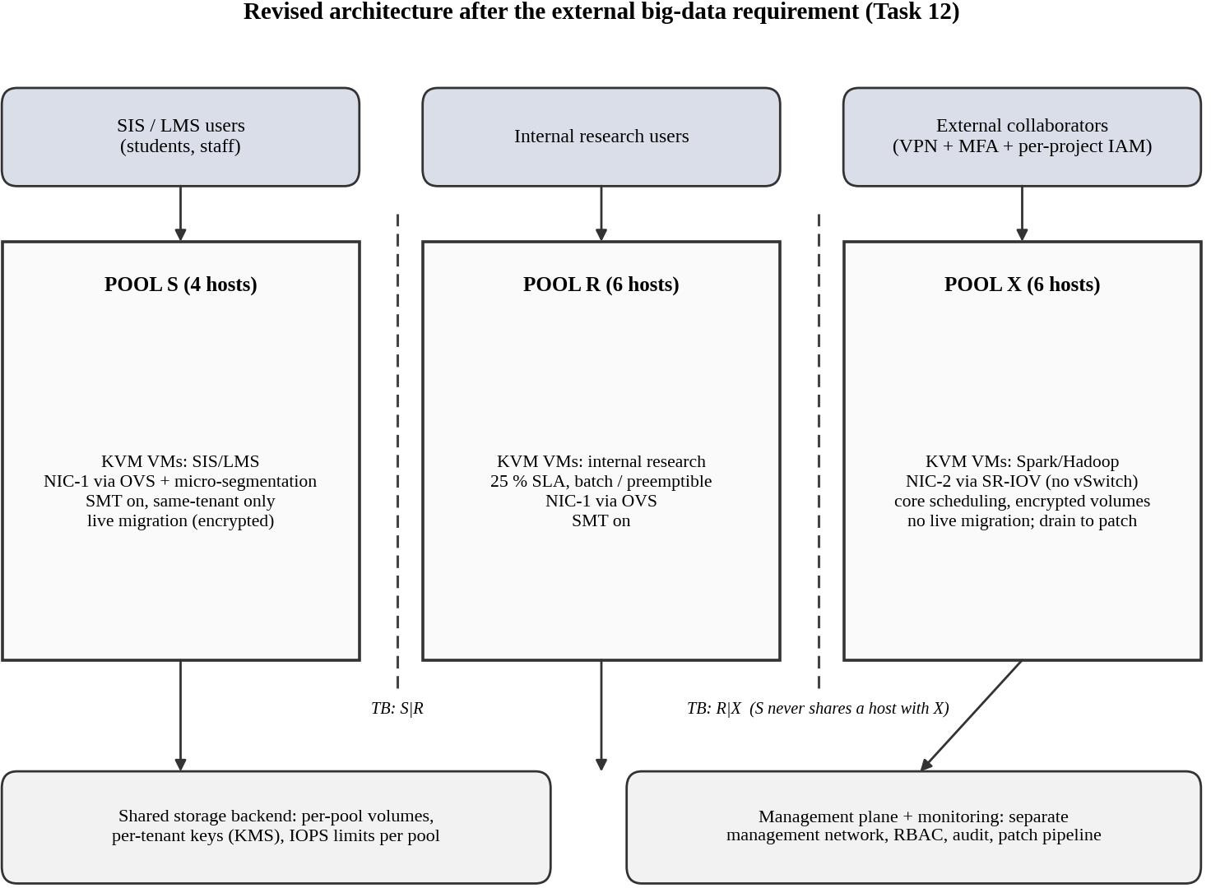

Figure 19: Revised architecture with host pools S, R and X
Table 49: What changes and its effect

Change | Description | Effect on density, throughput, attack surface
Host pools | S = 4 hosts (3 + 1 spare), R = 6 hosts (25 % target, pre-emptible), X = 6 hosts; 16 in total | Density per pool fixed by Task 3; zero co-location of S and X; attack surface between S and X removed
Dedicated NIC + SR-IOV for X | X uses NIC-2 with SR-IOV virtual functions, bypassing the vSwitch; NIC-1 stays for S and R | Per-packet cost falls to about native (0.4 µs): vSwitch cores no longer limit X; 10 instances × 2 Gbps = 20 Gbps (80 % of NIC-2); no sharing of the S network
Encrypted migration | TLS with multifd on a separate migration VLAN, only inside pool S and R; X is not live-migrated (drained for patching) | Migration of 8 GB: 3.8 s (instead of 31.8 s with one TLS stream); no clear-text memory on the network
Core scheduling instead of SMT off | A core is shared only by vCPUs of the same tenant | Keeps σ = 0.2; SMT off for all pools would need 18 hosts (> 16)
Storage separation | Per-pool volumes, per-tenant encryption keys, IOPS limits per pool | Removes the shared I/O queue between S and X (ρ no longer driven by X)
Elastic rule | In registration week research (R) jobs are paused and R hosts may join S (never X); hosts are wiped and rebooted when changing pool | Covers the 3× peak without extra hardware

D. Evidence-based defence

Hosts and options
Table 50: Options compared with the Task 6 decision function

ID | Option | Hosts | J | Feasible?
P1 | Retain: one shared KVM pool incl. external tenants | 16 | 36.1 | No – S and X co-located: no demonstrable isolation

ID | Option | Hosts | J | Feasible?
P2 | Modify: host pools S / R / X, KVM everywhere, SR-IOV + dedicated NIC for X, core scheduling | 16 | 25.4 | Yes
P3 | Redesign: gVisor (C) for external X, KVM pools for S and R | 19 | 28.1 | No – needs more hosts than available (X net-limited)
P4 | P2 with SMT disabled on all pools | 18 | 25.6 | No – exceeds 16 hosts
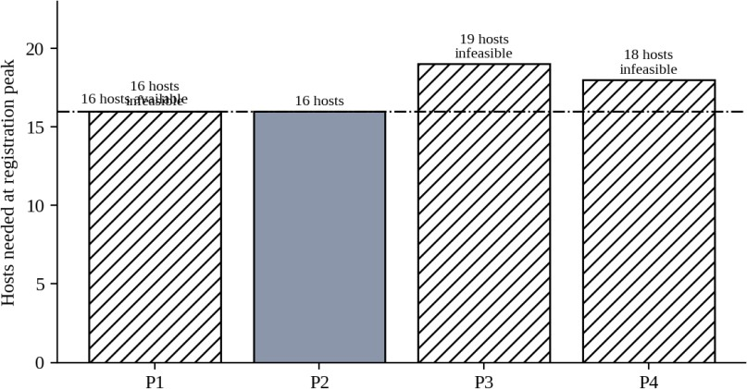
Figure 20: Hosts needed at registration peak for each option (16 available)

Pool-level performance check (model)
Table 51: Do the pools meet their targets?

Pool | CPU use at peak | Other resources | Result
S (4 hosts) | 240 / (4 × 83.9) = 71 % of  SLA capacity (95 % with 3 hosts) | IOPS 100 × 18k / 4 = 450k per host (75 % of 600k); NIC 11 Gbps | Meets ≤ 10 %; survives loss of one host
R (6 hosts, 25 %) | 600 / (6 × 100.7) = 99 % | Memory 300 × 8.5 / 6 = 425 GB of  496 GB | Meets the relaxed target; best-effort
X (6 hosts) | 432 / (6 × 83.9) = 86 % | Per host: 10 instances; IOPS 250k (42  %); 20 Gbps (80 % of NIC-2);  memory 165 GB (33 %) | Meets ≤ 10 %; long jobs run stably

Isolation, experiments and cost
  - Demonstrable isolation: separate host lists per pool (virsh list per host), separate NICs and VLANs, per-pool key hierarchy, automatic check that no host holds both S and X guests, audit log. Provide these as evidence to the regulator.
  - Noisy-neighbour experiment (Task 9): the model predicts S latency rises by (K+1)/2.4 on shared cores and by 1/(1 − 0.1K) on shared I/O; pools remove both because no X aggressor can reach S cores or the S device. State your measured values here: .
  - Mitigation experiment (Task 9): SMT off costs −14.7 % density (model); core scheduling keeps density. State your measured SMT/KPTI cost: .
  - Cost/density trade-off: the modified design uses all 16 hosts (J = 25.4) with no growth headroom; P4 (SMT off) needs 18; P3 needs 19; P1 is infeasible by law. Therefore MODIFY gives the only feasible option within 16 hosts.

Risks of the decision
Table 52: Residual risks and responses

Risk | Response
No spare host in R and X pools; pools are 100 % allocated | Ask for 1–2 additional hosts, or cap the number of external jobs; pause R in peak weeks
SR-IOV prevents live migration of X VMs | X jobs are hours long: drain and restart for patching; accept for external batch jobs
VM escape from X by a hypervisor bug | Separate pool means no student data on X hosts; storage and network are separate; keep QEMU and the kernel patched; review again if X grows
Parameters are assumptions | Re-calibrate the model with Task 8/9 data (exit rate, IOPS) before purchasing hardware
Final defence: the original shared-pool design needs all 16 hosts with no spare, lets external tenants share cores, caches and I/O queues with student records, and is not demonstrably isolated, so RETAIN is rejected. A full REDESIGN with gVisor needs 19 hosts and loses 52 % of network and I/O capability. MODIFY with host pools, SR-IOV and a dedicated NIC for X, core scheduling and encrypted multifd migration meets the performance targets (S at 71 % of its SLA capacity, X at 86 %), gives demonstrable isolation, and fits exactly in 16 hosts.

SUBMISSION CHECKLIST (student self-check)

Requirement | Status
Three distinct approaches with labelled diagrams, trust boundaries (Task 1) | Done
Dominant overhead per approach (Task 2) | Done
Mathematical model with worked examples (Task 3) | Done
Best / typical / worst analysis (Task 4) | Done
Threat model and comparison (Task 5) | Done
Trade-off formulation (Task 6) | Done
Mitigations with quantified cost (Task 7) | Done
Experiments run, scripts and environment documented (Task 8) | TO DO: run on your machine
Measured table and two graphs with mean ± sd (Task 9) | TO DO: fill from your data
Prediction vs measurement analysis (Task 10) | TO DO: write with your numbers
Final recommendation (Task 11) | Done (fill observed numbers)
Day-4 challenge A–D (Task 12) | Done (fill measured values)

Student Signature | Faculty Signature | Program Director

