CLOUD COMPUTING

LAB-PRACTICALS

Exp.No:1
1.Create a simple cloud software application for Flight Reservation System using any Cloud Service Provider to demonstrate SaaS include the necessary fields such as one way, round trip, From, to, Departure, Departure, Travelers & Class, Fare Type, International and Domestic Flights etc.
Aim:
To create a simple Cloud-based Flight Reservation System using a Cloud Service Provider to demonstrate Software as a Service (SaaS) with options for domestic and international flight reservations.
Procedure:
- Select a Cloud Service Provider such as Google Cloud, AWS, or Microsoft Azure to develop and host the application.
- Create a simple Flight Reservation System with a user-friendly interface.
- Add options for One Way and Round Trip flight bookings.
- Provide fields such as From, To, Departure Date, Return Date, Travelers & Class, and Fare Type.
- Add flight categories for Domestic Flights and International Flights.
- Allow the user to enter the required details and search for available flights.
- Display the selected flight details and fare, and provide a Book/Confirm Reservation option through the cloud-based application.
Ouputs

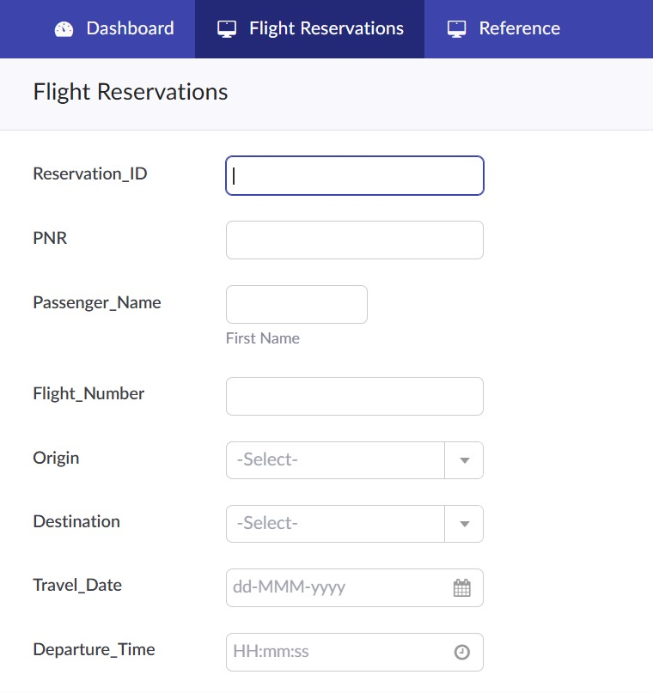
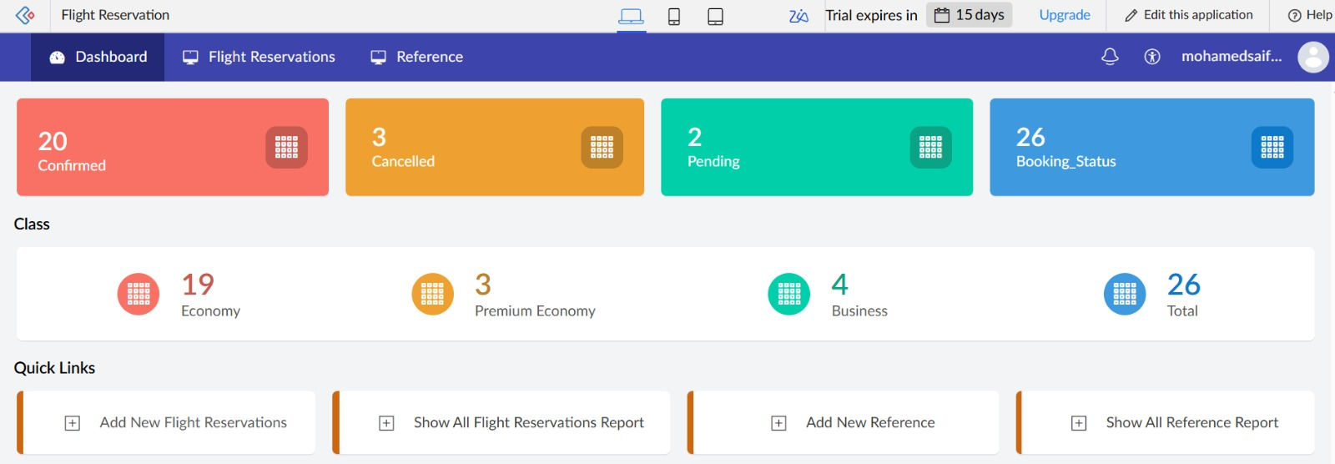
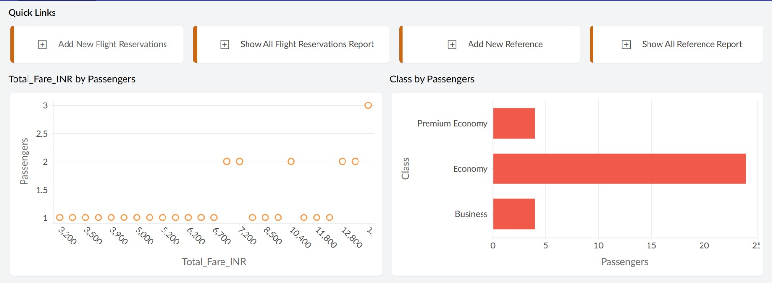

2. Create a simple cloud software application for Property Buying & Rental process (In Chennai city) using any Cloud Service Provider to demonstrate SaaS include the necessary fields such as Buy, Rent, commercial, Rental Agreement , Rental Agreement, Area, place, Range, property value etc.
Aim:
To create a simple Cloud-based Property Buying and Rental System for Chennai city using a Cloud Service Provider to demonstrate Software as a Service (SaaS).
Procedure:
- Select a Cloud Service Provider such as Google Cloud, AWS, or Microsoft Azure to host the application.
- Create a simple web-based Property Buying and Rental System for properties available in Chennai.
- Provide options for Buy and Rent, along with Residential and Commercial property types.
- Add necessary fields such as Property Name, Area, Place, Property Type, Property Value, and Price/Range.
- Provide a Rental Agreement option for properties selected for rent.
- Allow users to search and filter properties based on location, area, property type, and price range.
- Display the selected property details and provide options to Buy the property or initiate the Rental Agreement through the cloud application.
Ouputs
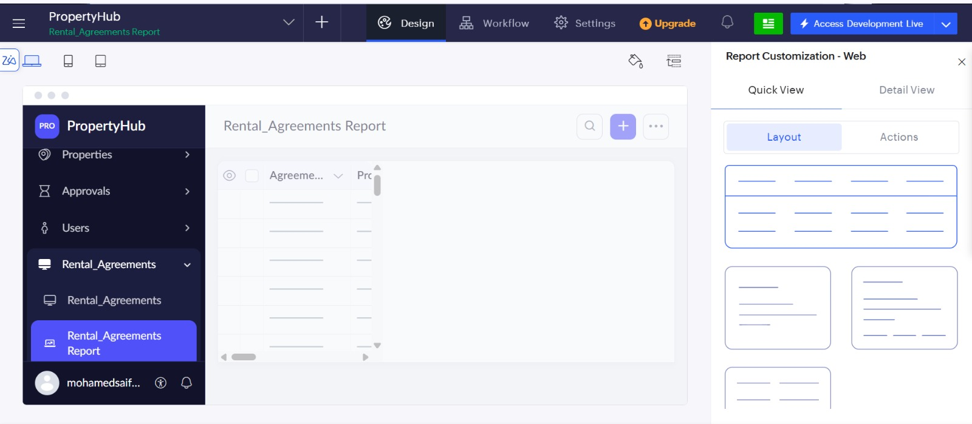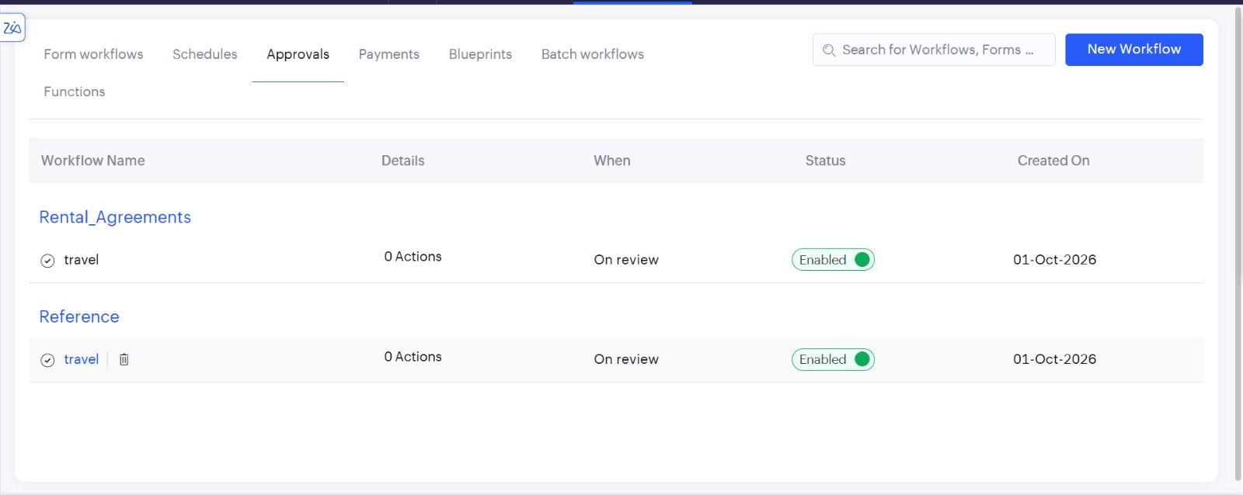

3.Create a simple cloud software application for Car Booking Reservation System using any Cloud Service Provider to demonstrate SaaS include the necessary fields such as search for cabs, from, to, rental , out station, Package type, hours/Days etc.
Aim:

To develop a simple cloud-based Car Booking Reservation System using a Cloud Service Provider to demonstrate the Software as a Service (SaaS) model. The application allows users to search and reserve cabs based on their travel requirements.

Procedure:
- Create a cloud-based application using any suitable Cloud Service Provider.
- Design a user interface with fields such as From, To, Rental, Outstation, and Package Type.
- Provide options to select hours/days, cab type, date, and number of passengers.
- Implement a cab search function to display available vehicles based on the entered details.
- Add a booking/reservation feature to store and manage customer booking information.
- Deploy the application on the cloud and access it through a web browser as a SaaS application.
- Test the system by searching for cabs and completing a sample reservation.

Outputs:

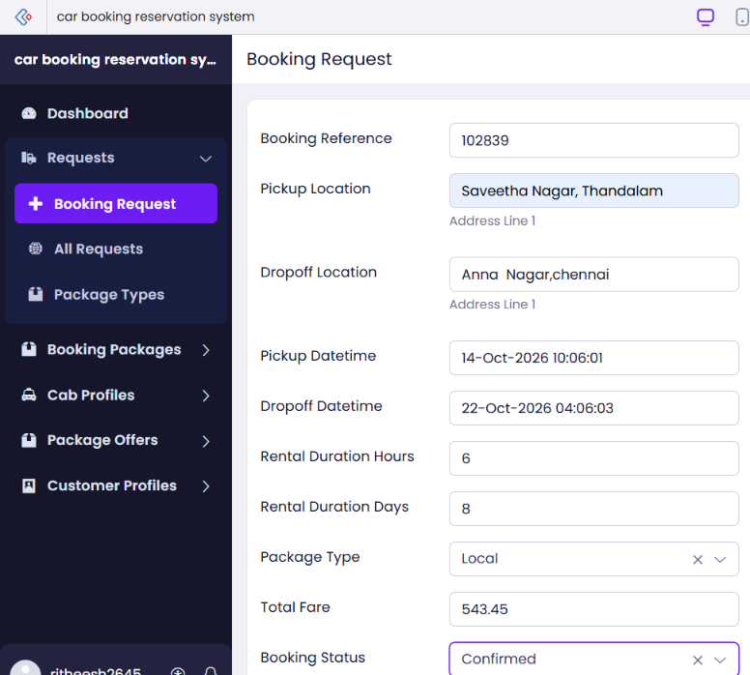
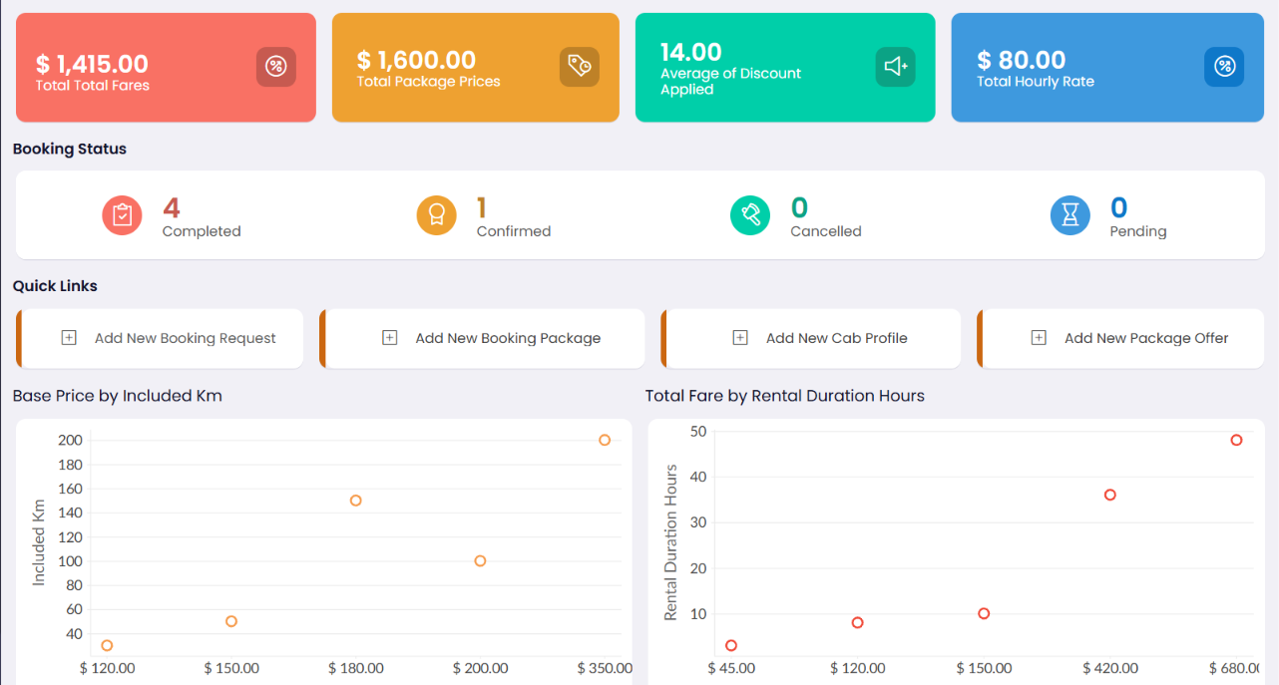
4. Create a simple cloud software application for Library book reservation system for SIMATS library using any Cloud Service Provider to demonstrate SaaS include the necessary fields such as Title of the book, author, publications, Year, edition, no of copies, Rack no, status (taken/returned) etc.
Aim
To develop a simple cloud-based Library Book Reservation System for the SIMATS Library using any Cloud Service Provider to demonstrate the Software as a Service (SaaS) model. The application helps users search, reserve, and manage library books efficiently.
Procedure
- Create a cloud-based Library Book Reservation application using a suitable Cloud Service Provider.
- Design a user interface with fields such as Book Title, Author, Publication, Year, and Edition.
- Add fields for Number of Copies, Rack Number, and Book Status such as Taken or Returned.
- Implement a search option to find books based on title, author, or publication.
- Provide a reservation facility for available books and update their reservation status.
- Store and manage book and reservation details using a cloud database.
- Deploy and test the application through a web browser as a SaaS application.

Outputs:
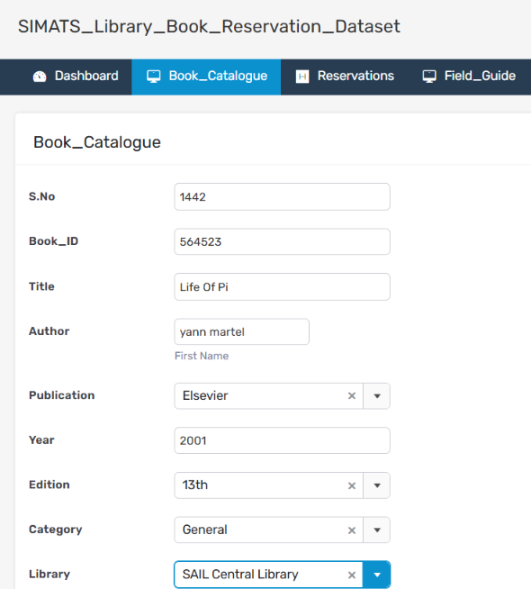
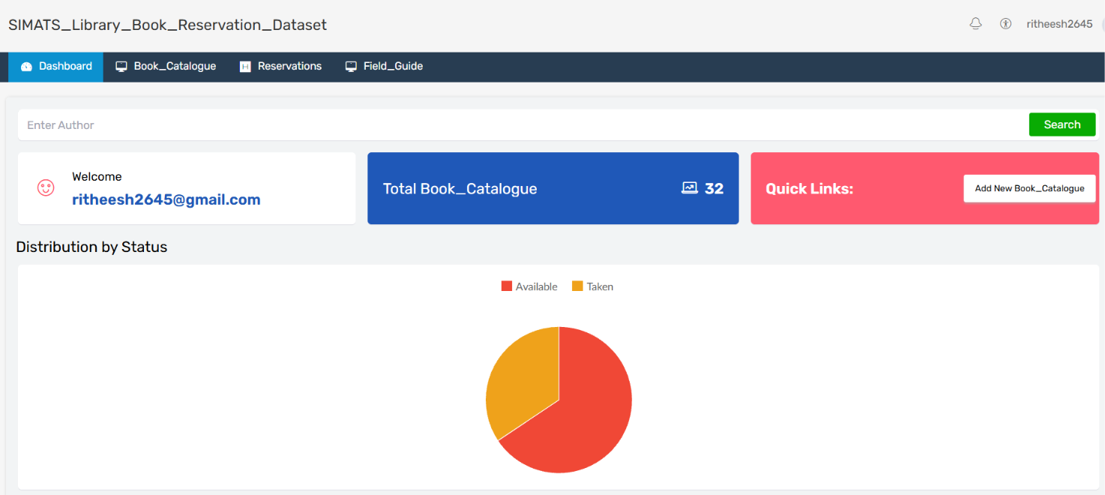

5. Create a simple cloud software application for Mark Sheet Processing System using any Cloud Service Provider to demonstrate SaaS include the necessary fields such as name of the student, Reg no of the student , Subjects , Marks, Average, percentage, rank, overall performance etc.

Aim:
To develop a simple cloud-based Mark Sheet Processing System using any Cloud Service Provider to demonstrate the Software as a Service (SaaS) model. The application calculates students' marks, average, percentage, rank, and overall performance efficiently.
Procedure:
- Create a cloud-based Mark Sheet Processing System using a suitable Cloud Service Provider.
- Design a user interface with fields such as Student Name, Register Number, Subjects, and Marks.
- Store the student and subject-wise marks securely in a cloud database.
- Implement functions to calculate the total marks, average, and percentage automatically.
- Generate the rank of students based on their overall marks and percentage.
- Display the student's overall performance such as Excellent, Good, Average, or Needs Improvement.
- Deploy and test the application through a web browser as a SaaS application.

Outputs:
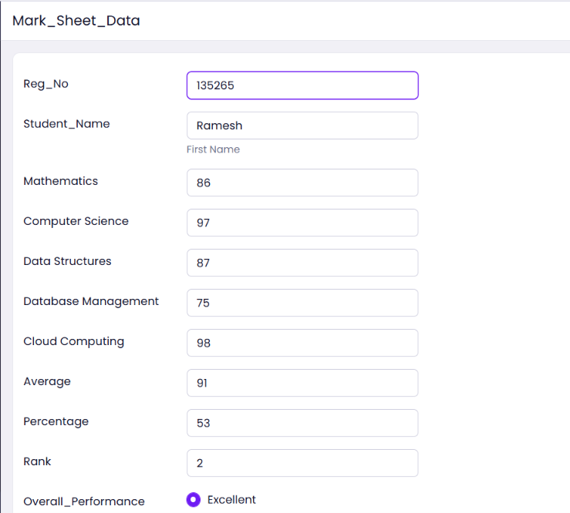
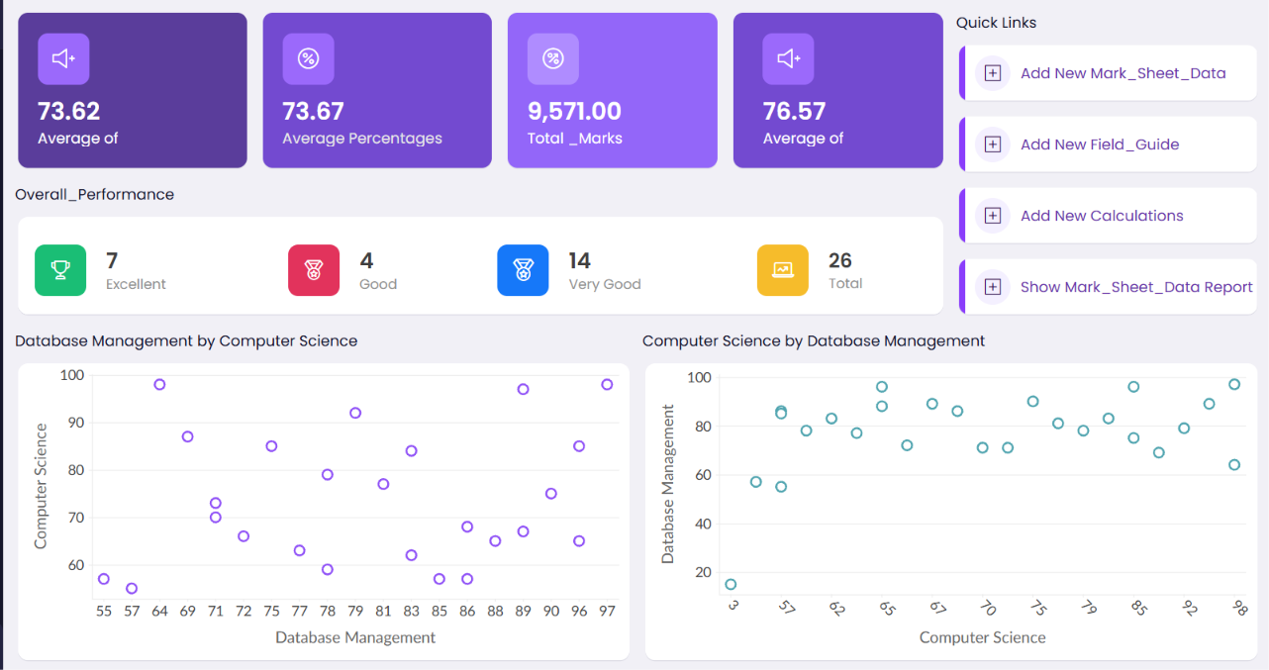

6. Create a simple cloud software application for Payroll Processing System using any Cloud Service Provider to demonstrate SaaS include the necessary fields such as Name of the employee, experience in present org , over all experience, basic pay, HRA, DA, TA, net pay, gross pay etc.
Aim
To develop a simple cloud-based Payroll Processing System using any Cloud Service Provider to demonstrate the Software as a Service (SaaS) model. The application manages employee details and automatically calculates salary components such as gross pay and net pay.
Procedure
- Create a cloud-based Payroll Processing System using a suitable Cloud Service Provider.
- Design a user interface with fields such as Employee Name, Experience in Present Organization, and Overall Experience.
- Add salary fields including Basic Pay, HRA, DA, TA, Gross Pay, and Net Pay.
- Store employee and payroll information securely in a cloud database.
- Implement calculations to automatically determine gross pay and net pay based on salary components.
- Display the processed payroll details for each employee in a clear format.
- Deploy and test the application through a web browser as a SaaS application.

Outputs:
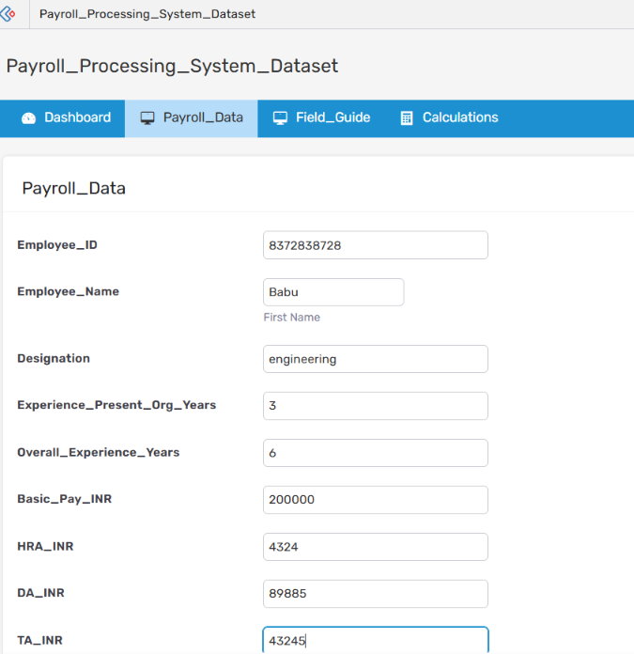
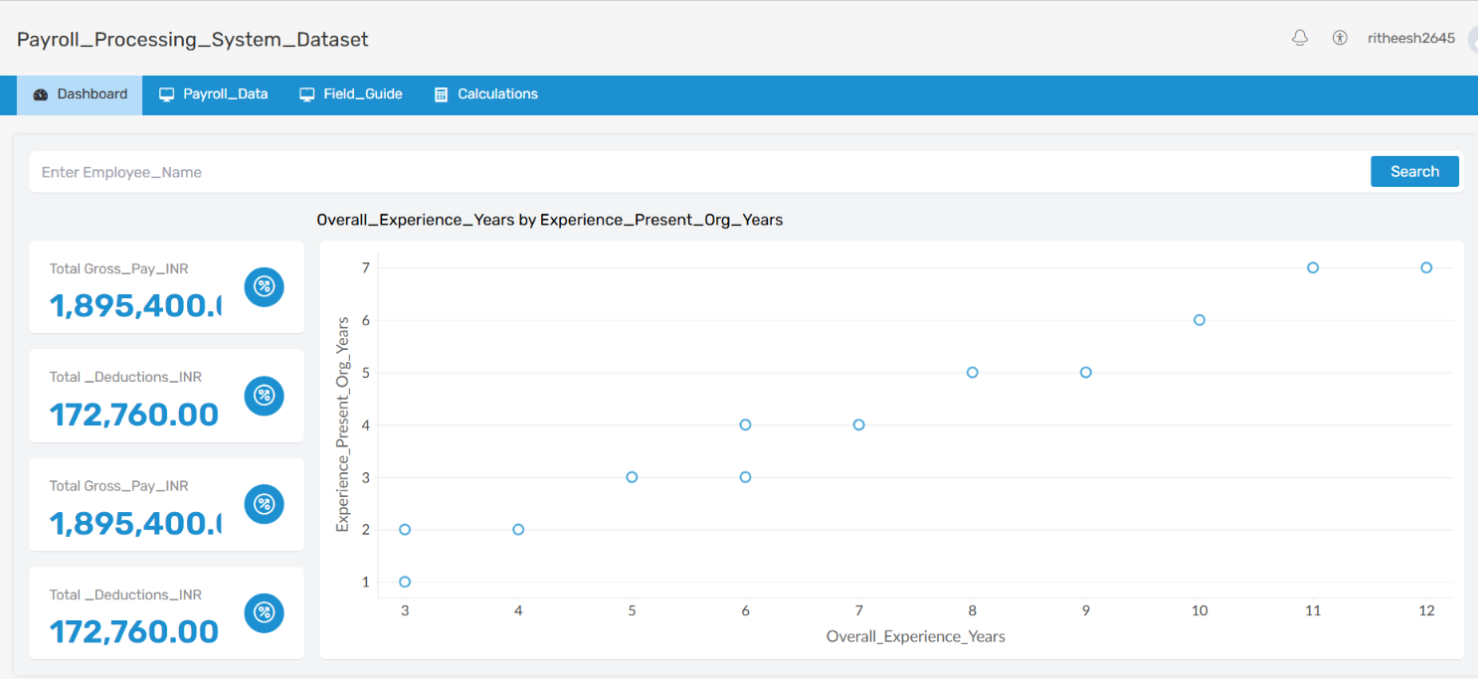

7.Create a simple cloud software application for Students Attendance System using any Cloud Service Provider to demonstrate SaaS include the necessary fields such as name of the students, course, present , Absent, course attendance, OD request, grade, attendance percentage, etc.
Aim:
To develop a simple cloud-based Students Attendance System using any Cloud Service Provider to demonstrate the Software as a Service (SaaS) model. The application records student attendance, OD requests, attendance percentage, and academic details efficiently.
Procedure
- Create a cloud-based Students Attendance System using a suitable Cloud Service Provider.
- Design a user interface with fields such as Student Name, Course, Present, and Absent.
- Add options to record course attendance, OD requests, grade, and attendance percentage.
- Store student attendance and related information securely in a cloud database.
- Implement automatic calculation of the attendance percentage based on present and absent hours.
- Provide an option to record and manage OD requests and update attendance accordingly.
- Deploy and test the application through a web browser as a SaaS application.

Output’s:
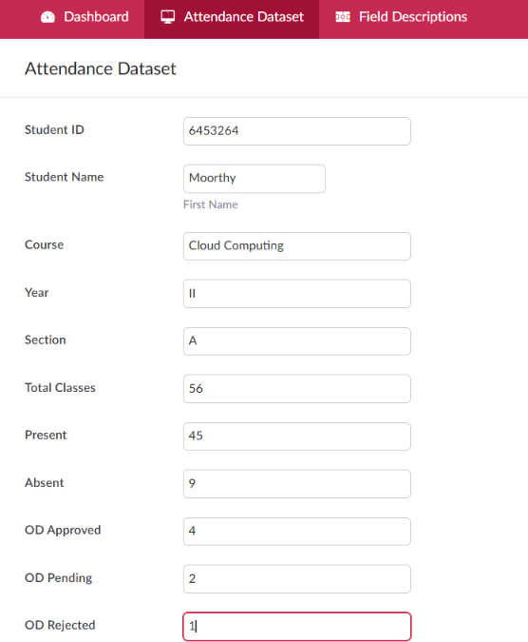

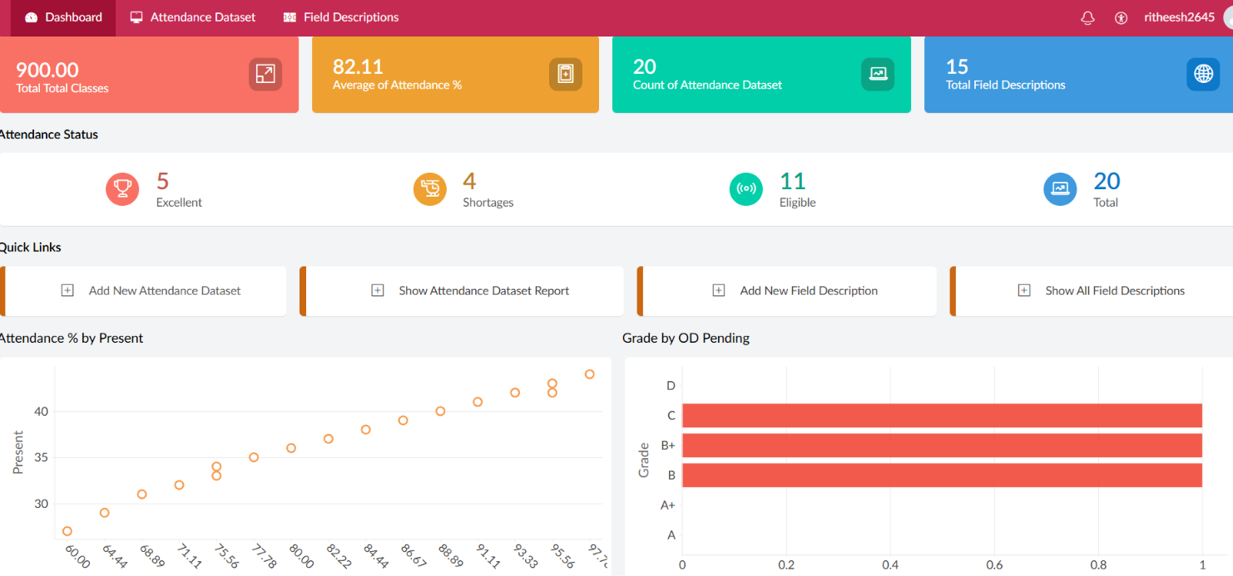
8. Create a simple cloud web application for student counselling system using any Cloud Service Provider to demonstrate SaaS with the fields of student name, age, address, phone, subjects studied, Year of passing, percentage of marks, domain interest, etc.
Aim:
To develop a simple cloud-based Student Counselling System using any Cloud Service Provider to demonstrate the Software as a Service (SaaS) model. The application stores student academic and personal details and helps counsellors understand students' interests and provide suitable guidance.
Procedure
- Create a cloud-based Student Counselling System using a suitable Cloud Service Provider.
- Design a web interface with fields such as Student Name, Age, Address, and Phone Number.
- Add academic fields including Subjects Studied, Year of Passing, and Percentage of Marks.
- Include Domain Interest to record the student's preferred academic or career domain.
- Store student counselling details securely in a cloud database.
- Provide options for counsellors to view and manage student information for suitable guidance.
- Deploy and test the web application through a browser as a SaaS application.

Outputs:
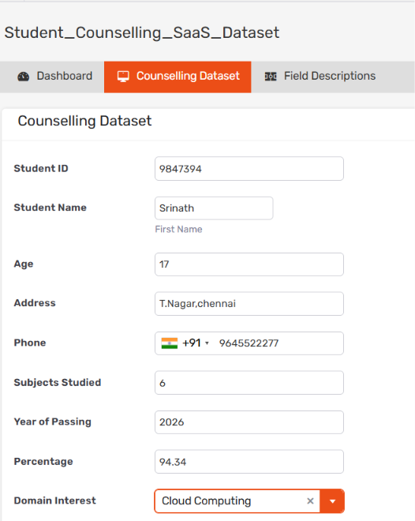
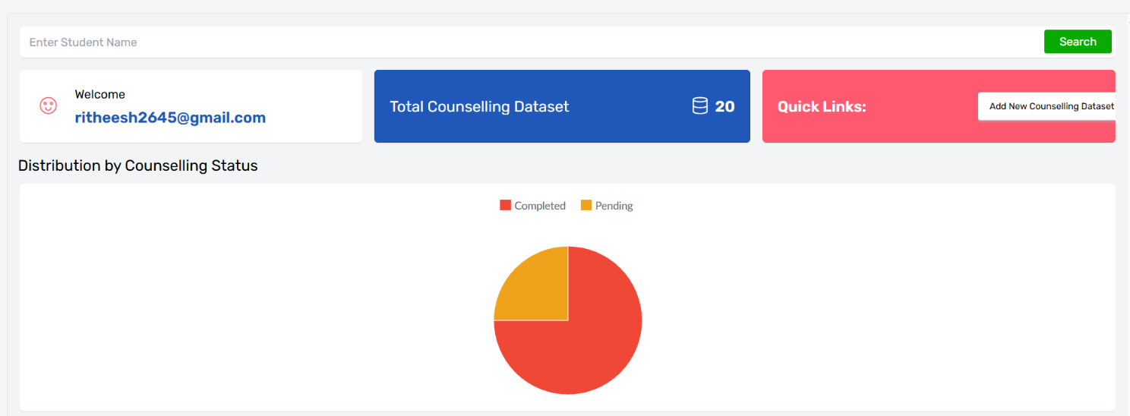9. Create a simple cloud software application for Hospital information system for SIMATS Hospital using any Cloud Service Provider to demonstrate SaaS with fields of patient name, age, address, phone, email, Attender name, attender phone, doctor name, diseases, etc.
Aim:
To develop a simple cloud-based Hospital Information System for SIMATS Hospital using any Cloud Service Provider to demonstrate the Software as a Service (SaaS) model. The application manages patient, attender, doctor, and disease-related information efficiently.
Procedure
- Create a cloud-based Hospital Information System using a suitable Cloud Service Provider.
- Design a web interface with fields such as Patient Name, Age, Address, Phone, and Email.
- Add fields for Attender Name, Attender Phone, Doctor Name, and Disease.
- Store patient and hospital information securely in a cloud database.
- Implement options to add, update, search, and view patient records.
- Provide authorized access to doctors or staff for managing patient information.
- Deploy and test the application through a web browser as a SaaS application.

Output’s:
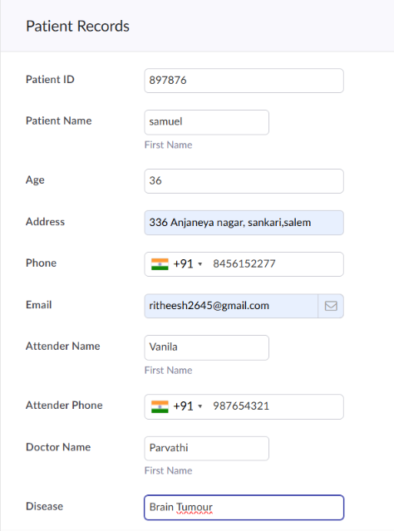
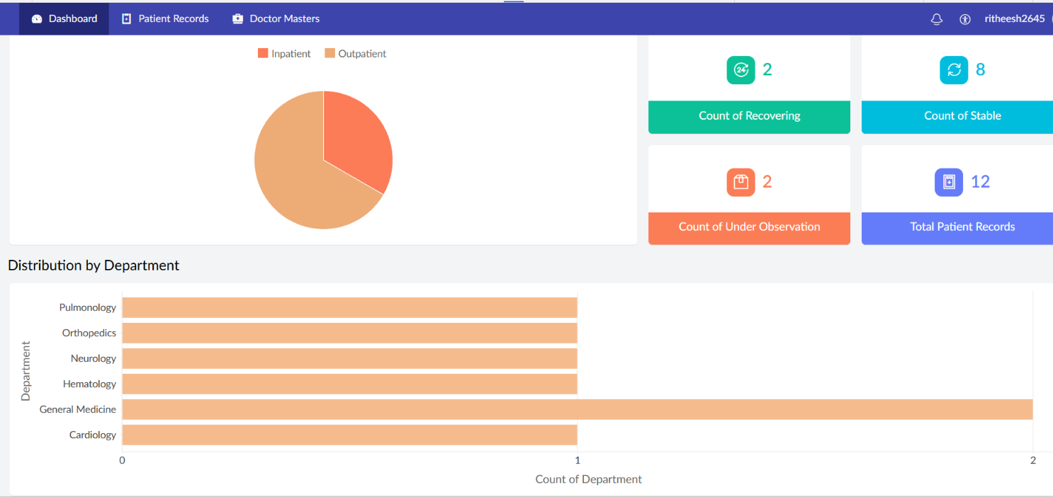
10. Create a simple cloud software application to run a c program to display the student information using any Cloud Service Provider to demonstrate SaaS with the template of student name, reg no, address, phone, age, courses, grades and attendance report, progress report, Semester mark sheet forms
Aim:
To develop a simple cloud-based Student Information System that runs a C program using any Cloud Service Provider to demonstrate the Software as a Service (SaaS) model. The application displays student details, academic performance, attendance, and semester information.
Procedure
- Create a cloud-based application using a suitable Cloud Service Provider to execute the C program.
- Design the program to accept Student Name, Register Number, Address, Phone, and Age.
- Include fields for Courses, Grades, and Attendance Report to record academic details.
- Implement options to display the student's Progress Report based on academic performance.
- Create a Semester Mark Sheet containing subject-wise marks and grades.
- Execute the C program on the cloud and display the student information in a structured format.
- Deploy and test the application through a web browser as a SaaS application.

Output’s:
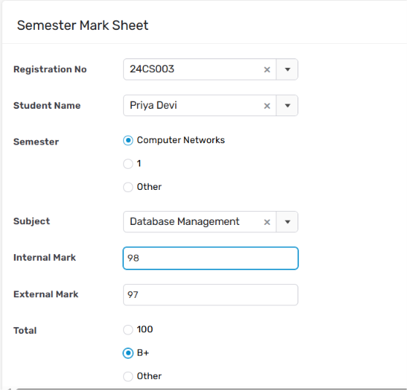
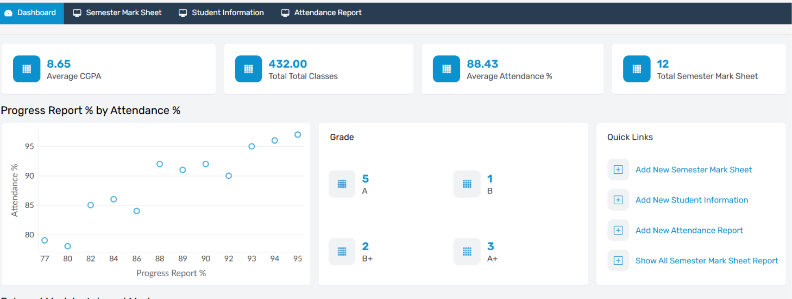

11. Create a simple cloud software application for online super market using any Cloud Service Provider to demonstrate SaaS with the template of customer name, address, phone, email, items, quantity etc. with the item classification form.
Aim
To develop a simple cloud-based Online Supermarket Application using any Cloud Service Provider to demonstrate the Software as a Service (SaaS) model. The application allows customers to enter their details, select items, specify quantities, and manage products through item classification.
Procedure
- Create a cloud-based Online Supermarket Application using a suitable Cloud Service Provider.
- Design a web interface with fields such as Customer Name, Address, Phone, and Email.
- Create an Item Classification Form to categorize products such as groceries, beverages, fruits, vegetables, and household items.
- Provide options to select items and their required quantities.
- Store customer, product, and order information securely in a cloud database.
- Implement functions to manage selected items and display the customer's order details.
- Deploy and test the application through a web browser as a SaaS application.

Output’s:
