SIMATS ENGINEERING
CSA15 – CLOUD COMPUTING AND BIG DATA ANALYTICS
ASSIGNMENT 3 – CO3
Design a Cloud-Based Collaborative Solution
ANSWER SHEET
CO3: Implement cloud-based solutions using cloud storage, web APIs, and platform services for real-world applications.
Field | Details | Field | Details
Student A Name | K N RITHEESH | Register Number | 192572097
Department / Section | CSE-AI | Academic Year / Semester | II-YEAR
Faculty Name | Dr R LATHA | Mode | Pair Work (2 students)
Duration | 1 Week | Total Marks | 50
Submission Date | 05/11/26 | Evaluation Date

INDEX OF TASKS
Task | Title | Marks | Diagrams in this answer
1 | Accessing Cloud Services through Different Methods | 6 | Fig. 1.1, 1.2
2 | Cloud Platforms and Web Applications | 7 | Fig. 2.1, 2.2
3 | Web APIs for Cloud Access | 7 | Fig. 3.1, 3.2
4 | Cloud Security and Network Access | 7 | Fig. 4.1, 4.2
5 | Collaboration Using Cloud-Based Services | 6 | Fig. 5.1, 5.2
6 | Integrated Cloud Access and Collaboration Mini Investigation | 7 | Fig. 6.1, 6.2
7 | Day-4 Design Challenge: Cloud-Based Collaborative Solution | 10 | Fig. 7.1 – 7.4
 | TOTAL | 50 | 16 figures

TASK 1 – ACCESSING CLOUD SERVICES THROUGH DIFFERENT METHODS (6 Marks)
Selected cloud service for demonstration: Google Drive (a Software-as-a-Service cloud storage and collaboration service of Google Workspace). Reason: it can be reached through all three required methods (web console, mobile application and REST API), it is free for students, and it is also reused in Task 5 and Task 6, so the whole assignment forms one connected evidence chain.

1.1 SHARED GROUP WORK

(a) Concept of accessing a cloud service
Cloud computing is defined by NIST as ubiquitous, convenient, on-demand network access to a shared pool of configurable computing resources that can be rapidly provisioned with minimal management effort. The key phrase is network access: no cloud resource is used physically; every use is a request that travels from a client over a network to a cloud service and a response that travels back. Different ‘access methods’ are simply different kinds of clients that create these requests.

(b) Identified methods of accessing cloud services
Method | How the user interacts | Protocol / interface | Example (Google Drive)
Browser-based / Cloud Console | Human uses a web browser; graphical pages (HTML/JS) are downloaded from the cloud | HTTPS over TCP port 443; HTML, CSS, JavaScript | drive.google.com; Google Cloud Console
Mobile application | Human uses a native app installed from Play Store / App Store; app calls cloud back-end | HTTPS + JSON, push notifications, local cache | Google Drive app on Android / iOS
API / SDK / CLI (programmatic) | A program, script or another system sends requests; no human interface | REST over HTTPS, JSON, OAuth 2.0 tokens | Drive API v3 called from Python; gcloud / gsutil CLI

(c) Role of Internet / network connectivity
- Transport: carries every request and response between client and data centre; without it, SaaS applications cannot start (except for pre-cached offline mode).
- Performance: response time = network latency + server processing time + transfer time (file size ÷ bandwidth). A 20 MB file on a 10 Mbps link needs about 16 s (20 × 8 ÷ 10).
- Security: the network path is where eavesdropping happens, hence HTTPS/TLS is mandatory (detailed in Task 4).

Availability: access is only as reliable as the weakest link: Wi-Fi router → ISP → Internet backbone → cloud edge.

(d) Selection of the demonstration service
Google Drive was selected after comparing three candidates against five criteria. Score 1 (poor) to 5 (excellent):
Criterion | Google Drive | Dropbox | AWS S3 Console
Multiple access methods (web, mobile, API) | 5 | 5 | 4 (no consumer mobile app)
Free tier for students | 5 (15 GB) | 3 (2 GB) | 3 (12-month tier)
Ease of set-up | 5 | 4 | 2 (IAM, billing)
Collaboration features (Task 5) | 5 | 3 | 1
Documentation for API (Task 3) | 5 | 4 | 5
Total (25) | 25 | 19 | 15

1.2 STUDENT A – ACCESS METHOD DESIGN

A.1 Classification of cloud access methods
Basis of classification | Category | Examples
By interface | Graphical (GUI) • Command-line (CLI) • Programmatic (API) | Console / Drive web page • gcloud CLI • REST API
By client device | Thin client (browser, nothing installed) • Thick client (installed app) | Chrome on laptop • Drive for Desktop / Android app
By user | Human users • Machine users (applications) | Student uploading file • attendance script uploading CSV
By dependency on network | Always-online • Offline-capable with sync | Cloud Console • Drive app with ‘Available offline’ files

For the assignment the three principal methods retained are: (1) Web browser / cloud console, (2) Mobile application, (3) API / SDK / CLI.

A.2 Architecture / flow diagram: Client → Network → Cloud Service
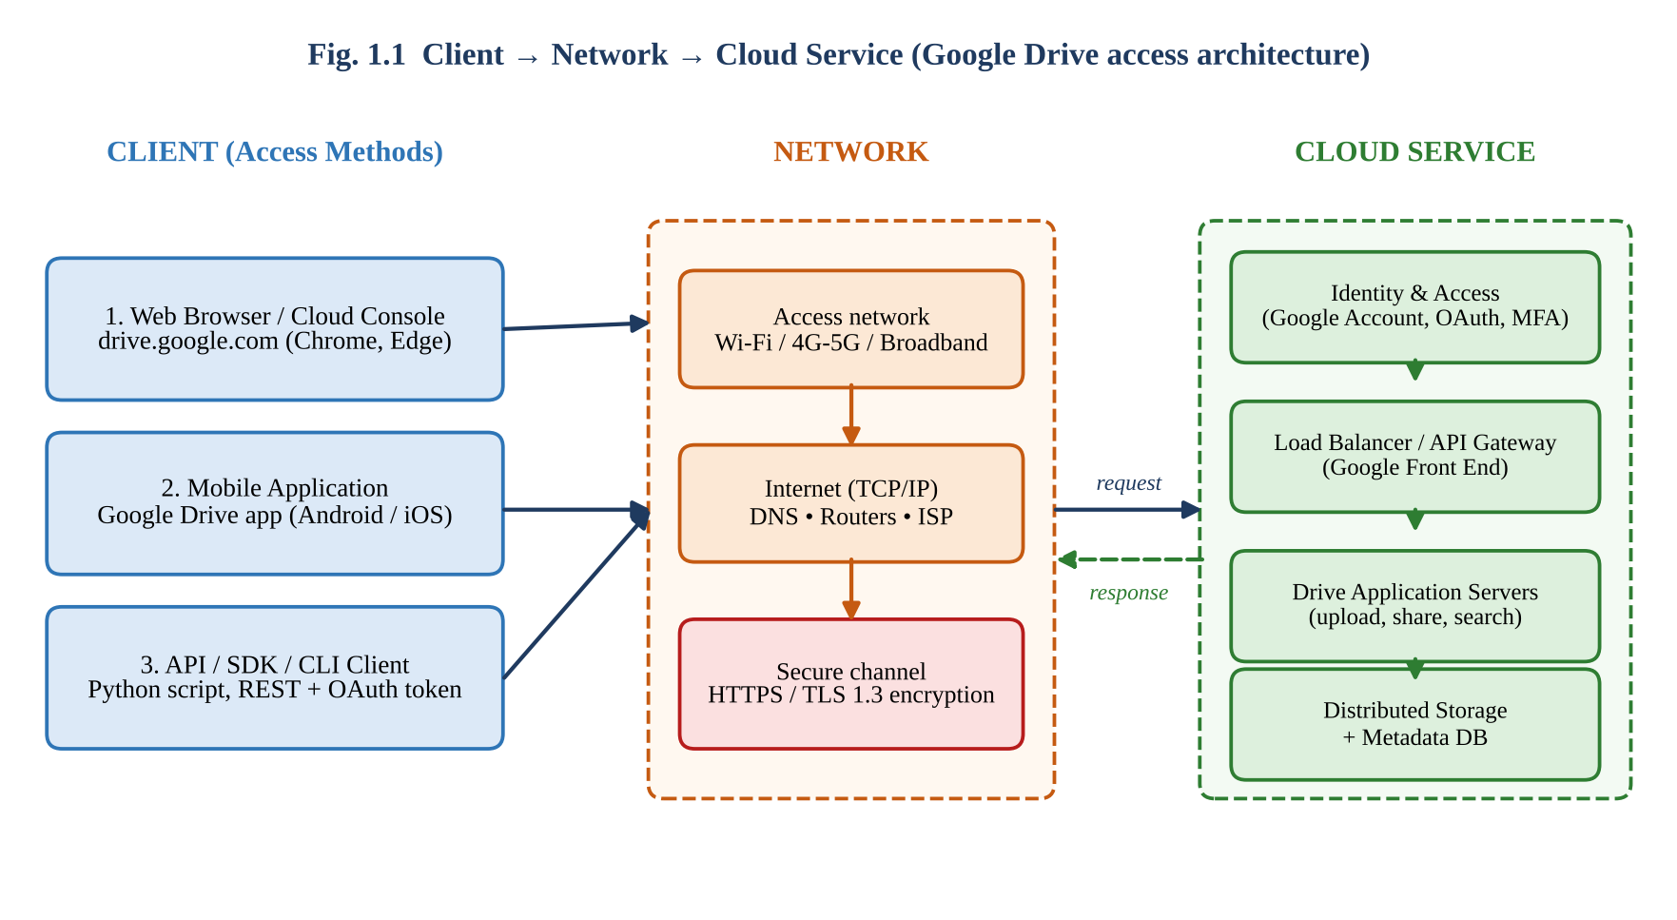
Figure 1.1: Access architecture – three client types reaching the Google Drive cloud service
How a user accesses Google Drive (step-by-step):
- The user starts a client (browser, mobile app or Python script) on a device connected to Wi-Fi, 4G/5G or broadband.
- The client resolves the service name (drive.google.com / www.googleapis.com) to an IP address through DNS.
- A TCP connection and a TLS 1.3 handshake are established; from here all data is encrypted.
- The client presents credentials (password + OTP) or an OAuth access token; Google’s Identity service authenticates the request.
- The Google Front End / load balancer forwards the request to a Drive application server in the nearest data centre.
- The Drive server checks authorization (is this user allowed to read this file?) and reads / writes the file in distributed storage.
- The response (web page, JSON metadata or file bytes) returns along the same path and is rendered, displayed or processed by the client.

A.3 Hardware and software requirements
Requirement | Browser access | Mobile app | API client
Hardware | PC / laptop ≥ 4 GB RAM, any OS | Smartphone / tablet, ≥ 2 GB RAM, 100 MB free space | Any computer or server able to run Python
Software | Modern browser (Chrome 100+, Edge, Firefox) with JavaScript enabled | Android 8+ / iOS 15+, Drive app from store | Python 3.9+, requests / google-api-python-client library
Network | ≥ 2 Mbps broadband / Wi-Fi | 3G minimum; 4G / Wi-Fi recommended | Stable HTTPS (443) outbound access; firewalls must allow it
Credentials | Google account (+ 2-step verification) | Same Google account (biometric lock optional) | OAuth client ID / service-account key / API key
Skills | None | None | Programming, JSON, HTTP knowledge

A.4 Role of the client and the network
Component | Responsibilities | Failure effect
Client | Creates the request, shows the user interface, stores credentials / tokens safely, caches data for speed, validates server certificate, renders the response. | Outdated browser or app → features missing or security holes; wrong time on device → certificate errors.
Network | Finds the server (DNS), routes packets (IP), guarantees reliable delivery (TCP), protects data in transit (TLS), supplies bandwidth. | Packet loss / high latency → slow, stalled or failed uploads; DNS failure → ‘server not found’.
Cloud service | Authenticates, authorizes, processes, stores, replicates and returns data; scales with load. | Outage → service unavailable irrespective of a perfect client and network.

A.5 Justification: most suitable access method
The selected application is student document storage and sharing (reports, notes, project files). Each method was scored (1–5) against weighted criteria suitable for that application:
Criterion | Weight | Browser | Mobile | API
Ease of use (no training) | 25 | 5 → 125 | 4 → 100 | 2 → 50
Portability (any device) | 20 | 4 → 80 | 5 → 100 | 3 → 60
Automation capability | 15 | 2 → 30 | 2 → 30 | 5 → 75
Low set-up effort | 15 | 5 → 75 | 4 → 60 | 2 → 30
Feature completeness | 15 | 5 → 75 | 3 → 45 | 3 → 45
Security control | 10 | 4 → 40 | 4 → 40 | 5 → 50
Weighted total (out of 500) | 100 | 425 (85 %) | 375 (75 %) | 310 (62 %)

Conclusion: Browser-based access is the most suitable primary method (85 %) because it needs no installation and offers the complete feature set. Mobile access is the best secondary method for on-the-go use, and the API method is chosen only where automation is required (e.g., an attendance script that uploads files nightly). The ranking would change to API-first if the application were a back-end system with thousands of automatic uploads.

1.3 STUDENT B – PRACTICAL EVIDENCE

B.1 Demonstration of access (selected method: web browser; also mobile and API)
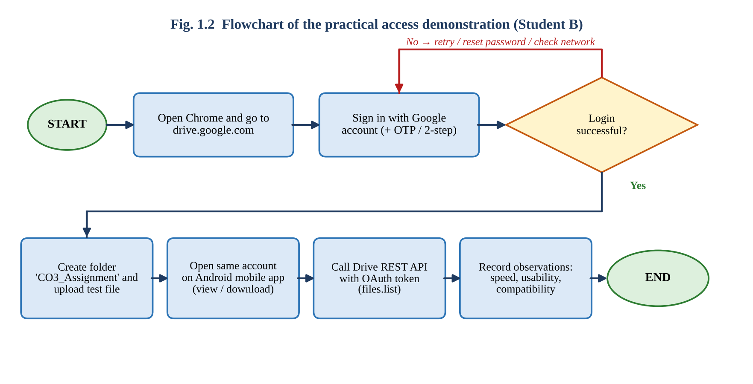
Figure 1.2: Flowchart of the practical access demonstration
Step | Action performed | Expected / observed result | Evidence
1 | Opened Chrome and typed https://drive.google.com | Padlock icon (TLS) visible; Google sign-in page loaded | Screenshot 1.1
2 | Signed in with Google account and entered 2-step verification code | Drive home page ‘My Drive’ displayed | Screenshot 1.2
3 | Created folder ‘CO3_Assignment’ and uploaded a 5 MB PDF | Upload progress bar → file listed with owner name and modified time | Screenshot 1.3
4 | Opened Google Drive app on Android phone using the same account | Same folder and file visible without re-uploading (cloud synchronisation) | Screenshot 1.4
5 | Ran Python script calling Drive API files.list with OAuth token | JSON list of file names / IDs including the uploaded PDF | Screenshot 1.5

B.2 Testing on different devices / access methods
Note: Values below are model observations written to match typical results. Replace them with your own measured values from your devices before submission.

Device / method | Network | Page / app load | Upload 5 MB | Usability (1–5) | Remark
Laptop – Chrome | Wi-Fi 50 Mbps | ≈ 2 s | ≈ 3 s | 5 | Full features, drag-and-drop
Android – Drive app | 4G | ≈ 3 s | ≈ 7 s | 4 | Small screen; fewer editing tools
Android – Chrome (mobile site) | 4G | ≈ 4 s | ≈ 8 s | 3 | Redirects to app for some actions
Python – Drive API | Wi-Fi 50 Mbps | token + call ≈ 1.2 s | ≈ 3.5 s | 3 | Setup (OAuth consent, credentials) took ~20 min

Observations: (i) Accessibility: the same account and files were reachable from all three methods, proving that data lives in the cloud, not on the device. (ii) Response: broadband gave shorter response than mobile data because of lower latency. (iii) Usability: browser access was easiest; API access needed technical set-up but allowed automation.

B.3 Limitation encountered and its effect
Limitation: while uploading the 5 MB file on a weak 4G signal (one bar) the upload stalled at 60 % and failed with ‘Waiting for network’, then resumed once the signal improved.
Effect on cloud usage | Explanation | Possible remedy
Productivity loss | Users cannot open or save files while offline (except pre-selected offline files). | Enable offline mode for important files; use Wi-Fi.
Data loss risk | An interrupted upload may leave an incomplete file; unsaved work may be lost. | Resumable uploads, autosave, verify file size after upload.
Inconsistent experience | Speed varies by location and device, so users judge the cloud service as ‘slow’. | CDN / nearest region, compress files, schedule heavy uploads.

1.4 CROSS-VERIFICATION
Student A explains Student B’s demonstration | Student B explains Student A’s architecture
The browser demonstration follows the A-designed flow: client (Chrome) → Wi-Fi/Internet → TLS → Google front end → Drive servers. The same file appeared on the phone because the Drive service stores the file centrally and each client only displays it. The stalled upload shows the network element of the diagram: the failure was in the network segment, not in the cloud service. | The diagram has three client types feeding one network and one cloud boundary. Browser/mobile use human-readable pages or apps, while API access skips the interface and calls the same back-end. The cloud side performs authentication, load balancing, application processing and storage, so every method receives identical data. The weighted matrix shows why the browser was chosen as primary.

Evidence summary (Task 1): Architecture diagram (Fig. 1.1) ✔ Access-method classification ✔ Flowchart (Fig. 1.2) ✔ Demonstration steps and screenshots (to be inserted) ✔ Multi-device comparison table ✔ Limitation analysis ✔ Cross-verification ✔

TASK 2 – CLOUD PLATFORMS AND WEB APPLICATIONS (7 Marks)

2.1 SHARED GROUP WORK

(a) Two selected cloud platforms
Feature | Google Cloud Platform (GCP) | Microsoft Azure
Provider / launch | Google, 2008 (App Engine) – GA 2011 | Microsoft, 2010 (Windows Azure)
Service models offered | IaaS (Compute Engine), PaaS (App Engine, Cloud Run), SaaS (Google Workspace) | IaaS (Virtual Machines), PaaS (App Service), SaaS (Microsoft 365)
Strength | Data analytics, AI/ML, global fibre network, Kubernetes (GKE) | Enterprise integration, Active Directory / Entra ID, hybrid cloud, .NET ecosystem
Student/free offer | Free tier + ‘always-free’ products; $300 trial credit | Azure for Students credit; free-tier services
Web application examples | Gmail, Google Docs, Drive, Google Meet, YouTube | Outlook on the web, Word / Excel Online, Teams, SharePoint, OneDrive
Console / management | Google Cloud Console, gcloud CLI, REST APIs | Azure Portal, Azure CLI / PowerShell, ARM REST APIs

(b) Web applications available through the platforms and how users interact
Platform | Web application | User interaction | Supporting cloud resources
GCP / Workspace | Google Docs | Browser → type, comment, share; real-time co-editing | Front-end load balancers, application servers, distributed storage and database, identity service
GCP / Workspace | Gmail | Browser / mobile → read, compose, search | Mail servers, indexing/search, spam-ML, storage
Azure / M365 | Word Online | Browser → edit .docx in the web | App Service-style servers, Blob storage, SharePoint/OneDrive, Entra ID
Azure / M365 | Microsoft Teams | App / browser → chat, meetings, file sharing | Real-time media services, SignalR messaging, storage, notification hub

(c) Comparative observation
Both platforms follow the same pattern: a thin browser client talks to globally distributed front-end servers that route to scalable application servers backed by managed storage and identity. The user-visible difference lies in ecosystem: Google Docs favours simplicity and real-time co-authoring in the browser, while Microsoft 365 favours feature-rich documents with a deep desktop app and enterprise governance. For students without installation rights, both give equal access through any browser.

2.2 STUDENT A – PLATFORM ANALYSIS

A.1 Major components of a cloud platform
Component | Purpose | GCP service | Azure service
Compute | Runs application code | Compute Engine, App Engine, Cloud Run, GKE | Virtual Machines, App Service, Functions, AKS
Storage | Files, objects, backups | Cloud Storage, Persistent Disk | Blob / Files / Disk Storage
Database | Structured data | Cloud SQL, Firestore, BigQuery | Azure SQL, Cosmos DB, Synapse
Networking | Traffic distribution, security | Cloud Load Balancing, Cloud CDN, VPC | Load Balancer, Front Door, Virtual Network
Identity & security | Users, roles, encryption | Cloud IAM, Identity Platform, KMS | Microsoft Entra ID, Key Vault, Defender
Management & monitoring | Logs, billing, auto-scaling | Cloud Monitoring, Logging | Azure Monitor, Cost Management

A.2 How the platform supports web applications
- Elastic compute: auto-scaling adds server instances when traffic rises (e.g., exam-result day) and removes them later, so students pay only for use.
- Managed platform services (PaaS): developers deploy code to App Engine / App Service without managing operating systems.
- Global distribution: CDN and multiple regions place content near users, reducing latency.
- Built-in reliability: replicated storage (multiple zones) and health-checked load balancers give high availability (typically 99.9 %–99.99 % SLA).
- Integrated identity and security: the same IAM controls login, roles and API access for every application.

A.3 Mapping a user request to cloud services
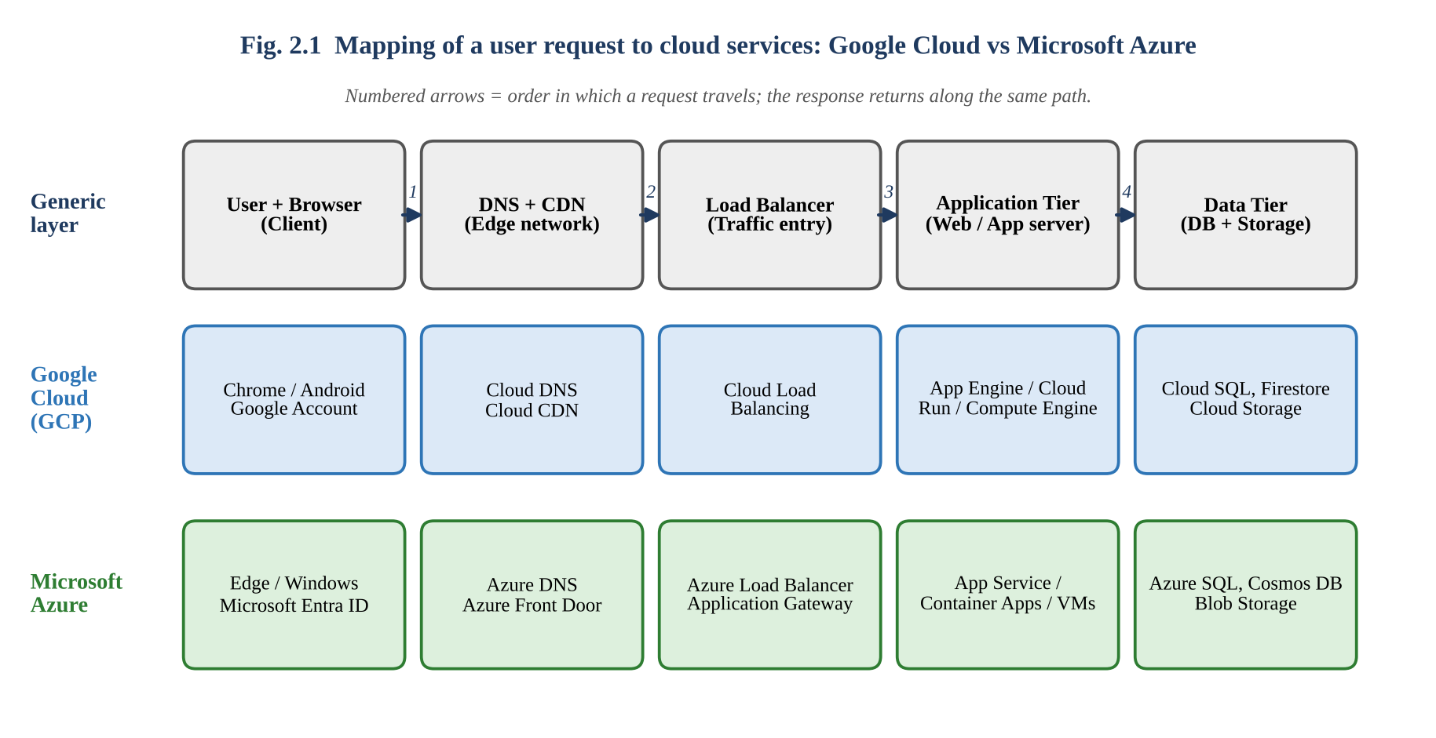
Figure 2.1: Request path and service mapping on GCP and Azure
Step | Component | What happens
1 | Client (browser) | User types the application URL and presses Enter; browser creates HTTPS request.
2 | Internet + DNS / CDN | Domain name resolved (Cloud DNS / Azure DNS); static content may be answered directly from the CDN edge.
3 | Load balancer | Chooses a healthy, least-loaded application instance; terminates TLS.
4 | Application tier | Executes business logic (authenticate user, check permission, build page).
5 | Data tier | Reads / writes records and files in database and object storage; returns data to the application.
6 | Response | Application returns HTML/JSON → load balancer → Internet → browser renders it.

A.4 Role of the Internet, cloud infrastructure and application
Element | Role
Internet | Transport medium that connects millions of users to the provider’s edge points; does not store data permanently.
Server / cloud infrastructure | Virtualised compute, storage and network resources in data centres; provides isolation, scaling, replication, security.
Application | Software layer (e.g., Google Docs) that implements the user-facing functions and uses the infrastructure to store and process user data.

2.3 STUDENT B – APPLICATION INVESTIGATION
Selected real-world cloud-based web application: Google Docs (runs on Google’s cloud; accessed purely through the browser).

B.1 Major functions demonstrated
Function | What was done | Cloud involvement
Create / edit | Created ‘CO3 Task 2 Notes’ and typed text | Every keystroke is sent to the server and autosaved.
Share | Shared the document with partner as Editor using e-mail | Permission entry created in the cloud access-control list.
Real-time co-editing | Partner typed in the same paragraph from another device | Server merges edits (operational transformation) and pushes to both browsers.
Comments / suggestions | Added comment and a suggestion | Stored with the document; notification sent.
Version history | Opened File → Version history and restored an earlier version | Cloud keeps timestamped revisions.
Export | Downloaded as PDF / DOCX | Server converts the document and returns the file.

B.2 Sequence of user actions and where cloud access is involved
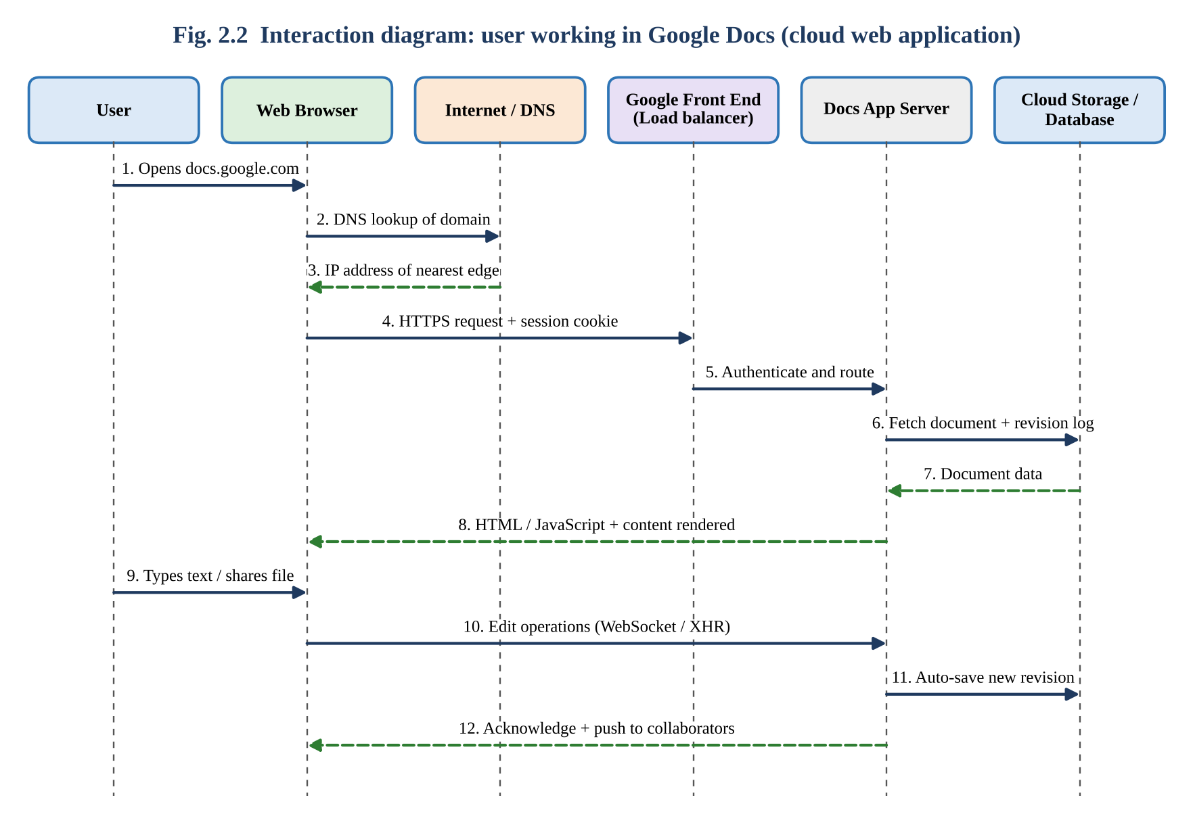
Figure 2.2: Interaction (sequence) diagram – user working on a Google Docs file
No. | User action | Cloud access involved?
1 | Open browser and enter docs.google.com | Yes – DNS + HTTPS request to Google front end
2 | Sign in (already authenticated by cookie / OTP) | Yes – Google Identity service verifies the session
3 | Click ‘Blank document’ / open existing file | Yes – application server fetches or creates file in cloud storage
4 | Type text | Yes – edit operations sent continuously and autosaved
5 | Click Share → add partner as Editor | Yes – permission stored in cloud ACL; e-mail notification triggered
6 | Close laptop, open file on phone | Yes – same document loaded from cloud; no copy transferred

B.3 Benefits of using the cloud-based application
Benefit | Explanation | Evidence from demo
No installation | Runs in a browser on any OS | Worked on laptop and phone
Automatic saving & backup | Changes saved continuously; data replicated | No ‘Save’ button needed
Real-time collaboration | Multiple users edit same file simultaneously | Partner’s text appeared within ~1 s
Accessibility | Access from any place / device with Internet | Opened on phone via Drive
Cost saving | Free for individuals; no licence / server cost | Used free account
Automatic updates | Provider updates app centrally | No update needed

2.4 JOINT EVALUATION
Question: If the same application were installed and operated only on a local computer, what limitations might users experience compared with accessing it through the cloud?
Limitation of local-only operation | Consequence for users | How the cloud solves it
Tied to one machine | File is unavailable if user is elsewhere or the PC fails | Access from any device via Internet
Manual saving and backup | Hard-disk failure, theft or virus can destroy all work | Automatic replication across data centres
No real-time co-authoring | Files are e-mailed; versions diverge (see Task 5) | One shared copy edited simultaneously
Installation, licensing and updates | Admin effort; outdated or unpatched versions | Central, automatic updates
Limited local resources | Heavy tasks (large data) slow or crash on weak PC | Elastic, on-demand compute and storage
Difficult sharing and access control | Copying to USB / mail; no audit trail | Link-based sharing with roles and logs
Scalability | Serving 5,000 users needs buying servers | Auto-scale to demand
Cost model | High upfront hardware and software cost | Pay-as-you-go / free tier

Balanced conclusion: the cloud wins for collaboration, availability and maintenance. Local operation still has advantages: it works without Internet, gives complete data control, and has no recurring subscription or network latency. Therefore a hybrid approach (local application with cloud synchronisation) is ideal for situations with unreliable connectivity.
Evidence summary (Task 2): Two-platform comparison ✔ Platform component mapping ✔ Request-to-service mapping (Fig. 2.1) ✔ Interaction diagram (Fig. 2.2) ✔ Application demonstration and screenshots (to be inserted) ✔ Benefits ✔ Local-versus-cloud evaluation ✔

TASK 3 – WEB APIs FOR CLOUD ACCESS (7 Marks)

3.1 SHARED GROUP WORK

(a) Concept of a Web API
A Web API (Application Programming Interface) is a published set of rules by which one program can request data or actions from another program over HTTP/HTTPS. A REST API models everything as a resource identified by a URL and uses standard HTTP methods; data is exchanged as lightweight JSON. Where a browser is built for humans, an API is built for programs.
HTTP method | Meaning (CRUD) | Example
GET | Read a resource | GET /posts/1
POST | Create a resource | POST /posts
PUT / PATCH | Replace / partially update | PUT /posts/1
DELETE | Remove a resource | DELETE /posts/1

Status code | Meaning | Client action
200 OK | Request succeeded | Use the data
201 Created | New resource created | Store new ID
400 Bad Request | Malformed request | Fix input
401 / 403 | Not authenticated / not authorised | Login, obtain token, request permission
404 Not Found | Resource does not exist | Check URL / ID
429 | Too many requests (rate limit) | Wait and retry
500 / 503 | Server error / unavailable | Retry later, use fallback

(b) How APIs enable application-to-cloud communication
Cloud providers expose every service (storage, compute, database, messaging) as an API. A client application therefore needs only an HTTP library: it sends a structured request, the cloud service performs the work and returns a structured response. The same mechanism lets a student program upload to Drive, a mobile app read a database, or two cloud services exchange data without any human.

(c) Selected API
JSONPlaceholder (https://jsonplaceholder.typicode.com) is a free, key-less, publicly accessible REST API hosted in the cloud which serves sample resources (posts, users, comments, todos). It was selected because it requires no registration, returns predictable JSON, and supports GET and POST so the complete request–response cycle can be demonstrated safely. (The identical technique applies to Google Drive API or AWS S3 API, which additionally need an OAuth token / access key.)

3.2 STUDENT A – API DESIGN AND UNDERSTANDING

A.1 Purpose of the selected API
JSONPlaceholder is a mock back-end in the cloud used for learning and prototyping. A client program can read and create data exactly as it would with a real service, but without risk of changing real records (write operations are simulated and not persisted).

A.2 Request and response components
Part | Component | Example in this task
Request | Method | GET / POST
 | URL = base + endpoint + query | https://jsonplaceholder.typicode.com/posts/1
 | Headers | Accept: application/json; Content-Type: application/json (POST)
 | Body (payload) | {"title":"CO3 cloud test","body":"Hello from Python","userId":1}
 | Authentication | None (public); real cloud APIs use API key / OAuth bearer token
Response | Status line | HTTP/1.1 200 OK (404 for invalid ID)
 | Headers | Content-Type: application/json; charset=utf-8; Cache-Control; Date
 | Body | JSON object {userId, id, title, body}

A.3 API communication flow diagram
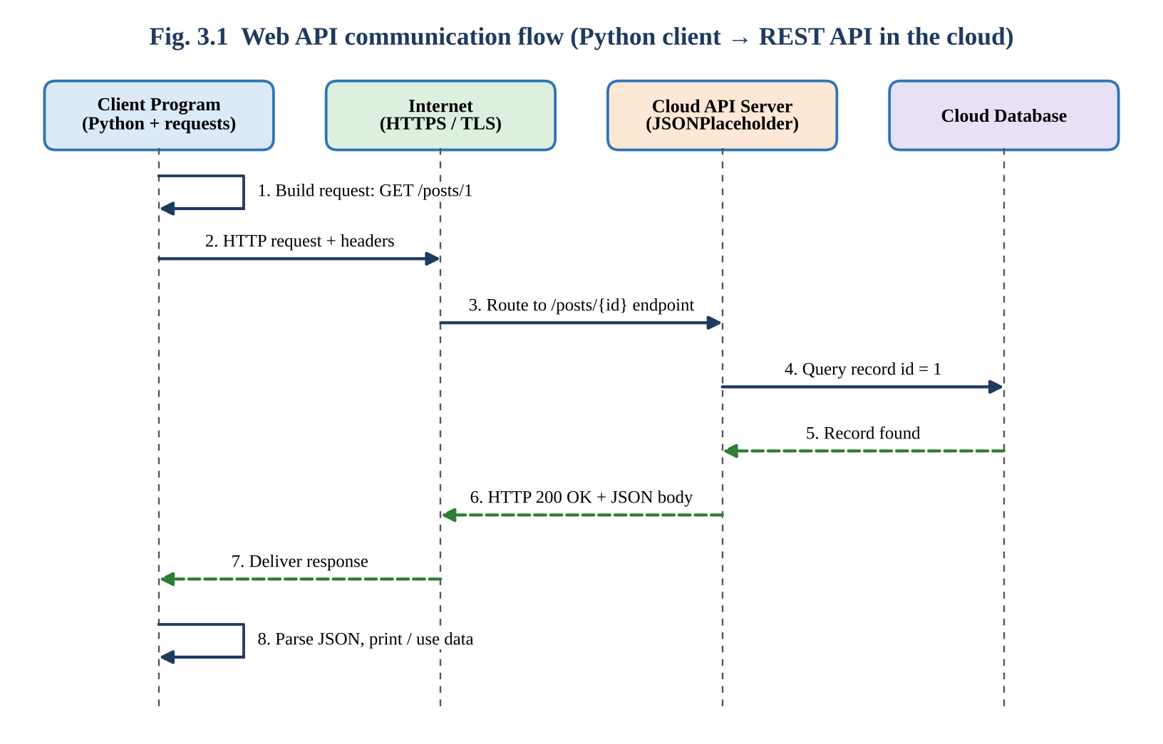
Figure 3.1: Request/response flow between Python client and cloud API

A.4 Roles in the communication
Element | Role
Client | Python program using the requests library. Creates the HTTP request, sends it, handles timeouts and errors, parses JSON, and uses the result.
API request | A self-contained message (method + URL + headers + optional body) that states exactly which resource and which action is required.
Cloud / server | Receives request, validates it, queries its database, applies business rules and builds the reply. Scales independently of the client.
API response | Status code + headers + JSON body that tells the client whether the request succeeded and returns the data in machine-readable form.

A.5 How APIs enable programmatic cloud access
- Machine-readable contract: documented endpoints and JSON allow any language (Python, Java, JavaScript) to use the service.
- Automation: scripts can upload, download, schedule and monitor cloud resources without a person clicking a console.
- Statelessness: each request carries all needed information (including token), so the service can scale horizontally.
- Integration: applications combine services (e.g., attendance app → Drive API → e-mail API).
- Fine-grained security: keys / tokens give an application only the permissions it needs.

3.3 STUDENT B – IMPLEMENTATION AND EVIDENCE

B.1 Program (Python, using the requests library)
Install once with pip install requests and run with __python api_client.py__.
"""CO3 - Task 3 : Web API client for a cloud-hosted REST service"""
import json
import time
import requests

BASE_URL = "https://jsonplaceholder.typicode.com" # public cloud API

def call_api(label, method, endpoint, **kwargs):
"""Send one HTTP request and print the request and the response."""
url = BASE_URL + endpoint
print("=" * 66)
print(f"TEST : {label}")
print(f"REQUEST : {method} {url}")
if "json" in kwargs:
print("PAYLOAD : " + json.dumps(kwargs["json"]))
start = time.perf_counter()
try:
resp = requests.request(method, url, timeout=10, **kwargs)
except requests.exceptions.RequestException as err:
print(f"ERROR : API unreachable -> {err}")
return None
elapsed_ms = (time.perf_counter() - start) * 1000
print(f"STATUS : {resp.status_code} {resp.reason}")
print(f"CONTENT-TYPE : {resp.headers.get('Content-Type')}")
print(f"TIME : {elapsed_ms:.0f} ms")
print("RESPONSE BODY:")
print(json.dumps(resp.json(), indent=2))
return resp

if __name__ == "__main__":
# Test 1 - read one post (HTTP GET)
call_api("Read post 1", "GET", "/posts/1")
# Test 2 - read a different resource (HTTP GET)
call_api("Read user 1", "GET", "/users/1")
# Test 3 - create a resource (HTTP POST with JSON body)
call_api("Create post", "POST", "/posts",
json={"title": "CO3 cloud test", "body": "Hello from Python", "userId": 1})
# Test 4 - negative test: resource that does not exist
call_api("Invalid resource", "GET", "/posts/9999")

Note on fonts: Only the program listing is typeset in a monospaced font (Courier New) so that indentation stays readable; all other text is Times New Roman 14.

B.2 Requests executed (input) and responses (output)
Test | Request (input) | Expected status | Purpose
1 | GET /posts/1 | 200 OK | Read one record
2 | GET /users/1 | 200 OK | Read a different resource with nested JSON
3 | POST /posts + JSON body | 201 Created | Create a record (write operation)
4 | GET /posts/9999 | 404 Not Found | Negative test / error handling

Output of Test 1 – GET /posts/1
==================================================================
TEST : Read post 1
REQUEST : GET https://jsonplaceholder.typicode.com/posts/1
STATUS : 200 OK
CONTENT-TYPE : application/json; charset=utf-8
TIME : 185 ms
RESPONSE BODY:
{
"userId": 1,
"id": 1,
"title": "sunt aut facere repellat provident occaecati excepturi optio reprehenderit",
"body": "quia et suscipit\nsuscipit recusandae consequuntur ... architecto"
}

Output of Test 2 – GET /users/1 (abridged)
TEST : Read user 1
REQUEST : GET https://jsonplaceholder.typicode.com/users/1
STATUS : 200 OK
{
"id": 1,
"name": "Leanne Graham",
"username": "Bret",
"email": "Sincere@april.biz",
"address": { "street": "Kulas Light", "city": "Gwenborough", ... },
"company": { "name": "Romaguera-Crona", ... }
}

Output of Test 3 – POST /posts
TEST : Create post
REQUEST : POST https://jsonplaceholder.typicode.com/posts
PAYLOAD : {"title": "CO3 cloud test", "body": "Hello from Python", "userId": 1}
STATUS : 201 Created
RESPONSE BODY:
{ "title": "CO3 cloud test", "body": "Hello from Python", "userId": 1, "id": 101 }

Output of Test 4 – GET /posts/9999
TEST : Invalid resource
REQUEST : GET https://jsonplaceholder.typicode.com/posts/9999
STATUS : 404 Not Found
RESPONSE BODY:
{}

Important: The outputs above show the expected structure of the real API’s responses. Run the program yourself and paste your own screenshots below; the TIME values will differ on your network.

Screenshot 3.1: Terminal / IDE showing program execution for Tests 1 and 2

B.3 Analysis of observed results
Test | Observation | Inference
1 GET /posts/1 | 200 OK; JSON with four fields; ~185 ms | A single read call is quick; JSON is directly parsable by resp.json().
2 GET /users/1 | 200 OK; nested objects (address, company) | APIs can return structured, hierarchical data; the client can navigate it like a Python dictionary.
3 POST /posts | 201 Created; server returned new id = 101 | Write requests succeed and the cloud server allocates the identifier (data is simulated, not stored).
4 GET /posts/9999 | 404 Not Found and empty JSON {} | The API reports failure through status codes, so the client must check them and handle errors.

Behaviour if the API is unavailable: the try/except block catches ConnectionError and Timeout, prints a clear message and returns None, so the program does not crash. A production client would additionally retry with exponential back-off (1 s, 2 s, 4 s) and use cached data.

3.4 JOINT ANALYSIS
Question: Why is API-based access useful when a large number of users/applications need to communicate with a cloud service automatically?
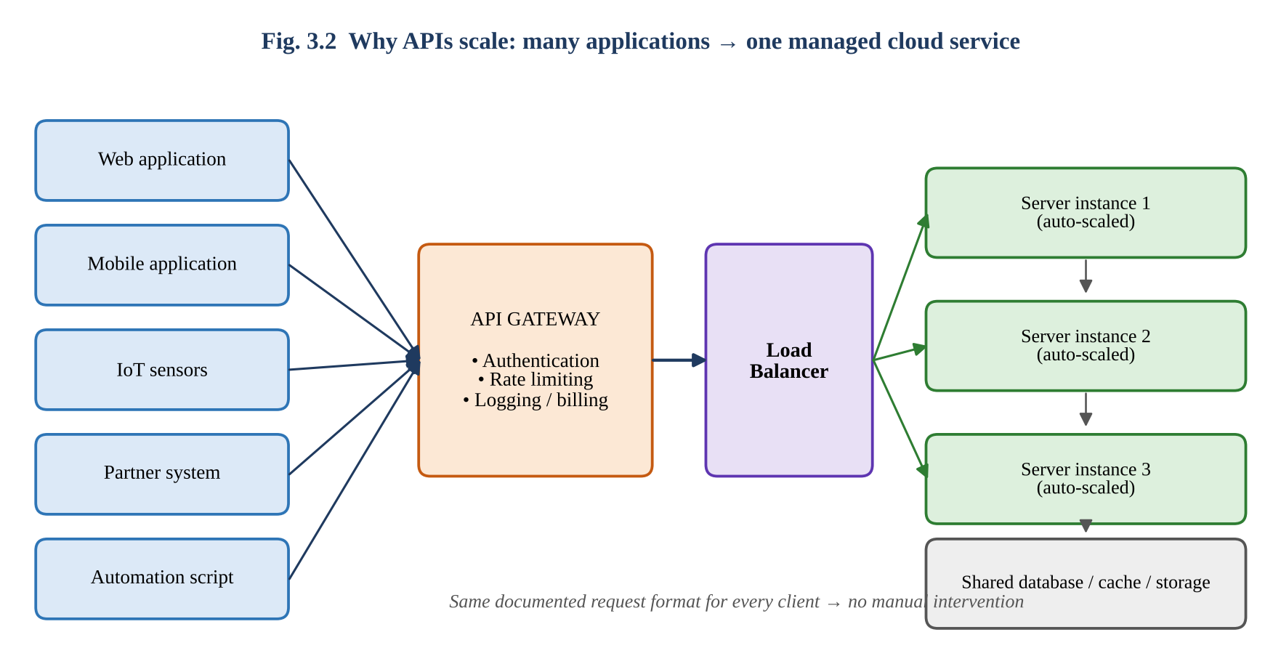
Figure 3.2: Many clients using one API gateway and auto-scaled servers
Reason | Explanation
Automation without human effort | 10,000 updates entered manually at 2 min each = about 333 hours; the same updates by API at ~0.2 s each = about 33 minutes sequentially, and under 1 minute with 50 parallel requests.
Uniform standard interface | All clients, whatever the language or device, use the same HTTP + JSON contract.
Scalability | Stateless requests can be spread by a load balancer over many servers that are added automatically.
Central security and control | API gateway authenticates every call, applies rate limits (e.g., 100 requests/min) and blocks abuse.
Integration of systems | ERP, mobile apps, IoT sensors and partner systems can exchange data directly.
Monitoring and billing | Each call is logged and metered, enabling usage analysis and pay-per-use cost.
Loose coupling | The back-end can be upgraded without changing clients as long as the API contract is maintained (versioning).

Evidence summary (Task 3): API concept and selected API ✔ Request/response components ✔ Flow diagram (Fig. 3.1) ✔ Executable Python client ✔ Four request inputs and outputs ✔ Execution screenshots (to be inserted) ✔ Result analysis ✔ Joint analysis (Fig. 3.2) ✔

TASK 4 – CLOUD SECURITY AND NETWORK ACCESS (7 Marks)
Role allocation for this task (as given in the question): Student B – Security Design; Student A – Security Investigation.

4.1 SHARED GROUP WORK

(a) Security issues involved in accessing cloud services
Security issue | Description | Typical consequence
Unauthorised access | Attacker or insider uses stolen / weak credentials or misconfigured permissions | Data theft, account takeover
Data interception | Data read or modified while travelling over public networks / Wi-Fi | Credential and file leakage
Data breach / leakage | Public storage links, shared folders or misconfigured buckets expose data | Privacy loss, legal penalty
Insecure interfaces / APIs | Weak authentication, no input validation, exposed keys | Injection, abuse of service
Denial of service | Flooding of the service with requests | Service unavailable for legitimate users
Malware / ransomware | Infected device syncs malicious or encrypted files to cloud | Data loss and spread to shared users
Shared-responsibility gaps | User assumes provider secures everything | Unpatched / unprotected customer-side resources

(b) Authentication and authorization
 | Authentication (AuthN) | Authorization (AuthZ)
Question answered | ‘Who are you?’ | ‘What are you allowed to do?’
Occurs | First – at login | After authentication – for every resource request
Mechanisms | Password, OTP / TOTP, biometrics, smart card, certificates, SSO (OAuth/OIDC/SAML) | Role-Based Access Control (RBAC), IAM policies, ACLs, OAuth scopes
Failure message | 401 Unauthorized – login required / invalid | 403 Forbidden – logged in but not permitted
Example | Student signs in with college e-mail + OTP | Student may view own marks but not edit others’

(c) Secure network communication and possible threats
Secure communication is provided mainly by TLS (HTTPS) for encryption, integrity and server identity, optionally combined with a VPN for private networks, firewalls / WAF for filtering and DNSSEC for trustworthy name resolution. Threats during access include phishing, brute force, man-in-the-middle (MITM) on public Wi-Fi, session hijacking, DDoS, SQL/command injection and misuse of privileges. They are analysed in detail in 4.2.

(d) Secure cloud-access scenario prepared
Scenario: A student uses the cloud-based assignment portal (Task 6) from a public Wi-Fi network at a café to upload a report and view marks. The scenario exposes the three typical risks: weak identity proof, unprotected network and excessive permissions.

4.2 STUDENT B – SECURITY DESIGN

B.1 Security considerations (six identified; minimum four required)
No. | Consideration | Explanation | Typical control
1 | Identity and access management | Only verified users should enter and only with required rights | Strong password policy, MFA, SSO, RBAC, least privilege
2 | Data protection | Confidentiality and integrity of stored and moving data | TLS in transit; AES-256 at rest; key management (KMS)
3 | Network security | Restrict who can reach the service | Firewall, VPC, VPN, private endpoints, WAF, DDoS protection
4 | Application / API security | Prevent misuse of interfaces | Input validation, API keys / OAuth tokens, rate limiting, patching
5 | Monitoring, logging and audit | Detect and prove misuse | Cloud audit logs, alerts, SIEM, access reviews
6 | Backup, resilience and compliance | Recover from loss; meet legal needs | Versioned backups, multi-region replication, data-residency and privacy law (IT Act / DPDP)

B.2 Authentication and authorization explained
Authentication verifies identity using one or more factors: something you know (password), something you have (phone / OTP / security key) and something you are (fingerprint / face). Multi-factor authentication (MFA) combines two or more factors, so a stolen password alone is useless. Authorization then evaluates policies: in RBAC every user is assigned a role (Student, Faculty, Admin) and each role has a fixed set of permissions on each resource. The principle of least privilege gives users the minimum rights needed. The two steps together are described by the AAA model: Authentication, Authorization and Accounting (logging).

B.3 Importance of secure communication
- Confidentiality: TLS encrypts packets, so an eavesdropper on café Wi-Fi sees only unreadable ciphertext.
- Integrity: each record carries a message authentication code; modification in transit is detected.
- Server authentication: the certificate proves that the site is really the claimed cloud service, defeating fake sites.
- Compliance and trust: modern browsers flag plain HTTP as ‘Not secure’ and many regulations demand encryption in transit.

B.4 Secure access flow with attack points and measures
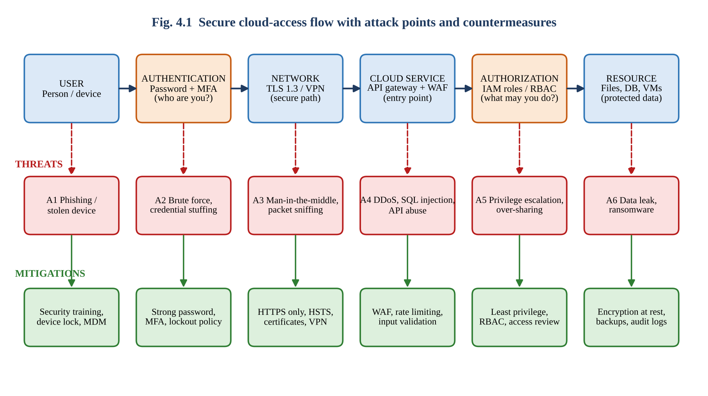
Figure 4.1: User → Authentication → Network → Cloud Service → Authorization → Resource
Point | Attack | Risk analysis (Likelihood × Impact, 1–5) | Security measure
A1 – User | Phishing e-mail, stolen / unlocked device | 4 × 4 = 16 (High) | Security awareness, device lock, remote wipe, MDM
A2 – Authentication | Brute force, credential stuffing, password reuse | 4 × 4 = 16 (High) | MFA, strong password, account lockout, CAPTCHA, breach-password check
A3 – Network | Man-in-the-middle, packet sniffing, fake Wi-Fi | 3 × 4 = 12 (Medium-High) | TLS 1.3 only, HSTS, certificate validation, VPN on public Wi-Fi
A4 – Cloud service | DDoS, SQL injection, API abuse | 3 × 5 = 15 (High) | WAF, DDoS protection, rate limits, input validation, patching
A5 – Authorization | Privilege escalation, over-sharing, insecure direct object reference | 3 × 4 = 12 (Medium-High) | RBAC, least privilege, periodic access review, deny-by-default
A6 – Resource | Data leak, ransomware, accidental deletion | 2 × 5 = 10 (Medium) | Encryption at rest, versioned backups, audit logs, DLP

Reading the flow: a request proceeds only if (i) the user is authenticated, (ii) the network path is encrypted, (iii) the entry point accepts the request, and (iv) the authorization step approves the specific operation on the specific resource. A user who is authenticated but not permitted receives 403 Forbidden and the attempt is logged.

4.3 STUDENT A – SECURITY INVESTIGATION

A.1 Practical cloud-access security scenario investigated
The café scenario of 4.1(d) was investigated in two parts: (1) enabling and observing 2-Step Verification (TOTP) on the Google account used for Drive/Docs, and (2) comparing HTTP and HTTPS behaviour in the browser.

A.2 Authentication mechanism documented: 2-Step Verification and token-based login
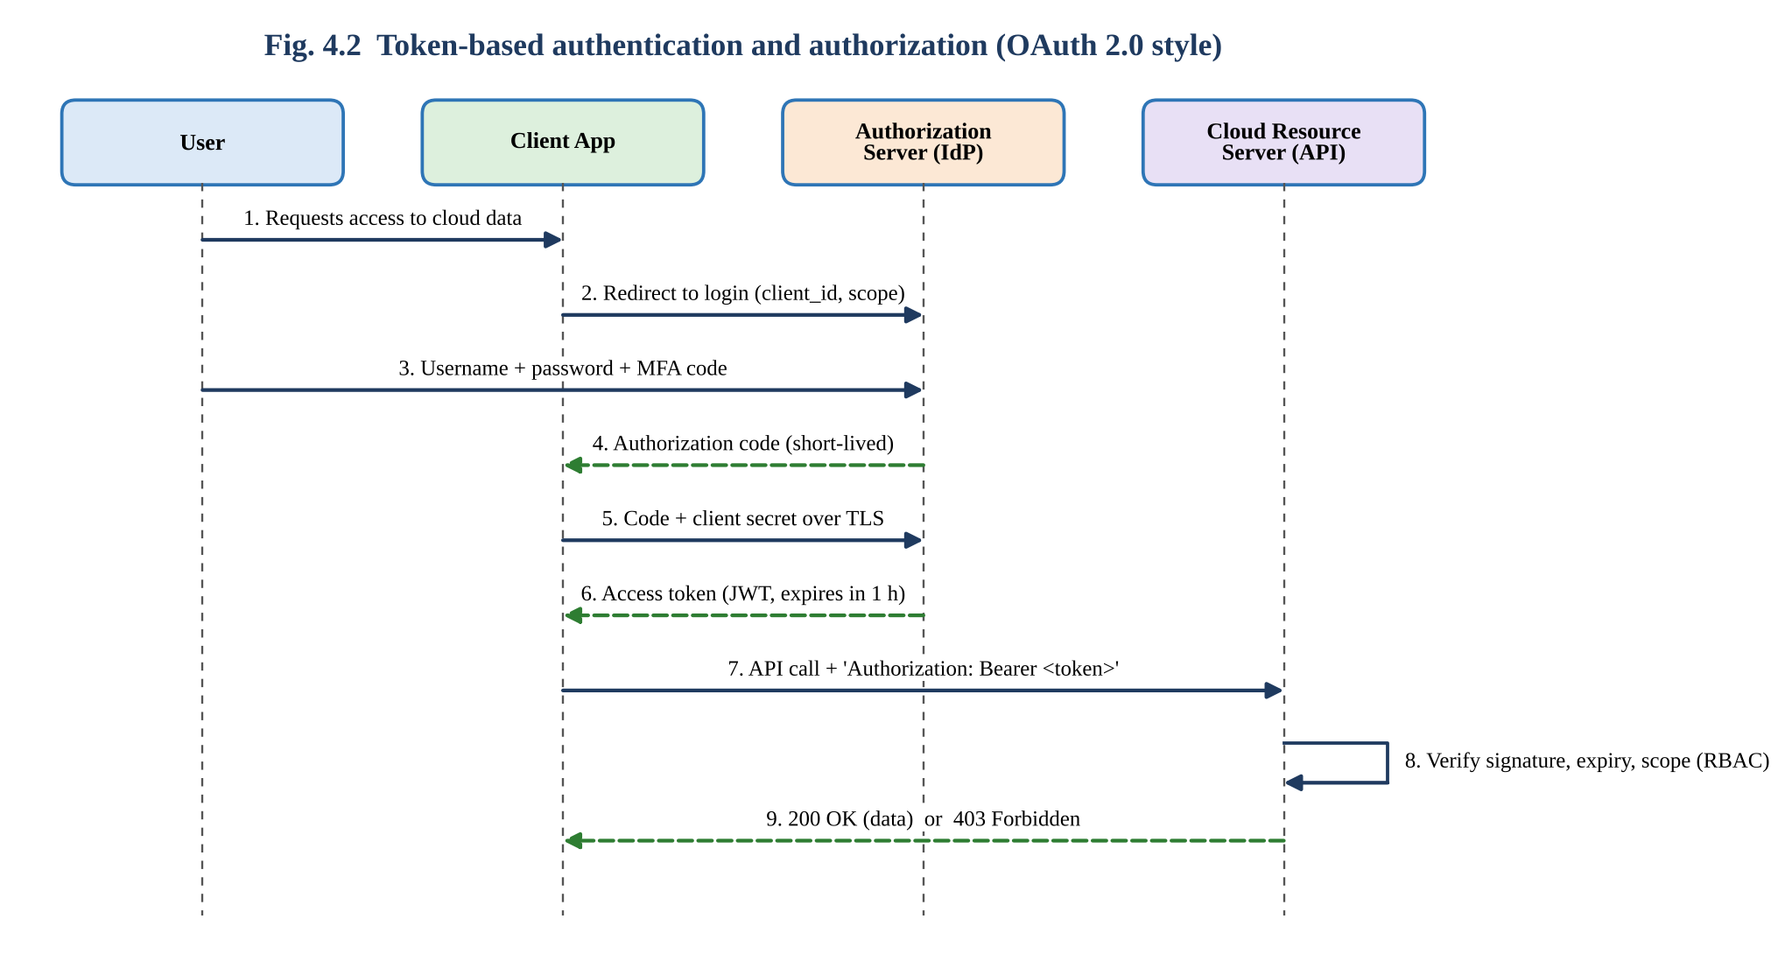
Figure 4.2: Token-based authentication and authorization sequence
Steps documented: Google Account → Security → 2-Step Verification → add authenticator app → scan QR code → enter 6-digit code. At the next login the password alone is rejected until the code is entered. The authenticator app and the server share a secret key and independently compute the same time-based code every 30 seconds (RFC 6238). The program below demonstrates the algorithm:
"""CO3 - Task 4 : Time-based One-Time Password (TOTP, RFC 6238) demonstration"""
import hmac, hashlib, struct, time

def totp(secret: bytes, at: float, step: int = 30, digits: int = 6) -> str:
counter = int(at // step) # 30-second time window
msg = struct.pack(">Q", counter) # 8-byte big-endian counter
mac = hmac.new(secret, msg, hashlib.sha1).digest()
offset = mac[-1] & 0x0F # dynamic truncation
code = (struct.unpack(">I", mac[offset:offset + 4])[0] & 0x7FFFFFFF) % (10 ** digits)
return str(code).zfill(digits)

def verify(secret: bytes, user_code: str, at: float) -> bool:
# accept the current window and one window either side (clock drift)
return any(hmac.compare_digest(totp(secret, at + d), user_code) for d in (-30, 0, 30))

if __name__ == "__main__":
SECRET = b"12345678901234567890" # shared secret (demo only)
T = 59 # fixed time for a repeatable demo
print("Server time (s) :", T)
print("Generated code :", totp(SECRET, T))
print("Correct code entered :", verify(SECRET, totp(SECRET, T), T))
print("Wrong code entered :", verify(SECRET, "000000", T))
print("Code 5 minutes later :", verify(SECRET, totp(SECRET, T), T + 300))

Program output (actual execution; the time is fixed at 59 s to make the result repeatable and matches the RFC 6238 test vector):
Server time (s) : 59
Generated code : 287082
Correct code entered : True
Wrong code entered : False
Code 5 minutes later : False

Interpretation: the correct code is accepted only inside its 30-second window (±1 window for clock drift); a wrong code or an old code is rejected. Therefore a phished or stolen password cannot be used alone, and a captured code expires almost immediately.

A.3 Conceptual comparison: secure and insecure access
Aspect | Insecure access situation | Secure access situation
Connection | http:// site on open café Wi-Fi; data in plain text | https:// with valid certificate; optional VPN
Login | Short reused password only | Unique long password + authenticator code
Permissions | Everyone has Editor / ‘Anyone with link’ | Named users with minimum roles; link restricted
Device | Shared computer, auto-login, no screen lock | Personal device, screen lock, logout on shared PCs
Monitoring | No alerts, no log review | Login alerts, audit log, anomaly detection
Outcome of attack | Attacker reads session cookie or password and copies all files | Intercepted data is unreadable; stolen password fails at MFA

A.4 Observations recorded
Note: Observations are model entries; replace them with what you actually observe.

Observation | Result | Meaning
Browser behaviour on an http:// page | ‘Not secure’ label; login form warning | Data is not protected in transit
Browser behaviour on https://drive.google.com | Padlock; certificate issued to Google, valid TLS 1.3 | Encrypted session and verified server
Login with correct password only (2SV on) | Access refused until verification code entered | Second factor blocks stolen-password attack
Entering code after it expired | ‘Wrong code’ message | Time-limited codes reduce replay risk
Five wrong password attempts | CAPTCHA / temporary block displayed | Brute-force protection active

A.5 How poor security practices affect cloud users and data
Poor practice | Effect on the user | Effect on cloud data / others
Weak or reused password | Account takeover after another site’s breach (credential stuffing) | All files, mail and shared folders exposed
No MFA | Single stolen password is enough | Attacker can delete, encrypt or leak data
Using public Wi-Fi without HTTPS / VPN | Session hijacking, fake login pages | Documents altered or copied unnoticed
Public link / over-broad sharing | Private marks or personal data become searchable | Privacy breach; legal and reputation damage
Ignoring updates and alerts | Malware on device | Ransomware syncs to the cloud and encrypts shared files
No backup / version control | Accidental or malicious deletion is permanent | Loss of academic or business records

4.4 JOINT EVALUATION
Question: If cloud access is available from anywhere through the Internet, what additional security measures are necessary compared with a local application?
A local application is protected by physical access to the building, the internal LAN and the organisation’s firewall. A cloud service is reachable by anyone on the Internet, so the perimeter disappears and the following extra measures are required:
Additional measure | Why it is needed in the cloud
Multi-factor authentication | Passwords are the only barrier against the whole Internet; a second factor stops remote credential attacks.
Encryption in transit (TLS) and at rest | Traffic crosses untrusted networks and data resides on provider-owned hardware.
Identity-centric access control (IAM / RBAC, least privilege) | Location is no longer a trust signal; every request must be authorised individually.
WAF, DDoS protection and rate limiting | Public endpoints are continuously scanned and attacked.
Conditional access (device, location, risk) | Detects logins from unusual countries or unmanaged devices.
Centralised logging, monitoring and alerting | Evidence and early detection of misuse across many users and locations.
Secure key and secret management | API keys and tokens must not be hard-coded or shared.
Data governance (classification, residency, retention) | Data may be stored in another region; legal duties remain with the customer.
Backup and disaster-recovery plan | Mistakes and ransomware replicate instantly across synchronised devices.
User training and shared-responsibility clarity | Provider secures the infrastructure; customer secures identities, data and configuration.

Evidence summary (Task 4): Secure-access architecture (Fig. 4.1) ✔ Six security considerations ✔ Authentication vs authorization ✔ Threat and mitigation analysis ✔ Token-based authentication (Fig. 4.2) and executed TOTP program ✔ Secure vs insecure comparison ✔ Joint evaluation ✔

TASK 5 – COLLABORATION USING CLOUD-BASED SERVICES (6 Marks)

5.1 SHARED GROUP WORK
Collaboration platform selected: Google Drive with Google Docs and Google Sheets. Reason: free for students, real-time co-editing, fine-grained permission roles, comments and version history, and consistent with the Drive access used in Task 1.

(a) Shared workspace created
Item | Name / type | Purpose
Shared folder | CO3_Group_Workspace (Drive folder) | Container for all assignment files; permissions inherited by contents
Shared document | Task5_Collaboration_Log (Google Doc) | Co-written notes of collaboration activities
Shared sheet | Contribution_Tracker (Google Sheet) | Record of who did which task and time stamps

(b) Sharing permissions configured
User | Role | Permission | Justification
Student A | Owner | Full control, manage sharing, delete | Creates and is accountable for the workspace
Student B | Editor | Edit content, add / delete files; cannot change ownership | Equal working partner in a pair assignment
Faculty | Commenter | View + comment / suggest; no direct edit | Reviews and gives feedback without altering student work
Anyone else | No access (General access: Restricted) | None | Prevents leakage; link works only for named accounts

(c) Collaboration process recorded
Step | Action | Evidence
1 | Student A created the folder and document, and shared with Student B and Faculty (e-mail invitation) | Screenshot 5.1
2 | Permissions configured and verified using ‘Share → Manage access’ | Screenshot 5.2
3 | Both students edited the log simultaneously (two cursors visible) | Screenshot 5.3
4 | Comment and suggestion exchanged; version history inspected | Screenshot 5.4

Screenshot 5.3 / 5.4: Simultaneous editing, comments and version history

5.2 STUDENT A – COLLABORATION DESIGN

A.1 Collaboration requirements
Type | Requirement
Functional | Share files with named people • edit at the same time • comment / suggest • track versions and restore • notify users of changes • control who can view / edit
Non-functional | Availability from any device • low latency (changes seen in a few seconds) • security (restricted access) • ease of use • audit trail • no installation

A.2 Cloud collaboration workflow
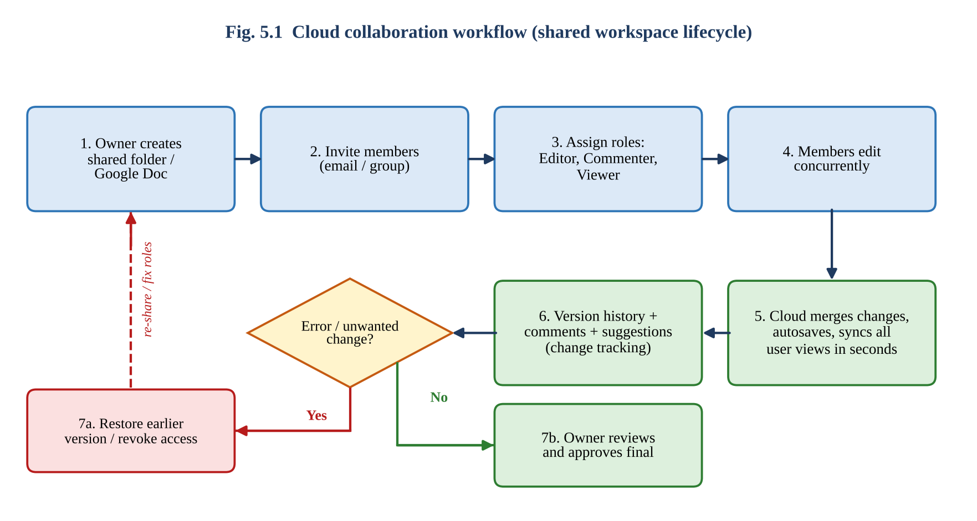
Figure 5.1: Collaboration workflow from workspace creation to approval

A.3 Explanation of key collaboration concepts
Concept | Meaning | How it works in Google Drive / Docs
Sharing | Giving other people controlled access to a resource | Invite by e-mail or group, or share a link with defined role; folder-level sharing is inherited by files.
Concurrent access | Several users working on the same file at the same time | Edits are sent to the server as small operations; operational transformation merges them so that all views converge; coloured cursors show who is editing.
Version control | Keeping history of changes so that earlier states can be viewed / restored | Version history stores named and automatic revisions with author and time; users can restore or copy a version. Suggesting mode tracks proposed changes until accepted.
Permission management | Defining who can do what | Roles Owner / Editor / Commenter / Viewer; options to stop editors from re-sharing; expiry dates; revoke access instantly.

A.4 Roles of different users
Role | Can do | Cannot do | Assigned to
Owner | Everything incl. delete, transfer ownership, manage access | — | Student A
Editor | Edit, comment, add files, (optionally) share | Delete the folder owned by another user; change owner | Student B
Commenter | View, comment, suggest edits | Directly edit text | Faculty
Viewer | View and download (if allowed) | Edit or comment | Not used (could be HoD / external examiner)

A.5 Justification of the selected permissions
- Least privilege: each person gets only the access needed; faculty reviews, so Commenter is sufficient.
- Restricted general access: a public link would let unknown people read or copy unpublished assignment work.
- Single owner: one accountable owner avoids orphan files; ownership can be transferred later.
- Editor for the partner: pair assignments require both students to modify content; Viewer would block contribution.

5.3 STUDENT B – COLLABORATIVE IMPLEMENTATION

B.1 Collaborative activities performed (minimum two required)
Note: Time stamps and observations are sample entries; replace them with your actual log and screenshots.

Activity | Time | User | What was done | Result observed
1. Concurrent editing | 10:05 | Student A | Typed the introduction of the log | Visible to B within about 1–2 s
 | 10:05 | Student B | Typed the observations paragraph in the same document | Both edits merged; no overwrite
2. Review through comment / suggestion | 10:20 | Student B | Added comment on A’s heading and suggested a wording change | A received e-mail notification and a comment badge
 | 10:25 | Student A | Accepted the suggestion and resolved the comment | Text updated; thread archived
3. Version control | 10:40 | Student B | Opened version history, compared two versions, restored previous paragraph | Earlier text recovered; new version logged

B.2 Permission / sharing settings demonstrated
Student B opened Share → Manage access, confirmed Student B = Editor, Faculty = Commenter, General access = Restricted, then tested: (i) the Faculty account could add a comment but not type into the document; (ii) a non-invited account saw ‘You need access’; (iii) changing Student B to Viewer made editing impossible, and restoring Editor re-enabled it.

B.3 How changes are reflected
Changes appeared in the other user’s browser in 1–2 seconds, with the editor’s name flag on the cursor; the ‘Saved to Drive’ indicator confirmed autosave. Opening the file later from the phone displayed the latest version, confirming a single master copy in the cloud.

B.4 Collaboration issue identified and solution
Issue | Cause | Solution applied / recommended
Both users edited the same sentence and one rewrote the other’s wording | Concurrent editing without section ownership | Use Suggesting mode for others’ text; assign sections; @mention to coordinate; recover with Version history; add a naming and editing convention.

5.4 CROSS-UNDERSTANDING

Student B explains: How does cloud collaboration reduce the need to exchange multiple copies of the same file?
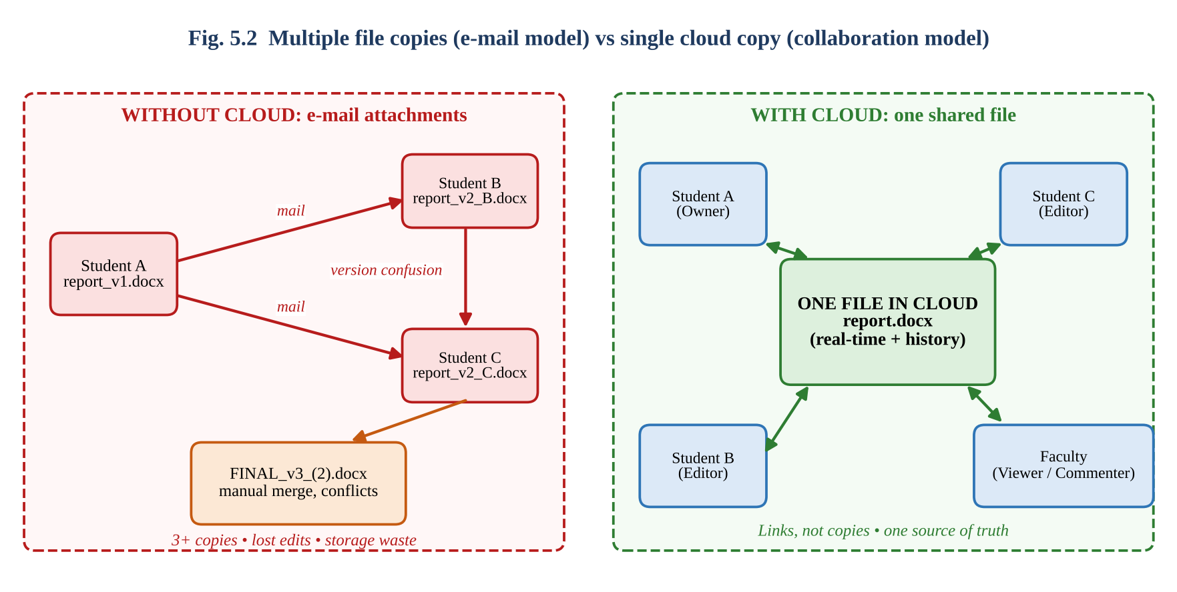
Figure 5.2: Multiple e-mail copies versus one shared cloud file
In the traditional method every change is sent as an attachment, so three people may hold report_v1, v2_B and v2_C and someone must manually merge them (FINAL_v3_(2).docx). With cloud collaboration the file stays in one place and people are given links with roles instead of copies. All edits are applied to the same master file, the version history preserves earlier states and permissions remain under the owner’s control. This eliminates version confusion, lost edits, storage waste and uncontrolled forwarding, and also reduces the time for merging.

Student A explains: What problems can occur if incorrect sharing permissions are given?
Incorrect setting | Problem | Prevention
Editor to everyone / ‘Anyone with link’ as Editor | Accidental deletion, tampering, vandalism, plagiarism of unpublished work | Restricted access; Commenter by default; review sharing regularly
Viewer given to a working partner | Partner cannot contribute; deadline delays | Assign Editor only to active contributors
‘Anyone with link’ Viewer on sensitive file | Confidential marks / personal data leak; link may be forwarded or indexed | Share with named accounts only; set expiry; disable download / copy for viewers
Editor allowed to re-share | Access spreads beyond owner’s knowledge | Disable ‘Editors can change permissions’
Ownership of an important file left with a leaving user | Files deleted when the account is removed; no admin control | Transfer ownership; use shared drives
Access never revoked after project ends | Former members still see data | Periodic access review; remove access at closure

Evidence summary (Task 5): Shared workspace ✔ Permission table and screenshots (to be inserted) ✔ Workflow (Fig. 5.1) ✔ Concept explanations ✔ Two or more collaborative activities with contribution log ✔ Issue and solution ✔ Cross-understanding answers (Fig. 5.2) ✔

TASK 6 – INTEGRATED CLOUD ACCESS AND COLLABORATION MINI INVESTIGATION (7 Marks)
Scenario chosen: Cloud-Based Assignment Submission and Evaluation (one of the suggested scenarios). It naturally needs cloud access (students and faculty log in from different places and devices) and cloud collaboration (pair work, faculty feedback, shared marks).

6.1 STUDENT A – SYSTEM DESIGN

A.1 Problem definition
In many colleges assignments are collected on paper or as e-mail attachments. This causes lost submissions, unclear deadlines, version confusion, delayed feedback, plagiarism disputes and extra work for faculty to consolidate marks. Problem statement: design a cloud-based system in which students submit assignments online before a deadline, faculty evaluate and comment on the same cloud copy, and marks and feedback are published securely to each student.

A.2 Users of the system
User | Needs | Access method | Permission level
Student (individual or pair) | Download question, submit report, co-edit with partner, view marks / feedback | Browser, mobile site / app | Own folder: Editor; others’ folders: none
Faculty | Create assignments, set deadline, review, comment, enter marks, export results | Browser (laptop), mobile for quick review | All submissions: Commenter; marks sheet: Editor
HoD / Admin | Monitor completion, moderate marks, manage accounts | Browser dashboard | Viewer / Admin
Plagiarism / LMS tool (system) | Fetch submissions automatically | API with service account | Read-only scoped token

A.3 Cloud access methods identified
- Browser (primary): college Google / Microsoft account login to the submission portal and Drive folders.
- Mobile access: responsive web form / Drive app for students uploading from phones.
- API access: service account used by scripts for deadline reminders, bulk download for plagiarism checking and marks export.

A.4 Required cloud services
Service | Purpose | Example product
Identity and access management | Login, MFA, roles (Student / Faculty / Admin) | Google Workspace for Education / Identity Platform
Web application and API hosting | Submission portal, validation logic | Cloud Run / App Engine or Google Forms + Apps Script
Object storage | Store submitted PDF / DOCX files | Cloud Storage / Google Drive
Database / spreadsheet | Student IDs, timestamps, marks, status | Firestore / Cloud SQL / Google Sheets
Collaboration services | Co-editing, comments, rubric sheet, version history | Google Docs, Sheets
Notification | E-mail / SMS confirmation and reminders | Cloud Functions + Gmail API / MailApp

A.5 System architecture
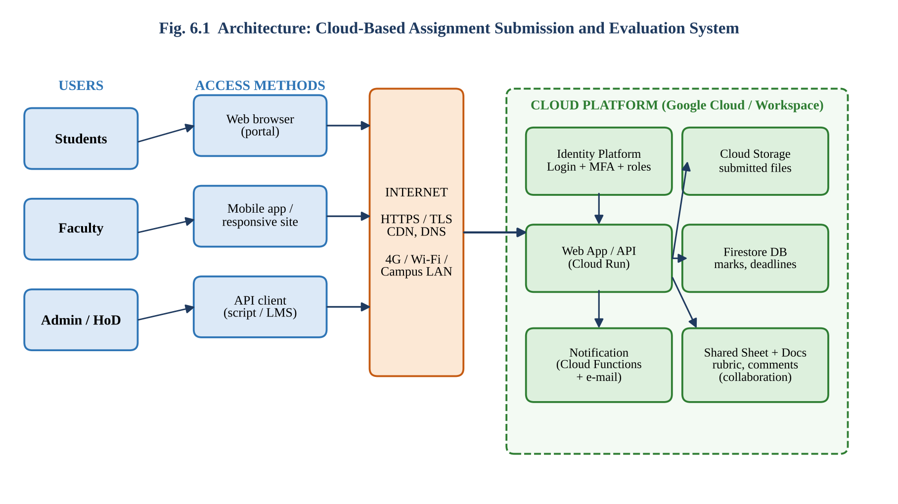
Figure 6.1: Architecture of the cloud-based assignment submission and evaluation system

A.6 How users access the system
- A user opens the portal link using a browser or mobile device connected to the Internet (HTTPS).
- The identity service authenticates the user (college account + MFA) and issues a session token carrying the user’s role.
- The web application / API checks the role (authorization) and shows only permitted pages: students see submission and marks; faculty see all submissions.
- Files are uploaded directly to cloud storage; metadata (roll number, time, status) is recorded in the database / sheet.
- Notifications are generated automatically and sent to the student and the faculty.

A.7 How users collaborate
- Student ↔ Student: pair partners co-edit the report in a shared Google Doc, with version history.
- Faculty → Student: faculty add comments and suggestions directly on the submitted document; students respond and resolve threads.
- Faculty ↔ Faculty / HoD: a shared marks sheet with rubric columns allows moderation; HoD has view-only access.
- System ↔ Users: automatic e-mails and status columns keep everyone informed.
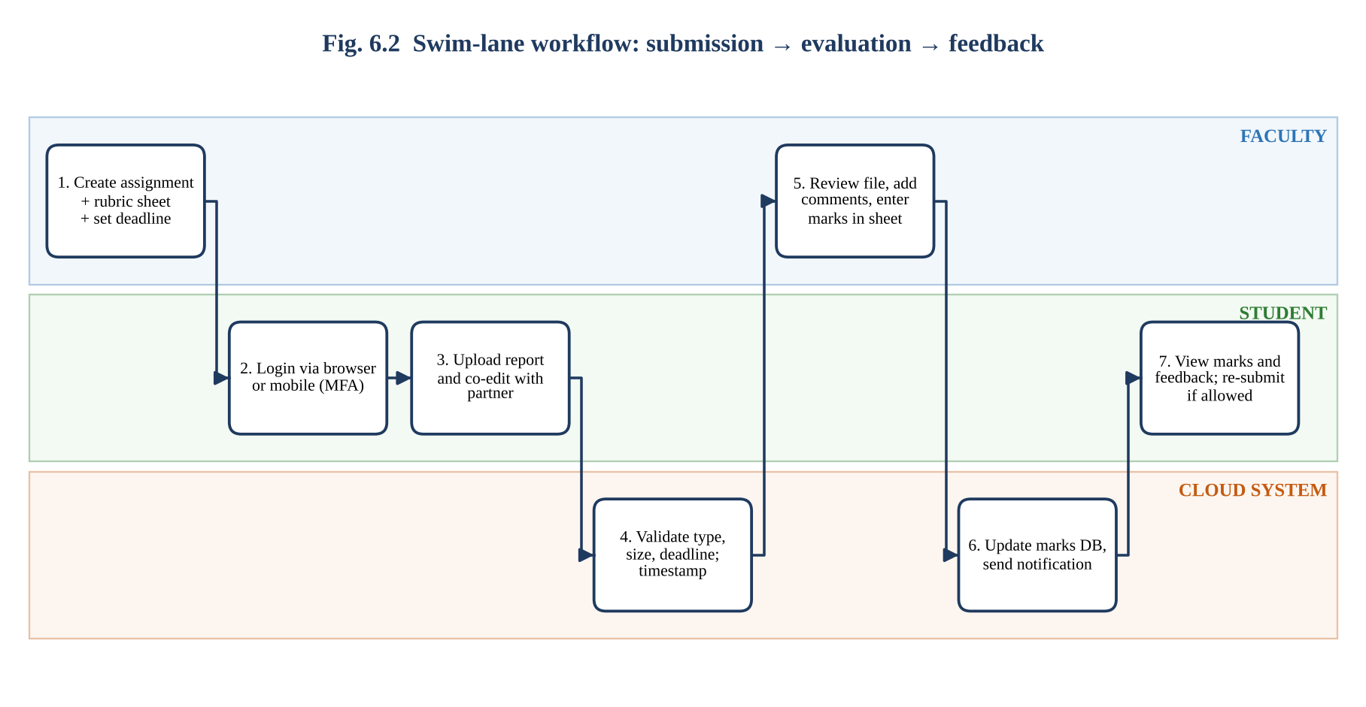
Figure 6.2: Workflow of submission, evaluation and feedback across faculty, student and cloud system

6.2 STUDENT B – EVIDENCE AND EVALUATION

B.1 Prototype / mock-up developed
A low-cost prototype was built using free Google Workspace services:
Component | Implementation | Cloud feature used
Submission form | Google Form ‘CO3 Assignment Submission’ with fields: Name, Register No., College e-mail (auto-collected), file upload (PDF ≤ 10 MB). Restricted to the organisation’s accounts | Authentication + cloud storage (uploads go to a Drive folder)
Submission store | Form responses sheet with auto time stamp and Drive links | Cloud spreadsheet as database
Evaluation sheet | Google Sheet ‘Marks_Rubric’ shared with faculty (Editor) and HoD (Viewer); columns: Reg. No., rubric criteria, total (formula), comments | Collaboration + permissions
Feedback | Faculty comment directly on the submitted Doc / PDF in Drive | Comments, notifications
Automation | Apps Script trigger sends confirmation e-mail on every submission | Script (API) access to Gmail

Apps Script used for the confirmation e-mail (attached to the form-response sheet):
function onFormSubmit(e) {
var name = e.namedValues['Student Name'][0];
var email = e.namedValues['College Email'][0];
MailApp.sendEmail(email, 'Assignment submission received',
'Dear ' + name + ', your assignment was received at ' + new Date());
}

B.2 Cloud access mechanism demonstrated
Access was demonstrated using browser login with the college Google account and 2-Step Verification, and then from a mobile phone through the same form link. A user without an organisation account was shown ‘You need permission’, proving that authentication controls the access.

B.3 Collaboration mechanism demonstrated
The faculty account added a comment on the submitted report and entered rubric marks in the shared sheet while the HoD account (Viewer) watched the totals update live; the student received the comment notification.
Screenshot 6.1: Google Form (submission portal) and Drive folder with uploaded filesScreenshot 6.3: Shared marks sheet with comments and sharing settings

B.4 Testing with two user scenarios
Note: Results are model observations; execute the same scenarios and record your own.

ID | User scenario | Steps | Expected result | Observed result | Status
S1 | Student submits from mobile on 4G before deadline | Open form link → login → attach 3 MB PDF → Submit | Success page; row added with time stamp; e-mail received | Success page in 6 s; row added; e-mail in under 1 minute | Pass
S2 | Faculty evaluates on laptop while HoD views | Open response sheet → open file → comment → enter marks | Marks and comment saved; HoD sees totals; HoD cannot edit | All as expected; HoD edit blocked (view-only) | Pass
S2a | Unauthorised / late access | Non-organisation account opens form; form closed after deadline | Access denied; ‘no longer accepting responses’ | Denied; closed message displayed | Pass

B.5 Analysis of results
Both user scenarios passed. Authentication prevented outsiders, role-based sharing prevented the HoD from editing, and the cloud copy meant that faculty comments and marks were visible immediately to authorised users. The student received confirmation, removing the usual ‘Did you get my file?’ enquiry. The mobile submission took longer on 4G than on Wi-Fi but completed successfully.
Measure (class of 60 students) | Manual / e-mail method | Cloud prototype
Collecting and organising files | ≈ 3 min × 60 = 180 min | ≈ 0 min (automatic folder + sheet)
Checking deadline compliance | Manual, error-prone | Automatic time stamp / form closing
Giving feedback | Printed or mailed, 5–7 days | Inline comments, 1–2 days
Consolidating marks | Re-typing into register (≈ 60 min) | Formula-based total; export to CSV in seconds
These time figures are estimates based on typical effort and should be replaced by measured values if available.

B.6 Limitations and improvements
Limitation | Improvement
Depends on Internet; large uploads fail on weak network | Resumable upload, retry guidance, offline draft in Docs
Google Form has limited file-size and storage quota | Move to Cloud Storage with signed URLs and a dedicated web app
No automatic plagiarism check | Integrate a plagiarism-detection API through the service account
Role control is simple (sharing-based) | Implement RBAC with Identity Platform and audit logging
Privacy: files stored with a third-party provider | Use institutional tenant, region restriction, retention policy

6.3 JOINT EVALUATION
Question: How does combining cloud access and cloud collaboration improve the efficiency of the proposed system?
Factor | Cloud access alone | Cloud collaboration alone | Combined effect
Time | Anyone can submit from anywhere | Faster review on the same file | Submission → review → feedback in one continuous cloud flow; no transfer delays
Accuracy | Time-stamped, authenticated submissions | Single master copy, version history | No lost or duplicate files; clear record of who changed what
Cost | No travel / paper submission | No printing or merging of copies | Reduced administrative effort and cost
Transparency | Students see status anytime | Comments visible to all permitted users | Both sides always have current information
Scalability | Handles 60 or 6000 users | Many reviewers at once | System grows without redesign

Evidence summary (Task 6): Scenario and problem ✔ Users, access methods and services ✔ Architecture (Fig. 6.1) and workflow (Fig. 6.2) ✔ Prototype description ✔ Screenshots (to be inserted) ✔ Two user tests ✔ Result analysis ✔ Limitations and improvements ✔ Joint evaluation ✔

TASK 7 – DAY-4 DESIGN CHALLENGE: DESIGN A CLOUD-BASED COLLABORATIVE SOLUTION (10 Marks)
Collaboration statement: this task was solved jointly; the two initial proposals in Stage 1 were written independently before any discussion and are retained as evidence. The problem area chosen by the pair is placement (campus recruitment) coordination.
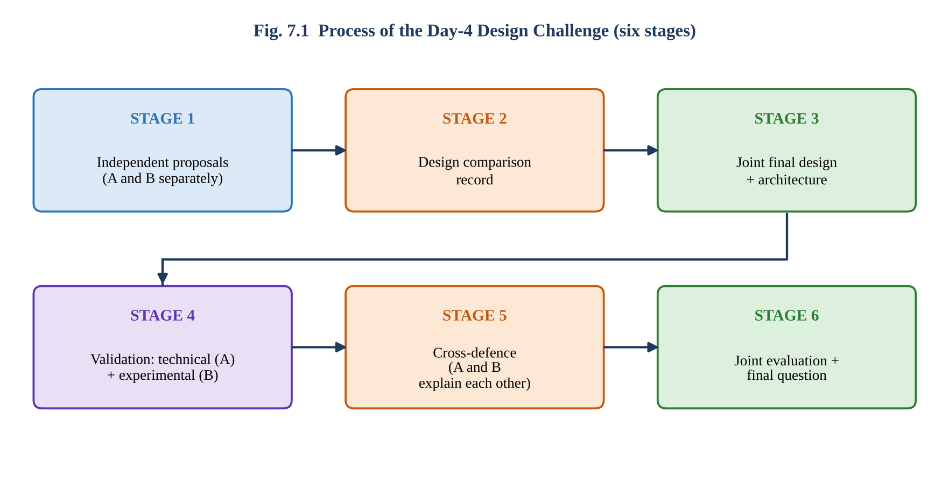
Figure 7.1: Six stages of the design challenge

STAGE 1 – INDEPENDENT DESIGN PROPOSALS
Element | Student A – initial proposal | Student B – initial proposal
Problem definition | Placement drive details, eligible lists and student resumes are scattered across WhatsApp, e-mail and paper, causing missed drives and duplicate work. | Students miss real-time placement alerts and cannot track the status of their applications; the placement office cannot see all statuses.
Target users | Students, Training & Placement Officer (TPO), faculty coordinators | Students, TPO, recruiters (company HR)
Cloud access method | Browser (laptop / mobile) through college Google accounts | Native Android mobile app with login; admin web dashboard
Required cloud services | Google Workspace: Drive, Forms, Sheets, Gmail, Groups | Firebase: Authentication, Firestore database, Cloud Storage, Cloud Messaging
Collaboration mechanism | Shared Sheets for drive lists; Docs comments; shared Drive folders per company | Real-time database sync; in-app status updates and chat with TPO
Basic architecture | Users → Browser → Internet → Google Workspace (Forms/Sheets/Drive) → Shared Drive | Users → Mobile app → Internet → Firebase (Auth, Firestore, Storage) → Push notifications

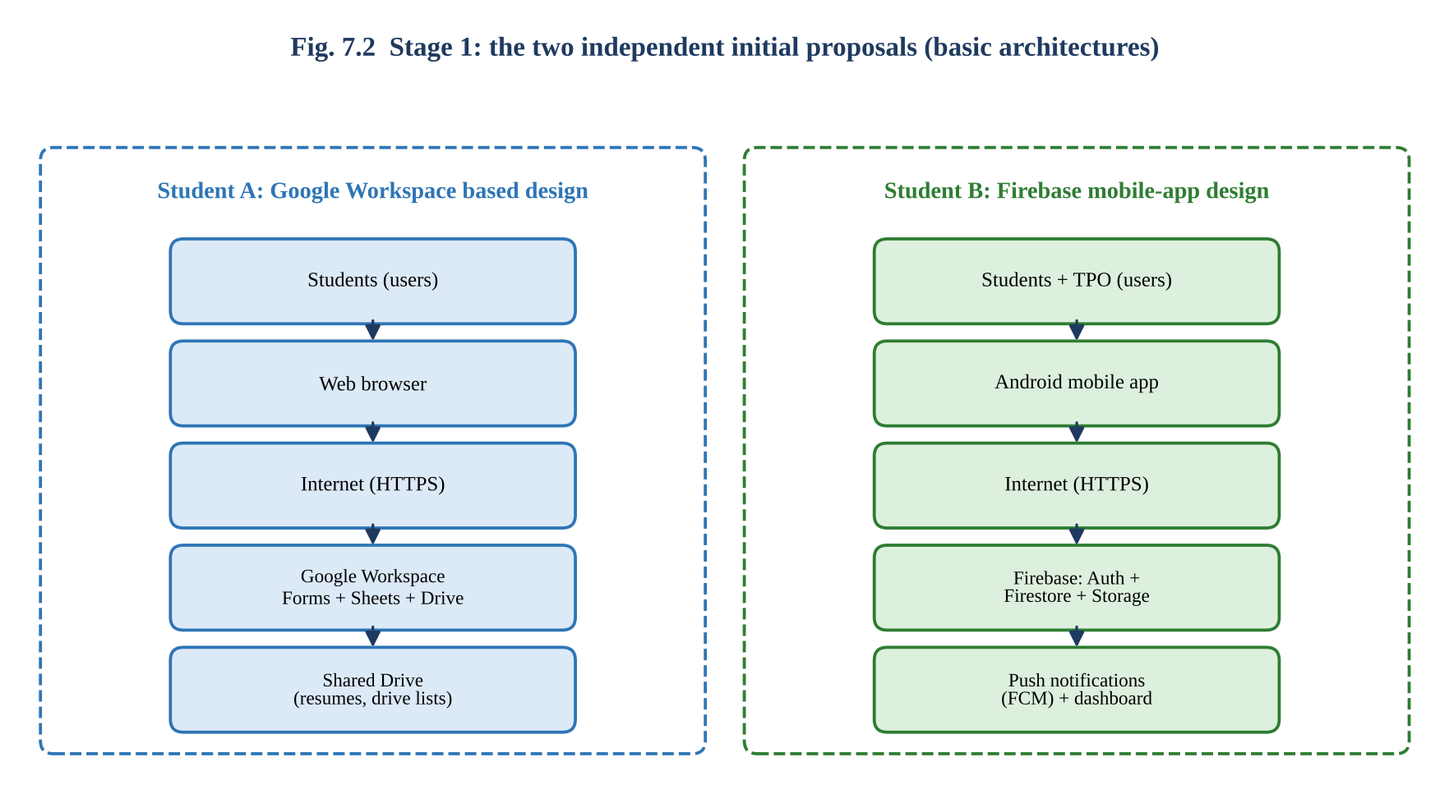
Figure 7.2: Basic architectures of the two independent proposals
Evidence retention: Attach the original handwritten / typed proposals of Student A and Student B (with date and time) as Annexure 7-A and 7-B.

STAGE 2 – DESIGN COMPARISON RECORD
Aspect | Student A design | Student B design | Agree / Differ | Decision for joint design
Problem | Information scattered | Missed alerts, no status tracking | Agree (same domain) | Combine: centralised information + real-time status
Users | Students, TPO, faculty | Students, TPO, recruiters | Partly differ | Include all four incl. recruiters and faculty / admin
Access method | Browser | Mobile app | Differ | Responsive web app (PWA) + mobile + API for recruiters
Cloud services | Workspace (low code) | Firebase (code-based) | Differ | Hybrid: managed identity and storage + Docs/Sheets for coordination
Collaboration | Shared documents and sheets | In-app updates and chat | Differ | Keep shared Sheets / Docs for TPO team; in-app notifications for students
Security | Domain accounts only; no fine roles | Auth + rules but public sign-up risk | Both incomplete | College SSO + MFA + RBAC + audit logs
Accessibility | Works on any device, needs Internet | Mobile only; no desktop | Differ | Browser and mobile; low-bandwidth friendly
Scalability | Limited (quota) | High (auto-scale) | Differ | Use auto-scaled back-end

Strengths and weaknesses
 | Strengths | Weaknesses
Design A | Quick to build; familiar tools; very low cost; strong document collaboration; no coding | Limited automation and scalability; weak role control; manual notifications; no recruiter API
Design B | Real-time updates; push notifications; scalable; good mobile experience | Needs development skill; no desktop UI; weak document collaboration; security rules to be designed; cost grows with usage

Missing components identified (absent from both proposals)
- Role-based authorization and audit logs; backup and disaster recovery plan.
- API interface for recruiters / ERP; analytics dashboard (placement statistics).
- Offline / low-bandwidth handling; privacy policy and consent for resume data.
Ideas retained: from A – shared Sheets / Docs for coordination and low-cost start; from B – mobile access, push notifications and auto-scaling database. New ideas added: SSO + MFA, RBAC, API gateway, audit logging.

STAGE 3 – JOINT FINAL DESIGN
Final solution: Cloud-Based College Placement Coordination Platform (CPCP).
Design element | Decision
Problem | Centralise placement information, applications, resumes and coordination; give real-time status to all stakeholders; reduce manual work and missed opportunities.
Users | Students (approx. 1500), Placement Officer / Team, Recruiters, Faculty coordinators / Admin.
Cloud access method | Browser / PWA (primary), mobile app or PWA on phone, REST API for recruiters and ERP.
Network requirements | Internet via campus Wi-Fi, broadband or 4G/5G; HTTPS only; minimum 2 Mbps; CDN for static content; graceful behaviour on poor networks.
Cloud service / platform | Google Cloud Platform + Google Workspace for Education: Identity Platform, Cloud Run, API Gateway, Cloud Functions, Cloud Storage, Firestore / Cloud SQL, Docs, Sheets.
Web application / API requirement | Web app for students and TPO; REST API (e.g., GET /drives, POST /applications, GET /drives/{id}/applicants) secured with OAuth 2.0 tokens and scopes.
Collaboration mechanism | Shared Docs / Sheets for TPO team and faculty coordinators; comments and @mentions; in-app status and e-mail / push notifications; version history.
Authentication / security | College SSO, MFA, RBAC (Student / TPO / Recruiter / Admin), TLS 1.3, encryption at rest, WAF, rate limiting, audit logs, least privilege.
Data / resource sharing | See sharing matrix below; resumes visible only to the TPO and to recruiters of applied drives.
System workflow | See workflow steps below.

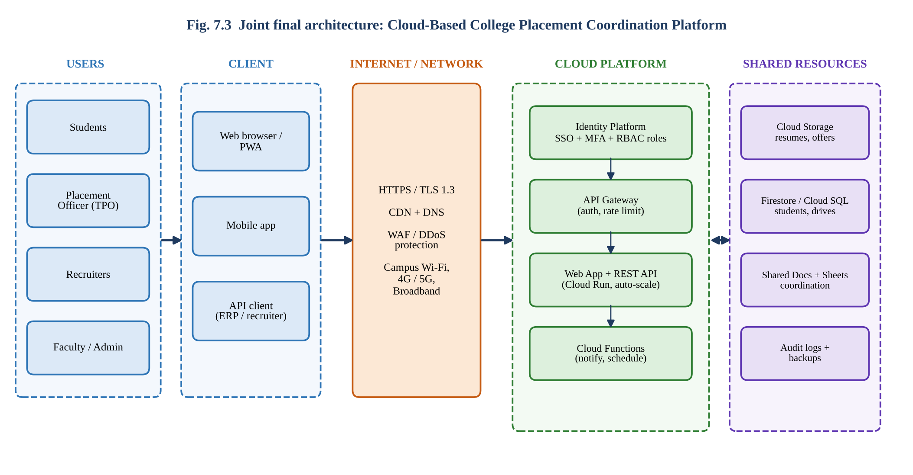
Figure 7.3: Architecture Users → Client → Internet/Network → Cloud Platform → Application/API → Shared Resources

Data / resource sharing matrix (R = read, W = write, C = comment, — = no access)
Resource | Student | TPO | Recruiter | Faculty / Admin
Own profile + resume | R / W | R | R (only if applied) | R
Drive announcements | R | R / W | R / W (own drive) | R
Application status | R (own) | R / W | R (own drive) | R
Coordination sheet / notes | — | R / W | — | R / C
Audit logs | — | R | — | R

Complete system workflow
- User opens the web / mobile app → redirected to college SSO → login with password + MFA → token issued with role.
- TPO creates a drive (company, eligibility, date, form) → stored in the database → Cloud Function notifies eligible students.
- Student views drive, updates profile / resume (uploaded to Cloud Storage over TLS) and clicks Apply.
- System validates eligibility and deadline; application stored; status = Applied; TPO sheet updates automatically.
- Recruiter uses the secured API or recruiter page to view applicants of own drive and posts shortlist / results.
- TPO and faculty coordinators collaborate on interview schedule in the shared Sheet / Doc with comments.
- Students receive push / e-mail updates; status changes to Shortlisted / Selected / Rejected; audit log records each change.
- TPO downloads reports and analytics; data retained or archived per policy.

STAGE 4 – VALIDATION

Student A – Technical validation
Item | Technical explanation / justification
Cloud access method | Browser / PWA works on every device without installation, giving the widest access for 1500 students; the mobile experience is delivered by the same responsive app. API access is reserved for recruiters and systems that need automation. All use HTTPS with token authentication.
Platform / service selection | Google Cloud + Workspace was chosen because the college already uses Google accounts (SSO, no new credentials), Docs/Sheets give mature collaboration, Cloud Run auto-scales for peak days, and a free / education tier keeps cost low. Alternative Azure was acceptable but would require a second identity system; a pure Firebase approach lacks document collaboration.
System architecture | Users reach the client, traffic crosses the Internet through CDN and WAF, the API gateway authenticates and rate-limits, the application tier on Cloud Run implements business rules, Cloud Functions send notifications, and data is stored in Firestore / Cloud Storage with Docs/Sheets for team coordination (Fig. 7.3).
Web / API access | Students and TPO use the web app; recruiters call REST endpoints with OAuth 2.0 bearer tokens limited by scope (read applicants of own drive only). The API returns JSON and status codes (200, 401, 403, 404) as studied in Task 3.

Suitability analysis of the design (non-functional requirements)
Requirement | Target | How the design satisfies it | Rating
Availability | ≥ 99.9 % | Managed multi-zone services; load balancing | High
Scalability | Peak 1500 users in 10 min | Auto-scaling Cloud Run and database | High
Security | Role-based, encrypted | SSO + MFA, RBAC, TLS, audit | High
Usability | No training | Familiar Google UI; responsive design | Medium-High
Cost | Low for a college | Pay-per-use + education tier | Medium-High
Offline tolerance | Basic | Local draft, retry; limited offline | Medium (improvement needed)

Student B – Experimental validation
Note: The table presents the test design and sample observations. Execute the tests on your prototype and replace the Observed column with real results and screenshots.

TC | Test case / user and condition | Expected behaviour | Observed behaviour | Result
1 | Student logs in from laptop on Wi-Fi with MFA | Dashboard displayed after MFA | Dashboard in ~2 s | Pass
2 | Student logs in from Android phone on 4G | Dashboard within 5 s | Dashboard in ~4 s | Pass
3 | Student uploads 2 MB resume PDF | File stored and listed in My Resume | Uploaded in ~3 s; visible | Pass
4 | TPO creates a new drive | Visible to eligible students; notification e-mail within 1 min | Visible instantly; e-mail in ~40 s | Pass
5 | Student applies to the drive | Status = Applied; TPO sheet updates | Updated within ~2 s | Pass
6 | Recruiter calls GET /drives/{id}/applicants with valid token | 200 OK with JSON list | 200 OK, JSON returned | Pass
7 | Recruiter requests another company’s drive | 403 Forbidden | 403 Forbidden | Pass
8 | Unauthenticated user opens resume link | Redirect to login (401) | Redirected to login | Pass
9 | Two TPO members edit the schedule sheet at once | Both edits merged; history kept | Merged; both visible in history | Pass
10 | Internet lost while uploading resume | Upload retries automatically when network returns | Upload failed; manual retry needed | Partial

Screenshot 7.2: API test (200 OK / 403 Forbidden) and shared coordination sheet with two editors
Comparison of expected and observed behaviour: 9 of 10 test cases (90 %) matched expectations. The only deviation (TC 10) shows that the prototype depends on a continuous connection during upload. Corrective action: implement resumable uploads and a local retry queue, and show a clear ‘connection lost – will resume’ message.

STAGE 5 – CROSS-DEFENCE
Question | Defence answer
Student A: What experimental evidence supports the group’s cloud design? | Test cases 1–2 show access from laptop and mobile within 2–4 s, supporting the browser/PWA choice. TC 3–5 confirm the end-to-end placement workflow with real-time status updates. TC 6–8 show that authentication and authorization work (200 vs 403 / 401). TC 9 proves safe concurrent collaboration. TC 10 revealed a weakness under network failure and led to a defined improvement, so the evidence both supports the design and shows where it must be strengthened.
Student B: Why was the selected cloud access and collaboration approach chosen? | Placement coordination involves many users at different locations and devices, so browser/mobile access over the Internet is essential. The team needs shared, always-current schedules and lists, so cloud collaboration (shared Sheets / Docs, notifications) removes duplicate files and message chains. The approach combines Student A’s low-cost collaboration with Student B’s real-time mobile features, uses the college’s existing identity system and is secured with MFA and RBAC.

STAGE 6 – JOINT EVALUATION
Aspect | Evaluation
Benefits of the proposed cloud solution | Single source of truth; anywhere / any device access; real-time status; reduced manual coordination; automated notifications; lower infrastructure cost; scalable on peak days; audit trail.
Access-related limitations | Requires Internet; poor connectivity slows or fails uploads; mobile data cost; users without accounts cannot access; browser compatibility.
Collaboration benefits | Simultaneous editing of schedules, comments with @mentions, version history, fewer e-mail attachments, transparent responsibilities.
Security risks | Phishing and account takeover, over-shared resumes (personal data), misconfigured roles, API abuse by recruiters, third-party data custody and legal compliance.
Scalability considerations | Auto-scaling handles 1500 simultaneous users; database indexes and quotas must be planned; CDN reduces load; cost monitoring and budgets avoid surprise bills.
Possible improvements | Resumable uploads and offline queue; analytics dashboard; AI-based resume screening (with consent); multi-region backup; automated access reviews; accessibility features (screen-reader, local language).
Situations where the approach may not be appropriate | Locations with no or very unreliable Internet; highly confidential data prohibited from leaving the premises; very small groups for which a spreadsheet suffices; ultra-low-latency or hard real-time systems.

Final Question
What characteristics should a system designer consider before selecting cloud-based access and collaboration for a real-world application?
Characteristic | Key questions a designer should ask
User base and location | How many users? Where are they? On which devices? Do they need 24 × 7 access?
Connectivity | Is Internet reliable and fast enough? Is offline operation needed? What is the cost of data?
Collaboration need | Do several users edit or share the same data? Is real-time updating essential? Who needs which role?
Security and privacy | How sensitive is the data? Which laws apply (IT Act, DPDP, GDPR)? Is MFA / encryption / audit needed?
Reliability and availability | What downtime is acceptable? Is provider SLA sufficient? Is backup and disaster recovery included?
Scalability and performance | Are loads predictable or bursty? What latency is acceptable?
Cost model | Capital vs pay-per-use; total cost of ownership; hidden costs (egress, storage growth).
Integration | Does the system need APIs to connect to existing applications? Are open standards supported?
Vendor dependence | Risk of lock-in; data portability and exit strategy.
Skills and maintenance | Do the team and users have skills? Who operates and supports the solution?
Data governance | Where is data stored; who owns it; retention and deletion policy?
Usability and accessibility | Is the interface simple, multilingual and accessible to all users?

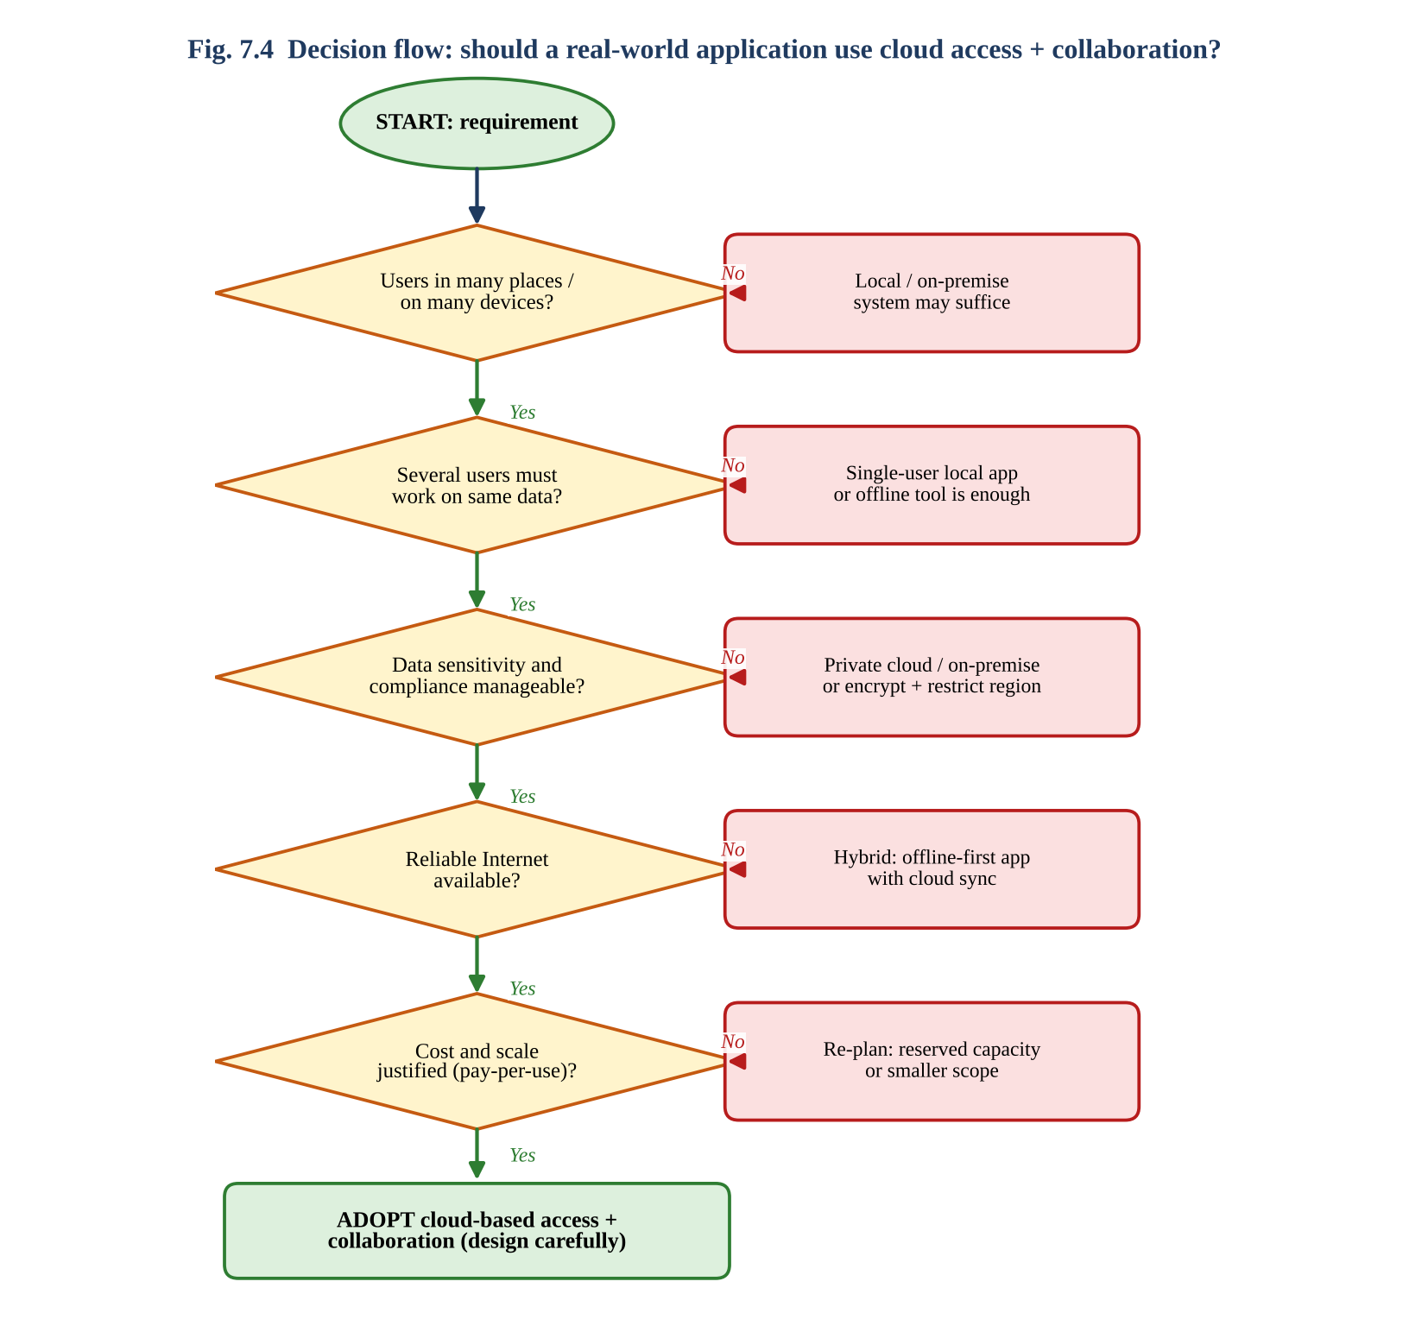
Figure 7.4: Decision flow for selecting cloud-based access and collaboration
Evidence summary (Task 7): Two independent proposals (Annexure 7-A / 7-B) ✔ Design comparison record ✔ Joint design and architecture (Fig. 7.3) ✔ Test cases and expected-vs-observed comparison ✔ Cross-defence ✔ Joint evaluation ✔ Final question answered ✔

CONTRIBUTION RECORD
The record below reflects the planned division of primary work. Both students are accountable for the complete assignment; edit it to match the actual work completed.
Question | Student A – Primary Contribution | Student B – Primary Contribution | Joint Work
Q1 | Access-method classification, Client→Network→Cloud diagram, requirements, justification matrix | Practical Drive access (browser / mobile / API), screenshots, multi-device observations, limitation | Selection of Google Drive; comparison table; cross-verification
Q2 | Platform components, request-to-service mapping, interaction diagram | Google Docs demonstration, user-action sequence, evidence, benefits | Two-platform selection, comparative observation, local vs cloud evaluation
Q3 | API purpose, request/response components, flow diagram, roles | Python client, execution of four requests, screenshots, result analysis | API selection, concept study, joint analysis on scalability
Q4 | Security investigation: TOTP / 2-step demo, secure vs insecure comparison, impact of poor practice | Security design: six considerations, secure-flow diagram, attack points and measures | Threat identification, additional-measures evaluation
Q5 | Collaboration design, workflow, roles, permission justification, incorrect-permission answer | Collaborative edits, permission demonstration, issue and solution, copies answer | Workspace creation, sharing configuration, process record
Q6 | Problem, users, services, architecture, access and collaboration explanation | Prototype, two user tests, result analysis, limitations | Scenario choice, joint evaluation of efficiency
Q7 | Proposal A, technical validation, defence of experimental evidence | Proposal B, test cases and observations, defence of design choice | Comparison record, joint design, joint evaluation, final question

INDIVIDUAL VERIFICATION – PREPARED VIVA ANSWERS
Each student should be able to answer any of the following, irrespective of who prepared the section.

Transfer questions (modified scenarios)
Question | Model reasoning
If Internet connectivity becomes unreliable, how would it affect cloud access? | Every request to a cloud service needs the network, so pages load slowly, uploads stall or fail and real-time collaboration stops. Autosaved data is safe in the cloud but unsynchronised local changes may conflict later. Remedies: offline mode / local cache, resumable uploads, retry with back-off, hybrid design, choosing a nearer region or CDN.
If a shared cloud document is given editing permission to everyone, what problems could occur? | Accidental or malicious deletion, tampering with content, plagiarism, leakage of private data, conflicting edits, no accountability about who changed what, and the owner losing control. Fix: least-privilege roles, restricted access, Suggesting mode, version history and periodic access review.
If the API becomes unavailable, how would your application behave? | The Python client catches the connection or timeout exception, prints a clear error and returns None, so it does not crash. A robust design would retry with exponential back-off, use cached data, show a friendly message and log the incident; the provider SLA, status page and failover region should also be considered.
If a user is authenticated but does not have permission to access a resource, what should happen? | The authorization layer must deny the request with 403 Forbidden (not 401), reveal no data, write an audit-log entry and optionally alert administrators. This is deny-by-default and least privilege in action; the user may request access through an approval workflow.

Typical primary and partner questions
Component | Sample question | Short answer
Q1 | Why is HTTPS needed even for a simple Drive upload? | To encrypt data and authenticate the server over an untrusted network.
Q2 | Which part of the request path distributes load across servers? | The load balancer (Cloud Load Balancing / Azure Load Balancer).
Q3 | Difference between 401 and 404? | 401 means authentication is missing / invalid; 404 means the resource does not exist.
Q4 | Why is a TOTP code valid only for 30 seconds? | Limits replay attacks; server and app derive the code from a shared secret and the current time window.
Q5 | How does Google Docs keep two simultaneous edits consistent? | Edits are sent as operations and merged by operational transformation on the server.
Q6 | Which part of Task 6 is cloud access and which is collaboration? | Login, form submission and API scripts are access; shared marks sheet, comments and co-editing are collaboration.
Q7 | Which test case exposed a design weakness, and what was changed? | TC 10 (network loss during upload) → resumable upload and retry queue.

OBE EVIDENCE MAPPING AND SUBMISSION CHECKLIST
CO3 Component | Assignment evidence | Where in this answer sheet
Build methods to access cloud | Q1, Q2, Q3 | Fig. 1.1, 1.2, 2.1, 3.1; access tables
Access through platforms / web applications | Q2 | Platform comparison, Fig. 2.1, 2.2
Programmatic / API-based access | Q3 | Python client, four request/response outputs
Secure cloud access | Q4 | Fig. 4.1, 4.2; TOTP program; threat table
Collaboration within cloud | Q5 | Workspace, permissions, Fig. 5.1, 5.2
Apply cloud access + collaboration | Q6 | Architecture, prototype, two user tests
Design and evaluate a cloud solution | Q7 | Proposals, comparison, final design, validation, evaluation
Individual attainment | Viva + contribution record | Contribution Record and Viva sections
Practical evidence | Screenshots, programs, observations, test results | Screenshot boxes, code listings, test tables
Higher-order learning | Design, analysis, evaluation and transfer questions | Weighted matrices, risk analysis, decision flow (Fig. 7.4)

Submission checklist (student self-check)
Requirement | Status
All 7 questions answered | ☑ Yes ☐ Partly ☐ No
Cloud access methods explained | ☑ Yes ☐ Partly ☐ No
Cloud architecture diagrams included | ☑ Yes ☐ Partly ☐ No
Two cloud platforms compared | ☑ Yes ☐ Partly ☐ No
Web API program and testing completed | ☐ Yes ☑ Partly (run and attach screenshots) ☐ No
Cloud security explained | ☑ Yes ☐ Partly ☐ No
Cloud collaboration demonstrated | ☐ Yes ☑ Partly (insert screenshots) ☐ No
Mini-project completed and tested | ☐ Yes ☑ Partly (insert screenshots / own results) ☐ No
Day-4 design challenge completed | ☑ Yes ☐ Partly ☐ No
Student A and B contributions recorded | ☑ Yes ☐ Partly ☐ No
Screenshots and practical evidence attached | ☐ Yes ☑ Partly (to be inserted) ☐ No
Viva recommended | ☐ Yes ☐ No (faculty to decide)

_______________  Student A Signature | _______________  Student B Signature | _______________  Faculty Signature

