CSA04 – OPERATING SYSTEMS
ASSIGNMENT 1 – ANSWER SHEET (CO1)
Evaluate and Justify the Operating-System Design of a Smart Hospital
Field | Details (fill in before submission)
Student name | K N RITHEESH
Register number | 192572097
Bloom's level | K5 – Evaluate (all tasks)

Contents of this answer sheet
Section | Title | Marks
Overview | Scenario summary, proposed architecture, OS decision flowchart | –
Task 1 | Requirements of each computing environment (ranking table, conflicts, history, single-OS alternative) | 4
Task 2 | Types of operating systems (SMP vs AMP, cluster fail-over, single-machine alternative) | 3
Task 3 | Operating-system structures (monolithic, layered, microkernel, modular, hybrid) | 4
Task 4 | Operating-system services (service table, protection of records, desktop-OS-on-tablet alternative) | 4
Task 5 | System calls (categories, read() flow, parameter passing, strace, stdio alternative) | 4
Task 6 | Cost of system calls (completed code, measured buffer sizes, mmap alternative) | 4
Task 7 | Process control (completed code, zombie/orphan, flush experiment, posix_spawn/threads) | 4
Task 8 | CPU states and protection (modes, interrupts, polling alternative) | 3
Task 9 | Memory hierarchy and I/O (placement plan, DMA vs interrupts) | 4
Task 10 | Measure and compare (system-call counts, user/kernel time, fork vs thread) | 4
Task 11 | Final recommendation and defence (plan, risks, scaling, virtual-machine alternative) | 4
Task 12 | Day-4 Design Challenge: impact, evaluation, adaptation, defence | 8
Appendices | Source code list, README template, commit plan | –

Scenario Summary and Proposed Architecture
A 500-bed hospital needs five kinds of computing environment: bedside monitors (alarm within 10 ms), nurse tablets, doctor workstations, a database server that must never stop, an imaging server that processes MRI scans on many processors, and a link to two partner hospitals. The IT team proposed one general-purpose OS everywhere; clinicians fear delayed alarms, database downtime during updates and short tablet battery life. This report evaluates each environment and defends a different OS for each.
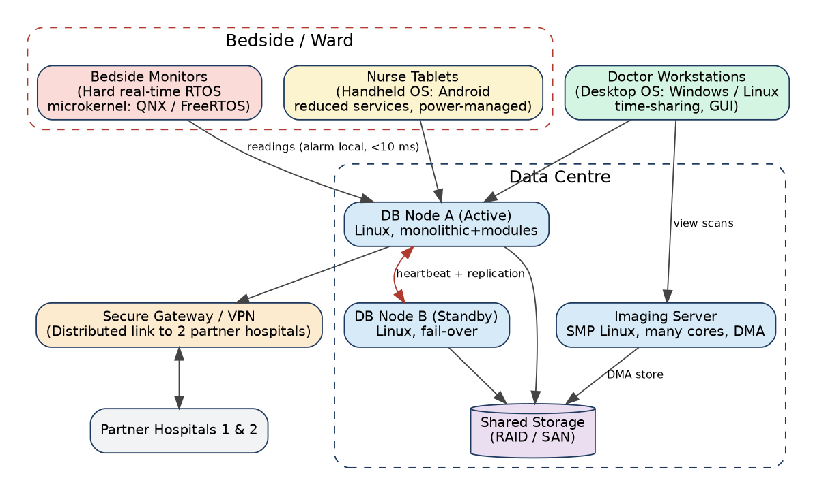
Figure 1 – Proposed OS plan for the hospital (colour = OS family)
Environment | Chosen OS type | Chosen structure | One-line reason
Bedside monitors | Hard real-time OS (RTOS) | Microkernel (QNX / FreeRTOS) | Guaranteed < 10 ms alarm; faulty driver cannot crash the kernel
Nurse tablets | Handheld OS (Android) | Modular/monolithic Linux kernel, reduced services | Battery life, touch UI, wireless
Doctor workstations | Desktop OS (Windows/Linux) | Hybrid / modular | Interactive time-sharing, many applications
Database server | Clustered, fail-over | Monolithic + loadable modules (Linux) | 24×7 availability, high I/O throughput
Imaging server | SMP multiprocessor | Monolithic + modules (Linux) | All cores run kernel and share memory for MRI processing
Partner link | Distributed system | Network services over secure VPN/TLS | Share records across 3 hospitals without a single owner

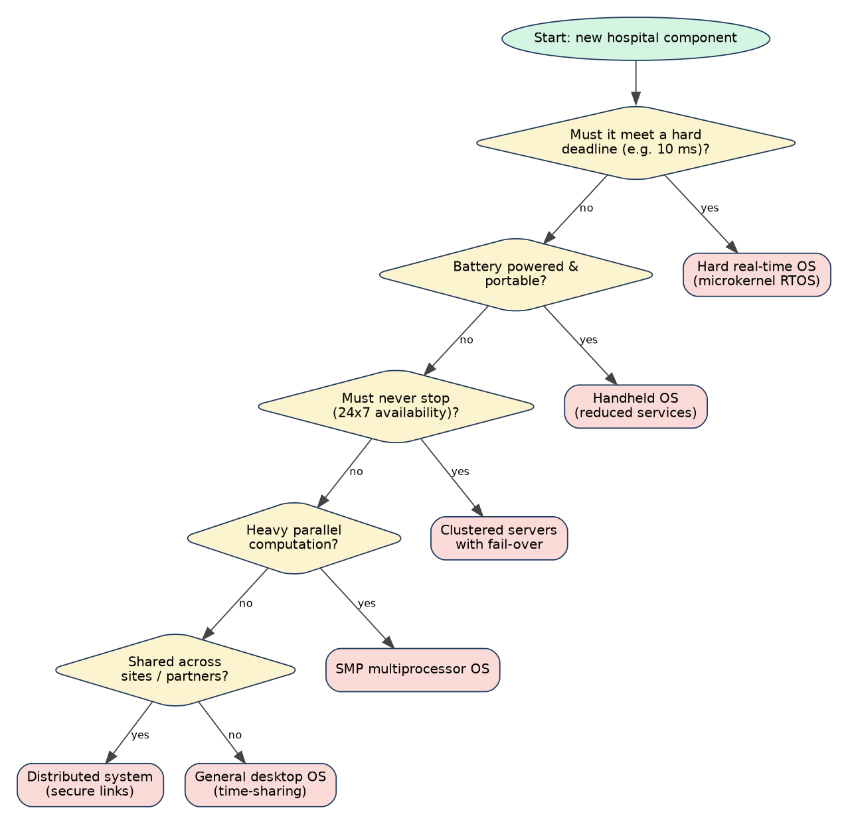
Figure 2 – Decision flowchart used to choose the OS type for every component

TASK 1 – Evaluate the Requirements of Each Computing Environment (4 Marks)

1.1 Requirement ranking for every environment
Each requirement is ranked 1 (most important) to 5 (least important). The ranking is justified in the table below the ranking.
Environment | Response time | Reliability | Throughput | Battery / power | Security
Bedside monitor | 1 (hard 10 ms deadline) | 2 (must run continuously) | 5 (few sensor samples) | 4 (mains + battery backup) | 3 (patient data in transit)
Nurse tablet | 3 (smooth touch UI) | 4 | 5 | 1 (must last a shift) | 2 (carries patient data, can be lost)
Doctor workstation | 3 (interactive) | 4 | 2 (many programs) | 5 (mains powered) | 1 (access to all records)
Database server | 3 (fast queries) | 1 (never stops) | 2 (thousands of transactions) | 5 | 1/2 (all records)
Imaging server | 4 | 3 | 1 (MRI = huge data/CPU) | 5 | 2
Partner link | 4 (seconds acceptable) | 3 | 4 | 5 | 1 (cross-organisation data)

Justification of the rankings
- Monitor – response time first: the requirement says an abnormal reading must raise an alarm within 10 ms. A missed deadline is a patient-safety failure, so timeliness outranks even throughput or features. Reliability is second because a crashed monitor is a silent monitor.
- Tablet – battery first: a tablet that dies mid-shift is useless; every service and background process costs energy. Security is second because tablets are portable and easily lost.
- Workstation – security first: doctors read and write any patient record; confidentiality and audit matter more than raw speed. Throughput is second because many applications run together (time-sharing).
- Database – reliability first: records must survive crashes, updates and disk failures; downtime stops treatment. Security shares first place because the database is the most valuable target.
- Imaging – throughput first: one MRI study is hundreds of MB and is processed in parallel; completion time per scan is the measure of success.
- Partner link – security first: data leaves the hospital; authentication, encryption and integrity are mandatory, while a delay of a second is harmless.

1.2 Conflicting requirements
Conflict | Why they clash | Resolution in this design
Fast response vs many users on one machine | Time-sharing switches between users; each switch and cache refill adds delay, and a busy system cannot promise a deadline | Do not share the monitor: it runs only a few real-time tasks on an RTOS
Throughput vs response time | Large batches (MRI) keep CPUs busy and delay short jobs | Separate imaging server from the monitoring path
Security vs performance/battery | Encryption, checks and logging use CPU time and energy | Hardware crypto on tablets; full protection on servers
Reliability vs easy updating | Patching needs restarts | Cluster fail-over: update node B, switch over, update node A
Rich features vs small/fast kernel | Every extra service adds code, memory and bugs | Minimal OS on monitors, full OS on workstations

1.3 Requirements critical to patient safety
- Alarm deadline (10 ms) on monitors – direct risk to life if missed.
- Database availability and integrity – wrong drug/allergy information or an unavailable record causes harm.
- Access control and audit – a patient's record must not be altered or leaked by unauthorised programs.
- Monitor isolation – a driver or application fault must not stop the alarm.
Tablet battery and MRI speed matter for efficiency, but their failure is recoverable (charge, re-run), so they are important rather than safety-critical.

1.4 Lessons from the history of operating systems
Generation | Key idea | Hospital environment where the lesson applies
Batch systems (1950s–60s) | Jobs run without user interaction; maximise CPU use | MRI image processing and nightly backups are batch jobs on the imaging/database servers
Time-sharing / multi-programming (1960s–70s) | Many users share one CPU by rapid switching; protection between users | Doctor workstations and the database server (many concurrent users, file protection)
Personal computers (1980s) | One user, responsive GUI, low cost | Doctor desktop workstations
Real-time systems | Correctness depends on meeting deadlines | Bedside monitors
Distributed / cluster systems (1990s) | Many machines cooperate; fail-over | Database cluster, partner-hospital link
Mobile / handheld (2000s–) | Power management, touch, wireless, app sandboxing | Nurse tablets

1.5 Alternative Concept and Complexity Analysis – one general-purpose OS everywhere
What the solution would be: install one OS (e.g. a standard Linux or Windows) on monitors, tablets, workstations and servers. All devices share one image, one patch process and one set of tools.
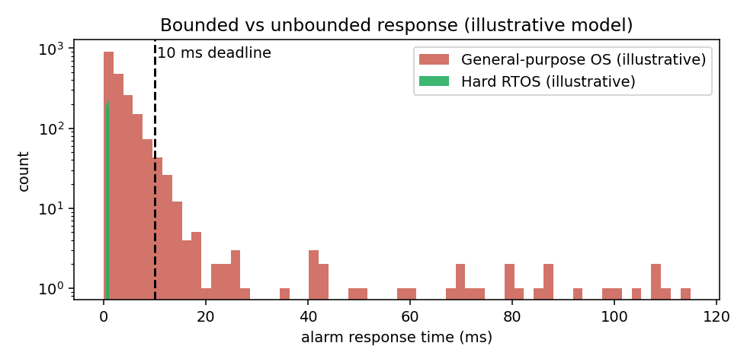
Figure 3 – Alarm response time: general-purpose OS (long tail, no bound) vs hard RTOS (bounded) – illustrative model
Criterion | One general-purpose OS | Different OS per environment (proposed)
Worst-case alarm response | Unbounded in theory – a time-sharing scheduler, page faults, disk I/O, and a long kernel path can delay the alarm task by tens or hundreds of ms (Figure 3). Time ≈ O(n) in the number of runnable tasks n plus unpredictable stalls | Bounded – priority-preemptive scheduler with O(1) dispatch; worst case = interrupt latency + dispatch + handler, e.g. ≈ 0.1–1 ms < 10 ms
Memory per monitor (typical) | Linux/Windows needs ≥ 512 MB–2 GB RAM and GBs of storage | FreeRTOS kernel ≈ 6–12 KB; QNX microkernel ≈ tens of KB; whole monitor image a few MB
Memory per tablet | Full desktop OS: GBs | Android/handheld: smaller, power-managed
Administration effort | Lowest: one image, one patch process, one skill set – O(1) OS types | Higher: ≈ 4 OS families (O(k) types) – but each is small and stable; devices patched separately
Patient safety | A routine update or background job can break alarm timing; large attack surface | Isolated, minimal, certifiable monitors
Judgement
A single general-purpose OS is cheaper to administer but cannot guarantee the 10 ms alarm and wastes memory/battery on small devices. Administration effort is a cost that can be managed (golden images, central management); a missed alarm cannot be recovered. Therefore the multi-OS design is justified.

TASK 2 – Judge the Type of Operating System for Each Environment (3 Marks)

2.1 Comparison of OS types
Type | Main feature | Strength | Weakness for the hospital
Mainframe | Batch + transaction processing, very high I/O and reliability | Huge throughput, very reliable | Very expensive, centralised; overkill for 500 beds
Desktop | Single user, GUI, time-sharing of applications | Rich software, usability | No timing guarantee; not for monitors/servers
Multiprocessor (SMP / AMP) | Several CPUs share memory and one OS | High throughput on one machine | One machine = single point of failure
Distributed | Machines cooperate over a network, appear as one system | Sharing, scalability, no single site | Network delay, security, complexity
Clustered | Group of computers with shared storage and heartbeat; fail-over | High availability | Needs shared storage, cluster software
Hard real-time | Deadlines are guaranteed | Predictable, small | Limited features, difficult to develop
Soft real-time | Deadlines usually met; late result still has some value | Flexible | Not safe where a miss is dangerous
Handheld | Small screen, battery, wireless, limited memory | Power-efficient | Limited processing, storage

2.2 Best OS type for each environment
Environment | Chosen type | Rejected alternatives and reasons
Bedside monitors | Hard real-time (QNX / FreeRTOS) | Soft real-time: a missed alarm could harm a patient. Desktop/general OS: no bounded delay.
Nurse tablets | Handheld (Android) | Desktop OS: too heavy, short battery. RTOS: no rich apps/UI.
Doctor workstations | Desktop (time-sharing) | Handheld: small screen/limited power. Mainframe: cost.
Database server | Clustered with fail-over | Single SMP: single point of failure. Mainframe: cost and lock-in.
Imaging server | Symmetric multiprocessor (SMP) | Asymmetric: master CPU becomes a bottleneck. Cluster: MRI needs shared memory for fast data exchange.
Partner link | Distributed system | Isolated systems: records cannot be shared. Single central server: owned by one hospital, single point of failure.

2.3 Symmetric vs asymmetric multiprocessing for the imaging server
Aspect | Symmetric (SMP) | Asymmetric (AMP)
Scheduling | Every CPU runs the OS and user code; any CPU takes any task | One master CPU runs the OS; slaves run assigned user tasks
Load balancing | Automatic, shared run queues | Master decides – it can become a bottleneck
Failure | System continues with fewer CPUs | Master failure stops everything
Complexity | Needs locking in kernel data structures | Simple kernel
MRI suitability | Best: MRI slices processed by many threads sharing memory | Poorer

2.4 Clustered system with fail-over for the database server
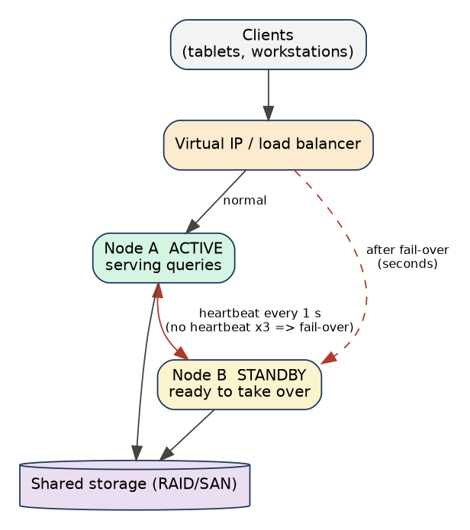
Figure 4 – Active/standby database cluster with heartbeat and fail-over
- Node A serves all queries; node B monitors A with a heartbeat (e.g. every 1 s).
- If three heartbeats are missed, B decides A has failed and takes over A's virtual IP address.
- B mounts the shared storage, runs database crash-recovery from the log and resumes service – typically within seconds.
- The faulty node is repaired; updates are applied one node at a time (rolling update).

2.5 Alternative Concept and Complexity Analysis – one large multiprocessor machine
What the solution would be: one large SMP machine (e.g. 64 cores, 1 TB RAM) runs the whole database.
Criterion | Single large multiprocessor | Cluster of smaller machines with fail-over
Availability | Single point of failure. If one machine has 99.9 % availability: downtime ≈ 8.76 h/year | Two independent nodes: unavailability ≈ 0.001² = 10⁻⁶ → 99.9999 % ≈ 31.5 s/year (ideal; add fail-over time of seconds per failure)
Cost | Large SMP price grows faster than linearly with CPUs (premium hardware) | Commodity machines; roughly linear cost, but 2× hardware and cluster software
Throughput vs processors (time) | Amdahl's law: S(p) = 1 / ((1 − f) + f/p). With 95 % parallel code: S(8)=5.9, S(64)=15.4, limit 20 | Active/standby: standby adds no throughput (it is for safety); active/active scales reads horizontally but needs data synchronisation
Memory (space) | One large shared memory (up to TBs) – simple, no data sharding | Each node has less memory; large data sets need sharding or shared storage
Maintenance | Updates need downtime | Rolling updates, no visible downtime
Judgement
Because the requirement says the database “must never stop”, availability dominates. A cluster eliminates the single point of failure and allows updates without stopping. A big SMP gives simpler memory and better single-query speed, but is rejected for the database; it is, however, ideal for the imaging server.

TASK 3 – Evaluate Operating-System Structures (4 Marks)
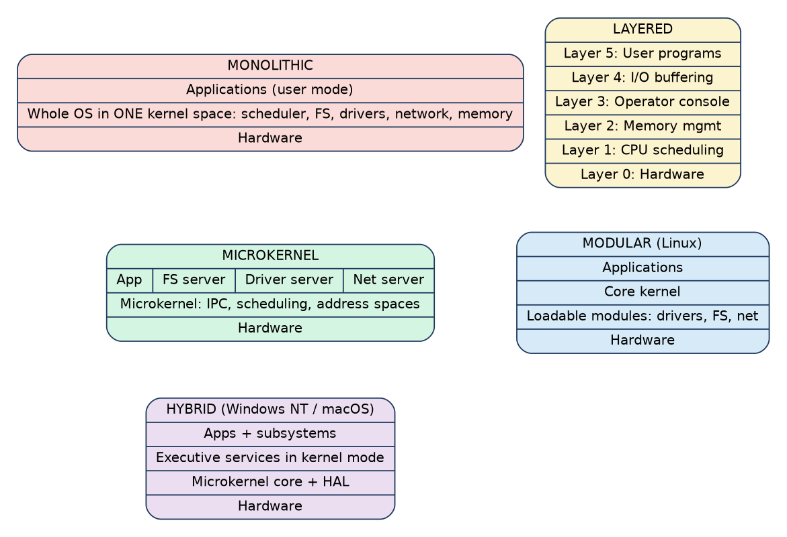
Figure 5 – Five OS structures

3.1 Comparison of structures
Structure | Reliability | Performance | Ease of updating | Example
Simple / monolithic | Low: a bug in any driver can crash the whole kernel | High: a service request is one system call, direct function calls inside the kernel | Hard: rebuild/reboot kernel | Early UNIX, MS-DOS, classic Linux
Layered | Medium: errors are localised to layers | Lower: each request crosses several layers | Medium: replace one layer | THE system
Microkernel | High: drivers/servers run in user space; failed server is restarted | Lower: message passing and context switches between servers | Easy: replace/restart a server without reboot | QNX, Minix, L4
Modular (loadable kernel modules) | Medium: modules run in kernel mode, so a bad module still crashes | High: as monolithic after loading | Easy: insmod/rmmod without reboot | Linux
Hybrid | Medium–high | Medium–high | Medium | Windows NT family, macOS/XNU

3.2 Structure of real systems
System | Structure
Linux | Monolithic kernel with loadable kernel modules (drivers, file systems). All kernel code in one address space in kernel mode.
Windows (NT) | Hybrid: HAL and microkernel at the core, Executive services (I/O manager, memory manager, security reference monitor) in kernel mode, user-mode subsystems and services.
Android | Linux kernel (modular) + Hardware Abstraction Layer + native libraries + Android Runtime + Application framework + Apps (layered stack above the kernel).
QNX | True microkernel: kernel provides only scheduling, IPC, interrupt handling; drivers, file system and network stack are separate user-space processes.
FreeRTOS | Very small kernel library (scheduler, queues, semaphores, timers) linked with the application into one image; no memory protection by default (MPU port available).

3.3 Structure chosen for two environments
Patient monitors → Microkernel RTOS
Reliability: the sensor driver, display and network stack run as separate processes; if the display driver crashes, the alarm task keeps running and the driver is restarted.
Predictability: a small kernel has short, bounded non-preemptible sections, so interrupt latency stays low.
Certification: small code size is easier to verify. Updates replace single servers.
Database server → Monolithic kernel with loadable modules (Linux)
Performance: the database issues many I/O system calls; a direct kernel path avoids IPC overhead.
Updatability: modules (e.g. storage drivers) can be loaded without reboot, and the cluster allows kernel updates one node at a time.
Risk (a driver bug crashes the node) is covered by the fail-over node.

3.4 Alternative Concept and Complexity Analysis – monolithic kernel on the bedside monitors
Criterion | Monolithic kernel | Microkernel (proposed)
Time cost of one service request | One system call: trap + kernel function ≈ 0.1 µs (measured here: ≈118 ns per getppid() call in a virtual machine). O(1) | Client → IPC → server → IPC → client: at least 2 message passes and 2–4 context switches ≈ 0.5–5 µs (typical). O(1) but a larger constant
Kernel memory | Large: Linux kernel image + modules ≈ 10–30 MB (typical) | Tiny kernel ≈ tens–hundreds of KB; servers loaded only if needed
Faulty driver | Runs in kernel mode with full privilege → whole system crashes (kernel panic) and the alarm stops | Driver is a user-space process → only that service restarts; alarm task unaffected
Verification | Millions of lines to verify | Small trusted base
Judgement: the 1–5 µs extra per request is negligible compared with the 10 ms deadline (≈ 0.05 %), while the isolation benefit is decisive. The microkernel is retained for monitors.

TASK 4 – Evaluate the Services an Operating System Must Provide (4 Marks)

4.1 Service table for every environment
Y = included, R = reduced, N = removed.
OS service | Monitor | Tablet | Workstation | Database server | Imaging server | Justification
User interface | N (fixed small display app) | Y (touch) | Y (GUI) | N (remote admin) | N | Only user-facing devices need a UI
Program execution | Y (fixed tasks) | Y | Y | Y | Y | Every system must load/run code
I/O operations | Y (sensor, alarm) | Y | Y | Y (disk, net) | Y (DMA) | Core purpose
File system | R (config/log flash) | Y | Y | Y (journaling) | Y | Monitor needs only a tiny store
Communication | Y (to central station) | Y (Wi-Fi) | Y | Y | Y | Records must move between devices
Error detection | Y (watchdog) | Y | Y | Y (ECC, logs) | Y | Critical for safety
Resource allocation | R (static priorities) | Y | Y | Y | Y | Fewer competing users on monitor
Accounting | N | R | R | Y (audit) | R | Audit is needed for records
Protection & security | R (authenticated updates) | Y | Y | Y | Y | Patient data must be protected

4.2 Services removed from the bedside monitor
- Graphical desktop and window manager – only a fixed display application is needed.
- Multi-user login and accounting – monitor has no interactive users.
- General file system and shell – small flash configuration is sufficient.
- Dynamic loading of arbitrary programs – fixed firmware image (also improves security).
Effect: less memory and flash, shorter boot time, fewer interrupts and background tasks, smaller attack surface, and simpler timing analysis.

4.3 Services essential for the database server
- File system with journaling and atomic writes – no corrupted records after a crash.
- I/O scheduling and caching – high transaction throughput.
- Resource allocation – CPU, memory and I/O fairly shared among queries.
- Error detection – ECC memory, disk errors, cluster heartbeat.
- Protection, security and accounting/audit – who read or changed which record.
- Communication – network service to tablets, workstations and cluster.

4.4 How the OS protects one patient's records from another user's programs
- Authentication: a user logs in; the OS gives the process a user ID.
- Access control: each file has an owner and permissions (or an ACL: doctor X may read patient P's record). On open(), the kernel checks permission and refuses with “permission denied”.
- Memory protection: each process has its own address space; base/limit registers or page tables (checked by the MMU) block access to another process's memory.
- Privileged operations: disk access only through system calls in kernel mode, so a user program cannot bypass the checks.
- Encryption and audit: records encrypted at rest/in transit; every access logged.

4.5 Alternative Concept and Complexity Analysis – full desktop OS on tablets
Criterion | Full desktop OS, all services | Reduced handheld OS (proposed)
Memory & storage (space) | ≈ 2–4 GB RAM at idle; 20–40 GB storage (typical) | ≈ 1–2 GB RAM; 4–8 GB system partition (typical)
Start-up time | 30–60 s: many services and drivers start | ≈ 10–20 s (typical), resumes from sleep in about 1 s
Battery life | Background services, indexing, updates keep CPU awake; typically 30–50 % shorter | Aggressive power management, suspend-friendly apps
Security | Large attack surface (all services) | Smaller attack surface, app sandboxing
Complexity | Time/space grows with number of services s: O(s) | Only required services
Judgement: the heavy desktop OS would miss the nurse's primary requirement (battery over a shift). The reduced handheld OS is retained.

TASK 5 – Examine System Calls (4 Marks)

5.1 Categories of system calls
Category | Purpose | Examples (POSIX) | Hospital example
Process control | Create, run, end, wait | fork, execve, wait, exit, kill | Shell starts a backup job
File management | Create, open, read, write, delete | open, read, write, close, unlink | Reading a patient record file
Device management | Request/release devices, read/write them | ioctl, read, write on /dev | Reading the sensor or MRI device
Information maintenance | Get/set time, system data, attributes | getpid, time, stat, uname | Time-stamping an alarm
Communication | Message passing, shared memory, sockets | pipe, socket, send, recv, shmget | Monitor sends reading to nurse station
Protection | Control access to resources | chmod, chown, umask, setuid | Restrict a record file to doctors

5.2 What happens when a program calls read()
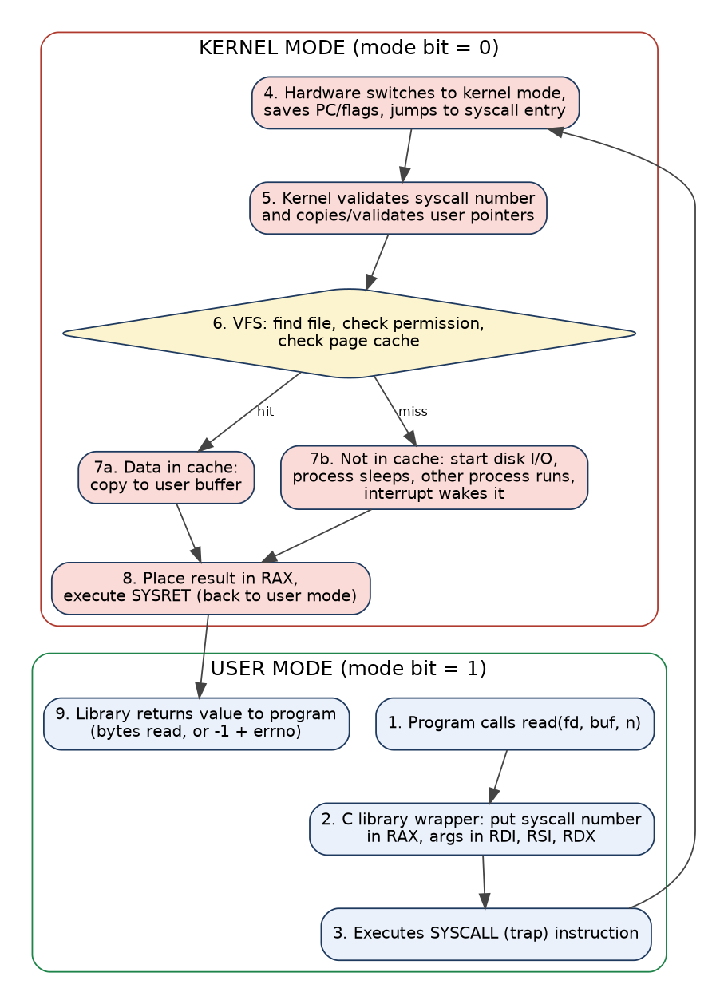
Figure 7 – Step-by-step flow of the read() system call
Step | Action | Mode
1 | Program executes read(fd, buf, n) – an ordinary function call to the C library | User
2 | The library wrapper loads the system-call number (0 = read on x86-64) into RAX and arguments into RDI, RSI, RDX | User
3 | The wrapper executes the trap instruction (syscall / int 0x80 / svc) | User → Kernel
4 | Hardware sets mode bit to kernel, saves return address/flags and jumps to the kernel's system-call handler | Kernel
5 | Kernel uses the number to index the system-call table and validates the arguments (is buf a valid user address?) | Kernel
6 | VFS finds the open file by descriptor, checks permission and looks in the page cache | Kernel
7 | If in cache: copy to user buffer. If not: start disk I/O, put process to sleep, schedule another; the disk interrupt wakes it | Kernel
8 | Result (bytes read or −errno) placed in RAX; return-from-trap instruction restores user mode | Kernel → User
9 | Library returns the value (−1 and errno on error) to the program | User

5.3 How parameters are passed to the kernel
Method | How | Advantage / limitation | Used by
Registers | Arguments placed directly in CPU registers | Fastest; limited number of parameters (about 6) | Linux x86-64
Block (table) in memory | Parameters stored in a block in memory; its address passed in a register | Unlimited size/number | Linux when many/large parameters, Solaris
Stack | Program pushes parameters on the stack; the OS pops them | Unlimited; extra memory access | Some older systems

5.4 strace evidence from a real program
Command to run on your Linux machine (attach the screenshot):
gcc -std=c11 -Wall -Wextra task6.c -o task6
strace -c ./task6 # summary table of system calls
strace -e trace=openat,read,write,close ./task6 2>&1 | head -40 # first calls
Measured with the ptrace-based counter (same information as strace -c) while the Task 6 program ran:
syscall calls
read 10027
write 10027
openat 9
close 9
mmap 8
brk 3
TOTAL 20103
Interpretation: the 10,001 + 21 + 4 = 10,026 read() calls reported by the program (plus one read by the dynamic loader) account for almost all of the 10,027 read system calls – the program output and the system-call count agree. Each read() is one mode switch into the kernel.

5.5 Alternative Concept and Complexity Analysis – fopen / fread / fwrite instead of open / read / write
Criterion | Direct system calls (buffer b) | C library stdio (buffer ≈ 4096 B)
Number of system calls for n bytes | ⌈n / b⌉ reads + ⌈n / b⌉ writes → O(n/b). With b = 1, n calls | ≈ n / 4096 reads/writes irrespective of the size the program asks for (e.g. fgetc/fputc 1 byte at a time still gives n/4096 calls)
Measured (16 MB, 4 KB) | 4,098 read + 4,097 write | 4,098 read + 4,097 write (identical – stdio uses a 4 KB buffer)
Extra space | Only the program's buffer b | Program buffer + library buffer (one per open FILE, ≈ 4 KB each): O(1) per file
Portability / convenience | Linux-specific, manual loop | Portable C, formatted I/O (fprintf)
Best when | Large reads, direct control, O_DIRECT, sockets | Many small reads/writes, text processing
Judgement: for the hospital's small configuration reads, stdio is simpler and nearly as fast. For bulk backup the program should use large buffers directly.

TASK 6 – Evaluate the Cost of System Calls (4 Marks)

6.1 Why a system call costs more than a function call
Extra work | Why
Trap and mode switch | The CPU must change privilege level, save/restore registers, switch stacks
Argument validation | Kernel must not trust user pointers – checks and copies (copy_from_user)
Cache/TLB effects | Kernel code and data evict user cache lines; some CPUs flush TLB/branch predictors for security (Spectre/Meltdown mitigations)
Scheduling | Blocking calls may cause a context switch
Possible I/O | A read() may wait for the device
Measured: a trivial system call (getppid) cost about 118 ns each (1,000,000 calls in 0.118 s). An ordinary function call or loop step costs about 1–2.5 ns (10,000,000 loop iterations in 0.025 s). So a system call is roughly 50–100× more expensive than a normal call, even though it does almost no work.

6.2 Complete the Code – Task 6 program (TODO 1 completed)
#define _POSIX_C_SOURCE 200809L
#include <stdio.h>
#include <fcntl.h>
#include <unistd.h>

long copy_file(const char *src, const char *dst, size_t bufsize)
{
char buf[8192];
int in = open(src, O_RDONLY);
if (in < 0) return -1;
int out = open(dst, O_WRONLY | O_CREAT | O_TRUNC, 0644);
if (out < 0) { close(in); return -1; }
long calls = 0;
ssize_t n;
/* TODO 1 - completed */
while (1) {
n = read(in, buf, bufsize); /* one read() system call */
calls++; /* count every read call */
if (n <= 0) break; /* 0 = end of file, -1 = error */
ssize_t done = 0; /* write exactly the n bytes read */
while (done < n) {
ssize_t w = write(out, buf + done, n - done);
if (w < 0) { close(in); close(out); return -1; }
done += w;
}
}
close(in);
close(out);
return (n < 0) ? -1 : calls;
}
/* main() is unchanged from the question */
Explanation: calls is incremented after every read(), including the final one that returns 0 (end of file). That is why 10,000 bytes with a 1-byte buffer need 10,001 calls; 10,000 / 512 = 19.5 → 20 data reads + 1 EOF = 21; 10,000 / 4096 = 2.44 → 3 data reads + 1 EOF = 4. The inner while loop handles a partial write, so exactly n bytes are written.
Output (executed, matches the expected output exactly):
buffer 1 bytes: 10001 read() calls
buffer 512 bytes: 21 read() calls
buffer 4096 bytes: 4 read() calls
Under strace -c ./task6 the read line should show about 10,026 + 1 ≈ 10,027 calls (my measurement: 10,027 reads, 10,027 writes), matching the sum of the program's three counts plus one read by the dynamic loader.

6.3 Effect of buffer size – measured on a 16 MB file
Buffer (bytes) | read() calls | Wall time (ms) | User CPU (ms) | Kernel CPU (ms)
1 (on 1 MB file) | 1,048,576 | 482 (for 1 MB!) | – | –
16 | 1,048,576 | 503.0 | 122.1 | 375.1
64 | 262,144 | 157.8 | 22.9 | 121.3
512 | 32,768 | 43.6 | 2.8 | 29.1
4,096 | 4,096 | 30.6 | 2.9 | 12.3
16,384 | 1,024 | 49.5 | 0.0 | 29.1
65,536 | 256 | 21.2 | 0.0 | 13.9
1,048,576 | 16 | 16.4 | 0.0 | 6.9
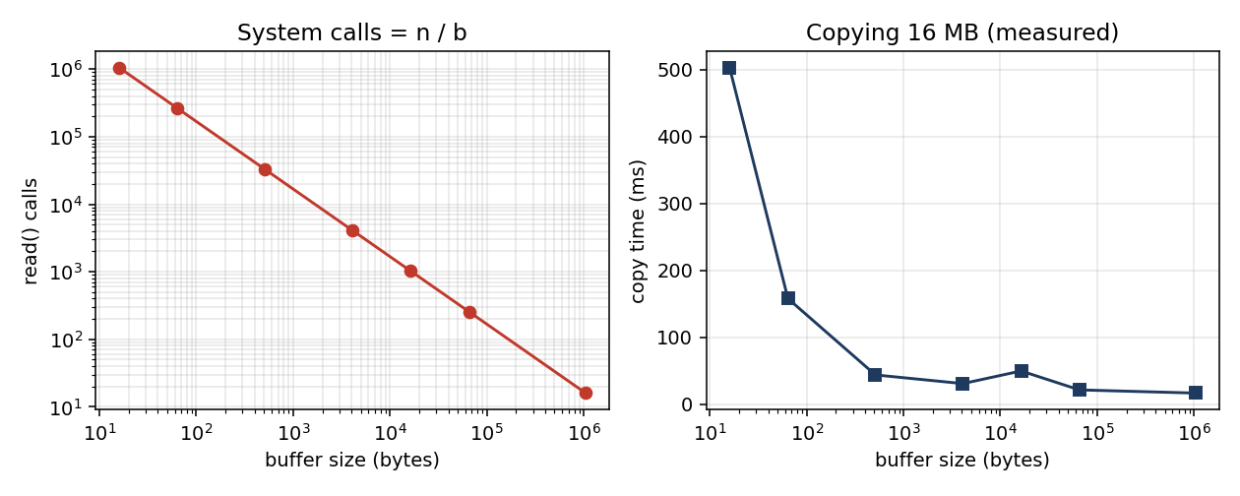
Figure 8 – read() calls fall as n/b; time falls steeply then flattens (measured)
Observations: (1) calls = n / b exactly. (2) Going from 16 B to 4 KB reduces time ≈ 16× because the kernel share (system-call overhead) collapses. (3) Beyond 4–64 KB the gain is small: the cost is dominated by the actual copy and storage speed, not by the call overhead. The 16,384 B reading is noise in a shared virtual machine – repeat the test three times and take the median in your own report.

6.4 Library buffering
fread/fwrite keep a buffer in user space (typically 4 KB). A program that asks for 1 byte at a time fills the buffer with one read() of 4 KB and then serves the next 4,095 requests from memory. Measured: 262,144 fread calls of 64 bytes took 24.6 ms, against 157.8 ms for 262,144 direct read() calls of 64 bytes. The library serves most requests from its buffer, so the number of real read() system calls is about n / 4096 = 4,096 (measured 4,098 for the 4 KB case in section 10.2).

6.5 Best buffer size for the hospital's backup program
Recommendation: 64 KB buffer (minimum 4 KB)
Below 4 KB the system-call overhead dominates (512 B: 32,768 calls). At 4 KB the kernel time is already small. At 64 KB the call count falls to 256 and the wall time to ≈ 21 ms, near the best result; 1 MB gives only a further 5 ms gain but needs 16× more memory per backup stream.
64 KB also matches common file-system read-ahead and stripe sizes, so it is a safe and memory-friendly choice.

6.6 Alternative Concept and Complexity Analysis – memory-mapped files (mmap)
Criterion | read()/write() with buffer b | mmap + memcpy
System calls | ≈ 2n/b (O(n/b)) | A few: open, fstat, mmap ×2, ftruncate, munmap (measured 46 total, of which 1 read and 1 write) – O(1)
Copying | Data copied kernel → user buffer → kernel (two copies) | Page cache pages mapped directly; one memcpy between mappings; page faults load pages on demand
Memory (space) | O(b) user memory regardless of file size | Address space O(n) (virtual); physical memory used only for resident pages, OS can evict
Measured 16 MB | 30.6 ms (4 KB); 21.2 ms (64 KB) | 20.7 ms (user 0 ms, kernel 9.2 ms)
Weak points | More calls for small buffers | Page-fault cost; errors appear as signals (SIGBUS); less control for streaming huge files on 32-bit systems
Judgement: mmap is as fast as the best buffered copy here and uses far fewer system calls. For the backup of very large files a 64 KB read/write loop remains simplest and most predictable; mmap is a good alternative when the same file is accessed randomly.

TASK 7 – Evaluate Process Control System Calls (4 Marks)

7.1 What fork(), exec(), wait() and exit() do
Call | Function | Return value
fork() | Creates a child process – a copy of the parent's address space (copy-on-write) with a new PID | Parent: child PID; child: 0; −1 on error
exec() family (execlp) | Replaces the current process image with a new program; same PID, code/data replaced | Does not return on success; −1 on failure
wait() / waitpid() | Parent blocks until a child terminates and collects its exit status (reaping) | PID of the child; status via WEXITSTATUS
exit() / _exit() | Terminates the process, closes files, returns status to parent. exit() also flushes stdio buffers; _exit() does not | Does not return

7.2 How a shell runs a command
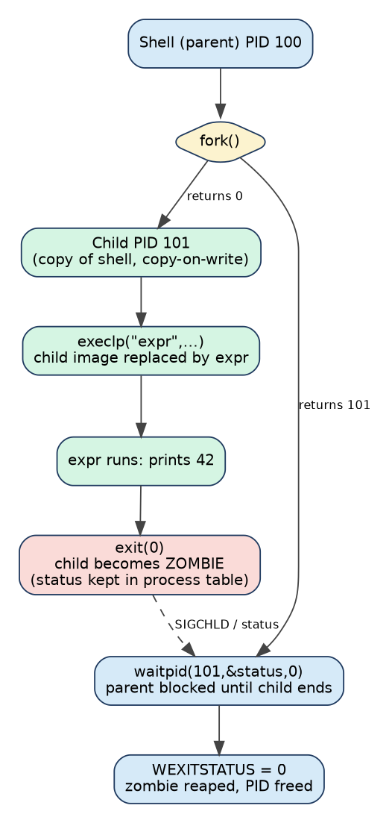
Figure 9 – Process diagram: shell runs “expr 6 * 7” (Job 1)
- The shell reads the line, then calls fork() – now two identical processes exist.
- The child calls exec to load the new program (expr). The parent calls waitpid().
- The program runs and calls exit(status). The child becomes a zombie until the parent reads its status.
- waitpid() returns; the shell obtains the status with WEXITSTATUS(status) (0 = success; shown by $?).

7.3 Zombie and orphan processes
 | Zombie | Orphan
Definition | Child has terminated but the parent has not yet called wait(); only a process-table entry remains | Parent terminates while the child is still running
Resources | Almost none (PID and status) | Normal running process
Problem | Too many fill the process table | None, normally
How the OS handles it | When the parent calls wait() the entry is freed; if the parent exits, init/systemd (PID 1) adopts and reaps it | init/systemd adopts the orphan and later reaps it

7.4 Why fork() followed by exec() instead of one “create process” call
- Flexibility: between fork and exec the child can redirect stdin/stdout, set up pipes, change directory, drop privileges or set environment variables – without a huge CreateProcess-style parameter list.
- Simplicity: two small orthogonal system calls; fork alone is useful (e.g. a server with a worker child).
- Efficiency: copy-on-write means the temporary copy created by fork is not actually copied when exec follows immediately.
Disadvantage: a fork of a large process still has to copy page tables (see measurement in 7.7).

7.5 Complete the Code – Task 7 program (TODO 1 completed)
int main(void)
{
pid_t pid;
int status;
printf("shell: running job 1\n");
fflush(stdout); /* empty the buffer before fork() */
/* TODO 1 - completed */
pid = fork();
if (pid < 0) { perror("fork"); return 1; }
if (pid == 0) { /* child */
execlp("expr", "expr", "6", "*", "7", (char *)NULL);
exit(127); /* only if exec fails */
}
waitpid(pid, &status, 0); /* parent waits */
printf("job 1 exit status %d\n", WEXITSTATUS(status));

printf("shell: running job 2\n");
fflush(stdout);
pid = fork();
if (pid == 0) _exit(3); /* a child that fails with code 3 */
waitpid(pid, &status, 0);
printf("job 2 exit status %d\n", WEXITSTATUS(status));
return 0;
}
Output (executed, matches the expected output):
shell: running job 1
42
job 1 exit status 0
shell: running job 2
job 2 exit status 3

7.6 Why stdout is flushed before each fork(), and the duplicated-line experiment
When stdout is a terminal it is line-buffered, but when it is redirected to a file or pipe it is fully buffered: text stays in the process's user-space buffer until it is full, flushed or the process exits. fork() copies this buffer to the child. If the buffer still holds text at fork time, both the parent and the child own a copy and each will print it when it flushes. Calling fflush(stdout) before fork() empties the buffer so nothing is duplicated.
Experiment: remove the second fflush(stdout), change _exit(3) to exit(3), and redirect the output (./task7v > out.txt). Result obtained:
shell: running job 1
42
job 1 exit status 0
shell: running job 2
job 1 exit status 0 <- duplicated
shell: running job 2 <- duplicated
job 2 exit status 3
Explanation: with the redirect, “job 1 exit status 0\nshell: running job 2\n” is still sitting in the unflushed buffer at the second fork(). The child is an exact copy, so it also holds that text. exit(3) flushes all stdio buffers, so the child writes the buffered text to the file, then the parent writes its own copy later. Hence “shell: running job 2” (and, here, the job 1 line before it) appears twice. With _exit(3) the child skips the flush and no duplicate appears. On a terminal the buffer is flushed at each newline, so no duplication is seen.

7.7 Alternative Concept and Complexity Analysis – posix_spawn() or threads
Criterion | fork() + exec() | posix_spawn() (or vfork) | Threads (pthread_create)
Time for 1,000 commands (measured, small parent) | 0.74–0.97 s (≈ 0.8 ms each, dominated by loading /bin/true) | 0.78–0.87 s (same) | 1,000 create+join: 18 ms (no new program – only a function runs)
Time with a 400 MB parent (measured) | 6.36 s – page tables of 400 MB copied each time | 0.72 s – no copy | –
Memory copied/shared | Copy-on-write; page-table copy is O(parent size) | Avoids copy (shares until exec); O(1) | Shares all memory
Isolation | Full: separate address space, crash of child does not hurt shell | Full (new process) | None: one faulty command can corrupt/crash all
Use for | Flexible set-up between fork and exec | Large servers launching many helpers | Concurrency inside one program, not command isolation
Judgement: a shell on the database server should keep fork+exec for correctness and flexibility but may use posix_spawn() when the parent is large (the measurement shows a ≈ 9× speed-up for a 400 MB parent). Threads are rejected for running independent commands because they give no isolation.

TASK 8 – Evaluate CPU States and Protection (3 Marks)

8.1 User mode, kernel mode and the mode bit
 | User mode (mode bit = 1) | Kernel (supervisor) mode (mode bit = 0)
Who runs | Applications | OS kernel, drivers
Instructions | Only non-privileged | All, including privileged instructions: I/O, halt, change page tables, load base/limit registers, disable interrupts, set timer
Switch to kernel | By system call (trap), interrupt or exception | –
Return to user | Return-from-trap instruction sets bit back | –
Effect of misuse | Executing a privileged instruction causes an exception; the OS terminates the program | –

8.2 Interrupts, traps and the timer interrupt
Event | Source | Example
Interrupt | Asynchronous, from hardware | Sensor signals abnormal reading; disk finished; key press
Trap (software interrupt) | Synchronous, caused by program | System call such as read()
Exception | Synchronous, error | Divide by zero, invalid memory access (page fault)
Timer interrupt | Periodic clock | Gives the OS control back every time slice (e.g. 1–10 ms) so no program can keep the CPU forever
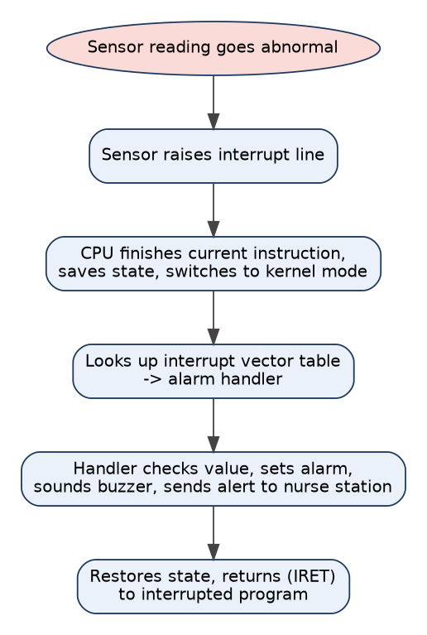
Figure 10 – Hardware-interrupt flow for an abnormal sensor reading

8.3 What would happen if any program could disable interrupts?
- A faulty or malicious application could disable interrupts and then loop forever: the timer interrupt never fires, so the scheduler never runs and the CPU never returns to the OS.
- The sensor interrupt would never be serviced – the alarm would not sound, a direct patient-safety failure.
- Disk, network and keyboard events would be lost; the system would appear frozen and only a hardware reset would recover it.
Therefore disabling interrupts (cli/sti) is a privileged instruction: executing it in user mode causes an exception.

8.4 How the hardware stops one program from reading another program's memory
- Base and limit registers: every address generated in user mode is compared with [base, base+limit); an out-of-range address raises a trap (segmentation fault). Only kernel mode may load these registers.
- Paging with the MMU: each process has its own page table; virtual addresses are translated to physical frames; pages belonging to other processes are simply not mapped. Page-table entries also carry read/write/execute and user/supervisor bits.
- The kernel's own memory is marked supervisor-only so user code cannot read or change it.

8.5 Alternative Concept and Complexity Analysis – polling instead of interrupts
Criterion | Polling (check sensor in a loop) | Interrupt-driven (proposed)
Worst-case delay before abnormal reading is noticed | Up to one polling interval T plus processing: e.g. T = 20 ms → up to 20 ms (violates 10 ms); to guarantee 10 ms the loop must poll every ≤ 5 ms | Interrupt latency only, typically a few µs to < 100 µs
CPU time wasted | Every poll costs CPU time even if nothing changed: with T = 1 ms and 2 µs per poll, 0.2 % CPU for each sensor; with a busy-wait loop 100 % | Zero until an event arrives; the CPU can sleep
Power | CPU repeatedly woken; prevents deep sleep – poor for battery backup | Sleeps between events; low power
Complexity | Time cost O(number of sensors × polls) | O(number of events)
Advantage | Simple, deterministic when the poll rate is fixed; no interrupt storms | Efficient, immediate
Judgement: use interrupts for the monitors. Polling is acceptable only for very fast, continuously active devices where an event is always ready.

TASK 9 – Evaluate the Memory Hierarchy and I/O Systems (4 Marks)

9.1 The memory hierarchy
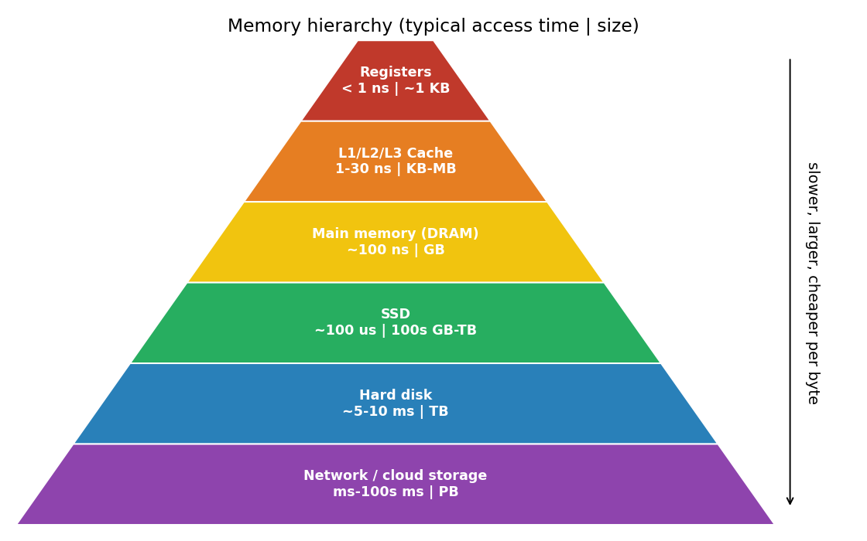
Figure 11 – Memory hierarchy with typical access times and sizes
Level | Typical access time | Typical size | Volatile?
Registers | < 1 ns | ≈ 1 KB | Yes
Cache (L1/L2/L3) | 1–30 ns | 32 KB–tens of MB | Yes
Main memory (DRAM) | ≈ 50–100 ns | GBs | Yes
SSD | ≈ 50–150 µs | 100s GB–TB | No
Hard disk | ≈ 5–10 ms | TBs | No
Network / cloud storage | ≈ 1–100s of ms | PBs | No
Each step down is about 10–1000× slower and larger. Programs work because of locality of reference: recently/nearby-used data is kept in the faster levels.

9.2 Data-placement plan
Data | Where to keep it | Reason
Monitor readings (live) | Registers/RAM of the monitor; ring buffer; recent history in flash | Must be processed within 10 ms; small
Active patient records (hot) | DB server RAM cache + SSD | Frequent random look-ups need µs access
Old patient records | Hard disk / network storage, replicated | Large and rarely read; cost per GB
MRI images being processed | Imaging server RAM (and SSD scratch) | Huge, processed repeatedly by many cores
MRI archive | Hard-disk array or network/cloud storage + backup | Hundreds of MB each, long retention
Backups | Network/cloud storage, off-site | Disaster recovery

9.3 Programmed I/O, interrupt-driven I/O and DMA
Method | How | CPU involvement | Suitable for
Programmed I/O (polling) | CPU repeatedly checks device status and moves each word | 100 % during transfer | Very simple/slow devices
Interrupt-driven I/O | Device interrupts when ready; CPU moves each word (or block) in the handler | One interrupt per word/event | Keyboard, sensors, monitors
DMA | CPU programs the DMA controller (address, count); controller moves data directly between device and memory; one interrupt at the end | Very low | MRI scanner, disks, network
Choice for each device: monitor sensors → interrupt-driven; MRI scanner and disks → DMA; tablets' touch screen → interrupt-driven.

9.4 Effect of caching on record look-up
Effective access time EAT = h × t_cache + (1 − h) × t_disk. With t_cache = 100 ns (RAM), t_disk = 5 ms and hit ratio h = 99 %: EAT ≈ 0.99×100 ns + 0.01×5,000,000 ns ≈ 50 µs. With h = 90 % it becomes ≈ 0.5 ms; without a cache 5 ms. A 1 % rise in hit ratio roughly halves the delay, so the database server needs a large RAM cache for hot records.

9.5 Alternative Concept and Complexity Analysis – interrupt per word instead of DMA for a 500 MB image
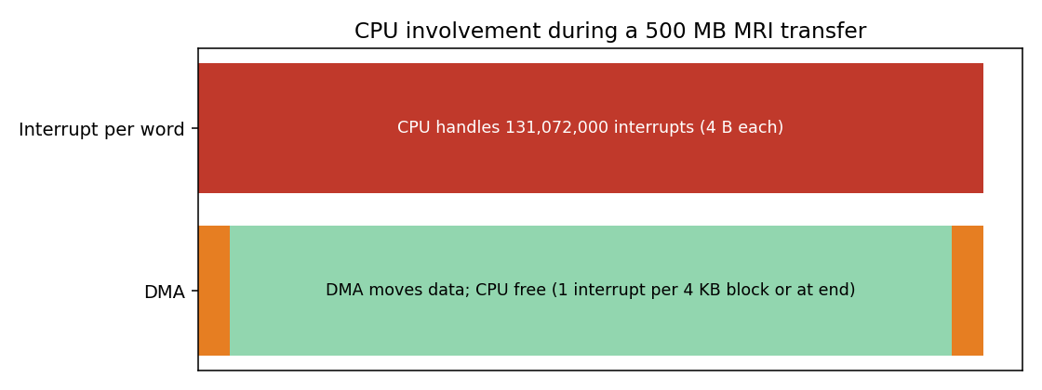
Figure 12 – CPU involvement for a 500 MB MRI transfer
Criterion | Interrupt-driven (one interrupt per 4-byte word) | DMA (proposed)
Number of interrupts | 500 MB = 524,288,000 B ÷ 4 B = 131,072,000 interrupts | One per transfer (or one per 4 KB block = 128,000 if chained)
CPU time (assuming 2 µs per interrupt, typical) | 131,072,000 × 2 µs ≈ 262 s of CPU time – the scan would be limited by the CPU, not the scanner | ≈ 128,000 × 2 µs = 0.26 s at most (about 1000× less)
Memory buffers needed | Tiny device buffer (one word) plus the destination in memory: O(1) transient buffering | DMA buffer or descriptor ring in memory (e.g. 1–64 MB, or the whole image), pinned for the controller: O(b)
Complexity | O(n) interrupts for n bytes | O(n/block) interrupts, O(1) CPU set-up
Judgement: per-word interrupts would consume the imaging server's CPU and delay everything else; DMA frees the processors to analyse the image while the next part arrives. DMA is chosen at the cost of reserved memory buffers.

TASK 10 – Measure and Compare (4 Marks)

10.1 Method
- Programs: task6.c (copy with different buffers), bench.c (copy/stdio/mmap/fork/thread benchmarks), spawn.c, mstrace.c (system-call counter) – listed in Appendix A.
- File: 16 MB generated test file; each result is a single run on a 1-vCPU virtual machine (repeat 3× and use the median in your own work).
- Commands to reproduce on your own Linux:
strace -c ./bench rw 4096
time ./bench rw 4096
time ./bench fork
time ./bench thread

10.2 Number of system calls (strace -c style) for different buffer sizes (16 MB copy)
Method | read() calls | write() calls | All system calls
read/write, 512 B | 32,770 | 32,769 | 65,577
read/write, 4,096 B | 4,098 | 4,097 | 8,233
read/write, 65,536 B | 258 | 257 | 553
stdio fread/fwrite, 4,096 B | 4,098 | 4,097 | 8,235
mmap copy | 1 | 1 | 46
The counts equal n / b plus start-up calls (about 10–40 for loading the program and libraries). stdio with a 4 KB buffer gives exactly the same count as direct 4 KB read/write.

10.3 User-mode and kernel-mode time (as reported by the time command / getrusage)
Method | Real (ms) | User (ms) | Sys (ms) | Comment
read/write 16 B | 503.0 | 122.1 | 375.1 | Kernel dominates – system-call overhead
read/write 64 B | 157.8 | 22.9 | 121.3 | Still kernel dominated
read/write 512 B | 43.6 | 2.8 | 29.1
read/write 4 KB | 30.6 | 2.9 | 12.3 | Best balance per memory
read/write 64 KB | 21.2 | 0.0 | 13.9
read/write 1 MB | 16.4 | 0.0 | 6.9 | Minimal kernel time
stdio 64 B requests | 24.6 | 12.1 | 4.3 | User time ↑ (library copies), kernel ↓
mmap | 20.7 | 0.0 | 9.2 | Few calls, page faults

10.4 Creating 1,000 processes and 1,000 threads
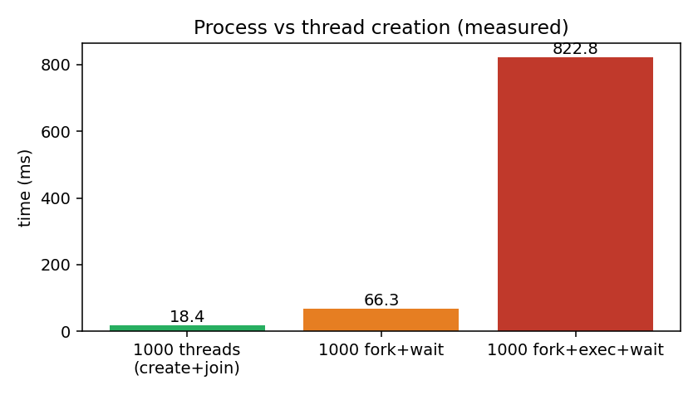
Figure 13 – Time to create 1,000 threads / processes (measured)
Operation (1,000 times) | Total time | Per item
pthread_create + join | 18.4 ms | 18 µs
fork() + wait (child exits immediately) | 66.3 ms | 66 µs
fork() + exec(/bin/true) + wait | 822.8 ms | 823 µs

10.5 Do the measurements support the earlier judgements?
Earlier judgement | Measurement result | Verdict
A system call is much more expensive than a function call (Task 6) | ≈118 ns per trivial syscall vs ≈ 2 ns per loop step | Supported
Larger buffers cut the number of system calls as n/b (Tasks 5, 6) | 16 B: 1,048,576 calls … 1 MB: 16 calls | Supported (exact)
Time keeps falling as buffer grows | Time flattens after about 4–64 KB; the 16 KB result was slower (noise) | Partly supported – diminishing returns; choose 64 KB
stdio ≈ direct read/write with matching buffer (Task 5) | 4,098 vs 4,098 reads | Supported
mmap needs only a few system calls (Task 6) | 46 vs 8,233 system calls; time similar | Supported
fork+exec is expensive; threads are cheap (Task 7) | Thread 18 µs vs fork 66 µs vs fork+exec 823 µs | Supported; exec (loading a program) is the dominant cost
posix_spawn helps for large parents (Task 7) | 400 MB parent: 6.36 s vs 0.72 s | Supported; no advantage for a small parent

10.6 Alternative Concept and Complexity Analysis – threads instead of processes
Criterion | 1,000 processes (fork) | 1,000 threads
Creation time (measured) | 66 ms (66 µs each) | 18 ms (18 µs each) ≈ 3.6× faster
Memory | Separate address space and page tables (copy-on-write sharing until written); more memory per unit | Share code, heap, globals, open files; only a separate stack (≈ 8 MB virtual, small resident) and thread control block
What is shared | Nothing by default (needs IPC, pipes, shared memory) | Address space, file descriptors, heap
Isolation / safety | A crash is limited to one process | A bug or crash affects all threads
Communication cost | IPC via kernel (system calls) | Plain memory access + locks
Explanation: a thread only needs a new stack and register set because everything else is shared, so there is less to set up; fork must duplicate page-table structures and file-descriptor tables. Threads suit the imaging server's parallel processing; processes suit isolation between services.

TASK 11 – Recommend and Defend the Operating-System Plan (4 Marks)

11.1 Complete plan
Environment | OS type | Structure | Key services | Protection | I/O method
Bedside monitor | Hard RTOS (QNX/FreeRTOS) | Microkernel | Program execution, I/O, error detection (watchdog), communication | MPU/MMU isolation, signed firmware updates | Interrupt-driven
Nurse tablet | Handheld (Android) | Modular Linux + layered framework | UI, communication, power management, file system | App sandbox, encryption, remote wipe | Interrupt-driven
Doctor workstation | Desktop (Windows/Linux) | Hybrid / modular | UI, multitasking, file system, communication | User accounts, ACLs, audit | Interrupt + DMA
Database server | Clustered fail-over | Monolithic + modules (Linux) | File system (journaling), caching, resource allocation, accounting | Authentication, ACLs, encryption, audit | DMA
Imaging server | SMP | Monolithic + modules (Linux) | Threads, memory management, scheduling | User separation, encrypted volumes | DMA
Partner link | Distributed system | Network services | Secure communication, naming | VPN/TLS, mutual authentication | Network DMA

11.2 Evidence from my analysis and measurements
- Monitors: model (Fig. 3) and Task 8 analysis show a general-purpose OS cannot bound alarm delay; the measured system-call cost (≈118 ns) and microkernel IPC cost (µs) are < 0.05 % of 10 ms, so the microkernel's overhead is affordable.
- Database/backup: measurements show 64 KB buffers cut system calls from 1,048,576 (16 B) to 256 and time from 503 ms to 21 ms; the hospital backup should use 64 KB buffers or mmap.
- Process management: fork+exec costs 0.8 ms per command, and 6.4 s per 1,000 commands from a 400 MB parent versus 0.72 s with posix_spawn; admin scripts on the DB server should use posix_spawn.
- Imaging: 131 million interrupts for per-word I/O versus 128,000 for DMA – DMA is mandatory.
- Cluster: two nodes lift availability from 99.9 % (8.76 h/year) to ≈ 99.9999 % (~31 s/year), ignoring fail-over time.

11.3 Limitations and risks
Risk / limitation | Mitigation
Several OS families increase administration and training cost | Central device management, standard images, documented procedures
RTOS limited features and developers' skills | Use certified RTOS (QNX) and keep monitor application minimal
Cluster adds complexity; split-brain (both nodes think they are active) | Quorum/witness disk, fencing
Shared storage is a single point of failure | RAID, replicated storage
Tablet loss / theft | Encryption, remote wipe, short session timeout
Microkernel IPC overhead | Negligible for monitors (measured vs deadline); performance-critical paths kept in one server
Update downtime | Rolling updates on cluster; staged roll-out for monitors

11.4 Does the plan scale to a group of three hospitals?
Ward (40 monitors, 10 tablets) → hospital (500 monitors, 120 tablets, 80 workstations) → three hospitals. Yes, with modifications: monitors, tablets and workstations scale by simply adding devices because each is independent and talks to the local database. The database cluster should grow from a pair to a larger cluster (or replicated databases per hospital with synchronisation); the partner link becomes a true distributed system with replication, conflict resolution and consistent patient identity across sites. Network bandwidth and a central identity/authentication service become the new bottlenecks.

11.5 Alternative Concept and Complexity Analysis – everything in virtual machines on two large servers
Criterion | Virtual machines on two large servers | Separate physical environments (proposed)
Response time for monitors | Hypervisor scheduling, shared CPU and I/O add jitter; a VM may be descheduled for ms – deadline cannot be guaranteed unless a real-time hypervisor with dedicated cores is used. Also: monitors are bedside devices and cannot run in the server room | Bounded: dedicated RTOS hardware
Memory/CPU overhead | Typical 2–10 % CPU and extra memory for each guest OS kernel and hypervisor (≈ hundreds of MB per VM) (typical) | None extra, but under-used hardware
Reliability | Two servers – if one fails, VMs restart on the other (live migration/HA); but a hypervisor fault or one-server loss affects many services at once (larger blast radius) | Fault of one device affects only that device
Cost/management | Fewer machines, easier backup/snapshots, quick provisioning | More hardware
Judgement: virtualise the servers (workstation back-ends, imaging, test systems) where consolidation helps, but keep the monitors on dedicated RTOS hardware, and keep the database as a cluster whose nodes are on different physical hosts.

TASK 12 – Day-4 Design Challenge: Re-evaluate and Adapt the Design (8 Marks)
Changed requirement
Remote monitoring devices are added in patients' homes (readings sent over the internet) and patient records move to a cloud service shared with the partner hospitals.

A. Impact Analysis (2 Marks)
Area | Original design | Affected how? | Impact
OS type – home device | None (new) | Needs a small, reliable, battery-powered embedded real-time OS that works without a nurse | New
OS type – records | Local clustered DB + partner distributed link | Records become a cloud distributed system with multiple owners | Major
Monitor OS (hospital) | Hard RTOS | Unchanged – still bedside and local | None
Tablets / workstations | Handheld / desktop | Must reach cloud records; network dependence | Moderate
Services | Local file system and communication | Need secure communication, identity, sync, offline operation | High
Protection | Local ACLs, trusted LAN | Internet exposure: TLS, authentication of devices and users, encryption, key management, audit, privacy law compliance | Critical
Response time | Alarm local at the bedside | A home alarm must not depend on the internet; cloud adds latency (tens–hundreds of ms) | High

B. Evaluation of the Original Design (2 Marks)
Aspect | Can the original plan support it? | Evidence / reasoning
Response time | Yes for local alarms (if kept local); no if the alarm waits for the cloud | A 10 ms deadline cannot be met over the internet; internet round-trip typically 20–200 ms. Original RTOS design supports local alarm in the device
Reliability | Partly | Clustered DB gives local availability, but internet outage, cloud failure or lost home connection are new failure points. Original design had no store-and-forward
Security | No | Original assumed a closed hospital LAN with one VPN link; homes and the cloud are untrusted, with many devices of many owners
Scalability | Partly | DB cluster designed for 3 hospitals; thousands of homes add many connections, needing a gateway/message queue
Overall | MODIFY (not redesign) | Core structure remains valid; add layers

C. Adaptation / Redesign (2 Marks)
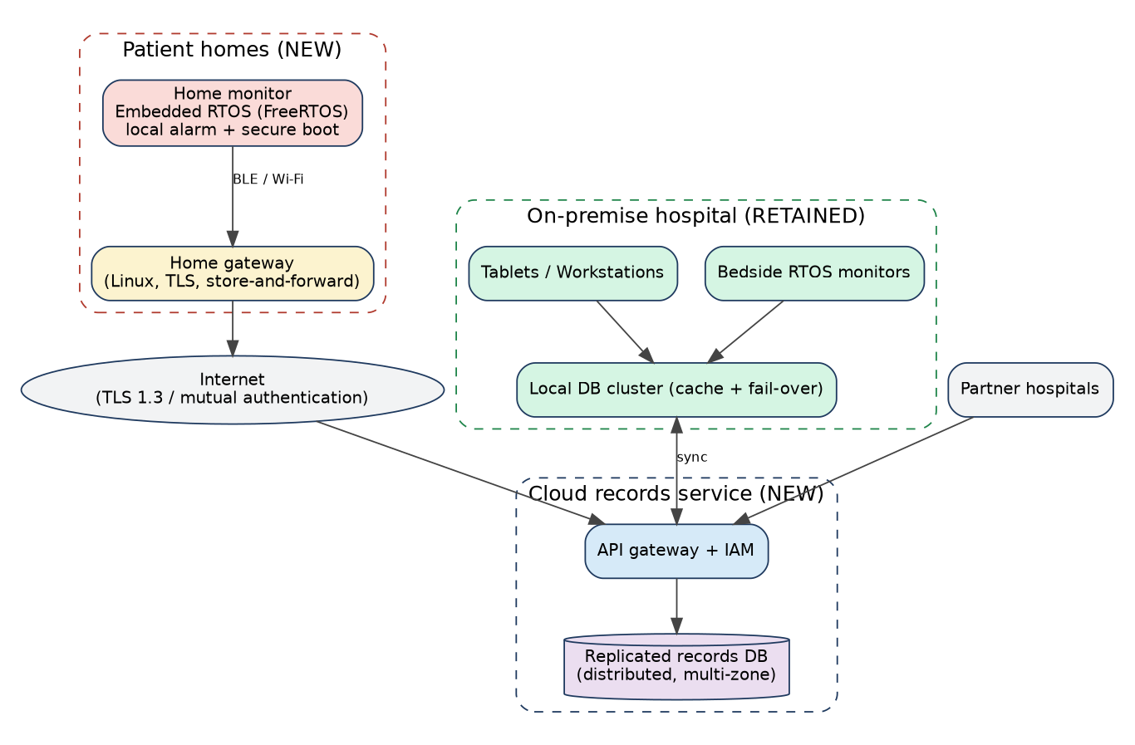
Figure 14 – Revised architecture with home monitoring and cloud records
Component | Revised OS plan
Home monitor | Embedded hard real-time OS (FreeRTOS/Zephyr class), microkernel-like, minimal services, raises the alarm locally (buzzer + SMS gateway) without the internet; secure boot, signed over-the-air updates, device certificate for authentication
Home gateway | Small Linux (modular) with TLS and store-and-forward: buffers readings during a network outage and transmits later
Cloud records | Distributed, replicated database across zones; API gateway with identity and access management; per-hospital tenancy; encryption at rest/in transit; full audit log
On-premise | Retain the clusters; the local DB cluster becomes a local cache/primary with synchronisation to cloud; monitors/tablets/workstations unchanged
Protection | Zero-trust: mutual TLS for every device, role-based access, least privilege, hardware-backed keys, intrusion detection
Decision: MODIFY. Keep the bedside RTOS design, the handheld, desktop and imaging choices and the database cluster, and add (1) an embedded RTOS for home devices, (2) a secure gateway, (3) a distributed cloud records service, and (4) a stronger security model.

D. Evidence-Based Defence (2 Marks)
Decision | Evidence | Trade-off accepted
Keep local real-time alarm on the home device (do not wait for the cloud) | Alarm deadline 10 ms vs internet round trip 20–200 ms (typical); interrupt-driven RTOS analysis (Task 8): latency in µs | Device needs more intelligence and its own battery/power management
Use a bounded RTOS instead of Linux at home | Task 1/3: general-purpose OS unbounded and memory-heavy; RTOS kernel kilobytes | Fewer features, specialised development
Store-and-forward gateway | Reliability: the internet is not under hospital control | Delay in cloud record updates after outages
Distributed replicated cloud DB | Cluster analysis (Task 2): replication removes the single point of failure; availability ≈ 99.9999 % for two replicas | Consistency vs latency, more complexity, cost; need conflict handling
Keep monitored local DB cluster as cache | Caching (Task 9): hit ratio 99 % gives ≈ 50 µs versus ms–100s of ms for cloud access | Synchronisation complexity
Strong protection model (mutual TLS, least privilege) | Protection analysis (Task 4, 8): hardware/OS isolation protects data but only inside a device; network exposure requires cryptography | CPU/battery cost of encryption (mitigated by hardware crypto)
MODIFY, not REDESIGN | Original components still meet their requirements; failures are in the new network/cloud dimension | Higher integration effort than pure retain, lower cost and risk than a full redesign
Final decision
The original design is retained for the hospital, modified for the new requirements: add an embedded RTOS at home with a local alarm, a secure store-and-forward gateway, a replicated distributed cloud record service, and zero-trust security. This keeps all safety-critical deadlines local and extends sharing without creating a new single point of failure.

Appendix A – Source Code Used for Measurements
Save each program in its own task folder in the GitHub repository (Task06, Task07, Task10). Compile with: gcc -std=c11 -Wall -Wextra -pthread file.c -o file (bench.c needs -D_GNU_SOURCE, already defined inside).

task7v.c – the flush experiment (modification of Task 7 program)
/* identical to task7.c except: the second fflush(stdout) is removed
and _exit(3) is replaced by exit(3).
Run: ./task7v > out.txt ; cat out.txt */

Measurement programs (provided as separate files in the repository)
File | Purpose
task6.c | Completed Task 6 program (read/write copy with different buffers)
task7.c / task7v.c | Completed Task 7 shell program and the buffer-duplication experiment
bench.c | Copy with read/write, stdio and mmap; 1,000 fork / fork+exec / thread creation; system-call cost
spawn.c | fork+exec versus posix_spawn for small and large (400 MB) parents
one.c | One-byte read/write copy of a 1 MB file (482 ms)
mstrace.c | ptrace-based system-call counter used because strace was not installed (use strace -c on your machine)

Appendix B – README.md Template and Commit Plan
# CSA04 Assignment 1 – Smart Hospital OS
Name: <your name> Register No: <your number>
Compiler: gcc 13.x OS: Ubuntu 24.04 (Linux 6.x)
Compile: gcc -std=c11 -Wall -Wextra -pthread taskN.c -o taskN
Run: ./taskN strace -c ./taskN time ./taskN

## Results
Task06: buffer 1 -> 10001 reads, 512 -> 21, 4096 -> 4 (matches expected)
Task07: job 1 exit status 0, job 2 exit status 3 (matches expected)
Task10: tables in report
Commit | Content
1 | Task01 – requirement table (report text)
2 | Task02/Task03 – diagrams (Graphviz .dot files)
3 | Task04, Task05 – service table, strace screenshot
4 | Task06 – task6.c + output + strace -c
5 | Task07 – task7.c, task7v.c + output + flush experiment
6 | Task08, Task09 – notes and calculations
7 | Task10 – bench.c, spawn.c, results tables
8 | Task11, Task12 – final plan, README.md
Make at least one commit per task on different days; the commit history will be checked.

