OPERATING SYSTEMS (CSA04)
ASSIGNMENT 2 – CO2
ANSWER SHEET
Process management, CPU scheduling, threads, inter-process communication, synchronisation and deadlock handling
Item | Details
Student name | K N RITHEESH
Register number | 192572097
Course | CSA0401- Operating Systems
Bloom's level | K5 – Evaluate (all six tasks)
GitHub repository | https://github.com/<your-user>/CSA04-<RegisterNumber>-Assignment2

Contents and mark allocation
Part | Content | Marks
Section 0 | Execution record, repository layout, measurement conditions | –
Q1 | Processes and process states (state diagram, PCB, fork(), 2,000-process evaluation) | 6
Q2 | CPU scheduling (Gantt charts, Round Robin code, quantum study, multilevel feedback queue) | 8
Q3 | Threads (resources, thread models, pthread speed-up, race condition, process alternative) | 6
Q4 | Inter-process communication (pipe, shared memory, timings, alternative design) | 6
Q5 | Synchronisation (critical section, Peterson, semaphores, monitors, locking decision) | 11
Q6 | Deadlock handling and the Banker's algorithm (parts A to F) | 13
Section 7 | Consolidated evidence checklist and viva preparation | –
Total |  | 50

Section 0 Execution Record and Measurement Conditions

0.1 How this answer sheet is organised
The assignment asks for the sequence Model → Design → Implement → Measure → Compare → Evaluate → Recommend. Every task below follows that sequence. Each “Complete the Code” program was completed without changing the rest of the given code, compiled with the stated command, executed, and its real output is pasted next to the expected output. Each “Alternative Concept and Complexity Analysis” gives the alternative design, its Big-O analysis and, wherever the alternative could be run, a measurement of it.
All C programs, scripts, outputs and diagrams quoted here are the files placed in the repository described in Section 0.2. The figures were generated from the measured data by a Python (matplotlib) script, so every number in a chart is also a number in a table or an output listing.

0.2 GitHub repository layout and commit plan
The repository is named CSA04-<RegisterNumber>-Assignment2, shared with the course faculty. There is one folder per task, and at least one commit per task so that the history shows progressive work.
CSA04-<RegisterNumber>-Assignment2/
README.md name, register no., gcc 13.3.0, Ubuntu 24.04, build + run steps, result notes
Q1/ q1_fork.c q1_bench.c output_fork.txt output_bench.txt screenshots/
Q2/ q2_rr.c sched.py output_rr_q1_q3_q20.txt gantt_charts.png
Q3/ q3_threads.c output_threads.txt
Q4/ q4_pipe.c q4_bench.c output_pipe.txt output_noclose.txt output_bench.txt
Q5/ q5_buffer.c q5_sync.c q5_lock.c run100.sh output_*.txt
Q6/ q6_banker.c q6_time.c output_banker.txt output_time.txt
report/ CSA04_Assignment2_AnswerSheet.docx
Table 0.1 Planned commit history
Commit | Message | Content
1 | Q1: fork demo and process evidence | q1_fork.c, ps and /proc output, state diagram, PCB
2 | Q1: 2,000-process benchmark | q1_bench.c, creation and switch timings
3 | Q2: Round Robin completed | q2_rr.c, quantum 1, 3, 20 outputs
4 | Q2: all algorithms and MLFQ | sched.py, Gantt charts, video workload
5 | Q3: pthread camera processing | q3_threads.c, speed-up table, race demo
6 | Q4: pipe and shared memory | q4_pipe.c, q4_bench.c, no-close experiment
7 | Q5: bounded buffer and locks | q5_buffer.c, 100-run script, q5_sync.c, q5_lock.c
8 | Q6: Banker's algorithm | q6_banker.c, q6_time.c, hand traces
9 | Report and README | Word answer sheet, final README

0.3 Measurement conditions and a note on honesty
Timings depend on the machine, so the conditions are stated. The measurements in this sheet were taken in a Linux container with one logical CPU core. Consequences are analysed where they matter:
- Q3 (threads): with one core no program can run two threads at the same instant, so the measured speed-up is about 1.0 for every pool size. This is itself the evidence for the question “why does speed-up stop increasing?”. The multi-core behaviour is projected with Amdahl's law and is labelled as a projection, never as a measurement.
- Q1 (context switch): the pipe ping-pong test measures the cost of a switch plus two system calls inside a virtualised kernel, so the process-versus-thread difference is small there. The text explains what a bare-metal multi-core machine adds (TLB flush, cache refill).
- Races: on one core a data race appears only when the scheduler happens to pre-empt a thread between a load and a store. The natural result is reported first; where a deterministic demonstration was needed, the window was widened with sched_yield() and this is stated in the text.
Before submission the student should re-run every program on his or her own laptop or lab machine (commands are in the README), and replace the timing tables by the new numbers if they differ. The designs, formulas, code and reasoning stay the same; only the measured constants change.

Q1 Processes and Process States

1.1 Problem and model
The online-examination server creates one process per student session, one for auto-saving answers and one for proctoring video. When 2,000 students log in together the machine becomes slow and some sessions appear to hang. To evaluate the design we first need an exact model of what a process is and how it moves through the system.
A process is a program in execution: the program code (text section), the current activity (program counter and registers), a stack, a data section and a heap. A program on disk is passive; a process is active. Two students running the same exam program are two processes sharing the same code file but owning separate stacks, heaps and data.

1.2 Process-state diagram
During its life every process is in one of five states. The kernel moves a process between them in response to events.
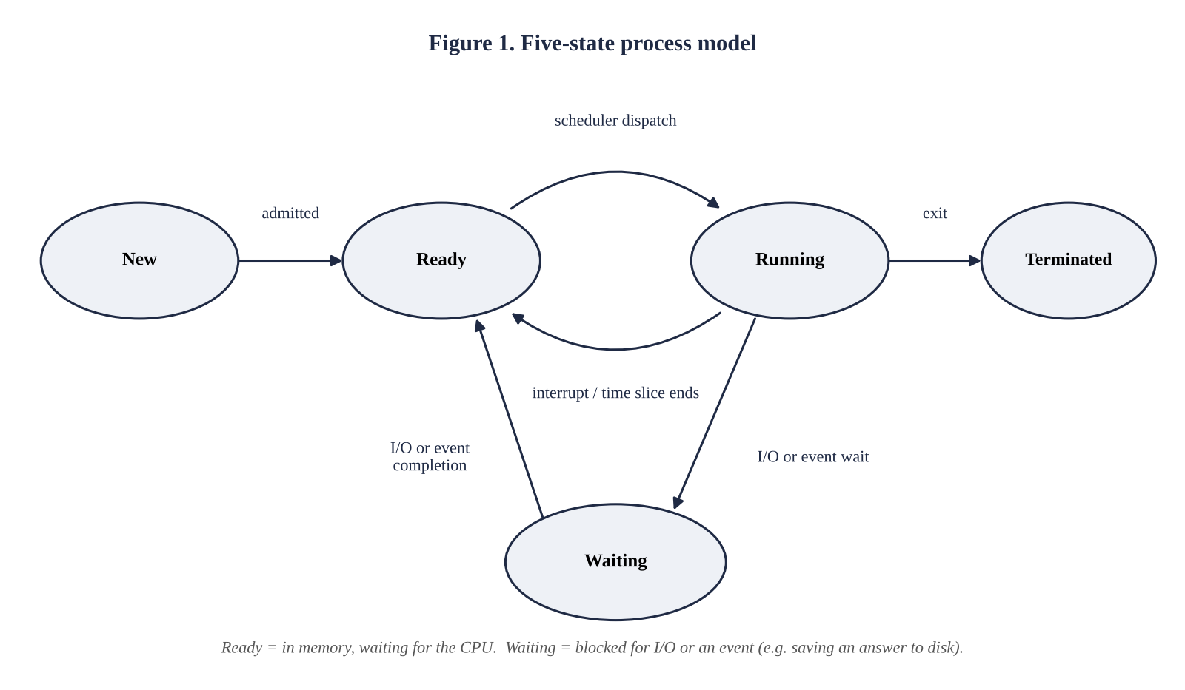
Table 1.1 State transitions
Transition | Cause | Exam-server example
New → Ready | Admitted by the long-term scheduler; PCB created, memory allocated | fork() returns for a new student session
Ready → Running | Short-term scheduler dispatches the process | Session is given a CPU core
Running → Ready | Time slice expires or a higher-priority process becomes ready (interrupt) | Session used its whole quantum
Running → Waiting | Process requests I/O or waits for an event | Session writes an answer to disk or waits for the network
Waiting → Ready | I/O or event completes (device interrupt) | Disk write finished
Running → Terminated | exit() called or the process is killed | Student submits the paper

1.3 Process control block (PCB)
The kernel represents each process by a process control block, also called a task control block. It holds everything needed to stop the process and later resume it as if nothing had happened. In Linux this structure is struct task_struct.
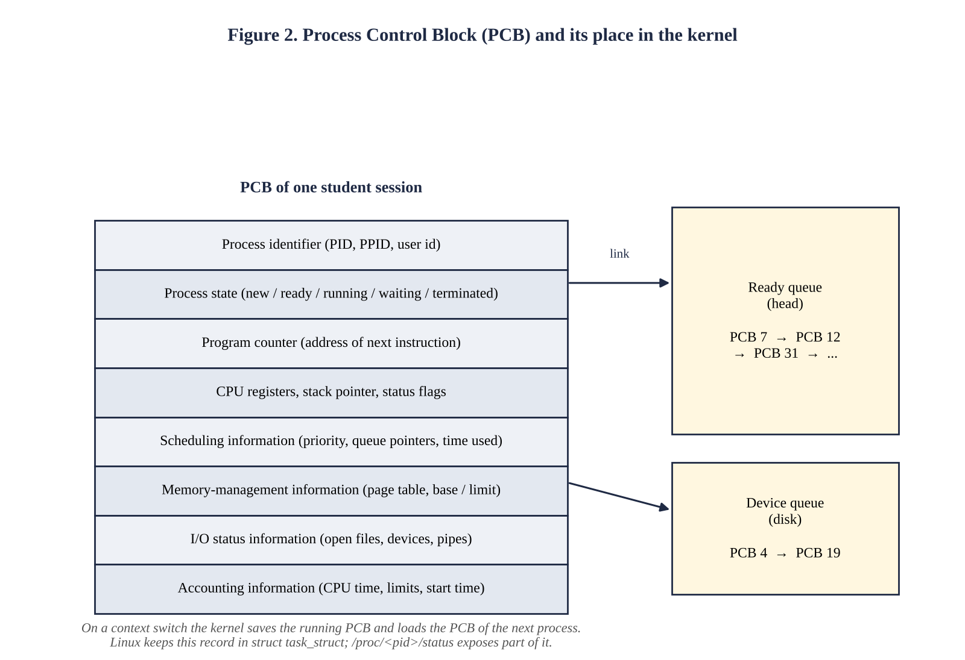
Table 1.2 PCB fields and why each is needed
Field | Content | Purpose
Process identifier | PID, parent PID, user id | Unique name; builds the process tree (fork)
Process state | new, ready, running, waiting, terminated | Tells the scheduler which queue holds the PCB
Program counter | Address of the next instruction | Resume at the correct instruction
CPU registers | Accumulators, index registers, stack pointer, flags | Restore the exact computation state
Scheduling information | Priority, queue pointers, CPU time used | Input to the scheduling algorithm
Memory-management information | Page-table pointer, segment or base/limit values | Gives the process its private address space
I/O status information | Open files, devices, pipes | Closed or inherited at exit/fork
Accounting information | CPU time used, time limits, start time | Billing, limits, statistics (ps TIME column)

Context switch. When the CPU passes from process A to process B the kernel (1) saves A's registers and program counter into A's PCB, (2) changes A's state, (3) selects B, (4) loads B's PCB into the hardware registers and (5) switches the address space. No useful work is done during these steps, so the switch time is pure overhead.

1.4 Implementation: creating processes with fork() and observing them
The program below plays the role of the exam server. The parent forks five “student sessions”. Each child prints its identity, sleeps for two seconds (the waiting state, as if waiting for I/O) and then terminates with exit status equal to its session number. The parent inspects the children with ps and /proc/<pid>/status and finally collects them with waitpid() so that no zombie remains.
Listing 1.1 q1_fork.c
#define _DEFAULT_SOURCE
#include <stdio.h>
#include <stdlib.h>
#include <string.h>
#define _DEFAULT_SOURCE
#include <unistd.h>
#include <sys/wait.h>
#define CHILDREN 5
static void show_proc(pid_t pid)
{
char path[64], line[256];
snprintf(path, sizeof path, "/proc/%d/status", (int)pid);
FILE *f = fopen(path, "r");
if (!f) { perror("fopen"); return; }
while (fgets(line, sizeof line, f))
if (!strncmp(line, "Name:", 5) || !strncmp(line, "State:", 6) ||
!strncmp(line, "Pid:", 4) || !strncmp(line, "PPid:", 5) ||
!strncmp(line, "VmRSS:", 6) || !strncmp(line, "voluntary_ctxt", 14))
printf(" %s", line);
fclose(f);
}
int main(void)
{
pid_t kids[CHILDREN];
printf("parent pid = %d\n", (int)getpid()); fflush(stdout);
for (int i = 0; i < CHILDREN; i++) {
pid_t pid = fork();
if (pid < 0) { perror("fork"); exit(1); }
if (pid == 0) { /* student session */
printf("session %d started: pid=%d ppid=%d\n", i + 1, (int)getpid(), (int)getppid());
fflush(stdout);
sleep(2); /* waiting state (I/O) */
_exit(i + 1); /* terminated state */
}
kids[i] = pid;
}
usleep(300000);
char cmd[128];
snprintf(cmd, sizeof cmd, "ps -o pid,ppid,stat,wchan:12,comm --ppid %d", (int)getpid());
printf("\n$ %s\n", cmd); fflush(stdout);
system(cmd);
printf("\n/proc/%d/status of first child:\n", (int)kids[0]);
show_proc(kids[0]);
for (int i = 0; i < CHILDREN; i++) {
int st; waitpid(kids[i], &st, 0);
printf("child %d exited with status %d\n", (int)kids[i], WEXITSTATUS(st));
}
return 0;
}
Output of q1_fork (real execution, Ubuntu 24.04, gcc 13.3.0)
parent pid = 144
session 1 started: pid=145 ppid=144
session 2 started: pid=146 ppid=144
session 3 started: pid=147 ppid=144
session 4 started: pid=148 ppid=144
session 5 started: pid=149 ppid=144

$ ps -o pid,ppid,stat,wchan:12,comm --ppid 144
PID PPID STAT WCHAN COMMAND
145 144 S hrtimer_nano q1_fork
146 144 S hrtimer_nano q1_fork
147 144 S hrtimer_nano q1_fork
148 144 S hrtimer_nano q1_fork
149 144 S hrtimer_nano q1_fork
150 144 S do_wait sh

/proc/145/status of first child:
Name: q1_fork
State: S (sleeping)
Pid: 145
PPid: 144
VmRSS: 916 kB
voluntary_ctxt_switches: 1
child 145 exited with status 1
child 146 exited with status 2
child 147 exited with status 3
child 148 exited with status 4
child 149 exited with status 5
Reading the evidence. The ps column STAT shows S (interruptible sleep = waiting state) for the five sessions and the column WCHAN shows the kernel function they sleep in (hrtimer_nano…, the nanosleep timer). Every PPID equals the parent's PID, so the parent–child tree is visible. The sh line is the shell that system() created to run ps. In /proc/129/status the field State: S (sleeping), VmRSS: 904 kB (resident memory) and voluntary_ctxt_switches: 1 come straight from the child's PCB: the single voluntary switch happened when the child blocked in sleep(). The exit statuses 1 to 5 prove that each child terminated independently and that the parent received them.

1.5 Evaluation: where does the time go with 2,000 active processes?
The second program (q1_bench.c) measures the quantities the question names. The parent first touches 50 MB of heap, as a real server does, and then creates 2,000 processes and, separately, 2,000 threads (64 KB stack each).
Output of q1_bench (real execution)
switch cost, process ping-pong : 1.35 us per switch
switch cost, thread ping-pong : 1.30 us per switch
fork : 2000 processes created in 2038.4 ms = 1019.2 us each (parent heap 50 MB, copy-on-write)
thread: 2000 threads created in 34.7 ms = 17.4 us each (64 KB stack)
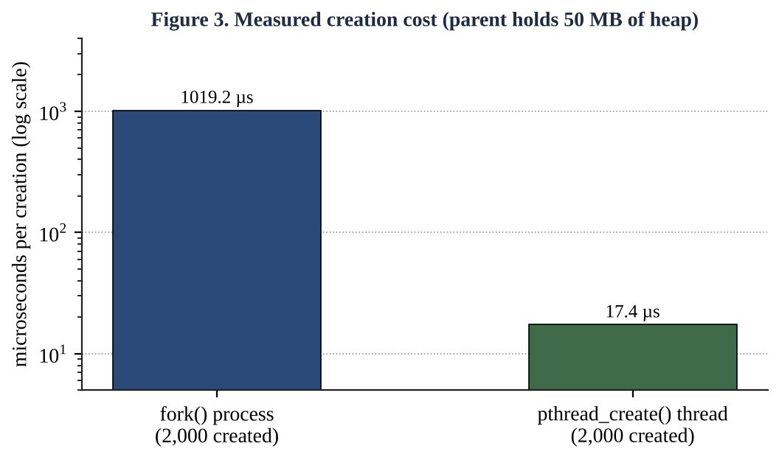
Table 1.3 Measured cost of one execution context
Quantity | Process (fork) | Thread (pthread_create) | Ratio
Creation time, 2,000 created | 1,019 µs each (2,038 ms total) | 17.4 µs each (34.7 ms total) | ≈ 59 × slower for a process
Context switch, pipe ping-pong | 1.35 µs | 1.30 µs | ≈ equal in this virtual machine
Kernel + address-space data per context | task_struct, kernel stack, page tables, private pages | task_struct, kernel stack, 64 KB user stack | process much larger

(a) Context-switch cost
A process switch has a direct cost (saving and loading the PCB, about 1 to 2 µs here) and an indirect cost: the TLB is flushed or tagged, and the CPU caches contain the previous process's data, so the new process runs slowly for a while until its working set is reloaded. With 2,000 processes on, say, 4 cores each core holds about 500 runnable-or-waiting processes. Linux's fair scheduler (CFS, and its successor EEVDF in recent kernels) aims to give every runnable task a turn within a period that grows with the number of runnable tasks; with the classical CFS defaults the period is about the number of runnable tasks × the minimum granularity of 0.75 ms. If only 20 % of the sessions are runnable (400 tasks, 100 per core) a session waits roughly 100 × 0.75 ms = 75 ms between its turns; if most are runnable it waits more than a quarter of a second. Each of these switches also pollutes the caches. This explains the “hang”: no process is stuck, each simply gets the CPU rarely.

(b) Memory per process
A forked child shares its parent's pages copy-on-write, but every page it modifies is copied, and the kernel must still allocate a task_struct, a kernel stack (16 KB on x86-64) and page tables for it. Using explicit assumptions, the total for 2,000 sessions can be modelled as:
Table 1.4 Memory model for 2,000 student sessions (assumptions stated; replace by your own VmRSS/PSS measurement)
Component per session | Process per student | Thread per student
Private runtime data (language runtime, buffers, copied pages) | 8 MB | 0.5 MB (session data only; runtime shared)
Page tables and kernel structures | ≈ 0.1 MB | ≈ 0.03 MB
User stack | included above | 0.06 MB (64 KB)
Total per session | ≈ 8.1 MB | ≈ 0.6 MB
Total for 2,000 sessions | ≈ 16.2 GB | ≈ 1.2 GB

The assumption of 8 MB private memory is reasonable for a process that embeds a runtime; the measured minimal child in Listing 1.1 already had 904 kB resident. When physical memory is exhausted the kernel swaps, and swapping makes the “waiting” state last milliseconds instead of microseconds — the second cause of hanging sessions.

(c) Time spent waiting for I/O
Answer-saving and video streaming are I/O-bound: if a process spends a fraction p of its time waiting, the probability that all n resident processes wait together is p^n, so CPU utilisation is approximately 1 − p^n. For p = 0.8, utilisation is 67 % with n = 5, 89 % with n = 10 and 99 % with n = 20. Beyond a few dozen processes per core extra processes add almost no utilisation, only memory and switching overhead. Hence 2,000 processes on a few cores is far past the useful point.

Judgement
A separate process per student is not a sound design at this scale. It is sound for isolation (one crashed session cannot corrupt another) but it costs 59 times more to create, about 13 times more memory per session in our model, and it overloads the scheduler. The logical flaw is treating “session” and “schedulable entity” as the same thing: a session is mostly idle (waiting for a student who is reading), so it needs a data structure, not a dedicated CPU context.

1.6 Design decision
Table 1.5 Comparison of the three designs
Criterion | One process per student | One thread per student | Fixed pool of worker processes
Creation cost | High (≈ 1 ms) | Low (≈ 17 µs) | Paid once at start-up
Memory for 2,000 sessions | ≈ 16 GB | ≈ 1.2 GB | ≈ 16 workers × 100 MB = 1.6 GB
Context switches | Many, expensive | Many, cheaper | Few (workers ≈ cores)
Isolation / crash effect | Excellent | One crash kills all sessions | Crash kills only one worker (1/16 of users)
Scalability to 10,000 users | Poor | Limited by thread count | Good (event loop per worker)
Complexity | Simple | Needs locks | Needs a dispatcher and session store

Decision: a fixed pool of worker processes (about one to two per core), each multiplexing many sessions with a small thread pool or an event loop; proctoring video runs in its own separate process group. Reasons: (1) the number of schedulable entities stays near the number of cores, so the scheduler period stays short and the 75 ms to 375 ms waits disappear; (2) memory is bounded by the pool size, not by the number of users; (3) a defect in one session can take down at most one worker (1/16 of students), whose sessions are restored from the auto-saved answers, which is much better than the all-or-nothing failure of a single multithreaded process; (4) creation cost is paid once at start-up. The price is the extra engineering of a dispatcher and externalised session state.

1.7 Alternative concept and complexity analysis: one thread per session inside one server process
Solution. The server starts once, then calls pthread_create() for every login. All threads share the address space (code, heap, open sockets, the exam question bank) and have only a private stack, registers and thread id. A shared structure such as the list of active sessions must be protected with a mutex (Q5).
Table 1.6 Process versus thread per session (n sessions)
Measure | Process per session | Thread per session
Creation time | T_fork = c₁ + c₂·(mapped pages) ≈ 1,019 µs measured; grows with parent size | T_thread ≈ 17 µs measured; independent of heap size
Memory | O(n·(S + A)) : S stack/kernel, A private address space | O(n·S + A) : address space shared once
Context switch | Address-space switch + TLB/cache effects | Registers and stack only, same address space
Data sharing | IPC (pipes, shared memory) needed – O(copy) | Direct shared variables – O(1) but needs locks
Effect of one crash | Isolated: one session lost | Whole server dies: all n sessions lost
Scheduler work per decision | O(1) per decision, but n entities → long period | same count of entities: period still grows with n

Context-switch time. Switching between threads of one process saves and restores only registers and the stack pointer; it keeps the address space, so the TLB and caches stay warm. A process switch must also change the page-table base register, which flushes untagged TLB entries. Per switch: T_proc ≈ T_thread + T_TLB/cache refill. Memory per session: a thread needs a stack of a few KB to 64 KB and a kernel stack, whereas a process needs a full address-space description (page tables, VMAs) plus its private pages — in our model 0.6 MB against 8.1 MB. Crash effect: a segmentation fault in any thread terminates the entire process, so thread-per-session turns a single-session failure into a total outage; the pool of worker processes chosen above limits that blast radius.

1.8 Evidence summary for Q1
- State diagram (Figure 1) and PCB description (Figure 2, Table 1.2).
- Working fork() program with ps and /proc evidence (Listing 1.1 and its output).
- Measured creation and switching costs (Table 1.3) and the memory/I-O model (Table 1.4).
- A defended design decision: fixed pool of worker processes (Section 1.6).

Q2 CPU Scheduling (8 marks)

2.1 Problem and model
A cloud video-encoding service runs short jobs (thumbnails, 2 s) and long jobs (full films, 20 min) on the same servers. Customers complain that small jobs wait behind large ones, while the company wants the processors fully used. Scheduling is the mechanism that decides which ready process receives the CPU, so the complaint is a statement about scheduling policy.
The criteria used throughout are defined for a process with arrival time A, burst time B and completion time C:
- Turnaround time TAT = C − A (total time in the system).
- Waiting time WT = TAT − B (time spent in the ready queue).
- Response time RT = (time of first execution) − A (how soon the job first reacts).
- CPU utilisation and throughput (jobs per unit time); context switches (overhead).
The same four-job workload is used for all algorithms so that the results are directly comparable (the same job set as the Round Robin program supplied with the question). Priorities are assigned for the priority algorithm; a smaller number means higher priority.
Table 2.1 Job set
Process | Arrival | Burst | Priority
P1 | 0 | 8 | 2
P2 | 1 | 4 | 3
P3 | 2 | 9 | 1
P4 | 3 | 5 | 4

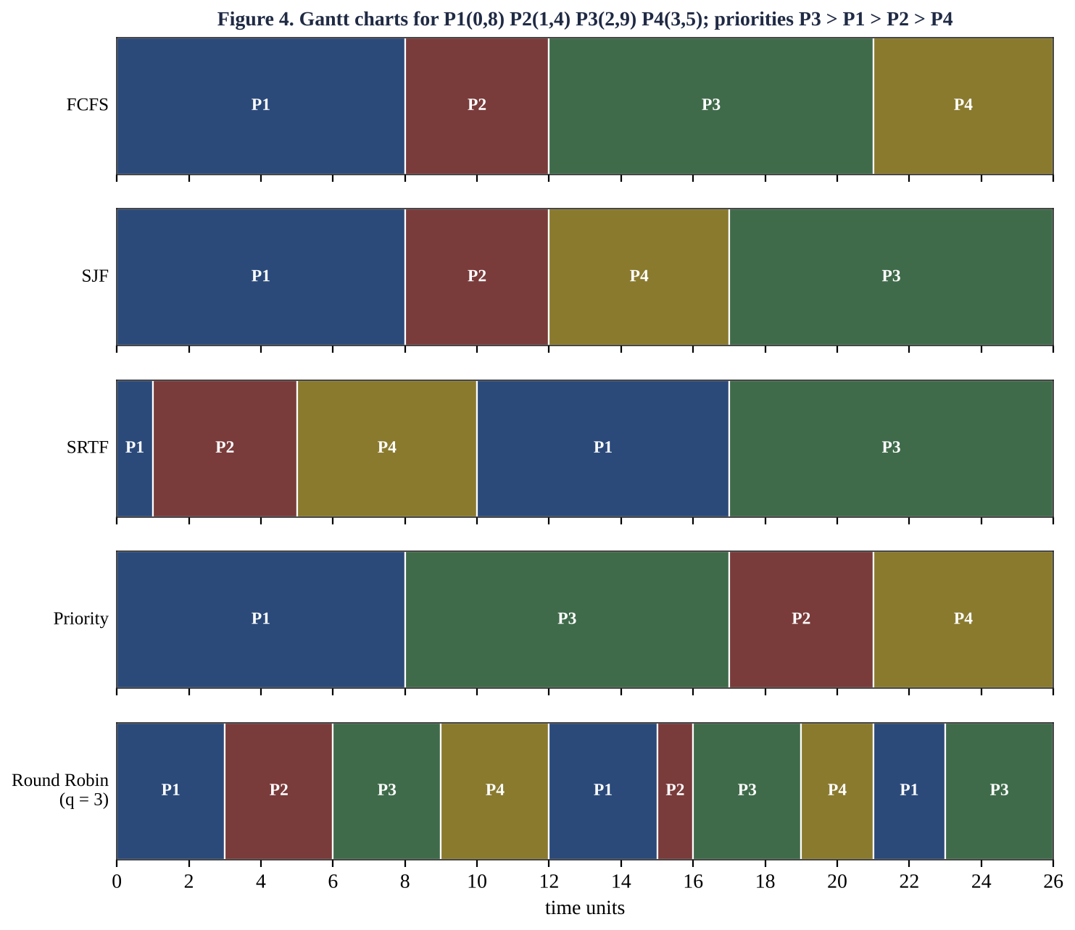

2.2 Gantt charts, waiting, turnaround and response times

(a) First-Come First-Served (FCFS)
Jobs run in arrival order without pre-emption: P1(0-8) P2(8-12) P3(12-21) P4(21-26). P1 starts at 0 and holds the CPU until 8, so P2, which needs only 4 units, waits 7 units. This is the convoy effect: short jobs queue behind a long one — exactly the customers' complaint.
Process | Arrival | Burst | Completion | TAT | WT | RT
P1 | 0 | 8 | 8 | 8 | 0 | 0
P2 | 1 | 4 | 12 | 11 | 7 | 7
P3 | 2 | 9 | 21 | 19 | 10 | 10
P4 | 3 | 5 | 26 | 23 | 18 | 18
Average |  |  |  | 15.25 | 8.75 | 8.75

(b) Shortest-Job-First (SJF, non-pre-emptive)
At every completion the shortest ready job is chosen. At t = 0 only P1 is present, so it runs to 8. At t = 8, P2 (4), P3 (9) and P4 (5) are ready: P2, then P4, then P3. Gantt: P1(0-8) P2(8-12) P4(12-17) P3(17-26). SJF is provably optimal for average waiting time among non-pre-emptive schedules, but it needs the burst length in advance (estimated by exponential averaging τ(n+1) = α·t(n) + (1 − α)·τ(n)).
Process | Arrival | Burst | Completion | TAT | WT | RT
P1 | 0 | 8 | 8 | 8 | 0 | 0
P2 | 1 | 4 | 12 | 11 | 7 | 7
P3 | 2 | 9 | 26 | 24 | 15 | 15
P4 | 3 | 5 | 17 | 14 | 9 | 9
Average |  |  |  | 14.25 | 7.75 | 7.75

(c) Shortest-Remaining-Time-First (SRTF, pre-emptive SJF)
When a job arrives whose burst is shorter than the remaining time of the running job, it pre-empts. At t = 1, P2 (4) is shorter than P1's remaining 7, so P1 is pre-empted; at t = 2 P3 (9) and at t = 3 P4 (5) do not beat P2's remaining time. Gantt: P1(0-1) P2(1-5) P4(5-10) P1(10-17) P3(17-26). This policy gives the lowest average waiting time of all five.
Process | Arrival | Burst | Completion | TAT | WT | RT
P1 | 0 | 8 | 17 | 17 | 9 | 0
P2 | 1 | 4 | 5 | 4 | 0 | 0
P3 | 2 | 9 | 26 | 24 | 15 | 15
P4 | 3 | 5 | 10 | 7 | 2 | 2
Average |  |  |  | 13.00 | 6.50 | 4.25

(d) Priority scheduling (non-pre-emptive)
Priorities are P3 (1) > P1 (2) > P2 (3) > P4 (4). P1 is alone at t = 0 and runs to 8; then P3, P2, P4 in priority order. Gantt: P1(0-8) P3(8-17) P2(17-21) P4(21-26). Priority order ignores burst length, so P2 (a short job of low priority) waits 16 units. The important job P3 waits 6 units instead of 10 under FCFS, but the overall average waiting time (10.00) is worse than FCFS and SJF.
Process | Arrival | Burst | Completion | TAT | WT | RT
P1 | 0 | 8 | 8 | 8 | 0 | 0
P2 | 1 | 4 | 21 | 20 | 16 | 16
P3 | 2 | 9 | 17 | 15 | 6 | 6
P4 | 3 | 5 | 26 | 23 | 18 | 18
Average |  |  |  | 16.50 | 10.00 | 10.00

(e) Round Robin (time quantum 3)
Each job runs for at most one quantum and, if unfinished, returns to the tail of the ready queue. Gantt: P1(0-3) P2(3-6) P3(6-9) P4(9-12) P1(12-15) P2(15-16) P3(16-19) P4(19-21) P1(21-23) P3(23-26). Response time is excellent (average 3.0) because every job starts within a few quanta, but waiting and turnaround times are the worst of the five, because jobs are interleaved and finish late.
Process | Arrival | Burst | Completion | TAT | WT | RT
P1 | 0 | 8 | 23 | 23 | 15 | 0
P2 | 1 | 4 | 16 | 15 | 11 | 2
P3 | 2 | 9 | 26 | 24 | 15 | 4
P4 | 3 | 5 | 21 | 18 | 13 | 6
Average |  |  |  | 20.00 | 13.50 | 3.00

Table 2.2 Comparison for the job set
Algorithm | Avg TAT | Avg WT | Avg RT | Pre-emptive | Starvation risk
FCFS | 15.25 | 8.75 | 8.75 | no | no
SJF | 14.25 | 7.75 | 7.75 | no | yes
SRTF | 13.00 | 6.50 | 4.25 | yes | yes
Priority | 16.50 | 10.00 | 10.00 | no | yes
Round Robin (q=3) | 20.00 | 13.50 | 3.00 | yes | no

Verification. The Round Robin row was reproduced twice: by the Python model used for the table and by the C program below, whose output for quantum 3 matches the expected output of the question exactly (average TAT 20.00, average WT 13.50).

2.3 Complete the Code: Round Robin in C
TODO 1 was completed as follows. The process p taken from the queue runs for min(quantum, left[p]) time units; the Gantt entry is printed; time advances; every process that has now arrived and is not yet in the queue is appended before p is re-queued (this ordering rule matters: a job that arrives during p's slice gets in line ahead of p); finally p is appended again if it still has work, otherwise its finish time is recorded. The program was extended only by reading the quantum from the command line and counting context switches (a change of running process between consecutive slices).
Listing 2.1 q2_rr.c (TODO 1 completed)
#include <stdio.h>
#include <stdlib.h>
#define N 4
int main(int argc, char **argv)
{
const char *name[N] = {"P1", "P2", "P3", "P4"};
int arrival[N] = {0, 1, 2, 3};
int burst[N] = {8, 4, 9, 5};
int quantum = argc > 1 ? atoi(argv[1]) : 3;
int left[N], finish[N], queue[256], head = 0, tail = 0, added[N] = {0};
for (int i = 0; i < N; i++) left[i] = burst[i];
int time = 0, done = 0, switches = 0, last = -1;
queue[tail++] = 0;
added[0] = 1;
printf("Gantt:");
while (done < N) {
int p = queue[head++];
/* TODO 1 completed */
int run = left[p] < quantum ? left[p] : quantum;
printf(" %s(%d-%d)", name[p], time, time + run);
time += run;
left[p] -= run;
if (last != -1 && last != p) switches++;
last = p;
for (int i = 0; i < N; i++)
if (!added[i] && arrival[i] <= time) { queue[tail++] = i; added[i] = 1; }
if (left[p] > 0) queue[tail++] = p;
else { finish[p] = time; done++; }
}
double tw = 0, tt = 0;
printf("\nProcess TAT WT\n");
for (int i = 0; i < N; i++) {
int tat = finish[i] - arrival[i], wt = tat - burst[i];
tt += tat;
tw += wt;
printf("%-7s %4d %3d\n", name[i], tat, wt);
}
printf("Average TAT = %.2f, average WT = %.2f\n", tt / N, tw / N);
printf("Context switches = %d\n", switches);
return 0;
}
Output for quantum 3 (matches the expected output) and for quantum 1 and 20
== quantum 3
Gantt: P1(0-3) P2(3-6) P3(6-9) P4(9-12) P1(12-15) P2(15-16) P3(16-19) P4(19-21) P1(21-23) P3(23-26)
Process TAT WT
P1 23 15
P2 15 11
P3 24 15
P4 18 13
Average TAT = 20.00, average WT = 13.50
Context switches = 9
== quantum 1
Gantt: P1(0-1) P2(1-2) P1(2-3) P3(3-4) P2(4-5) P4(5-6) P1(6-7) P3(7-8) P2(8-9) P4(9-10) P1(10-11) P3(11-12)
P2(12-13) P4(13-14) P1(14-15) P3(15-16) P4(16-17) P1(17-18) P3(18-19) P4(19-20) P1(20-21) P3(21-22)
P1(22-23) P3(23-24) P3(24-25) P3(25-26)
Process TAT WT
P1 23 15
P2 12 8
P3 24 15
P4 17 12
Average TAT = 19.00, average WT = 12.50
Context switches = 23
== quantum 20
Gantt: P1(0-8) P2(8-12) P3(12-21) P4(21-26)
Process TAT WT
P1 8 0
P2 11 7
P3 19 10
P4 23 18
Average TAT = 15.25, average WT = 8.75
Context switches = 3

2.4 Evaluation of the time quantum
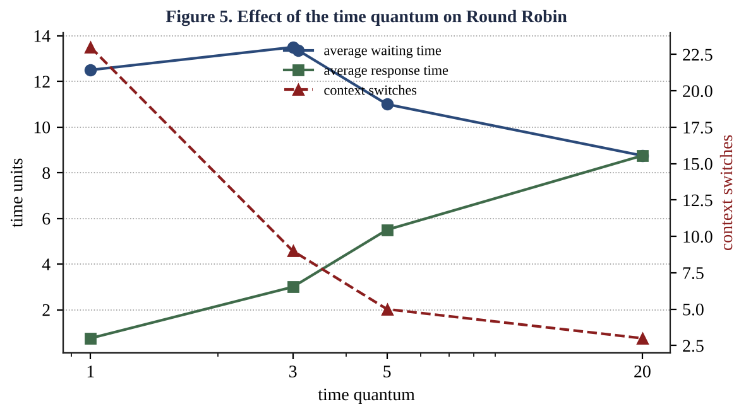
Table 2.3 Round Robin with quantum 1, 3, 5 and 20 (same job set)
Quantum | Avg TAT | Avg WT | Avg RT | Context switches
1 | 19.00 | 12.50 | 0.75 | 23
3 | 20.00 | 13.50 | 3.00 | 9
5 | 17.50 | 11.00 | 5.50 | 5
20 | 15.25 | 8.75 | 8.75 | 3

Interpretation. With quantum 1 the average response time is only 0.75 but the system performs 23 context switches in 26 time units; with a real switch cost of c, overhead is c × 23 added to useful work of 26 units, so if c is 10 % of a unit, about 8 % of the CPU time is lost. With quantum 20 (larger than every burst) Round Robin degenerates into FCFS: only 3 switches, best average waiting time (8.75) but response time equal to waiting time (8.75), i.e. the convoy effect returns. Quantum 3 and 5 sit between the extremes. The rule of thumb is that the quantum should be longer than most interactive bursts (about 80 % of bursts shorter than the quantum) and much longer than the switch time.

Starvation and ageing
SJF/SRTF and priority scheduling can starve a job indefinitely: if a stream of short jobs (or high-priority jobs) keeps arriving, a long (or low-priority) job never reaches the head of the queue. In the film service, a 20-minute film could wait forever behind thumbnails. Ageing removes starvation by increasing the priority of a waiting job as time passes, for example priority = base − ⌊waiting time / 60 s⌋: after at most (priority levels × 60 s) the oldest job is the highest-priority job and must run. Ageing bounds the waiting time while keeping the preference for short jobs in the short term.

Multilevel feedback queue (MLFQ)
An MLFQ keeps several queues with different quanta and policy, and lets processes move between them according to their behaviour.
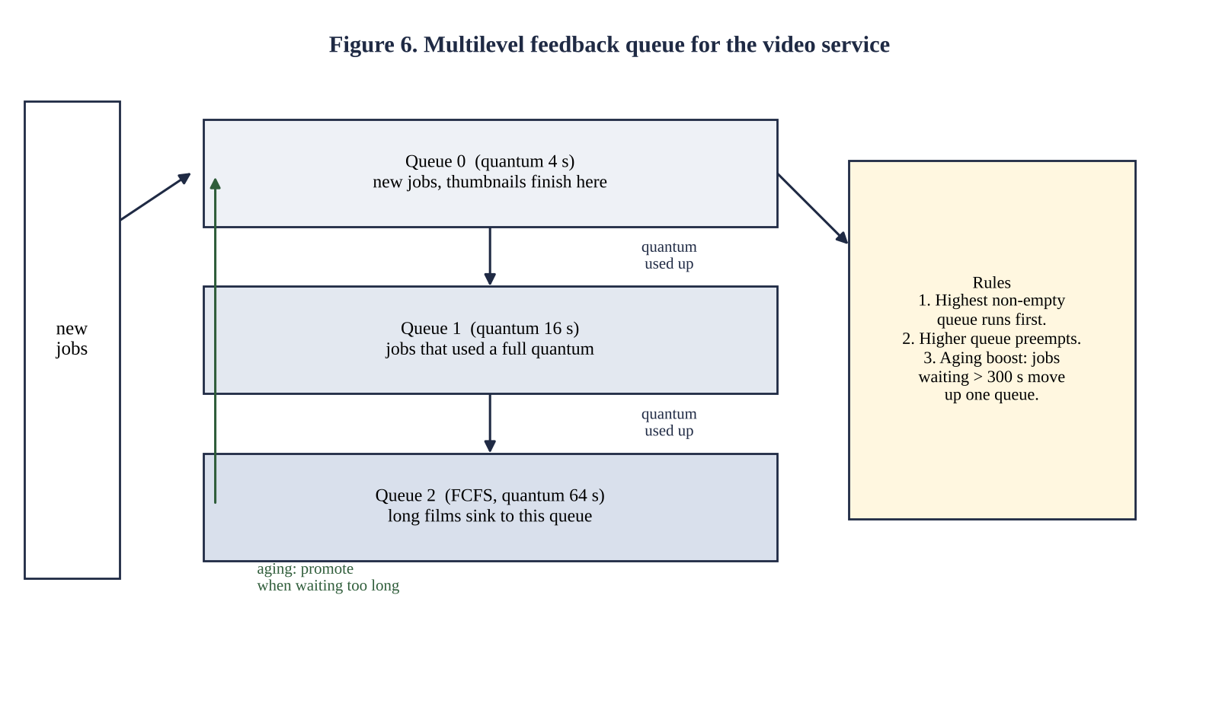
A new job enters queue 0 with a short quantum (4 s). A thumbnail needs 2 s, so it finishes in queue 0 and never leaves it: it is treated like a short job without anyone knowing its burst length in advance. A film uses its full quantum, is demoted to queue 1 (quantum 16 s) and then to queue 2 (FCFS-like, 64 s) where it runs with few interruptions and therefore few context switches. A higher queue pre-empts a lower one, so new thumbnails always overtake films. Ageing promotes a film that has waited too long, preventing starvation.

2.5 Video-service workload and design decision
To decide for the actual service, a workload with the stated sizes was simulated: two films of 1,200 s arriving at t = 0 and t = 5, and four thumbnails of 2 s arriving at t = 1, 2, 3 and 6 (times in seconds). Average waiting times were computed for each policy.
Table 2.4 Average waiting time (seconds) of short and long jobs
Policy | Thumbnails (2 s) | Films (20 min) | Remark
FCFS | 1500.0 | 600.5 | Convoy effect: thumbnails wait 20 min
SJF (non-pre-emptive) | 1200.0 | 601.5 | Film started at t=0 cannot be pre-empted
Round Robin, q = 4 s | 6.0 | 1201.5 | Good for short jobs, many switches
Round Robin, q = 60 s | 75.0 | 1175.5 | Thumbnails wait up to a quantum
MLFQ 4 / 16 / 64 s | 5.0 | 1191.5 | Best short-job result; films finish at the same time

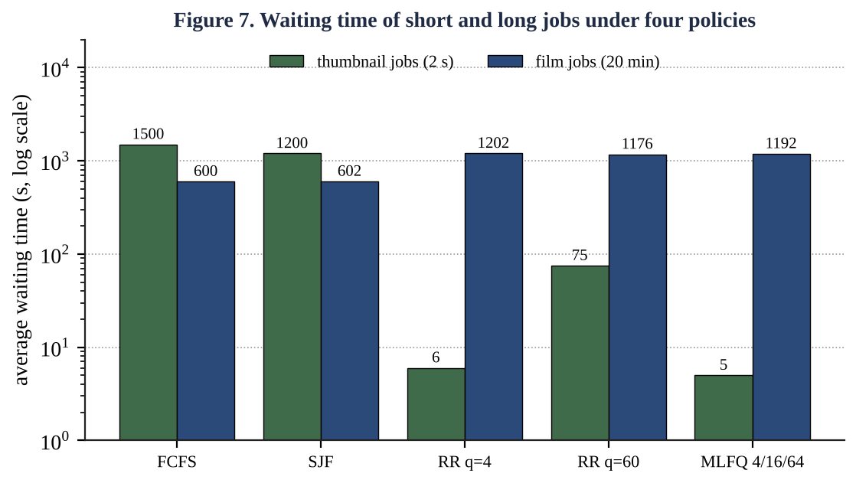
Recommendation: a multilevel feedback queue (queue quanta about 4 s / 16 s / 64 s, higher queue pre-empts, ageing every few minutes). It lowers the thumbnails' average wait from 1,500 s (FCFS) and 1,200 s (SJF) to 5 s, while the films' average wait changes only from 600 s to about 1,192 s, i.e. the films finish at almost the same time because the total work is unchanged and the processors remain fully busy (utilisation is not reduced by any of these policies). Pure Round Robin helps the thumbnails as well, but it must use a small quantum, giving many switches for the long films; MLFQ gives long jobs a long quantum automatically. SJF or SRTF need burst predictions and can starve films.

2.6 Alternative concept and complexity analysis: MLFQ instead of one Round Robin queue
Table 2.5 Single Round Robin queue versus MLFQ versus SJF
Measure | Single RR queue | MLFQ (k levels) | SJF / SRTF
Average waiting time of short jobs | Depends on q: q = 4 gives 6 s; q = 60 gives 75 s | 5 s (finish inside queue 0) | 1,200 s here: the film was already running and cannot be pre-empted; pre-emptive SRTF would fix this
Average waiting time of long jobs | 1,201.5 s (q = 4) | 1,191.5 s | 601.5 s (films run first)
Scheduling cost per decision | O(1) (take queue head) | O(1) per queue, O(k) to find the first non-empty queue, k constant | O(n) scan, or O(log n) with a heap
Space | O(n) | O(n) plus k queues | O(n)
Context switches | Many for long jobs when q small | Few for long jobs (large quantum at low levels) | Few (SJF) or one per arrival (SRTF)
Starvation risk | None | Possible for long jobs; removed by ageing boost | High unless ageing is added

Reasoning. For n ready jobs, choosing the shortest job requires finding a minimum: O(n) with a list, O(log n) per operation with a heap. An MLFQ with k fixed levels needs only O(1) per queue operation, because the next job is the head of the first non-empty queue (k is a small constant such as 3 to 8). Its price is complexity of tuning (number of queues, quanta, promotion rule) and the possibility of gaming (a process that voluntarily yields just before its quantum ends stays in a high queue; the fix is to account for total CPU time used at a level).

2.7 Evidence summary for Q2
- Correct Gantt charts and averages for FCFS, SJF, SRTF, priority and Round Robin (Figure 4, Tables 2.2).
- Working Round Robin program with matching expected output (Listing 2.1).
- Quantum study for 1, 3, 5, 20 (Table 2.3, Figure 5).
- Justified recommendation using calculated averages (Table 2.4, Figure 7): multilevel feedback queue with ageing.

Q3 Threads (6 marks)

3.1 Problem and model
A city traffic system reads number plates from 64 cameras. The first version processes the cameras one after another and falls behind during peak hours. The cameras are independent of one another, so the work is data-parallel: the same operation (plate detection) is applied to 64 independent frames. A thread is the unit of CPU execution inside a process; several threads of one process can run at the same time on different cores while sharing the process's memory.

3.2 Resources shared by threads and resources private to each thread
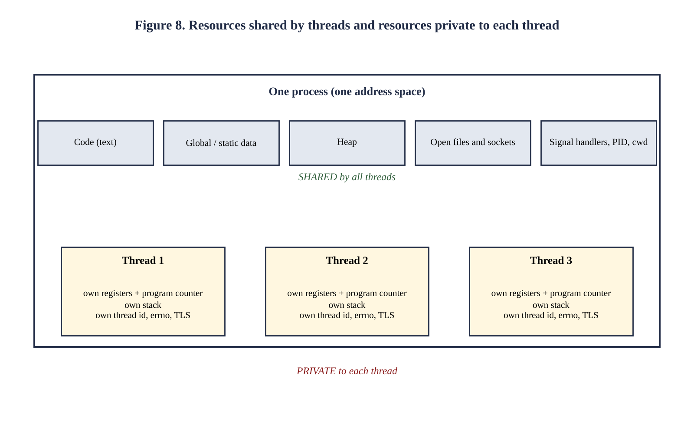
Table 3.1 Shared and private resources
Shared by all threads of a process | Private to each thread
Code (text) section | Thread id
Global and static data | Program counter and CPU registers
Heap (malloc memory) | Stack (local variables, return addresses)
Open files, sockets, working directory | Thread-local storage, errno
Signal handlers, process id, user id | Scheduling priority and signal mask

Because the heap and globals are shared, communication between threads is just a memory access, which is fast but dangerous: it creates the race conditions studied in Section 3.6.

3.3 User-level and kernel-level threads; multithreading models
Table 3.2 User-level versus kernel-level threads
Aspect | User-level threads | Kernel-level threads
Managed by | A thread library in user space; the kernel sees one process | The operating-system kernel
Creation and switch cost | Very low (function call, no system call) | Higher (system call, kernel data structures)
Blocking system call | Blocks the whole process (all threads) | Only the calling thread blocks; others run
Multiprocessor use | Cannot run two threads at the same instant | Threads run on different cores in parallel
Scheduling | Library scheduler; no pre-emption by the kernel | Kernel scheduler, pre-emptive
Example | Green threads, early Java, GNU Pth | Linux NPTL pthreads, Windows threads

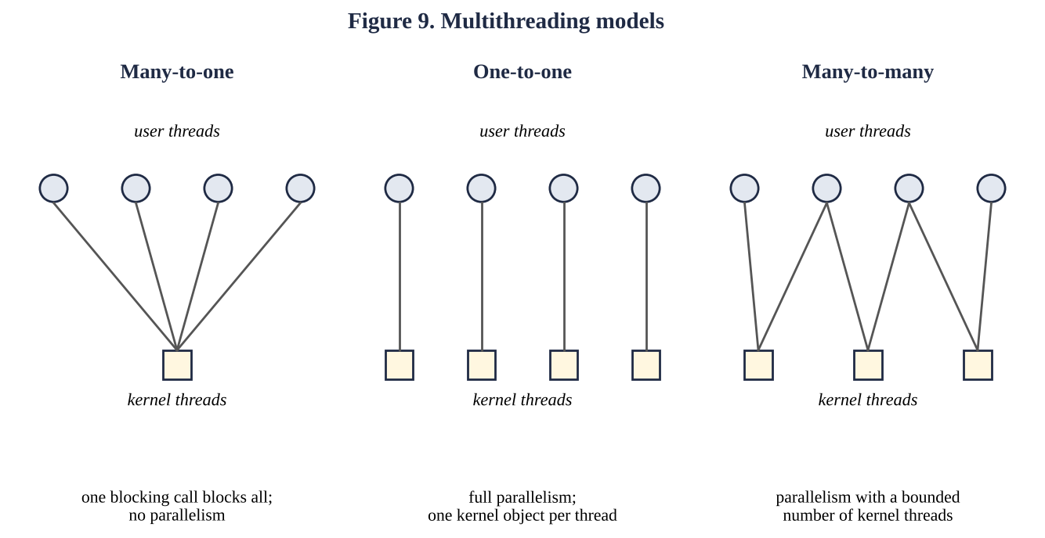
Table 3.3 Mapping models
Model | Mapping | Advantage | Disadvantage
Many-to-one | Many user threads → one kernel thread | Cheap thread management | No parallelism; one blocking call blocks all
One-to-one | Each user thread → its own kernel thread | True parallelism; blocking is local (used by Linux, Windows) | One kernel object per thread limits the number of threads
Many-to-many | n user threads → m ≤ n kernel threads | Parallelism with a bounded number of kernel threads | Complex to implement (Solaris early versions)

POSIX threads on Linux (the NPTL library used below) implement the one-to-one model, so the program can use all cores that the machine has.

3.4 Implementation: processing 64 camera frames
The program q3_threads.c simulates plate recognition on 64 frames of 4,096 pixels each (a repeated filter pass of about 4 ms per frame). It runs the work in six ways: serially, with one thread per camera (64 threads), with pools of 4, 8 and 16 threads that fetch the next camera number from an atomic counter (self-scheduling work queue), and, for the alternative design of Section 3.7, with 4 and 8 processes. Each variant is run three times and the best time is kept to reduce noise from other activity.
Listing 3.1 q3_threads.c
#define _GNU_SOURCE
#include <stdio.h>
#include <stdlib.h>
#include <unistd.h>
#include <pthread.h>
#include <sched.h>
#include <stdatomic.h>
#include <time.h>
#include <sys/wait.h>
#define CAMERAS 64
#define PIXELS 4096
static volatile unsigned char frame[CAMERAS][PIXELS];
static volatile unsigned long result[CAMERAS];
static atomic_int next_cam;
static double now(void){struct timespec t;clock_gettime(CLOCK_MONOTONIC,&t);return t.tv_sec+t.tv_nsec*1e-9;}
/* stand-in for plate detection: repeated convolution-like pass over the frame */
static unsigned long process_frame(int c)
{
unsigned long acc = 0;
for (int rep = 0; rep < 600; rep++)
for (int i = 1; i < PIXELS - 1; i++)
acc += (unsigned long)(frame[c][i-1] + 2*frame[c][i] + frame[c][i+1]) ^ (unsigned long)rep;
return acc;
}
static void *one_camera(void *a){int c=(int)(long)a;result[c]=process_frame(c);return NULL;}
static void *pool_worker(void *a){(void)a;int c;while((c=atomic_fetch_add(&next_cam,1))<CAMERAS)result[c]=pr
ocess_frame(c);return NULL;}
static double run_serial(void){double t=now();for(int c=0;c<CAMERAS;c++)result[c]=process_frame(c);return
now()-t;}
static double run_per_camera(void){pthread_t th[CAMERAS];double t=now();for(long
c=0;c<CAMERAS;c++)pthread_create(&th[c],NULL,one_camera,(void*)c);for(int
c=0;c<CAMERAS;c++)pthread_join(th[c],NULL);return now()-t;}
static double run_pool(int n){pthread_t th[64];atomic_store(&next_cam,0);double t=now();for(int
i=0;i<n;i++)pthread_create(&th[i],NULL,pool_worker,NULL);for(int i=0;i<n;i++)pthread_join(th[i],NULL);return
now()-t;}
static double run_processes(int n)
{
int fd[2]; pipe(fd); double t=now();
for(int k=0;k<n;k++){ if(fork()==0){ close(fd[0]); for(int c=k;c<CAMERAS;c+=n){ unsigned long
r=process_frame(c); struct {int c; unsigned long r;} m={c,r}; write(fd[1],&m,sizeof m);} _exit(0);} }
close(fd[1]); struct {int c; unsigned long r;} m; int got=0;
while(read(fd[0],&m,sizeof m)==sizeof m){result[m.c]=m.r;got++;}
while(wait(NULL)>0); (void)got; return now()-t;
}
/* race demonstration */
#define INC 2000000
static volatile long unsafe_counter; static long mutex_counter; static atomic_long atomic_counter;
static pthread_mutex_t lk=PTHREAD_MUTEX_INITIALIZER;
static void *inc_unsafe(void*a){(void)a;for(int i=0;i<INC;i++)unsafe_counter++;return NULL;}
static void *inc_window(void*a){(void)a;for(int i=0;i<INC/100;i++){long t=unsafe_counter;
if(i%50==0)sched_yield(); unsafe_counter=t+1;}return NULL;}
static void *inc_mutex(void*a){(void)a;for(int i=0;i<INC;i++){pthread_mutex_lock(&lk);mutex_counter++;pthrea
d_mutex_unlock(&lk);}return NULL;}
static void *inc_atomic(void*a){(void)a;for(int i=0;i<INC;i++)atomic_fetch_add(&atomic_counter,1);return
NULL;}
static void race(void*(*f)(void*),const char*nm,long expect,volatile long*c,atomic_long*ac)
{
pthread_t th[4]; double t=now();
for(int i=0;i<4;i++)pthread_create(&th[i],NULL,f,NULL);
for(int i=0;i<4;i++)pthread_join(th[i],NULL);
long v=c?*c:atomic_load(ac);
printf("%-34s expected %8ld, got %8ld, lost %7ld, %.3f s\n",nm,expect,v,expect-v,now()-t);
}
int main(void)
{
for(int c=0;c<CAMERAS;c++)for(int i=0;i<PIXELS;i++)frame[c][i]=(unsigned char)((c*31+i*7)&255);
printf("CPU cores available: %ld\n",sysconf(_SC_NPROCESSORS_ONLN));
double ts=0; for(int k=0;k<3;k++){double x=run_serial(); if(k==0||x<ts)ts=x;}
printf("%-28s %7.3f s speed-up 1.00\n","serial (1 thread)",ts);
double b;
b=1e9;for(int k=0;k<3;k++){double x=run_per_camera();if(x<b)b=x;} printf("%-28s %7.3f s speed-up
%.2f\n","64 threads (1 per camera)",b,ts/b);
int ps[]={4,8,16};
for(int j=0;j<3;j++){b=1e9;for(int k=0;k<3;k++){double x=run_pool(ps[j]);if(x<b)b=x;} printf("pool of
%-2d threads %7.3f s speed-up %.2f\n",ps[j],b,ts/b);}
for(int j=0;j<2;j++){int n=j?8:4;b=1e9;for(int k=0;k<3;k++){double x=run_processes(n);if(x<b)b=x;}
printf("%d processes + pipe %7.3f s speed-up %.2f\n",n,b,ts/b);}
printf("\nShared counter, 4 threads:\n");
race(inc_unsafe,"no protection (natural)",4L*INC,&unsafe_counter,NULL);
unsafe_counter=0; race(inc_window,"no protection (window widened)",4L*(INC/100),&unsafe_counter,NULL);
race(inc_mutex,"mutex",4L*INC,&mutex_counter,NULL);
race(inc_atomic,"atomic_fetch_add",4L*INC,NULL,&atomic_counter);
return 0;
}

3.5 Measured speed-up and why it stops increasing
Output of q3_threads (real execution)
CPU cores available: 1
serial (1 thread) 0.272 s speed-up 1.00
64 threads (1 per camera) 0.260 s speed-up 1.05
pool of 4 threads 0.254 s speed-up 1.07
pool of 8 threads 0.258 s speed-up 1.05
pool of 16 threads 0.253 s speed-up 1.08
4 processes + pipe 0.271 s speed-up 1.00
8 processes + pipe 0.259 s speed-up 1.05

Shared counter, 4 threads:
no protection (natural) expected 8000000, got 4511135, lost 3488865, 0.021 s
no protection (window widened) expected 80000, got 20000, lost 60000, 0.002 s
mutex expected 8000000, got 8000000, lost 0, 0.199 s
atomic_fetch_add expected 8000000, got 8000000, lost 0, 0.062 s
Table 3.4 Speed-up S = T_serial / T_parallel (measured on a machine with 1 core)
Variant | Time (s) | Speed-up
Serial (1 thread) | 0.272 | 1.00
64 threads, one per camera | 0.260 | 1.05
Pool of 4 threads | 0.254 | 1.07
Pool of 8 threads | 0.258 | 1.05
Pool of 16 threads | 0.253 | 1.08

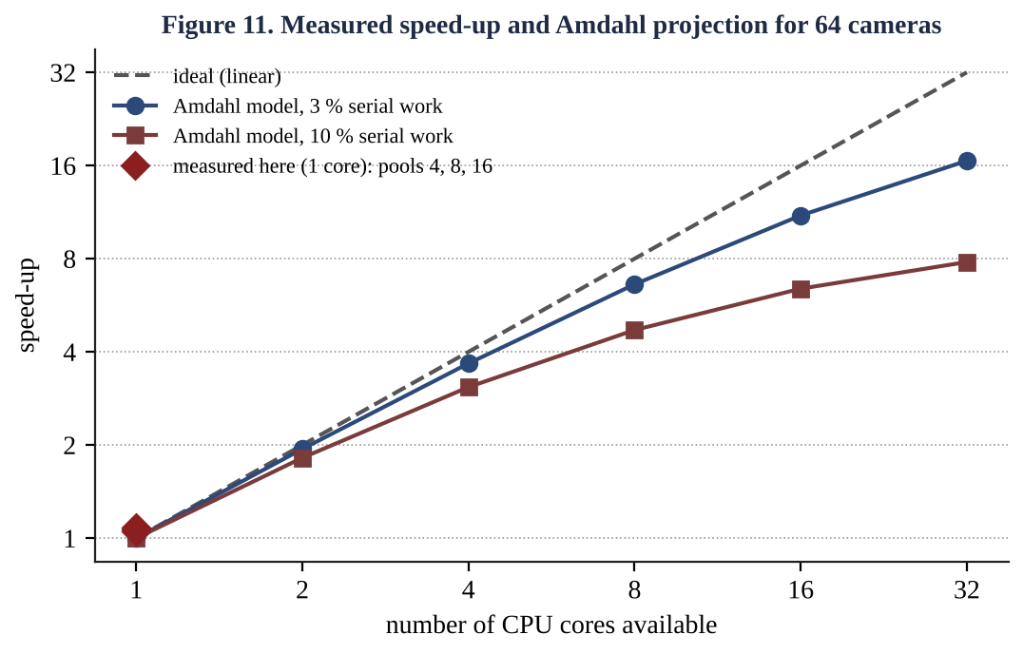
Observation. The machine has one core, so the speed-up is about 1.05 for every variant. The tiny gain above 1 comes from overlapping the small amount of non-compute work (thread start-up, cache warm-up) and is within measurement noise. This is not a failure of the threads: it measures the upper bound set by the hardware. The speed-up of a CPU-bound program cannot exceed the number of cores c.
Why speed-up stops increasing (general explanation).
- Core count. With p threads on c cores, only min(p, c) run at once. Pools of 8 and 16 on 4 cores give no more than 4.
- Amdahl's law. If a fraction s of the work is serial (reading frames from the network, merging results, writing the report), speed-up is S(c) = 1 / (s + (1 − s)/c) and can never exceed 1/s. With s = 3 %: S(4) = 3.67, S(8) = 6.84, S(16) = 11.6 and the limit is 33; with s = 10 %: S(4) = 3.08, S(8) = 4.71, S(16) = 6.40 and the limit is 10 (Figure 11, the projection curves).
- Overheads that grow with threads. Thread creation (17 µs each), context switches among more threads than cores, cache and TLB pollution.
- Shared-resource contention. Locks, the memory bus and shared caches serialise parts of the work; a memory-bound frame filter saturates memory bandwidth before it saturates the cores.
- Load imbalance. With 64 frames and 16 threads, each gets 4 frames only if frames take equal time; one slow frame delays the last thread (the pool of the program reduces this by self-scheduling).
Projection for the lab machine. On a 4-core laptop with s ≈ 3 % the model predicts about 3.7 for a pool of 4 and almost nothing more for pools of 8 or 16; on 8 cores about 6.8. The student should measure nproc on his or her machine and compare with this table. A pool whose size equals the number of cores is the best design: it achieves the available speed-up with the least overhead, and it is also bounded in memory unlike 64 threads.

3.6 What happens to shared counters without protection
Cameras report a car count into one global counter. The statement counter++ is not one machine instruction: it is a load, an add and a store. If a thread is pre-empted after the load, another thread may update the counter, and the first thread then overwrites it with a stale value. This is a race condition, and the lost increment is a lost update.
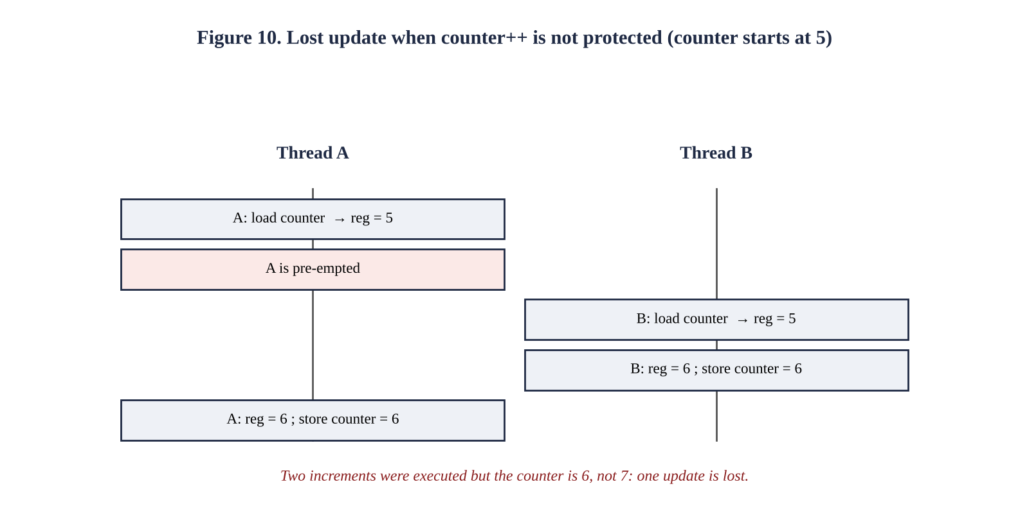
The program runs four threads, each adding 2,000,000 times to the same counter, in four ways. The “widened window” line forces a sched_yield() between the load and the store of 1/100 of the increments to show the effect deterministically even on one core.
Table 3.5 Shared counter, 4 threads (expected 8,000,000; widened-window test expected 80,000)
Method | Result | Lost updates | Time
No protection (natural) | 4,511,135 | 3,488,865 | 0.021 s
No protection (window widened) | 20,000 | 60,000 | 0.002 s
Mutex lock/unlock | 8,000,000 | 0 | 0.199 s
atomic_fetch_add | 8,000,000 | 0 | 0.062 s

The natural race lost between 3.5 and 5.4 million of 8 million updates in two separate runs (the amount differs between runs, which is the signature of a race). The unprotected version is the fastest only because it is wrong. The mutex is correct but 9 times slower than the wrong version, the atomic instruction is correct and 3 times slower. This cost is the price of correctness and motivates the fine-grained locking decision of Q5.

3.7 Alternative concept and complexity analysis: processing frames with several processes
Solution. The parent calls fork() p times; child k processes cameras k, k + p, k + 2p, … and writes each result as a small record into a pipe; the parent reads the records and collects them (see run_processes() in Listing 3.1). Processes do not share memory, so the combination of results needs IPC (pipe, shared memory or message queue) instead of simply writing into a shared array.
Table 3.6 Threads versus processes for the 64-camera job (p workers, N = 64 frames)
Measure | Threads | Processes
Creation time (measured, Q1) | 17.4 µs each; 64 threads ≈ 1.1 ms | 1,019 µs each; 64 processes ≈ 65 ms (with 50 MB parent)
Measured total time, 4 workers / 8 workers | 0.254 s / 0.258 s (pool of 4 / 8) | 0.271 s / 0.259 s
Switching | Registers and stack; same address space | Address-space switch, TLB/cache effects
Memory | O(p·S + F): frames F stored once | O(p·(S + A) + F): each process may copy the data it touches
Combining results | Shared array; O(1) per result, needs a mutex only for shared counters | IPC: O(r) per result of r bytes through the kernel (2 copies)
Failure isolation | A bug in one worker can crash all | A crashing worker affects only itself; parent can restart it
Total time model | T ≈ p·T_thr + (N/c')·t_f + T_sync | T ≈ p·T_fork + (N/c')·t_f + N·T_ipc

Here c' = min(p, c) is the number of cores that are actually used and t_f is the time per frame. Both designs have the same dominant term (N/c')·t_f = O(N/c'); they differ in the additive overhead terms: p·T_fork + N·T_ipc against p·T_thr + T_sync. For 64 frames of 4 ms the compute term is 256 ms, while the process overhead is 65 ms for creation alone: an extra 25 %, which explains why processes are slightly slower in the 4-worker measurement (0.271 s against 0.254 s). Processes win when isolation matters more than speed (a bug in the plate recogniser should not kill the whole traffic system).

3.8 Evidence summary for Q3
- Working multithreaded program with per-camera threads and pools of 4, 8 and 16 (Listing 3.1).
- Measured speed-up for each pool size and a reasoned explanation of why it stops (Table 3.4, Figure 11).
- Evaluation of the user/kernel thread models (Tables 3.2 and 3.3, Figure 9).
- Demonstration and cure of the lost-update race (Table 3.5, Figure 10).

Q4 Inter-Process Communication (6 marks)

4.1 Problem and model
A weather station has one process that reads sensors and another that analyses the readings. They must exchange data continuously without losing readings. Because the two processes have separate address spaces, the operating system must provide a communication channel. There are two fundamental models:
- Message passing: the processes exchange messages through the kernel with send/receive operations (pipes, message queues, sockets). The kernel manages the buffer and synchronisation.
- Shared memory: the kernel maps one region into the address spaces of both processes; they read and write it like ordinary memory. The kernel is involved only in setting up the region.
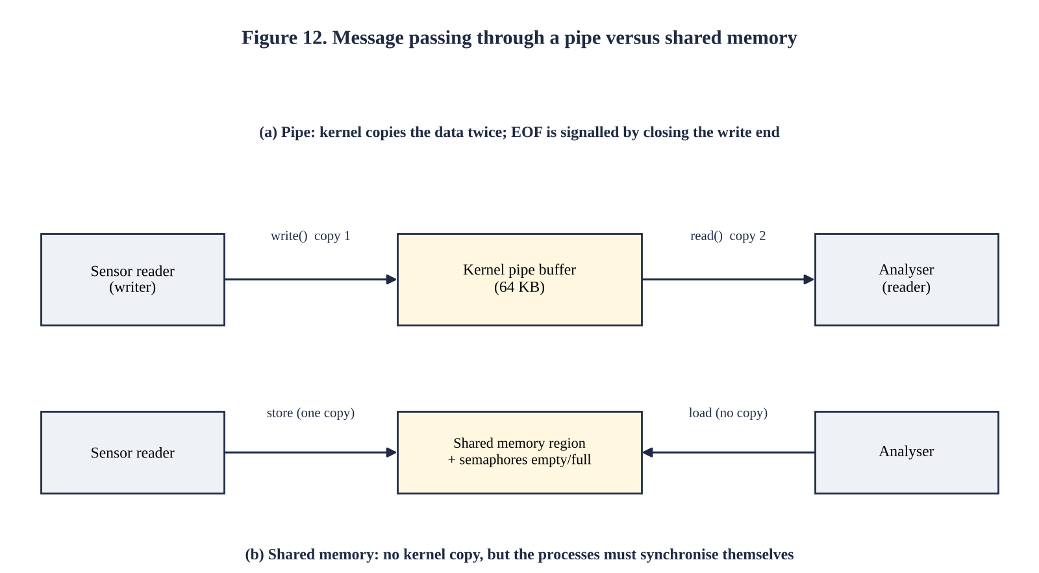
Table 4.1 Shared memory versus message passing
Aspect | Message passing (pipe, message queue) | Shared memory
Data copying | Copied user → kernel → user (two copies) | No kernel copy after set-up (one store, one load)
Speed | Slower per byte; one system call per message | Fastest IPC; system calls only for synchronisation
Synchronisation | Provided by the kernel (blocking read/write, full/empty buffer) | Must be added by the programmer (semaphore, mutex)
Ease of programming | Easy; no race conditions on the data | Harder; races, ordering and cache-coherence issues
Suitability | Small messages; distributed systems | Large data volumes on one machine

4.2 Complete the Code: sensor reader and analyser over a pipe
TODO 1 was completed with a loop that reads one int at a time from fd[0] until read() returns 0, i.e. until all write ends of the pipe are closed. Each value updates the count, the sum and the maximum. The test is written == (ssize_t)sizeof r so that a short read is treated as the end of data, not as a reading. A compile-time switch NO_CLOSE was added only for the experiment of Section 4.3; without it the program is exactly the given program with TODO 1 completed.
Listing 4.1 q4_pipe.c
#define _POSIX_C_SOURCE 200809L
#include <stdio.h>
#include <unistd.h>
#include <sys/wait.h>
/* The parent (sensor reader) sends readings to the child (analyser) through a pipe. */
int main(void)
{
int fd[2];
if (pipe(fd) == -1) { perror("pipe"); return 1; }
pid_t pid = fork();
if (pid == 0) {
close(fd[1]); /* child only reads */
int r, count = 0, sum = 0, max = 0;
/* TODO 1 completed */
while (read(fd[0], &r, sizeof r) == (ssize_t)sizeof r) {
count++;
sum += r;
if (r > max) max = r;
}
printf("analyser: %d readings, average %.1f, max %d\n", count,
count ? (double)sum / count : 0.0, max);
close(fd[0]);
fflush(stdout);
_exit(0);
}
close(fd[0]); /* parent only writes */
int readings[] = {31, 33, 36, 34, 41, 38};
for (int i = 0; i < 6; i++)
if (write(fd[1], &readings[i], sizeof readings[i]) < 0) perror("write");
#ifndef NO_CLOSE
close(fd[1]); /* signals end of data to the child */
#endif
waitpid(pid, NULL, 0);
printf("reader: done\n");
return 0;
}
Output (matches the expected output)
analyser: 6 readings, average 35.5, max 41
reader: done

4.3 How the pipe signals the end of data; the experiment without close(fd[1])
A pipe has a read end and a write end, each shared by every process that holds the descriptor. `read()` returns 0 (end of file) only when no process holds the write end open and the pipe is empty. The parent's close(fd[1]) is therefore the end-of-data signal. While at least one descriptor of the write end remains open, an empty pipe makes read() block, because more data could still arrive.
The experiment: the program was compiled with -DNO_CLOSE, which removes close(fd[1]) from the parent, and run under timeout 3.
Output of the experiment (no analyser line is ever printed)
exit status of timeout = 124 (124 means the program was still blocked after 3 s)
Explanation. The child (analyser) closed its own copy of the write end at start-up, but the parent still holds fd[1]. After the child has read the six readings the pipe is empty, but the write end is still open (in the parent), so read() blocks instead of returning 0. The child never prints its result or exits. The parent meanwhile calls waitpid(), waiting for the child. Each process waits for the other: a deadlock. The exit status 124 shows that the program was still blocked when timeout killed it after three seconds.

4.4 Second implementation: shared memory with semaphores
The second implementation uses an anonymous shared mapping (mmap with MAP_SHARED | MAP_ANONYMOUS) that is inherited by the child created with fork(). The region contains a ring of 8 slots of 64 KB and two process-shared POSIX semaphores: empty (free slots, initial value 8) and full (filled slots, initial value 0). The producer waits on empty, stores a chunk into the next slot, then posts full; the consumer waits on full, reads the slot, then posts empty. With a single producer and a single consumer no mutex is needed, because each index is changed by exactly one process, and the semaphores guarantee that a slot is never overwritten before it is read and never read before it is written. This is the bounded-buffer solution of Q5 with a mutex-free special case. A POSIX message queue (mq_open, mq_send, mq_receive) is the third alternative: it is message passing, preserves message boundaries and priorities, and is synchronised by the kernel, but copies the data twice like the pipe; it was not benchmarked here.
Listing 4.2 q4_bench.c (pipe and shared-memory transfer of 1, 10 and 100 MB)
#define _GNU_SOURCE
#include <stdio.h>
#include <stdlib.h>
#include <string.h>
#include <unistd.h>
#include <semaphore.h>
#include <time.h>
#include <sys/mman.h>
#include <sys/wait.h>
#define CHUNK (64*1024)
#define SLOTS 8
static double now(void){struct timespec t;clock_gettime(CLOCK_MONOTONIC,&t);return t.tv_sec+t.tv_nsec*1e-9;}
struct shm { sem_t empty, full; size_t len[SLOTS]; char data[SLOTS][CHUNK]; };
static double via_pipe(size_t total)
{
int fd[2]; pipe(fd); char *buf=malloc(CHUNK); memset(buf,7,CHUNK); double t=now();
pid_t pid=fork();
if(pid==0){close(fd[1]);char*rb=malloc(CHUNK);size_t got=0;unsigned long s=0;ssize_t n;
while((n=read(fd[0],rb,CHUNK))>0){got+=n;s+=rb[0];} _exit(got==total?0:1);}
close(fd[0]); size_t sent=0; while(sent<total){size_t n=total-sent<CHUNK?total-sent:CHUNK;
write(fd[1],buf,n); sent+=n;}
close(fd[1]); int st; waitpid(pid,&st,0); double e=now()-t; free(buf); return WEXITSTATUS(st)?-1:e;
}
static double via_shm(size_t total)
{
struct shm *s=mmap(NULL,sizeof *s,PROT_READ|PROT_WRITE,MAP_SHARED|MAP_ANONYMOUS,-1,0);
sem_init(&s->empty,1,SLOTS); sem_init(&s->full,1,0); char *buf=malloc(CHUNK); memset(buf,7,CHUNK);
double t=now();
pid_t pid=fork();
if(pid==0){size_t got=0;int o=0;unsigned long sum=0;
while(got<total){sem_wait(&s->full); got+=s->len[o]; sum+=s->data[o][0]; o=(o+1)%SLOTS;
sem_post(&s->empty);} _exit(0);}
size_t sent=0; int in=0;
while(sent<total){size_t n=total-sent<CHUNK?total-sent:CHUNK; sem_wait(&s->empty);
memcpy(s->data[in],buf,n); s->len[in]=n; in=(in+1)%SLOTS; sem_post(&s->full); sent+=n;}
waitpid(pid,NULL,0); double e=now()-t; free(buf); munmap(s,sizeof *s); return e;
}
int main(void)
{
size_t mb[]={1,10,100};
printf("%-8s %12s %12s\n","size","pipe (s)","shm+sem (s)");
for(int i=0;i<3;i++){
double bp=1e9,bs=1e9;
for(int k=0;k<3;k++){double a=via_pipe(mb[i]<<20); if(a>0&&a<bp)bp=a; double b=via_shm(mb[i]<<20);
if(b<bs)bs=b;}
printf("%-3zu MB %12.4f %12.4f (pipe %.0f MB/s, shm %.0f
MB/s)\n",mb[i],bp,bs,mb[i]/bp,mb[i]/bs);
}
return 0;
}

4.5 Growth investigation: measured transfer time
Output of q4_bench (best of three runs, 64 KB chunks)
size pipe (s) shm+sem (s)
1 MB 0.0002 0.0003 (pipe 4115 MB/s, shm 3437 MB/s)
10 MB 0.0016 0.0010 (pipe 6335 MB/s, shm 10467 MB/s)
100 MB 0.0153 0.0087 (pipe 6530 MB/s, shm 11539 MB/s)
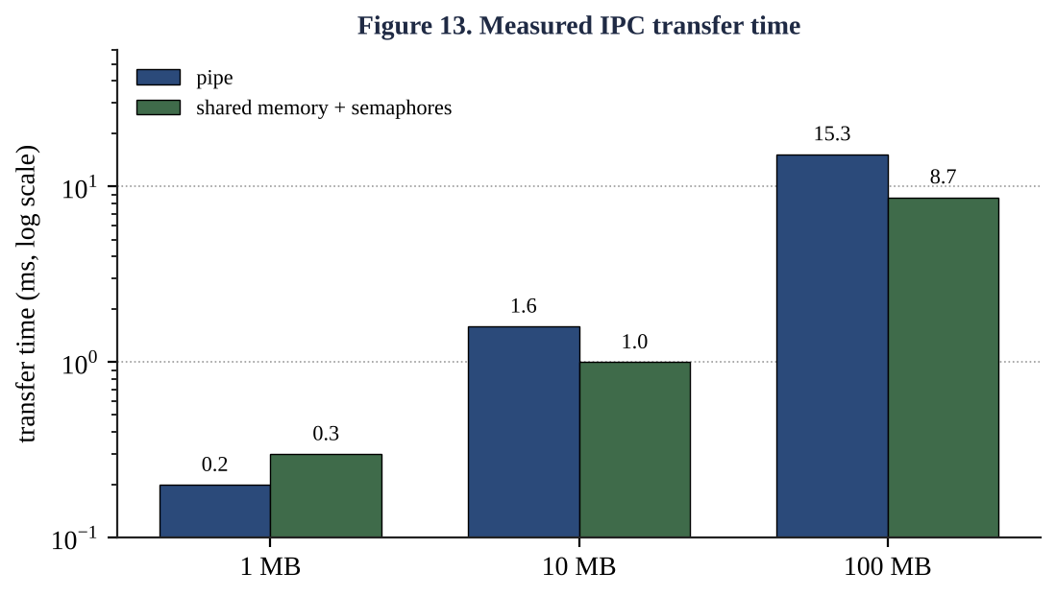
Table 4.2 Transfer time and throughput
Data size | Pipe | Shared memory + semaphores | Shared memory is faster by
1 MB | 0.2 ms (4,115 MB/s) | 0.3 ms (3,437 MB/s) | 0.8 × (slower)
10 MB | 1.6 ms (6,335 MB/s) | 1.0 ms (10,467 MB/s) | 1.6 ×
100 MB | 15.3 ms (6,530 MB/s) | 8.7 ms (11,539 MB/s) | 1.8 ×

Evaluation. (1) Both methods are linear: multiplying the data by 10 multiplies the time by about 9.6 (pipe) and 8.7 (shared memory), so T(n) = O(n) for both. They differ in the constant per byte: the pipe copies each byte twice through the kernel and needs about one system call per 64 KB, the shared-memory version copies once into the region (the producer could generate data in place and copy zero times) and uses a semaphore operation per chunk. At 100 MB the difference is 1.8 times. (2) At 1 MB the fixed costs of creating the mapping, the semaphores and the child process dominate, and shared memory is slower: for small messages the pipe is as good as shared memory and much simpler. (3) The pipe automatically provides flow control: when its 64 KB buffer is full the writer blocks, so no reading is lost; shared memory achieves the same only with the empty/full semaphores.

4.6 Which method copies, and which needs extra synchronisation
- Copies the data: the pipe (and any message queue). The kernel copies the writer's buffer into a kernel buffer, then into the reader's buffer: two copies, per byte.
- Does not copy: shared memory. After the mapping both processes access the same physical pages.
- Needs extra synchronisation: shared memory. The kernel does not know when the writer has finished a record or whether the reader has consumed it; without a semaphore the reader can read a half-written value, or the writer can overwrite an unread one (lost readings). Pipes need none because read() blocks when the pipe is empty and write() blocks when it is full.

4.7 Alternative concept and complexity analysis: shared memory with a semaphore instead of a pipe
Solution for the six-reading program. The parent creates the shared region and a semaphore, forks, and writes the readings; the child waits on the semaphore, then reads. Sketch:
struct shared { sem_t data_ready; int n; int readings[6]; };
struct shared *s = mmap(NULL, sizeof *s, PROT_READ|PROT_WRITE,
MAP_SHARED|MAP_ANONYMOUS, -1, 0);
sem_init(&s->data_ready, 1, 0); /* 1 = shared between processes */
if (fork() == 0) { /* analyser */
sem_wait(&s->data_ready); /* block until the reader has finished */
/* count, sum and max over s->readings[0 .. s->n-1] */
_exit(0);
}
for (int i = 0; i < 6; i++) s->readings[i] = reading_from_sensor(i);
s->n = 6;
sem_post(&s->data_ready); /* signal: data is complete */
wait(NULL);
Table 4.3 Pipe versus shared memory with semaphore, for n readings
Measure | Pipe | Shared memory + semaphore
Time to transfer n readings | T ≈ n·(c_sys/k + 2·t_copy), O(n) (k readings per system call) | T ≈ n·t_store + (n/k)·t_sem, O(n) with smaller constant
Copies per byte | 2 (user→kernel, kernel→user) | 0 or 1
System calls | ≈ 2 n/k (read and write) | ≈ 2 n/k semaphore operations (fast path in user space, no call if uncontended)
Synchronisation needed | None (kernel blocks) | Semaphore (and a mutex with several writers)
Failure behaviour | Writer crash closes pipe → reader sees EOF | Reader may wait forever; needs a timeout or robust semaphore
Space | Kernel buffer 64 KB (fixed) | Region size (chosen by programmer)

4.8 Justified choice of method
Choice for the weather station: a pipe for the sensor readings themselves, and shared memory only if the readings become large. A reading is 4 bytes and a station produces a few thousand per second, so the volume is trivial (a kilobyte-scale stream). At that volume the kernel copy costs microseconds, while the pipe gives flow control, end-of-data signalling and no data races for free, which together give the required “no lost readings” guarantee with the least code. Shared memory pays off when the data is large (images, 10 to 100 MB: 1.8 times faster) or when a record must be read by many processes; then the extra semaphore protocol is worth its complexity.

4.9 Evidence summary for Q4
- Two working IPC implementations (Listing 4.1 pipe; Listing 4.2 shared memory with semaphores).
- Measured transfer times for 1, 10 and 100 MB (Table 4.2, Figure 13).
- The no-close() experiment with evidence of blocking and explanation (Section 4.3).
- A justified choice of method (Section 4.8).

Q5 Synchronisation: Critical Sections, Semaphores and Monitors (11 marks)

5.1 Problem and model
Thousands of agents book seats on the same trains at the same time. Without synchronisation the same seat is sometimes sold twice; with a single global lock the system becomes very slow. The correctness requirement (the invariant) is: a seat is sold at most once, and the seat counter equals the number of seats still free. The booking code that checks a seat and then marks it sold is a critical section: a region that accesses shared data and must not be executed by two agents at once.

5.2 From the principle to a design
The only starting point given is: a solution to the critical-section problem must guarantee mutual exclusion, progress and bounded waiting. Each requirement is converted below into a concrete design rule for the booking system and into a test.
Table 5.1 Converting the principle into a design
Requirement | Meaning | Design rule for the booking system | How it is tested
Mutual exclusion | At most one process in its critical section | Every access to a seat record is bracketed by lock/unlock of the lock that owns that record | Stress test: 8 agents, no double sale (Section 5.8)
Progress | Only processes wanting to enter take part in choosing who enters, and the choice is not postponed indefinitely | Lock acquisition never depends on agents outside the critical section; no agent holds a lock while idle | No lock held across user think-time; all agents finish
Bounded waiting | A limit on how many times others enter after a process has asked | Fair lock (FIFO wake-up of waiting agents) and no hold-and-wait of several locks without a global order | Every agent completes its 400 requests in the test

The structure that results is the standard four-part pattern: entry section (acquire lock) → critical section (check seat, mark sold) → exit section (release lock) → remainder section. The remaining design questions are which mechanism implements the entry/exit sections (Peterson, semaphore, mutex, monitor, atomic instruction) and how large a region a lock protects (granularity, Section 5.8).

5.3 Peterson's solution for two processes
/* shared */ int turn; bool flag[2];
/* process P_i, j = 1 - i */
do {
flag[i] = true; /* I want to enter */
turn = j; /* but you may go first */
while (flag[j] && turn == j) ; /* busy wait */
/* ---- critical section ---- */
flag[i] = false; /* exit section */
/* ---- remainder section ---- */
} while (true);
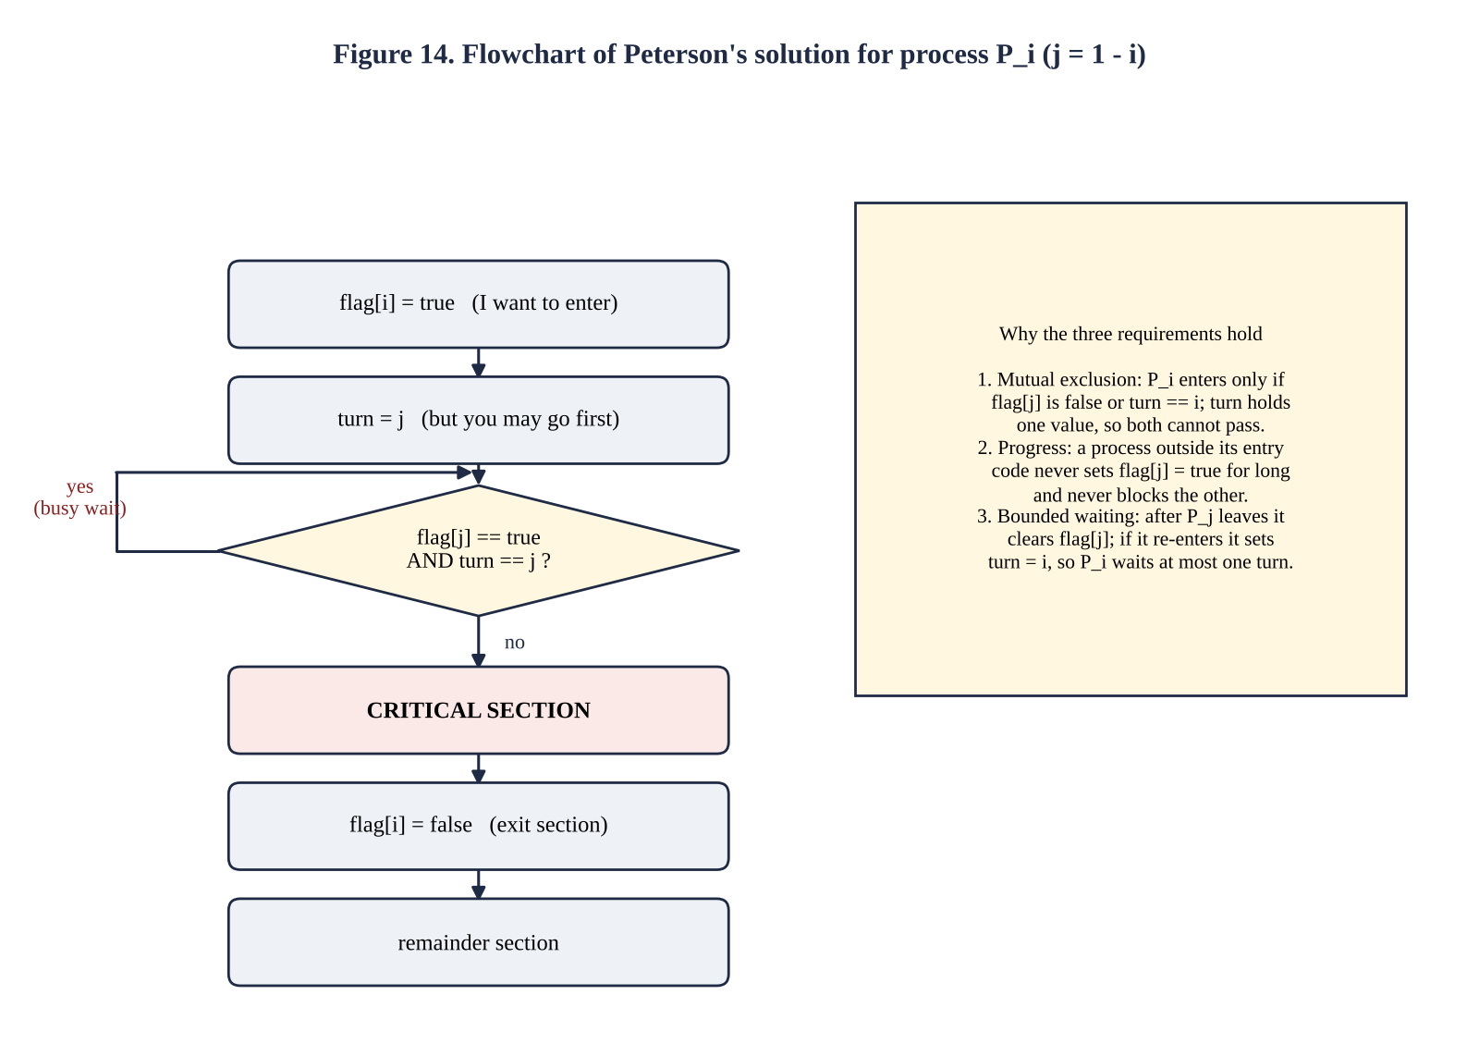
Why the three requirements hold.
- Mutual exclusion. Suppose both P0 and P1 are in the critical section. Each passed its while-test, so for P0 either flag[1] = false or turn = 0, and for P1 either flag[0] = false or turn = 1. Both flags are true while both are in or entering (each set its own flag before testing), so the conditions reduce to turn = 0 and turn = 1 at the same time. A single variable cannot have two values; contradiction. Therefore only one process can be inside.
- Progress. If P_j is not interested, flag[j] is false, so P_i's test fails immediately and it enters; a process in the remainder section cannot block another. If both are interested, turn decides, and the one whose turn it is enters. The decision is made in a bounded number of steps by the two processes only.
- Bounded waiting. When P_j leaves it sets flag[j] = false, which releases P_i. If P_j re-enters at once it sets turn = i before testing, so P_i has priority: P_i waits for at most one entry of P_j.
Why Peterson's solution may fail on modern processors. The proof assumes that the instructions of each process execute in program order and that a store by one CPU is immediately visible to the other. Modern machines break both assumptions: (1) the compiler may reorder or cache the variables in registers (since the busy-wait loop has no visible side effect, it may even be converted into an infinite loop); (2) the CPU has store buffers and out-of-order execution: on x86 a store may become visible after a later load. In Peterson's entry code the store turn = j can be delayed past the load of flag[j]; then both processes may read the other's old flag value (false), both pass the test, and mutual exclusion is violated. ARM and POWER reorder even more freely. The repair is a memory barrier: declare the variables _Atomic with sequentially consistent ordering (the default of C11 atomic_store/atomic_load) or insert mfence between the stores and the loads. Peterson also works for only two processes and wastes CPU in a busy-wait loop, so real systems use hardware atomic instructions (test-and-set, compare-and-swap) inside semaphores and mutexes.

5.4 Counting and binary semaphores protecting the seat counter
A semaphore is an integer variable accessed only through two atomic operations, wait (P) and signal (V):
wait(S): while (S <= 0) block the caller on S's queue; S = S - 1;
signal(S): S = S + 1; if (a process is blocked on S) wake one of them;
The implementation blocks the caller on a queue instead of spinning, so a waiting agent does not consume CPU. A binary semaphore (values 0 and 1) behaves like a lock (mutex). A counting semaphore has an arbitrary non-negative initial value and counts units of a resource.
sem_t seat_lock; /* binary semaphore, initial value 1 */
sem_t free_seats; /* counting semaphore, initial value = number of seats */
int sold = 0; /* shared counter */

bool book(int agent) {
if (sem_trywait(&free_seats) != 0) return false; /* counting: seats left? */
sem_wait(&seat_lock); /* binary: enter critical section */
sold++; assign_seat(agent); /* update shared data */
sem_post(&seat_lock); /* exit critical section */
return true;
}
void cancel(void) { sem_wait(&seat_lock); sold--; sem_post(&seat_lock); sem_post(&free_seats); }
The counting semaphore free_seats makes overbooking impossible: the (N+1)-th agent finds the counter at 0 and is refused without entering the critical section. The binary semaphore makes the update of sold and of the seat map atomic with respect to other agents.

5.5 The bounded-buffer (producer–consumer) problem
Booking requests are produced by many agents and consumed by the database writer through a buffer of N slots. Three semaphores solve it: empty (counts free slots, initial N), full (counts filled slots, initial 0) and a mutex protecting the indices in/out.
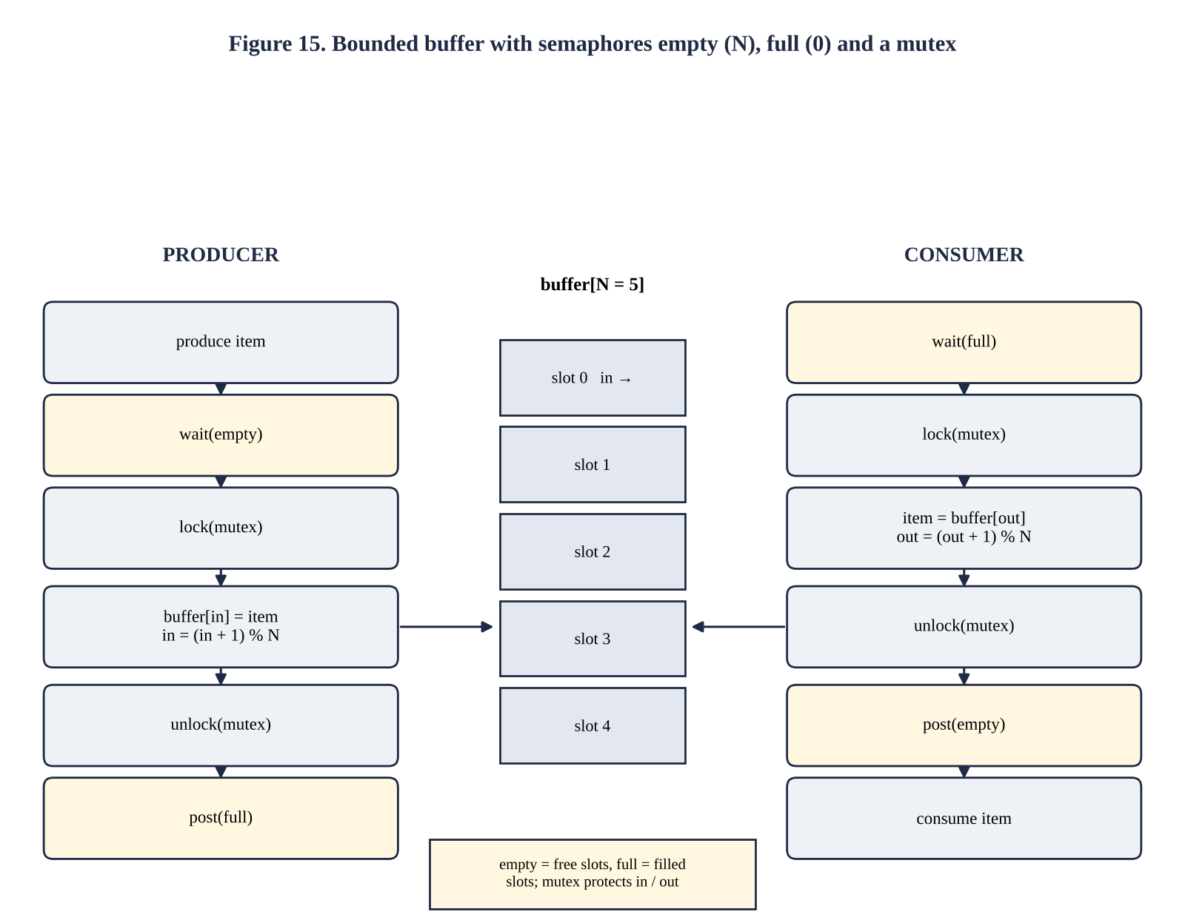
Why the order matters. The producer must wait(empty) before locking the mutex. If it locked first and then found the buffer full, it would sleep while holding the mutex, and the consumer could never lock it to make room: deadlock. Each side waits on its resource semaphore first, then enters the short critical section.
Complete the Code. TODO 1 and TODO 2 were completed as specified in the question. To allow the later tests with several producers and consumers, the program was generalised without changing the algorithm: a command-line argument selects the number of producers = consumers, each producer generates unique item numbers (id × ITEMS + item), and a seen[] array counts how many times each item was consumed. For the default run (one producer, one consumer, 20 items) the output is the expected one.
Listing 5.1 q5_buffer.c (TODO 1 and TODO 2 completed)
#define _POSIX_C_SOURCE 200809L
#include <stdio.h>
#include <stdlib.h>
#include <pthread.h>
#include <semaphore.h>
#include <stdatomic.h>
#include <sched.h>
#define SIZE 5
int ITEMS = 20, P = 1, C = 1; /* items per producer, producers, consumers */
int buffer[SIZE], in = 0, out = 0;
sem_t empty, full;
pthread_mutex_t lock = PTHREAD_MUTEX_INITIALIZER;
long consumed_sum = 0;
atomic_int seen[100000]; /* how many times each item id was consumed */
#ifdef NO_MUTEX
#define LOCK()
#define UNLOCK()
#else
#define LOCK() pthread_mutex_lock(&lock)
#define UNLOCK() pthread_mutex_unlock(&lock)
#endif
void *producer(void *arg)
{
int id = (int)(long)arg;
for (int item = 1; item <= ITEMS; item++) {
/* TODO 1 completed */
sem_wait(&empty);
LOCK();
int slot = in;
#ifdef WIDEN
sched_yield(); /* widen the race window for the demonstration */
#endif
buffer[slot] = id * ITEMS + item;
in = (slot + 1) % SIZE;
UNLOCK();
sem_post(&full);
}
return NULL;
}
void *consumer(void *arg)
{
(void)arg;
int mine = P * ITEMS / C;
for (int k = 0; k < mine; k++) {
/* TODO 2 completed */
sem_wait(&full);
LOCK();
int item = buffer[out];
out = (out + 1) % SIZE;
UNLOCK();
sem_post(&empty);
atomic_fetch_add(&seen[item], 1);
__atomic_fetch_add(&consumed_sum, item, __ATOMIC_SEQ_CST);
}
return NULL;
}
int main(int argc, char **argv)
{
if (argc > 1) P = C = atoi(argv[1]);
if (argc > 2) ITEMS = atoi(argv[2]);
sem_init(&empty, 0, SIZE);
sem_init(&full, 0, 0);
pthread_t p[16], c[16];
for (long i = 0; i < P; i++) pthread_create(&p[i], NULL, producer, (void *)i);
for (int i = 0; i < C; i++) pthread_create(&c[i], NULL, consumer, NULL);
for (int i = 0; i < P; i++) pthread_join(p[i], NULL);
for (int i = 0; i < C; i++) pthread_join(c[i], NULL);
long N = (long)P * ITEMS; int once = 0;
for (int i = 1; i <= N; i++) if (seen[i] == 1) once++;
printf("items consumed: %ld, sum = %ld (expected %ld)", N, consumed_sum, N * (N + 1) / 2);
if (argc > 1) printf("; consumed exactly once: %d of %ld", once, N);
printf("\n");
sem_destroy(&empty);
sem_destroy(&full);
return 0;
}
Output: single run, 100 repeated runs, 4 + 4 threads, and tests with the mutex removed
--- single run (1 producer, 1 consumer)
items consumed: 20, sum = 210 (expected 210)
--- 100 runs, 1 producer + 1 consumer: distinct output lines
100 items consumed: 20, sum = 210 (expected 210)
--- 4 producers + 4 consumers, 5000 items each, with mutex
items consumed: 20000, sum = 200010000 (expected 200010000); consumed exactly once: 20000 of 20000
--- 1 producer + 1 consumer, 20 runs, with mutex removed
20 items consumed: 20, sum = 210 (expected 210)
--- 4 producers + 4 consumers, mutex removed, 5 runs (timeout 10 s each)
items consumed: 20000, sum = 200010000 (expected 200010000); consumed exactly once: 20000 of 20000
items consumed: 20000, sum = 200010000 (expected 200010000); consumed exactly once: 20000 of 20000
items consumed: 20000, sum = 200010000 (expected 200010000); consumed exactly once: 20000 of 20000
items consumed: 20000, sum = 200010000 (expected 200010000); consumed exactly once: 20000 of 20000
items consumed: 20000, sum = 200010000 (expected 200010000); consumed exactly once: 20000 of 20000
--- with mutex still correct:
items consumed: 20000, sum = 200010000 (expected 200010000); consumed exactly once: 20000 of 20000
--- mutex removed, race window widened with sched_yield, 4+4 threads (timeout 10 s)
items consumed: 20000, sum = 210334305 (expected 200010000); consumed exactly once: 7425 of 20000
items consumed: 20000, sum = 251134688 (expected 200010000); consumed exactly once: 5144 of 20000
items consumed: 20000, sum = 225101092 (expected 200010000); consumed exactly once: 6422 of 20000
Table 5.2 Test results for the bounded buffer
Test | Items | Sum / expected | Consumed exactly once
1 producer + 1 consumer, 100 runs | 20 per run | 210 / 210 in all 100 runs | 20 of 20 (sum identical)
4 producers + 4 consumers, with mutex | 20,000 | 200,010,000 / 200,010,000 | 20,000 of 20,000
1 + 1, mutex removed, 20 runs | 20 per run | 210 / 210 in all runs | (correct: one producer, one consumer)
4 + 4, mutex removed (race window natural) | 20,000 | correct in 5 of 5 runs on this 1-core machine | 20,000 of 20,000
4 + 4, mutex removed, window widened (sched_yield) | 20,000 | 210,334,305; 251,134,688; 225,101,092 (expected 200,010,000) | 7,425; 5,144; 6,422 of 20,000

Conclusion of the test. (1) With the mutex, every item is consumed exactly once with 1 and with 4 producers and consumers, and the sum is always the expected one. (2) Removing the mutex is safe only for exactly one producer and one consumer, because in is written only by the producer and out only by the consumer; the semaphores alone then suffice. (3) With several producers or consumers the unprotected in/out become shared data. Two producers can read the same in, store into the same slot and advance in once: one item is overwritten (lost) and another slot is read twice (duplicated). On this single-core machine the natural window was too small to be hit in five runs, which proves nothing; with the window widened, only 5,144 to 7,425 of the 20,000 items were consumed exactly once. Absence of failure in a test is not a proof of correctness: the mutex is required.

5.6 Readers–writers and dining philosophers

Readers–writers (first variant: readers have priority)
Many agents only read the seat map (enquiries) while few write (bookings). Readers can share the data; a writer needs exclusive access. Shared: semaphore rw_mutex = 1; semaphore mutex = 1; int read_count = 0;
/* writer */ /* reader */
wait(rw_mutex); wait(mutex);
write the seat map read_count++;
signal(rw_mutex); if (read_count == 1) wait(rw_mutex); /* first reader locks writers
out */
signal(mutex);
read the seat map
wait(mutex);
read_count--;
if (read_count == 0) signal(rw_mutex); /* last reader lets writers
in */
signal(mutex);
Mutual exclusion between a writer and any reader is given by rw_mutex; mutex protects read_count. The weakness: a continuous stream of readers can starve the writer. The second variant gives writers priority and may starve readers; a fair solution queues requests in arrival order (or uses pthread_rwlock_t with a fairness policy).

Dining philosophers
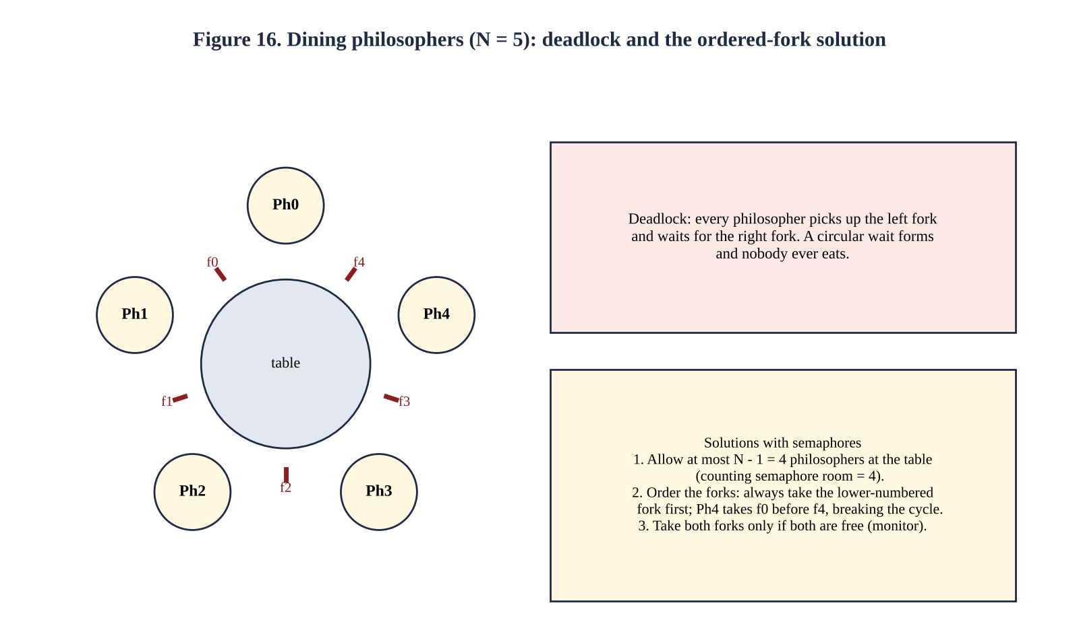
semaphore fork[5] = {1,1,1,1,1}; semaphore room = 4; /* at most 4 at the table */
void philosopher(int i) {
while (true) {
think();
wait(room);
wait(fork[i]); wait(fork[(i+1) % 5]); /* pick up both forks */
eat();
signal(fork[(i+1) % 5]); signal(fork[i]);
signal(room);
}
}
With five philosophers and five forks the naive solution (each takes the left fork, then the right) deadlocks when all five take the left fork at the same moment: the four necessary conditions (Q6) all hold. The counting semaphore room of value 4 guarantees that at least one philosopher can obtain two forks, so the circular wait cannot close. The alternative resource ordering (every philosopher takes the lower-numbered fork first, so philosopher 4 takes fork 0 before fork 4) breaks the circular-wait condition directly. Both solutions are deadlock-free; neither by itself prevents starvation of an unlucky philosopher.

5.7 Monitors and condition variables
A monitor is a language-level abstraction that packages shared data with the procedures that operate on it and guarantees that only one process is active inside the monitor at a time. Mutual exclusion is automatic, so the programmer can no longer forget a wait, reverse two waits or forget a signal. Waiting for a condition (for example “a seat is free”) uses condition variables with two operations: x.wait() releases the monitor and sleeps; x.signal() wakes one waiting process (which re-checks the condition).
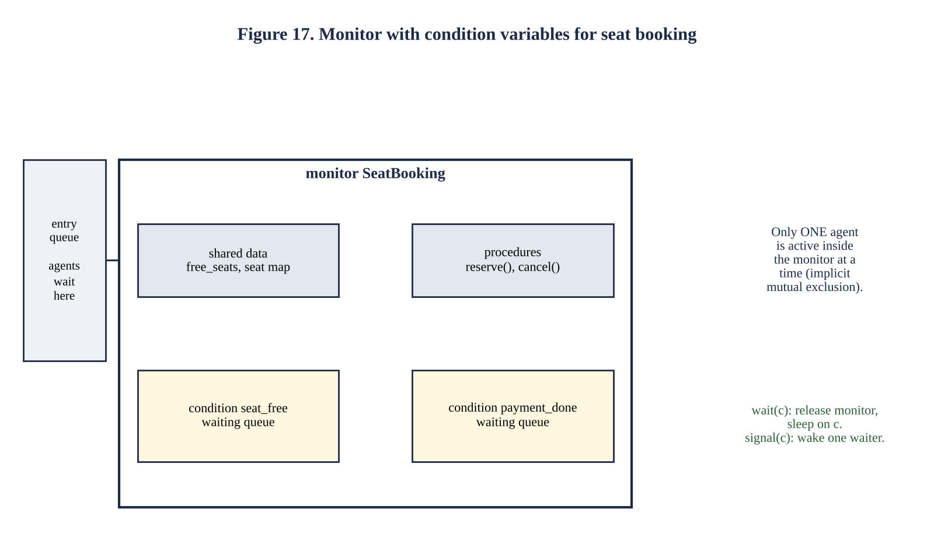
monitor SeatBooking {
int free_seats = N; condition seat_free;
void reserve() {
while (free_seats == 0) seat_free.wait(); /* releases the monitor while waiting */
free_seats--;
}
void cancel() { free_seats++; seat_free.signal(); }
}
/* the same in POSIX C: pthread_mutex_t m; pthread_cond_t seat_free; */
void reserve(void) {
pthread_mutex_lock(&m);
while (free_seats == 0) pthread_cond_wait(&seat_free, &m);
free_seats--;
pthread_mutex_unlock(&m);
}
Why a monitor is easier to get right. (1) The compiler or the language enforces mutual exclusion; with semaphores correctness depends on every programmer using the P/V pairs in the right order. (2) The condition is tested in a while loop under the monitor lock, so there is no gap between “test” and “sleep” in which a signal could be lost. (3) The shared data cannot be reached except through the monitor procedures. (4) The bounded-buffer problem needs three semaphores and a careful ordering, but one mutex and two condition variables (not_full, not_empty) in a monitor. The cost is that a monitor needs language support or, in C, the discipline of using pthread_mutex_t and pthread_cond_t together as above.

5.8 Deployment decision: one lock, one lock per train or one lock per coach
The decision was evaluated by experiment. The program q5_lock.c models 20 trains × 10 coaches × 40 seats. Eight agent threads each send 400 random booking requests. A successful booking spends 100 µs inside the critical section (payment and database check, simulated with usleep(100)), because in a real system the check-and-sell action contains I/O; this is exactly what makes a coarse lock hurt. Four configurations were run: no lock (to show the original bug), one global lock, one lock per train, one lock per coach.
Listing 5.2 q5_lock.c
#define _GNU_SOURCE
#include <stdio.h>
#include <stdlib.h>
#include <unistd.h>
#include <pthread.h>
#include <stdatomic.h>
#include <time.h>
#define TRAINS 20
#define COACHES 10
#define SEATS 40
#define THREADS 8
#define PER_THREAD 400
static double now(void){struct timespec t;clock_gettime(CLOCK_MONOTONIC,&t);return t.tv_sec+t.tv_nsec*1e-9;}
static int seat[TRAINS][COACHES][SEATS]; /* 0 free, otherwise booking agent id */
static pthread_mutex_t g=PTHREAD_MUTEX_INITIALIZER, tl[TRAINS], cl[TRAINS][COACHES];
static atomic_int sold, rejected, double_sold; static int mode; /* 0 none, 1 global, 2 train, 3 coach */
static void *agent(void *a)
{
int id=(int)(long)a+1; unsigned s=id*7919u;
for(int i=0;i<PER_THREAD;i++){
s=s*1103515245u+12345u; int t=(s>>8)%TRAINS; s=s*1103515245u+12345u; int c=(s>>8)%COACHES;
s=s*1103515245u+12345u; int k=(s>>8)%SEATS;
pthread_mutex_t *m=mode==1?&g:mode==2?&tl[t]:mode==3?&cl[t][c]:NULL;
if(m)pthread_mutex_lock(m);
if(seat[t][c][k]==0){
usleep(100); /* payment / database check inside the critical section
*/
if(seat[t][c][k]!=0) atomic_fetch_add(&double_sold,1); /* someone else sold it meanwhile */
seat[t][c][k]=id; atomic_fetch_add(&sold,1);
} else atomic_fetch_add(&rejected,1);
if(m)pthread_mutex_unlock(m);
}
return NULL;
}
int main(void)
{
const char *nm[]={"no lock","one global lock","one lock per train","one lock per coach"};
for(int t=0;t<TRAINS;t++){pthread_mutex_init(&tl[t],NULL);for(int
c=0;c<COACHES;c++)pthread_mutex_init(&cl[t][c],NULL);}
for(mode=0;mode<4;mode++){
for(int t=0;t<TRAINS;t++)for(int c=0;c<COACHES;c++)for(int k=0;k<SEATS;k++)seat[t][c][k]=0;
atomic_store(&sold,0);atomic_store(&rejected,0);atomic_store(&double_sold,0);
pthread_t th[THREADS]; double t0=now();
for(long i=0;i<THREADS;i++)pthread_create(&th[i],NULL,agent,(void*)i);
for(int i=0;i<THREADS;i++)pthread_join(th[i],NULL);
double e=now()-t0; int n=THREADS*PER_THREAD;
printf("%-20s time %.3f s throughput %6.0f requests/s double-sold seats
%d\n",nm[mode],e,n/e,double_sold);
}
return 0;
}
Output of q5_lock (real execution)
no lock time 0.062 s throughput 51551 requests/s double-sold seats 2
one global lock time 0.453 s throughput 7060 requests/s double-sold seats 0
one lock per train time 0.075 s throughput 42885 requests/s double-sold seats 0
one lock per coach time 0.061 s throughput 52543 requests/s double-sold seats 0
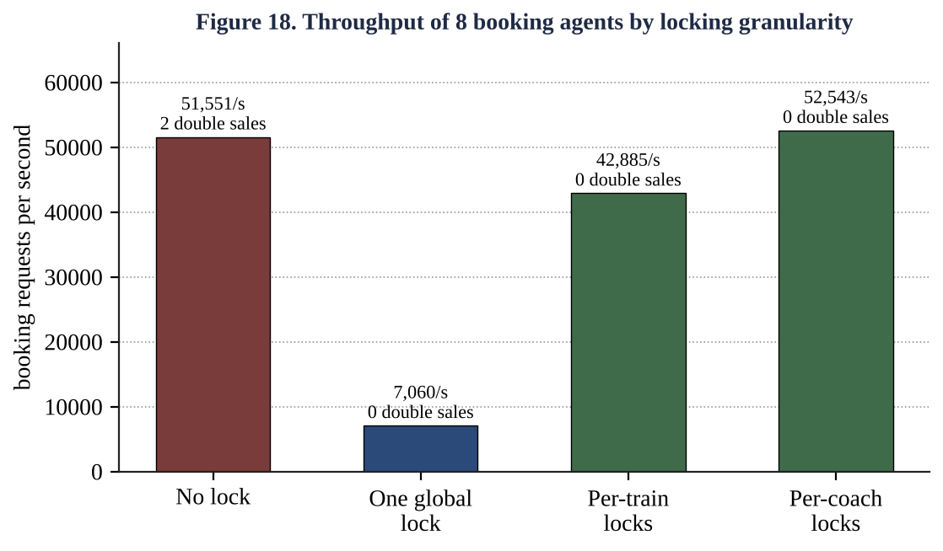
Table 5.3 Locking granularity: throughput and correctness
Configuration | Time (s) | Requests/s | Double-sold seats | Speed-up vs global
No lock | 0.062 | 51,551 | 2 (bug) | 7.3 ×
One global lock | 0.453 | 7,060 | 0 | 1.0 ×
One lock per train (20 locks) | 0.075 | 42,885 | 0 | 6.1 ×
One lock per coach (200 locks) | 0.061 | 52,543 | 0 | 7.4 ×

Decision: one lock per coach for ordinary seat sales, plus a train-level lock for operations that touch a whole train, with the fixed lock order train → coach (and coaches in ascending number when one booking needs seats in two coaches). Evidence: the global lock serialises the 100 µs of I/O of all agents, giving 7,060 requests/s; per-train locks raise this 6.1-fold and per-coach locks 7.4-fold to 52,543/s, the same as having no lock at all, yet with zero double sales (the unlocked version sold 2 seats twice). A per-coach lock is also the smallest region that still contains the whole check-and-sell action, so mutual exclusion is preserved. Finer than a coach (per seat) adds memory and lock operations with almost no further gain, while a train-level lock stays necessary for operations that must see a consistent train (printing the reservation chart, cancelling a train). The lock order prevents the deadlock that two agents each holding one coach and wanting the other would create (see Q6).

5.9 Alternative concept and complexity analysis: atomic operations or a spin lock
Solution. If the protected operation is only a counter update, no semaphore or mutex is needed. atomic_fetch_add(&counter, 1) executes the load-add-store as one indivisible hardware instruction (lock xadd on x86), and a spin lock (pthread_spin_lock) busy-waits on an atomic flag instead of putting the thread to sleep. Both were measured in q5_sync.c.
Listing 5.3 q5_sync.c
#define _GNU_SOURCE
#include <stdio.h>
#include <stdlib.h>
#include <unistd.h>
#include <pthread.h>
#include <stdatomic.h>
#include <time.h>
#include <sys/resource.h>
static double now(void){struct timespec t;clock_gettime(CLOCK_MONOTONIC,&t);return t.tv_sec+t.tv_nsec*1e-9;}
static double cpu(void){struct rusage r;getrusage(RUSAGE_SELF,&r);return
r.ru_utime.tv_sec+r.ru_stime.tv_sec+(r.ru_utime.tv_usec+r.ru_stime.tv_usec)*1e-6;}
static pthread_mutex_t mx=PTHREAD_MUTEX_INITIALIZER; static pthread_spinlock_t sp; static atomic_long at;
static long cnt;
static long PER; static int LONGCS;
static void *w_mutex(void*a){(void)a;for(long i=0;i<PER;i++){pthread_mutex_lock(&mx);cnt++;if(LONGCS)usleep(
200);pthread_mutex_unlock(&mx);}return NULL;}
static void *w_spin(void*a){(void)a;for(long i=0;i<PER;i++){pthread_spin_lock(&sp);cnt++;if(LONGCS)usleep(20
0);pthread_spin_unlock(&sp);}return NULL;}
static void *w_atomic(void*a){(void)a;for(long i=0;i<PER;i++)atomic_fetch_add(&at,1);return NULL;}
static void run(const char*nm,void*(*f)(void*),int T,long total)
{
pthread_t th[16]; PER=total/T; cnt=0; atomic_store(&at,0); double t=now(),c=cpu();
for(int i=0;i<T;i++)pthread_create(&th[i],NULL,f,NULL); for(int i=0;i<T;i++)pthread_join(th[i],NULL);
double w=now()-t,cc=cpu()-c; long done=f==w_atomic?atomic_load(&at):cnt;
printf("%-8s threads=%-2d updates=%-8ld wall=%.4f s cpu=%.4f s %.1f ns/update (count
%s)\n",nm,T,total,w,cc,w/total*1e9,done==PER*T?"ok":"WRONG");
}
int main(void)
{
pthread_spin_init(&sp,0); int Ts[]={1,4,16};
printf("Short critical section (counter++), 800000 updates in total\n");
for(int j=0;j<3;j++){run("mutex",w_mutex,Ts[j],800000);run("spin",w_spin,Ts[j],800000);run("atomic",w_at
omic,Ts[j],800000);}
printf("\nLong critical section (200 us sleep inside), 4 threads, 200 updates in total\n");
LONGCS=1; run("mutex",w_mutex,4,200); run("spin",w_spin,4,200);
return 0;
}
Output of q5_sync (real execution)
Short critical section (counter++), 800000 updates in total
mutex threads=1 updates=800000 wall=0.0158 s cpu=0.0158 s 19.8 ns/update (count ok)
spin threads=1 updates=800000 wall=0.0109 s cpu=0.0109 s 13.6 ns/update (count ok)
atomic threads=1 updates=800000 wall=0.0056 s cpu=0.0054 s 7.0 ns/update (count ok)
mutex threads=4 updates=800000 wall=0.0161 s cpu=0.0161 s 20.2 ns/update (count ok)
spin threads=4 updates=800000 wall=0.0298 s cpu=0.0241 s 37.3 ns/update (count ok)
atomic threads=4 updates=800000 wall=0.0073 s cpu=0.0073 s 9.1 ns/update (count ok)
mutex threads=16 updates=800000 wall=0.0210 s cpu=0.0208 s 26.3 ns/update (count ok)
spin threads=16 updates=800000 wall=0.0547 s cpu=0.0545 s 68.4 ns/update (count ok)
atomic threads=16 updates=800000 wall=0.0084 s cpu=0.0082 s 10.5 ns/update (count ok)

Long critical section (200 us sleep inside), 4 threads, 200 updates in total
mutex threads=4 updates=200 wall=0.0613 s cpu=0.0063 s 306397.6 ns/update (count ok)
spin threads=4 updates=200 wall=0.0775 s cpu=0.0637 s 387576.7 ns/update (count ok)
Table 5.4 Time per update (ns), 800,000 updates in total, 1-core machine
Threads | Mutex | Spin lock | Atomic add
1 | 19.8 | 13.6 | 7.0
4 | 20.2 | 37.3 | 9.1
16 | 26.3 | 68.4 | 10.5

Table 5.5 Long critical section (200 µs inside), 4 threads, 200 updates
Method | Wall time | CPU time used | Comment
Mutex | 0.0613 s | 0.0063 s | Waiters sleep: CPU almost free for other work
Spin lock | 0.0775 s | 0.0637 s | About 10 × more CPU burnt while waiting; slower as well

Table 5.6 Complexity and suitability
Property | Semaphore / mutex | Spin lock | Atomic instruction
Cost without contention | O(1), a few tens of ns (atomic op + occasional system call) | O(1), cheapest lock | O(1), cheapest (one instruction)
Cost under contention | Thread sleeps; context switch ≈ 1 to 5 µs | Burns CPU: wasted time ≈ (hold time) × (waiting threads) | Hardware serialises cache-line; grows slowly (7 → 10.5 ns for 1 → 16 threads)
CPU wasted by waiting | None (blocked) | High if the critical section is long or the holder is pre-empted | None (no waiting)
Protects | Any length of code | Very short code on multi-core machines | Single variable only
Suits a long critical section | Yes (waiters sleep) | No | No (cannot cover several statements)

Evaluation. The measurements show the same ordering at every thread count: atomic add is the fastest (7 to 10.5 ns) and grows least as threads are added; the mutex costs 20 to 26 ns; the spin lock is cheapest for one thread but degrades fastest with contention, 68 ns with 16 threads, because on one core a thread that spins while the lock holder is not running burns its entire time slice. With a long critical section (Table 5.5) the spin lock consumed about ten times more CPU time than the mutex without finishing earlier. Rule: atomics for a single counter; spin locks only for very short critical sections on multi-core machines where the holder is never pre-empted (inside kernels); mutexes/semaphores for long critical sections such as the booking transaction, where waiting threads must sleep.

5.10 Evidence summary for Q5
- Student-derived design from the three requirements (Table 5.1), Peterson analysis (Figure 14) and its failure on modern CPUs.
- Working semaphore code (Listing 5.1) with 100-run, 4 + 4 and no-mutex test evidence (Table 5.2).
- Semaphore, readers–writers, dining-philosophers and monitor solutions (Sections 5.4 to 5.7).
- Measured locking comparison and defended decision (Table 5.3, Figure 18); alternative atomic/spin-lock measurements (Tables 5.4 to 5.6).

Q6 Deadlock Handling and the Banker's Algorithm (13 marks)

6.0 Problem and model
A research centre runs jobs that need several shared resources at once (GPUs, licences for simulation software and high-speed storage). Jobs sometimes wait for each other forever and the whole cluster stops until an administrator intervenes. A set of processes is deadlocked when every process in the set is waiting for an event (the release of a resource) that can only be caused by another process in the set.

A. Characterise deadlock (2 marks)
Deadlock can occur only if all four of the following conditions hold at the same time (Coffman conditions).
Table 6.1 The four necessary conditions in the cluster
Condition | Meaning | Where it appears in the cluster
1. Mutual exclusion | At least one resource is held in a non-sharable mode | A GPU, a licence seat or a storage lane is used by one job at a time
2. Hold and wait | A process holds resources while waiting for others | Job P1 keeps its GPU while it waits for a licence
3. No pre-emption | A resource can be released only voluntarily by its holder | A running simulation cannot lose its licence or GPU without being aborted
4. Circular wait | There is a cycle P1 → P2 → … → Pn → P1 of processes each waiting for a resource held by the next | P1 waits for P2's licence, P2 for P3's storage, P3 for P1's GPU

In the resource-allocation graph a request edge Pi → Rj means that Pi is waiting for Rj and an assignment edge Rj → Pi means that Rj is held by Pi. Figure 19 shows the cluster at the moment of deadlock with three jobs and three resource types with a single instance each: P1 holds the GPU (R1) and requests the licence (R2); P2 holds the licence and requests storage (R3); P3 holds storage and requests the GPU. The cycle P1 → R2 → P2 → R3 → P3 → R1 → P1 exists. With one instance per resource a cycle is both necessary and sufficient for deadlock; with several instances a cycle is necessary but not sufficient.
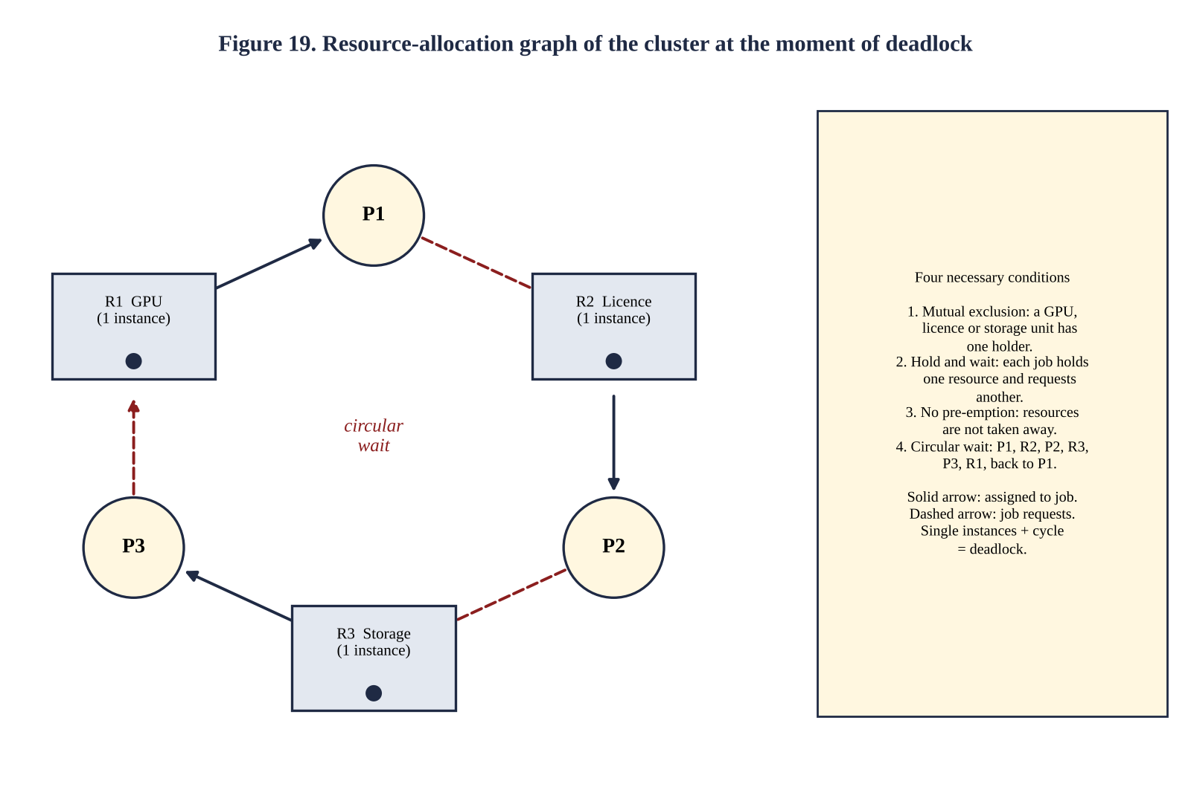
All four conditions are visible in the figure: the resources are single-holder (1), every job has an assignment edge and a request edge (2), there is no way to take an assigned resource back (3), and the six edges form a closed loop (4). Removing any one of them (for example breaking the cycle by forcing the order GPU < licence < storage) makes the deadlock impossible.

Complete the Code: the safety algorithm
TODO 1 was completed as follows: for every unfinished process p compute need = max − alloc; if need ≤ work in every resource, p can run to completion with the resources that are free, then it returns everything it holds, so work += alloc[p]; the process is marked finished and appended to the safe sequence, and found is set. If a whole pass finds no process, the state is unsafe.
Listing 6.1 q6_banker.c (TODO 1 completed)
#include <stdio.h>
#include <string.h>
#define P 5
#define R 3
int avail[R] = {3, 3, 2};
int maxm[P][R] = {{7, 5, 3}, {3, 2, 2}, {9, 0, 2}, {2, 2, 2}, {4, 3, 3}};
int alloc[P][R] = {{0, 1, 0}, {2, 0, 0}, {3, 0, 2}, {2, 1, 1}, {0, 0, 2}};
/* Returns 1 if the state is safe and stores a safe sequence in seq. */
int is_safe(int seq[P])
{
int work[R], finish[P] = {0}, count = 0;
memcpy(work, avail, sizeof work);
while (count < P) {
int found = 0;
for (int p = 0; p < P; p++) {
if (finish[p]) continue;
/* TODO 1 completed */
int ok = 1;
for (int r = 0; r < R; r++)
if (maxm[p][r] - alloc[p][r] > work[r]) { ok = 0; break; }
if (ok) {
for (int r = 0; r < R; r++) work[r] += alloc[p][r];
finish[p] = 1;
seq[count++] = p;
found = 1;
}
}
if (!found) return 0;
}
return 1;
}
void request(int p, const int req[R])
{
for (int r = 0; r < R; r++)
if (req[r] > maxm[p][r] - alloc[p][r] || req[r] > avail[r]) {
printf("P%d request: must wait (not available)\n", p);
return;
}
for (int r = 0; r < R; r++) { avail[r] -= req[r]; alloc[p][r] += req[r]; }
int seq[P];
if (is_safe(seq)) {
printf("P%d request: granted, safe sequence", p);
for (int i = 0; i < P; i++) printf(" P%d", seq[i]);
printf("\n");
} else {
for (int r = 0; r < R; r++) { avail[r] += req[r]; alloc[p][r] -= req[r]; }
printf("P%d request: denied (unsafe)\n", p);
}
}
int main(void)
{
int seq[P];
if (is_safe(seq)) {
printf("initial state safe:");
for (int i = 0; i < P; i++) printf(" P%d", seq[i]);
printf("\n");
}
request(1, (int[R]){1, 0, 2});
request(4, (int[R]){3, 3, 0});
request(0, (int[R]){0, 2, 0});
return 0;
}
Output (matches the expected output exactly)
initial state safe: P1 P3 P4 P0 P2
P1 request: granted, safe sequence P1 P3 P4 P0 P2
P4 request: must wait (not available)
P0 request: denied (unsafe)

Hand verification of the initial state
Table 6.2 Initial state (Available = (3, 3, 2); total resources (10, 5, 7))
Process | Allocation A B C | Maximum A B C | Need = Max − Alloc
P0 | 0 1 0 | 7 5 3 | 7 4 3
P1 | 2 0 0 | 3 2 2 | 1 2 2
P2 | 3 0 2 | 9 0 2 | 6 0 0
P3 | 2 1 1 | 2 2 2 | 0 1 1
P4 | 0 0 2 | 4 3 3 | 4 3 1

Table 6.3 Safety algorithm trace
Step | Work before | Process tested | Need ≤ Work ? | Work after (Work + Alloc)
1 | (3,3,2) | P0 (7,4,3) | No (7 > 3) | –
 | (3,3,2) | P1 (1,2,2) | Yes | (5,3,2)
 | (5,3,2) | P2 (6,0,0) | No (6 > 5) | –
2 | (5,3,2) | P3 (0,1,1) | Yes | (7,4,3)
3 | (7,4,3) | P4 (4,3,1) | Yes | (7,4,5)
4 | (7,4,5) | P0 (7,4,3) | Yes | (7,5,5)
5 | (7,5,5) | P2 (6,0,0) | Yes | (10,5,7)

All five processes finish; the safe sequence is ⟨P1, P3, P4, P0, P2⟩, and the final work vector (10, 5, 7) equals the total number of instances, a useful consistency check.

Show by hand why the request of P0 for (0, 2, 0) leads to an unsafe state
The three requests are processed in order. First, P1 requests (1, 0, 2): Request ≤ Need (1,2,2) ✓; Request ≤ Available (3,3,2) ✓. Pretend allocation: Available = (2,3,0), Alloc(P1) = (3,0,2), Need(P1) = (0,2,0). Safety: from Work = (2,3,0), P1 (0,2,0) fits → (5,3,2); P3 → (7,4,3); P4 → (7,4,5); P0 → (7,5,5); P2 → (10,5,7). Safe, so the request is granted (sequence P1 P3 P4 P0 P2). Second, P4 requests (3, 3, 0): Request ≤ Need (4,3,1) ✓ but Request (3,3,0) ≤ Available (2,3,0) fails in the first resource (3 > 2), so P4 must wait. Third, P0 requests (0, 2, 0): Request ≤ Need (7,4,3) ✓; Request ≤ Available (2,3,0) ✓. Pretend allocation:
Table 6.4 State after pretending to grant (0, 2, 0) to P0 — Available = (2, 1, 0)
Process | Allocation | Need | Can finish with Work = (2,1,0) ?
P0 | 0 3 0 | 7 2 3 | No: 7 > 2 (A)
P1 | 3 0 2 | 0 2 0 | No: needs 2 of B, only 1 free
P2 | 3 0 2 | 6 0 0 | No: 6 > 2 (A)
P3 | 2 1 1 | 0 1 1 | No: needs 1 of C, none free
P4 | 0 0 2 | 4 3 1 | No: 4 > 2 (A)

Result. With Work = (2, 1, 0) no process can obtain its remaining need, so no process can ever finish and release resources: the state is unsafe. The two units of B given to P0 were the units that P1 needed to complete (its need is (0, 2, 0)). The request is therefore denied and the pretend allocation is rolled back (Available returns to (2, 3, 0)). The state is not yet a deadlock — it only might become one if all processes demanded their maximum — but the Banker's algorithm refuses to enter it.

Alternative concept and complexity analysis: detection and recovery instead of the Banker's algorithm
Solution. The system lets processes obtain any available resource at once (no safety check), and a detection algorithm runs periodically, for example every five minutes. It uses the same structures but with the current Request matrix instead of Need: Work = Available; Finish[i] = false if Alloc_i ≠ 0; repeatedly find an i with Finish[i] = false and Request_i ≤ Work, add Alloc_i to Work and set Finish[i] = true. Every process with Finish[i] = false at the end is deadlocked. Recovery: abort all deadlocked jobs, or abort them one at a time (re-running detection after each abort) choosing the victim of least cost (least work done since its last checkpoint, fewest resources held, lowest priority, fewest previous aborts to avoid starving one job), or pre-empt resources and roll the victim back to a checkpoint.
Table 6.5 Banker's algorithm versus detection and recovery
Measure | Banker's algorithm (avoidance) | Detection and recovery
Time per request | O(m·n²): the request test (O(m)) plus a full safety check | O(m): just test availability and allocate; no check
Extra periodic cost | None | One detection run O(m·n²) every T minutes; measured 0.81 ms for n = 1,000 (Table 6.9), i.e. 0.81 ms / 300 s = 0.0003 % of the time
Deadlock can occur ? | Never (always stays in a safe state) | Yes, for up to T minutes before it is found; the involved resources sit idle
Work lost | None (a request is delayed, not killed) | Aborted job loses all work since its last checkpoint; with a 2-hour-old job this is 2 hours × the resources it held
Knowledge needed | Maximum demand of every job in advance; fixed resource counts | None
Resource utilisation | Lower: safe-state requirement may leave resources idle even when a request is available | Higher: resources are given out immediately

B. Compare the strategies (3 marks)
Table 6.6 Evaluation of the four strategies for the research cluster
Strategy | How it works | Strengths | Weaknesses for this cluster | Verdict
Prevention | Make one of the four conditions impossible: allocate everything at once (no hold-and-wait); pre-empt when blocked (no no-pre-emption); impose an order GPU < licence < storage (no circular wait) | No run-time cost; deadlock impossible by construction; the ordering rule is trivial to implement | Mutual exclusion cannot be removed for GPUs and licences; all-at-once allocation leaves resources idle and starves large jobs; pre-emption needs checkpoints and cannot take back a licence | Use the ordering rule inside jobs; not all-at-once as the main method
Avoidance (Banker's) | Grant a request only if the resulting state is safe | Never deadlocks; no job is aborted | Needs maximum demands; fixed number of resources; O(m·n²) per check; conservative | Good if jobs declare their demands (batch submission does)
Detection and recovery | Allow deadlock, detect periodically, abort a victim | Maximum utilisation; no advance knowledge | Aborts lose work; detection delay; needs checkpoints and a victim policy | Useful as a safety net
Ignore (ostrich) | Pretend deadlock never happens; an administrator restarts | Zero cost and zero complexity; reasonable when deadlock is very rare | This cluster already stops repeatedly; every incident halts all research | Rejected

C. Apply the Banker's algorithm (4 marks)
The implementation consists of the two algorithms of Figure 20, both coded in Listing 6.1: is_safe() is the safety algorithm and request() is the resource-request algorithm. The request algorithm (i) rejects a request larger than the declared need (a process may not exceed its stated maximum), (ii) makes the process wait if the request exceeds Available, (iii) pretends to allocate, (iv) calls the safety algorithm, and (v) either keeps the allocation or restores the old state.
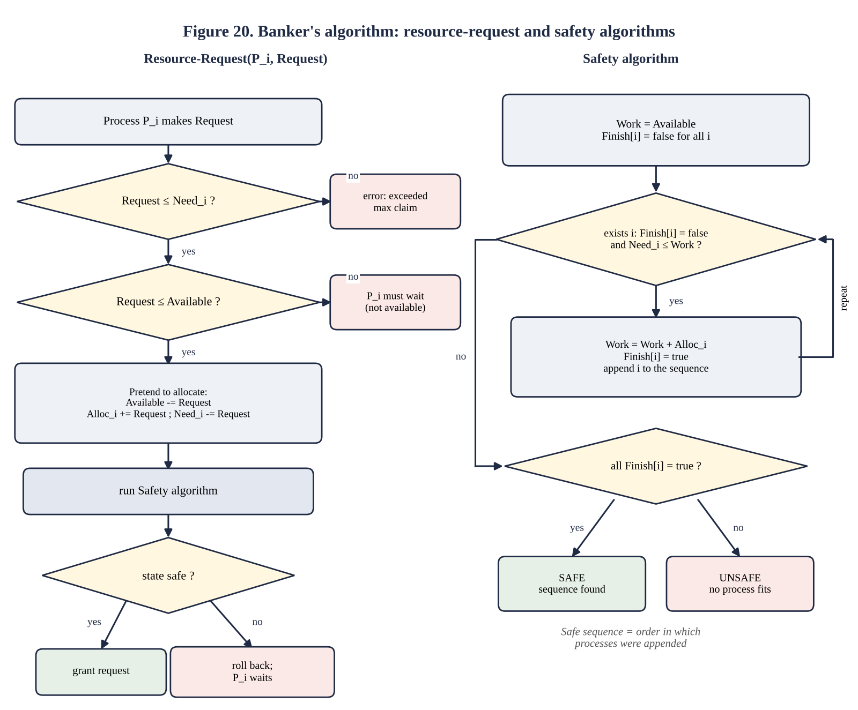
Table 6.7 Decisions for the three requests of the question
Request | Test 1: ≤ Need | Test 2: ≤ Available | Safety of new state | Decision
P1 asks (1,0,2) | (1,0,2) ≤ (1,2,2) ✓ | (1,0,2) ≤ (3,3,2) ✓ | Safe: P1 P3 P4 P0 P2 | Granted
P4 asks (3,3,0) | (3,3,0) ≤ (4,3,1) ✓ | (3,3,0) ≤ (2,3,0) ✗ (3 > 2) | not evaluated | Must wait
P0 asks (0,2,0) | (0,2,0) ≤ (7,4,3) ✓ | (0,2,0) ≤ (2,3,0) ✓ | Unsafe (Table 6.4) | Denied, rolled back

Complexity of the safety algorithm. The while loop runs at most n times (each pass that does not return finishes at least one process), each pass examines n processes, and each examination compares m resource types: O(m·n²) in the worst case. The request algorithm adds only O(m). In the worst case only one process becomes finishable per pass; in typical states more than one is, and in an unsafe state the loop stops after one failed pass, so the cost is O(m·n).

D. Predict before implementing (1 mark)
Prediction. The running time of the safety algorithm is T(n, m) ≈ k·m·n² in the worst case. Therefore (1) multiplying the number of processes by 10 multiplies the time by about 100: T(100)/T(10) ≈ 100 and T(1000)/T(100) ≈ 100, a straight line of slope 2 on a log–log plot; (2) the time is proportional to m (doubling the number of resource types doubles the time); (3) for a random or unsafe state the algorithm ends after the first pass, so the time grows only about 10-fold when n grows 10-fold (slope 1). The test: time the safety check for n = 10, 100, 1,000 on a worst-case state and compare the ratios with 100.

E. Measure (1 mark)
q6_time.c builds two kinds of state with m = 3 resource types: (a) a worst-case state in which process p needs n − p units of resource 0 and holds 1, with 1 unit available, so that only the last unfinished process can run in every pass, forcing n passes of n tests (it is a safe state), and (b) a random state, usually unsafe. Each size is repeated many times and the average is taken.
Listing 6.2 q6_time.c
#define _GNU_SOURCE
#include <stdio.h>
#include <stdlib.h>
#include <string.h>
#include <time.h>
#define M 3
static double now(void){struct timespec t;clock_gettime(CLOCK_MONOTONIC,&t);return t.tv_sec+t.tv_nsec*1e-9;}
/* worst case: only the last unfinished process can run in each pass, so n passes of n checks each */
static int safe(int n,int(*need)[M],int(*alloc)[M],int*avail)
{
int work[M],count=0; char *fin=calloc(n,1); memcpy(work,avail,sizeof work);
while(count<n){int found=0;
for(int p=0;p<n;p++){ if(fin[p])continue; int ok=1; for(int
r=0;r<M;r++)if(need[p][r]>work[r]){ok=0;break;}
if(ok){for(int r=0;r<M;r++)work[r]+=alloc[p][r];fin[p]=1;count++;found=1;} }
if(!found){free(fin);return 0;} }
free(fin); return 1;
}
int main(void)
{
int ns[]={10,100,1000}; int ms[]={1,3};
printf("%-8s %-18s %-18s\n","n","worst case (ms)","random state (ms)");
for(int i=0;i<3;i++){
int n=ns[i]; int (*need)[M]=malloc(sizeof(int[M])*n),(*alloc)[M]=malloc(sizeof(int[M])*n); int
avail[M]={1,1,1};
for(int p=0;p<n;p++)for(int r=0;r<M;r++){need[p][r]=n-p;alloc[p][r]=1;}
int reps=n==10?20000:n==100?200:2; double t=now(); int ok=0; for(int
k=0;k<reps;k++)ok=safe(n,need,alloc,avail); double w=(now()-t)/reps*1e3;
srand(1); for(int p=0;p<n;p++)for(int r=0;r<M;r++){alloc[p][r]=rand()%3;need[p][r]=rand()%4;} int
av[M]={5,5,5};
reps=n==10?20000:n==100?2000:20; t=now(); for(int k=0;k<reps;k++)safe(n,need,alloc,av); double
rd=(now()-t)/reps*1e3;
printf("%-8d %-18.5f %-18.5f (worst-case state safe=%d)\n",n,w,rd,ok);
free(need);free(alloc);
}
(void)ms; return 0;
}
Output of q6_time (real execution)
n worst case (ms) random state (ms)
10 0.00014 0.00003 (worst-case state safe=1)
100 0.00977 0.00024 (worst-case state safe=1)
1000 0.81466 0.00253 (worst-case state safe=1)
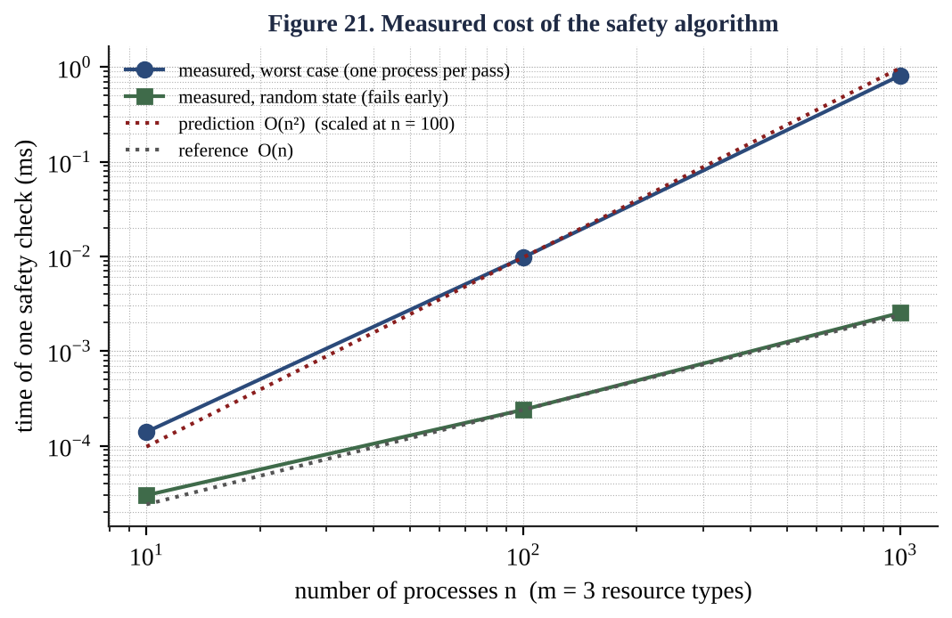
Table 6.8 Measured time of one safety check (m = 3)
n | Worst case (ms) | Ratio to previous | Predicted ratio | Random state (ms) | Ratio
10 | 0.00014 | – | – | 0.00003 | –
100 | 0.00977 | 69.8 | 100 | 0.00024 | 8.0
1,000 | 0.81466 | 83.4 | 100 | 0.00253 | 10.5

Comparison with the prediction. The measured growth factors are 69.8 and 83.4 instead of 100; on the log–log plot the average slope is about 1.9 (log₁₀ 69.8 = 1.84 and log₁₀ 83.4 = 1.92), very close to the predicted slope 2. The ratio is below 100 for small n because fixed costs (allocation of the finish array, copying work, loop start-up) are a large share of a tiny total and do not grow with n²; the ratio moves towards 100 as n grows (69.8 → 83.4). For the random state the ratios 8.0 and 10.5 confirm the linear behaviour, O(m·n), of the early-exit case. The prediction is therefore confirmed: the worst-case cost of the safety check is quadratic in the number of processes. In absolute terms it is cheap: 0.8 ms for 1,000 processes.

F. Defend the final design (2 marks)
Recommendation for the research centre: a layered design. (1) Primary: avoidance by the Banker's algorithm at the job scheduler. Each job states its maximum GPUs, licences and storage when it is submitted (batch schedulers already ask for this), so the main objection to the Banker's algorithm, the need to know maximum demands in advance, is satisfied by the submission form. A request that would lead to an unsafe state simply waits. (2) Prevention inside jobs by a fixed global order GPU < licence < storage for any job that acquires resources step by step, at no run-time cost. (3) Safety net: detection every five minutes with checkpoint-based recovery for jobs that exceed their declared maximum or use resources the scheduler does not know about. Ignoring deadlock is rejected because it is the current failure.
Cost of the Banker's algorithm. The measured safety check takes 0.14 µs for 10 jobs, 9.8 µs for 100 jobs and 0.81 ms for 1,000 jobs (Table 6.8). A research cluster has tens to hundreds of concurrent jobs and each job runs for minutes to hours, so a check of 10 µs to 1 ms per resource request is negligible, less than one millionth of a typical job's run time. The cost is not a reason to reject avoidance; if the cluster reached tens of thousands of jobs the O(m·n²) cost could be reduced by checking only the processes affected by a request or by batching requests.
Need to know maximum demands in advance. This is the real limitation. Its consequences and how the design contains them: (a) users over-declare to be safe, which makes the safe-state test conservative and leaves resources idle; this is mitigated by charging users for declared, not used, resources and by comparing declared and actual use; (b) a job that exceeds its declared maximum is rejected by the request algorithm (test 1) and can be killed or queued again with a new claim, instead of causing a deadlock; (c) the number of resources must be fixed: when a licence server or a GPU is added or fails, the Available vector and the safety result must be recomputed; (d) the Banker's algorithm does not help for resources the scheduler does not control, which is why the detection safety net remains.
Why not the alternatives alone. Prevention by all-at-once allocation would be simple, but a job needing 8 GPUs and 4 licences would wait until all are free and may starve, and licence seats are expensive to leave idle. Detection and recovery alone would increase utilisation, but each deadlock would still cost an aborted job's work (hours of GPU time) and a delay of up to the detection period. The layered design uses each technique where it is strongest: a few microseconds of avoidance on the common path, a free ordering rule for step-by-step acquisition and an inexpensive watchdog for the exceptions.

6.1 Evidence summary for Q6
- Resource-allocation graph with all four conditions identified (Figure 19, Table 6.1).
- Working Banker's implementation with correct safe sequences and decisions (Listing 6.1, Tables 6.2 to 6.7).
- Predicted growth, measured times and comparison (Section D, Table 6.8, Figure 21).
- Strategy comparison (Table 6.6) and a defended layered recommendation (Section F).

Section 7 Consolidated Evidence Checklist and Viva Preparation

7.1 Evidence checklist
Task | Evidence required | Where in this sheet | Done
Q1 | State diagram, PCB, fork() program with ps evidence, defended design | Figures 1-3, Listing 1.1, Section 1.6 | ✓
Q2 | Gantt charts and averages for 5 algorithms, RR program, quantum study, recommendation | Figures 4-7, Listing 2.1, Tables 2.2-2.4 | ✓
Q3 | Multithreaded program, speed-up per pool size, thread-model evaluation | Listing 3.1, Table 3.4, Figures 9-11 | ✓
Q4 | Two IPC implementations, transfer times, justified choice | Listings 4.1-4.2, Table 4.2, Section 4.8 | ✓
Q5 | Derived design, semaphore code, test evidence, measured locking decision | Table 5.1, Listing 5.1, Tables 5.2-5.3 | ✓
Q6 | RAG with four conditions, Banker implementation, prediction, measurement, recommendation | Figures 19-21, Listings 6.1-6.2, Section F | ✓

7.2 Likely viva questions with model answers
- Why does a process in the waiting state not use the CPU? It is blocked on an event; the scheduler only picks processes from the ready queue. A device interrupt moves it back to ready.
- What is saved in a context switch? Program counter, registers, stack pointer, state and memory-management information, into the PCB of the outgoing process; the incoming PCB is loaded.
- What does fork() return? 0 in the child, the child's PID in the parent, -1 on failure. Memory is copied lazily (copy-on-write).
- Why is SJF optimal, and what is its problem? It minimises average waiting time among non-pre-emptive schedules because short jobs delay fewer others; it needs burst lengths and can starve long jobs.
- What happens to Round Robin when the quantum is very large or very small? Large: it becomes FCFS. Small: context-switch overhead dominates (23 switches for q = 1 in our job set).
- Which resources do threads share? Code, data, heap, open files; each has its own stack, registers and thread id.
- Why did the speed-up stay near 1.0? The test machine had one core; speed-up is limited by min(threads, cores) and by Amdahl's serial fraction.
- How does a reader know the pipe is finished? read() returns 0 when every write end is closed; a forgotten close() in the parent keeps the reader blocked forever.
- Which IPC method avoids copies, and what does it cost? Shared memory; it needs explicit synchronisation (semaphores) from the programmer.
- Why must the producer wait(empty) before locking the mutex? Otherwise it can sleep holding the mutex and the consumer can never free a slot: deadlock.
- Why can Peterson's algorithm fail on modern CPUs? Store buffers and reordering let the load of flag[j] pass the store to turn; barriers or sequentially consistent atomics are required.
- Spin lock or mutex for a long critical section? Mutex: waiters sleep. A spin lock wasted about ten times more CPU in our measurement.
- State the four deadlock conditions. Mutual exclusion, hold and wait, no pre-emption, circular wait.
- Why is the state after granting (0,2,0) to P0 unsafe? Work becomes (2,1,0) and no process's need fits in it; P1 needs 2 units of B and only 1 is left.
- What is the complexity of the safety algorithm and was it confirmed? O(m·n²); measured growth factors 69.8 and 83.4 per tenfold increase in n, slope about 1.9.

7.3 Reproducing every result
gcc -std=c11 -Wall -Wextra -pthread -o q1_fork Q1/q1_fork.c && ./q1_fork
gcc -std=c11 -Wall -Wextra -o q2_rr Q2/q2_rr.c && ./q2_rr 3 && ./q2_rr 1 && ./q2_rr 20
gcc -std=gnu11 -O1 -pthread -o q3_threads Q3/q3_threads.c && ./q3_threads
gcc -std=c11 -Wall -Wextra -o q4_pipe Q4/q4_pipe.c && ./q4_pipe
gcc -std=gnu11 -O2 -pthread -o q4_bench Q4/q4_bench.c && ./q4_bench
gcc -std=c11 -Wall -Wextra -pthread -o q5_buffer Q5/q5_buffer.c
for i in $(seq 100); do ./q5_buffer; done | sort | uniq -c
gcc -std=c11 -Wall -Wextra -o q6_banker Q6/q6_banker.c && ./q6_banker
Remember: the README must list your name, register number, gcc version, Linux distribution, the exact compile command and the result of each task, and the commit history must show at least one commit per task.

