**Experiment No-1**

Establish an AWS account. Use the AWS Management Console to launch an EC2 instance and connect to it.

**Step1:** Login into AWS

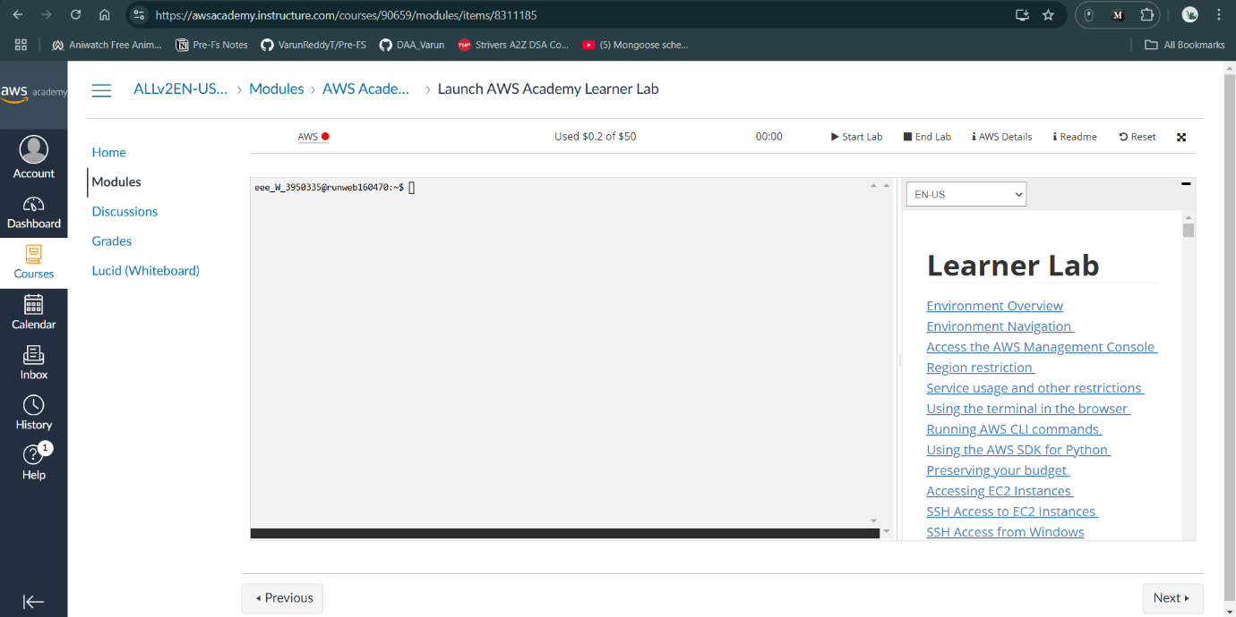

**Step2:** Activate AWS (Green Colour) → Click **Start Lab → click AWS search EC2 in** search Bar

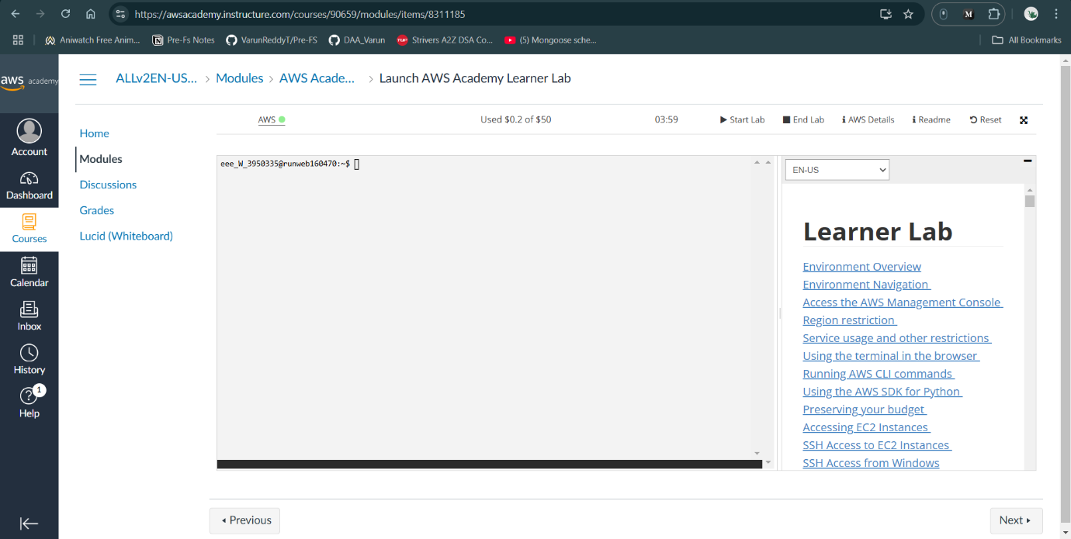

1. In search bar type EC2 (Elastic Compute cloud)

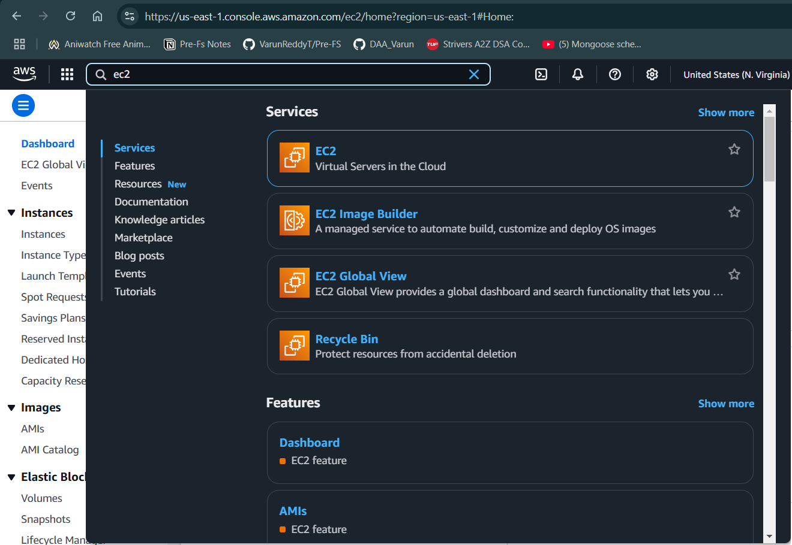

1. You will get EC2 Dashboard contains resources

* Instances (choose)
* Elastics IPs
* Key Pairs
* Snapshot

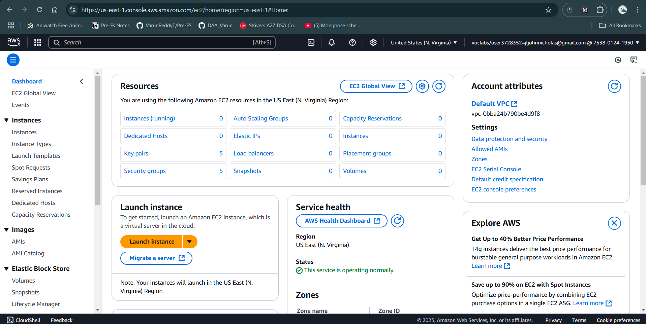

1. First Launch Instance

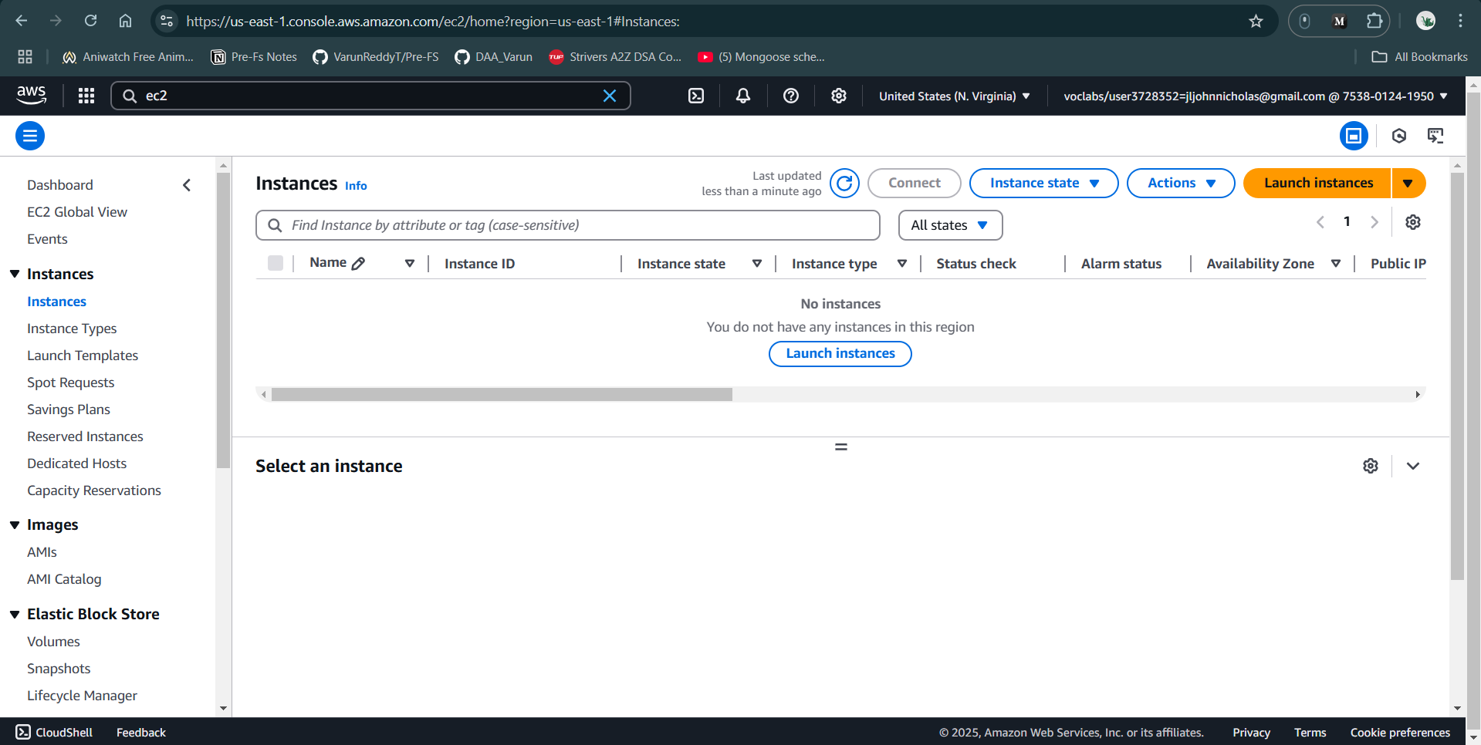

1. EC2 allows you to create virtual machines, or instances, that run on the AWS Cloud

* Name and tags: Rollno_EC2
* Application and OS Images (Amazon Machine Image): you can choose Ubuntu/Windows
* Amazon Machine Image (AMI): choose **Free tier eligible** like Amazon Linux 2023 AMI
* Description: explains about machine advantage
* Architecture: 64 Bit

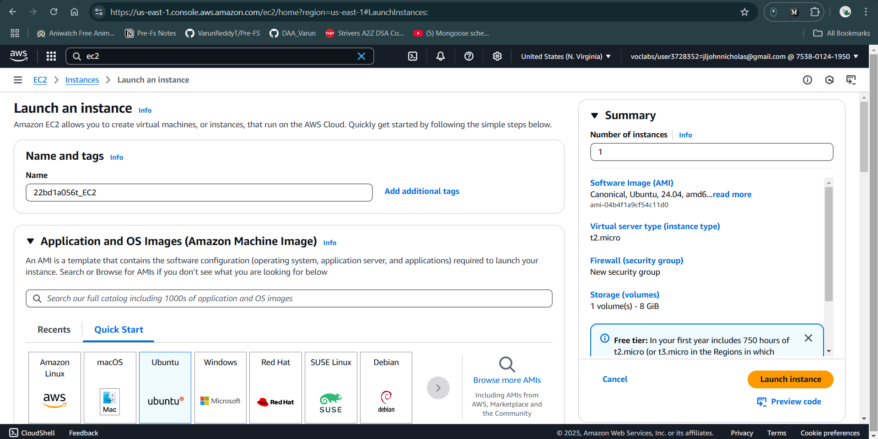

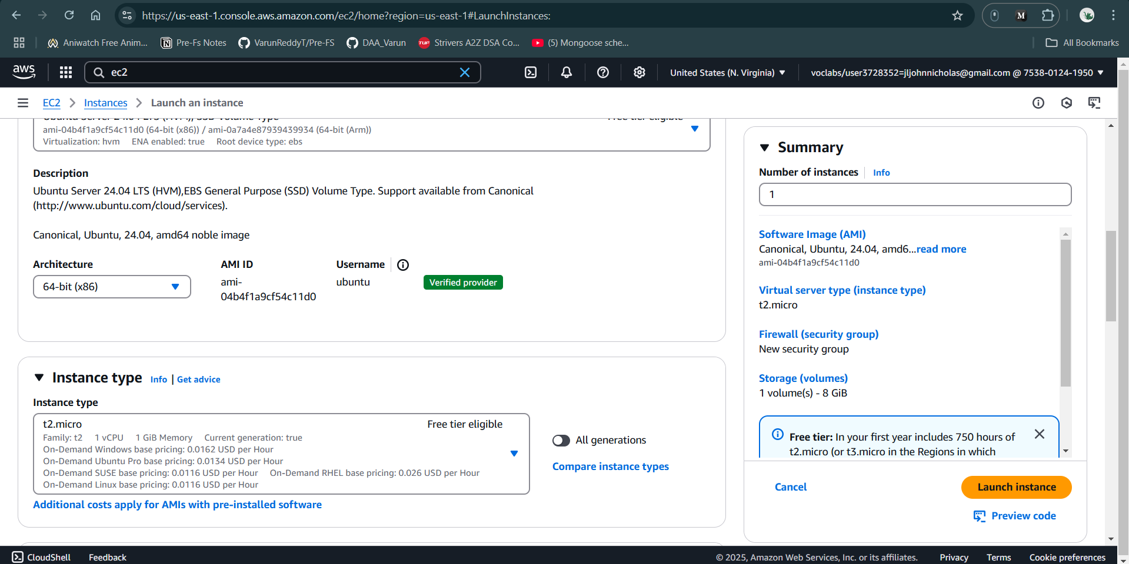

1. Instance type: t2.micro (**Free tier eligible**)
2. Key pair (login): Create & Download {Everyone have Unique} & Download

* RSA (choose)
* ED25519
* PEM: (Choose)
* PPK

1. **Network settings**  : click checkbox **Allow SSH traffic from** & Choose **Anywhere to access** system

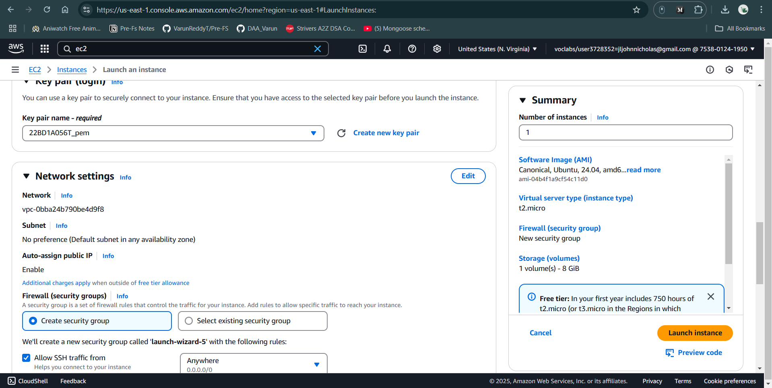

1. Configure storage:
2. In Summary choose 2 Instances

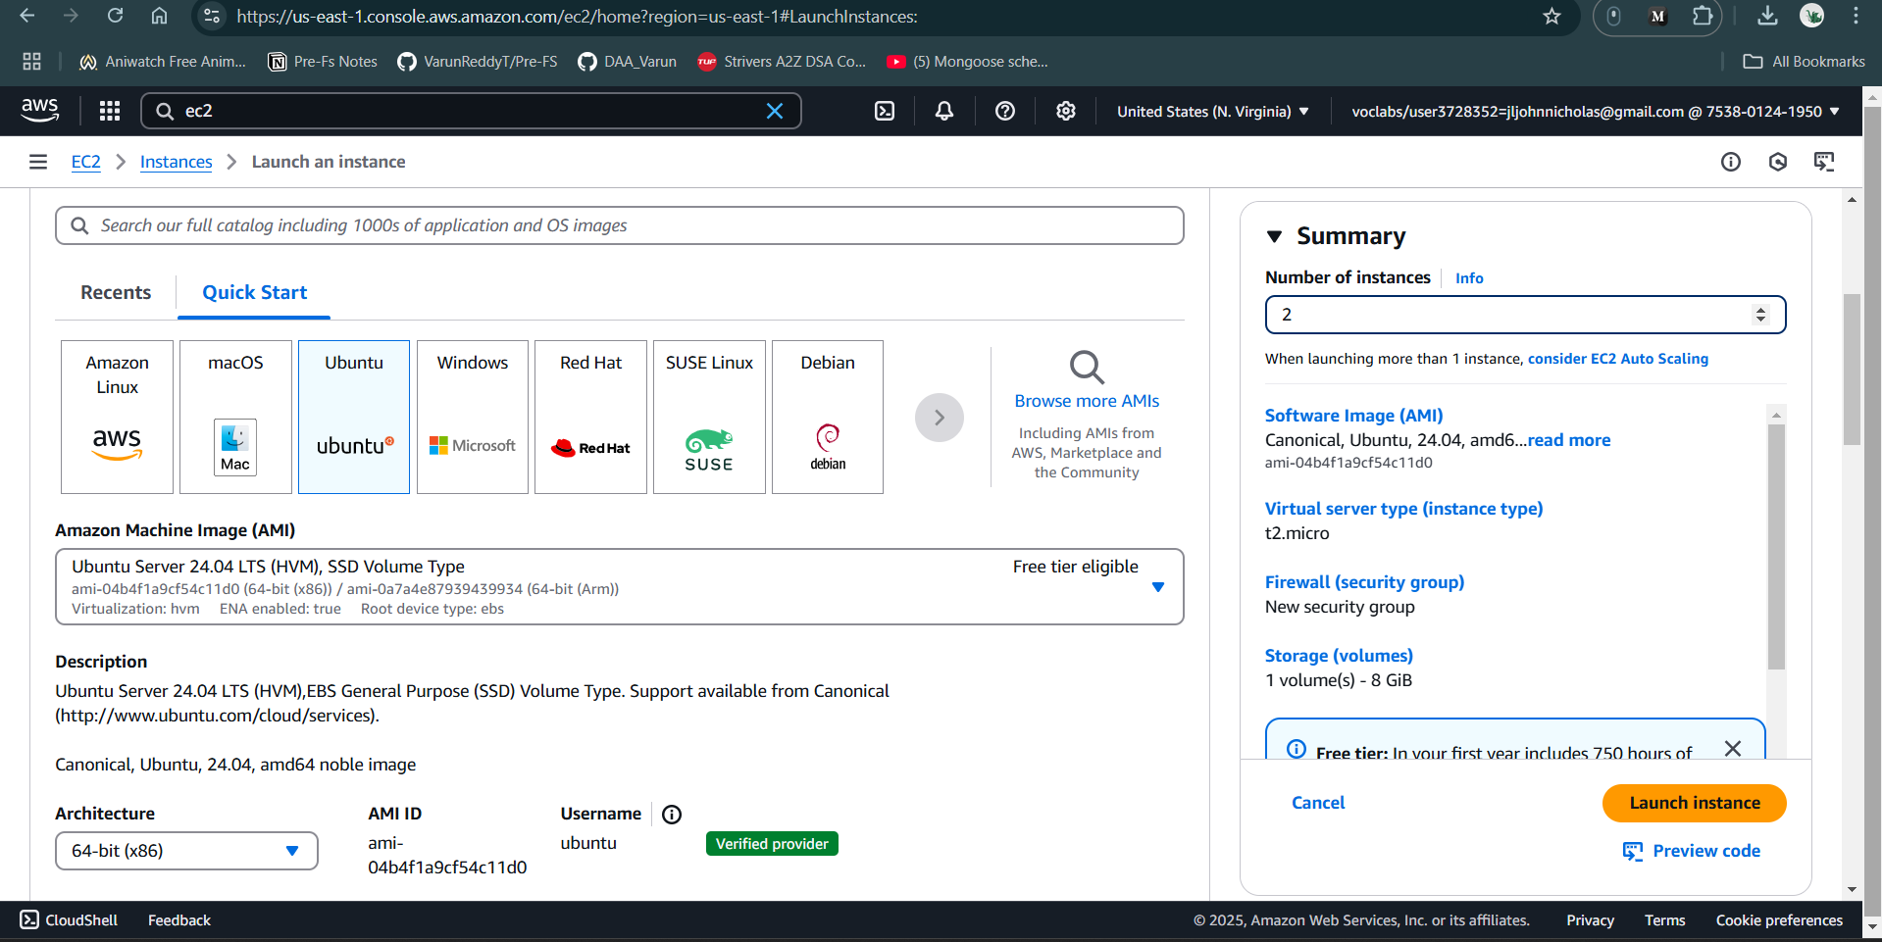

1. Click Launch Instance
2. GO Back & check Instance is create by 2/2 steps execution 1. For Software check & 2nd for Hardware check
3. Select the Instance Created & Click on **Connect**

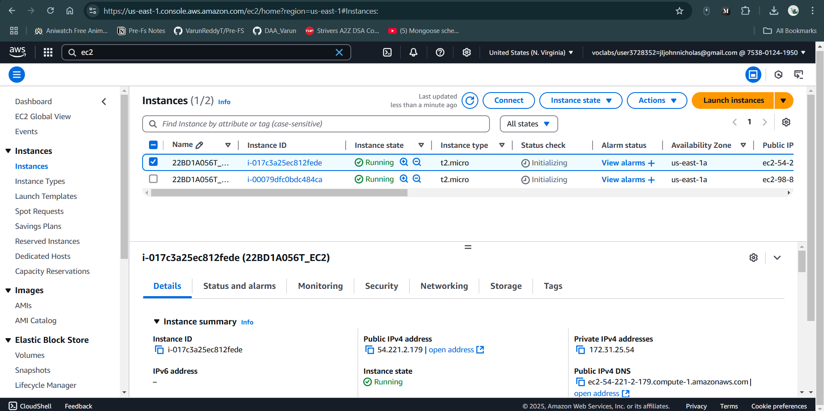

1. After connecting UI Look Like Below

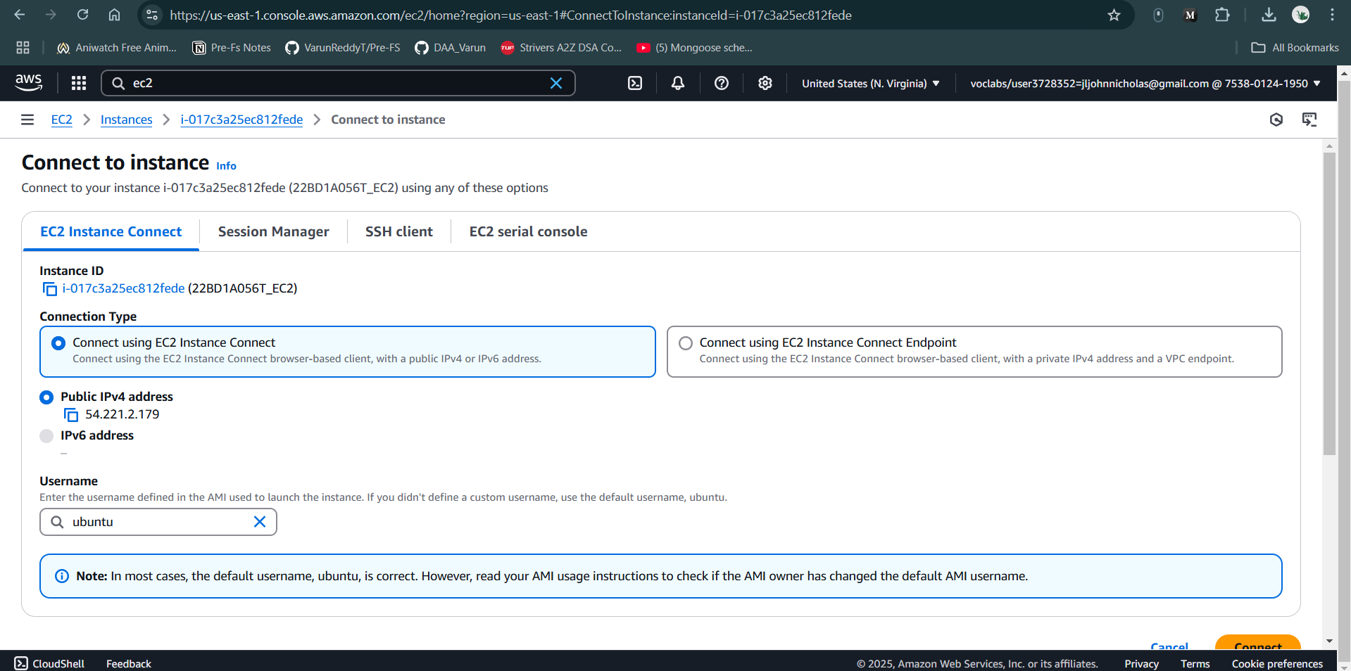

1. First connect with **EC2 Instance Connect** **Method-1**

* click on connect
* UI Looks Like Below

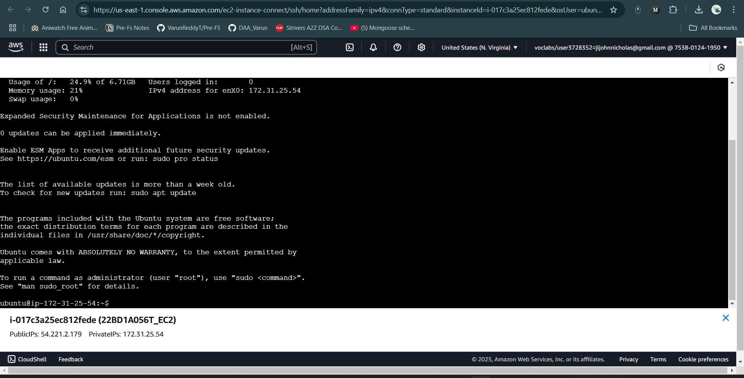

* perform unix commands like create directory with your Roll no, chmod, ls, vi, install java package & run the java code

Install Java Package

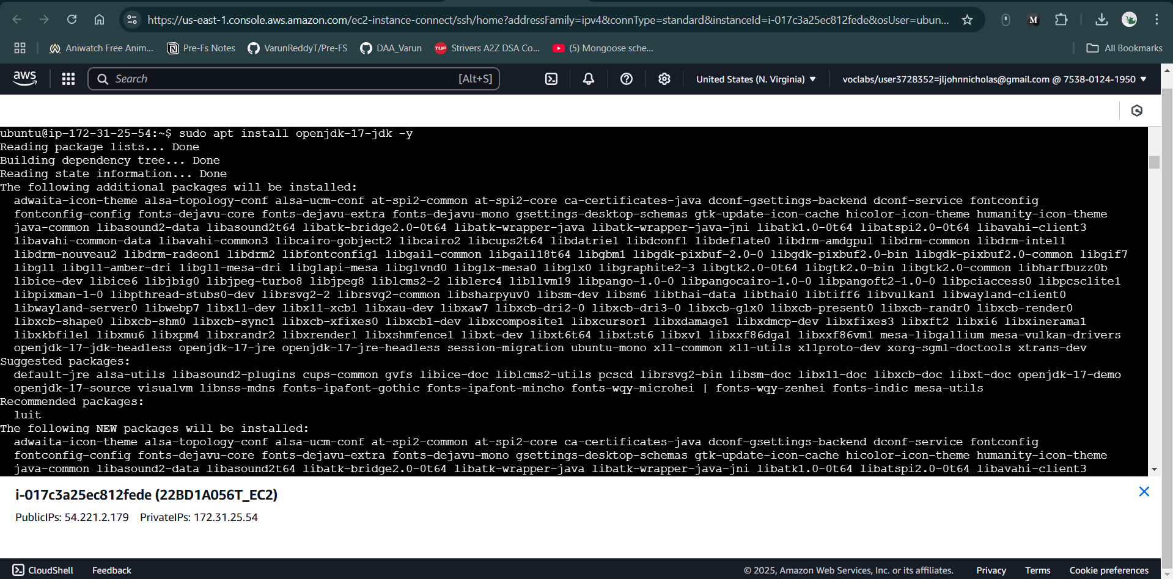

Create a Java file, compile and run.

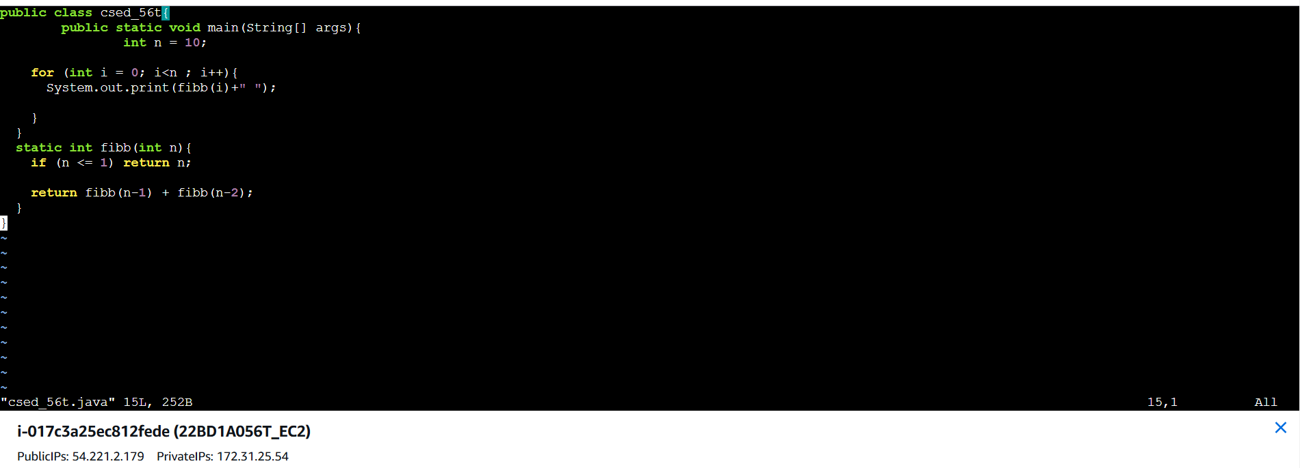

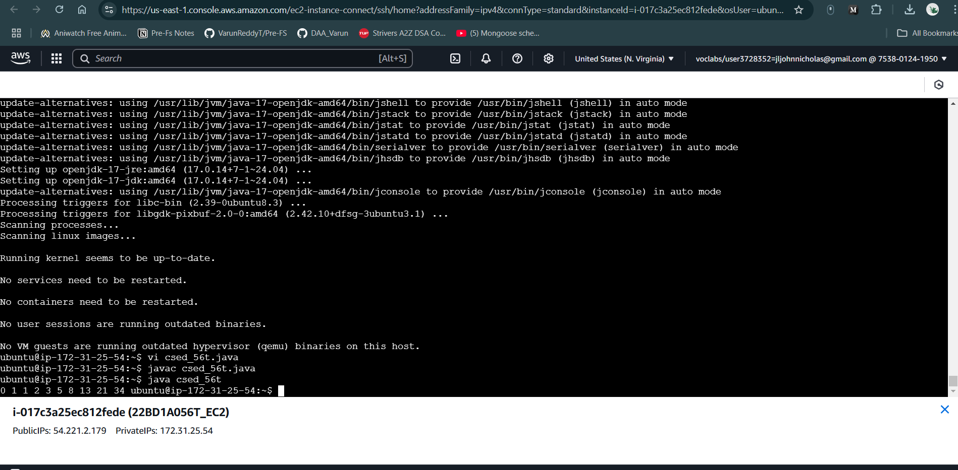

**Method 2: Connect with SSH**

**CONNECT Putty with EC2 Machine using PEM key pair..**

1. Open putty key generation & load your Private PEM file & Save the Private Key

* convert PEM File into PPK (Putty private key)

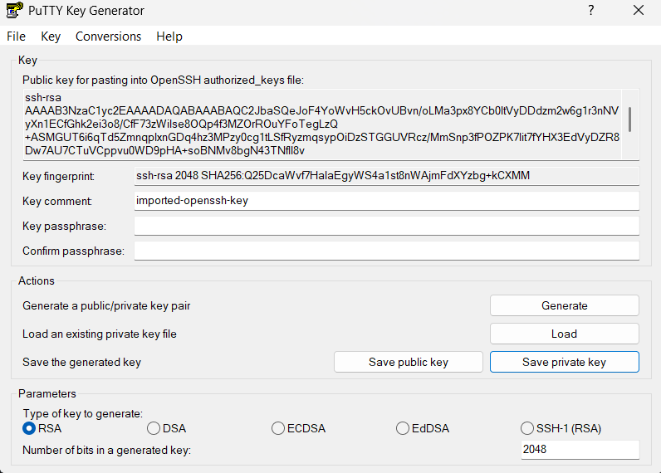

* No

1. Now open Putty
2. Now copy public IPV4 link from SSH Connect **to your instance using its Public DNS**:

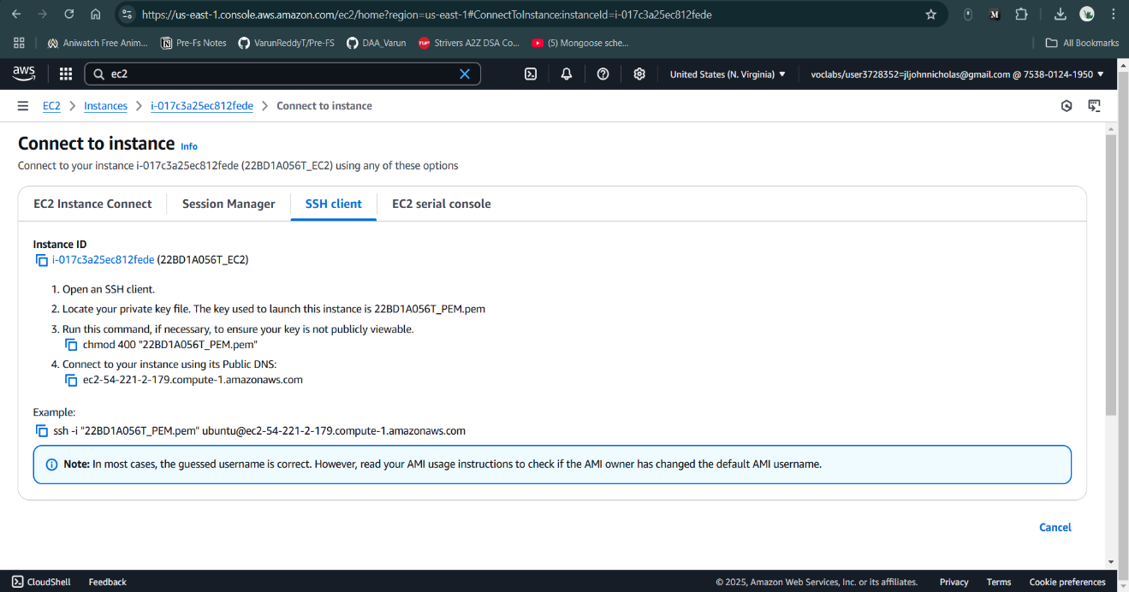

1. paste link in putty Host Name (ec2-3-88-215-253.compute-1.amazonaws.com) port 22

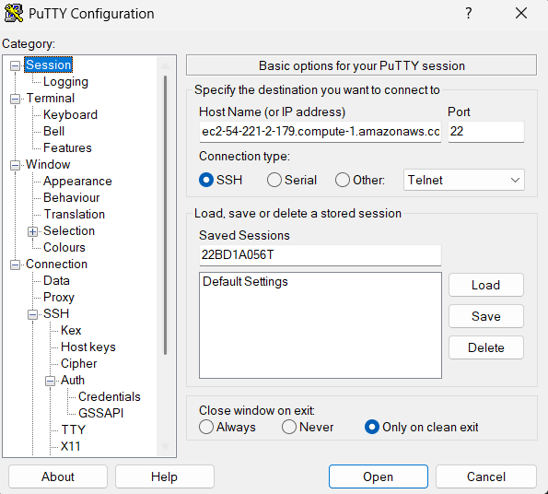

1. In connection click Data & type ubuntu in Auto-login username

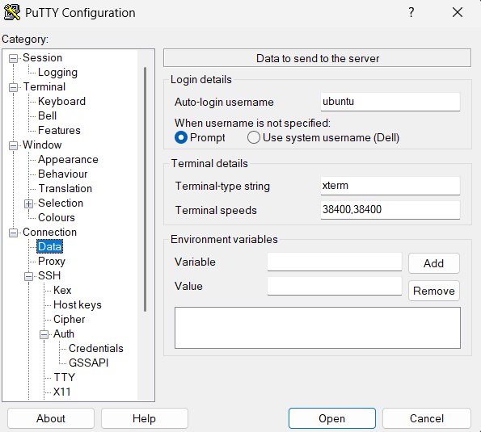

1. Save the Session with your Roll no



1. Load PPK File connection → SSH → Auth → credentials → insert PPK File → click on open

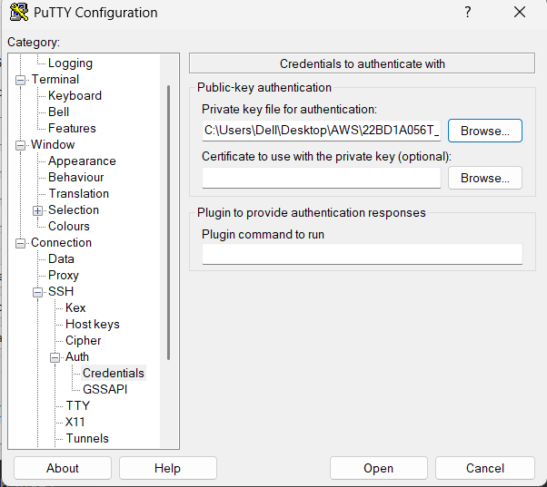

1. Accept the pop

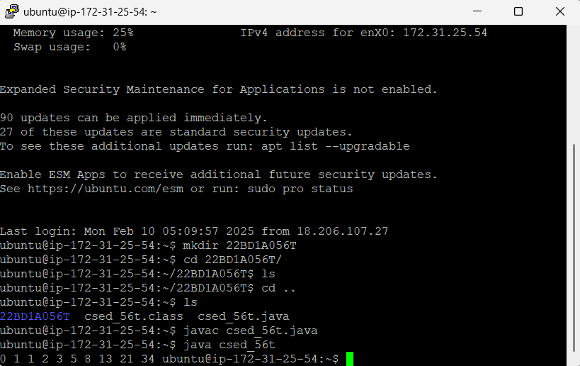

1. Same console in server terminal as to visible

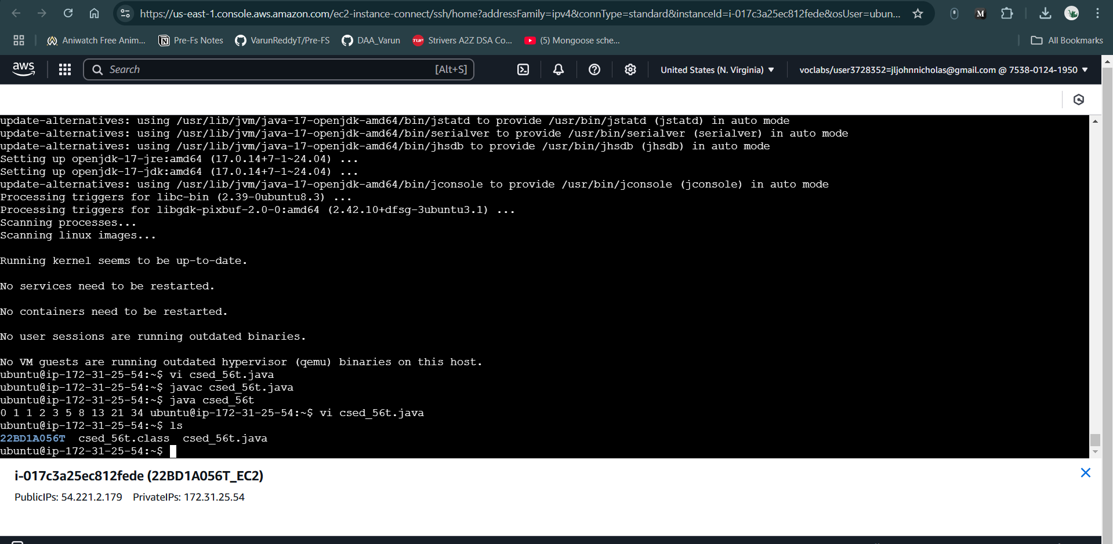

https://awsacademy.instructure.com/