**Experiment-4:**

Create and configure storage services and upload files and objects using Amazon EBS, Amazon EFS and Amazon S3

**Part-1:  Attach and Mount Extra EBS (Amazon Elastic Block Store) Volume to Linux EC2 in AWS**

**Step 1: Access AWS Academy and Start the Lab**

1. Log in to [**AWS Academy**](https://awsacademy.instructure.com/).
2. Navigate to **Launch AWS Academy Learner Lab** and start the lab.
3. Click the **AWS Button** to activate your session.

**Step 2: Add an Extra EBS Volume (10GB) to an Existing EC2 Instance**

1. Open the **EC2 Dashboard** in the AWS Management Console.
2. Locate and select your **EC2 instance** (associated with your Roll Number).
3. In the instance details, click on the **Storage** tab.

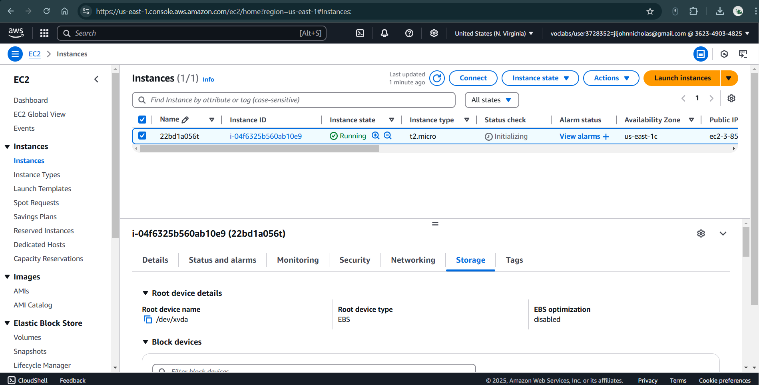

**Fig 4.1.1: Launching EC2 Instance**

1. Here, you will see information about existing storage, including the **current volume size (8 GiB)** and **Volume ID**.

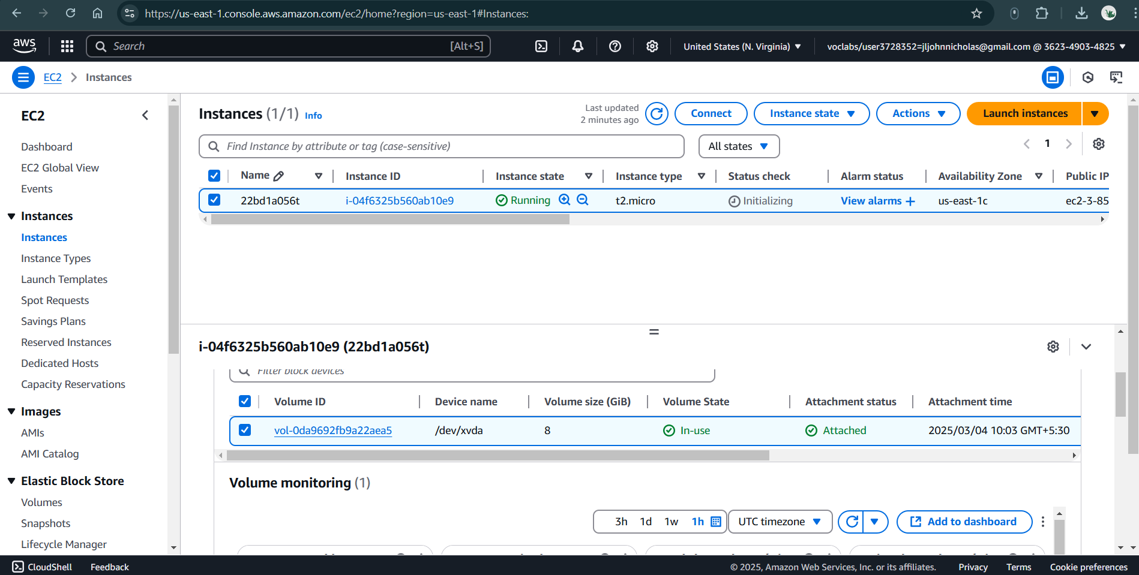

**Fig 4.1.2: Information about existing storage**

**Step 3: Create a New 10GB EBS Volume**

1. In the left-hand menu, go to **Elastic Block Store (EBS)** → **Volumes**.

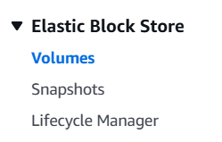

1. Click **Create Volume** (top-right corner of the page).

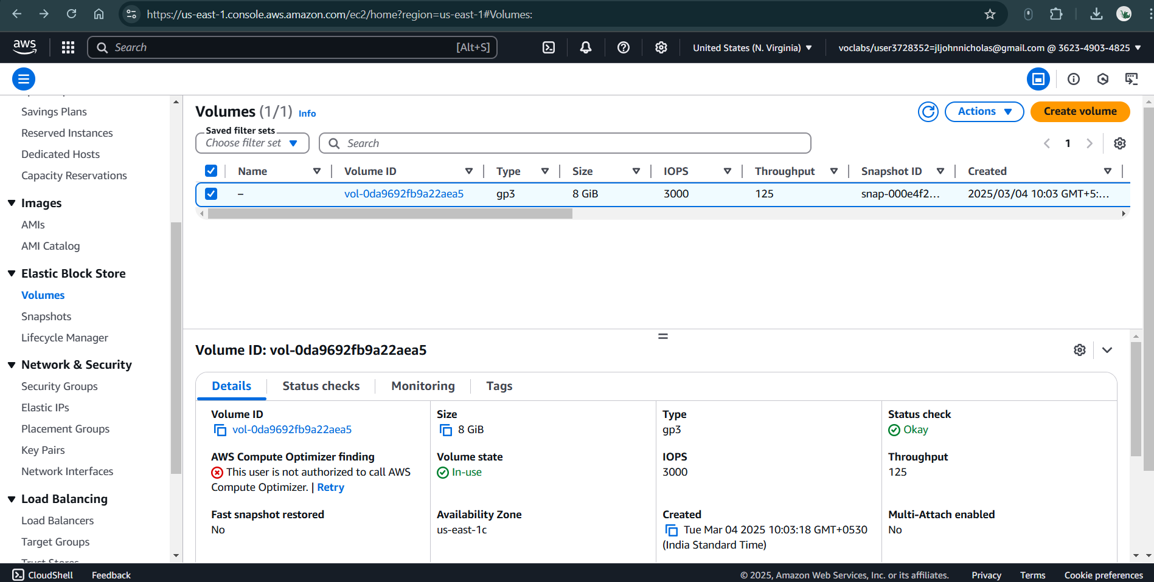

**Fig 4.1.3: Create volume**

1. Configure the new volume:
   * **Volume Type**: General Purpose SSD (**gp2**) *(or choose as per your need)*
   * **Size**: **10 GiB**
   * **Availability Zone**: Must match your EC2 instance’s availability zone. *(Example: us-east-1b)*
   * **Tags (Optional)**:
     + **Key**: Roll No
     + **Value**: Extra-Volume-RollNo

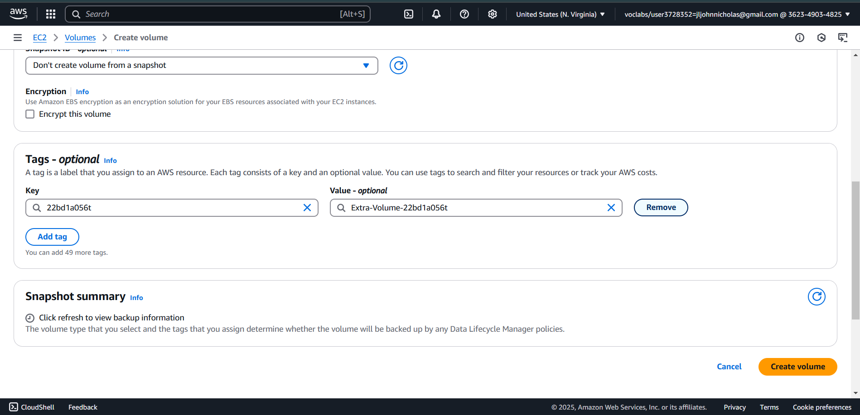

**Fig 4.1.4: Configure the new volume**

1. Click **Create Volume** to finalize.
2. Verify that the **Volume ID** of your instance matches the new EBS volume’s **Availability Zone**.

**Step 4: Attach the Newly Created Volume**

1. In the **EBS Volumes** section, locate the volume you just created.
2. Select the volume, click **Actions** (beside "Create Volume"), and choose **Attach Volume**.

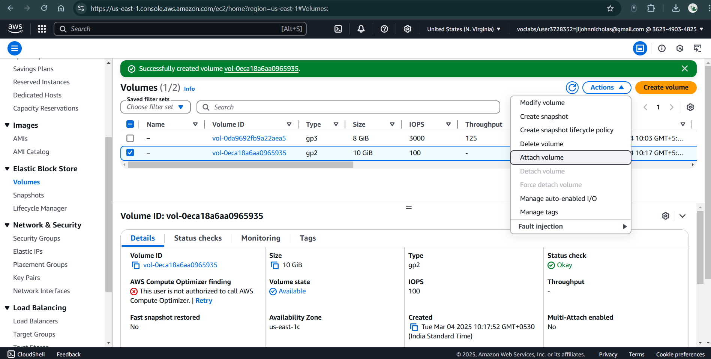

**Fig 4.1.5: Attach the volume**

1. Select your EC2 instance (linked to your Roll Number).
2. Set the **Device Name** as /dev/sdf *(default name)*.
3. Click **Attach Volume**.

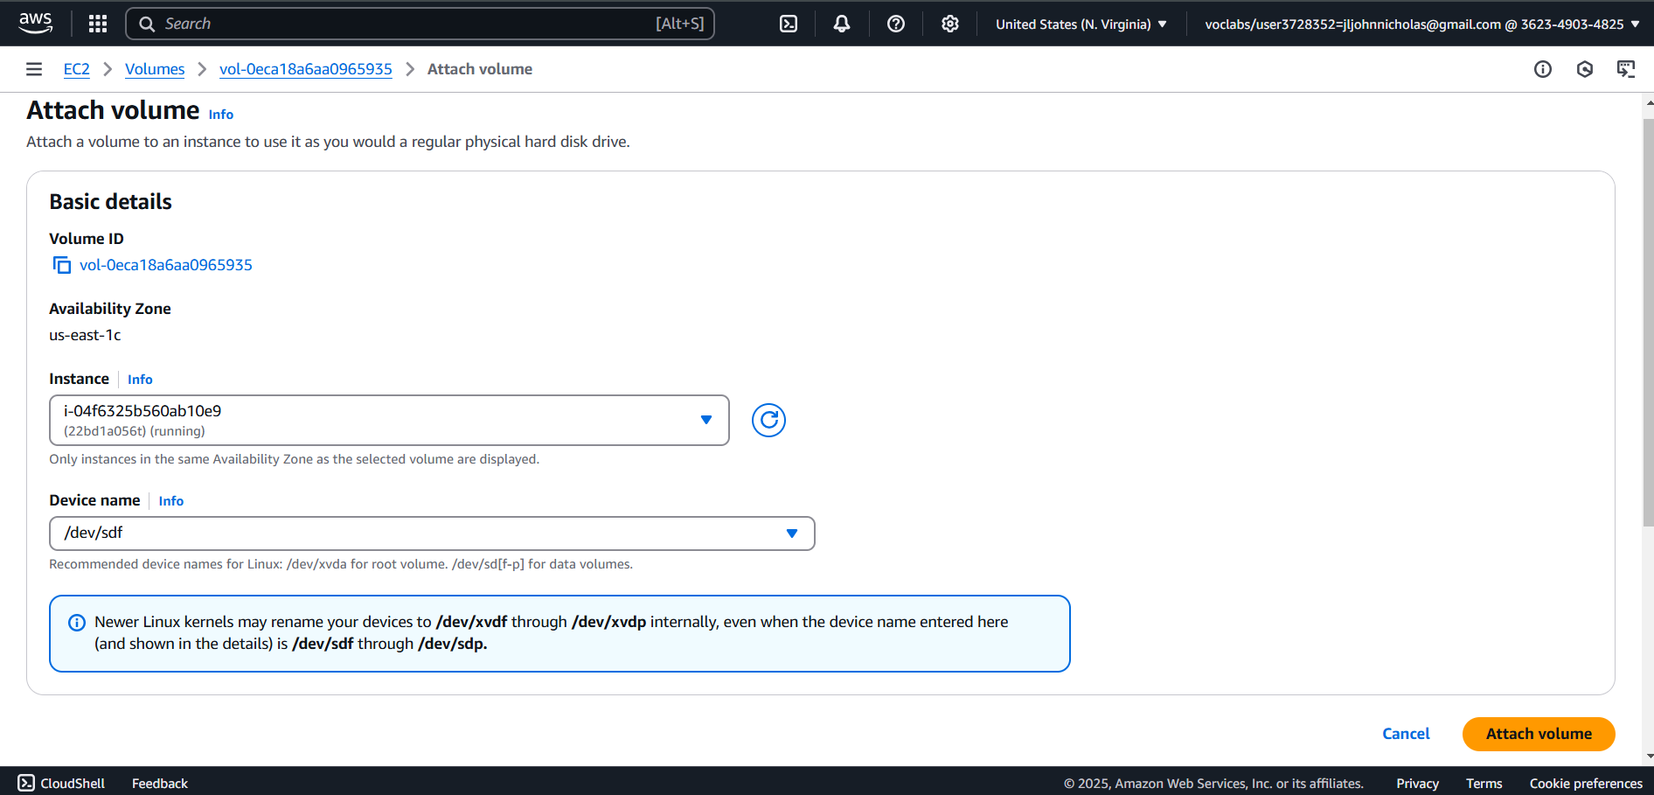

**Fig 4.1.5: Select EC2 instance and set Device name**

1. The new volume will now be in the **in-use** state.

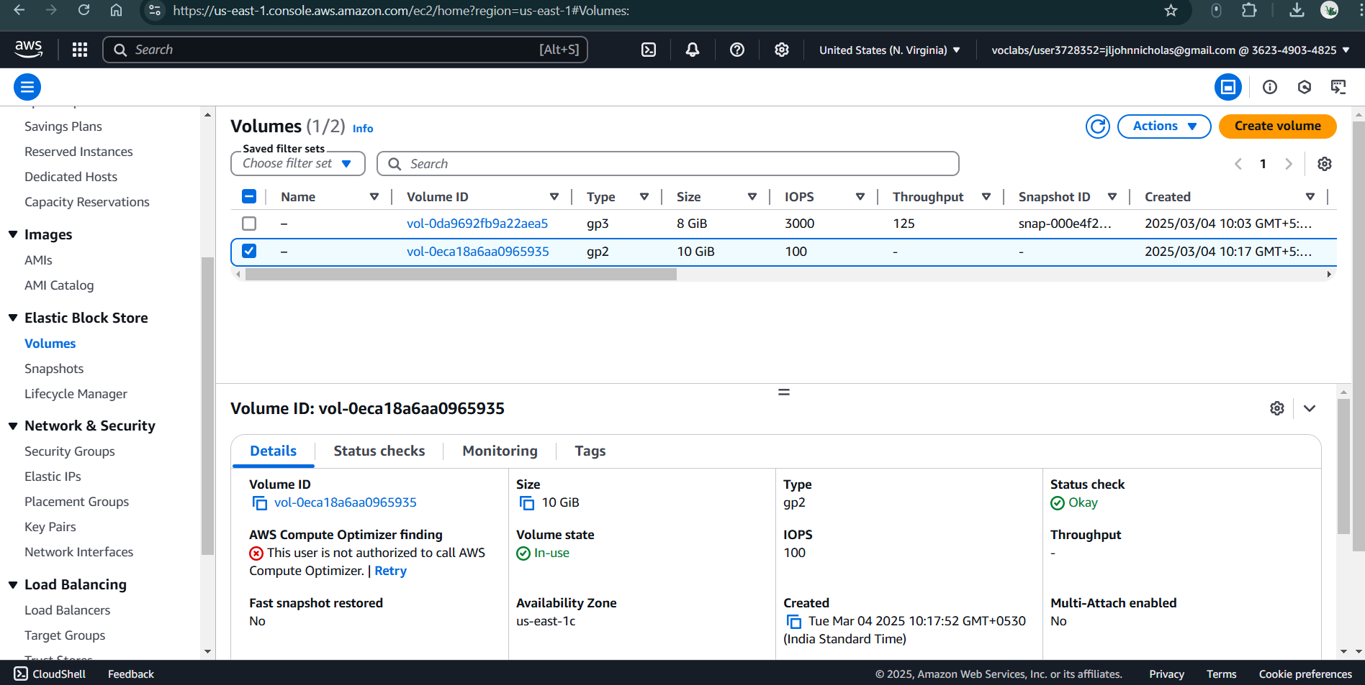

**Fig 4.1.6: Volume state: In-Use**

**Step 5: Verify and Mount the Attached Volume**

1. Connect to your EC2 instance:
   * Go to the **EC2 Dashboard** → **Instances**.
   * Select your instance and click **Connect** → **EC2 Instance Connect**.
2. Switch to the root user:

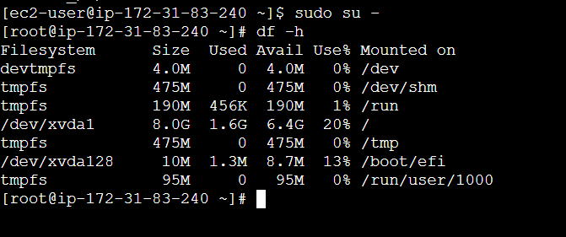 *(At this point, the new volume will not appear because it is not yet formatted or mounted.)*

1. List all block devices to confirm the new volume:

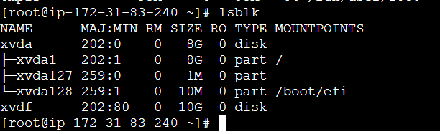

1. Check if a filesystem exists on the new volume:

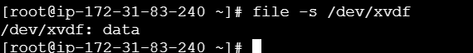

If the output shows **"data"**, it means the volume is blank and needs to be formatted.

1. Format the new volume with the XFS file system:

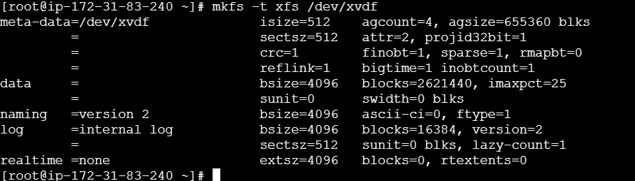

1. Verify that the file system is now created:



*(The output should now indicate an XFS file system.)*

**Step 6: Mount the Volume to the EC2 Instance**

1. Create a new directory to mount the volume:
2. Mount the volume to the directory:
3. Verify the mounted directory:
4. Check the mounted file system:

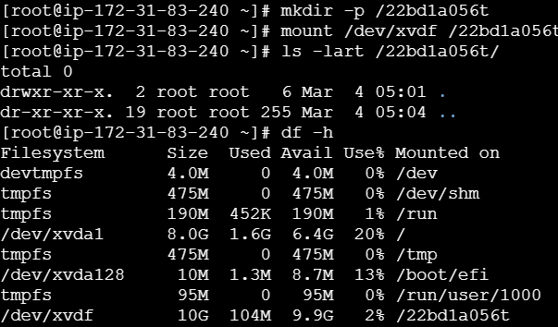

1. Creating a File called 1.txt
2. Open vi editor & Insert your Roll no
3. To save 1.txt File

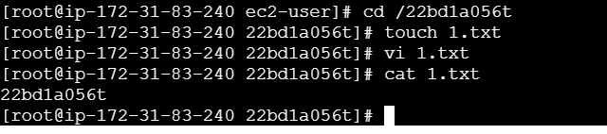

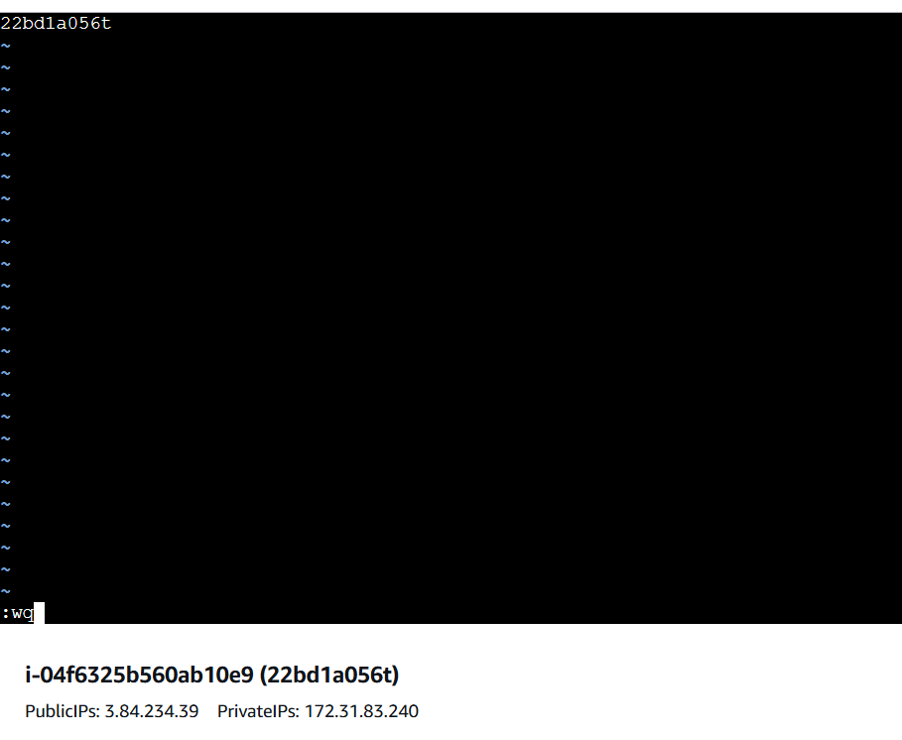

1. ls -lart /Rollno/ You can see/ able access the Directory

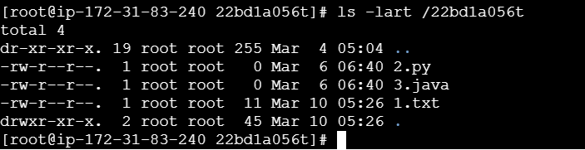

1. To confirm the total size of the attached volume:

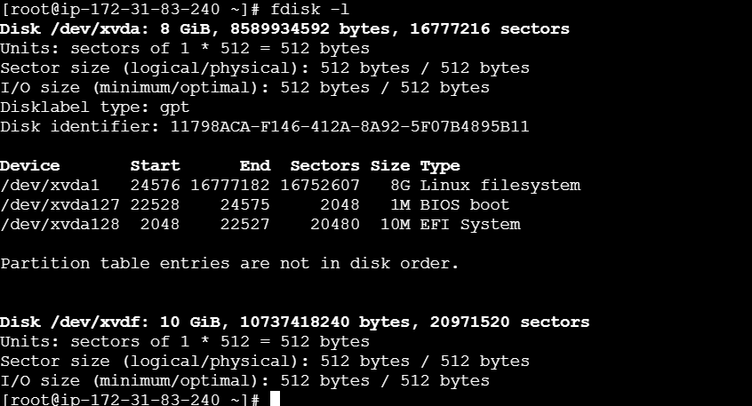

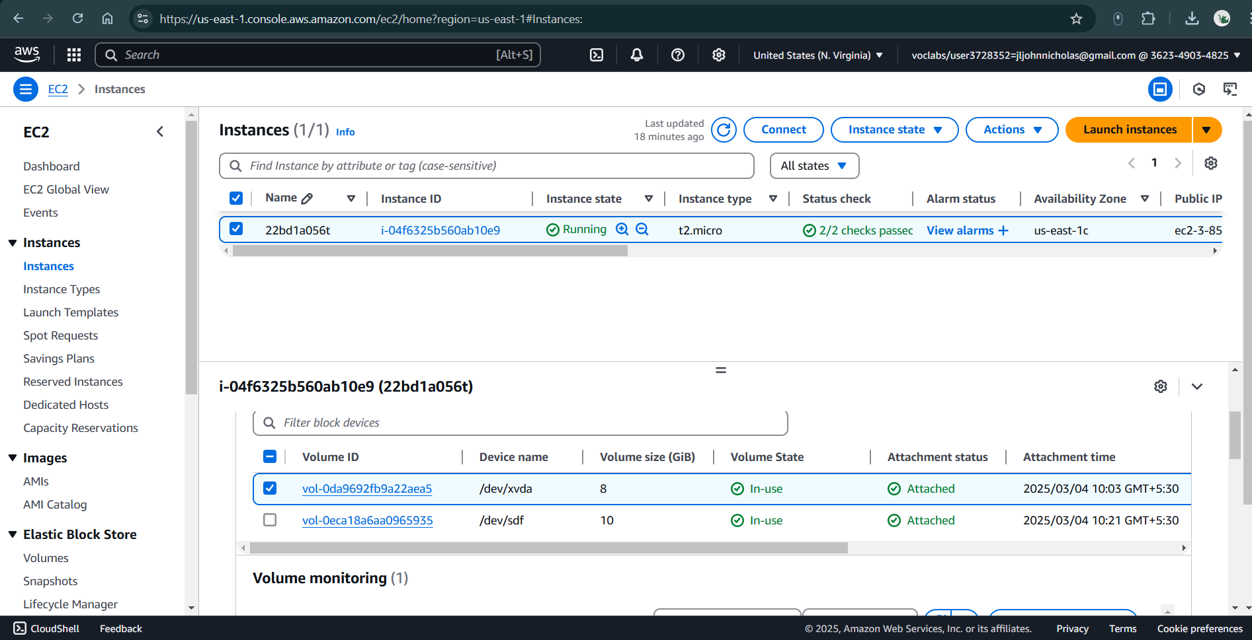

**Fig 4.1.6: Volume attached**

**Part-2: Creating Files in EBS, taking a Snapshot & Attaching to Another Region**

**Step 1: Creating Files in EBS**

1. Navigate to the mounted directory
2. Verify the current directory
3. Create files and add content
   * Create a Python file for adding two numbers
   * Create a Java file with a welcome message
4. Check if the files were created successfully

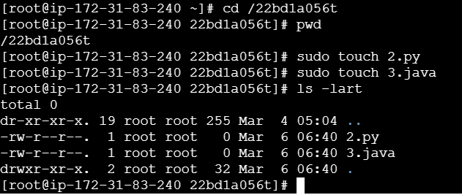

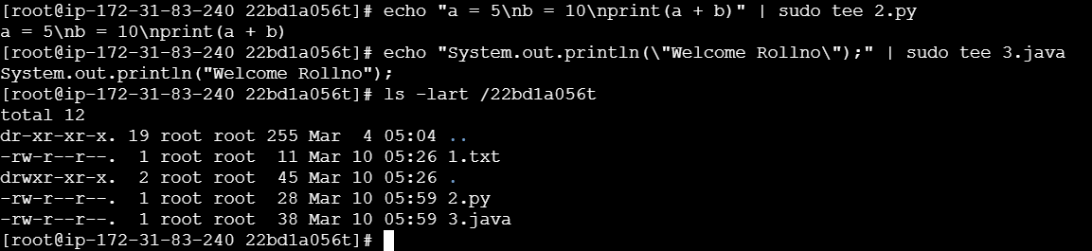

**Step 2: Import the Key Pair into the New AWS Region**

1. Go to AWS Management Console → EC2 Dashboard.
2. In the top-right corner, click on the region selector (e.g., "US East (N. Virginia)") and select your new region (e.g., "US West (Oregon)").
3. In the left sidebar, scroll down to Network & Security → Click Key Pairs.
4. Click Import Key Pair (Top-right corner).
5. Enter a name (e.g., my-key-new-region).
6. Upload your PEM file (my-key.pem).
7. Click Import Key Pair.

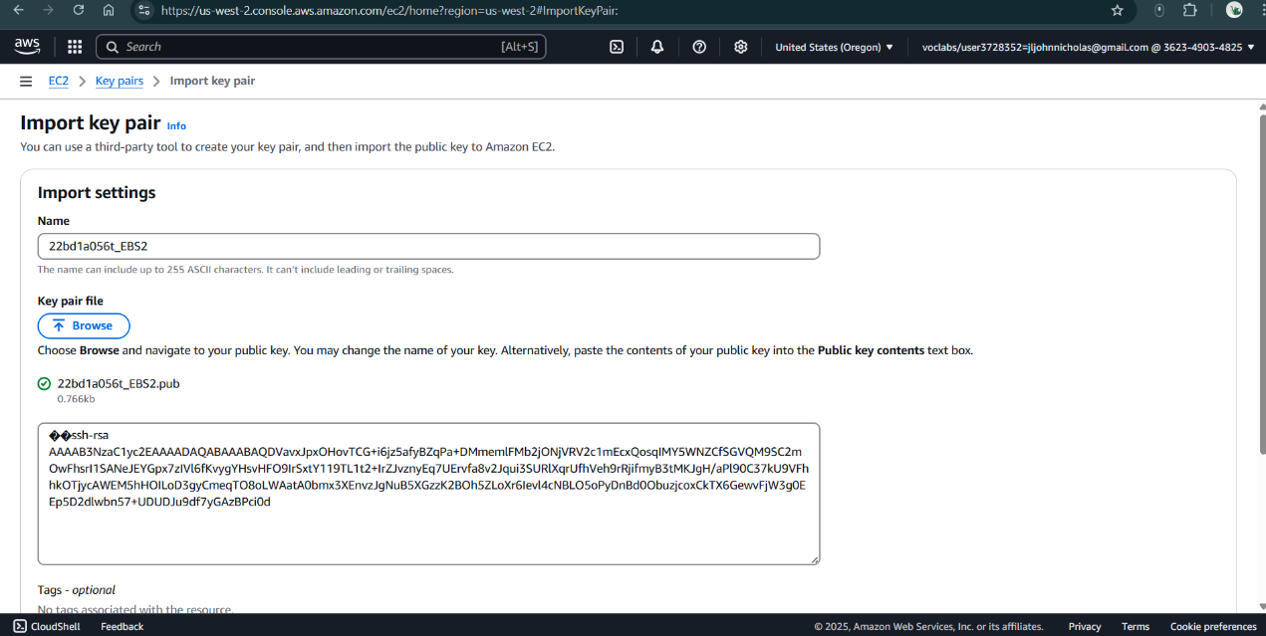

**Fig 4.2.1: Importing key pair in new region**

**Step 3: Create Another EC2 Instance in a Different AWS Region**

1. **Go to EC2 Dashboard in another region (e.g., Oregon - us-west-2)**.
2. **Create a new EC2 instance**:
   * **Instance Name:** Rollno_EBS_OtherRegion
   * **Key Pair:** Use the **same existing key pair**.
   * **Storage:** 8 GiB (Default).
   * **Launch the instance**.

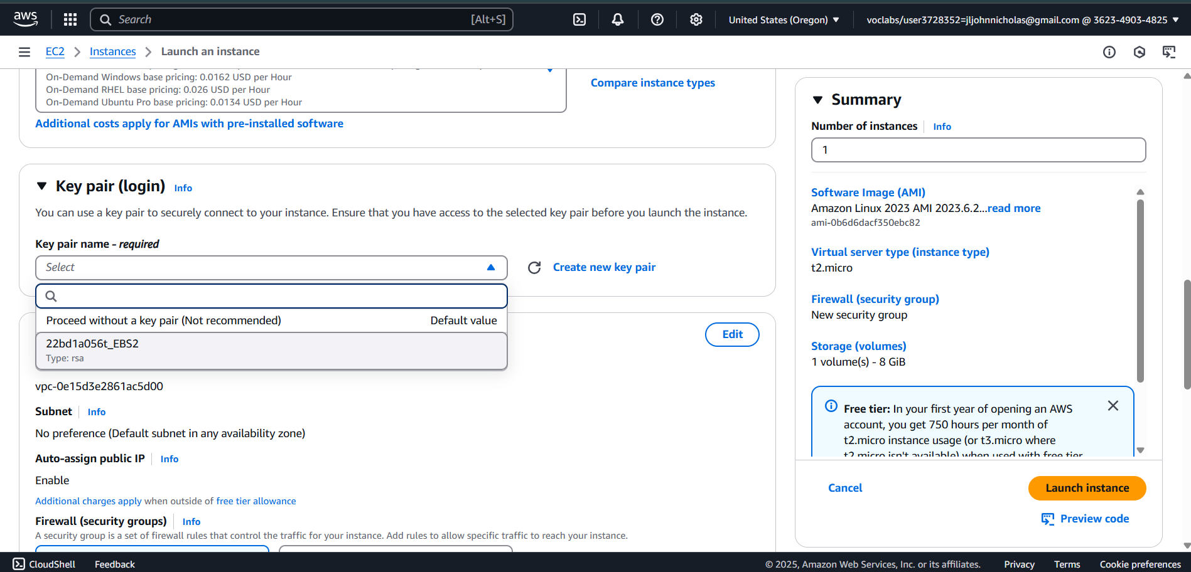

**Fig 4.2.2: Create EC2 instance in new region**

1. **Connect to the new EC2 instance via SSH**:

* ssh -i your-key.pem ec2-user@<new-instance-public-ip>
* Replace <new-instance-public-ip> with the new instance’s public IP.

1. **Check the disk size**:

* sudo fdisk -l
* You should see **only the default 8 GiB disk**.

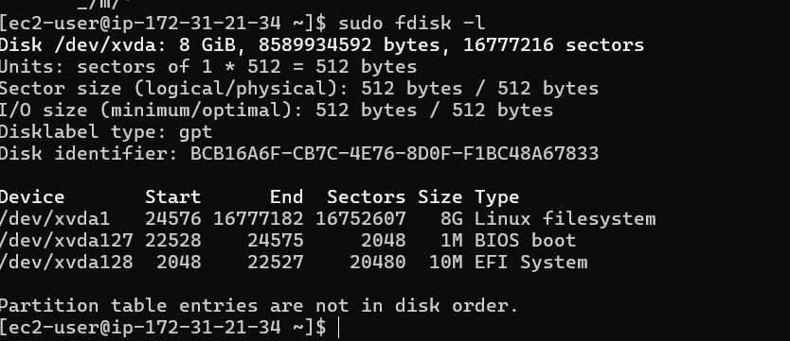

**Step 4: Create a Snapshot from the Old Instance**

1. Go to the AWS EC2 Console (Old Region).
2. Navigate to: Elastic Block Store → Volumes.

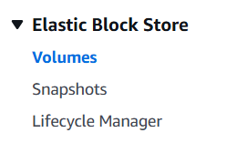

1. Select the 10 GiB volume.
2. Click "Actions" → "Create Snapshot".
3. Provide snapshot details:
   * Description: Snapshot_Rollno
4. Click "Create Snapshot".

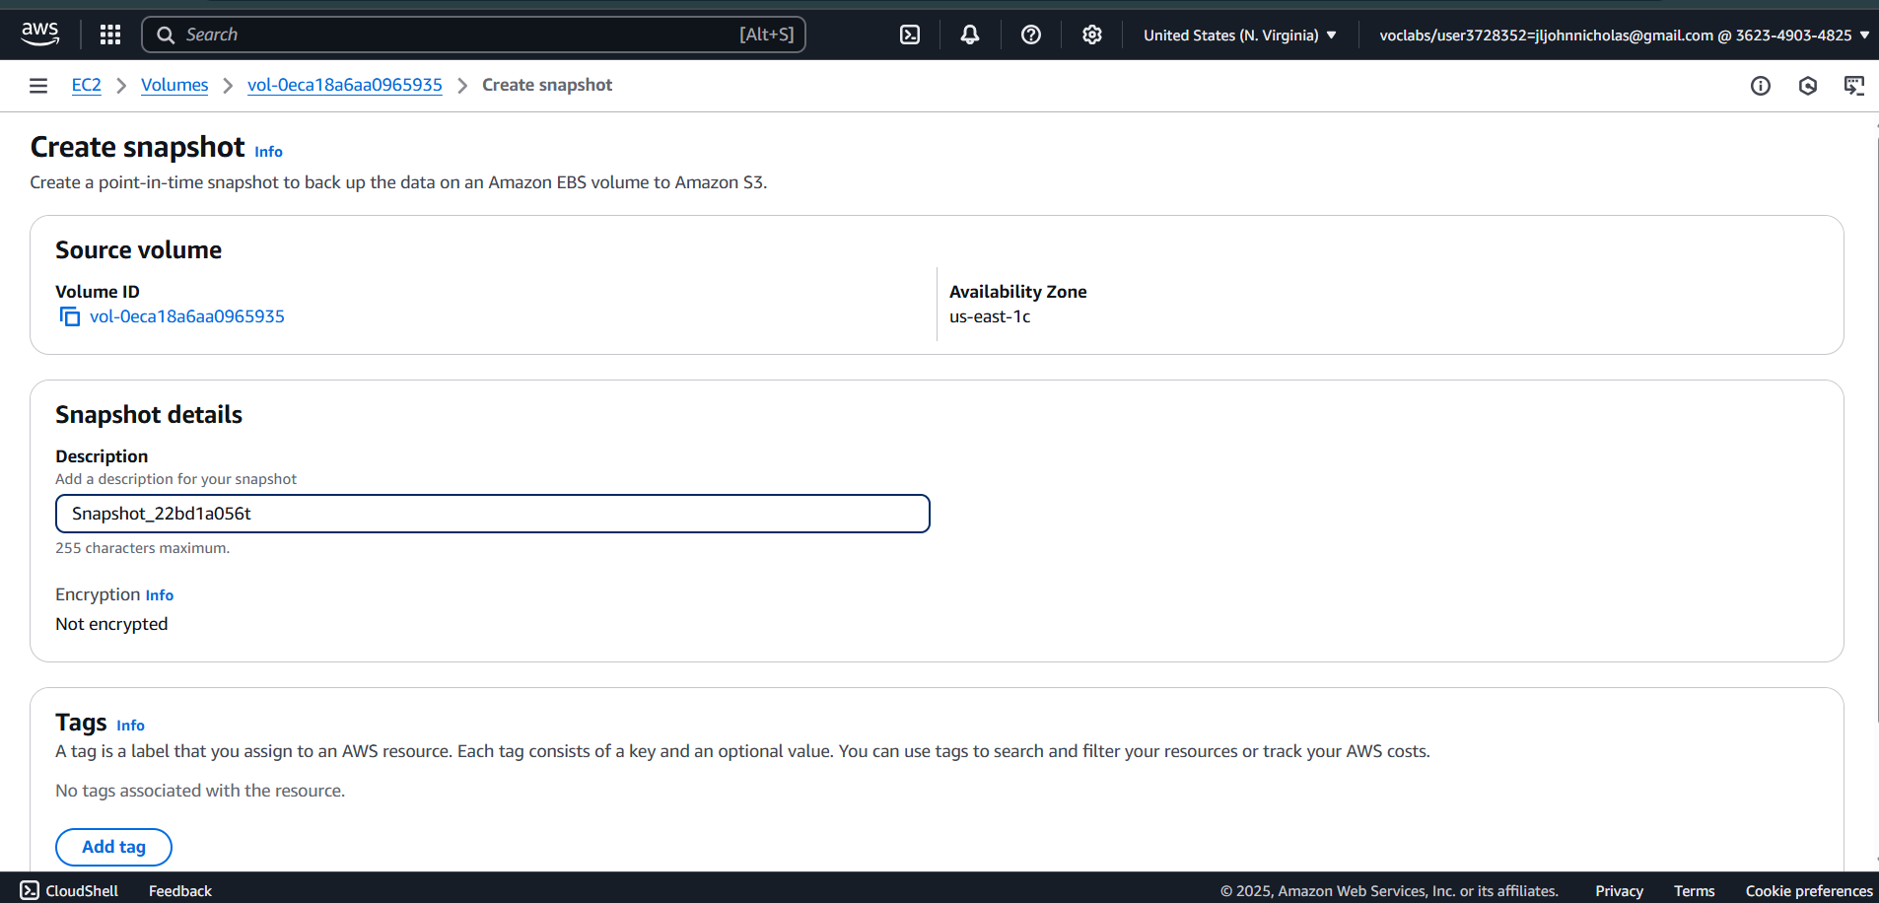

**Fig 4.2.3: Create Snapshot from old instance**

1. Verify the snapshot:
   * Go to Elastic Block Store → Snapshots.
   * Check Snapshot ID & Status (Wait for it to show "available").

**Step 5: Copy the Snapshot to the New Region**

1. Go to **EC2 Dashboard → Snapshots** (in the old region).
2. Select the **snapshot you just created**.
3. Click **Actions → Copy Snapshot**.
4. Under **Destination Region**, select the **new region** where you are setting up the second EC2 instance.
5. Click **Copy**.

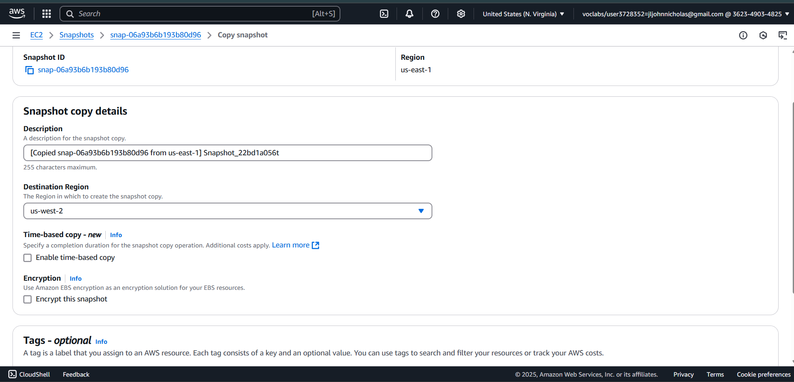

**Fig 4.2.4: Copy the Snapshot to new region**

1. Wait until the copy process is complete (status will change to **"available"** in the new region).

**Step 6: Attach the Snapshot to the New EC2 Instance**

1. Go to Snapshots (New Region).
2. Select the Snapshot → Click Actions → Create Volume from Snapshot.
3. Choose the New Region (Same as the new EC2 instance).
4. Click "Create Volume".

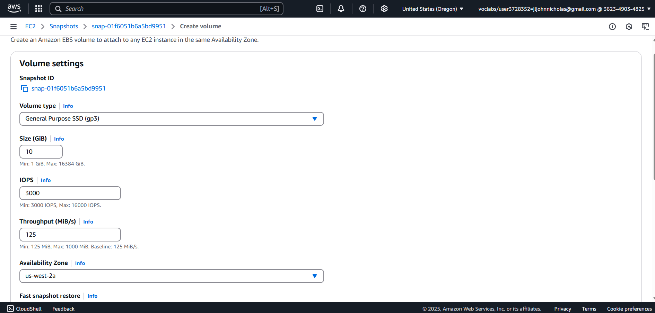

**Fig 4.2.5: Attach the Snapshot to the New EC2 Instance**

1. Rename the new volume as Snap-Rollno-OtherRegion (Optional).
2. Attach the Volume to the New Instance:
   * Go to **Elastic Block Store → Volumes**.
   * Select the new **10 GiB volume**.
   * Click **Actions → Attach Volume**.
   * Select the **new EC2 instance**.
   * **Device Name:** /dev/sdf
   * Click **Attach**.

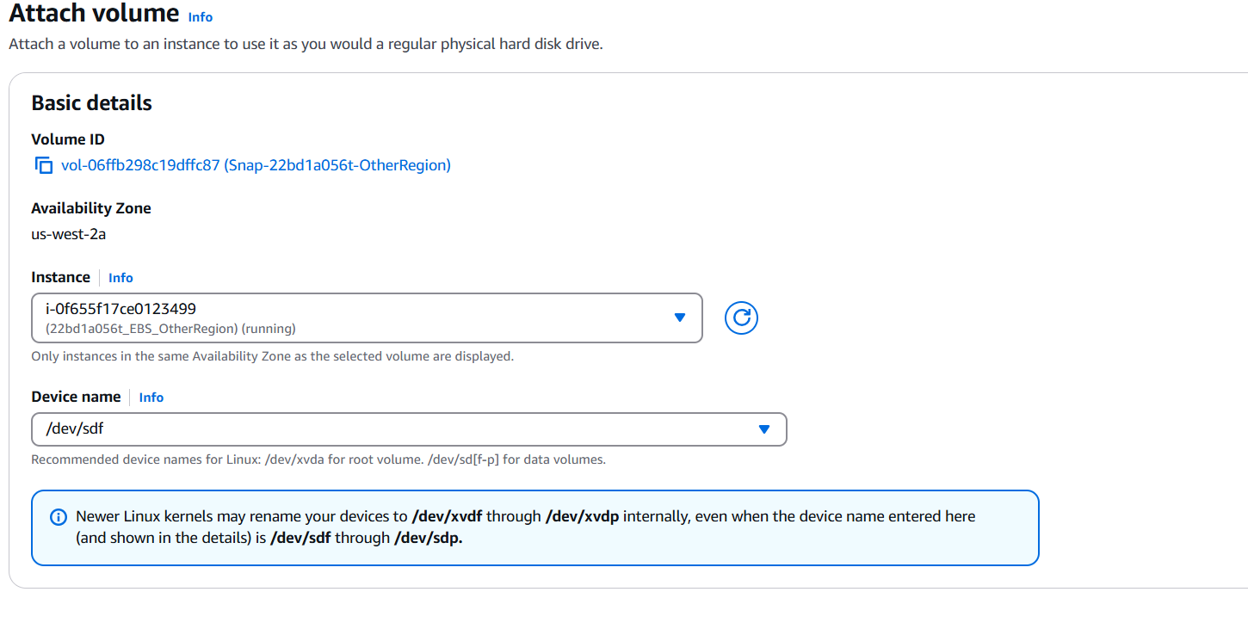

**Fig 4.2.6: Attach the Volume to the New EC2 Instance**

1. Verify the Attached Volume in the New EC2 Instance. You should now see **the 10 GiB volume** attached.

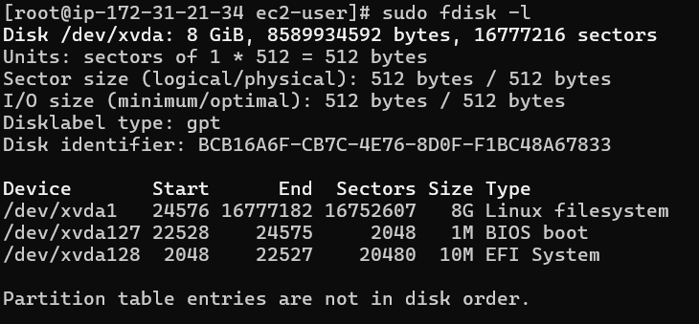

1. Mount the volume in the new instance
2. Check if files are available. You should see **1.txt**, **2.py and 3.java**

