**Part-3: Setting Up Elastic File System (EFS)**

**Agenda: Creating EFS and mounting to EC2**

* Create 2 Instance namely Rollno-KMIT, Rollno-NGIT
* Creating EFS System
* Communicate with two servers

**Step 1: Launch Two EC2 Instances**

1. Go to EC2 Dashboard → Launch Instances.
2. Create two EC2 instances:
   * Instance-1 Name: Rollno-KMIT
   * Instance-2 Name: Rollno-NGIT
3. Use the same Key Pair (PEM file) for both instances.
4. Keep default settings (8 GiB storage).
5. Ensure both instances are in the same VPC and region.
6. Click Launch.



**Fig 4.3.1: Two instances created**

**Step 2: Create a Security Group for EFS**

1. Go to EC2 Dashboard → Security Groups.
2. Click Create Security Group.
3. Enter:
   * Name: Rollno_EFS
   * Description: EFS SG
   * VPC: Default
4. Add Inbound Rules:

* **Rule 1 & 2:**
* **Type:** NFS
* **Port Range:** 2049
* **Source:** **Custom**
* **Select Security Group**: (of **Instance 1** & **Instance 2)**

1. Click Create Security Group.

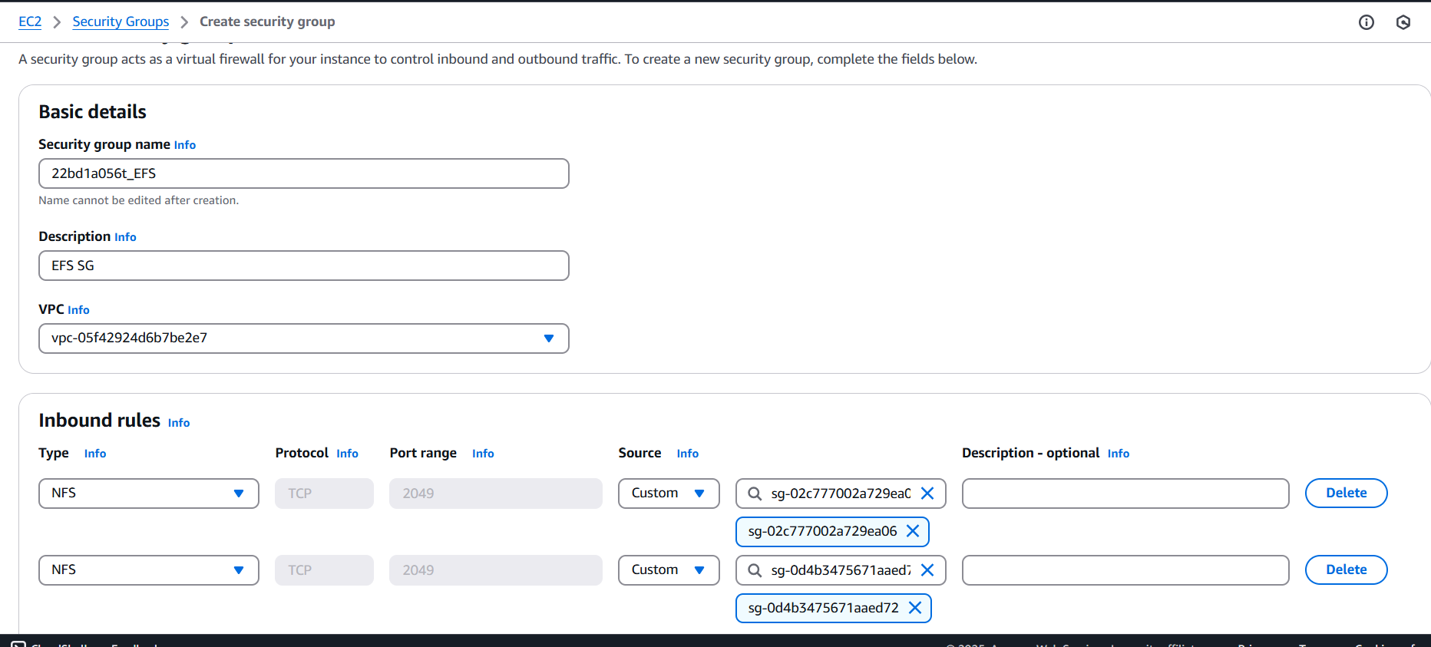

**Fig 4.3.2: Security Group for EFS**

**Step 3: Create an EFS File System**

1. Go to AWS Console → Search "EFS" → Click Elastic File System.

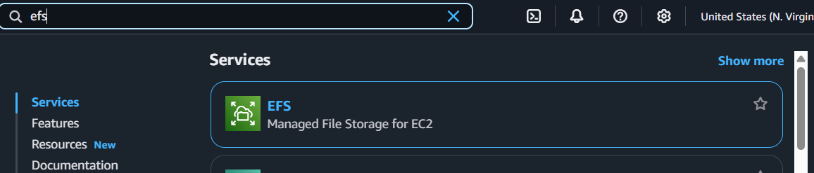

**Fig 4.3.3: Search for EFS in AWS console**

1. Click Create File System.
2. Enter Details:

* Name: Rollno
* VPC: Default (same as EC2 instance)

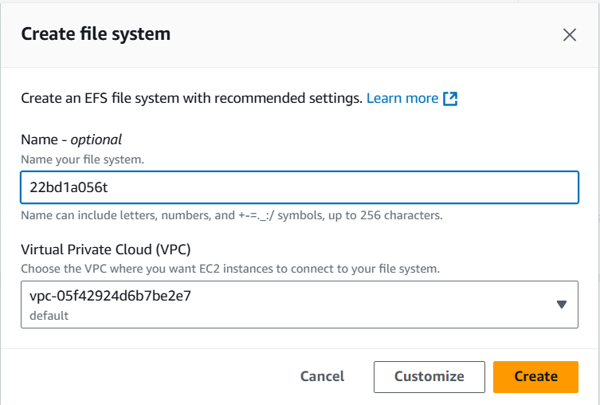

**Fig 4.3.4: Select same VPC as EC2 instances**

* Storage Class: Standard or One Zone
* Enable automatic backups: Disable (Optional)
* Lifecycle Management: 7 days (Move unused data to Infrequent Access)

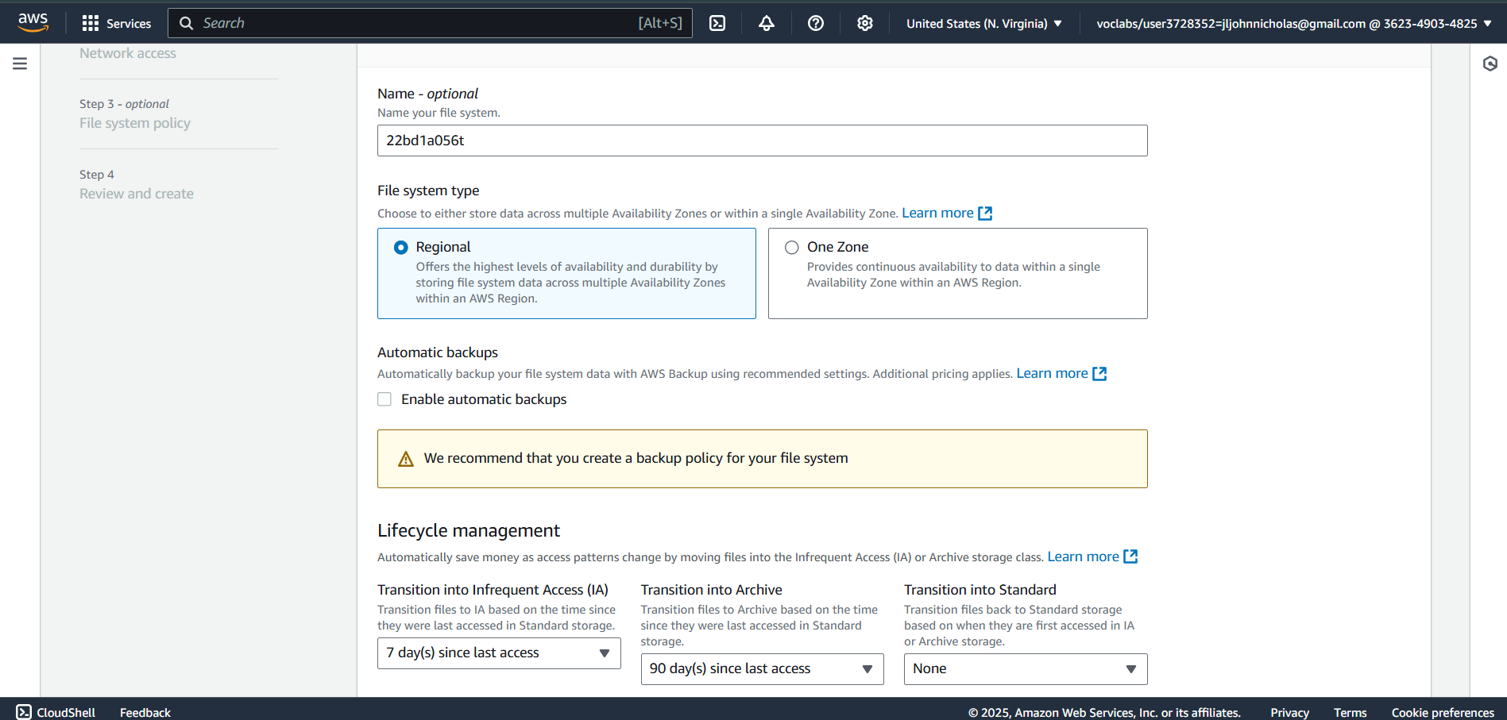

**Fig 4.3.5: Lifecycle Management: 7 days (Move unused data to Infrequent Access)**

* Encryption: Disable (Optional)
* Performance Mode: General Purpose (Default)
* Throughput Mode: Select Elastic (Recommended)

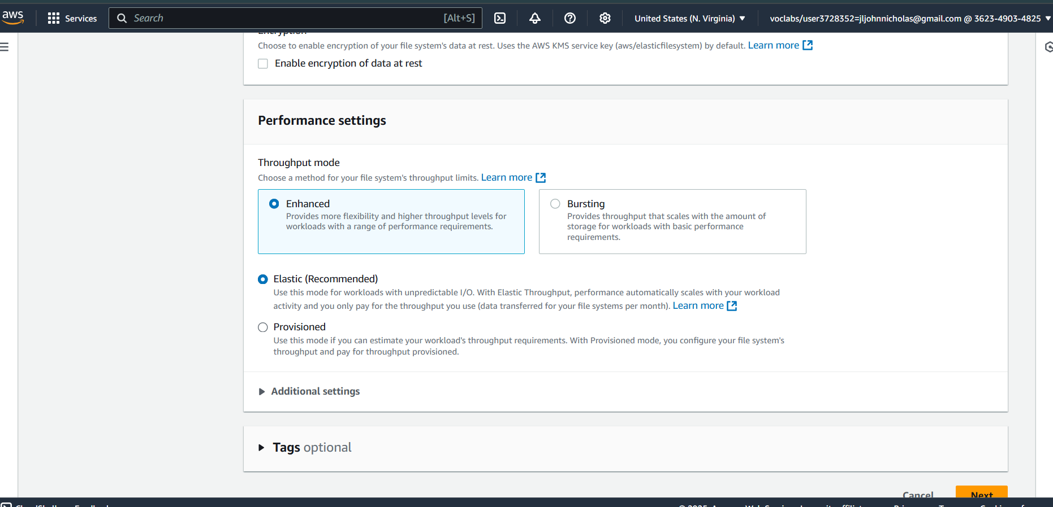

**Fig 4.3.6: Throughput Mode: Select Elastic (Recommended)**

* VPC: Select the same VPC
* Security Group: Select Rollno_EFS (created earlier)

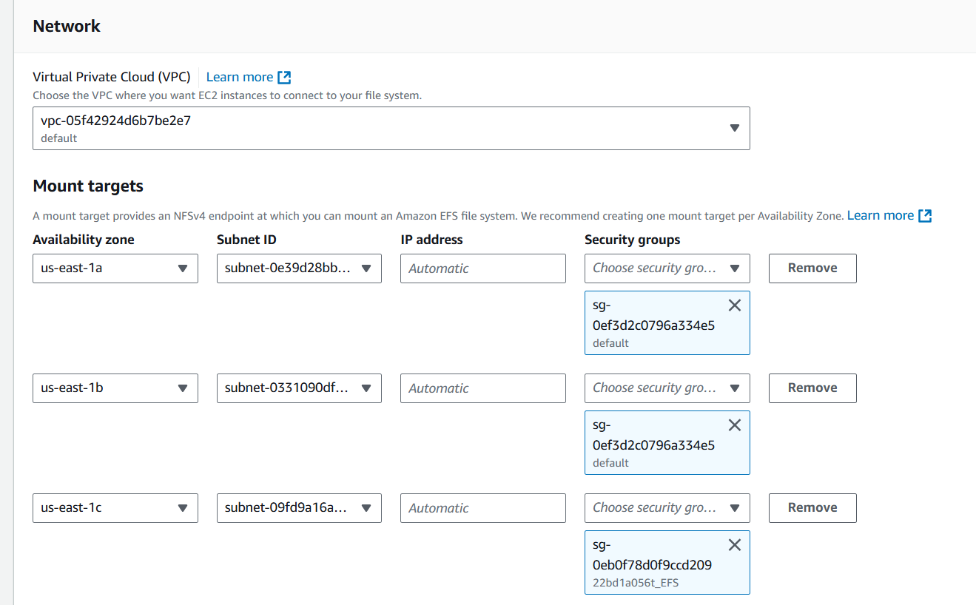

**Fig 4.3.7: Select the Security Group created earlier**

1. Click Create.

**Step 4: Attach EFS to EC2 Instances**

1. **Go to EFS Dashboard → File Systems**.
2. Click on the **EFS you created (Rollno)**.

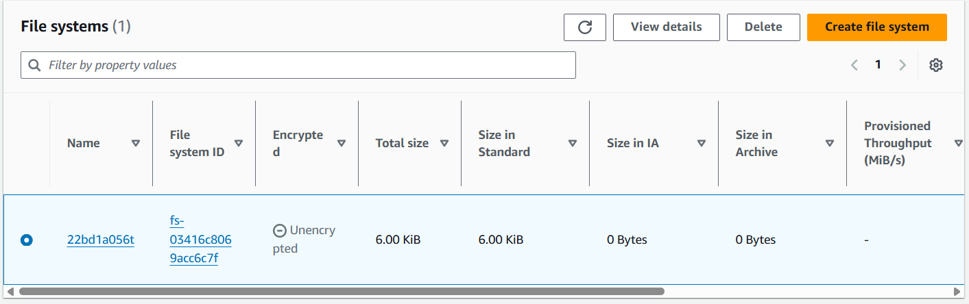

**Fig 4.3.8: Click on the EFS created**

1. Click **Attach**.

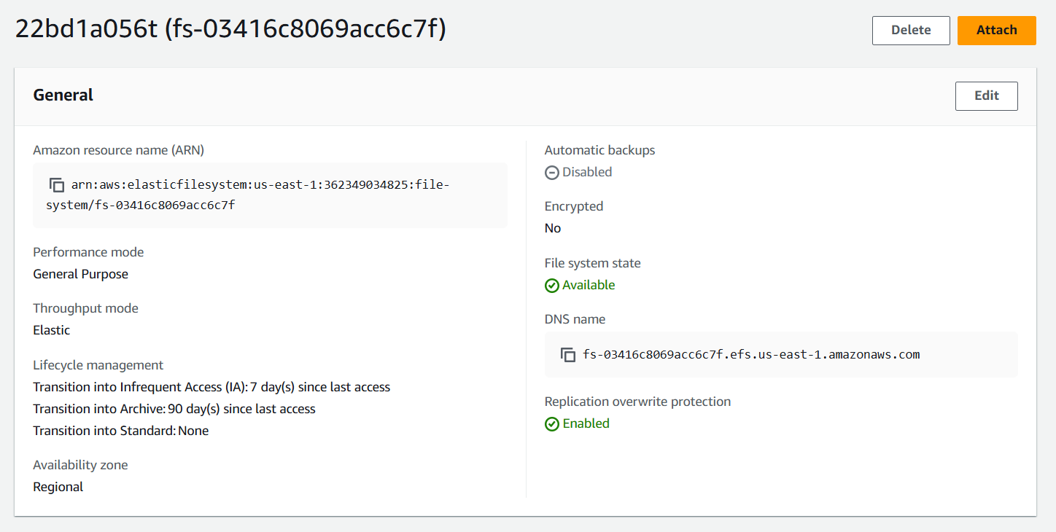

**Fig 4.3.9: Click on attach**

1. Under **"Mount via NFS Client"**, copy the command.

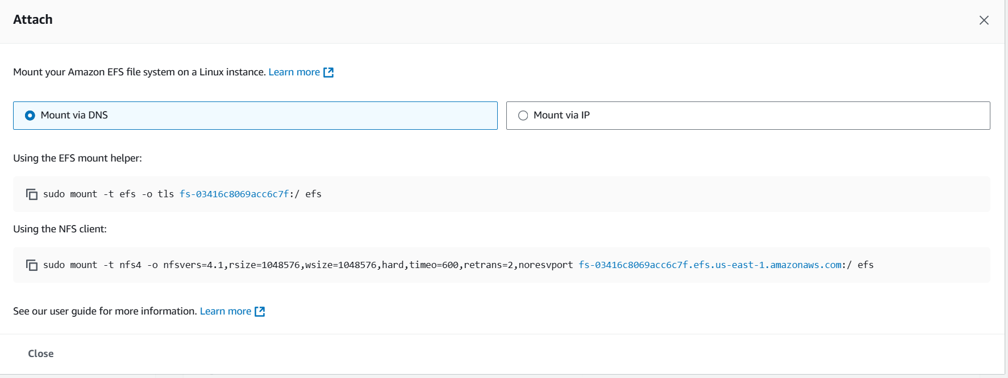

**Fig 4.3.10: Copy the command under “Mount via NFS client”**

**Step 5: Connect to Instance-1 & Mount EFS**

1. **Connect to Instance-1 (Rollno-KMIT)** using PuTTY or SSH
2. Switch to root
3. Install **Amazon EFS utilities**

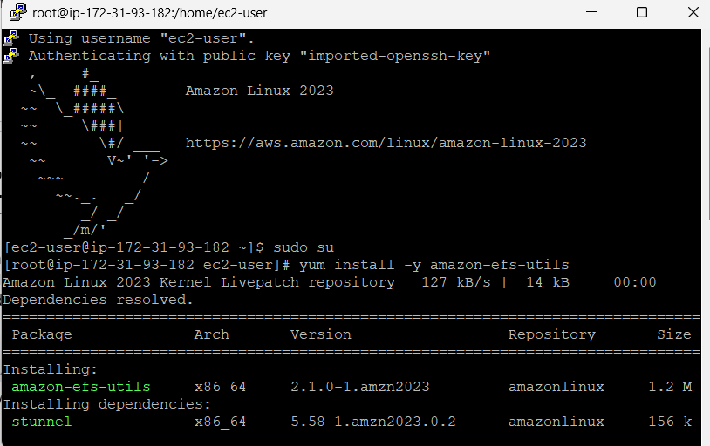

1. Create a directory for mounting

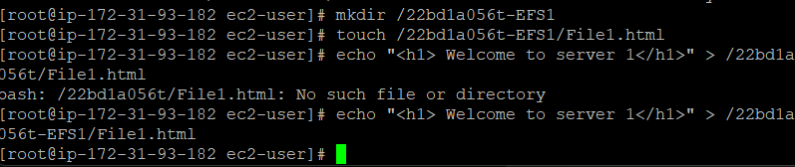

1. Mount the **EFS**:
   * Go to **EFS Dashboard → Click on the created EFS → Attach**
   * Copy the **mount command (NFS Client method)**
2. Verify the mount

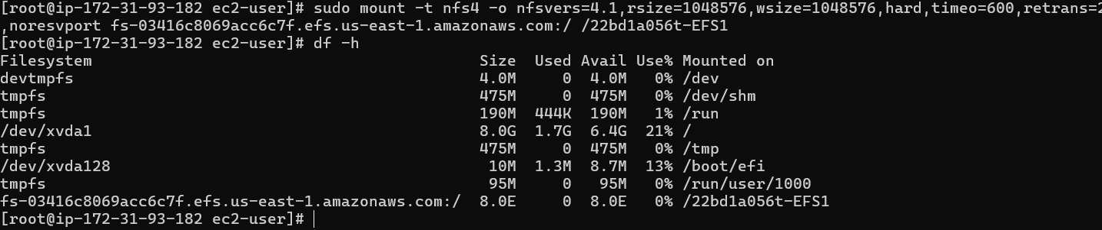

**Step 6: Connect to Instance-2 & Mount EFS**

1. **Connect to Instance-2 (Rollno-NGIT)** using PuTTY or SSH
2. Switch to root
3. Install **Amazon EFS utilities**

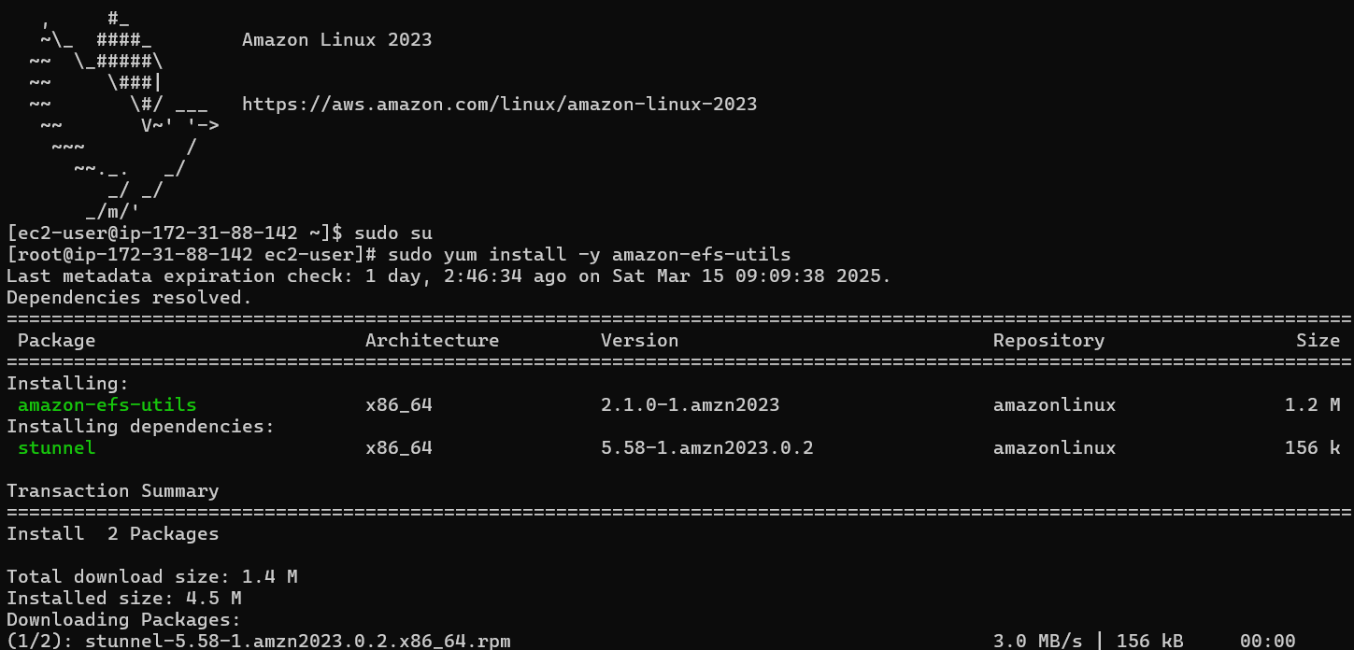

1. Create a directory for mounting:
2. Mount the **EFS** using the same command as **Instance-1**
3. Verify the mount

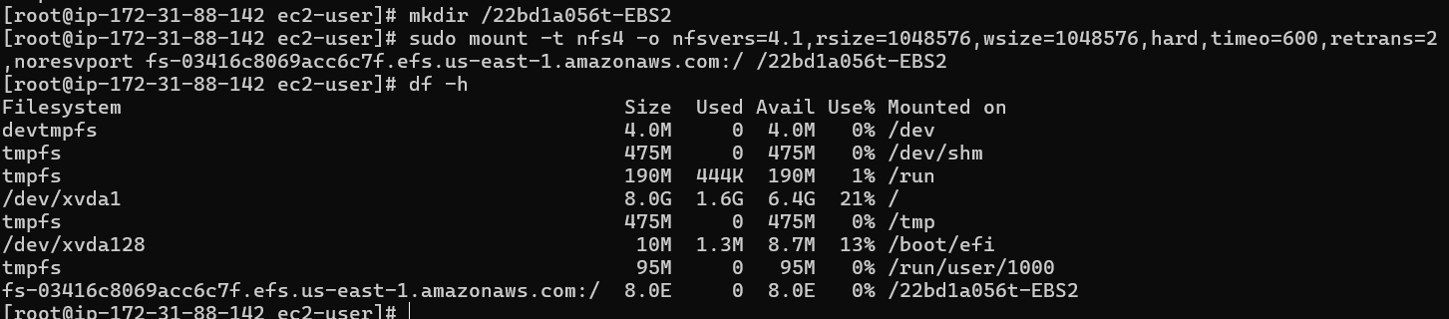

**Step 7: Verify Communication Between Instances Using File1.html**

1. Create a Test File from Instance-1 (Rollno-KMIT)

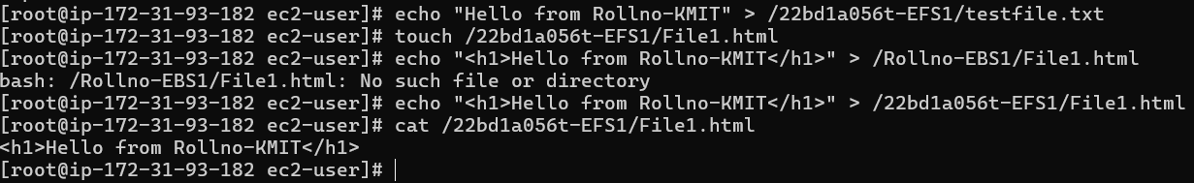

1. Check if the File is Accessible from Instance-2 (Rollno-NGIT)

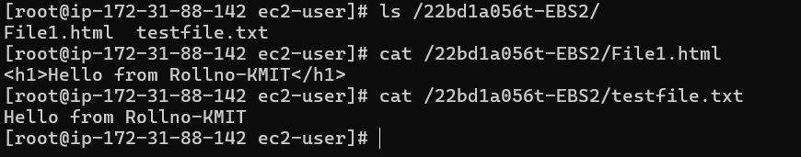

1. Expected Result

If File1.html is visible and contains "Hello from Rollno-KMIT", EFS is successfully mounted and shared between both instances.