| **Experiment: 2**  Create your First AWS S3 Bucket and Upload Content to Bucket and Manage their Access and Create Static Website using AWS S3 |
| --- |

1. **Login** into AWS Account then **Start Lab** Launch **AWS Console Home**
2. In console home **search** **S3** (Scalable storage in the cloud)

**Advantage: Store and retrieve any amount of data from anywhere**

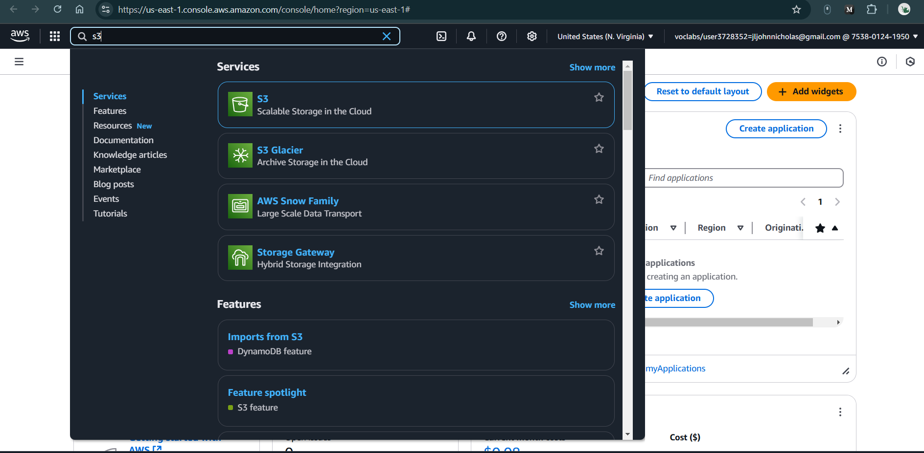

**Figure 2.1:** Searching s3 bucket in search bar

1. It will navigate to below page, then click **Create a bucket**

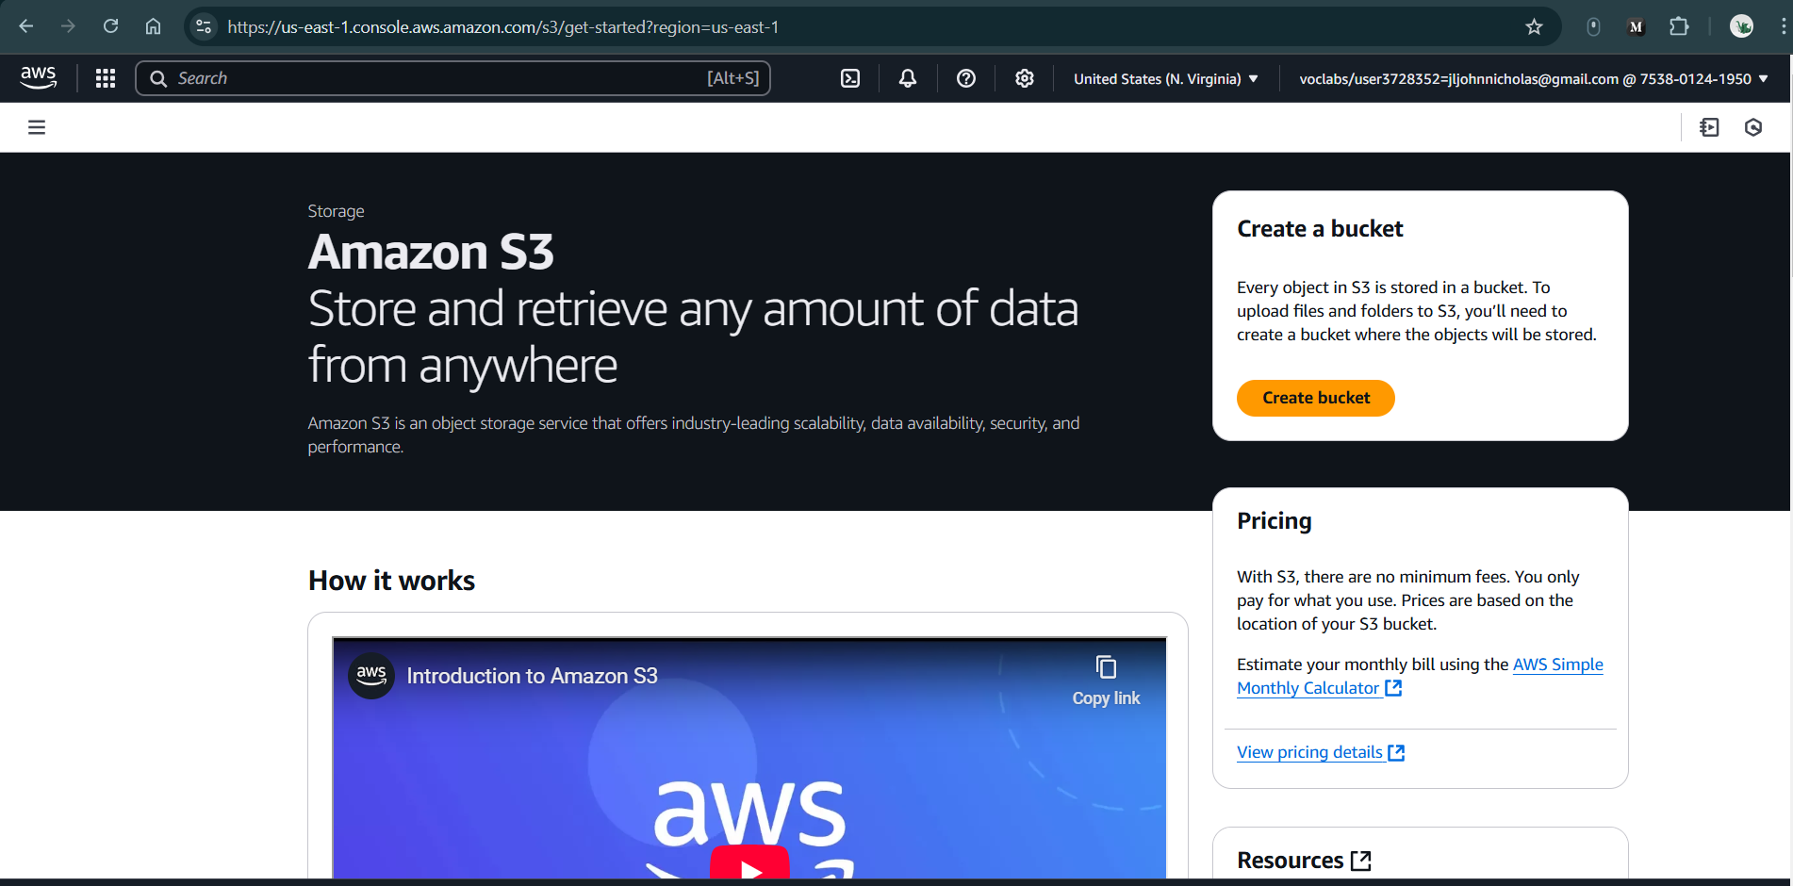

**Figure 2.2:** Click Create bucket

1. **Create Bucket:**
   1. General configuration
      1. **Bucket Name:** RollNumber-S3
      2. Note: see rules to create bucket Name like no capitals, no “_”, no space etc
   2. Object Ownership
      1. Choose **Object Ownership**
   3. **Block Public Access settings for this bucket** (Keep default)
   4. **Bucket Versioning** : click to **enable**
   5. **Tags - optional (0)** (Keep default)
   6. **Default encryption**
      1. **Encryption type :** Server-side encryption with Amazon S3 managed keys (SSE-S3)
      2. **Bucket Key :** Enable
   7. **Advanced settings** (Keep default)
   8. **Finally Click on Create Bucket**

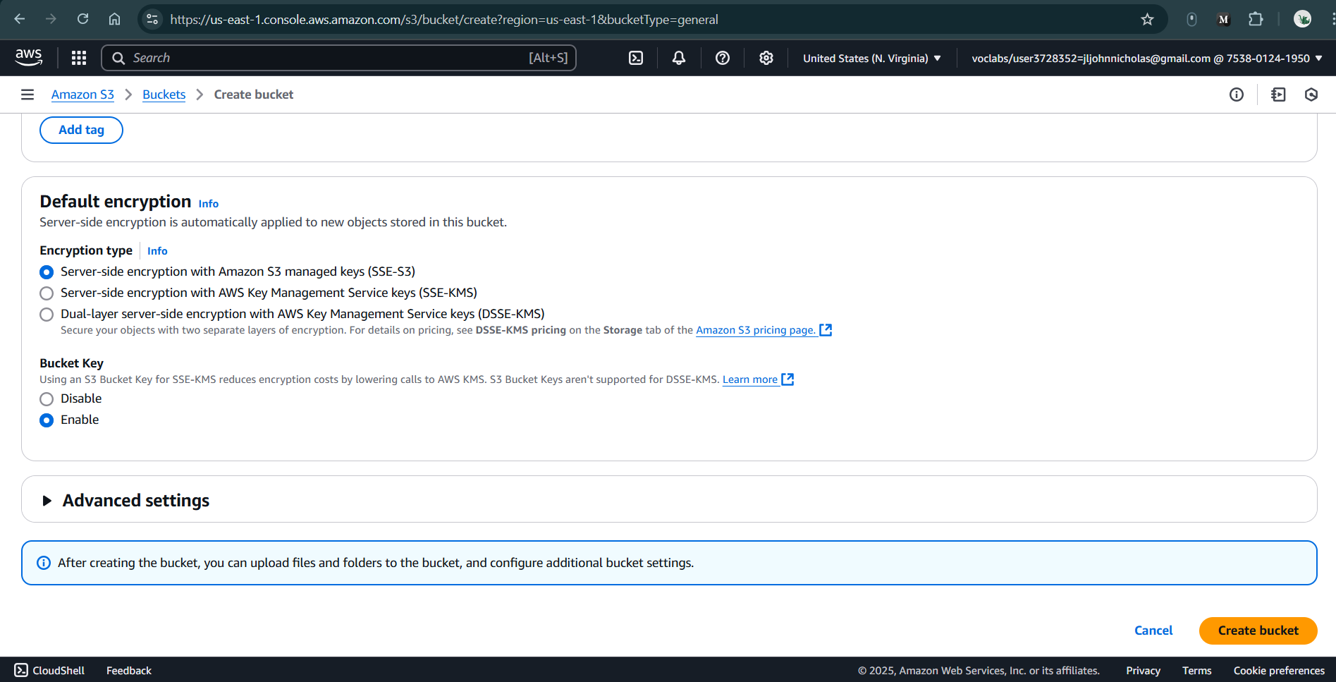

**Figure 2.3:** Setting all the general configurations for S3 Bucket

1. **S3 Bucket Created Successfully with below Image**

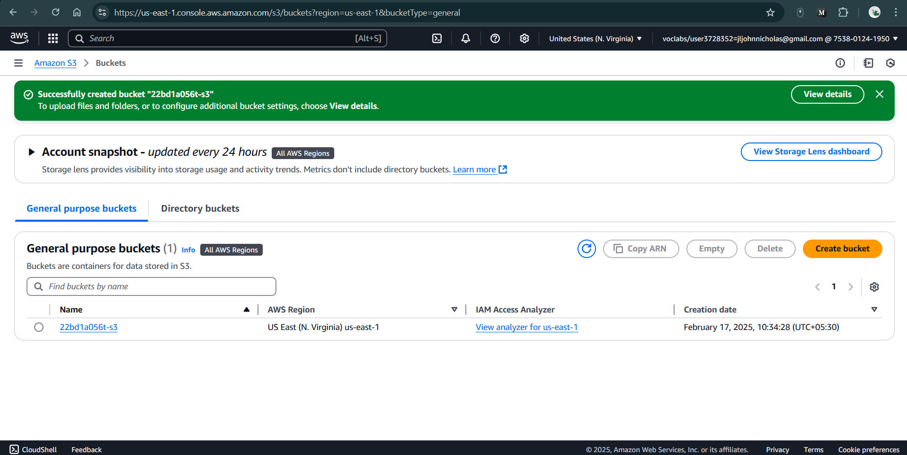

**Figure 2.3:** Successfully created S3 Bucket

1. **Click on view Details (Green Color above picture)**

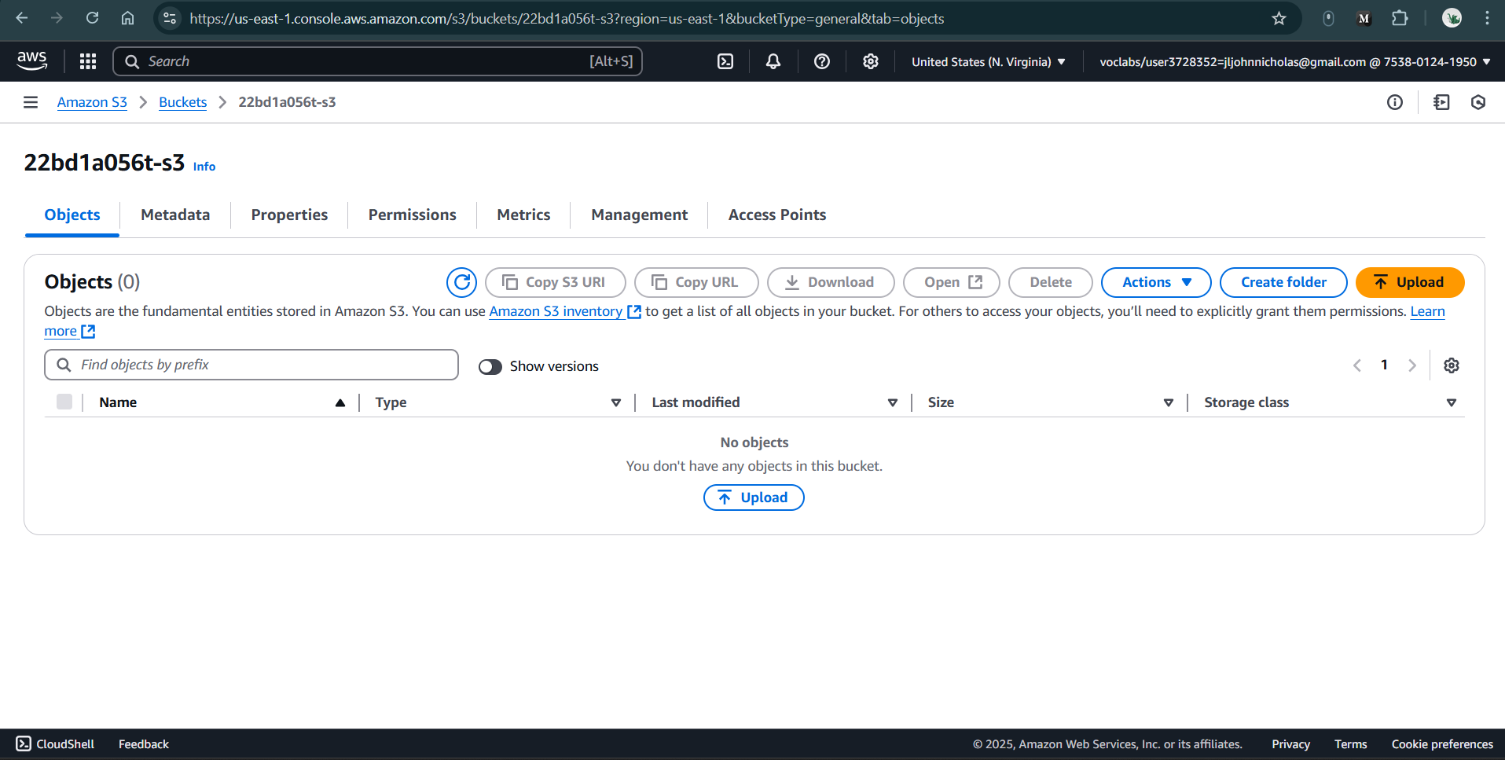

**Figure 2.4:** Click on Upload

1. **Click on buckets 🡪 click on bucket Name & Upload the File**

**Project TASK:**

* 1. While Uploading Files, you need to create a React JS File
  2. **File contains Basic Details like**
     1. **Text Box:** You need to Enter your **name**
     2. **Button:** While clicking this button, you need to display message as

**“Hi ‘Name!!!’ Welcome to S3 Bucket”**

| **Step 1:** npx create-react-app rollNumber-app  **Step 2:** cd shanker-app  **Step 3:** Create a component called welcome.js & Paste Below file..   | import React, { useState } from 'react';  const WelcomeMessage = () => {  const [name, setName] = useState('John'); *// Pre-filled name*  const [showMessage, setShowMessage] = useState(false);  const handleButtonClick = () => {  setShowMessage(true);  };  return (  <div style={{ textAlign: "center", marginTop: "20px" }}>  <input  type="text"  value={name}  onChange={(e) => setName(e.target.value)}  placeholder="Enter your name"  />  <button onClick={handleButtonClick}>Show Welcome Message</button>  {showMessage && <p>Hi "{name}!!!" Welcome to S3 bucket</p>}  </div>  );  };  export default WelcomeMessage; | | --- |   **Step 4:** Import WelcomeMessage.js file in App.js  import WelcomeMessage from “./component/Welcome”;  function App() {  return (  <div className="App">  <WelcomeMessage />  </div>  );  }  export default App;  Step 5: run the code **npm start**    **Figure 2.5:** Output of React App in localhost  **Step 6:** Build the app  npm run build    **Figure 2.6:** After npm run build, a build folder gets created |
| --- | --- |

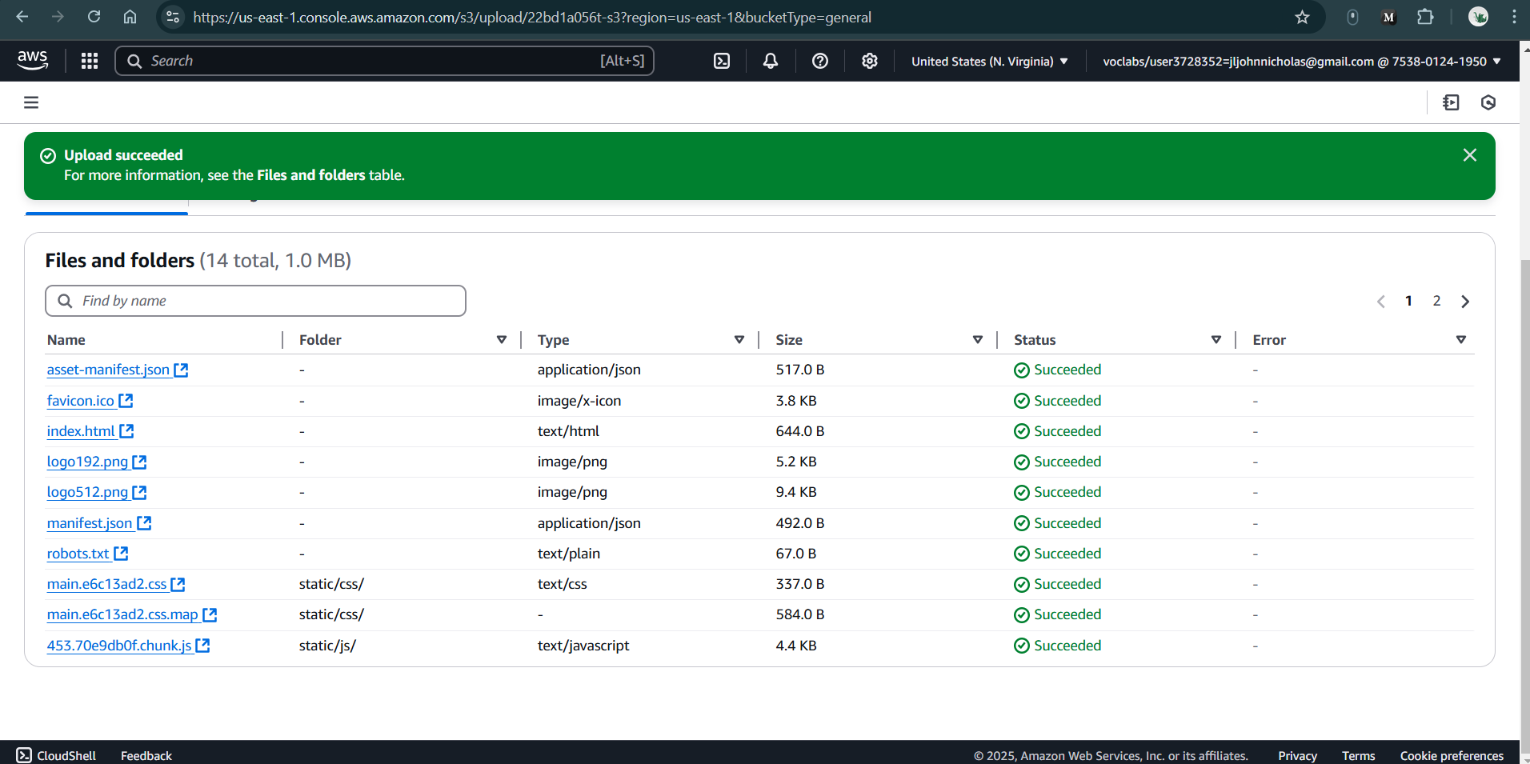

**Figure 2.7:** Upload all the contents of the build folder

1. **Click on property tab🡪** go to bottom you will find **Static website hosting** click on **Edit** click & **enable**

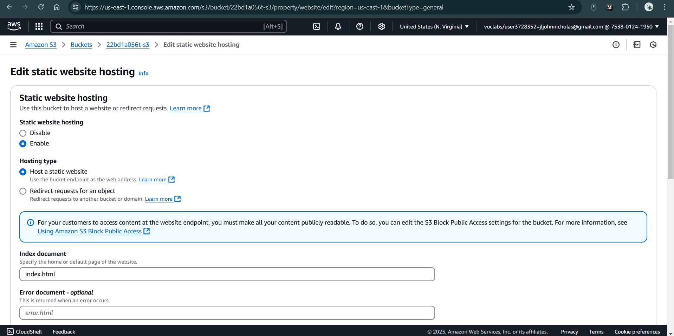

**Figure 2.8:** Edit the configurations of static web hosting

**Static website hosting**

* 1. **Static website hosting:** enable
  2. **Hosting type:** Host a static website
  3. **Index document:** index.html
  4. **Remaining:** default & click save change

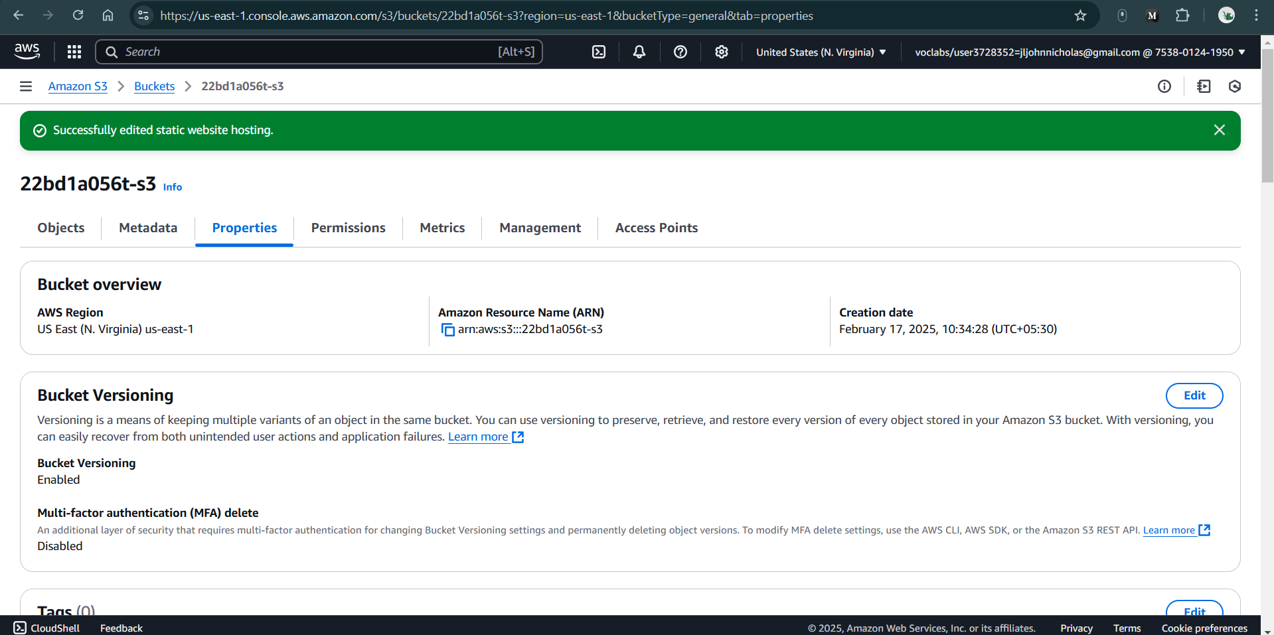

**Figure 2.9:** Successfully edited static website hosting

1. **Now click on Permissions:**
   1. **Block public access (bucket settings): enable all permission (default is blocking all)**
   2. **Click edit and disable all 🡪 save changes**

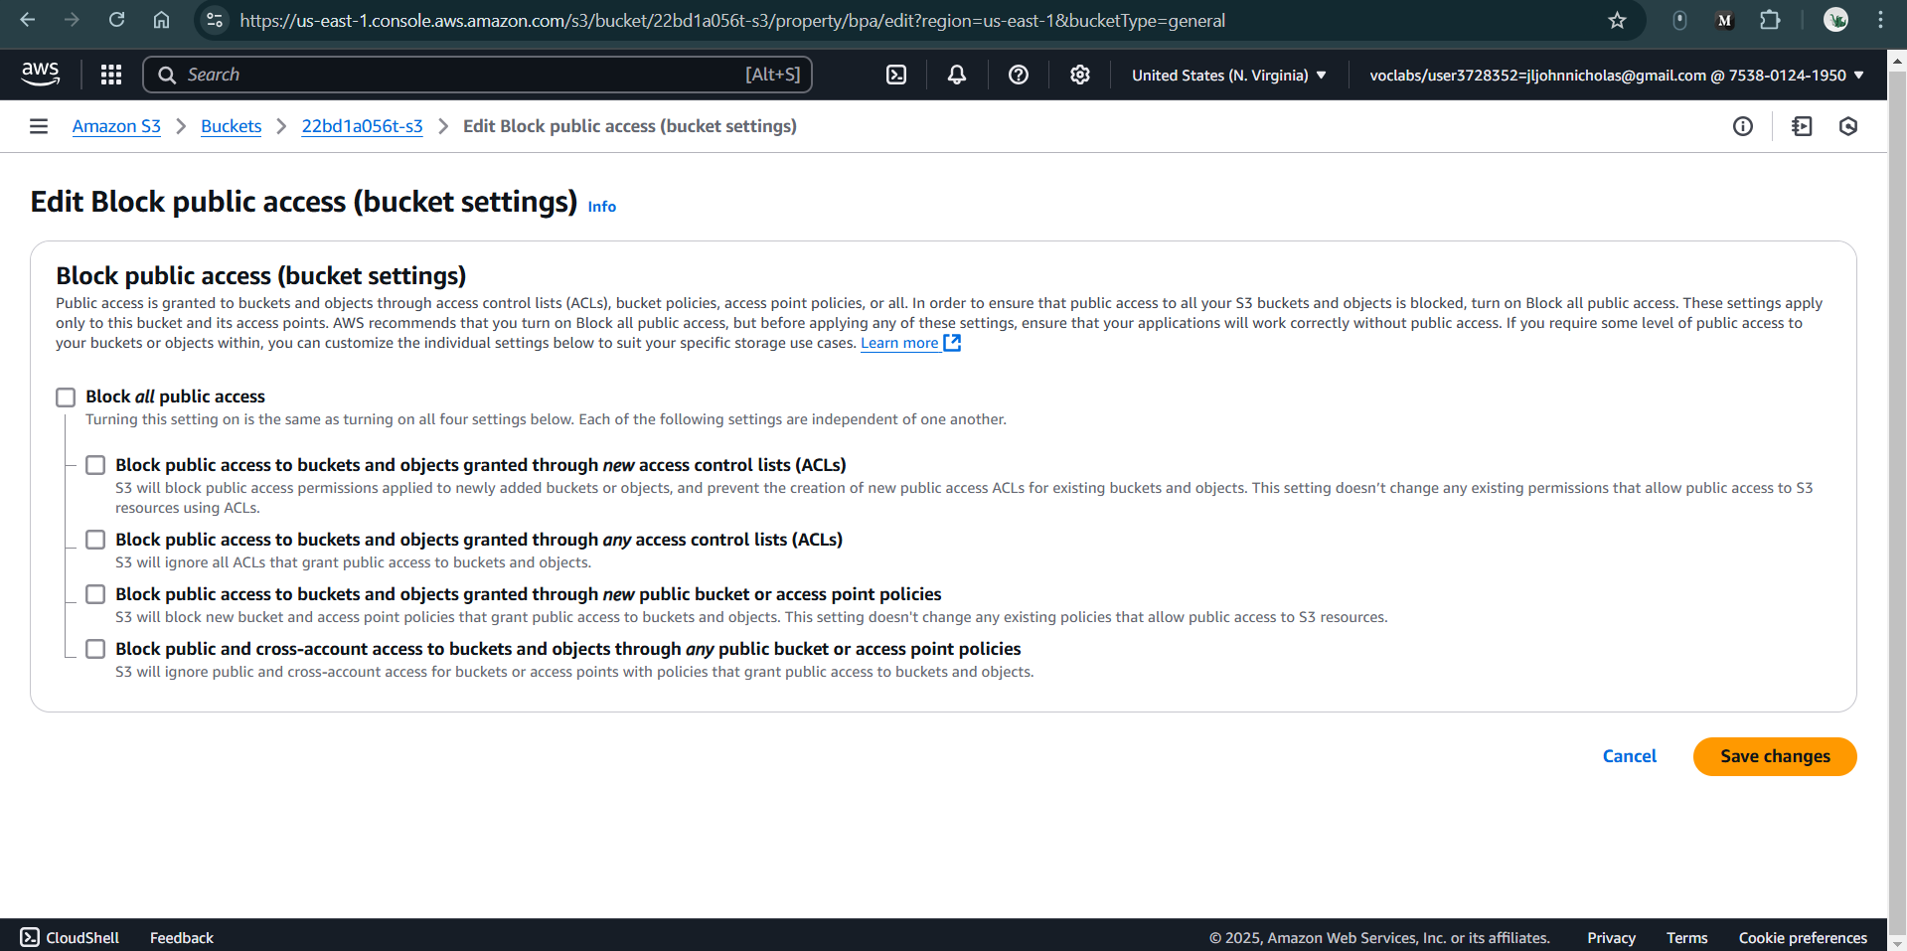

**Figure 2.10:** Disable Block all public access

* 1. **It will ask confirmation type confirm & click OK**

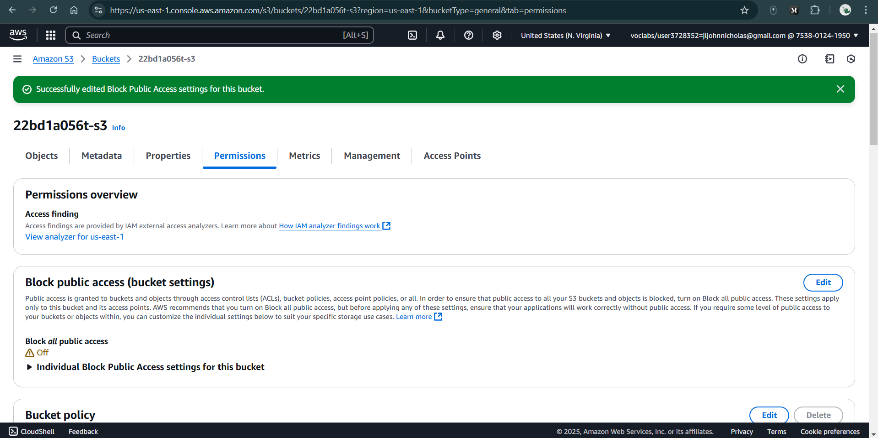

**Figure 2.11:** Successfully disabled Block Public Access

1. Scroll down, you will find **Bucket Policy: click on edit**

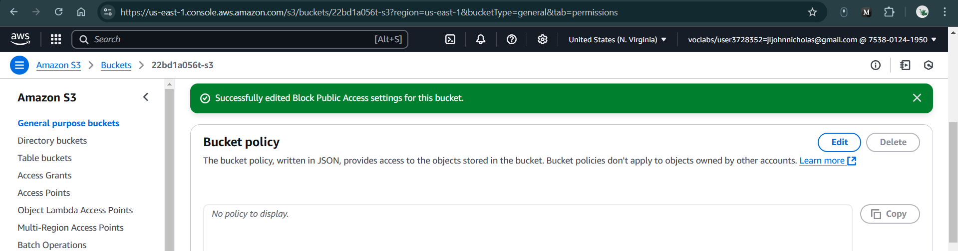

**Figure 2.12:** Edit Bucket Policy

1. **You will navigate below Image**

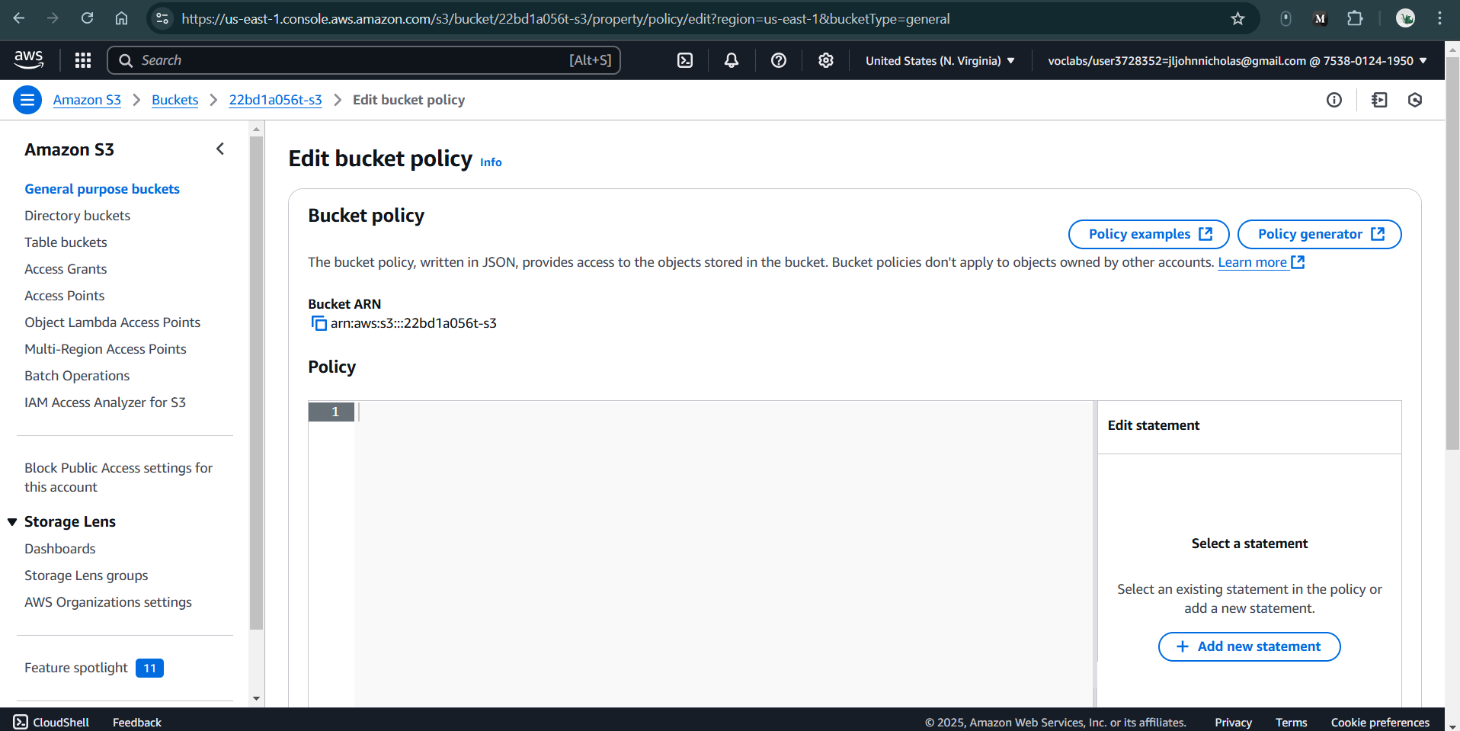

**Figure 2.13:** Navigated to Edit Bucket Policy

1. Now click **on Policy generator** now you will navigate to another page

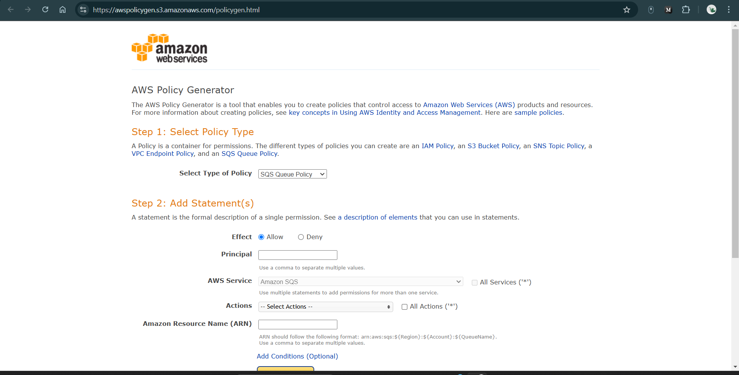

**Figure 2.14:** Navigated to awspolicygen

**AWS Policy Generator**

1. **Step 1: Select Policy Type :** select **S3 Bucket policy**
2. **Step 2: Add Statement(s)**
   1. **Principal add: \***
   2. **Actions:** Get Object (select)
   3. **Amazon Resource Name (ARN):** go back previous tab &Copy ARN **paste ARN** Example: **arn:aws:s3:::22bd1a056t-s3**

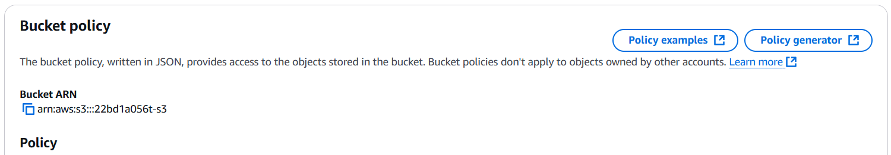

**Figure 2.15:** Copy the Bucket ARN

* 1. **Click Add statement**

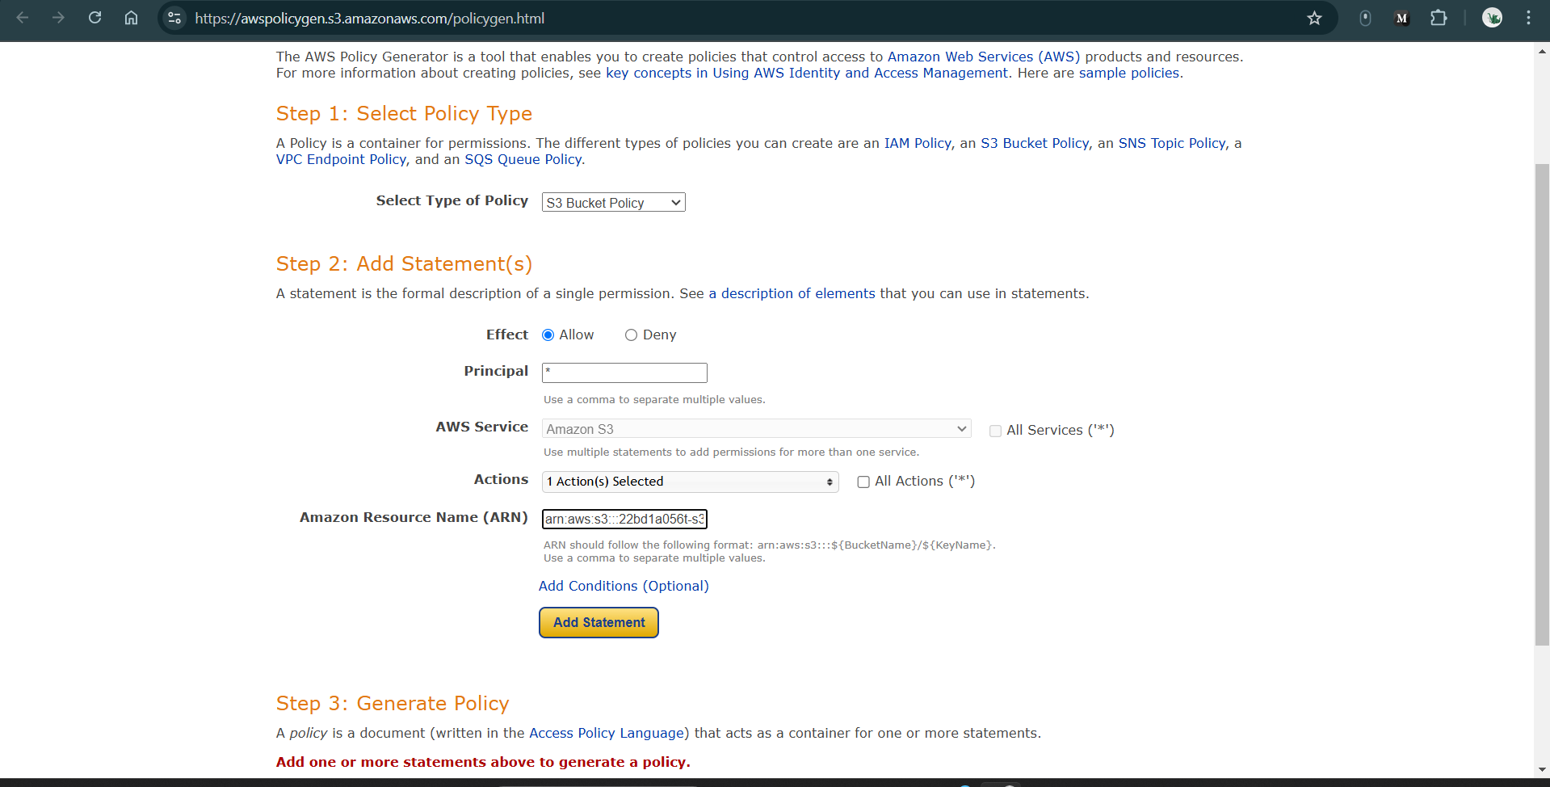

**Figure 2.16:** Set the required configurations in awspolicygen

* 1. **Click generate policy: copy the JSON Format (sample shown below)**

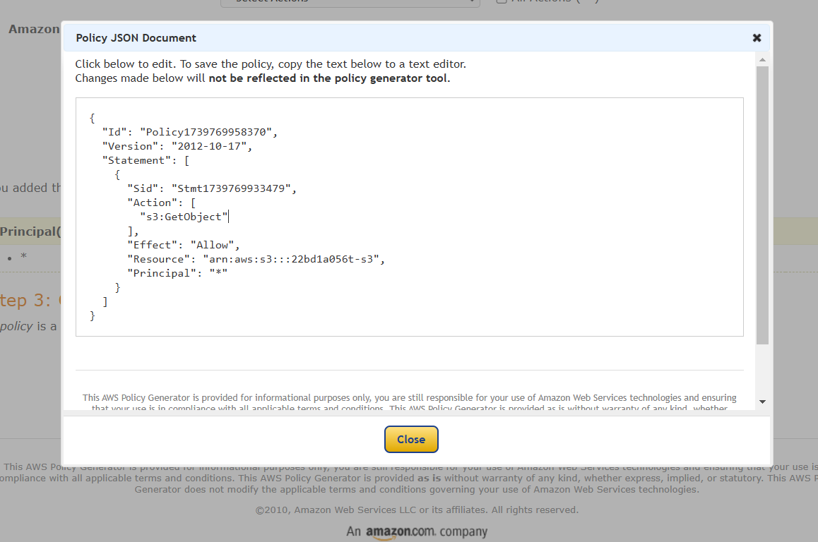

**Figure 2.17:** Copy the Policy JSON Document

* 1. **Now copied JSON Format as to paste in policy**

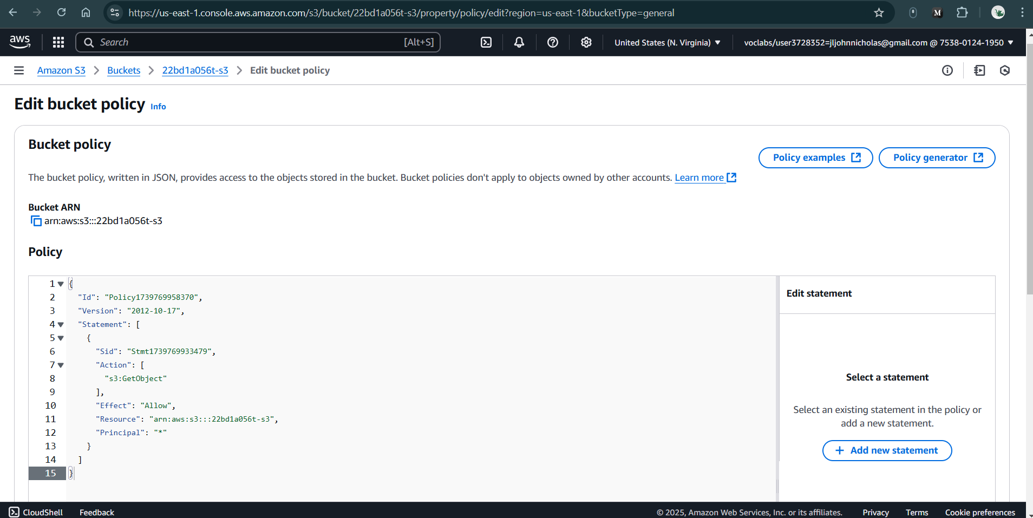

**Figure 2.18:** Paste the copied JSON document to Bucket Policy

* 1. **Line no 11 Resource:** add **/* {**otherwise it will not work}

**Eg: "Resource": "arn:aws:s3:::22bd1a056t-s3/*",**

* 1. **Simply click & save the changes**

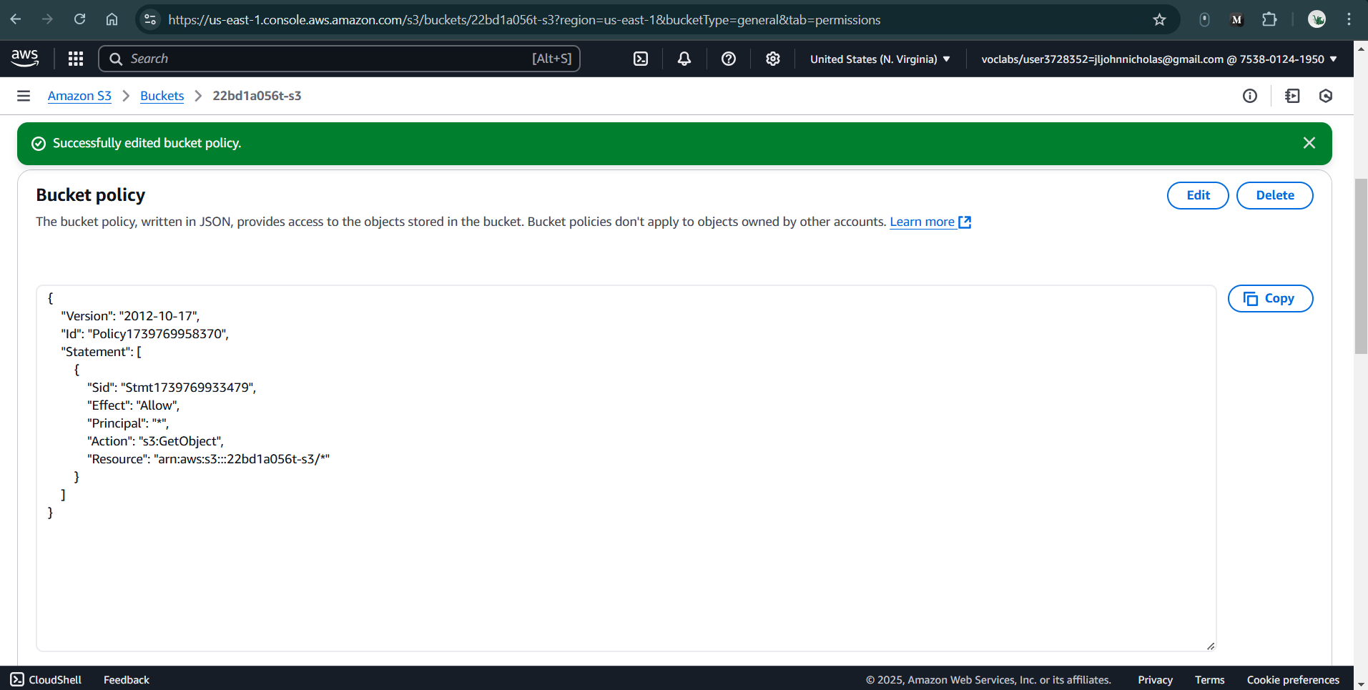

**Figure 2.19:** Successfully edited Bucket Policy

1. Now go to **Objects** Section tab & upload all files from **Build** Folder generated by command npm **run build**

Just Drag & Drop to upload

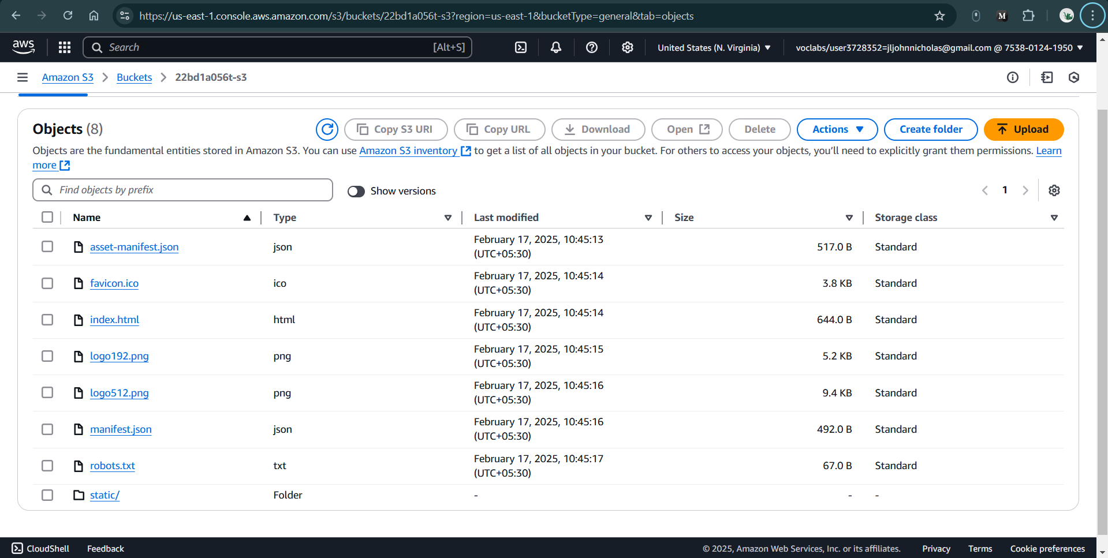

**Figure 2.20:** Drag and drop the contents of build folder to Upload

1. **Click & upload you will get below uploaded Information**



**Figure 2.21:** Successfully Uploaded

1. **Now you need to find url**

**Properties 🡪 Static website hosting (scroll down)**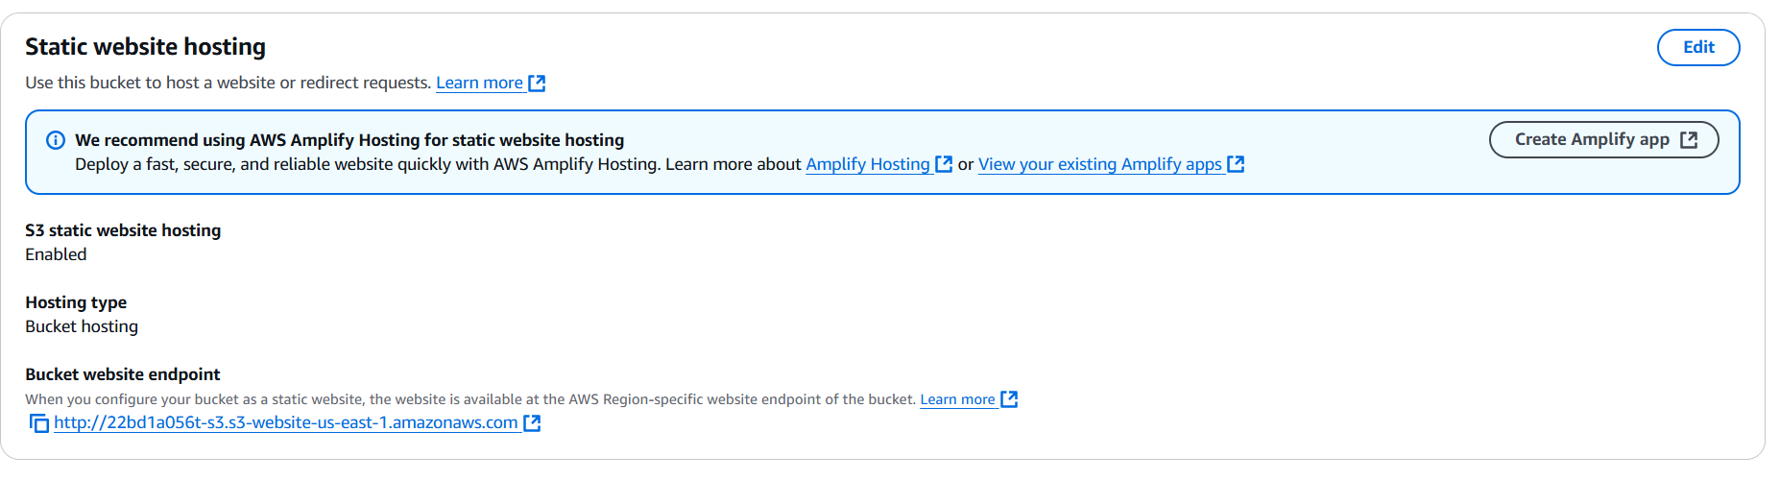

**Figure 2.22:** Copy and navigate to Bucket website endpoint in another tab

**You will find url**

[**http://22bd1a056t-s3.s3-website-us-east-1.amazonaws.com/**](http://22bd1a056t-s3.s3-website-us-east-1.amazonaws.com/)

**That it… you have created a Web hosting successfully in S3 BUCKET**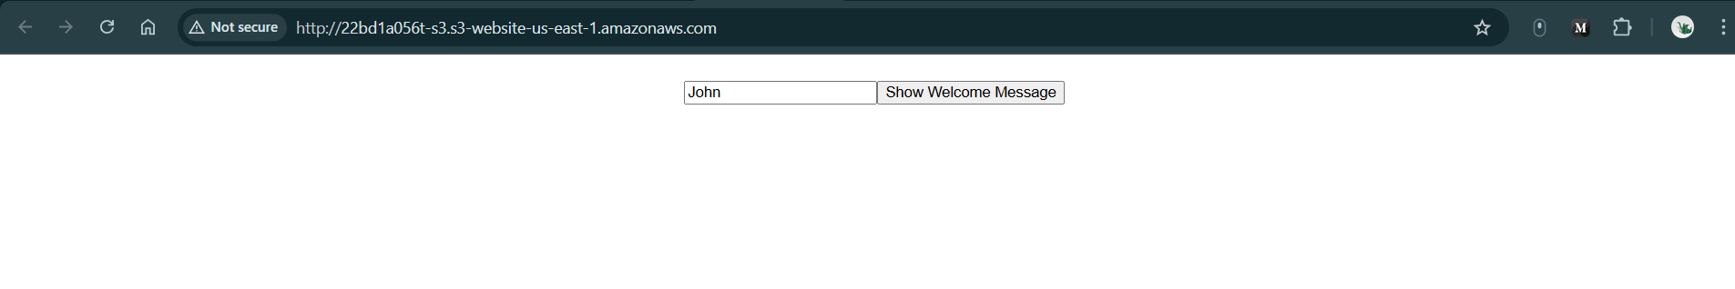

**Figure 2.23:** Successfully hosted the S3 Bucket