|  |
| --- |
| **Experiment: 2.1**  **Create a s3 Bucket versioning**   1. Create a Bucket name as Name-Rollno 2. Upload a File1.jpeg (kmit logo with ur name & rollno) and give permissions as follows    * Bucket level permission (Enable)    * Object level permission (Enable)    * Finally get the **URL** for File1.jpeg which should be publicly visible. 3. Now Enable s3 versioning 4. Again upload File1.jpeg (Here kmit logo with kmit full form & location) 5. Now Display the File1.jpeg (Which one will show) 6. Again upload File1.jpeg (Here it contains logos of kmit,ngit) in 1 file 7. Again upload File1.jpeg (Here it contains logos of kmit, ngit, kmecs) in 1 file 8. Again upload File1.jpeg (Here it contains logos of kmit, ngit, kmecs. kmces) in 1 file 9. Now Display File1.jpeg (which output will be displays) 10. Finally, I need to see the **6th point imag**e, then how can I get that image?   **Note:** In all Images you need to have your name & roll no  **Delete the Image:**   1. Delete a particular Image 2. How to retrieve/ revert that image back? 3. Explain detail about hoe S3 bucket Maintaining version   Remember: If the bucket is deleted permanently, we can’t retrieved but object deleted. |

1. **Login** into AWS Account then **Start Lab** Launch **AWS Console Home**
2. In console home **search** **S3** (Scalable storage in the cloud)

**Advantage: Store and retrieve any amount of data from anywhere**

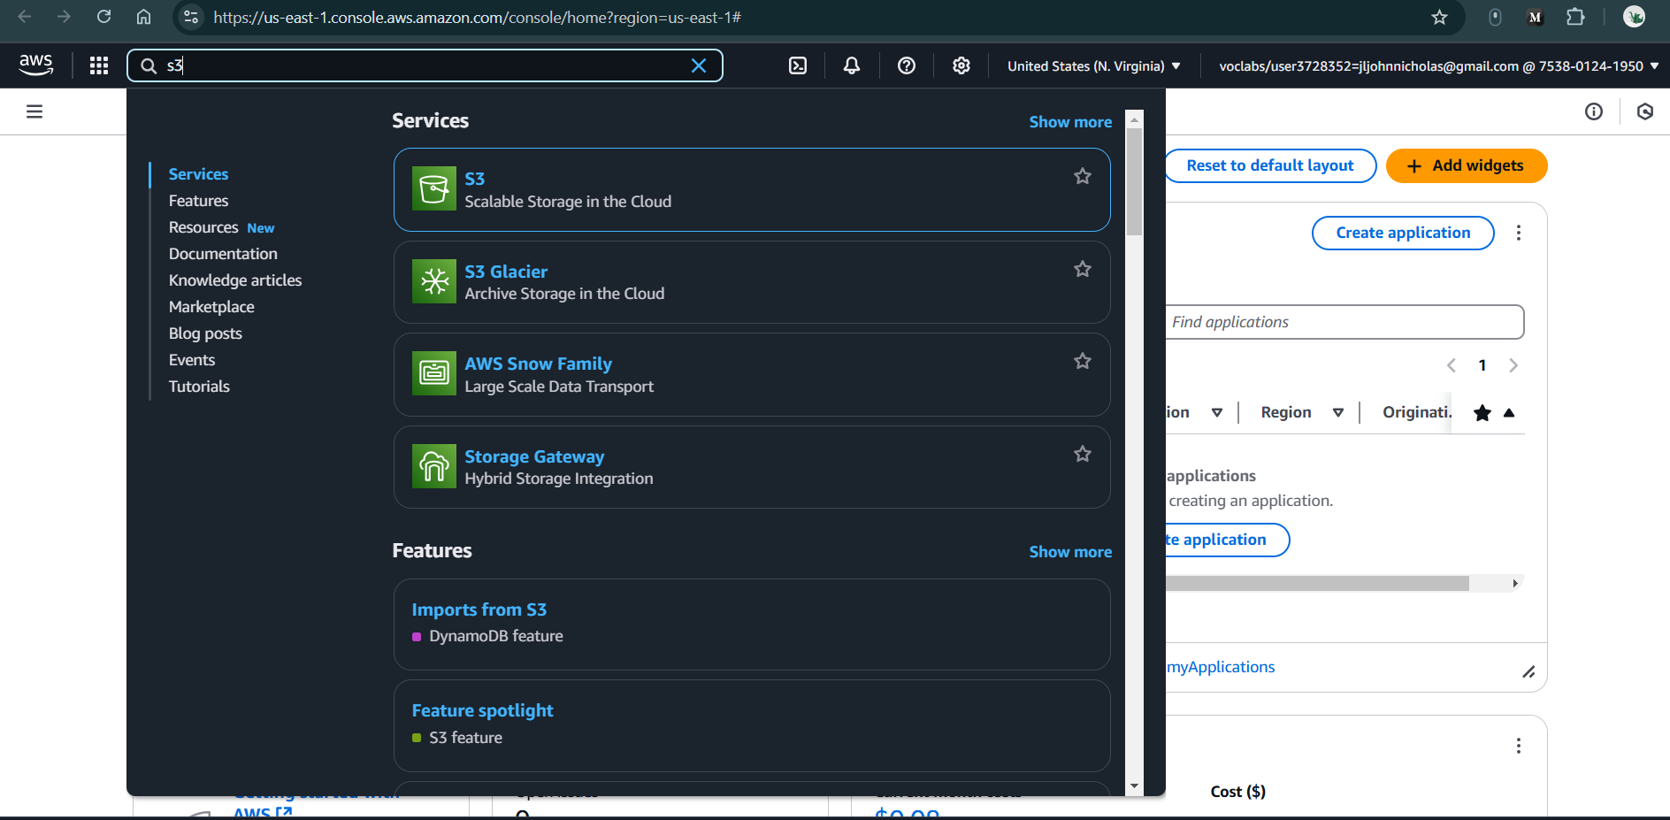

**Figure 2.1.1:** Searching s3 bucket in search bar

1. It will navigate to below page, then click **Create a bucket**

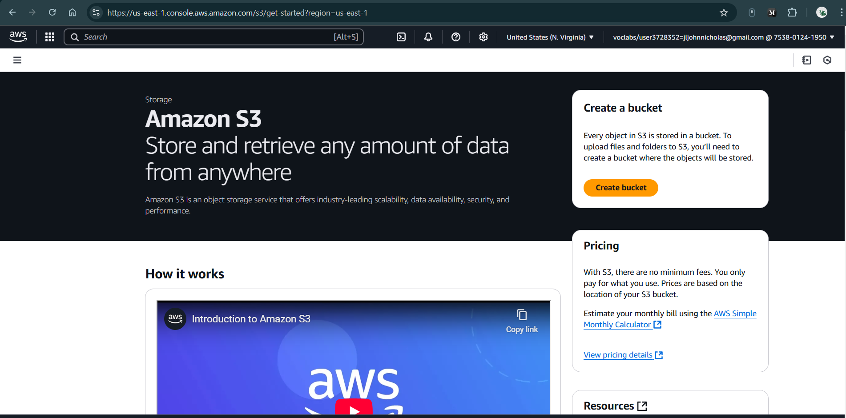

**Figure 2.1.2:** Click Create bucket

1. **Create Bucket:**
   1. General configuration
      1. **Bucket Name:** RollNumber
      2. Note: see rules to create bucket Name like no capitals, no “_”, no space etc
   2. Object Ownership
      1. Choose **Object Ownership**
   3. **Block Public Access settings for this bucket** (Keep default)
   4. **Bucket Versioning**: click to **enable**
   5. **Tags - optional (0)** (Keep default)
   6. **Default encryption**
      1. **Encryption type:** Server-side encryption with Amazon S3 managed keys (SSE-S3)
      2. **Bucket Key:** Enable
   7. **Advanced settings** (Keep default)
   8. **Finally Click on Create Bucket**

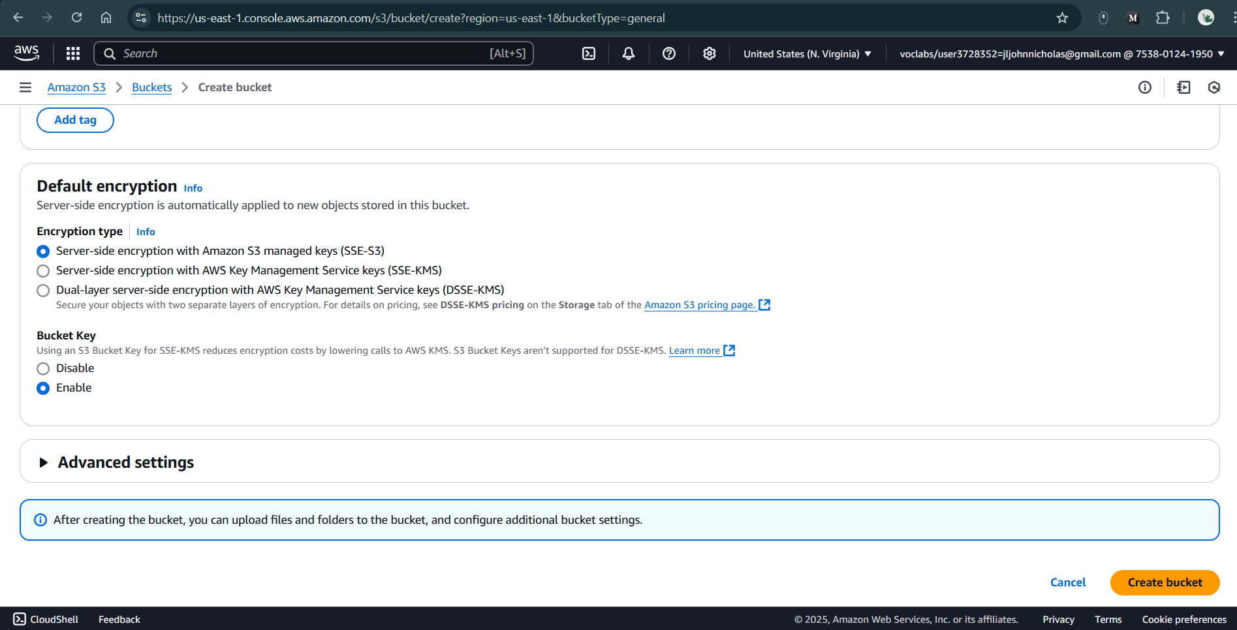

**Figure 2.1.3:** Setting all the general configurations for S3 Bucket

1. **S3 Bucket Created Successfully with below Image**

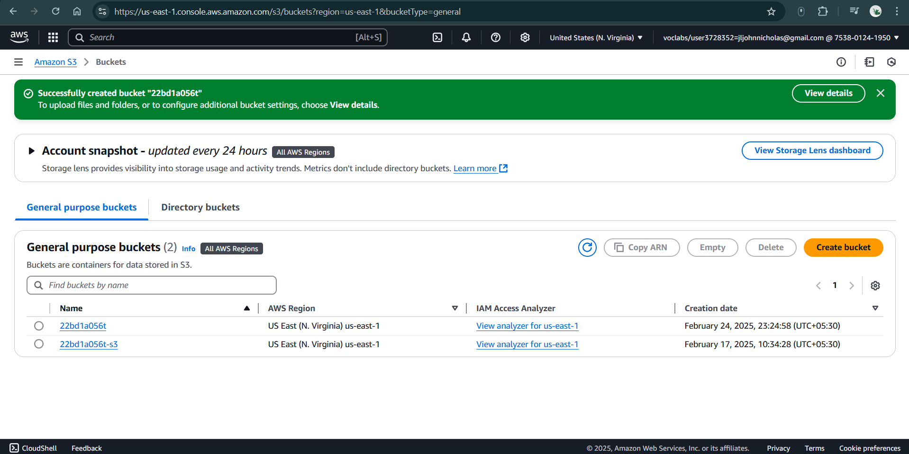

**Figure 2.1.3:** Successfully created S3 Bucket

1. **Click on view Details (Green Color above picture)**
2. **Upload the First Image (File1.jpeg - KMIT Logo with Name & Roll No)**

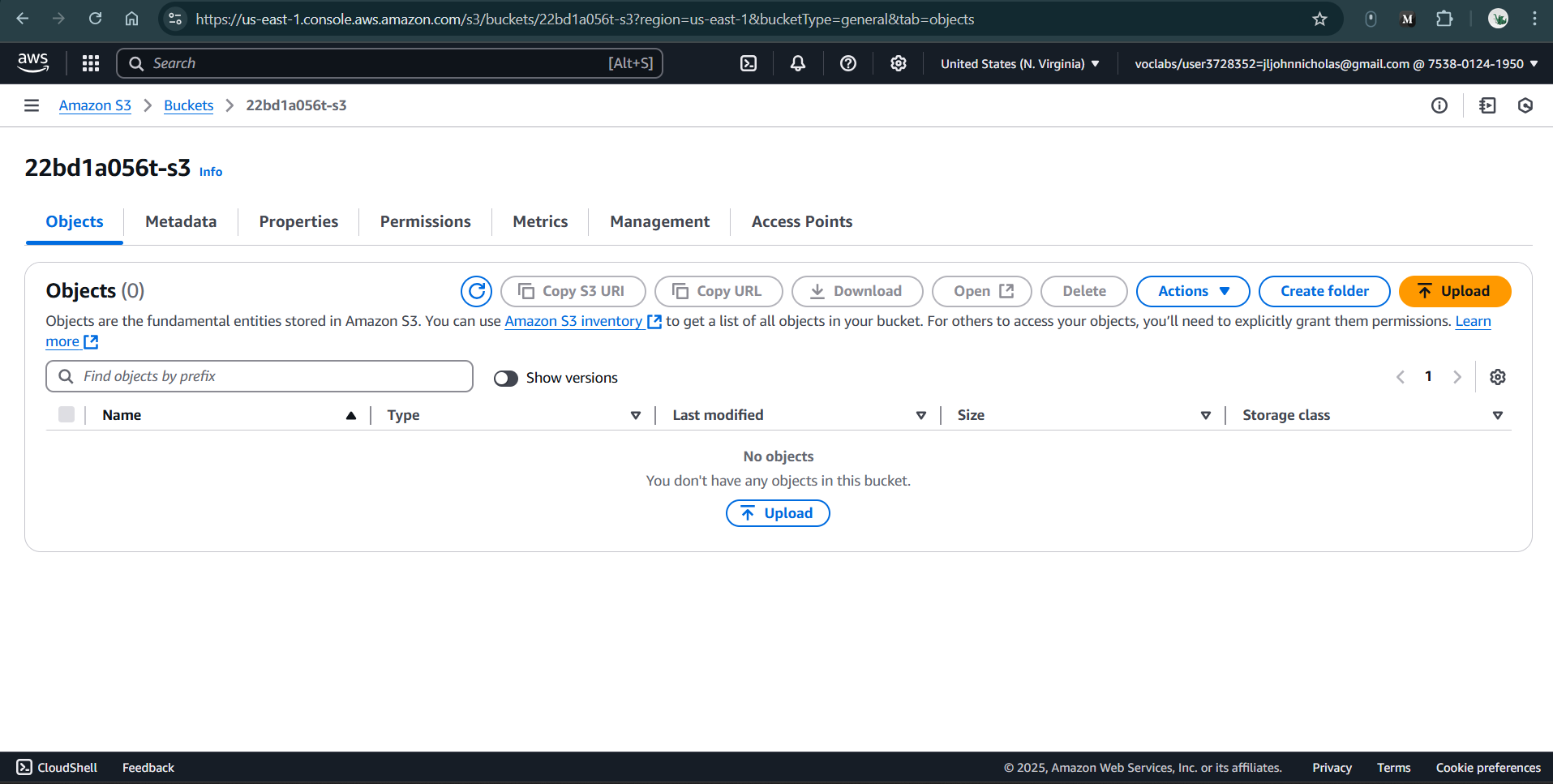

**Figure 2.1.4:** Click on Upload

1. Click the "Upload" button.
2. Click "Add files", then select your File1.jpeg (image containing the KMIT logo + Your Name & Roll No).

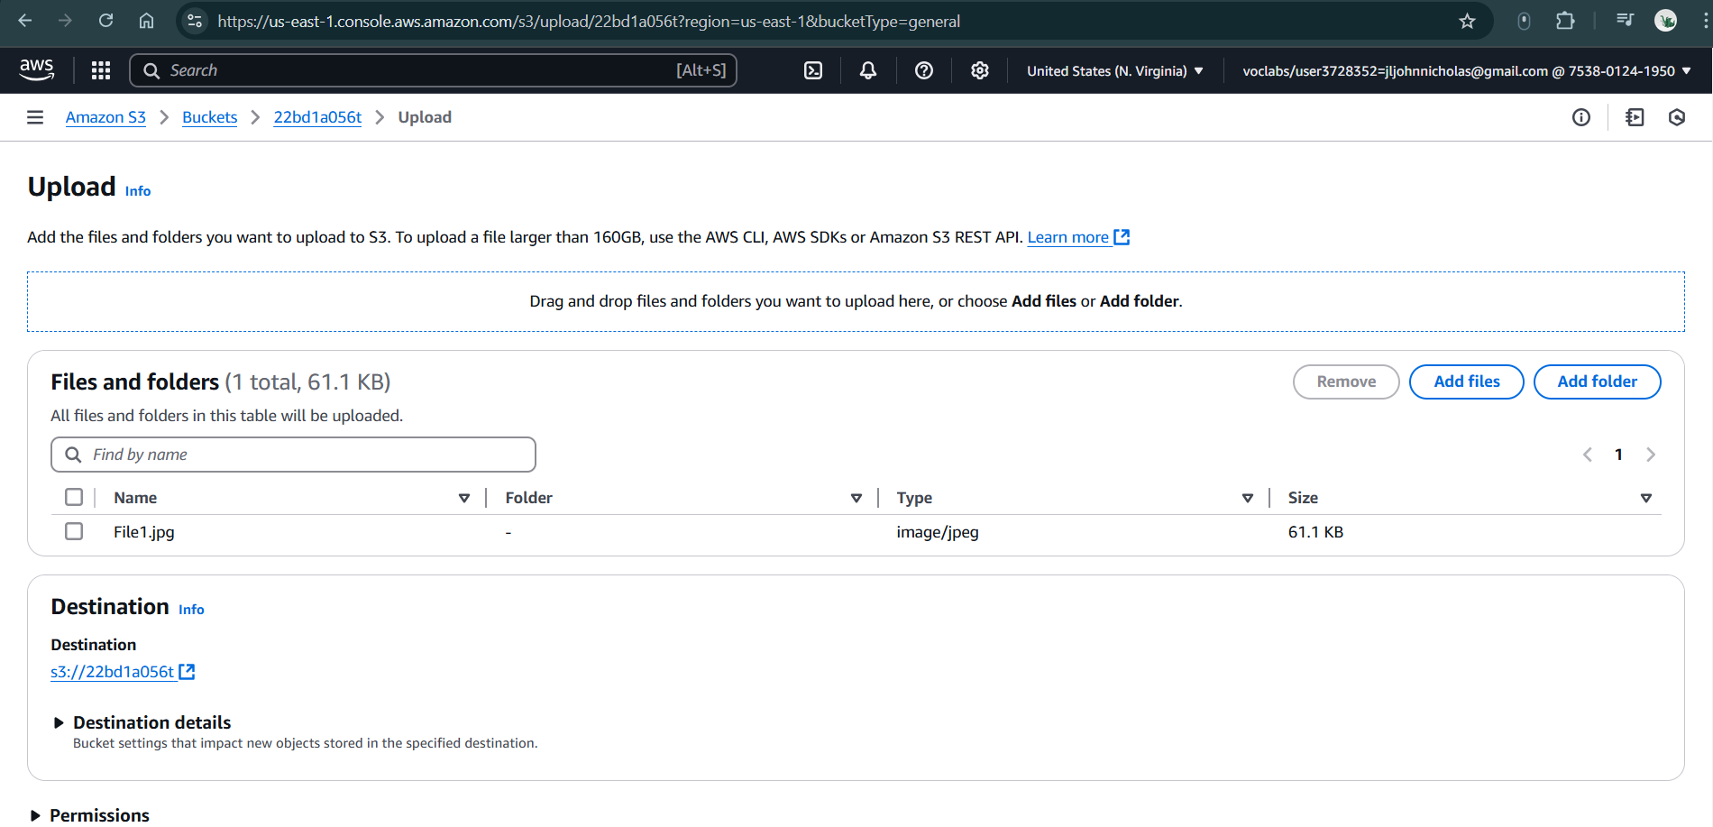

**Figure 2.1.5:** Select or drag and drop File1.jpeg

1. Scroll down and click "Upload".

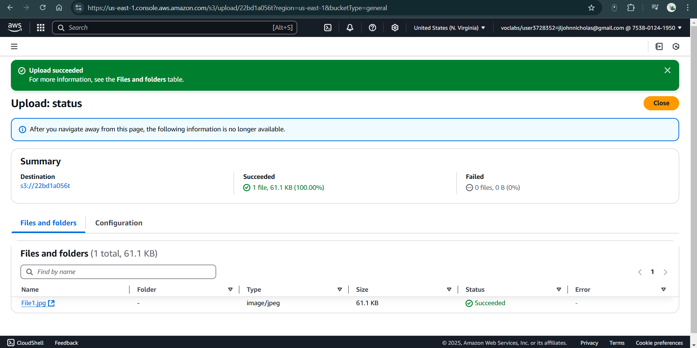

**Figure 2.1.6:** Upload the file

1. **Ensure Public Access is Enabled**
2. Open AWS S3 Console.
3. Go to your bucket.
4. Click on the Permissions tab.
5. Scroll down to Block Public Access (bucket settings).
6. Click Edit.
7. Uncheck "Block all public access" if it is enabled.
8. Click Save changes.

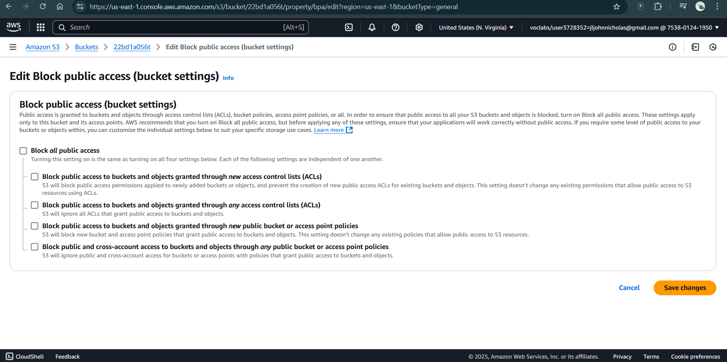

**Figure 2.1.7:** Uncheck "Block all public access"

1. **Update the Bucket Policy**

Since ACL-based access is blocked (Bucket Owner Enforced), we must use a Bucket Policy to allow public access.

1. Open AWS S3 Console.
2. Go to your S3 Bucket → Click Permissions tab.
3. Scroll down to Bucket Policy → Click Edit.
4. Replace Your-Bucket-Name in the following policy and paste it:

{

"Version": "2012-10-17",

"Statement": [

{

"Effect": "Allow",

"Principal": "*",

"Action": "s3:GetObjectVersion",

"Resource": "arn:aws:s3:::22bd1a056t/*"

},

{

"Effect": "Allow",

"Principal": "*",

"Action": "s3:GetObject",

"Resource": "arn:aws:s3:::22bd1a056t/*"

}

]

}

1. Click Save changes.

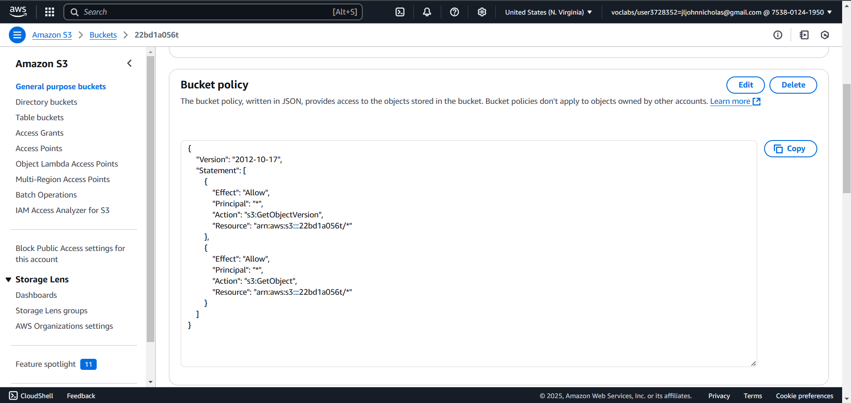

**Figure 2.1.8:** Update Bucket Policy

1. **Test Public Access**
2. Open your bucket.
3. Click on File1.jpeg.
4. Scroll down to Object URL.
5. Open a new browser window.
6. Paste the Object URL and hit Enter.
7. The image should now be visible.

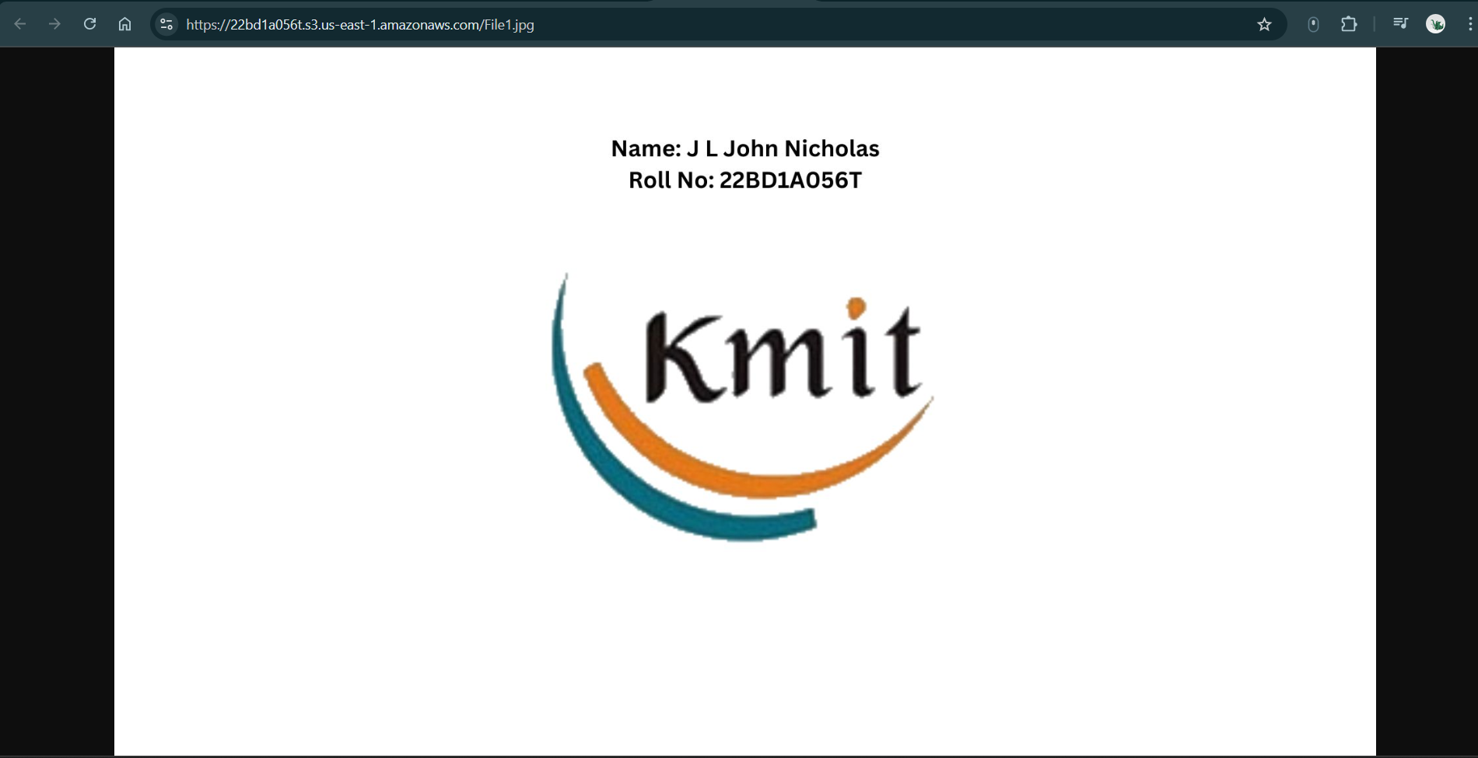

**Figure 2.1.9:** Open File1.jpeg in browser using Object URL

1. **Enable S3 Versioning**
2. Open your S3 bucket.
3. Click on the "Properties" tab.
4. Scroll down to the "Bucket Versioning" section.
5. Click Edit → Enable Versioning.
6. Click Save changes.

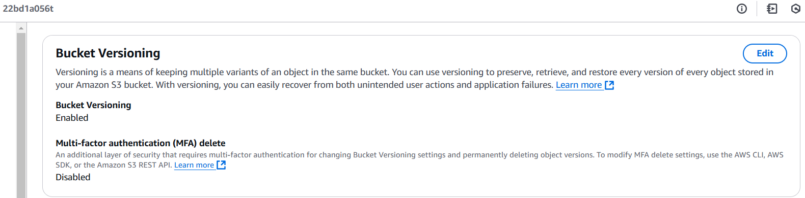

**Figure 2.1.10:** Enable Bucket Versioning

1. **Upload Updated Versions of File1.jpeg**

Each time you upload a new file, use the same file name (File1.jpeg). AWS S3 will store it as a new version.

1. Upload the Second Image:

* Create a new image (File1.jpeg) that contains:
* KMIT logo + KMIT full form & Location + Your Name & Roll No.
* Upload it to the same bucket using the same steps as before.

1. Upload the Third Image:

* Create another version of File1.jpeg containing:
* Logos of KMIT, NGIT + Your Name & Roll No.
* Upload it again.

1. Upload the Fourth Image:

* Modify File1.jpeg to include:
* Logos of KMIT, NGIT, KMEC + Your Name & Roll No.
* Upload it.

1. Upload the Fifth Image:

* Modify File1.jpeg to include:
* Logos of KMIT, NGIT, KMEC, KMCES + Your Name & Roll No.
* Upload it.

Each upload creates a new version of File1.jpeg, keeping all previous versions in S3.

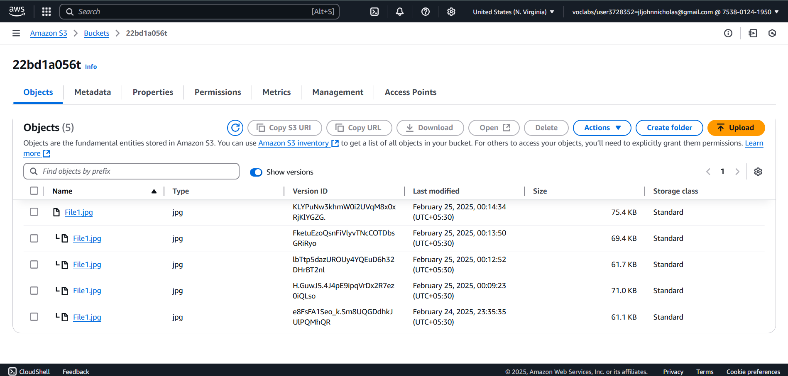

**Figure 2.1.11:** Toggle “Show versions” to see all previous versions in S3

1. **Display the Current File**
2. Copy the **Object URL** of File1.jpeg.
3. Open it in a browser.
4. Since AWS **always serves the latest version**, the image with **KMIT, NGIT, KMEC, KMCES logos** will be displayed.

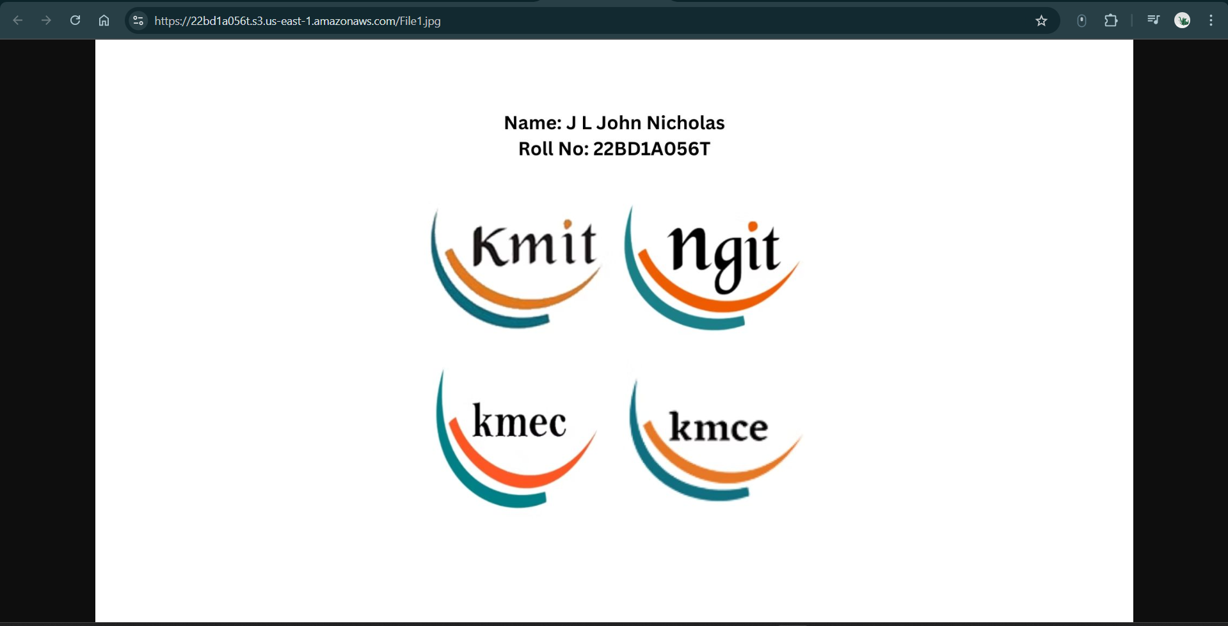

**Figure 2.1.12:** Display latest version of File1.jpeg in new tab using Object URL

1. **Retrieve an Older Version**

If you want to see or revert to an older image:

1. Open your S3 Bucket → Click on File1.jpeg.
2. Click the “Versions” tab.
3. You will see a list of all uploaded versions with Version IDs.
4. Select the version that contains KMIT full form & location.
5. Click Download to view it.

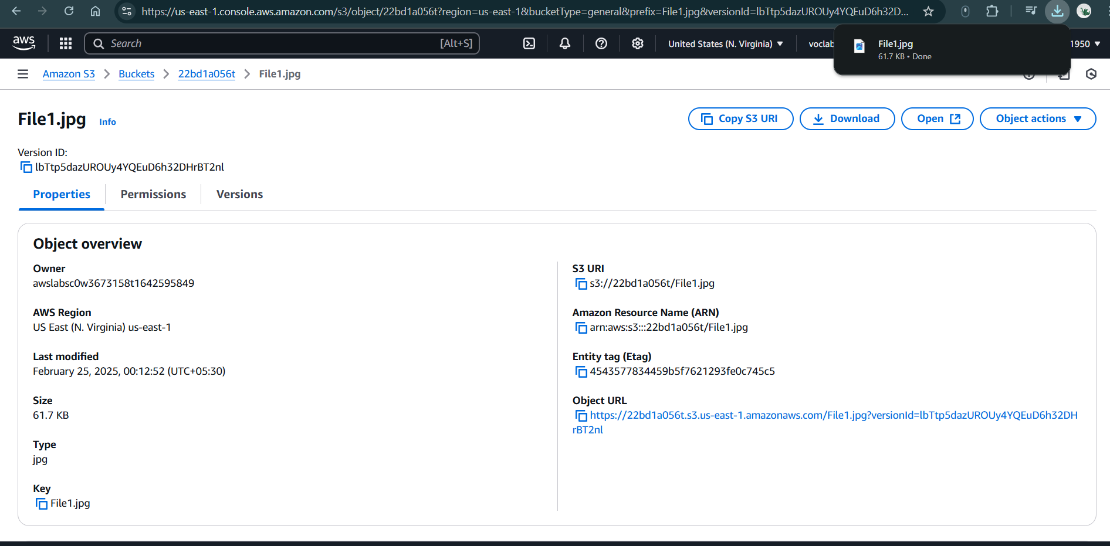

**Figure 2.1.13:** Download the previous version of File1.jpeg

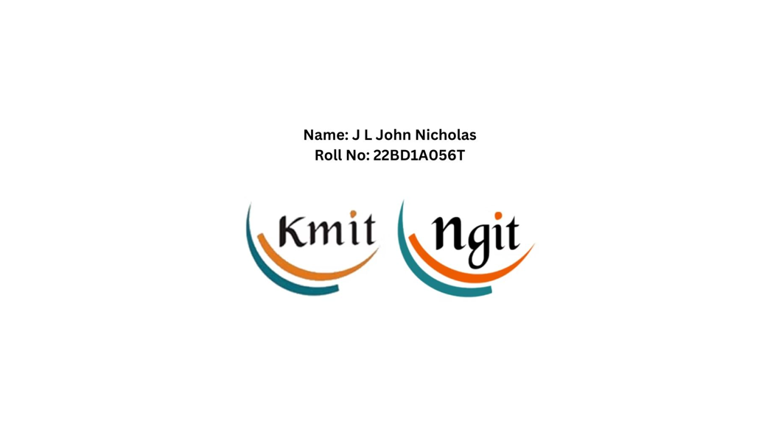

**Figure 2.1.14:** View the Downloaded previous version of File1.jpeg

If you want this version to be publicly accessible:

Re-upload it using the same file name (File1.jpeg) to make it the latest version.

1. **To delete an image (object) in an S3 bucket:**
2. Go to the AWS Management Console → Navigate to S3.
3. Open the bucket and locate the image.
4. Select the image and click Delete.
5. If Versioning is enabled, the object is not permanently deleted; instead, a delete marker is added.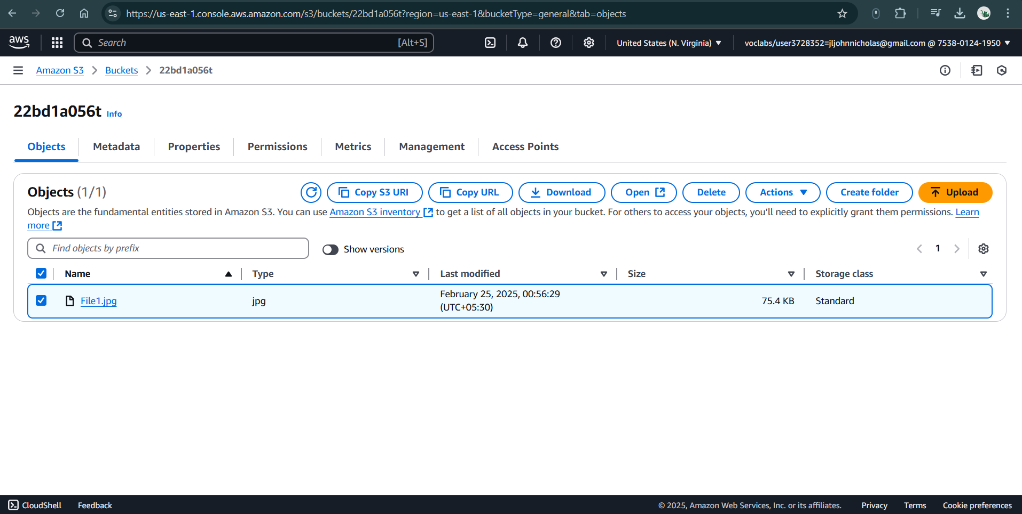

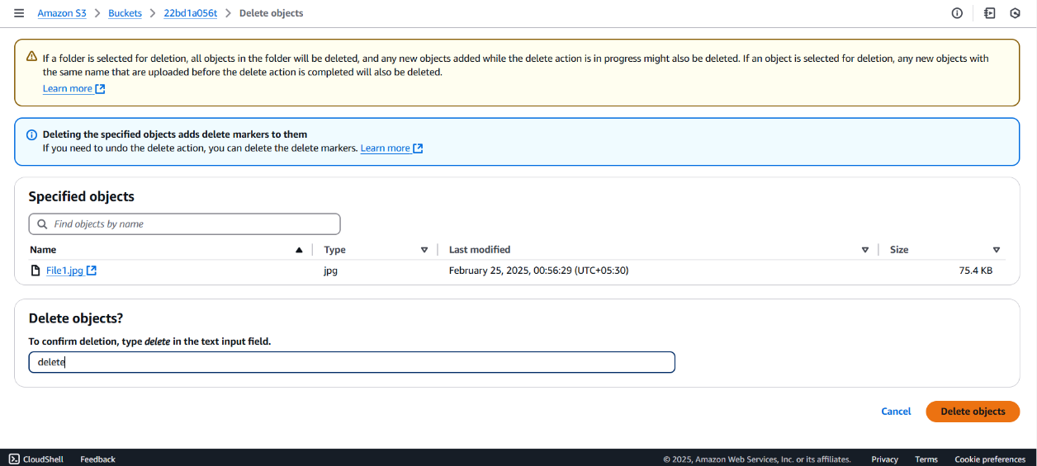

**Figure 2.1.15:** Select the image (object) in S3 Bucket

Note: If you delete a file without selecting a version, AWS will add a delete marker, hiding the file but keeping older versions.

1. **Restoring (Reverting) a Deleted Image in S3**

If Versioning is enabled, you can retrieve/revert the deleted image by removing the delete marker:

1. Open the S3 bucket in the AWS Console.
2. Click on the image’s name to see the Versions tab.
3. Find the delete marker and delete it.
4. The original image will be restored.
5. If Versioning is not enabled, then deletion is permanent, and the object cannot be recovered unless you have a backup.

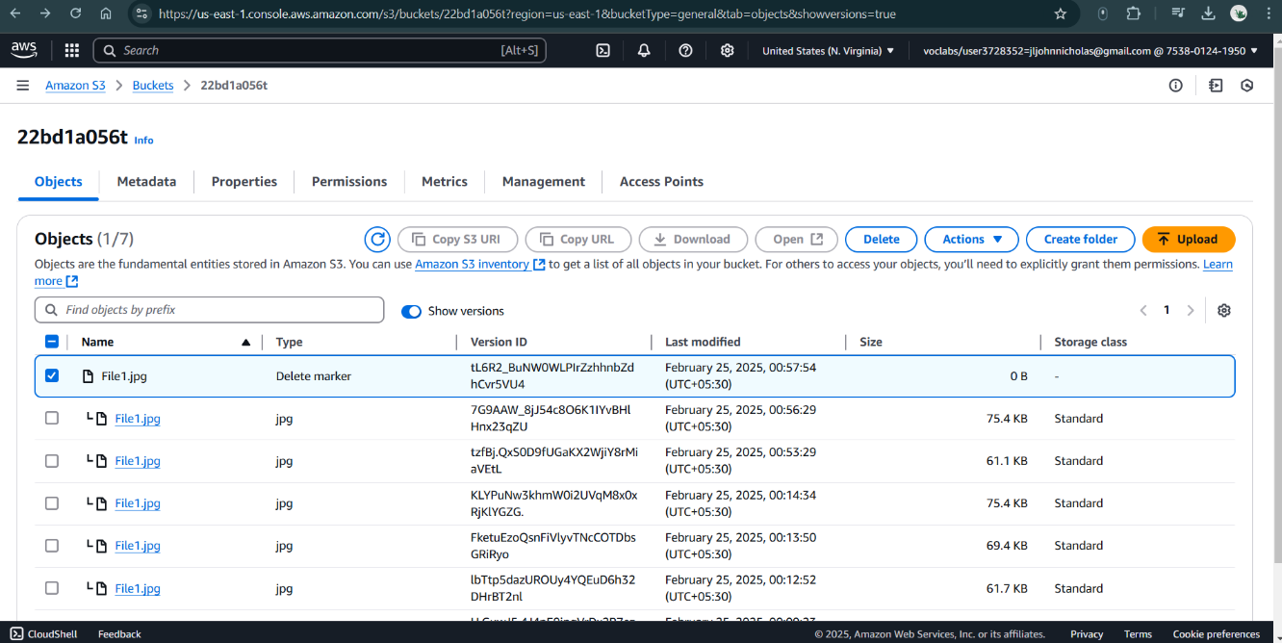

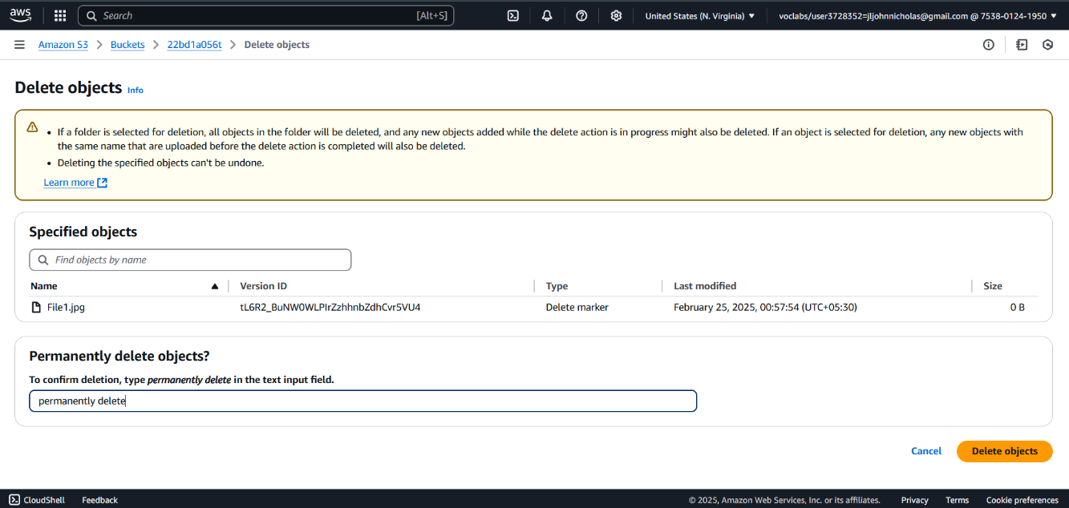

**Figure 2.1.16:** Type *permanently delete* to delete the ‘delete marker’

1. **View the restored image using the Object URL again**

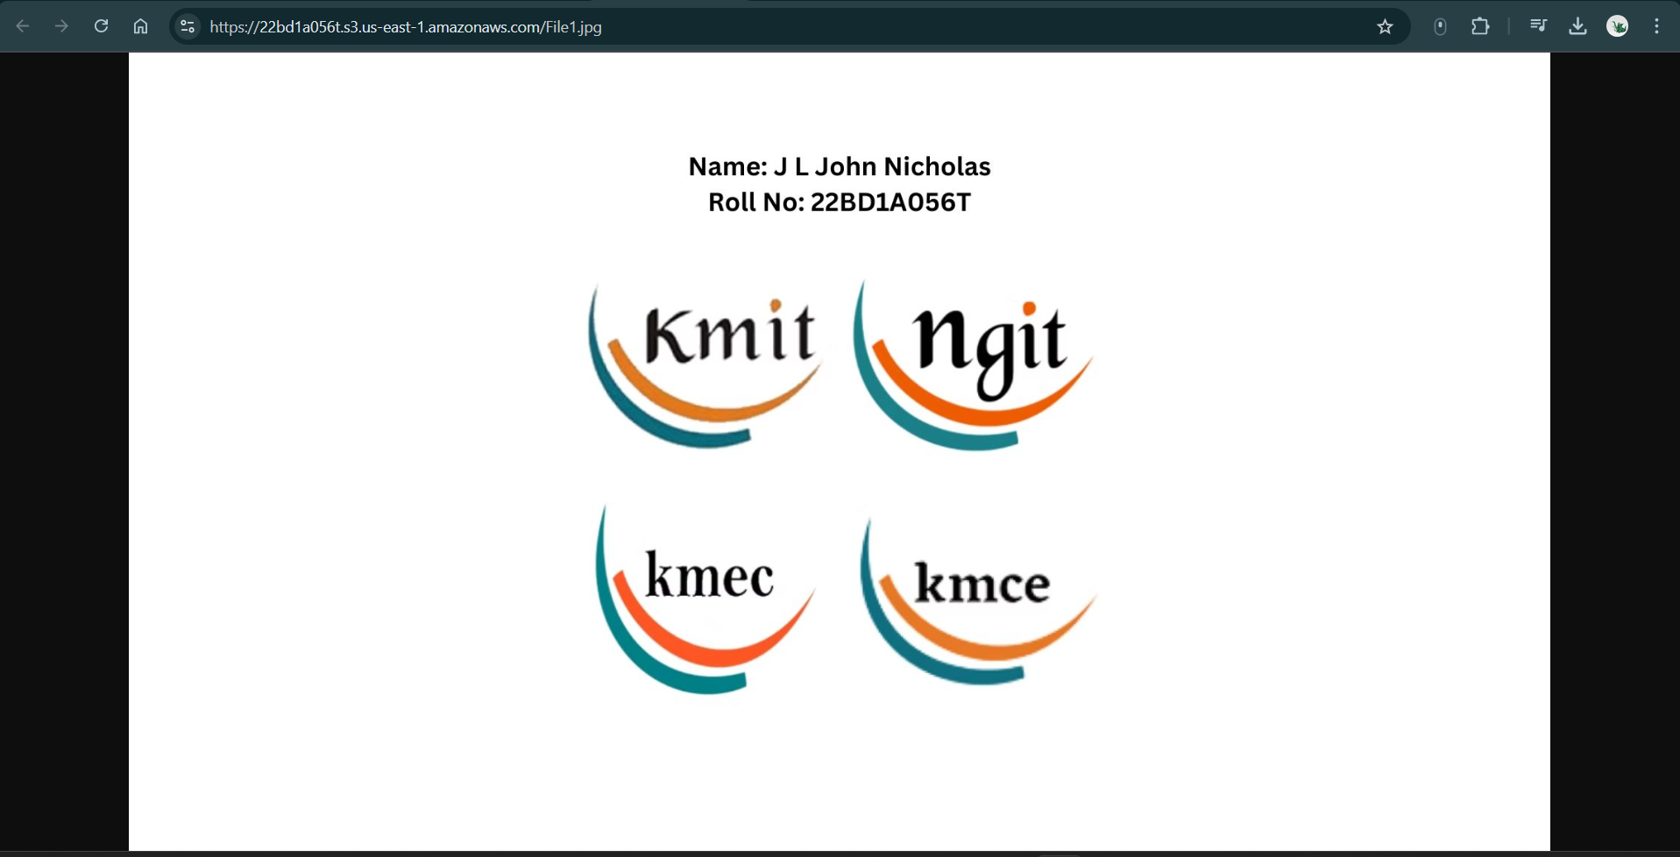

**Figure 2.1.17:** Restored image

Object URL: <https://22bd1a056t.s3.us-east-1.amazonaws.com/File1.jpg>