**Experiment-5:** Creating an Amazon VPC

**Step 1: Open AWS VPC**

* Start your AWS Lab.
* Go to AWS Management Console.
* In the Search Bar, type VPC and select it.

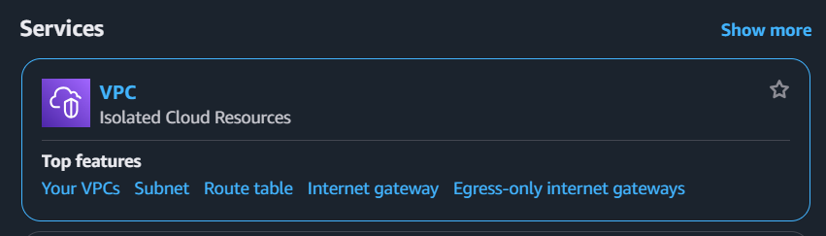

**Fig 5.1: Search for VPC**

**Step 2: Navigate to VPC Dashboard**

* Click on VPC.
* You will be redirected to the VPC Dashboard.

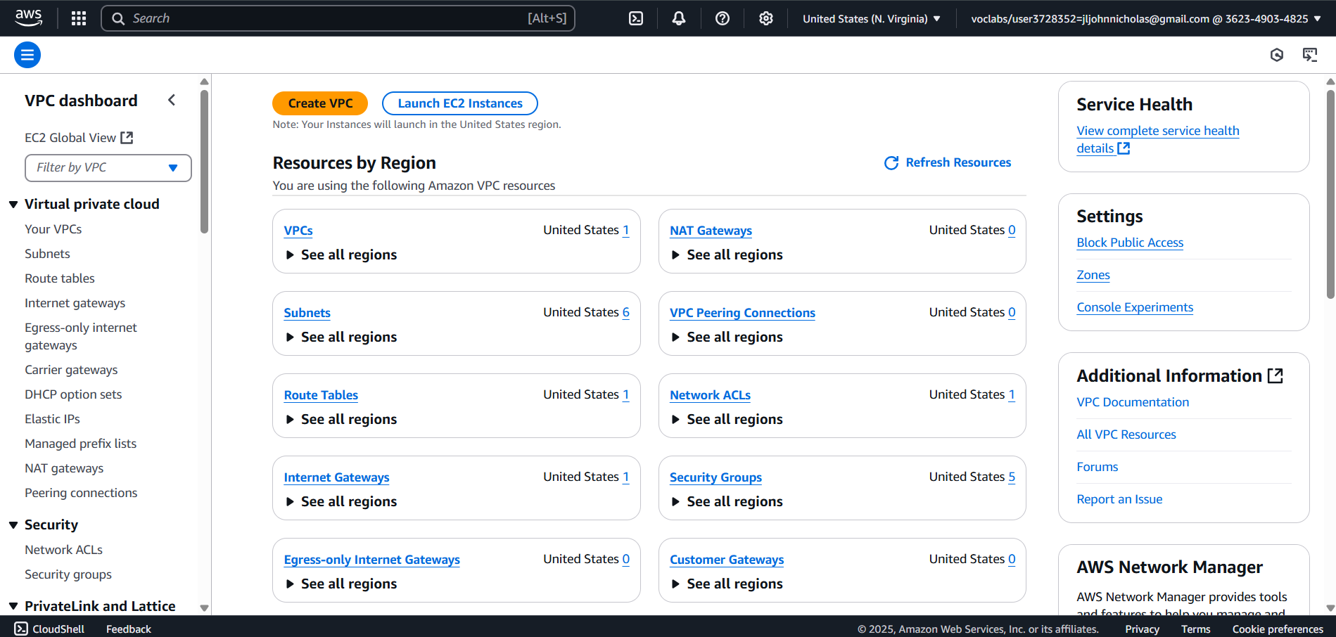

**Fig 5.2: VPC Dashboard**

**Step 3: Create a New VPC**

* Click on Create VPC.

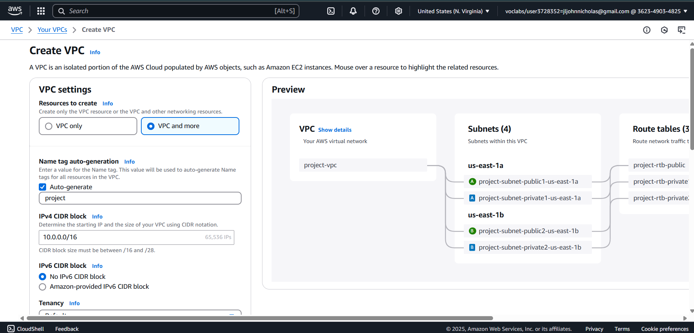

**Fig 5.3: Create VPC**

**VPC Settings:**

* Resources to create → Select "Resources to create".
* Name tag (optional) → Enter Rollno-VPC.
* IPv4 CIDR block → Choose "IPv4 CIDR manual input".
* IPv4 CIDR → Enter 12.0.0.0/16.
* IPv6 CIDR block → Select "No IPv6 CIDR block".
* Tenancy → Keep Default.

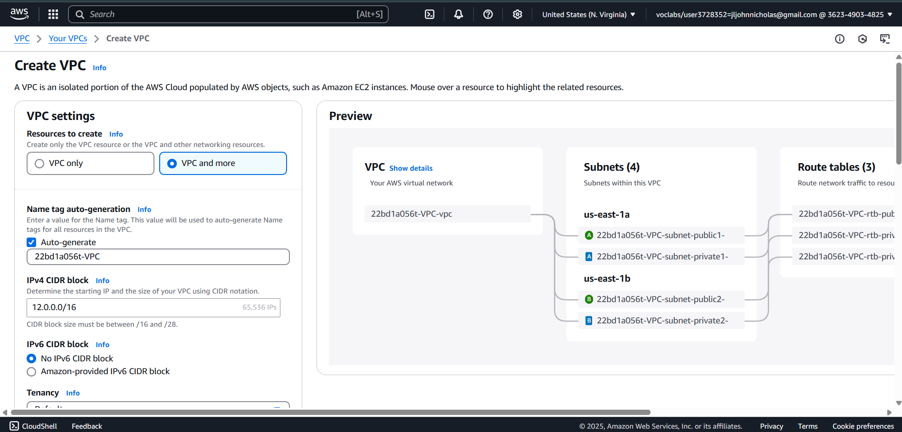

**Fig 5.4: Configure VPC settings**

* Tags →
* Key: Your Name
* Value: Rollno-VPC

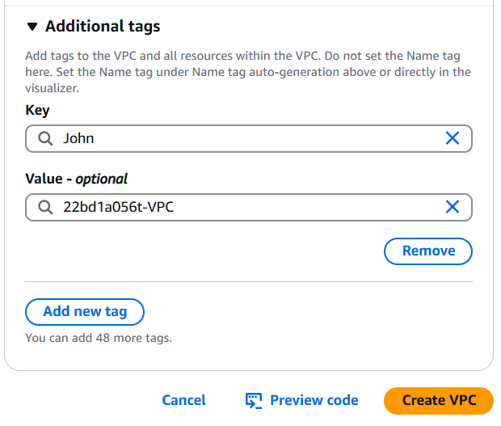

**Fig 5.5: VPC Additional Tags**

* Click Create VPC.

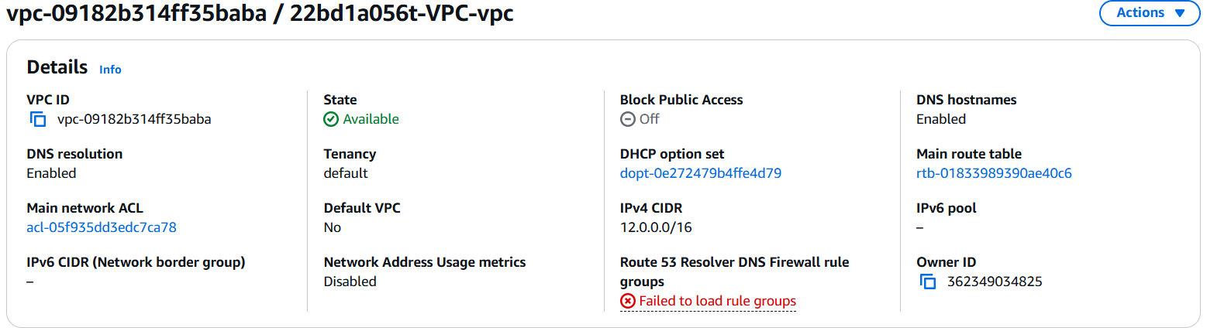

**Fig 5.6: Created VPC**

**Step 4: Create an Internet Gateway (IGW)**

* Click on Internet Gateways (left-side panel).
* Click Create Internet Gateway.

**Internet Gateway Settings:**

* Name tag → Enter Rollno-IG.
* Tags → (Optional, keep Default).
* Click Create Internet Gateway.

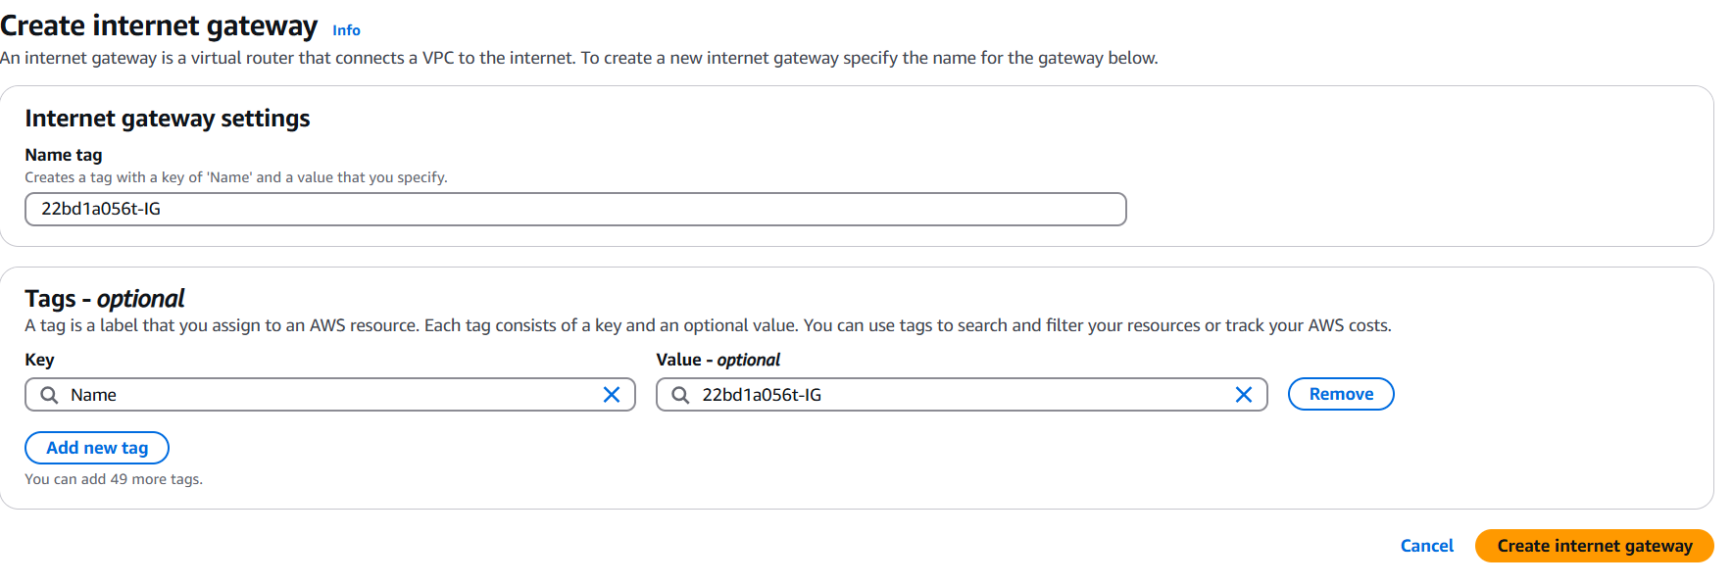

**Fig 5.7: Internet Gateway Settings**

**Attach Internet Gateway to VPC:**

* Select the Internet Gateway you created.
* Click Actions → Attach to VPC.
* Select your VPC created in Step 3.
* Click Attach Internet Gateway.

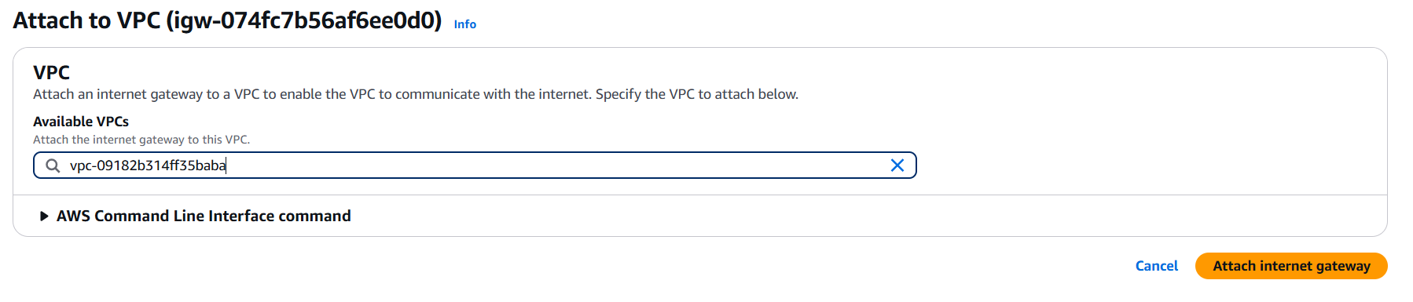

**Fig 5.8: Attach to VPC**

**Step 5: Create Subnets**

* Click on Subnets (left panel) **-->** Click Create Subnet **-->** Select your VPC created earlier.

**Create Public Subnet**

* Subnet name → Rollno-public-SB1.
* Availability Zone → US (N. Virginia) - us-east-1a.
* IPv4 CIDR block → 12.0.0.0/20.
* Keep Default Tags.
* Click Add New Subnet.

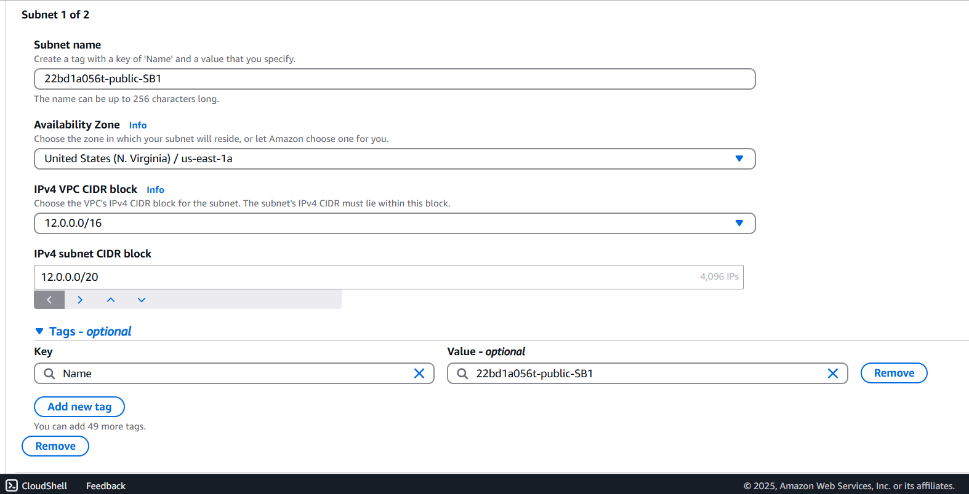

**Fig 5.9: Public subnet**

**Create Private Subnet**

* Subnet name → Rollno-private-SB2.
* Availability Zone → US (N. Virginia) - us-east-1a.
* IPv4 CIDR block → 12.0.16.0/20.

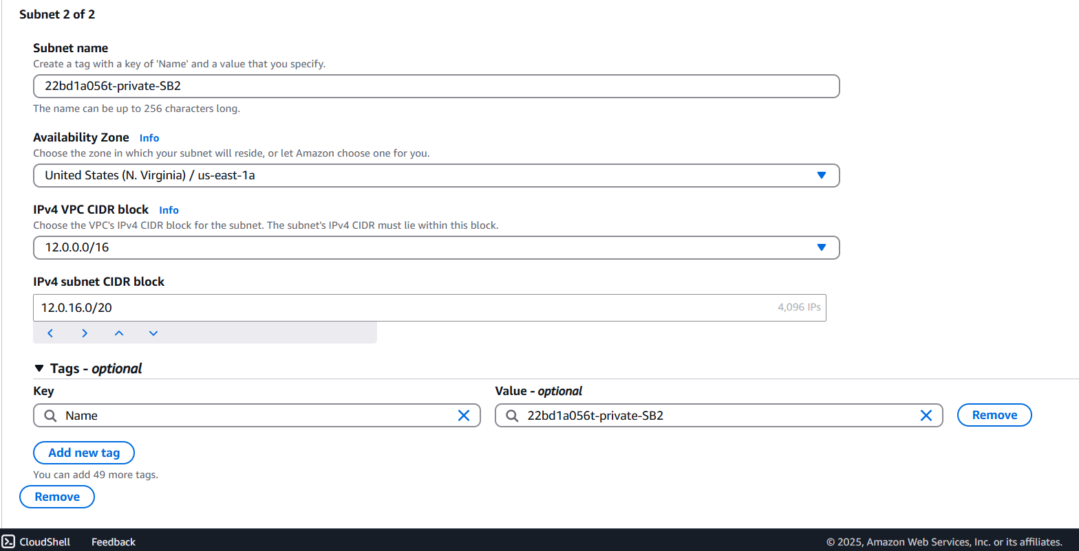

**Fig 5.10: Private subnet**

* Click Create Subnet.

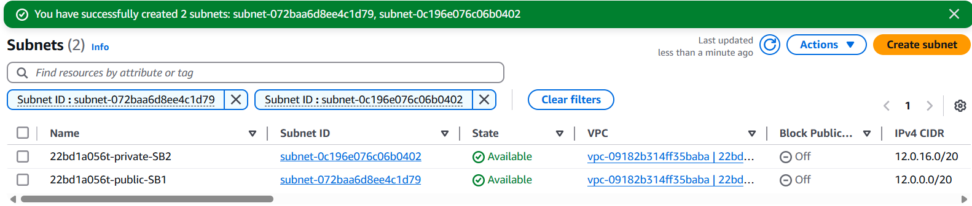

**Fig 5.11: Internet Gateway Settings**

**Step 6: Create a Route Table**

* Click on Route Tables (left panel).
* Click Create Route Table.

**Public Route Table Settings**

* Name → Rollno-Public-RT.
* VPC → Select your VPC created earlier.
* Tags → Keep Default.
* Click Create Route Table.

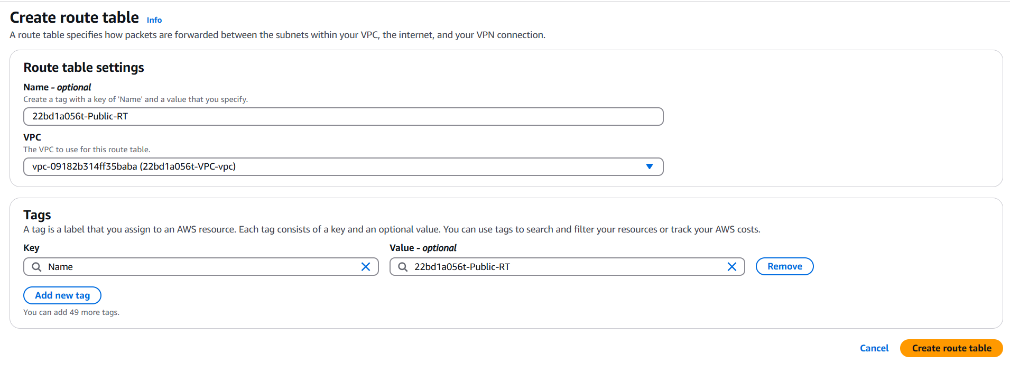

**Fig 5.12: Create public route table**

**Provide Internet Access to Public Route Table**

1. Select the Route Table and click Edit Route.
2. Click Add Route.
3. Destination: 0.0.0.0/0 (Internet).
4. Target: Select Internet Gateway (IGW).
5. Click Save Changes.

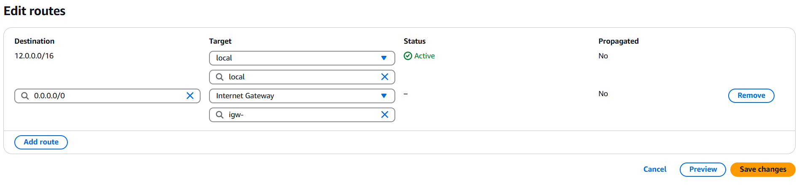

**Fig 5.13: Edit routes**

**Associate Public Subnet with Public Route Table**

* In Route Tables, go to Subnet Association.
* Click Edit Subnet Association.
* Select Rollno-public-SB1 (Checkbox).

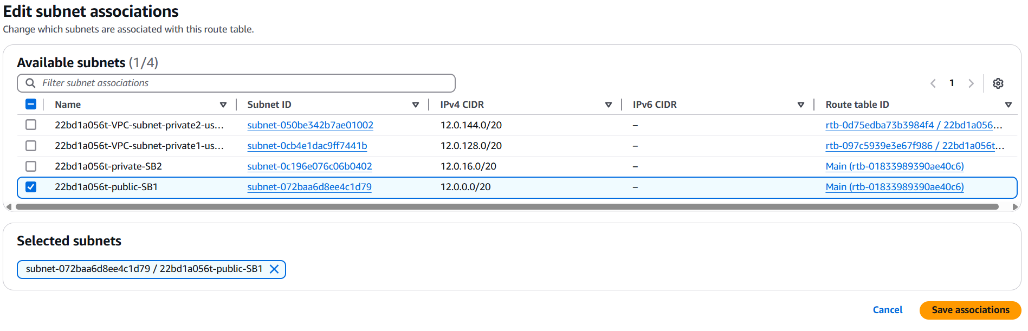

**Fig 5.14: Edit subnet associations**

**Step 7: Create a Private Route Table**

* Click Create Route Table.
* Name → Rollno-private-RT.
* VPC → Select your VPC.
* Click Create Route Table.

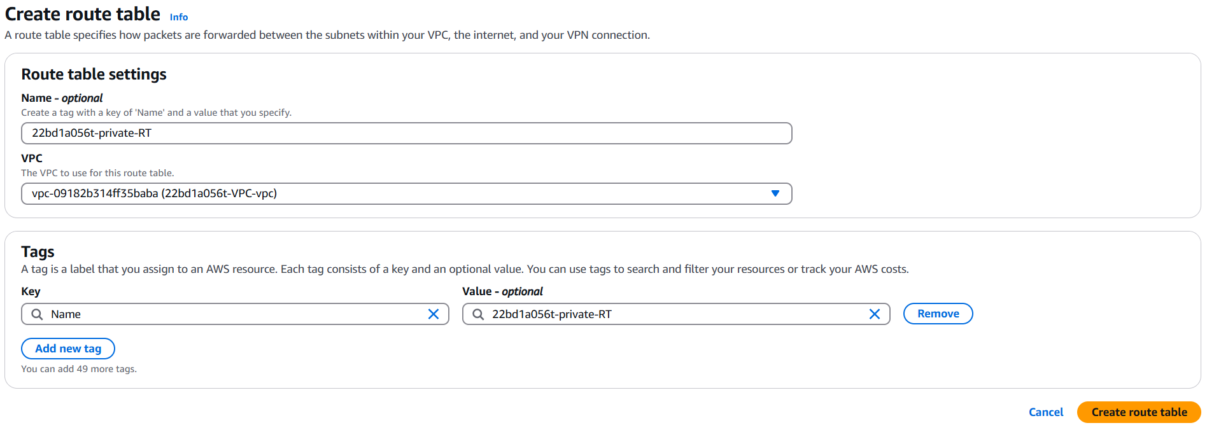

**Fig 5.15: Create private route table**

**Associate Private Subnet with Private Route Table**

* Select Rollno-private-RT.
* Go to Subnet Association.
* Click Edit Subnet Association.
* Select Rollno-private-SB2.
* Click Save Association.

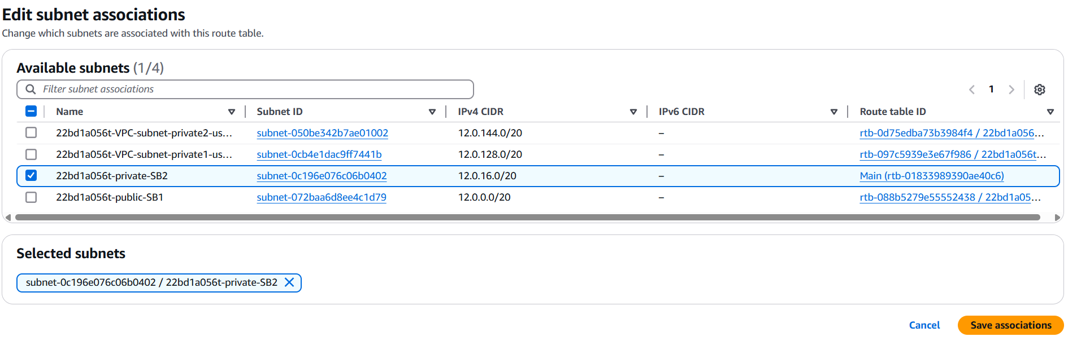

**Fig 5.16: Associate Private Subnet with Private Route Table**

**Step 8: Create a Resource inside the public subnet (EC2)**

1. Navigate to EC2 → Click on Instances.
2. Create a new instance with the following details:
   1. Name: EC1_Rollno_Public_subnet-Instance
   2. OS: Ubuntu
   3. Key Pair: Use an existing PPK file.
3. Edit Network Settings:
   1. VPC: Select the one created earlier (Rollno-VPC).
   2. Subnet: Choose the public subnet (Rollno-public-SB1).
   3. Auto-Assign Public IP: Enable (to assign a public IP).
4. Configure Firewall (Security Group):
   1. Security Group Name: Public-Rollno-ec2-SG
   2. Description: Same as the name.
   3. Rules:
      1. Type: SSH
      2. Protocol: TCP
      3. Port: 22
      4. Source Type: Anywhere (0.0.0.0/0)
5. Launch the Instance.

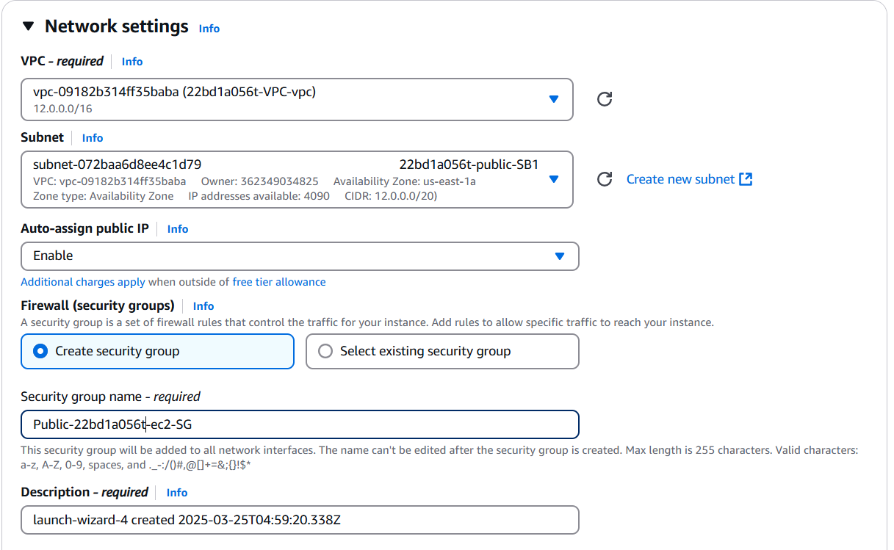

**Fig 5.17: EC2 instance for Public subnet**

1. **Copy the Public IP Address** of the instance.

**Step 9: Connect to the Public Subnet using SSH (Putty)**

1. Use Putty to connect via SSH to the public instance.
2. Steps to follow in the Terminal:
   * Identify the Private Key (PPK file).
3. Once connected, verify by checking the Public Subnet IP (12.0.0.0).

**Step 10: Create an EC2 Instance in the Private Subnet**

1. Create a new instance with the following details:
   * Name: EC2_Rollno_Private_subnet-Instance
2. Edit Network Settings:
   * VPC: Select the one created earlier (Rollno-VPC).
   * Subnet: Choose the private subnet (Rollno-private-SB1).
   * Auto-Assign Public IP: Disable (private instances don’t need public IP).
3. Configure Firewall (Security Group):
   * Security Group Name: Private-Rollno-ec2-SG
   * Description: Same as the name.
   * Rules:
     + Type: SSH
     + Protocol: TCP
     + Port: 22
     + Source Type: Custom (12.0.2.0/24) (Only accessible from the Bastion Host).

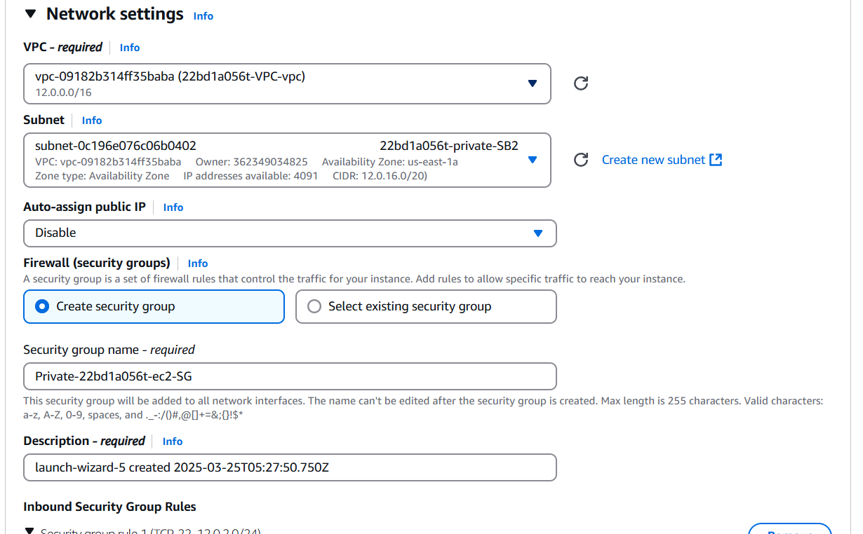

**Fig 5.18: EC2 instance for Private subnet**

1. Storage & Advanced Details: Keep the default settings.
2. Launch the Instance.

**Step 11: Connect Public Subnet (Bastion Host) to Private Subnet**

1. Go to EC2 Instance: EC1_Rollno_Public_subnet-Instance (Bastion Host).
2. Already connected through Putty (Step 9).
3. Create a private key file
4. Copy and Paste the Private Key of your PPK file into aws_privatekey_ec2.pem and save.

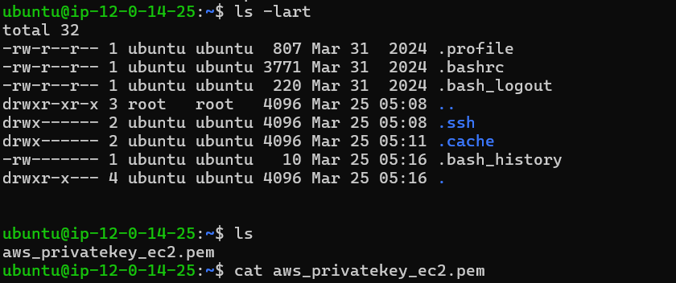

1. Set the correct permissions:



1. Find and copy the Private IP Address of the private instance (EC2_Rollno_Private_subnet-Instance).

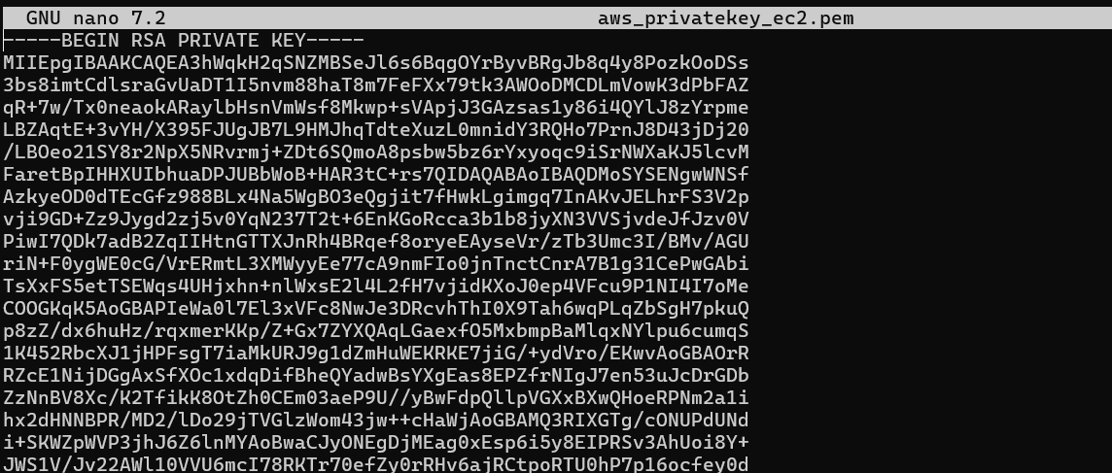

1. Connect from the public instance to the private instance:
2. Confirm the connection by typing "yes" if prompted.
3. Now, you are successfully connected to the private EC2 instance using the Bastion Host.

