- <html> … </html> — The root element. ...
- <head> … </head> — The document head. ...
- <title> … </title> — The page title. ...
- <body> … </body> — The page's content. ...
- <h1> … </h1> — A section heading. ...
  - <h2> … </h2>
  - <h3> … </h3>
  - .<h4> … </h4>
  - <h5> … </h5>
  - <h6> … </h6>
- <p> … </p> — A paragraph. ...
- <a> … </a> — A link. ...
- <img> — An image.
Formatting Tages:

HTML Formatting Elements
Formatting elements were designed to display special types of text:
- <b> - Bold text
- <strong> - Important text
- <i> - Italic text
- <em> - Emphasized text
- <mark> - Marked text
- <small> - Smaller text
- <del> - Deleted text
- <ins> - Inserted text
- <sub> - Subscript text
- <sup> - Superscript text

<!DOCTYPE html>
<html>
<head>
<title>Page Title</title>
<style>
body {background-color: powderblue;}
h1 {color: red;}
p {color: blue;}
</style>
</head>
<body>

<h1>This is a Heading</h1>
<p>This is a paragraph.</p>

<p>The content of the body element is displayed in the browser window.</p>
<p>The content of the title element is displayed in the browser tab, in favorites and in search-engine results.</p>

</body>
</html>

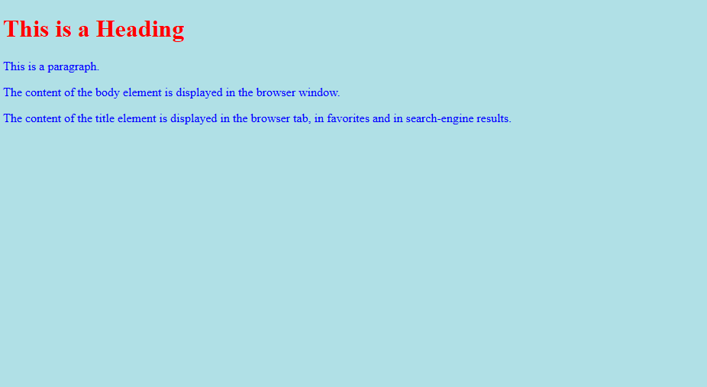

<!DOCTYPE html>
<html>
<body>

<h1 style="background-color:#ff0000;">#ff0000</h1>
<h1 style="background-color:#0000ff;">#0000ff</h1>
<h1 style="background-color:#3cb371;">#3cb371</h1>
<h1 style="background-color:#ee82ee;">#ee82ee</h1>
<h1 style="background-color:#ffa500;">#ffa500</h1>
<h1 style="background-color:#6a5acd;">#6a5acd</h1>

</body>
</html>

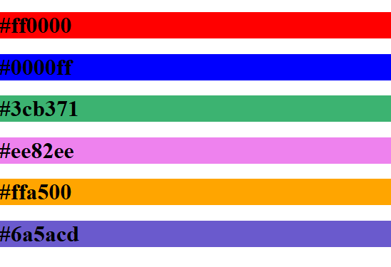

Form TAGS

<!DOCTYPE html>
<html>
<body>

<h2>HTML Forms</h2>

<form action="/action_page.php">
<label for="fname">First name:</label><br>
<input type="text" id="fname" name="fname" value="Mother Theresa"><br>
<label for="lname">Last name:</label><br>
<input type="text" id="lname" name="lname" value="Institution"><br><br>
<input type="submit" value="Submit">
</form>

<p>If you click the "Submit" button, the form-data will be sent to a page called "/action_page.php".</p>

</body>
</html>

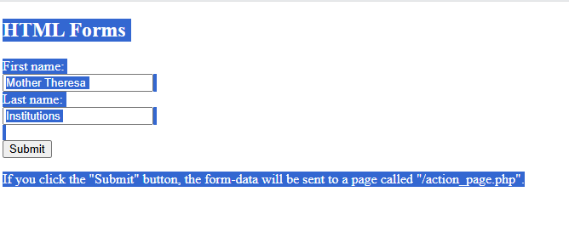

<input type="text"> Displays a single-line text input field
<input type="radio"> Displays a radio button
(for selecting one of many choices)
<input type="checkbox"> Displays a checkbox (for selecting zero or more of many choices)
<input type="submit"> Displays a submit button (for submitting the form)
<input type="button"> Displays a clickable button

<!DOCTYPE html>
<html>
<body>
<h2>Text input fields</h2>
<form>
<label for="fname">First name:</label><br>
<input type="text" id="fname" name="fname" value="Mother"><br>
<label for="lname">Theresa </label><br>
<input type="text" id="lname" name="lname" value="Doe">
</form>

<p>Note that the form itself is not visible.</p>

<p>Also note that the default width of text input fields is 20 characters.</p>

</body>
</html>

