1.
#include <iostream>
using namespace std;

class Student {
string name;
int marks;
public:
Student(string n, int m) {
name = n;
marks = m;
}
void display() {
cout << name << " " << marks << endl;
}
};

int main() {
Student s1("Riya", 90);
s1.display();
}
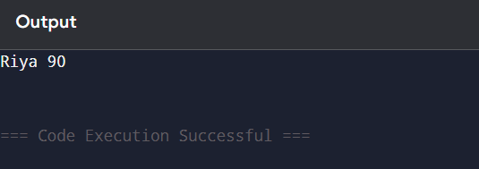

2. #include <iostream>
using namespace std;

class Bank {
double balance;
public:
void setBalance(double b) {
balance = b;
}
double getBalance() {
return balance;
}
};

int main() {
Bank b;
b.setBalance(5000);
cout << b.getBalance();
}
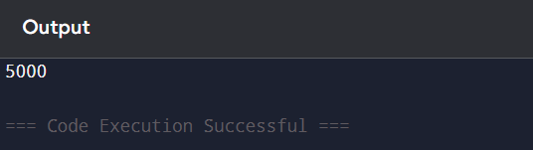

3.
#include <iostream>
using namespace std;

class Animal {
public:
void eat() {
cout << "Eating\n";
}
};

class Dog : public Animal {
public:
void bark() {
cout << "Barking\n";
}
};

int main() {
Dog d;
d.eat();
d.bark();
}
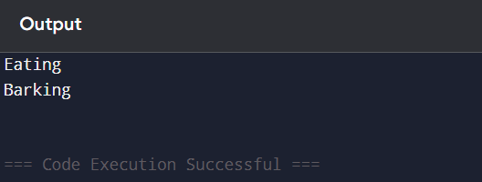

4.
#include <iostream>
using namespace std;

class A {
public:
void showA() {
cout << "Class A\n";
}
};

class B : public A {
public:
void showB() {
cout << "Class B\n";
}
};

class C : public B {
public:
void showC() {
cout << "Class C\n";
}
};

int main() {
C obj;
obj.showA();
obj.showB();
obj.showC();
}
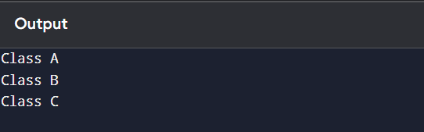
5.
#include <iostream>
using namespace std;

class A {
public:
void showA() {
cout << "A\n";
}
};

class B {
public:
void showB() {
cout << "B\n";
}
};

class C : public A, public B {
};

int main() {
C obj;
obj.showA();
obj.showB();
}
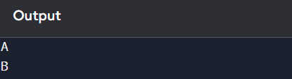
6.
#include <iostream>
using namespace std;

class Math {
public:
int add(int a, int b) {
return a + b;
}
int add(int a, int b, int c) {
return a + b + c;
}
};

int main() {
Math m;
cout << m.add(2,3) << endl;
cout << m.add(2,3,4);
}
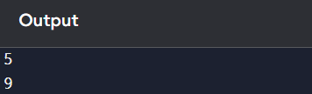
7.
#include <iostream>
using namespace std;

class Complex {
int real, imag;
public:
Complex(int r, int i) {
real = r;
imag = i;
}
Complex operator+(Complex c) {
return Complex(real + c.real, imag + c.imag);
}
void display() {
cout << real << "+" << imag << "i\n";
}
};

int main() {
Complex c1(2,3), c2(4,5);
Complex c3 = c1 + c2;
c3.display();
}
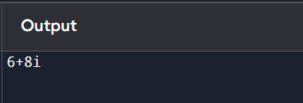
8.
#include <iostream>
using namespace std;

class Base {
public:
virtual void show() {
cout << "Base\n";
}
};

class Derived : public Base {
public:
void show() {
cout << "Derived\n";
}
};

int main() {
Base *b;
Derived d;
b = &d;
b->show();
}
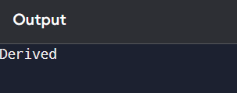
9.
#include <iostream>
using namespace std;

class Shape {
public:
virtual void draw() = 0;
};

class Circle : public Shape {
public:
void draw() {
cout << "Circle\n";
}
};

int main() {
Circle c;
c.draw();
}
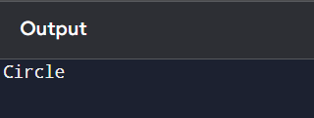
10.
#include <iostream>
using namespace std;

class Test {
int x;
public:
Test(int a) { x = a; }
friend void display(Test t);
};

void display(Test t) {
cout << t.x;
}

int main() {
Test t(10);
display(t);
}
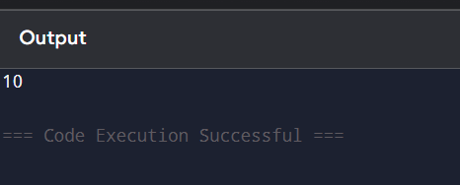
11. #include <iostream>
using namespace std;

class Count {
public:
static int c;
Count() {
c++;
}
};

int Count::c = 0;

int main() {
Count a, b, c;
cout << Count::c;
}
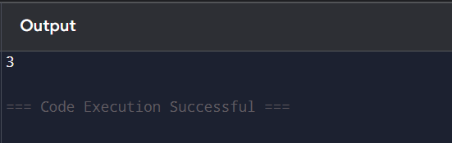
12.
#include <iostream>
using namespace std;

class Count {
public:
static int c;
Count() {
c++;
}
};

int Count::c = 0;

int main() {
Count a, b, c;
cout << Count::c;
}
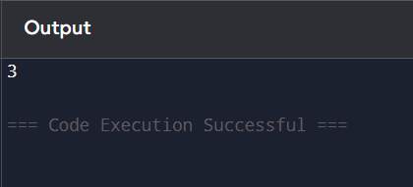
13.
include <iostream>
using namespace std;

class Demo {
public:
Demo() {
cout << "Default\n";
}
Demo(int x) {
cout << x << endl;
}
};

int main() {
Demo d1;
Demo d2(10);
}
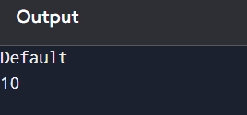
14.
#include <iostream>
using namespace std;

class Test {
public:
~Test() {
cout << "Destroyed\n";
}
};

int main() {
Test t;
}

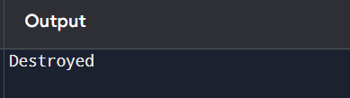
15.
#include <iostream>
using namespace std;

class Demo {
public:
inline int square(int x) {
return x*x;
}
};

int main() {
Demo d;
cout << d.square(5);
}
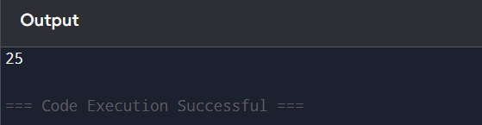
16.
#include <iostream>
using namespace std;

class Test {
int x;
public:
void set(int x) {
this->x = x;
}
void show() {
cout << x;
}
};

int main() {
Test t;
t.set(20);
t.show();
}

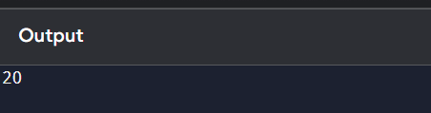
17.
// Aim: Access structure using pointer

#include <iostream>
using namespace std;

struct Student {
int roll;
string name;
};

int main() {
Student s = {101, "rithi
"};
Student *ptr = &s;

cout << "Roll: " << ptr->roll << endl;
cout << "Name: " << ptr->name << endl;

return 0;
}
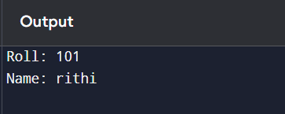
18.
#include <iostream>
using namespace std;

class Address {
public:
string city;
Address(string c) { city = c; }
};

class Person {
Address *addr;
public:
Person(Address *a) {
addr = a;
}
void show() {
cout << addr->city;
}
};

int main() {
Address a("Chennai");
Person p(&a);
p.show();
}
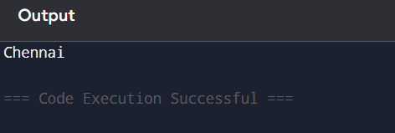
19.
#include <iostream>
using namespace std;

class Engine {
public:
void start() {
cout << "Engine Start\n";
}
};

class Car {
Engine e;
public:
void startCar() {
e.start();
}
};

int main() {
Car c;
c.startCar();
}
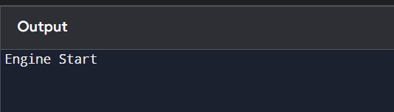
20.
#include <iostream>
using namespace std;

class Parent {
public:
void show() {
cout << "Parent\n";
}
};

class Child : public Parent {
public:
void show() {
cout << "Child\n";
}
};

int main() {
Child c;
c.show();
}
