Linux Lab

Rithik raj /17MIS1171

1:

SL command

Code:

From root user install: sudo apt install sl

And run the command:sl

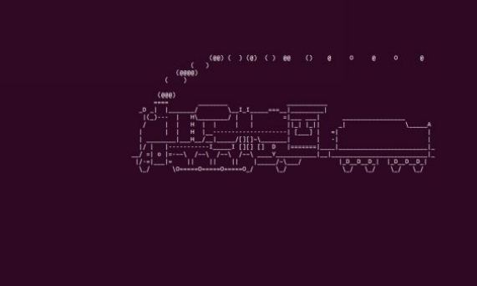

2:

REverse the string: what ever input is given it’ll print in reverse order.

Code: rev

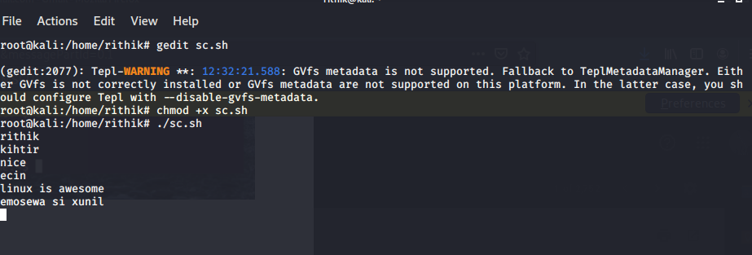

3:vmstat :to check the virtual machine state and condition of cpu

code:vmstat 1200 > vmstat1.data

filename= "/home/srihari/vmstat1.data"

tail -f $filename |

while read $line do

if [ (cat vmstat1.data | grep "swap")>0 ]

then

echo "some rogue process has consumed massive amounts of memory"> swap.txt

fi

if [ (cat vmstat1.data | grep "r")>1 ]

then

echo "some process are waiting to execute"> runqueue.txt

fi

if [ (cat vmstat1.data | grep "cpu")>1000 ]

then

echo "cpu usage is more"> cpu.txt

fi

End

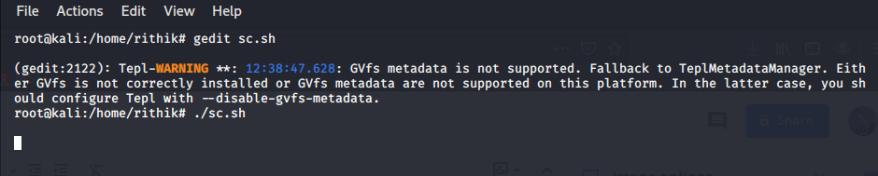

Therefore my system is in good health ,or else there should be an alert message,popping up.

EXPLANATION:

the vmstat 1200 – monitors every 24 hours and puts the data into the vmstat1.data

grep “swap”- the swap should always be zero if its not then some process has consumed massive memory.

That will be monitored in this line

grep “r”- the running queue is constantly above process 1 it indicates the system is slow and some process

is waiting to be executed. That will be monitored here.

Grep “cpu”- it indicates the cpu usage of the system. If the cpu usage is more it will be monitored and will

alert in this line.