## CREATE A CHATBOT IN PYTHON

**Chatbot:**

## Chatbots are conversational tools that perform routine tasks efficiently. It Communicates with users using interactive text or speech capabilities. People like them because they help them get through those tasks quickly so they can focus their attention on high-level, strategic, and engaging activities.

## Phase 4:­­­­

## Development Part2

In this part you will continue building your project. Continue building the chatbot by integrating it into a web app using Flask.

**Step 1:**

**Create a Flask Project**

1. Create a new directory for your Flask project.

2. Inside this directory, create a virtual environment:

**Python code:**

python -m venv venv

source venv/bin/activate # On Windows, use 'venv\Scripts\activate'

3. Install Flask:

**Python code:**

pip install Flask

**Step 2:**

**Create a Basic Flask Web App**

1. Create a file named app.py in your project directory.

2. In app.py, import Flask and create a basic Flask app:

**Python code:**

from flask import Flask, render_template, request

app = Flask(__name)

@app.route('/')

def home():

return render_template('index.html')

if __name__ == '__main__':

app.run(debug=True)

**Step 3:**

**Create HTML Templates**

1. Create a folder named templates in your project directory.

2. Inside the templates folder, create an HTML file named index.html:

**HTML code:**

<!DOCTYPE html>

<html>

<head>

<title>Chatbot</title>

</head>

<body>

<h1>Chatbot</h1>

<div id="chat-box"></div>

<input type="text" id="user-input" placeholder="Type your message">

<button id="send-button">Send</button>

<script src="static/chatbot.js"></script>

</body>

</html>

**Step 4:**

**Create JavaScript for Chatbot**

1. Create a folder named static in your project directory.

2. Inside the static folder, create a JavaScript file named chatbot.js. This file will handle user input and responses from the chatbot.

**JavaScript code**

// chatbot.js

const chatBox = document.getElementById('chat-box');

const userInput = document.getElementById('user-input');

const sendButton = document.getElementById('send-button');

sendButton.addEventListener('click', () => {

const userMessage = userInput.value;

chatBox.innerHTML += `<p>User: ${userMessage}</p>`;

// Send user message to the server for processing

fetch('/chat', {

method: 'POST',

body: JSON.stringify({ userMessage }),

headers: {

'Content-Type': 'application/json',

},

})

.then(response => response.json())

.then(data => {

const chatbotMessage = data.chatbotMessage;

chatBox.innerHTML += `<p>Chatbot: ${chatbotMessage}</p>`;

});

userInput.value = '';

});

**Step 5:**

**Implement Chatbot Logic in Flask**

1. In app.py, add a new route to handle user messages and return chatbot responses.

**Python code:**

import json

# Import your chatbot implementation here

@app.route('/chat', methods=['POST'])

def chat():

data = json.loads(request.data)

user_message = data['userMessage']

# Implement your chatbot logic here

chatbot_response = get_chatbot_response(user_message)

return json.dumps({'chatbotMessage': chatbot_response})

2. Implement the get_chatbot_response function using your existing chatbot logic. This function should take a user message as input and return the chatbot's response.

**Step 6:**

**Run Your Flask App**

1.Run your Flask app using the following command:

**Python Code:**

**python app.py**

2**.** Access your chatbot web app by opening a web browser and navigating to http://localhost:5000.

Our chatbot is now integrated into a Flask web app. Users can interact with it through the web interface. Make sure you adapt the chatbot logic and responses to suit your specific use case and chatbot implementation. You can also enhance the web interface to make it more interactive and visually appealing

**PROGRAM FOR CHATBOT DEVELOPMENT:**

import random

def chatbot_response(msg):

user_message = msg.lower()

if 'hi' in user_message or 'hello' in user_message:

return "Hello! How can I help you today?"

elif 'how are you' in user_message:

return "I'm doing great, thank you! How can I help you today?"

elif 'what is your name' in user_message:

return "I'm a chatbot, you can call me anything you like!"

elif 'who are you' in user_message:

return "I'm a chatbot, here to help you with any questions you have!"

elif 'bye' in user_message or 'goodbye' in user_message:

return "Goodbye! Have a great day!"

elif 'thanks' in user_message or 'thank you' in user_message:

return "You're welcome! If you have any other questions, feel free to ask!"

elif 'what' or 'how' or 'why' or 'where' or 'when' in user_message:

return "I'm not sure about that, but I can try to help you find the answer!"

else:

return "I'm not sure how to respond to that. If you have any other questions, feel free to ask!"

def chatbot():

print("Hi! I'm a chatbot and I'm here to help you with any questions you have!")

while True:

user_message = input("You: ")

if user_message == "quit":

break

response = chatbot_response (user_message)

print("Chatbot: " + response)

chatbot ()

**SAMPLE OUTPUT FOR CHATBOT:**

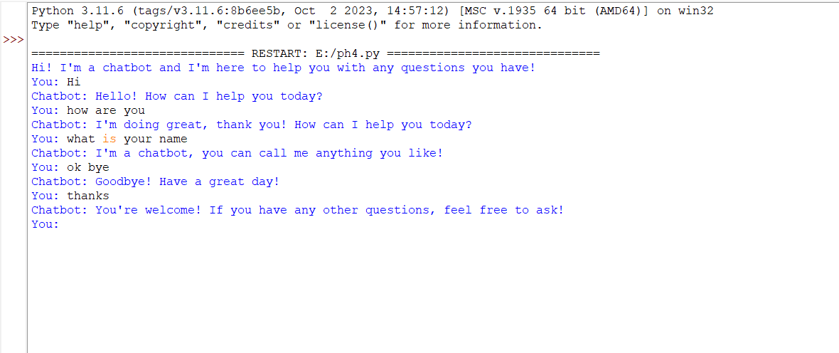

**Architectural Diagram in Chatbot:**

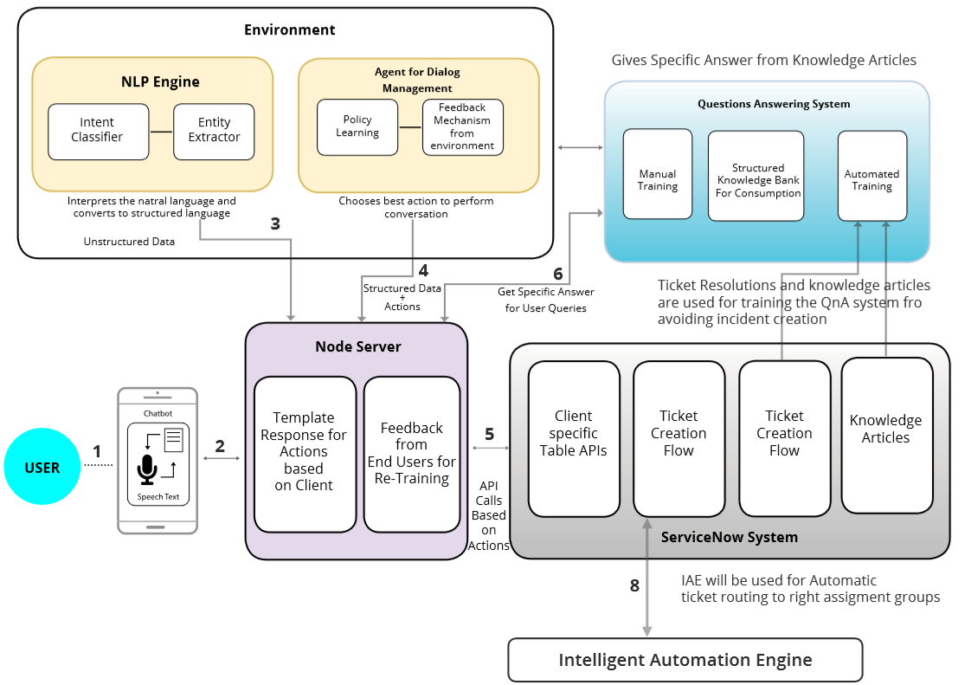

**Fig 1.1 Architectural design in chatbot**

**By:**

**Rithik Roshan B**

**912421104033**