QuantiFi 2026, Team 21
Find the structure, prove it out of sample, then trade it
Team members: Michael Xu, Rithik Singh, Selena Zhang, Jeffery Hu
PnL, days −2 to 0 | Products traded | Distinct strategies | Sharpe ratio (per day) | Profit factor | Winning 1,000 tick blocks
487,376 | 26 of 26 | 10 | 8.2 | 10.8 | 30 of 30

Summary. We were given raw order books and anonymous trades, nothing else. Every strategy in our trader is built on a structural feature we found in that data (a hidden pricing rule, a volatility smile, a mean reverting anchor, a post jump drift) and was kept only if it stayed profitable on a day it had not been tuned on. Our guiding trade off: earn the spread rather than pay it, and cross the spread only where the expected move dwarfs it. Nine of our ten strategies are profitable on every training day; the tenth is the LYCHEE hedge, whose job is to offset risk rather than earn. Each strategy also carries a guard that switches it to plain market making if the pattern it relies on stops holding on the scoring day.
1. How we worked: independent silos first, shared methods last
We organised the team the way a multi manager hedge fund organises its pods. Each of us owned a set of products and worked alone, with our own notebooks, our own branch of the code and our own decision log, and we deliberately held back from discussing strategy ideas until late in the competition. The aim was to avoid group think: if everyone studies the same first chart, everyone builds the same strategy, and the team ends up testing one idea several times. Working apart, we reached genuinely different answers for the same products. For TELLURIUM one of us built an informed flow market maker with a glide after large jumps, while another independently built the bipower variation jump detector we use now. For the vouchers one approach priced each strike off its own slow implied volatility and the other fitted a smile across all strikes.
Only once each silo had a tested strategy did we pool our work. We ran every teammate's complete file through the same backtester, compared PnL product by product and day by day, and kept the better approach for each product. The shared methods mattered as much as the strategies: one of us brought the leave one day out protocol, another the overlap corrected statistics, another the synthetic stress days, and applying everyone's tests to everyone's strategies is where our largest improvements came from (Figure 1). The merge also exposed mistakes no single silo could see, such as a voucher signal that read the market trade feed and cost about 30k on the official engine.
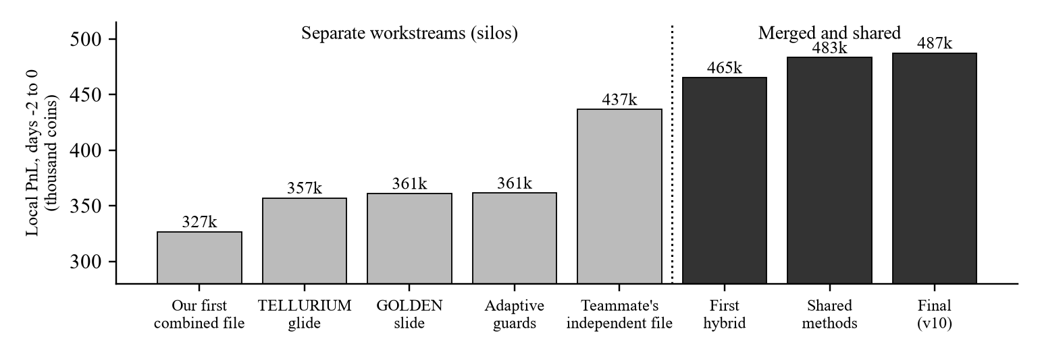
Figure 1. Local PnL of successive versions of our trader. Grey bars were built inside separate workstreams; black bars came after we merged and shared methods.
2. Data, a calibrated simulator, and how we validated
Each training day provides a three level order book snapshot for every product at 10,000 ticks and an anonymous list of bot trades. Before designing strategies we rebuilt the backtester locally so every idea could be scored offline. The one ambiguity in the rules was whether a resting order fills for its full size or only up to the size of the bot trade that crosses it; for the organisers' example trader the two readings differ nineteen fold. The example trader scored 1,613 on the portal, exactly our capped fill prediction (527, 608 and 478 by day). Later, one version scored 7% below our replica; the portal's per product view put the whole gap in the vouchers, and we traced it to the one feature that read the market trade feed, which the official engine delivers differently. We removed that dependency and the two engines now agree.
A microstructure finding that shaped every market maker. Outside TELLURIUM, every bot trade prints exactly at the best bid or best ask, and a resting order fills whenever a trade prints at or through its price. Improving the best price by a tick therefore wins no extra fills and only gives away a coin on every fill. The usual trade off between quote price and fill probability (Hollifield, Miller and Sandås, 2004) does not exist here, so all our passive quotes join the touch, which raised profit on every market made product on every day.
Validation protocol. (i) Leave one day out: tune on two days, score on the third. (ii) Neighbourhood robustness: a setting is accepted only if nearby settings are also profitable on every day. (iii) The Probability of Backtest Overfitting (PBO), estimated by combinatorially symmetric cross validation on six half day blocks (Bailey et al., 2017). (iv) Honest statistics: overlapping windows inflated naive t statistics by 4 to 30 times, so every predictive claim was retested with Newey and West errors on non overlapping windows, and 1,144 lead lag tests were corrected with the Benjamini and Hochberg procedure. This mattered early: one market making grid earned 51k on its tuning days and only 7k on unseen days. Our final search scored 361 settings across eight strategies and adopted a change only if it beat the current setting on the held out day in all three rotations; three changes passed (TOFFEE_CAKE, PINK_PEARLS, PAPER_LANTERNS).
Code design. One Trader class runs the ten strategies in independent blocks, so an error in one can never stop the others trading. All memory between ticks lives in traderData as compact JSON of about 2,000 characters. The file uses only the Python standard library, runs in about 0.5 ms per tick, and sizes every order inside the position limits, so no order is ever rejected.
3. Strategy map
Products | Strategy | Structural edge it exploits | Day −2 | Day −1 | Day 0 | Total
10 LYCHEE vouchers | 1. Volatility smile relative value | Strikes that stray from the fitted smile snap back | 72.4k | 56.4k | 61.0k | 189.8k
LYCHEE | 2. Market making leaning to the delta hedge | Offsets part of the vouchers' exposure to the underlying | 1.0k | −2.3k | 0.5k | −0.8k
TELLURIUM | 3. Post jump drift | After a confirmed jump the drift persists about 250 ticks | 28.2k | 41.6k | 33.8k | 103.7k
TOFFEE_CAKE | 4. Anchored market making | Price keeps reverting to about 5,000 | 27.0k | 28.1k | 25.6k | 80.7k
PAPER_LANTERNS | 5. Trend aware market making | Noisy price around a slowly trending value | 20.5k | 20.2k | 19.4k | 60.1k
PINK_PEARLS | 6. Relative value off a hidden rule | The five pearls sum to 50,000 and PINK corrects deviations | 9.9k | 9.0k | 9.2k | 28.1k
FRUIT_BASKET and fruits | 7. Hedged basket arbitrage | Basket = 2 DRAGONFRUIT + 3 GRANADILLA + 1 MANGOSTEEN | 1.6k | 5.3k | 1.0k | 7.9k
GOLDEN_PEARLS | 8. Plateau market making | Price sits on flat levels that occasionally step | 0.2k | 2.0k | 2.9k | 5.0k
AMETHYST | 9. Fixed value market making | Price never leaves 10,000 | 0.5k | 0.6k | 0.5k | 1.6k
JELLY, PEANUT_BUTTER, WHITE, BLACK, BLUE | 10. Small market making, tight inventory caps | Spread capture on random walk products, sized for breadth | 2.7k | 7.8k | 0.8k | 11.3k
All 26 products |  |  | 163.9k | 168.6k | 154.8k | 487.4k

The vouchers (39%) and TELLURIUM (21%) earn about 60% of PnL, both from structural rather than fitted edges; TOFFEE_CAKE and PAPER_LANTERNS add another 29%.
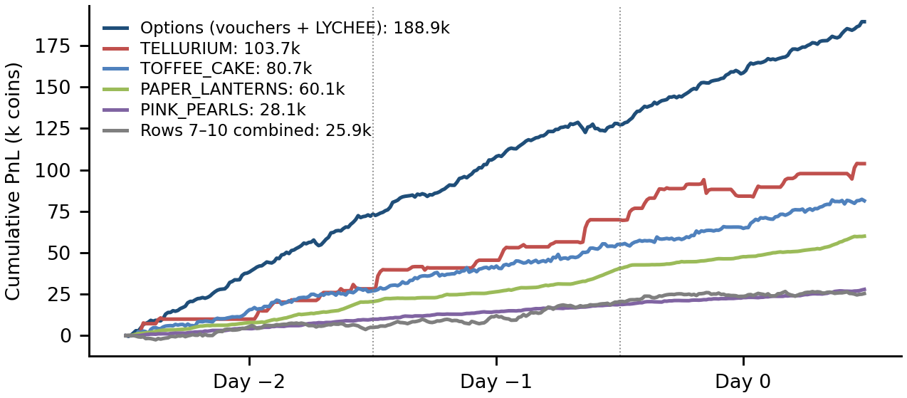
Figure 2. Cumulative PnL of the final trader over the three training days (local replica, official fill rule). The grey line combines the four smallest strategies; every line is profitable on every day.
4. The core strategies
4.1 Options: trading the volatility smile
Every tick we invert Black and Scholes to get each voucher's implied volatility, fit a vega weighted quadratic smile in log moneyness, smooth its coefficients over about 50 ticks, and price each voucher off the curve. Vouchers above the smile are sold and vouchers below it are bought, quoting at the touch at least 2 coins from fair and taking any quote 3 or more coins through it. We work in total volatility (σ√T), so the code never needs the time to expiry and cannot break if the scoring day is not the one we expect. LYCHEE quotes lean toward the book's delta hedge position. All nine quote settings we tried were profitable in every half day block, and their PBO of 0.35 says the edge comes from the smile itself rather than the parameters, so we use one setting for all strikes instead of tuning each one.
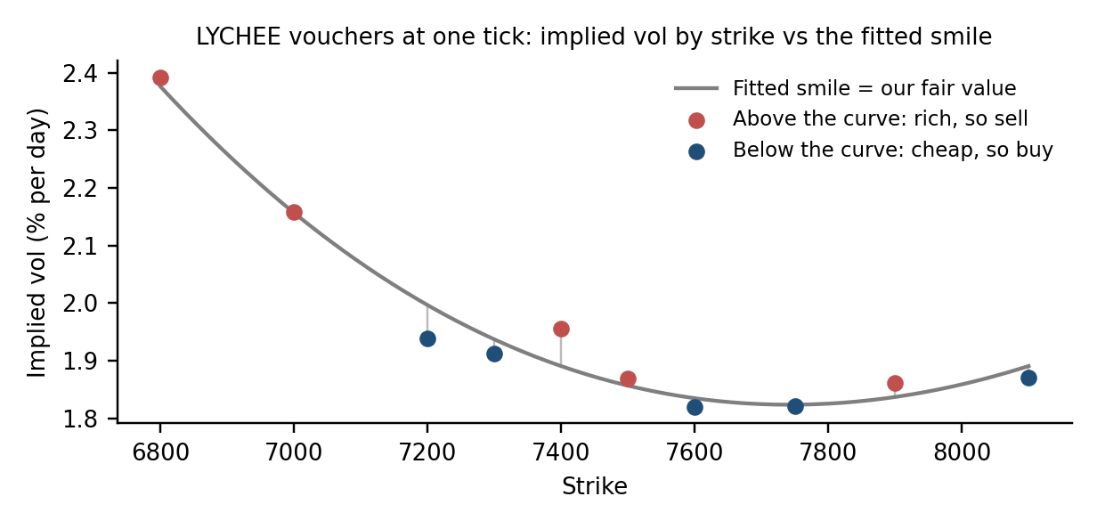
Figure 3. The voucher smile at one tick. Strikes above the fitted curve are rich and sold; strikes below it are cheap and bought.
4.2 Pearls: a hidden conservation rule, and a detector in case it moves
The five pearl prices always sum to about 50,000, with a standard deviation of only about 5 coins. When the sum drifts, PINK is the pearl that corrects it, closing 59 to 73% of a deviation within 50 ticks; the other four barely respond. We price PINK as its mid minus 80% of the sum's deviation from 50,000 and quote at the touch around that value. With the signal off PINK earns roughly nothing; with it, 9 to 10k every day. GOLDEN sits on plateaus that occasionally step down, and we quote around the current plateau.
We then asked what happens if a different pearl takes over the correcting role on the scoring day. The final trader measures, from past data only, each pearl's slope of its 20 tick change on the sum deviation 20 ticks earlier. On the training days PINK's slope is between −0.35 and −0.41 on every day while every other pearl lies between −0.07 and +0.09, so the signal goes to whichever pearl is below −0.25, the current corrector keeps the role while its slope stays below −0.1, and if no pearl qualifies all five fall back to plain market making. On the real days this changes nothing. When we moved the role to BLACK, BLUE or WHITE in the data, the pearls earned 34.3k, 32.2k and 15.8k, against 4.1k, −11.1k and −14.5k for a fixed PINK rule. A first version without the hysteresis switched too eagerly and lost 14k on the real days, so it was rejected.
4.3 TELLURIUM: confirm the jump, then ride the drift
TELLURIUM's trade flow is strongly informed: after a buyer initiated trade the price is about 13 coins higher 20 ticks later than after a seller initiated one, so plain market making earns only about 3k a day after adverse selection. Instead we trade only after jumps. A jump is a three tick move larger than 5.5 times local volatility, where local volatility comes from bipower variation so the jump does not inflate its own benchmark (Barndorff-Nielsen and Shephard, 2006; Lee and Mykland, 2008). We wait 20 ticks and trade the direction of the drift between ticks 3 and 20, which is right 84% of the time over the next 230 ticks (+80 coins on average), and hold the full position to tick 250. Beyond that the drift is a coin flip, so a 35k in sample gain from holding longer was rejected. Volatility multipliers of 5 and 6 perform alike, and the PBO is 0.00.
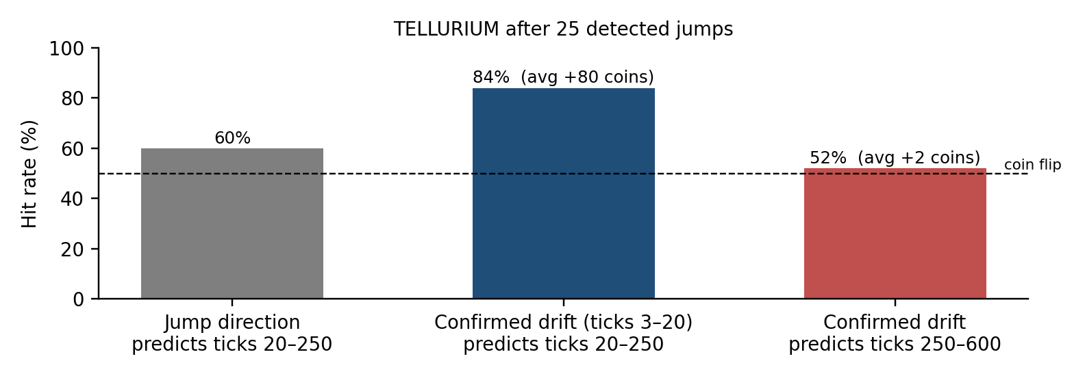
Figure 4. TELLURIUM around 25 detected jumps. The confirmed drift predicts the next 230 ticks; the jump's own direction barely does.
4.4 TOFFEE_CAKE, PAPER_LANTERNS and the basket
TOFFEE_CAKE reverts to about 5,000 with a half life of roughly 70 ticks, and its trade flow is contrarian. We market make around 60% of a fast moving average and 40% of a slowly adapting anchor at 5,000, take quotes 9 or more coins through fair, and skew quotes against inventory; all 27 neighbouring settings were profitable on every day. PAPER_LANTERNS flips tick to tick around a slowly trending value, so we quote around a moving average projected 100 ticks along its own slope (all 27 neighbours profitable on every day). The basket premium over 2 DRAGONFRUIT + 3 GRANADILLA + 1 MANGOSTEEN wanders, so mean reversion to a moving average failed; what works is a small position proportional to the premium's distance from zero, fully hedged with the fruits. Unhedged versions lost up to 40k.
5. Inside the code: the market making engine and the exact rules
Our engine is an inventory aware market maker that one of us first built for an earlier university algorithmic trading competition, rewritten for this engine. Every tick, for every product, it runs five steps. (1) Fair value from the product's own rule. (2) Room: buy room = limit − position and sell room = limit + position, and every order below is sized from it, so no limit can be breached. (3) Take every quote at least take coins through fair. (4) Inventory skew: reservation price r = fair − skew × (position − target) / cap, the reservation price idea of Avellaneda and Stoikov (2008); the target is zero, or the delta hedge for LYCHEE. (5) Quote at bid = min(best bid, floor(r − edge)) and ask = max(best ask, ceil(r + edge)), never crossing the book.
Component | Rule, as implemented
Option pricing | Black and Scholes with zero rates in total volatility v: C = S·N(d₁) − K·N(d₁ − v), d₁ = (ln(S/K) + v²/2)/v. Implied v by 40 step bisection; strikes with under 0.25 coins of time value are skipped.
Smile fit | v(m) = a + b·m + c·m², m = ln(K/S), least squares weighted by vega; coefficients smoothed over 50 ticks.
Delta hedge | Book delta = Σ position × N(d₁). LYCHEE's target is minus that delta within a 40 unit cap; the skew pulls quotes toward it.
PINK_PEARLS | fair = mid − 0.8 × (sum of pearl mids − 50,000); off if a 200 tick average of the deviation exceeds 40. The role moves to another pearl if the detector in 4.2 says so.
TELLURIUM | Jump = 3 tick move > 5.5 × √(3 × bipower variance). At tick 20 take ±40 units in the direction of the drift since tick 3; close at tick 250. Guard: skip new trades while fewer than 3 of the last 6 paper traded signals won.
GOLDEN_PEARLS | Plateau = running average while the mid stays within 3 coins. A 3 to 15 coin move is a slide, ridden with 20 units until 8 ticks pass without a new extreme.
TOFFEE_CAKE | fair = 0.6 × EMA₅(mid) + 0.4 × anchor; anchor is 5,000 unless a 2,000 tick average has moved more than 20 away. Take at 9, quote 2 from fair.
PAPER_LANTERNS | fair = EMA₁₅(mid) + 100 × slope, slope = average per tick change of that average over 50 ticks.
Basket | Target = −clip(premium / 1,000, −1, 1) × 13 baskets; each fruit held at −weight × basket position; trade only when the target moves by 4.
JELLY, PEANUT_BUTTER | fair = 5 tick average; join the best bid only if below fair and position < 2.5, the best ask only if above fair and position > −2.5; 5 units per quote.

6. Robustness: two complementary stress simulators
Day 1 is unseen, so we stress tested the trader in two independent ways. Edited real days change one structural fact at a time in the real data (TOFFEE_CAKE's centre, the pearl sum and which pearl corrects it, TELLURIUM's post jump drift, the implied volatility level, overall volatility, spread width, mirrored prices and reshuffled 2,500 tick blocks), which keeps the real order book shapes and trade flow. Fully synthetic days come from a generative model fitted to each product's mechanism (a mean reverting TOFFEE_CAKE, segmented PAPER_LANTERNS trends, TELLURIUM jumps replayed from the 28 real jump shapes, the pearl sum rule, the basket identity, a voucher smile with per strike wobble) and start where day 0 ended, as day 1 will. Each guard was judged on how much loss it prevented in these cases, not on PnL from the real days. The design draws on what we read: block resampling that keeps short range dependence (Politis and Romano, 1994), the stylised facts a realistic synthetic market should reproduce (Cont, 2001), regime switching and change detection for the guards (Hamilton, 1989; Page, 1954), and the upward bias in the best of many backtests (Bailey and López de Prado, 2014).
Assumption that could break | Guard in the final trader | Stress case | Without guard | With guard
PINK corrects the 50,000 pearl sum | Online corrector detector (4.2) | Role moved to BLACK, BLUE, WHITE | 4.1k, −11.1k, −14.5k | 34.3k, 32.2k, 15.8k
TELLURIUM drifts after a jump | Pause while fewer than 3 of the last 6 signals won | Drift reverses after every jump | −101.7k | −59.4k
The pearls sum to 50,000 | Signal off if the sum drifts more than 40 away | Sum moved to 50,100 | trades a broken rule | plain market making
TOFFEE_CAKE reverts to 5,000 | Anchor adapts once more than 20 away | Centre moved to 5,050 | fights the new level | follows the new centre
JELLY, PEANUT_BUTTER have no edge | Tiny caps, quote only beyond fair | 7 cases (volatility, spread, mirror, reshuffle) | older quoter | better in all 7

Monte Carlo results on fully synthetic days. Ten fresh days were simulated, each starting where day 0 ended, with the final trader run unchanged. The trader made money on every simulated day, and each core strategy kept 71% to 105% of its in sample daily PnL. The weakest result is the sleeve of small market makers, which lost on 4 of 10 days and kept 26%; it is sized small for breadth precisely because it has no edge. TELLURIUM keeps 71%, consistent with its dependence on how many jumps a day brings.
Strategy (simulated) | Mean per day | Std. dev. | Worst 5% | Worst day | Winning days | Sharpe per day | Kept of in sample
Whole trader | 144.7k | 17.6k | 120.6k | 114.6k | 10 of 10 | 8.2 | 89%
Vouchers | 59.9k | 7.4k | 48.7k | 46.8k | 10 of 10 | 8.1 | 95%
TOFFEE_CAKE | 25.6k | 4.3k | 20.0k | 19.3k | 10 of 10 | 6.0 | 95%
TELLURIUM | 24.5k | 7.8k | 16.5k | 14.9k | 10 of 10 | 3.1 | 71%
PAPER_LANTERNS | 20.9k | 3.9k | 15.1k | 13.6k | 10 of 10 | 5.4 | 104%
AMETHYST, GOLDEN, PINK | 12.2k | 3.9k | 8.6k | 8.5k | 10 of 10 | 3.1 | 105%
Other 10 small market makers | 1.6k | 3.6k | −0.9k | −1.2k | 6 of 10 | 0.5 | 26%

Across the ten days the trader made 2,826 fills a day; the median intraday drawdown was 5.1k and the worst 9.7k, and because no day lost money the cumulative PnL never fell below a previous peak. Our fill stress is Monte Carlo too: dropping a random 5% or 50% of passive fills barely moves the taking based edges, while TELLURIUM and the options book are the most fill sensitive. Machine learning was tested honestly against simple models: gradient boosted trees on 13 order book and flow features lost to linear regression in 14 of 16 out of sample tests, and a linear model explains 43% of PAPER_LANTERNS' next 10 tick move but almost nothing for most other products, so we kept transparent rules and used the models to confirm where predictability exists.
7. Risk adjusted performance, trade offs and risks
On the three real days, returns are PnL over 1,000 tick blocks (30 in total) with a zero risk free rate; Sharpe and Sortino are scaled to one day by √10, the profit factor uses 100 tick intervals, and drawdown is the largest fall within a day. "No losing block" means the Sortino ratio is unbounded because no block lost money.
Strategy family | Sharpe (per day) | Sortino (per day) | Profit factor | Max drawdown | Winning blocks
Whole trader | 8.2 | no losing block | 10.8 | 7.3k | 30 of 30
Options | 7.9 | no losing block | 5.9 | 6.1k | 30 of 30
PAPER_LANTERNS | 5.3 | no losing block | 19.7 | 0.3k | 30 of 30
TOFFEE_CAKE | 4.9 | 90.8 | 2.2 | 2.9k | 29 of 30
Pearls | 3.1 | 13.9 | 2.4 | 3.0k | 26 of 30
TELLURIUM | 2.6 | 11.5 | 4.7 | 10.3k | 21 of 30
AMETHYST, JELLY, PEANUT_BUTTER | 1.0 | 2.2 | 1.3 | 2.5k | 16 of 30
Basket and fruits | 0.9 | 1.7 | 1.3 | 4.4k | 17 of 30

Every family except the two small breadth sleeves clears the common out of sample bar of a Sharpe ratio above 1, and every profit factor is above 1.2. As a walk forward style check, each day's PnL divided by the average of the other two days is 1.01, 1.06 and 0.93, well above the 0.5 that usually signals over optimisation, and the share of winning 100 tick intervals (84% overall) moves by under 3 points between days.
Trade offs we chose. (i) Earn the spread instead of predicting direction, except where the expected move dwarfs the spread (TELLURIUM: about 80 coins expected against a 9 coin spread). (ii) Hedge the option book passively: chasing the full hedge every tick cost 8 to 38k for only a modest variance reduction. (iii) Prefer one robust setting over per product fine tuning wherever the overfitting tests said the choice was noise. (iv) Trade random walk products small: they count for breadth without being able to hurt us. Risks. TELLURIUM is 21% of PnL from about 25 trades and has the deepest drawdown (10.3k), so a scoring day with few jumps would earn little there. The voucher book is not fully delta hedged, so a large one way LYCHEE move is our main tail scenario. Because settings were chosen on the same three days, we expect the scoring day to land below the training average; the Monte Carlo days suggest about 145k, with a worst simulated day of 115k.
8. Ideas we tested and rejected
Idea | What happened on unseen data or across nearby settings
Basket premium mean reversion or momentum against a moving average | Swings of ±50k per day with an unstable sign
Selling options because implied volatility exceeds realised | Lost money on day −1 under every setting
Unwinding inventory at fair value (the same top team's approach) | Options 188k to 148k; PINK 25.7k to 16.7k
Voucher fair value nudged toward informed trade flow | +2.8k on our replica, about −30k on the official engine
Cross product lead lag signals | 24% of 1,144 tests passed a naive filter, against 25% by pure chance

References. Avellaneda and Stoikov (2008), High frequency trading in a limit order book, Quantitative Finance 8(3). Bailey and López de Prado (2014), The deflated Sharpe ratio, Journal of Portfolio Management 40(5). Bailey, Borwein, López de Prado and Zhu (2017), The probability of backtest overfitting, Journal of Computational Finance 20(4). Barndorff-Nielsen and Shephard (2006), Econometrics of testing for jumps in financial economics using bipower variation, Journal of Financial Econometrics 4(1). Cont (2001), Empirical properties of asset returns: stylized facts and statistical issues, Quantitative Finance 1(2). Hamilton (1989), A new approach to the economic analysis of nonstationary time series and the business cycle, Econometrica 57(2). Hollifield, Miller and Sandås (2004), Empirical analysis of limit order markets, Review of Economic Studies 71(4). Lee and Mykland (2008), Jumps in financial markets: a new nonparametric test and jump dynamics, Review of Financial Studies 21(6). Page (1954), Continuous inspection schemes, Biometrika 41. Politis and Romano (1994), The stationary bootstrap, Journal of the American Statistical Association 89(428).

