microt_lmer

Rithika Lakshminarayanan

12/8/2021

## Read participant data

participant_data <- read_csv("participant_data.csv")

## Rows: 3030 Columns: 6

## -- Column specification --------------------------------------------------------  
## Delimiter: ","  
## dbl (6): participant_id, day, prompts, answers, sleep_hours, ema

##   
## i Use `spec()` to retrieve the full column specification for this data.  
## i Specify the column types or set `show_col_types = FALSE` to quiet this message.

# Linear mixed effects model  
  
fit <- lmer(answers ~ prompts*ema + sleep_hours + (1 | participant_id), participant_data)  
  
summary(fit)

## Linear mixed model fit by REML ['lmerMod']  
## Formula: answers ~ prompts * ema + sleep_hours + (1 | participant_id)  
## Data: participant_data  
##   
## REML criterion at convergence: 10730.5  
##   
## Scaled residuals:   
## Min 1Q Median 3Q Max   
## -3.4073 -0.6649 0.0051 0.6408 3.7962   
##   
## Random effects:  
## Groups Name Variance Std.Dev.  
## participant_id (Intercept) 3.125 1.768   
## Residual 1.758 1.326   
## Number of obs: 3030, groups: participant_id, 101  
##   
## Fixed effects:  
## Estimate Std. Error t value  
## (Intercept) 3.80434 0.31175 12.203  
## prompts 0.03096 0.02095 1.478  
## ema 0.54468 0.29572 1.842  
## sleep_hours -0.01312 0.01380 -0.950  
## prompts:ema -0.04145 0.02621 -1.581  
##   
## Correlation of Fixed Effects:  
## (Intr) prmpts ema slp_hr  
## prompts -0.746   
## ema -0.473 0.616   
## sleep_hours -0.331 -0.005 0.001   
## prompts:ema 0.464 -0.623 -0.986 0.003

## Including Plots

You can also embed plots, for example:

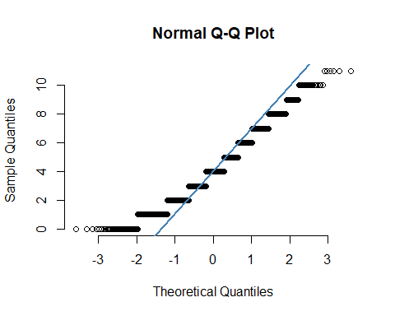

res = resid(fit)  
plot(participant_data$answers, res, ylab="Residuals", xlab="Prompts answered", main="EMA and uEMA prompts answered")   
abline(0, 0)

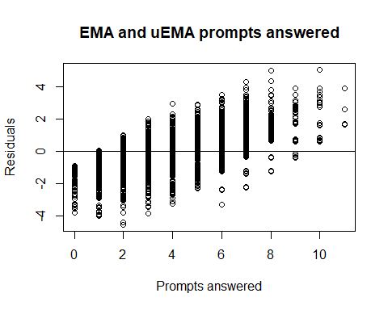

$$Y=μ+β_{1}sleep+β_{2}questions+β_{3}EMA+β_{23}questions.EMA+subject+error$$