AN ABSTRACT OF THE THESIS OF

Student Name for the degree of Master of Degree Name in Official Name of Major presented on Defense Date.

Title: Underlined Title here.

Abstract approved: ______________________________________________________
Major I. Professor

Begin text here, using the same spacing, font style and font size as within the body of the text in your document.

©Copyright by Your Name
Defense Date (unless a copyright application was filed earlier)
All Rights Reserved
Title

by
Student Name

A THESIS

submitted to

Oregon State University

in partial fulfillment of
the requirements for the
degree of

Master of Science

Presented Defense Date
Commencement June (Following Defense Date) & year
Master of Science thesis of Student Name presented on Defense Date

APPROVED:

Major Professor, representing Electrical and Computer Engineering

Director of the School of Electrical Engineering and Computer Science

Dean of the Graduate School

I understand that my thesis will become part of the permanent collection of Oregon State University libraries. My signature below authorizes release of my thesis to any reader upon request.

Student Name, Author
ACKNOWLEDGEMENTS

The author expresses sincere appreciation…..

TABLE OF CONTENTS

Page
1 Student Responsibility 1
2 General Format 2
3 Page Layout and Text Requirements 4
3.1 Margin Requirements 4
3.2 Page Numbering 4
3.2.1 Pretext Pages 4
3.2.2 Body 4
3.3 Title 4
4 Text Format Requirements 5
4.1 Font 5
4.2 Headings 5
4.3 Appendix Heading Page 5
4.4 Blocked Quotes 5
4.5 References 6
4.6 Endnotes 6
4.7 Orphan Lines/Headers/Footnotes 6
5 Figures 7
5.1 Figure Labels and Captions 7
5.2 Landscaping 7
5.3 Mounting 8
5.4 Color 8
TABLE OF CONTENTS (Continued)

Page
5.5 Oversized Figures 8
6 Document Parts -In Order of Appearance 9
6.1 Pretext Pages 9
6.2 Body of Text 17
6.3 Bibliography 17
6.4 Appendix/Appendices (optional) 17
6.5 Flyleaf (a blank page not numbered) 17
7 Printing and Packaging 18
7.1 Cotton Bond Paper 18
7.2 Printing Specifications 18
7.3 Envelope Preparation 18
7.4 Doctoral Students Only 19
8 Copyright Permissions 20
9 Ethics 21
Bibliography 22
Appendices 23

LIST OF FIGURES

Figure Page
1. Chapter Heading Page for Manuscript Document Format. 3
2. Abstract Page for Master’s Degree 9
3. Abstract Page for MAIS Degree 9
4. Abstract Page for Doctoral Degree 10
5. Optional Copyright Page. 10
6. Title Page. 11
7. Approval Page. 12
8. Acknowledgement Page. 13
9. Contribution of Authors (manuscript format only). 13
10a. Table of Contents with numbering. 14
10b. Table of Contents without numbering. 15
11a. List of Figures/Tables with Consecutive Numbering. 16
11b. List of Figures/Tables with Numbering by chapter 16

1 Student Responsibility
You will be guided and advised by your major professor, your examining committee, and the staff at the OSU Graduate School while you work on your thesis document. However, the ultimate responsibility for the document rests with you. You are responsible for:
- Obtaining the necessary information to prepare the document
- Meeting the deadlines associated with its preparation (see the Guide to Success, at http://oregonstate.edu/dept/grad_school/current/success.html)
- Submitting the necessary forms described in the Guide to Success
- Ensuring that your document conforms to all requirements in this Thesis Guide.
Your document must clearly state your objectives and conclusions, and present your results in a lucid and succinct manner. It must have a professional appearance and be user-friendly.

2 General Format
Standard Document Format refers to one thesis document that addresses a single theme. The Pretext Pages, Introduction, Conclusion, and Bibliography are mandatory. Your committee determines the additional chapters; you choose the chapter titles. The following parts comprise the Standard Document Format:
- Pretext Pages (see model pages illustrated in Section 6.1)
- Chapter 1 – Introduction
- Chapter 2 – Literature Review
- Chapter 3 – Materials and Methods
- Chapter 4 – Results
- Chapter 5 – Discussion
- Chapter 6 – Conclusion
- Bibliography
- Appendices (optional)
Manuscript Document Format is a single thesis document made up of several scholarly manuscripts or journal articles addressing a common theme. All manuscripts/articles must be related or address a single, common theme. You must be the primary author of each manuscript. Co-authors other than your major professor must be mentioned in a Contribution of Authors page (see Section 6.1) in the pretext section of the document. The following parts comprise the Manuscript Document Format:
- Pretext Pages (see model pages illustrated in Section 6.1)
- Chapter 1 – General Introduction (common introduction linking all manuscripts thematically)
- Chapter 2 – First Manuscript
- Chapter 3 – Second Manuscript
- Chapter 4 – General Conclusion (common conclusion linking all manuscripts thematically)
- Bibliography (common bibliography covering all manuscripts, although each manuscript may have its own reference section)
- Appendices – (optional)
Note: Within the larger Manuscript Format thesis document, Chapter Heading Pages (see Figure 1 below) precede individual manuscripts that have already been published. Manuscripts must uniformly conform to these thesis guidelines.
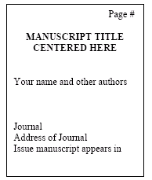
Figure 1. Chapter Heading Page for Manuscript Document Format.

3 Page Layout and Text Requirements

3.1 Margin Requirements
The left margin must be at least 1.5 inches (recommend 1.7). All other margins must be at least 1 inch. Nothing may invade a margin. Every page must meet margin requirements.

3.2 Page Numbering
Page numbers must appear at the top right corner of pages, at least 1inch from the top edge of the page and at least 1 inch from the right edge of the page. Page numbers must not invade any margins. There should be at least one return between the page number and the first line of text.

3.2.1 Pretext Pages
Do not number pretext pages.

3.2.2 Body
The body of the text, including Appendix/Appendices and Bibliography, are numbered consecutively with Arabic Numbers (e.g. 2, 3, etc.). Page one, although counted, is not numbered. Most software comes with the ability to suppress page one numbering. If your software does not have this ability, remove the page number from page one manually.

3.3 Title
Your document begins with its title repeated and centered on page one. Titles longer than one line should be single-spaced. The document's title does not count as a heading level.

4 Text Format Requirements

4.1 Font
Use regular, unadorned print, 10- to12-point size for text (headings may be 14-point only if all headings are 14-point). Use the same font style and font size throughout.

4.2 Headings
Chapter names are Level 1 headings. Subheadings of a chapter are Level 2 headings. Subheadings of chapter subheadings are Level 3 headings, and so forth. Each level must look different from the other levels. Headings of the same level must look the same throughout the document. All headings, regardless of level, must be the same font size. Either number all headings or number none (see Section 6.1). Single space headings that are more than one line, and use adequate and consistent spacing between headings and the text. A minimum of two subheadings may be used within a given level. Each level 1 heading begins a new page.

4.3 Appendix Heading Page
A numbered, counted page should be inserted in front of your document's appendix/appendices. The word APPENDIX (or APPENDICES) should be centered about 1/3 down this page. This heading page and its page number should appear in the Table of Contents.

4.4 Blocked Quotes
Use Blocked Quotes for quoted material longer than three lines. Use the same font size as within the text. Single-space the quotation, and indent it evenly on both sides. There is no need to justify quotations.

4.5 References
Use the same font size as within the text. Choose a reference style with the guidance of your major professor and your committee and be consistent. Single-space each citation, and use adequate and consistent spacing between citations.

4.6 Endnotes
Footnotes collected at the end of a chapter are called endnotes. Use the same font size as within the text. Single-space each endnote, and use adequate and consistent spacing between endnotes.

4.7 Orphan Lines/Headers/Footnotes
No orphan lines may appear at the top or bottom of a page. No headers or footers may be used. Footnotes are acceptable.

5 Figures
Figures may be located in one of two places in your document. You must choose one system, and use it consistently throughout your work.
- Insert the figure within the text, as close as possible after the first reference is made to it.
- Place your figures at the end of the chapter in which it is first discussed or referenced.

5.1 Figure Labels and Captions
A figure’s labels denote the type of figure (Map, Illustration, etc.) and its number, and a figure’s caption is its title and description. Every figure must have a label and caption unless there is only one figure of its type in the document. Use consecutive label numbers by order of appearance within the text. Each figure must have a unique number. Illustrations that take up more than one page should have the label followed by “(Continued)” on the second page. Label and caption font size is the same as body text size. Use adequate (at least one return) and consistent spacing between and figure and its label and caption and between the figure and text. A figure’s label and caption should be placed outside its boundaries, commonly above a table and below an illustration. If both a figure and its label and caption do not fit on one page, place only the label on the page with the figure, and place the label and caption on a separate page that precedes the figure (called a legend page). Single-space the label and caption and center it 1/3 of the way down the page. Include no other text on this page. List the page number of the legend page in the pretext list.

5.2 Landscaping
Because of their shape, some figures may need to be placed crosswise on a page. If so, the top of the figure should be at the left margin as viewed normally (i.e. portrait orientation), and the caption should be parallel to the right margin. The page number keeps the same location and orientation as all other page numbers in the text. Margin requirements apply.

5.3 Mounting
Figures should be photocopied directly onto the cotton bond paper whenever possible. If it is necessary to use original figures, they must be mounted onto the cotton bond paper with a spray adhesive. Rubber cement should not be used, because it yellows and deteriorates over time. To test if your figure is correctly mounted, put your fingernail under an edge and try to lift it away from the cotton bond paper—if it lifts even slightly at any edge, you must fasten it again.

5.4 Color
Color used to differentiate lines, bars, or segments will reproduce as shades of gray on microfilm and in photocopies. Choose high-contrast colors that will remain distinct in the black-and-white process, or use symbols with or without the color. Photocopy the image directly onto cotton bond paper or use a laser printer. Do not print with water-based ink.

5.5 Oversized Figures
- There are 3 ways of managing the inclusion of oversized figures: Reduction: Photographically reduce the size of figures to meet margin requirements. Page numbers and figure captions must remain the same font size as the text.
- Accordion Fold: The final, folded page must be 11 inches in height and no more than 8 inches wide. Fold the page from right to left, making the final folded width 8 inches. Fold the page a second time from left to right so the page number appears in the same position as all other pages in the text.
- Pocket Addition: Valley Library will attach a pocket to the back binding and fold the figure to fit it. Doctoral students must submit an extra (third) copy of the figure.

6 Document Parts –In Order of Appearance
Regardless of general format, the thesis includes particular parts in an established order as listed below. Model pages are provided for most pretext pages. In all cases, margin requirements apply (see above) and the same font style/size must be used in the body of the text and elsewhere. All titles of pretext pages should be formatted identically with respect to font size and style.

6.1 Pretext Pages
- Flyleaf – a blank page.
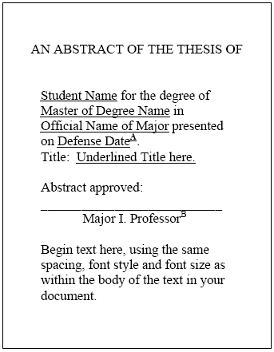
Figure 2. Abstract Page for Master’s Degree
^{A}The line breaks in these four lines do not imply hard returns. Hard return after the defense date only.
^{B}Include major professor’s middle initial unless there is none. Do not include his/her title. Co-major professors may share the same signature line; put both names below the line.
- Abstract (see Figures 2, 3, 4). An abstract is a summary of the document’s purpose, methods, major findings, and conclusions. All library copy abstracts must include the major professor’s original signature. Your name (designated “Student Name”) must appear exactly the same throughout the document. In all cases, use the official name of the major, found in the Graduate Catalog pages 9-13. Underline where indicated.
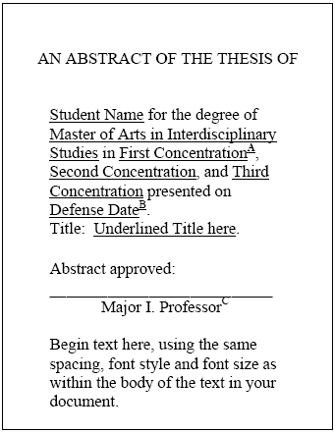
Figure 3. Abstract Page for MAIS Degree
^{A}Use official Major names for Areas of Concentration (Graduate Catalog, 9-14).
^{B}Hard return after the defense date only.
^{C}Include major professor’s middle initial unless there is none. Do not include his/her title. Co-major professors may share the same signature line; put both names below the line.
- Copyright Page (see Figure 5)—optional but recommended. Print your name exactly as you did in the Abstract. Wording should begin 10 returns from the first line.
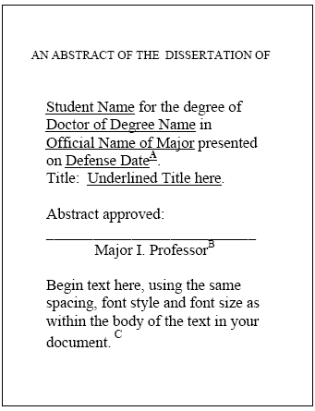
Figure 4. Abstract Page for Doctoral Degree
^{A}The line breaks in these four lines do not imply hard returns. Hard return after the defense date only.
^{B}Include major professor’s middle initial unless there is none. Do not include his/her title. Co-major professors may share the same signature line; put both names below the line.
^{C}Doctoral abstracts are limited to 350 words maximum.

Figure 5. Optional Copyright Page.

- Title Page (see Figure 6)
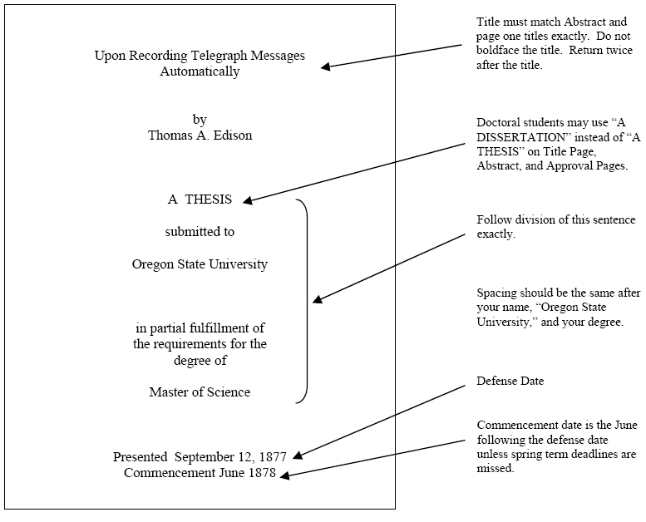
Figure 6. Title Page.

- Approval Page (see Figure 7). On the Approval Page, the Major Professor represents the major. The Approval Page considers your advisor as your major professor, regardless of his/her official rank or tenure home. Official major names and department names can be found in the Graduate Catalog. Some majors and departments have the same name while others differ. The major name used on the Approval Page should exactly match the one on the Abstract. All signatures collected on the library copies’ approval pages must be original. Your signature constitutes consent to have your document available for public reference in Valley Library.
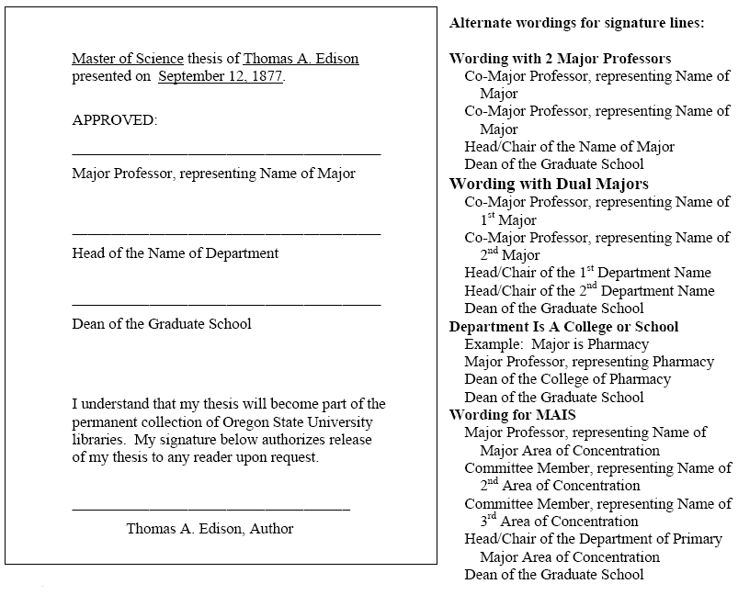
Figure 7. Approval Page.

- Acknowledgments (see Figure 8)—optional but recommended. The exact content of this page is up to you.
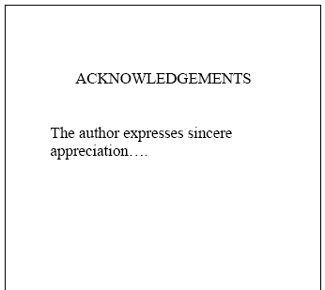
Figure 8. Acknowledgement Page.
- Contribution of Authors (see Figure 9)—manuscript document format only
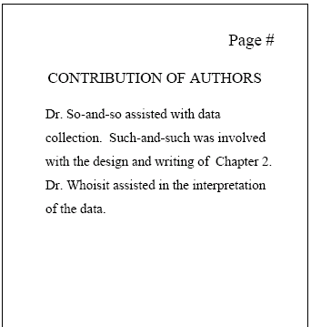
Figure 9. Contribution of Authors (manuscript format only).

- Table of Contents (see figures 10a and 10b, next page). Ensure that the page numbers accurately reflect where the headings appear in the text. Listing the chapter headings in the Table of Contents is required; listing the subheadings is optional, and you may list some levels but not others. Levels are denoted by indention in the Table of Contents. Wording, spelling, and capitalization of headings in the Table of Contents must match the heading in the body of the text exactly. If headings are numbered in the Table of Contents, they must be numbered correspondingly in the text. List appendix or appendices (if applicable) in the Table of Contents or in a separate List of Appendices. In either case, list the Appendices Heading Page (see page 3) in the Table of Contents. When listing an individual appendix, include its title. If the Table of Contents is more than one page, subsequent pages should be headed “TABLE OF CONTENTS (Continued).” Return twice between the TABLE OF CONTENTS heading and the first item in the table. Do not underline, bold, or italicize in the Table of Contents (unless the heading is a scientific species name).
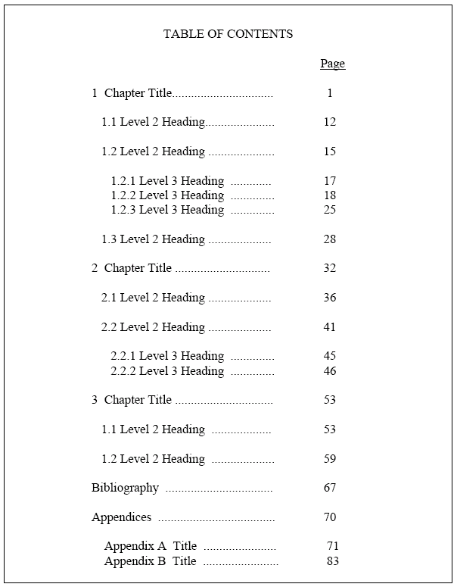
Figure 10a. Table of Contents with numbering.
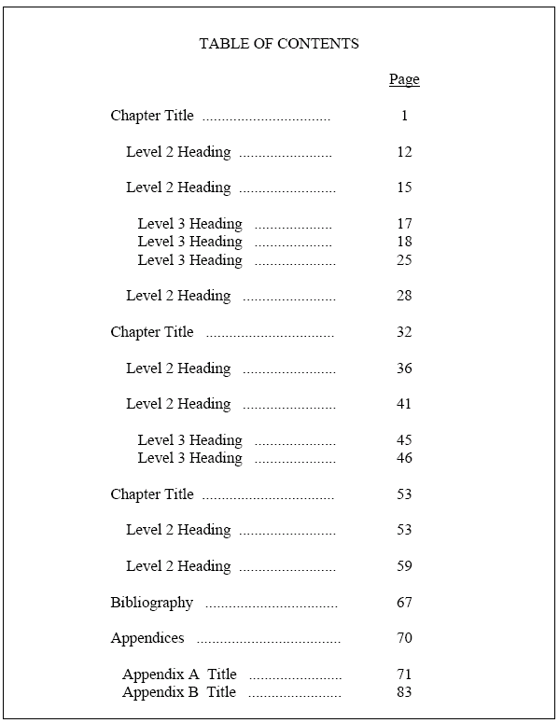
Figure 10b. Table of Contents without numbering.

- List of Figures (see figures 11a and 11b). Lists are required if two or more figures appear within the text.
- List of Tables (see figures 11a and 11b). Lists are required if two or more tables appear within the text.
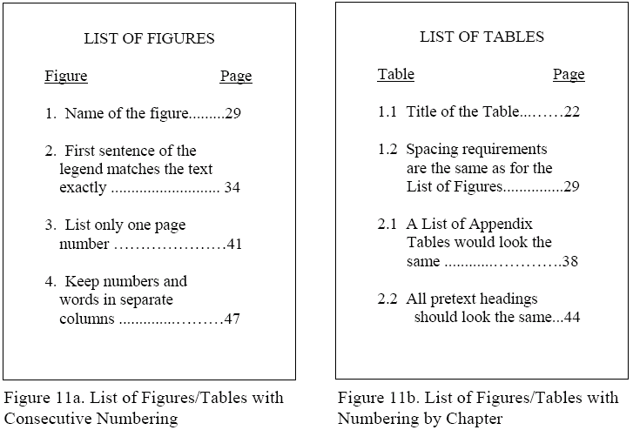
Figure 11a. List of Figures/Tables with Consecutive Numbering.
Choose one of the two methods of numbering in the model pages illustrated in Figures 11a and 11b and use it for both Lists of Figures and Lists of Tables. If a list is longer than one page, subsequent pages should be headed “LIST OF FIGURES (Continued)” or “LIST OF TABLES (Continued).” The first sentence of the figure or table caption must be listed, and the wording must match the text exactly. List only one page number per figure or table. When there is a legend page in front of a figure (see information on FIGURES below), list the legend page only. Figures in the appendices are listed on a separate List of Appendix Figures list. Return twice between the LIST OF FIGURES/TABLES heading and the first listing.
Figure 11b. List of Figures/Tables with Numbering by chapter
Single-space listings with a single return if double spacing is used in the text, or 2 returns if 1.5 spacing is used.
- List of Appendices (optional). If list of appendices is short, it may bee attached to the Table of Contents. For more than 5 appendices, or list different heading levels are listed in the appendices, a separate List of Appendices is required. If two or more figures appear in the appendices, a List of Appendix Figures and/or a List of Appendix Tables is required.
- List of Appendix Figures. For two or more figures in the appendices.
- List of Appendix Tables. For two or more tables in the appendices.
- Other Lists. If you are including other lists, such as lists of abbreviations, nomenclature, symbols, and so forth, each list must have its own page. The elements of these lists do not need numbering or page numbers.
- Dedication (optional) If desired, you may dedicate your document to the honor of someone. Dedications are usually short. Margin requirements apply. Use the same font/font size as text body. Arrangement of page is at your discretion.
- Preface (optional)

6.2 Body of Text
Follow standard or manuscript document format.

6.3 Bibliography

6.4 Appendix/Appendices (optional)

6.5 Flyleaf (a blank page not numbered)

7 Printing and Packaging

7.1 Cotton Bond Paper
Cotton bond paper contains a minimum of 25% cotton bond fiber and has a weight of at least 16 lbs. (Standard cotton bond is usually 20 lbs.) Each sheet has a watermark with the cotton content noted. Cotton bond paper should be white for all documents and should not have texture or design lines. Purchase enough to use the same paper throughout the document and for any pages that are corrected after submission. Flyleaf pages are also the same paper.

7.2 Printing Specifications
The document's text must appear on only one side of the cotton bond paper. It is preferable to photocopy the final document onto cotton bond paper; however, it is permissible to use a laser printer. Do not use inkjet or water soluble ink. Pages that have bleeding ink will be returned. Pages with broken text, ink blemishes, and crooked text must be recopied. Remember to examine the pagination of your document before you put it on cotton bond paper. Pages from page 2 onward should have consecutive page numbers that are the same font size and located in the same position. After the copying process is complete, count the pages again to be sure none were skipped.

7.3 Envelope Preparation
Submit two library copies of your thesis in separate manila envelopes that have clasps. Choose an envelope that is appropriate to the size of your document. Pages put in envelopes that are too large or too small may be damaged before they reach the library. Fasten a copy of the document's Title Page (see Figure 6) to the outside of each envelope. Additional pages, copyright permission letters, enclosures such as maps and disks, and so forth should be placed inside the envelope. Oversized attachments may be packaged in separate envelopes or tubes that are properly labeled with your name and the title of your document. Documents that are not properly packaged will not be accepted at the time of submission.

7.4 Doctoral Students Only
An extra Abstract (see Figure 4) with an original signature must be submitted with your library copies for archiving. Also submit the microfilming form, found in the center of the folder Publishing Your Dissertation, and a cashier receipt for the microfilm fee. Copyright fee for an ISBN number is optional.

8 Copyright Permission
To answer questions regarding copyright law, OSU has a Copyright Center (541-737-3978). Website: http://osu.orst.edu/admin/printing/copyright/copyright.htm
You should assume that any material from other sources that you use in your thesis, including text, pictures, musical compositions, graphs, charts, cartoons, and so forth, is copyrighted. You must obtain written permission from the copyright owner to use it. To obtain written permission, send the copyright owner a concise letter specifying your intended use and allow ample time for a response. If you get no response or if you are denied permission, you must remove the copyrighted material from your document. A doctoral student should send out copyright permission requests at least four months before his or her defense date. Be sure to state that copies of the document may be distributed by ProQuest by request.
You must submit a copy (keep the original in a safe place) of all letters granting the use of copyrighted material to the Graduate School.
In the US, if you have created an original document, it is automatically copyrighted for the period of your lifetime plus fifty years. Formal notice or registration is not necessary; nevertheless, you should include a copyright page (see Figure 5) in your document to alert readers that you are the copyright owner and that you acknowledge your legal rights. You may wish to register your copyright, though this step is optional.
Registration establishes public record of your document, its copyright and your name and address. Students who choose to register the copyright personally should contact: Registration of Copyright, Copyright Office, Library of Congress, Washington, DC 20540.

9 Ethics
Ethical research practice requires you to avoid:
- Plagiarism: failure to acknowledge the work of others by using proper citations and obtaining written permission to use copyrighted material.
- Fabrication: the creation of fictitious research results.
- Falsification: alteration of research results by misrepresentation or selective reporting of findings.

Bibliography

Appendices

