IPC SYSTEM CALL  
P1 LAB EVAL

RITHIKA SRI J  
CB.EN.U4CSE19025  
22.02.2020

(1) officer.c

#include<sys/types.h>  
#include<sys/ipc.h>  
#include<sys/msg.h>  
#include<stdio.h>  
#include<stdlib.h>  
struct msgfmt{  
   long int type;  
   int number;  
 };  
  
int main(){  
 int msgid;  
 static int a,b,c;  
 a=0;b=0;c=0;  
 key_t key=1910;  
 struct msgfmt vote;  
 msgid=msgget(key,0666);  
 for(int i=1;i<6;i++){  
  if(msgrcv(msgid,&vote,sizeof(vote),0,0)<0){  
   printf("error in message receiving\n");  
   exit(1);  
   }  
  switch(vote.number)  
  {  
    case 1:  
    a++;  
    break;  
    case 2:  
    b++;  
    break;  
    case 3:  
    c++;  
    break;  
    default:  
    printf("Invalid contestant!\n");  
  }  
 }  
 if(a+b+c==5){  
   msgctl(msgid, IPC_RMID, NULL);  
   printf("**FINAL RESULTS AFTER 5 VOTES**\n");  
   printf("Vote: PERSON1=%d PERSON2=%d PERSON3=%d\n",a,b,c);  
   if(a>b && a>c){  
   printf("PERSON1 WON\n");  
   }else if(b>a && b>c){  
   printf("PERSON2 WON\n");  
   }else{  
   printf("PERSON3 WON\n");  
   }    
 }  
 return 0;  
}

**Voter1.c**

#include<sys/types.h>  
#include<sys/ipc.h>  
#include<sys/msg.h>  
#include<stdio.h>  
#include<stdlib.h>  
struct msgfmt{  
   long int type;  
   int number;  
 };  
int main(){  
 int msgid;  
 int votecast;  
 key_t key=1910;  
 struct msgfmt voter1;  
 if(msgid=msgget(key,IPC_CREAT|0666)<0){  
 printf("error in message queue creation");  
 exit(0);}  
 voter1.type=1;  
 printf("Cast your vote v1\n");  
 printf("1->\"PERSON1\" 2->\"PERSON2\" 3->\"PERSON3\".Enter the number to vote  favourable contestant.\n");  
 scanf("%d",&votecast);  
 voter1.number=votecast;  
 msgsnd(msgid,&voter1,sizeof(voter1),IPC_NOWAIT);  
 return 0;  
}

**Voter2.c**

#include<sys/types.h>  
#include<sys/ipc.h>  
#include<sys/msg.h>  
#include<stdio.h>  
#include<stdlib.h>  
struct msgfmt{  
   long int type;  
   int number;  
 };  
int main(){  
 int msgid;  
 int votecast;  
 key_t key=1910;  
 struct msgfmt voter2;  
 msgid=msgget(key,0666);  
 voter2.type=1;  
 printf("Cast your vote v2\n");  
 printf("1->\"PERSON1\" 2->\"PERSON2\" 3->\"PERSON3\".Enter the number to vote  favourable contestant.\n");  
 scanf("%d",&votecast);  
 voter2.number=votecast;  
 msgsnd(msgid,&voter2,sizeof(voter2),IPC_NOWAIT);  
 return 0;  
}

**Voter3.c**

#include<sys/types.h>  
#include<sys/ipc.h>  
#include<sys/msg.h>  
#include<stdio.h>  
#include<stdlib.h>  
struct msgfmt{  
   long int type;  
   int number;  
 };  
int main(){  
 int msgid;  
 int votecast;  
 key_t key=1910;  
 struct msgfmt voter3;  
 msgid=msgget(key,0666);  
 voter3.type=1;  
 printf("Cast your vote v3\n");  
 printf("1->\"PERSON1\" 2->\"PERSON2\" 3->\"PERSON3\".Enter the number to vote  favourable contestant.\n");  
 scanf("%d",&votecast);  
 voter3.number=votecast;  
 msgsnd(msgid,&voter3,sizeof(voter3),IPC_NOWAIT);  
 return 0;  
}

**Voter4.c**

#include<sys/types.h>  
#include<sys/ipc.h>  
#include<sys/msg.h>  
#include<stdio.h>  
#include<stdlib.h>  
struct msgfmt{  
   long int type;  
   int number;  
 };  
int main(){  
 int msgid;  
 int votecast;  
 key_t key=1910;  
 struct msgfmt voter4;  
 msgid=msgget(key,0666);  
 voter4.type=1;  
 printf("Cast your vote v4\n");  
 printf("1->\"PERSON1\" 2->\"PERSON2\" 3->\"PERSON3\".Enter the number to vote  favourable contestant.\n");  
 scanf("%d",&votecast);  
 voter4.number=votecast;  
 msgsnd(msgid,&voter4,sizeof(voter4),IPC_NOWAIT);  
 return 0;  
}

**Voter5.c**

#include<sys/types.h>  
#include<sys/ipc.h>  
#include<sys/msg.h>  
#include<stdio.h>  
#include<stdlib.h>  
struct msgfmt{  
   long int type;  
   int number;  
 };  
int main(){  
 int msgid;  
 int votecast;  
 key_t key=1910;  
 struct msgfmt voter5;  
 msgid=msgget(key,0666);  
 voter5.type=1;  
 printf("Cast your vote v5\n");  
 printf("1->\"PERSON1\" 2->\"PERSON2\" 3->\"PERSON3\".Enter the number to vote  favourable contestant.\n");  
 scanf("%d",&votecast);  
 voter5.number=votecast;  
 msgsnd(msgid,&voter5,sizeof(voter5),IPC_NOWAIT);  
 return 0;  
}

**OUTPUT:  
V1**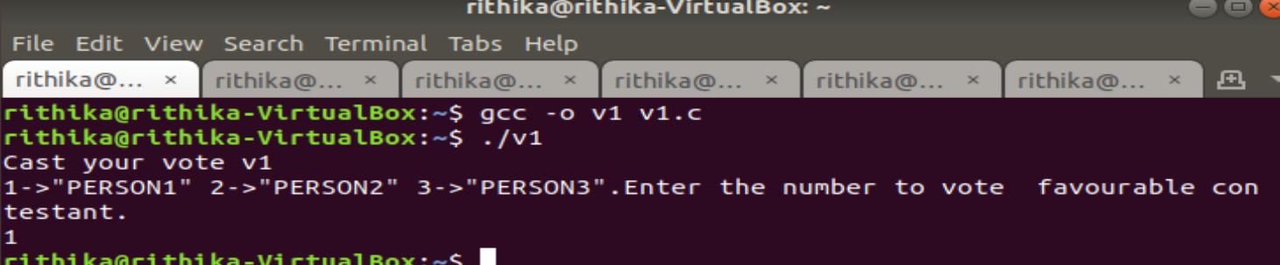

V2  
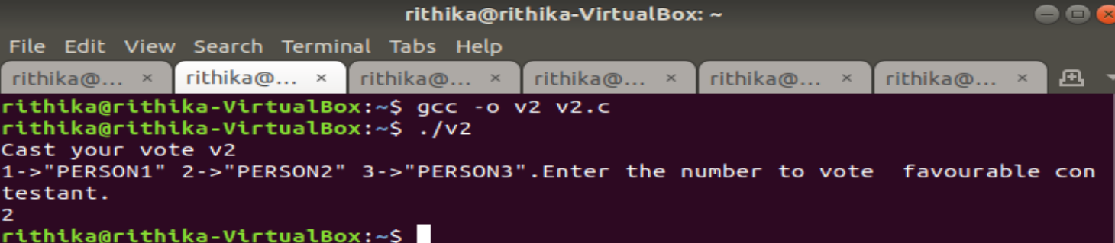

V3  
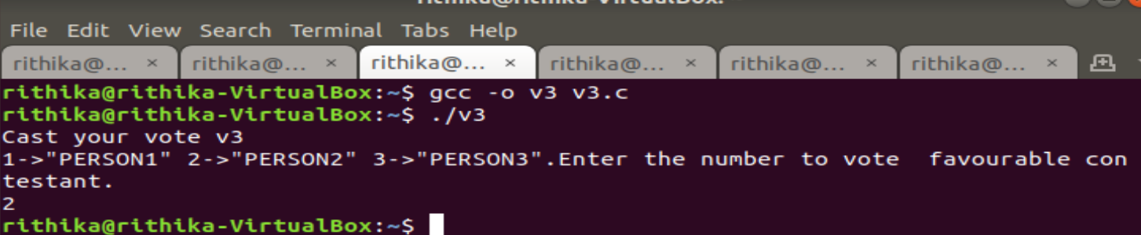

V4  
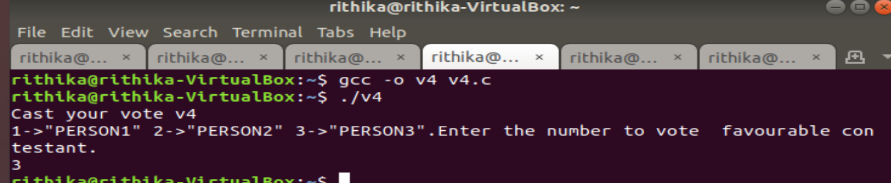

V5  
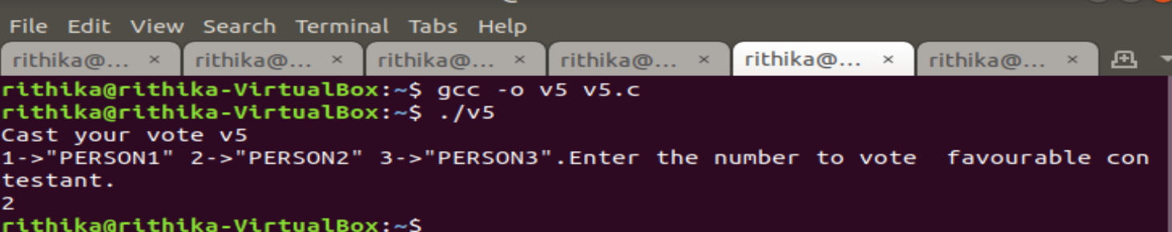

OFFICER  
