EXPERIMENT – 2
Upload and Analyze the data set given in csv format and perform data preprocessing and visualization.

PROGRAM:-
import pandas as pd
import numpy as np
import matplotlib.pyplot as plt
from google.colab import files
uploaded=files.upload()
df=pd.read_csv('SALES DATA - SALES DATA.csv')
print(df.head())
print(df.isnull().sum())
df['Sales']=(df['Sales'].fillna(df['Sales'].mean))
df.dropna(subset=['Product','Quantity','Region'],inplace=True)
print(df.describe())
product_summary=df.groupby('Product').agg({
'Sales':'sum',
'Quantity':'sum'
}).reset_index()
print(product_summary)
plt.figure(figsize=(10,6))
plt.bar(product_summary['Product'],product_summary['Sales'])
plt.xlabel('Product')
plt.ylabel('Total Sales')
plt.title('Total Sales by Product')
plt.show()
df['Date']=pd.to_datetime(df['Date'],format='%d-%m-%Y')
sales_over_time=df.groupby('Date').agg({'Sales':'sum'}).reset_index()
plt.figure(figsize=(10,6))
plt.plot(sales_over_time['Date'],sales_over_time['Sales'])
plt.xlabel('Date')
plt.ylabel('Total Sales')
plt.title('Sales Over Time')
plt.show()
pivot_table=df.pivot_table(values='Sales',index='Region',columns='Product',aggfunc='sum',fill_value=0)
print(pivot_table)
correlation_matrix=df.select_dtypes(include='number').corr()
print(correlation_matrix)
import seaborn as sns
plt.figure(figsize=(10,6))
sns.heatmap(correlation_matrix,annot=True,cmap='coolwarm')
plt.title('Correlation Matrix')
plt.show()

OURPUT:-

Date Product Sales Quantity Region
0 01-01-2023 Product A 200 4 North
1 02-01-2023 Product B 150 3 South
2 03-01-2023 Product A 220 5 North
3 04-01-2023 Product C 300 6 East
4 05-01-2023 Product B 180 4 West
Date 0
Product 0
Sales 0
Quantity 0
Region 0
dtype: int64
Sales Quantity
count 16.000000 16.000000
mean 237.500000 5.375000
std 64.031242 1.746425
min 150.000000 3.000000
25% 187.500000 4.000000
50% 225.000000 5.500000
75% 302.500000 7.000000
max 340.000000 8.000000
Product Sales Quantity
0 Product A 1350 33
1 Product B 850 17
2 Product C 1600 36

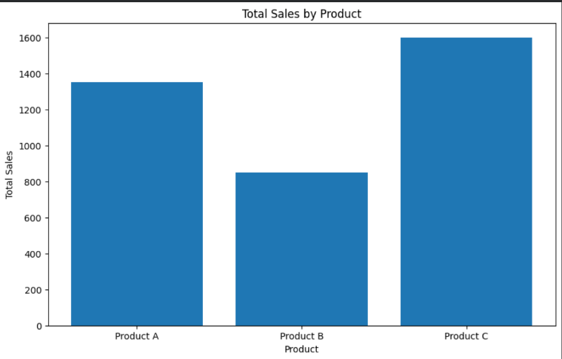
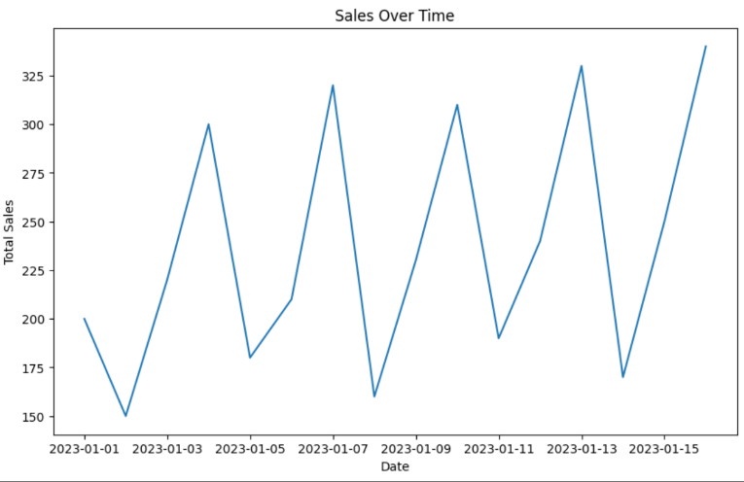
Product Product A Product B Product C
Region
East 0 0 1600
North 1350 0 0
South 0 480 0
West 0 370 0
Sales Quantity
Sales 1.000000 0.944922
Quantity 0.944922 1.000000
