Experiment -1

1.a. Analyze the trend of data
science job postings over the last decade for the given data on the number of data science job
postings each year. Use pandas for data manipulation and matplotlib for visualization.
PROGRAM:-
import pandas as pd
import matplotlib.pyplot as plt
data ={'Year': list(range(2010,2021)),
'Job posting':[150,300,450,600,800,1200,1600,2100,2700,3400,4200]}
df=pd.DataFrame(data)
plt.plot(df['Year'],df['Job posting'],marker='o')
plt.title("Trend of Data Science Job Postings")
plt.xlabel('Year')
plt.ylabel('Number of Job Postings')
plt.show()
OUTPUT:-
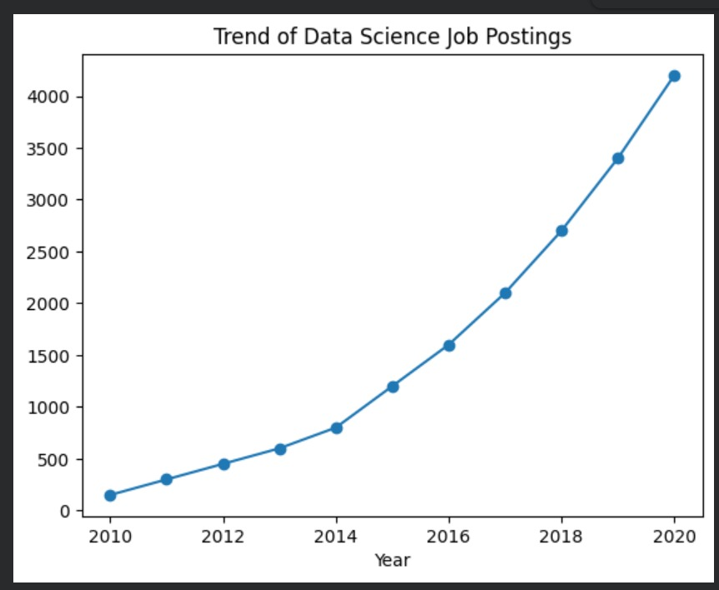

1.b.Analyze
and visualize the distribution of various data science roles (Data Analyst,
Data Engineer, Data Scientist, etc.) from a dataset.
PROGRAM:-
import pandas as pd
import matplotlib.pyplot as plt
roles=['Data Analyst','Data Engineer','Data Scientist','ML Engineer','Business Analyst']
counts=[300,500,450,200,150]
plt.bar(roles,counts)
plt.title('Distribution of Data Science Roles')
plt.xlabel('Roles')
plt.ylabel('Count')
plt.show()
OUTPUT:-
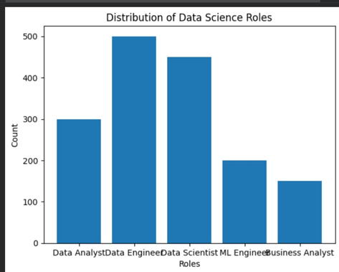

1.c.Conduct
an experiment to differentiate Structured , Un-structured and Semi structured data based on data sets given.
PROGRAM:-
import pandas as pd
structured_data=pd.DataFrame({
'ID':[1,2,3],
'Name':['Alice','Bob','Charlie'],
'Age':[25,30,35]
})
print("Structured Data:\n",structured_data)
unstructured_data="This is an example of unstructured data.it can be a piece of text, an image, or a video file."
print("\nUnstructured Data:\n",unstructured_data)
semi_structured_data={'ID':1,'Name':'Alice','Attributes':{'Height':165,'Weight':68}}
print("\nSemi-structured Data:\n",semi_structured_data)
OUTPUT:-
Structured Data:
ID Name Age
0 1 Alice 25
1 2 Bob 30
2 3 Charlie 35

Unstructured Data:
This is an example of unstructured data.it can be a piece of text, an image, or a video file.
Semi-structured Data:
{'ID': 1, 'Name': 'Alice', 'Attributes': {'Height': 165, 'Weight': 68}}

1.d.Conduct
an experiment to encrypt and decrypt given sensitive data using the cryptography library fernet.
PROGRAM:-
Import pandas as pd
from cryptography.fernet import Fernet
key = Fernet.generate_key()
f = Fernet(key)
token = f.encrypt(b"Rajalakshmi Engineering College")
token
b'...'
f.decrypt(token)
b'Rajalakshmi Engineering College'
key = Fernet.generate_key()
cipher_suite = Fernet(key)
plain_text = b"Rajalakshmi Engineering College."
cipher_text = cipher_suite.encrypt(plain_text)
decrypted_text = cipher_suite.decrypt(cipher_text)
print("Original Data:", plain_text)
print("Encrypted Data:", cipher_text)
print("Decrypted Data:", decrypted_text)
OUTPUT:-
Original Data: b'Rajalakshmi Engineering College.'
Encrypted Data: b'gAAAAABqfKxkWnnrfj9EG1MdQ8V5lo-bltGUGZtSmxnPlf_5NqAxYxh3nRoOQcF_h-nSVSpst6B6XnhQh2SehFrCdKAZrcm8MGcKc8sfA4R536lgLnjS47smFgZnHnAWJ8r9ZNKVK4lb'
Decrypted Data: b'Rajalakshmi Engineering College.'

