# INTRODUCTION

* 1. Overview

BUILD A CRM – APPLICATION FOR SCHOOLS AND COLLEGES

The project aim is to provide real time knowledge for all the students who have basic knowledge of salesforce and looking for a real time project .it helps to maintain and manage school related problems.

Purpose

At the start, an event manager makes planning decisions, such as the time, location, and theme of their event. During an event, event managers oversee the event live and make sure things run smoothly

1. **Problem Definition & Design Thinking**
   1. Empathy Map

Paste the empathy map screenshot

* 1. Ideation & Brainstorming Map

Paste the Ideation & brainstorming map screenshot

# RESULT

* 1. Data Model:

|  |  |
| --- | --- |
| Field label | Data type |
| Phone number | phone |
| school | Master detail relationship |

|  |  |
| --- | --- |
| **Object name** | **Fields in the Object** |
| obj1-school object |  |
| obj2-school object |  |

|  |  |
| --- | --- |
| Field label | Data type |
| Parent address | Text area |
| Parent number | phone |

Activity & Screenshot

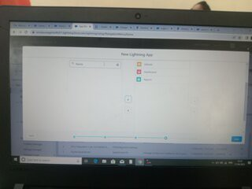

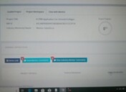

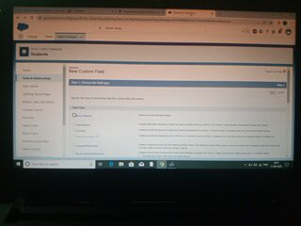

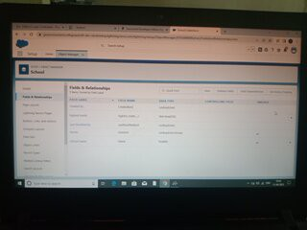

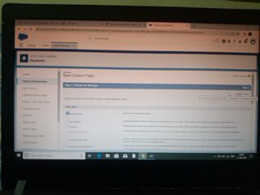

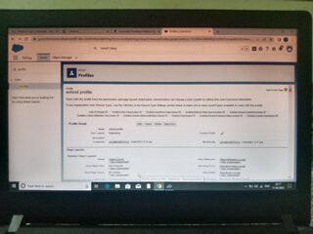

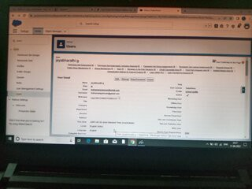

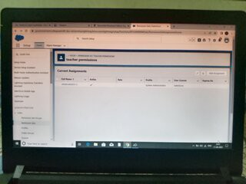

# Trailhead Profile Public URL

**Team Leader - https://trailblazer.me/id/ris26**

**Team Member 1 -https://trailblazer.me/id/sup34**

Team Member 2 - https://trailblazer.me/id/gopit12

Team Member 3 –https://trailblazer.me/id/jayg9

1. **ADVANTAGES**

* **Know to establish results**
* **Manage the marks of students**
* **Creativity**
* **Skilled Team**

# APPLICATIONS

# CONCLUSION

# Here we know how to store the information of schools.

# FUTURE SCOP

In future our project gets more importace because storing of

Informations is very essential. I so we think our project makes an impact in future.