ALGORITHM – FINANCIAL DATA ANALYSIS USING PYTHON
Pandas Data Analysis Program

Algorithm
1. Start the program.
2. Import the Pandas library using the statement: import pandas as pd.
3. Read the financial_data.csv file using pd.read_csv() and store the data in the variable data.
4. Display the first six rows of the dataset using data.head().
5. Display the structure and information of the dataset using data.info(), including the number of entries, columns, data types, and memory usage.
6. Generate and display summary statistics using data.describe(), including count, mean, standard deviation, minimum, quartiles, and maximum.
7. Import the Tkinter library and the askopenfilename function from tkinter.filedialog if a file-selection window is required.
8. Hide the main Tkinter window using Tk().withdraw().
9. Display the results in the Python/VS Code terminal.
10. Stop the program.

Output
The program displays the first rows of the dataset, dataset information, and descriptive summary statistics such as count, mean, standard deviation, minimum, quartiles, and maximum.
Program Screenshot

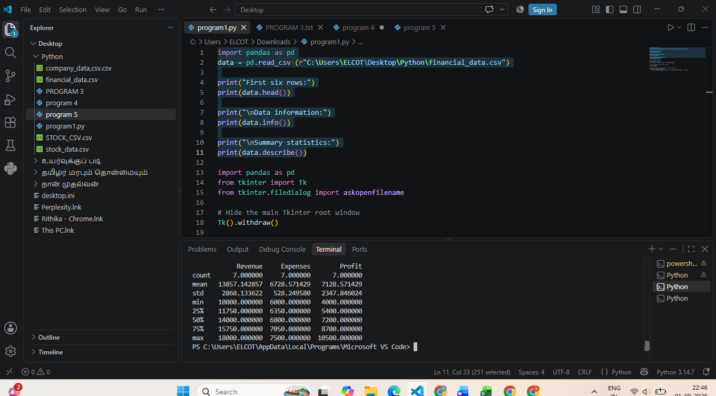
Figure 1: Python program and terminal output in Visual Studio Code

