Submitted by – Rithika
1.INVARIANCE?:
if A is a subtype of B, then Container<A> is NOT a subtype of Container<B>
Cannot substitute one generic type with another—even if their inner types have inheritance
Example : Bank Management
BankAccount:
|--SavingsAccount
|--CurrentAccount
We know that SavingsAccount IS-A BankAccount
But, List<SavingsAccount> is NOT a List<BankAccount> as they can have CurrentAccount also
Error in the code because of mismatch of generic containers
In java:
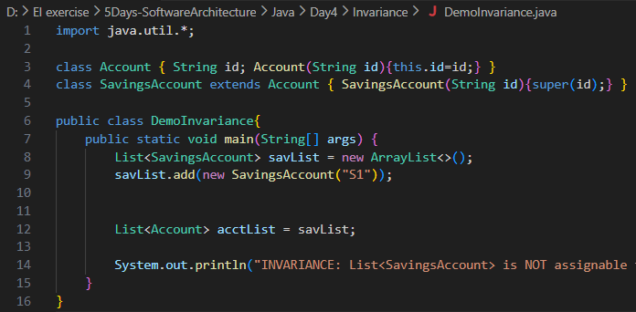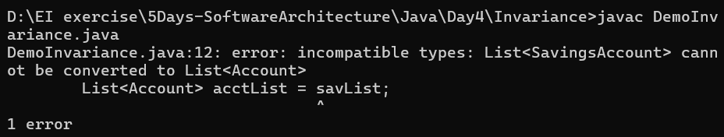
In typescript: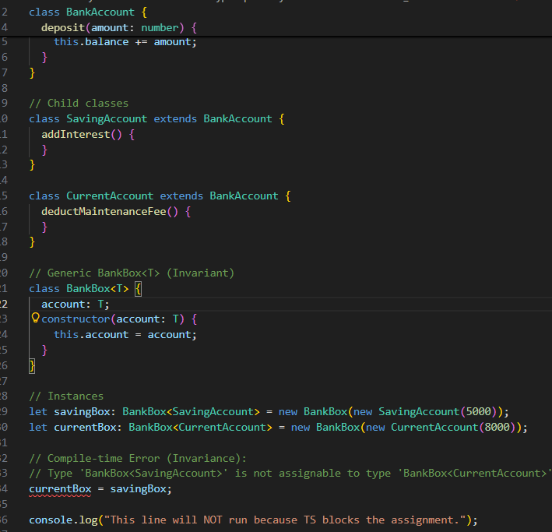
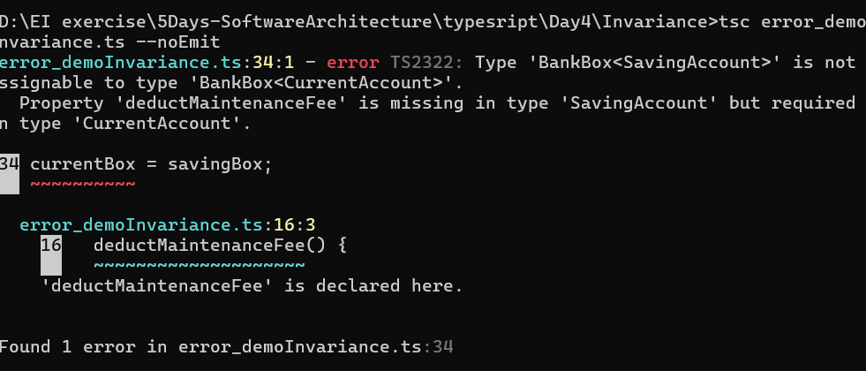

Error-free code:
In Java:
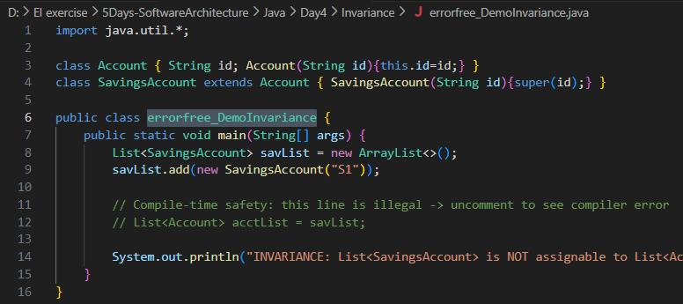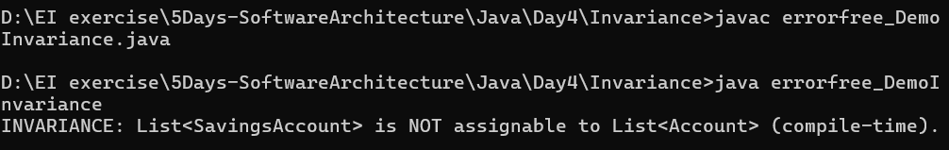
In Typescript:
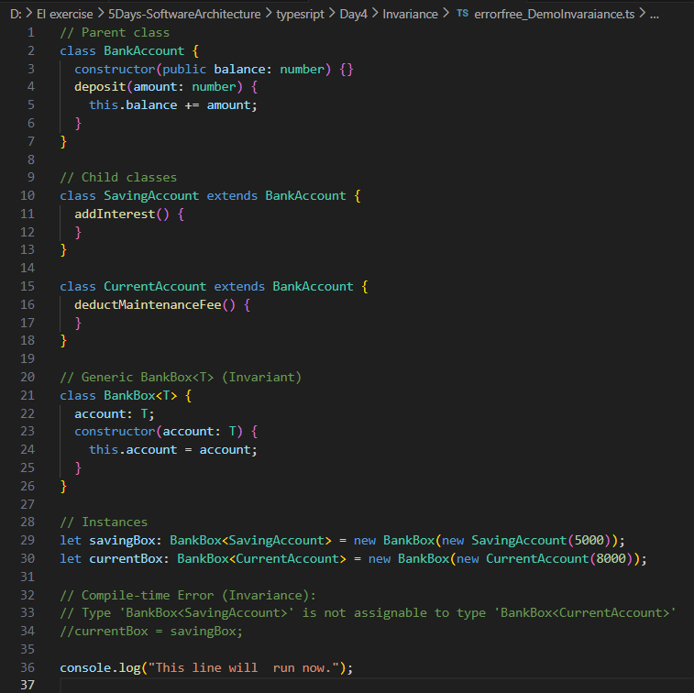

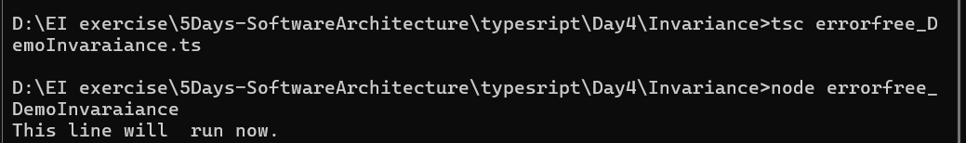
2.COVARIANCE?:
If A is a subtype of B, then Container<A> IS a subtype of Container<B> only read, no writing
Array Trap in java and structural typing nuance in Typescript:
Reading from the array is safe, but
Writing a base type into the derived-type array is unsafe and can cause runtime errors

Example:( in java)
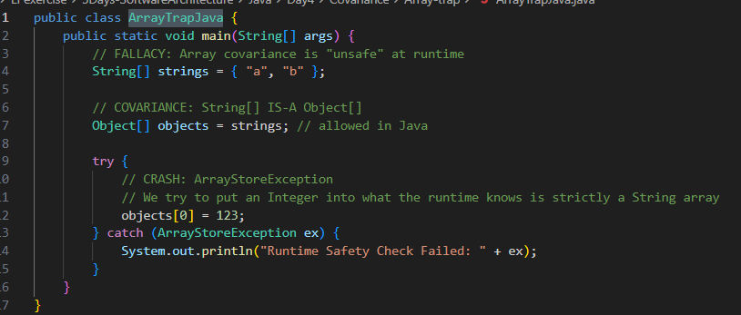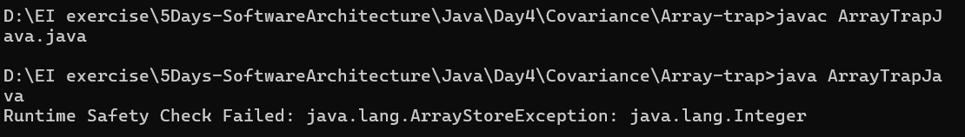

Example: ( In typescript)
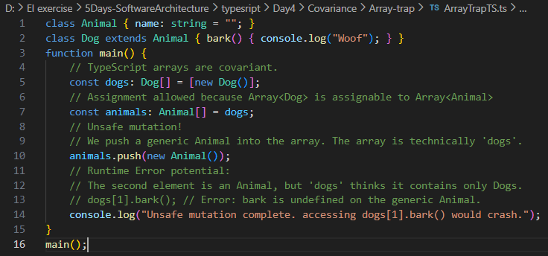
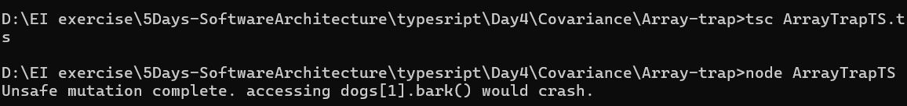

What are Mutable Arrays in TS?:
Array where user can do CRUD operations
Ex:
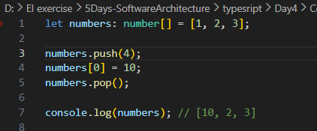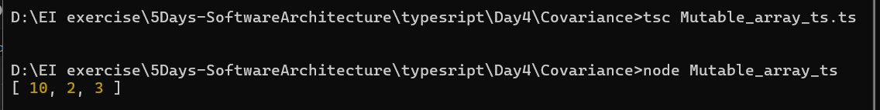
What is ReadonlyArray<T> in TypeScript?
An array that cannot be changed.
- No push
- No pop
- No modifying items
Ex:
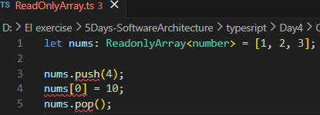
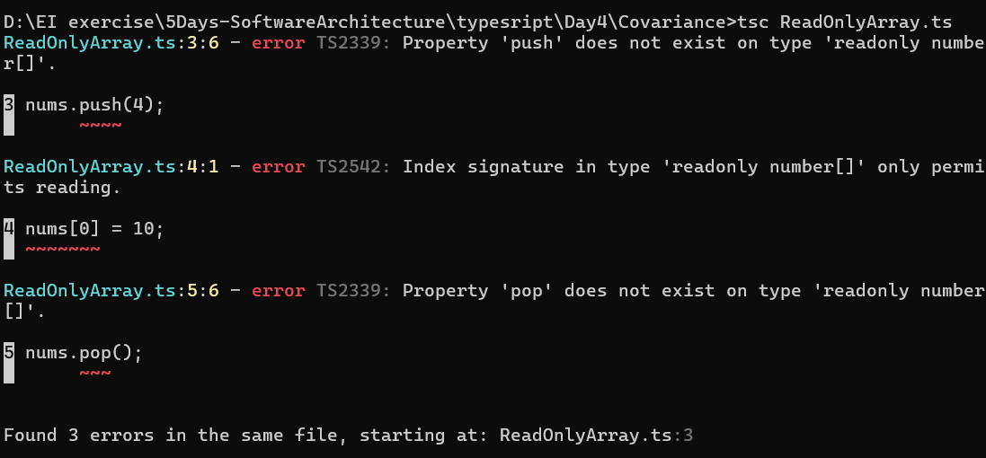

Why ReadonlyArray Is Safe?
No mutation is allowed, so no way to create runtime type errors. Thus Safe Covariance

Example: Bank Management
A function that only reads account details should accept:
- list of BankAccount
- list of SavingsAccount
- list of CurrentAccount
Because reading is always safe.

In java: ? extends gives a read-only
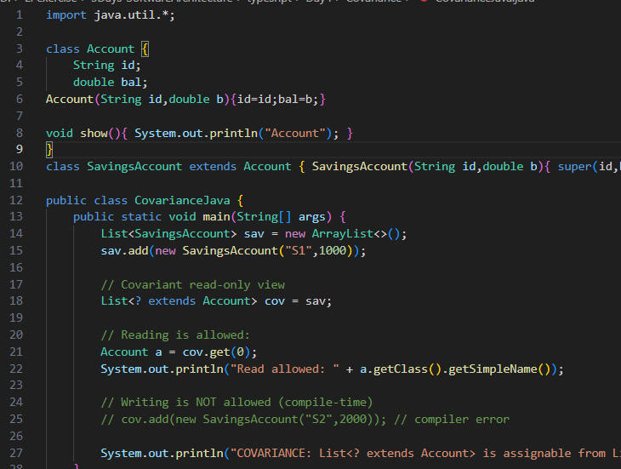
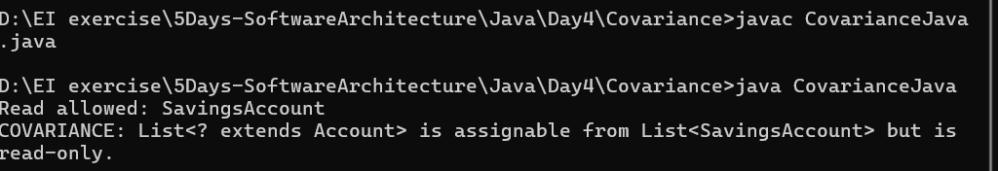

In TypeScript:
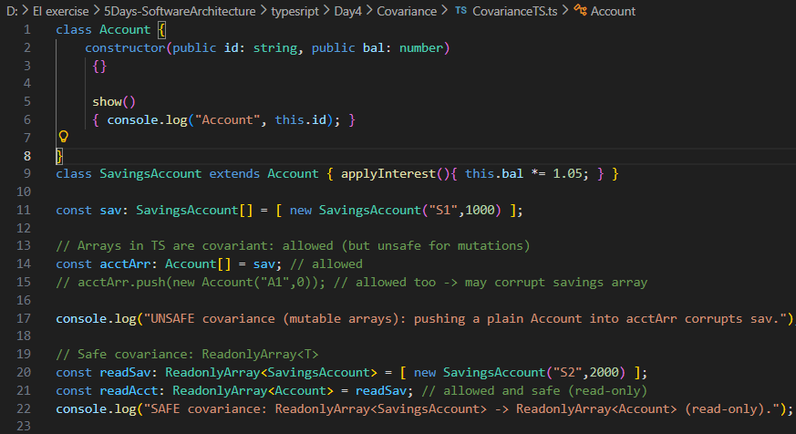
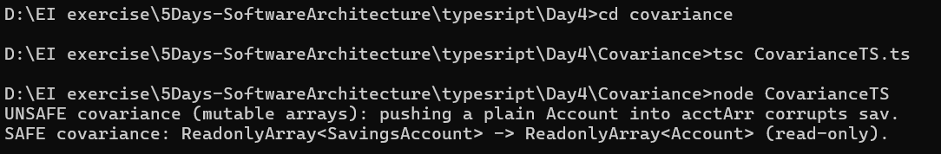

3.CONTRAVARIANCE?:
If A is a subtype of B, then Container<B> IS a subtype of Container<A>
Given example:
In java:
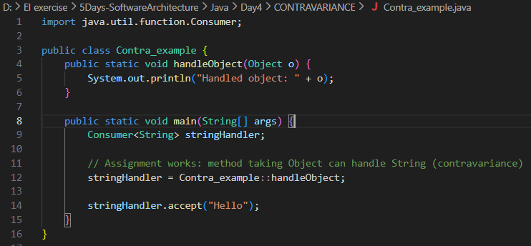
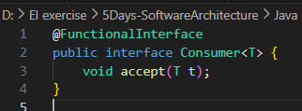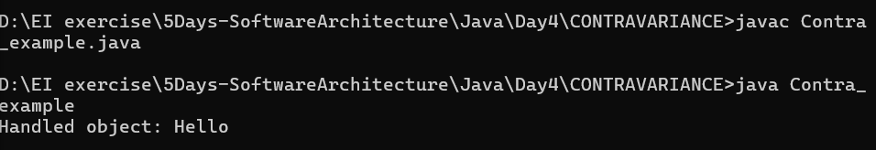
In typescript:
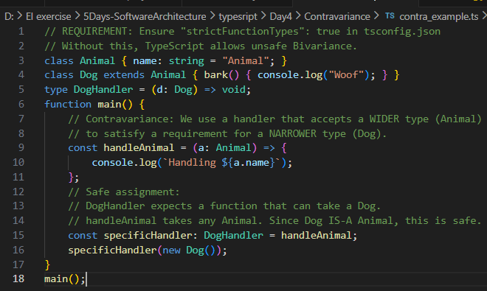
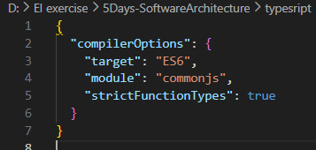
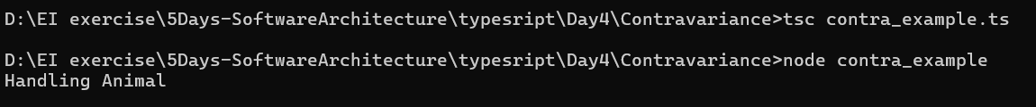 ‘
My Example: Bank Management
- A bank system with: A method that processes accounts.
- A processor expecting a general account (BankAccount) , can also process specific accounts (SavingsAccount).
- So:
Processor<BankAccount> can substitute Processor<SavingsAccount>

In java:
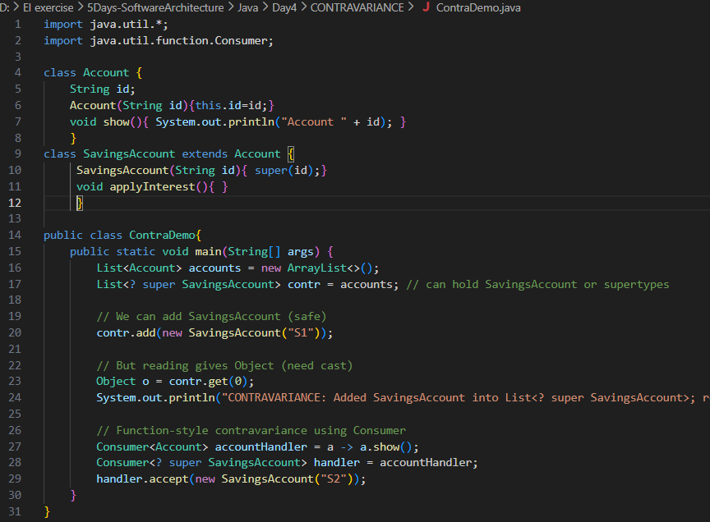
In Typescript: - handleAnyAccount can handle any account, so assigning it to a SavingsAccount consumer is safe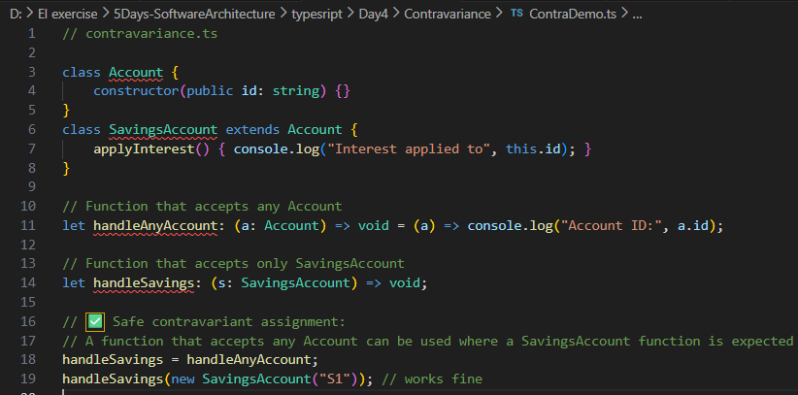
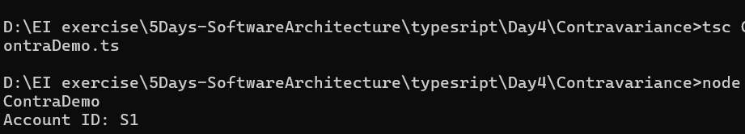

Bivariance- To assign a function to another function type even if the parameter types don’t strictly match — in both direction.
They causes runtime errors
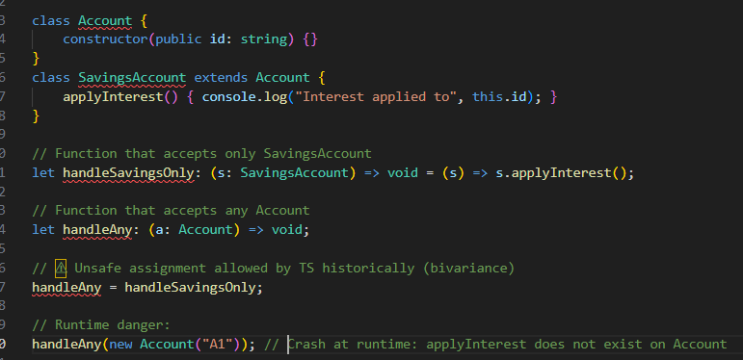
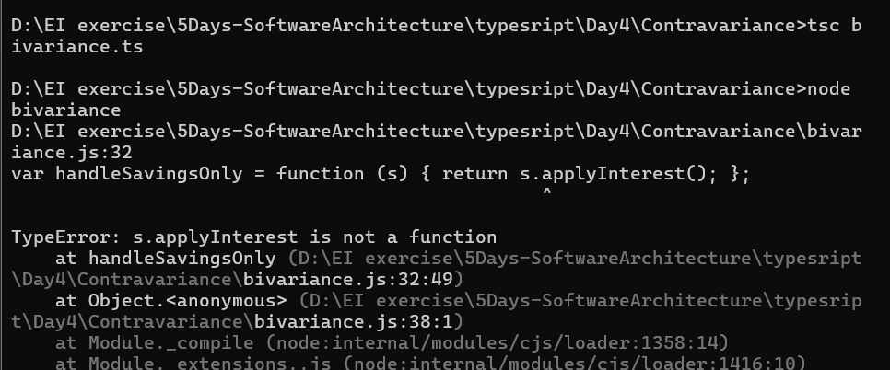

strictFunctionTypes:
Step | Behavior
Without strictFunctionTypes | TS allows unsafe function assignment (bivariance). Code compiles → runtime may crash if function misused.
With strictFunctionTypes | TS blocks unsafe assignment at compile time (enforces contravariance). Code won’t compile.
Running JS in Node | Node does not know TS types. JS runs fine even if assignment is unsafe (type info is erased).

Using tsconfig.json with strict :true
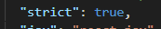
Shows Compile time error as –
- cannot assign a function that expects a narrower type (SavingsAccount) to a variable that expects a wider type (Account) because it could be called with a plain Account
- This prevents unsafe assignments before you even run your code.
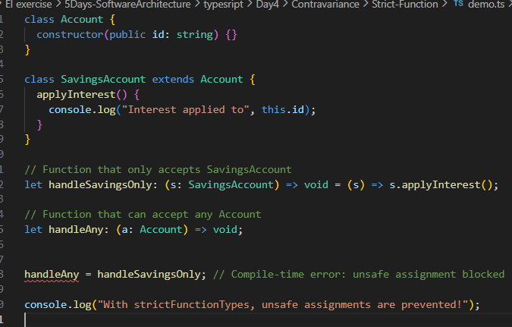
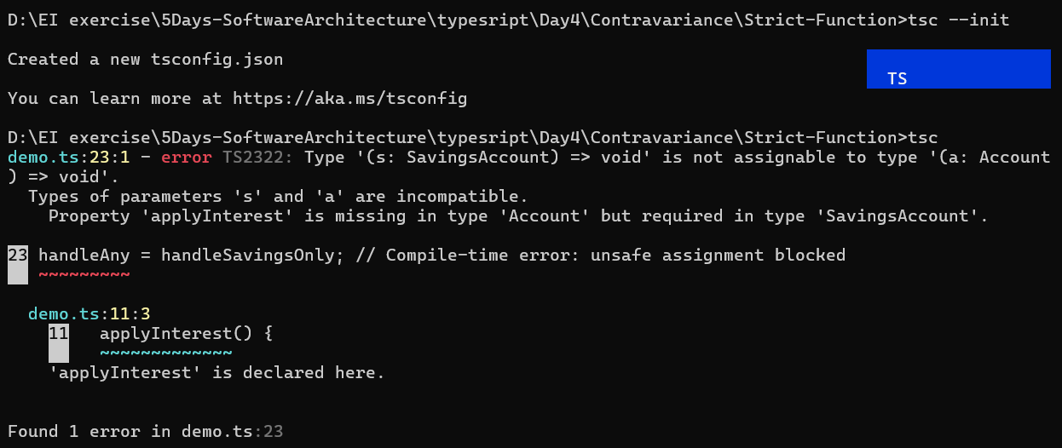

Change them to uncomment then sno error occurs , code execute successfully
--strictFunctionTypes → TS enables strict function type checking.
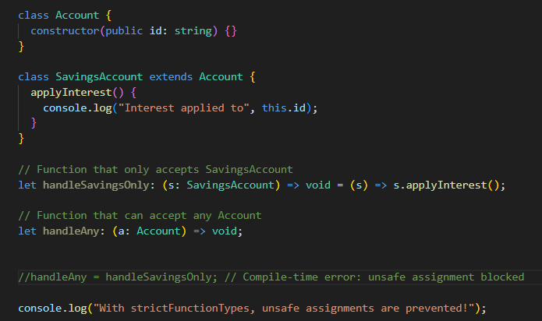
Distinguish Invariance, Covariance, and Contravariance
Concept | Direction | Safe For | Unsafe For
Invariance | None | Read + Write | N/A
Covariance | Child → Parent | Read-only | Writing
Contravariance | Parent → Child | Writing | Reading

