Submitted by – Rithika
Blackbox?: (SonarQube, Chatgpt,..)
Hides the internal working
i/p -> o/p
Ex: ATM Machine ( Enter pin -> money comes out but, internal banking logic is hidden.)
Problems:
- cannot improve system design
- don’t understand the real reason behind results
First-Principles Reconstruction?:
Looks at Internal Mechanism - > Rebuild the logic from scratch
Software Architecture?:
Planning , Structuring , designing how the whole system works together.
Not about coding
Code Quality?:
How good, clean, understandable, and maintainable the code is
Ex :( Poor code – what a, b,c represent no one knows)
int a=10,b=20,c=a+b;
System.out.println(c);
Ex :( Good code- Readable , understandable)
int marksTamil = 10;
int marksEnglish = 20;
int totalMarks = marksTamil + marksEnglish;
System.out.println(totalMarks);

Coupling?:
How much one part of the code depends on another part
Classes tightly connected -> tight coupling
Ex:( Tight coupling)
Class A depends /tied to class B
If Class B is replaced or Methods in class B is changed , then A must also be changed
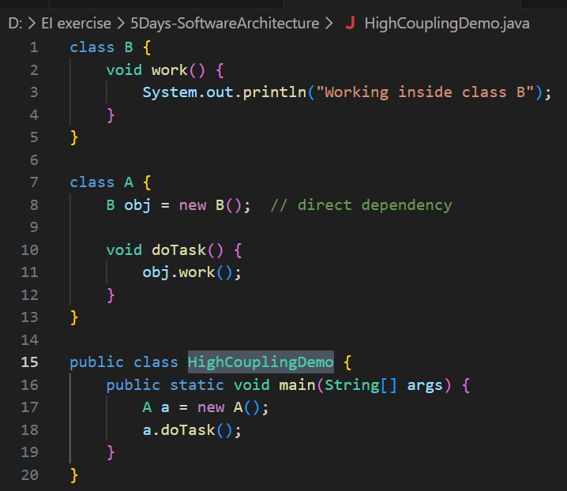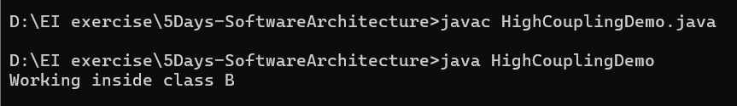
Classes work independently -> loose coupling
EX :( Loose Coupling - Uses interface to reduce dependency)
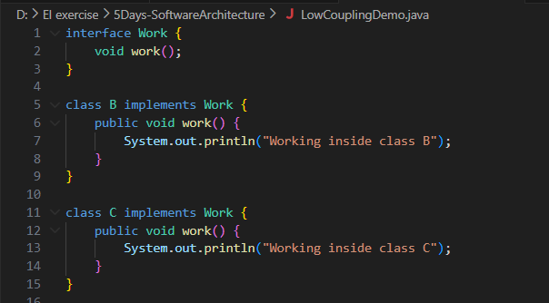
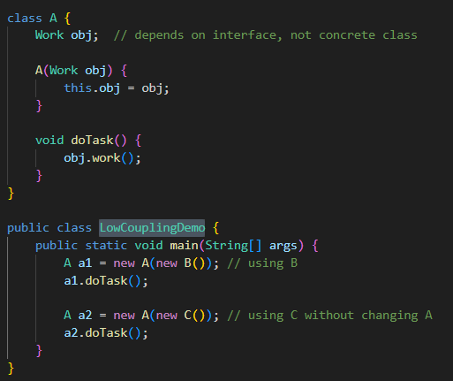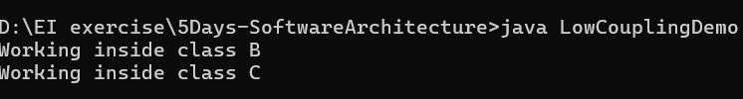

Cohesion?:
How much the parts inside a single module/class belong together and focus on doing one specific job
Low Cohesion : one class tries to do too many unrelated things.
EX:
class StudentManager {
void calculateMarks() { }
void printReport() { }
void storeDatabase() { }
void sendSMS() { }
}
High cohesion : each module/class has one clear purpose
Ex: - Each class has one responsibility
class MarksCalculator {
void calculateMarks() { }
}

class ReportPrinter {
void printReport() { }
}

class DatabaseStore {
void storeDatabase() { }
}

class SmsSender {
void sendSMS() { }
}
Low Cohesion: One module [Messy Module]
├── Marks
├── Print
├── Save DB
└── Send SMS
High Cohesion: each separate modules- [Marks] [Print] [DB] [SMS]
Note :
Good architecture needs:
- Low Coupling (less dependency between modules)
- High Cohesion (each module focused on one job)
Complexity?:
How complicated your code is to understand, test, and maintain.
Having so many conditions, branches, loops – complexity increases
Cyclomatic Complexity?:
A number that tells how many independent paths exist in your code.
CC= Number of decision +1

M = E - N + 2P
E = the number of edges in the control flow graph
N = the number of nodes in the control flow graph
P = the number of connected components
M= Cyclomatic complexity
Ex : E=7, N=7, P=1 = 7-7+2= 2
A = 10
IF B > C THEN
A = B
ELSE
A = C
ENDIF
Print A
Print B
Print C
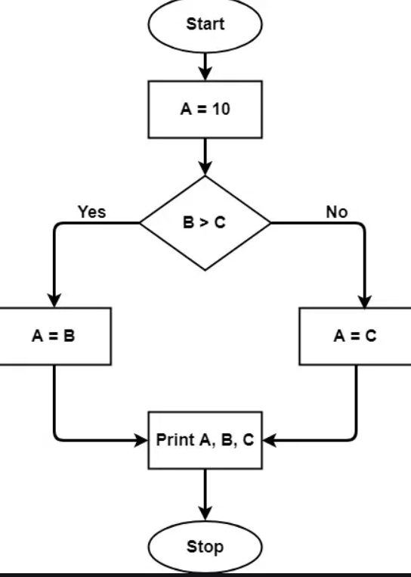

Abstraction?
hiding details and showing only what is necessary
Virtual Method Table?:
The exact method that needs to be called is decided at runtime using a structure called the Virtual Method Table (VTable).
Object Memory
| Object Header |
| VTable Pointer | ---> [Address of obj.Method]
| Fields |
- Read the VTable pointer
- Look up the correct function address
- Jump to that function
Ex:
class Student {
void study() {
System.out.println("Student is studying general subjects");
}
}
class ScienceStudent extends Student {
@Override
void study() {
System.out.println("Science student is studying Physics and Chemistry");
}
}
class ArtsStudent extends Student {
@Override
void study() {
System.out.println("Arts student is studying History and Literature");
}
}
public class VirtualMethodStudentDemo {
static void startStudy(Student s) {
s.study();
}
public static void main(String[] args) {
Student s1 = new ScienceStudent();
s1.study(); // Output: Science student is studying Physics and Chemistry
Student s2 = new ArtsStudent();
s2.study(); // Output: Arts student is studying History and Literature
ScienceStudent sc = new ScienceStudent();
sc.study(); // Output: Science student is studying Physics and Chemistry
ArtsStudent ar = new ArtsStudent();
ar.study(); // Output: Arts student is studying History and Literature
System.out.println("\n--- Using method with Student reference ---");
startStudy(s1); // Output: Science student is studying Physics and Chemistry
startStudy(s2); // Output: Arts student is studying History and Literature
System.out.println("\n--- Randomized student example ---");
Student s3;
if (Math.random() > 0.5) {
s3 = new ScienceStudent();
} else {
s3 = new ArtsStudent();
}
s3.study(); // Could be Science or Arts depending on runtime
}
}
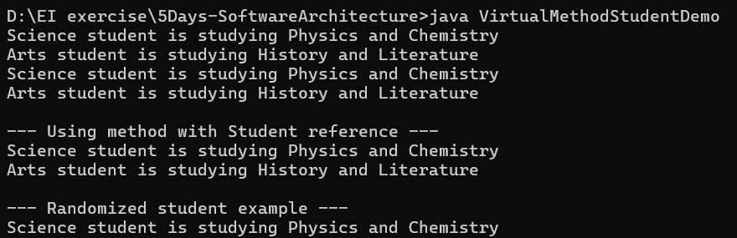
Thus Abstraction have Cost - Look up VTable → then jump, Slightly slow
Compiler Optimization?(Microbenching Trap):
- Devirtualization
It converts the virtual call into a direct call, skipping the VTable lookup
Before:
VTable lookup -> call obj.Method()
After:
Direct call- > call obj.Method()
- Inlining:
Complier replace method call with actual method body
No method call , No virtual dispatch
- PGO- Profile Guided Optimization:
The runtime observes which branches and methods are actually used at runtime.
How to Force Real Virtual Dispatch?:
- Reflection: to call methods dynamically by name at runtime, so the compiler cannot optimize.
- Randomized obj : Use of random func(), to find which obj to be used at runtime so that the compiler cannot optimize.

IN Java -Randomized :
import java.util.Random;

class Student {
void study() {
int x = 0;
x++;
}
}

class ScienceStudent extends Student {
@Override
void study() {
int x = 1;
x++;
}
}

class ArtsStudent extends Student {
@Override
void study() {
int x = 2;
x++;
}
}

public class VirtualCallBenchmark {
public static void main(String[] args) {
final int iterations = 10_000_000;
Random random = new Random();

Student s1 = new ScienceStudent();
long start1 = System.nanoTime();
for (int i = 0; i < iterations; i++) {
s1.study();
}
long end1 = System.nanoTime();
System.out.println("Optimized virtual call (same type): " + (end1 - start1) + " ns");

long start2 = System.nanoTime();
for (int i = 0; i < iterations; i++) {
Student s = random.nextBoolean() ? new ScienceStudent() : new ArtsStudent();
s.study();
}
long end2 = System.nanoTime();
System.out.println("Forced virtual call (random type): " + (end2 - start2) + " ns");
}
}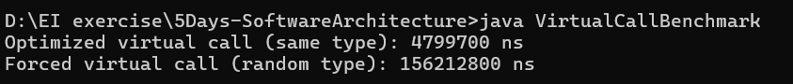
IN TYPESCRIPT- Randomized obj:
class Student {
study(): void {
let x = 0;
x++;
}}
class ScienceStudent extends Student {
study(): void {
let x = 1;
x++;
}}
class ArtsStudent extends Student {
study(): void {
let x = 2;
x++;
}}
const iterations = 10_000_000;
let s1: Student = new ScienceStudent();
let start1 = performance.now();
for (let i = 0; i < iterations; i++) s1.study();
let end1 = performance.now();
console.log(`Optimized virtual call (same type): ${end1 - start1} ms`);
let random = () => Math.random() > 0.5;
let start2 = performance.now();
for (let i = 0; i < iterations; i++) {
let s: Student = random() ? new ScienceStudent() : new ArtsStudent();
s.study();
}
let end2 = performance.now();
console.log(`Forced virtual call (random type): ${end2 - start2} ms`);
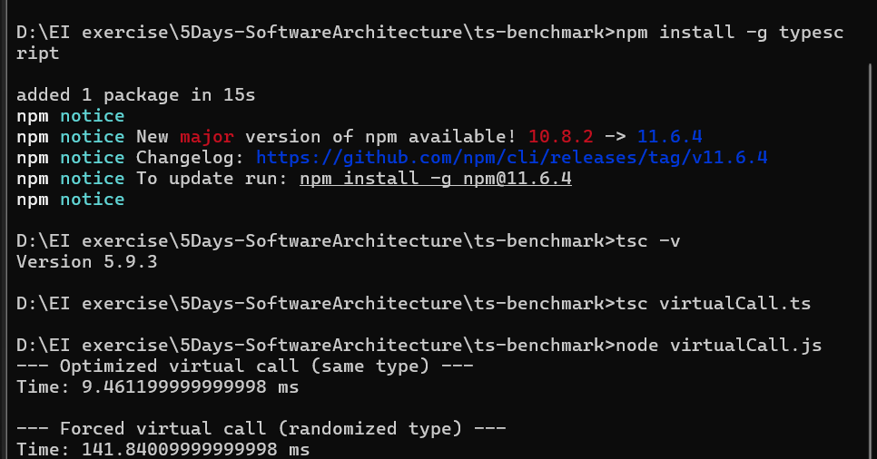
In Java – Reflection
import java.lang.reflect.Method;
class Student {
public void study() {
System.out.println("Student studies general subjects");
}
}
class ScienceStudent extends Student {
@Override
public void study() {
System.out.println("Science student studies Physics and Chemistry");
}}
class ArtsStudent extends Student {
@Override
public void study() {
System.out.println("Arts student studies History and Literature");
}}
public class ReflectionDemo {
public static void main(String[] args) throws Exception {
Student s1 = new ScienceStudent();
Student s2 = new ArtsStudent();

System.out.println("--- Normal Virtual Call ---");
Student s = s1;
s.study();
System.out.println("\n--- Reflection Call ---");
s = Math.random() > 0.5 ? s1 : s2;
Method m = s.getClass().getMethod("study");
m.invoke(s);
}}
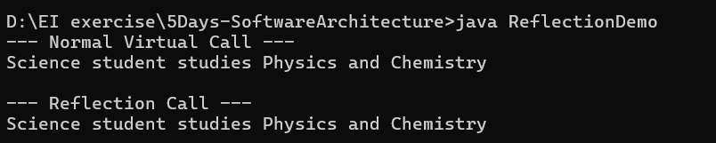
In TypeScript:
class Student {
study(): void {
console.log("Student studies general subjects");
}}
class ScienceStudent extends Student {
study(): void {
console.log("Science student studies Physics and Chemistry");
}}
class ArtsStudent extends Student {
study(): void {
console.log("Arts student studies History and Literature"); }}
const s1: Student = new ScienceStudent();
const s2: Student = new ArtsStudent();
console.log("--- Normal Virtual Call ---");
let s: Student = s1;
s.study();
console.log("\n--- Reflection Call ---");
s = Math.random() > 0.5 ? s1 : s2;
(s as any)["study"]();
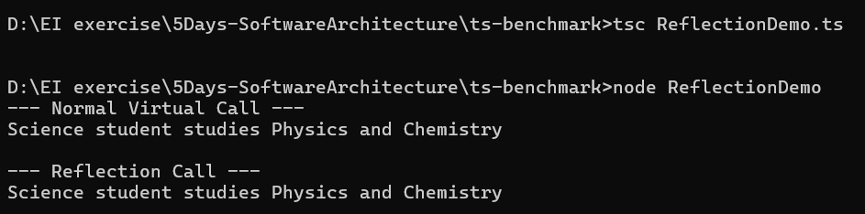
Comparative study :
Type | What it does | Optimization possibility
Virtual call | Always ScienceStudent | JVM may inline / devirtualize → fastest
Randomized call | Random ScienceStudent or ArtsStudent | True virtual call (VTable lookup) → slower than optimized
Reflection call | Random + method via reflection | Forced runtime lookup → slowest, no compiler optimization

Weighted Methods per Class (WMC)?:
calculating the weight for each method.
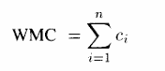
Metric | High WMC | Low WMC
Maintainability | Hard | Easy
Testability | Hard | Easy
Cyclomatic Complexity | High | Low
Reusability | Low | High
Example Class | Processor | CleanProcessor

Ex : IN java
Class Processor: One method with nested logic, CC is high → High WMC
Class CleanProcessor: Split logic → each method simple, CC low → Low WMC
Benefit: Easier to test, extend, maintain, reuse
// POOR: High WMC
class Processor {
void process(String user, double amount) {
if (user != null && !user.isEmpty()) {
if (amount > 0) {
System.out.println("Valid user and amount, processing...");
if (amount < 1000) {
System.out.println("Small payment, fast track");
} else {
System.out.println("Large payment, require approval");
}
} else {
System.out.println("Invalid amount!");
}
} else {
System.out.println("Invalid user!");
}}}
// GOOD: Low WMC (Split logic into multiple methods)
class CleanProcessor {
void process(String user, double amount) {
if (!validateUser(user)) return;
if (!validateAmount(amount)) return;
handlePayment(amount);
}
private boolean validateUser(String user) {
if (user == null || user.isEmpty()) {
System.out.println("Invalid user!");
return false;
}
return true;
}
private boolean validateAmount(double amount) {
if (amount <= 0) {
System.out.println("Invalid amount!");
return false;
}
return true;
}
private void handlePayment(double amount) {
System.out.println("Processing payment: " + amount);
if (amount < 1000) System.out.println("Small payment, fast track");
else System.out.println("Large payment, require approval");
}}
public class WMCExample {
public static void main(String[] args) {
new Processor().process("Alice", 500);
new CleanProcessor().process("Bob", 1500);
}
}
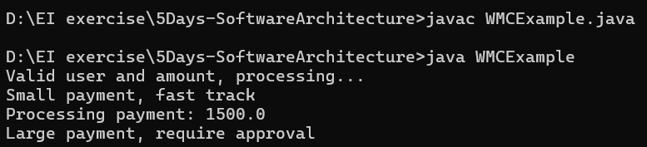
In TypeScript:
// POOR: High WMC
class Processor {
process(user: string, amount: number): void {
if (user && user.length > 0) {
if (amount > 0) {
console.log("Valid user and amount, processing...");
if (amount < 1000) console.log("Small payment, fast track");
else console.log("Large payment, require approval");
} else {
console.log("Invalid amount!");
}
} else {
console.log("Invalid user!");
}}}
// GOOD: Low WMC
class CleanProcessor {
process(user: string, amount: number): void {
if (!this.validateUser(user)) return;
if (!this.validateAmount(amount)) return;
this.handlePayment(amount);
}

private validateUser(user: string): boolean {
if (!user || user.length === 0) {
console.log("Invalid user!");
return false;
}
return true;
}
private validateAmount(amount: number): boolean {
if (amount <= 0) {
console.log("Invalid amount!");
return false;
}
return true;
}
private handlePayment(amount: number): void {
console.log("Processing payment:", amount);
if (amount < 1000) console.log("Small payment, fast track");
else console.log("Large payment, require approval");
}
}
new Processor().process("Alice", 500);
new CleanProcessor().process("Bob", 1500);
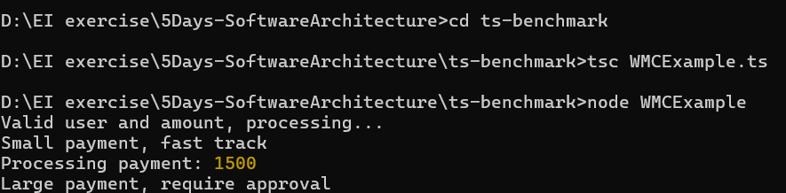
Depth of Inheritance Tree?:
The maximum level reached by walking the dependency tree ecursively so until an element is encountered which does not Extends anything.
High DIT= Tight coupling
Here DIT = 4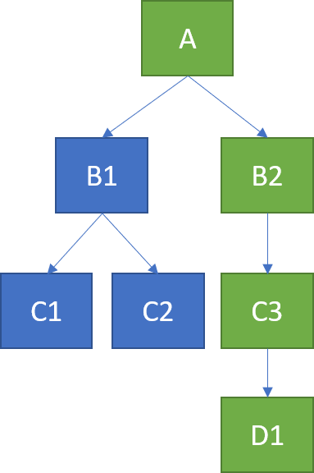
In Java:
import java.lang.reflect.Field;

class Widget {
protected boolean enabled = true;
public void render() { System.out.println("Widget render (enabled=" + enabled + ")"); }
}

class Button extends Widget {
public void render() { System.out.println("Button render (enabled=" + enabled + ")"); }
}

class ActionButton extends Button {
public void render() { System.out.println("ActionButton render (enabled=" + enabled + ")"); }
public void act() { System.out.println("ActionButton.act()"); }
}

class SaveButton extends ActionButton {
public void render() {
if (!enabled) System.out.println("SaveButton disabled");
else System.out.println("SaveButton render (saving enabled)");
}
}

interface Clickable {
void click();
}

class Renderer {
void render(String what, boolean enabled) {
if (!enabled) System.out.println(what + " render: Disabled");
else System.out.println(what + " render: OK");
}
}

class PaymentHandler {
void handlePayment(double amount) { System.out.println("Handling payment: " + amount); }
}

class ComposeButton implements Clickable {
private final Renderer renderer;
private final PaymentHandler paymentHandler;
private boolean enabled = true;

ComposeButton(Renderer r, PaymentHandler p) {
this.renderer = r;
this.paymentHandler = p;
}

public void click() {
if (!enabled) { System.out.println("ComposeButton: Disabled"); return; }
renderer.render("ComposeButton", enabled);
paymentHandler.handlePayment(42.0);
}

public void setEnabled(boolean e) { this.enabled = e; }
}

public class DitFragileDemo {
public static void main(String[] args) throws Exception {
System.out.println("=== DEEP INHERITANCE (POOR) ===");
SaveButton save = new SaveButton();
System.out.println("Initial call:");
save.render();
Field f = Widget.class.getDeclaredField("enabled");
f.setAccessible(true);
f.setBoolean(save, false);
System.out.println("After base-change simulation:");
save.render();
System.out.println("\n=== COMPOSITION (GOOD) ===");
Renderer r = new Renderer();
PaymentHandler p = new PaymentHandler();
ComposeButton cb = new ComposeButton(r, p);
System.out.println("ComposeButton click (enabled true):");
cb.click();
cb.setEnabled(false);
System.out.println("ComposeButton click (enabled false):");
cb.click();
}
}
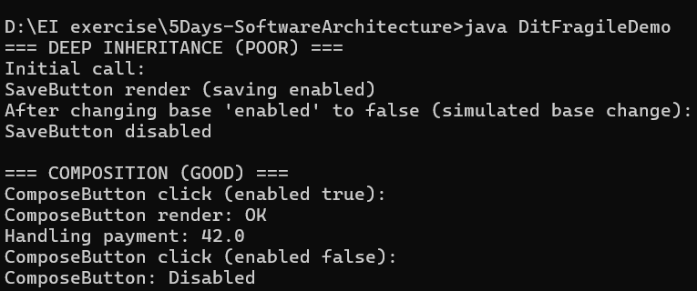
In TypeScript:
class Widget {
protected enabled: boolean = true;
render() { console.log(`Widget render (enabled=${this.enabled})`); }
}

class Button extends Widget {
render() { console.log(`Button render (enabled=${this.enabled})`); }
}

class ActionButton extends Button {
render() { console.log(`ActionButton render (enabled=${this.enabled})`); }
act() { console.log("ActionButton.act()"); }
}

class SaveButton extends ActionButton {
render() {
if (!this.enabled) console.log("SaveButton disabled");
else console.log("SaveButton render (saving enabled)");
}
}

interface IClickable { click(): void; }

class Renderer {
render(what: string, enabled: boolean) {
if (!enabled) console.log(`${what} render: Disabled`);
else console.log(`${what} render: OK`);
}
}

class PaymentHandler {
handlePayment(amount: number) { console.log(`Handling payment: ${amount}`); }
}

class ComposeButton implements IClickable {
private enabled = true;
constructor(private renderer: Renderer, private paymentHandler: PaymentHandler) {}
click(): void {
if (!this.enabled) { console.log("ComposeButton: Disabled"); return; }
this.renderer.render("ComposeButton", this.enabled);
this.paymentHandler.handlePayment(99.99);
}
setEnabled(e: boolean) { this.enabled = e; }
}

console.log("=== DEEP INHERITANCE (POOR) ===");
const save = new SaveButton();
console.log("Initial call:");
save.render();
(save as any).enabled = false;
console.log("After base-change simulation:");
save.render();

console.log("\n=== COMPOSITION (GOOD) ===");
const renderer = new Renderer();
const payment = new PaymentHandler();
const cb = new ComposeButton(renderer, payment);
console.log("ComposeButton click (enabled true):");
cb.click();
cb.setEnabled(false);
console.log("ComposeButton click (enabled false):");
cb.click();
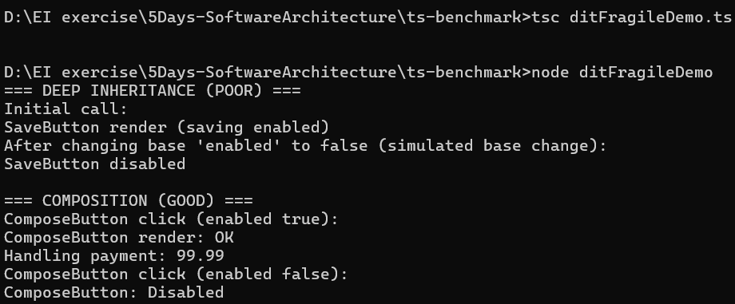
Number of children: NOC
Number of immediate subclasses subordinated to the class in the class hierarchy
IN java:
Design | Meaning | Why it Matters
POOR: Concrete BaseShape with children | High NOC on concrete class | A change in BaseShape affects Circle and Square unintentionally (ripple effect — fragile)
GOOD: IShape interface with decorator + registry | High NOC on interface | Many safe extensions; no ripple effect; new shapes added without modifying existing code

import java.util.ArrayList;
import java.util.List;
class BaseShape {
public void draw() {
System.out.println("[BaseShape] set color = RED");
}
}

class Circle extends BaseShape {
public void draw() {
super.draw();
System.out.println("Circle draws");
}
}

class Square extends BaseShape {
public void draw() {
super.draw();
System.out.println("Square draws");
}
}

interface IShape {
void draw();
}

class GoodCircle implements IShape {
public void draw() { System.out.println("GoodCircle draws"); }
}

class GoodSquare implements IShape {
public void draw() { System.out.println("GoodSquare draws"); }
}

class ColoredShapeDecorator implements IShape {
private final IShape inner;
private final String color;
ColoredShapeDecorator(IShape inner, String color) {
this.inner = inner;
this.color = color;
}
public void draw() {
System.out.println("[Decorator] set color = " + color);
inner.draw();
}
}

class ShapeRegistry {
private static final List<Class<? extends IShape>> implementations = new ArrayList<>();
static void register(Class<? extends IShape> impl) { implementations.add(impl); }
static int noc() { return implementations.size(); }
static List<IShape> createAll() {
List<IShape> list = new ArrayList<>();
for (Class<? extends IShape> c : implementations) {
try { list.add(c.getDeclaredConstructor().newInstance()); }
catch (Exception e) {}
}
return list;
}
}
public class NocDemo {
public static void main(String[] args) {
System.out.println("=== POOR DESIGN ===");
List<BaseShape> poor = List.of(new Circle(), new Square());
poor.forEach(BaseShape::draw);

System.out.println("\nBaseShape color changed → downstream effects:");
poor.forEach(s -> System.out.println(s.getClass().getSimpleName() + " now behaves differently due to shared change"));

System.out.println("\n=== GOOD DESIGN ===");
ShapeRegistry.register(GoodCircle.class);
ShapeRegistry.register(GoodSquare.class);
System.out.println("NOC = " + ShapeRegistry.noc());
ShapeRegistry.createAll().forEach(s -> new ColoredShapeDecorator(s, "GREEN").draw());

System.out.println("\nAdd new implementation dynamically:");
class GoodTriangle implements IShape { public void draw() { System.out.println("GoodTriangle draws"); } }
ShapeRegistry.register(GoodTriangle.class);
System.out.println("NOC = " + ShapeRegistry.noc());
ShapeRegistry.createAll().forEach(s -> new ColoredShapeDecorator(s, "PURPLE").draw());
}
}
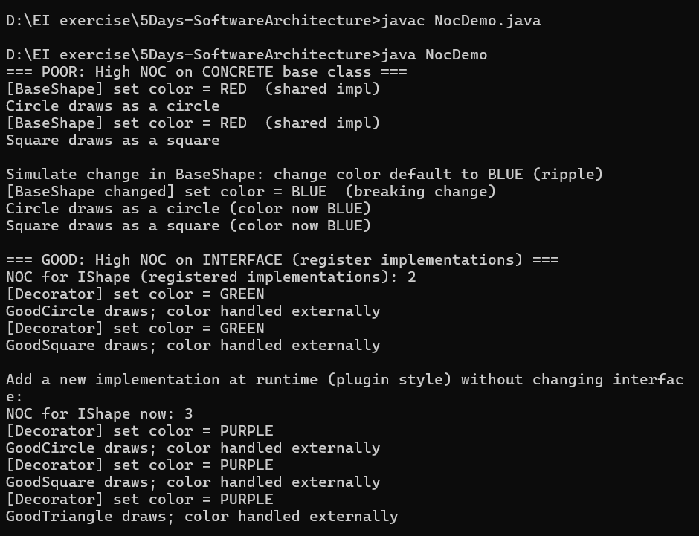
In TypeScript:
class BaseShape {
draw() { console.log("[BaseShape] set color = RED"); }
}
class Circle extends BaseShape {
draw() { super.draw(); console.log("Circle draws"); }
}
class Square extends BaseShape {
draw() { super.draw(); console.log("Square draws"); }
}

interface IShape { draw(): void; }

class GoodCircle implements IShape {
draw() { console.log("GoodCircle draws"); }
}
class GoodSquare implements IShape {
draw() { console.log("GoodSquare draws"); }
}

class ColoredShapeDecorator implements IShape {
constructor(private inner: IShape, private color: string) {}
draw() {
console.log(`[Decorator] set color = ${this.color}`);
this.inner.draw();
}
}

class ShapeRegistry {
private static impls: Array<new () => IShape> = [];
static register(impl: new () => IShape) { this.impls.push(impl); }
static noc(): number { return this.impls.length; }
static createAll(): IShape[] { return this.impls.map(C => new C()); }
}

console.log("=== POOR DESIGN ===");
const poorShapes = [new Circle(), new Square()];
poorShapes.forEach(s => s.draw());

console.log("\nBaseShape changed → downstream effects:");
poorShapes.forEach(s => console.log(s.constructor.name + " affected"));

console.log("\n=== GOOD DESIGN ===");
ShapeRegistry.register(GoodCircle);
ShapeRegistry.register(GoodSquare);
console.log("NOC =", ShapeRegistry.noc());
ShapeRegistry.createAll().forEach(s => new ColoredShapeDecorator(s, "GREEN").draw());

console.log("\nAdd new implementation:");
class GoodTriangle implements IShape { draw() { console.log("GoodTriangle draws"); } }
ShapeRegistry.register(GoodTriangle);
console.log("NOC =", ShapeRegistry.noc());
ShapeRegistry.createAll().forEach(s => new ColoredShapeDecorator(s, "PURPLE").draw());
Design | Meaning | Why it Matters
POOR — BaseShape subclassing | High NOC on concrete class | Central logic change breaks all children
GOOD — IShape interface extensibility | High NOC on abstraction | New shapes are added safely and independently

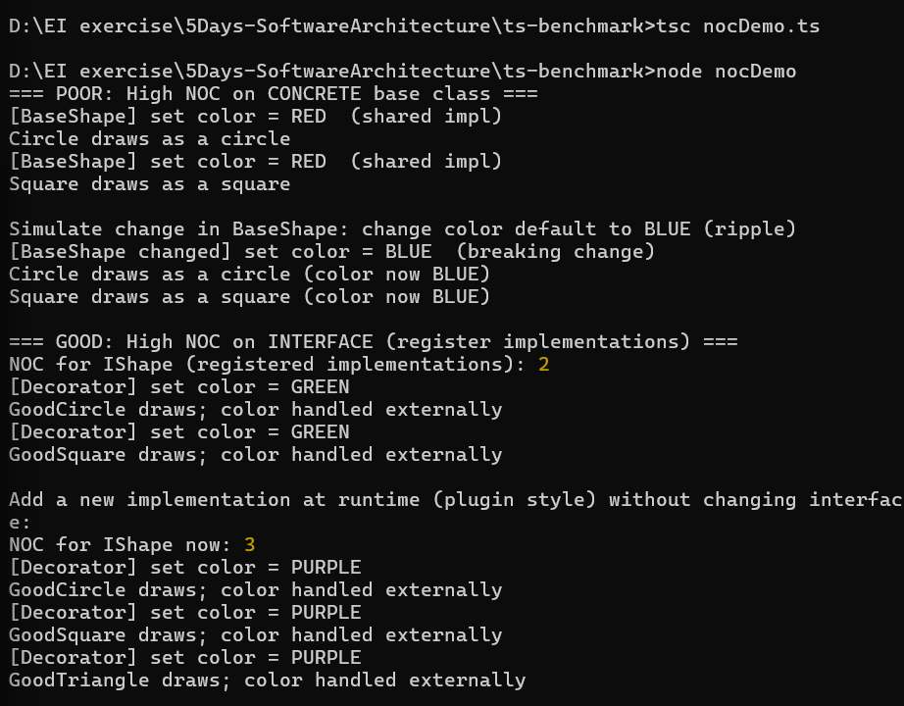

Coupling Between the Object Class?
The count of the number of other classes to which it is coupled
In java:
import java.util.ArrayList;
import java.util.List;

class Logger {
void log(String msg) { System.out.println("[Logger] " + msg); }
}

class SqlDatabase {
void save(String payload) { System.out.println("[SqlDatabase] saved: " + payload); }
}

class LegacyDb {
void persist(String payload) { System.out.println("[LegacyDb] persisted: " + payload); }
}

class LegacyDbAdapter extends SqlDatabase {
private final LegacyDb legacy = new LegacyDb();
@Override
void save(String payload) { legacy.persist(payload); }
}

class Order {
final String id;
final double amount;
Order(String id, double amount) { this.id = id; this.amount = amount; }
public String toString() { return id + ":" + amount; }
}

class OrderService {
void checkout(Order o) {
Logger logger = new Logger();
SqlDatabase db = new SqlDatabase();
logger.log("Processing " + o);
db.save(o.toString());
logger.log("Completed " + o);
}
}

interface ILogger { void log(String msg); }
interface IDatabase { void save(String payload); }

class CleanOrderService {
private final ILogger logger;
private final IDatabase db;
CleanOrderService(ILogger logger, IDatabase db) { this.logger = logger; this.db = db; }
void checkout(Order o) {
logger.log("Processing " + o);
db.save(o.toString());
logger.log("Completed " + o);
}
}

class MockLogger implements ILogger { public void log(String msg) { System.out.println("[MockLogger] " + msg); } }
class MockDatabase implements IDatabase { public void save(String payload) { System.out.println("[MockDatabase] saved: " + payload); } }

interface EventListener { void on(Object event); }

class EventBus {
private final List<EventListener> listeners = new ArrayList<>();
void subscribe(EventListener l) { listeners.add(l); }
void publish(Object e) { for (EventListener l : listeners) l.on(e); }
}

class EventOrderService {
private final EventBus bus;
EventOrderService(EventBus bus) { this.bus = bus; }
void checkout(Order o) { bus.publish(o); }
}

class OrderHandler implements EventListener {
private final ILogger logger;
private final IDatabase db;
OrderHandler(ILogger logger, IDatabase db) { this.logger = logger; this.db = db; }
public void on(Object event) {
if (!(event instanceof Order)) return;
Order o = (Order) event;
logger.log("Event handling " + o);
db.save(o.toString());
}
}
public class OrderCboDemo {
public static void main(String[] args) {
System.out.println("=== POOR: High CBO (tight coupling) ===");
OrderService poor = new OrderService();
poor.checkout(new Order("o-1", 99.9));
System.out.println("\n=== GOOD: Low CBO (DI via interfaces) ===");
CleanOrderService clean = new CleanOrderService(new MockLogger(), new MockDatabase());
clean.checkout(new Order("o-2", 199.9));
System.out.println("\n=== GOOD: Adapter for legacy DB (still low CBO) ===");
CleanOrderService adapted = new CleanOrderService(new Logger()::log, new LegacyDbAdapter()::save);
adapted.checkout(new Order("o-3", 299.9));
System.out.println("\n=== GOOD: Event-driven decoupling ===");
EventBus bus = new EventBus();
OrderHandler handler = new OrderHandler(new Logger()::log, new MockDatabase());
bus.subscribe(handler);
EventOrderService evtService = new EventOrderService(bus);
evtService.checkout(new Order("o-4", 49.9));
}
}
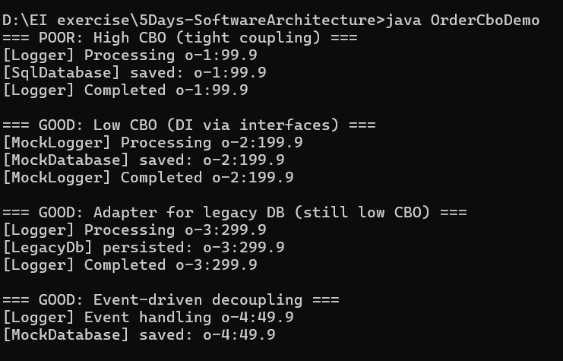
In TypeScript:
class Logger {
log(msg: string) { console.log("[Logger] " + msg); }
}
class SqlDatabase {
save(payload: string) { console.log("[SqlDatabase] saved: " + payload); }
}
class LegacyDb {
persist(payload: string) { console.log("[LegacyDb] persisted: " + payload); }
}
class LegacyDbAdapter extends SqlDatabase {
private legacy = new LegacyDb();
save(payload: string) { this.legacy.persist(payload); }
}
type Order = { id: string, amount: number };

class OrderService {
checkout(o: Order) {
const logger = new Logger();
const db = new SqlDatabase();
logger.log("Processing " + JSON.stringify(o));
db.save(JSON.stringify(o));
logger.log("Completed " + JSON.stringify(o));
}
}

interface ILogger { log(msg: string): void; }
interface IDatabase { save(payload: string): void; }

class CleanOrderService {
constructor(private logger: ILogger, private db: IDatabase) {}
checkout(o: Order) {
this.logger.log("Processing " + JSON.stringify(o));
this.db.save(JSON.stringify(o));
this.logger.log("Completed " + JSON.stringify(o));
}
}
class MockLogger implements ILogger { log(msg: string) { console.log("[MockLogger] " + msg); } }
class MockDatabase implements IDatabase { save(payload: string) { console.log("[MockDatabase] saved: " + payload); } }
class EventBus {
private listeners: Array<(e: any) => void> = [];
subscribe(fn: (e: any) => void) { this.listeners.push(fn); }
publish(e: any) { this.listeners.forEach(fn => fn(e)); }
}
class EventOrderService {
constructor(private bus: EventBus) {}
checkout(o: Order) { this.bus.publish(o); }
}
function orderHandlerFactory(logger: ILogger, db: IDatabase) {
return (e: any) => {
if (!e || !e.id) return;
logger.log("Event handling " + JSON.stringify(e));
db.save(JSON.stringify(e));
};
}
console.log("=== POOR: High CBO (tight coupling) ===");
new OrderService().checkout({ id: "o-1", amount: 99.9 });
console.log("\n=== GOOD: Low CBO (DI via interfaces) ===");
new CleanOrderService(new MockLogger(), new MockDatabase()).checkout({ id: "o-2", amount: 199.9 });
console.log("\n=== GOOD: Adapter for legacy DB ===");
new CleanOrderService(new Logger(), new LegacyDbAdapter()).checkout({ id: "o-3", amount: 299.9 });
console.log("\n=== GOOD: Event-driven decoupling ===");
const bus = new EventBus();
bus.subscribe(orderHandlerFactory(new Logger(), new MockDatabase()));
const evt = new EventOrderService(bus);
evt.checkout({ id: "o-4", amount: 49.9 });
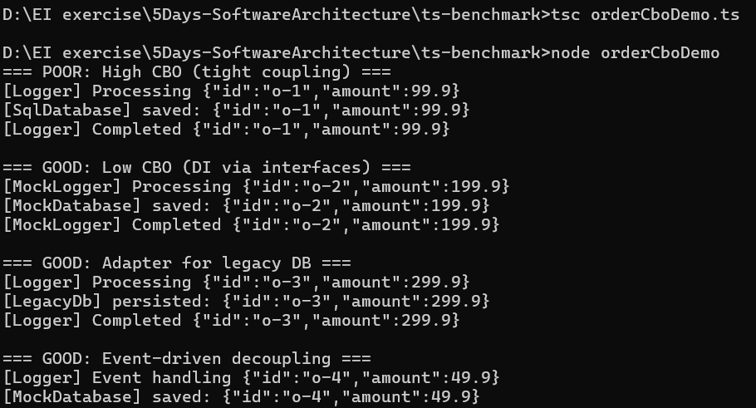

Response For a Class (RFC)?
|RS| where RS= Response set fr the class
RS= { M} U {Ri}
{Ri}-> set of method called by method i
{M} -> set of all methods in the class
In java:
import java.util.Random;
class AuthService {
boolean checkCredentials(String user) { return true; }
}
class Database {
void connect() { System.out.println("[DB] connect"); }
void save(String payload) { System.out.println("[DB] save: " + payload); }
void close() { System.out.println("[DB] close"); }
}
class EmailService {
void sendReceipt(String to, String body) { System.out.println("[Email] to=" + to); }
}
class Logger {
void info(String m) { System.out.println("[Log] " + m); }
void error(String m) { System.out.println("[Log-Err] " + m); }
}
class Order {
final String id; final double amount;
Order(String id, double amount){ this.id = id; this.amount = amount; }
public String toString(){ return id + ":" + amount; }
}
class OrderProcessor { // POOR: chatty object (high RFC)
private final AuthService auth = new AuthService();
private final Database db = new Database();
private final EmailService email = new EmailService();
private final Logger logger = new Logger();
void process(Order o, String user) {
logger.info("Start " + o);
if (!auth.checkCredentials(user)) { logger.error("auth fail"); return; }
db.connect();
db.save(o.toString());
email.sendReceipt(user, "Thanks for order " + o.id);
logger.info("Done " + o);
db.close();
}
// illustrative RFC count (not computed via analysis)
static int illustrativeRFC() {
int M = 1; // methods owned (process)
int R = 6; // external methods called: auth.checkCredentials, db.connect, db.save, email.sendReceipt, logger.info, db.close
return M + R;
}
}
class TransactionFacade { // Facade that groups many calls
private final AuthService auth;
private final Database db;
private final EmailService email;
private final Logger logger;
TransactionFacade(AuthService auth, Database db, EmailService email, Logger logger) {
this.auth = auth; this.db = db; this.email = email; this.logger = logger;
}
boolean handleTransaction(Order o, String user) {
logger.info("Facade start " + o);
if (!auth.checkCredentials(user)) { logger.error("auth fail"); return false; }
db.connect();
db.save(o.toString());
email.sendReceipt(user, "Thanks for order " + o.id);
logger.info("Facade done " + o);
db.close();
return true;
}
}
class CleanProcessor { // GOOD: low RFC because it delegates to a single facade call
private final TransactionFacade facade;
CleanProcessor(TransactionFacade facade){ this.facade = facade; }
void process(Order o, String user){
facade.handleTransaction(o, user);
}
static int illustrativeRFC(){
int M = 1; // process
int R = 1; // facade.handleTransaction
return M + R;
}
}
public class RfcDemo {
public static void main(String[] args){
Order o1 = new Order("o-101", 49.99);
Order o2 = new Order("o-202", 149.50);
System.out.println("=== POOR: High RFC (chatty) ===");
OrderProcessor p = new OrderProcessor();
p.process(o1, "alice@example.com");
System.out.println("OrderProcessor RFC (illustrative) = " + OrderProcessor.illustrativeRFC());
System.out.println("\n=== GOOD: Low RFC (facade) ===");
TransactionFacade facade = new TransactionFacade(new AuthService(), new Database(), new EmailService(), new Logger());
CleanProcessor cp = new CleanProcessor(facade);
cp.process(o2, "bob@example.com");
System.out.println("CleanProcessor RFC (illustrative) = " + CleanProcessor.illustrativeRFC());
System.out.println("\n=== Creative: Run many mixed processors to show behavior ===");
Random rnd = new Random();
for (int i=0;i<3;i++){
Order o = new Order("batch-"+i, rnd.nextDouble()*200);
if (rnd.nextBoolean()) p.process(o, "user@x");
else cp.process(o, "user@y");
} } }
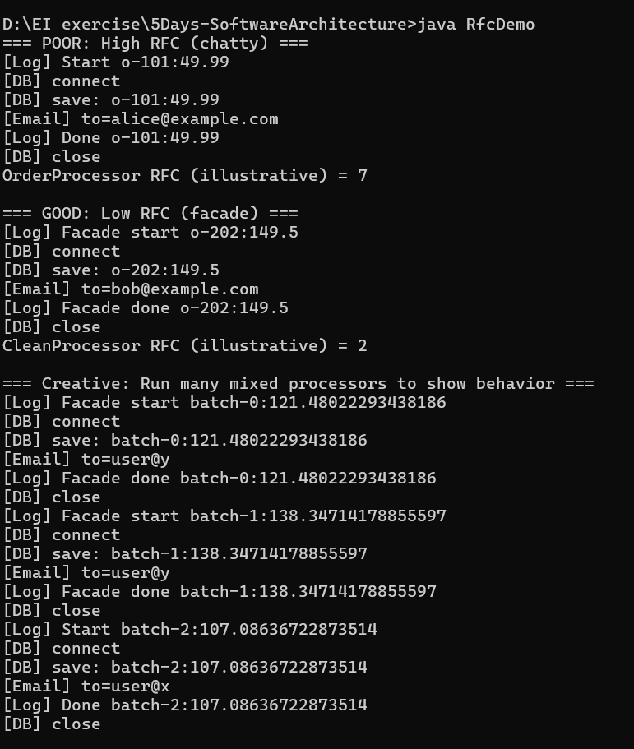

In typescript:
class AuthService {
checkCredentials(user: string): boolean { return true; }
}
class Database {
connect() { console.log("[DB] connect"); }
save(payload: string) { console.log("[DB] save:", payload); }
close() { console.log("[DB] close"); }
}
class EmailService {
sendReceipt(to: string, body: string) { console.log("[Email] to=", to); }
}
class Logger {
info(m: string) { console.log("[Log]", m); }
error(m: string) { console.log("[Log-Err]", m); }
}
type Order = { id: string; amount: number; };

class OrderProcessor {
private auth = new AuthService();
private db = new Database();
private email = new EmailService();
private logger = new Logger();

process(o: Order, user: string) {
this.logger.info("Start " + JSON.stringify(o));
if (!this.auth.checkCredentials(user)) { this.logger.error("auth fail"); return; }
this.db.connect();
this.db.save(JSON.stringify(o));
this.email.sendReceipt(user, "Thanks " + o.id);
this.logger.info("Done " + JSON.stringify(o));
this.db.close();
}

static illustrativeRFC(): number {
const M = 1;
const R = 6;
return M + R;
}
}

class TransactionFacade {
constructor(private auth: AuthService, private db: Database, private email: EmailService, private logger: Logger) {}
handleTransaction(o: Order, user: string): boolean {
this.logger.info("Facade start " + JSON.stringify(o));
if (!this.auth.checkCredentials(user)) { this.logger.error("auth fail"); return false; }
this.db.connect();
this.db.save(JSON.stringify(o));
this.email.sendReceipt(user, "Thanks " + o.id);
this.logger.info("Facade done " + JSON.stringify(o));
this.db.close();
return true;
}
}

class CleanProcessor {
constructor(private facade: TransactionFacade) {}
process(o: Order, user: string) { this.facade.handleTransaction(o, user); }
static illustrativeRFC(): number { return 1 + 1; }
}

console.log("=== POOR: High RFC (chatty) ===");
const poor = new OrderProcessor();
poor.process({ id: "o-11", amount: 9.99 }, "alice@x.com");
console.log("OrderProcessor RFC (illustrative) =", OrderProcessor.illustrativeRFC());

console.log("\n=== GOOD: Low RFC (facade) ===");
const facade = new TransactionFacade(new AuthService(), new Database(), new EmailService(), new Logger());
const clean = new CleanProcessor(facade);
clean.process({ id: "o-22", amount: 29.99 }, "bob@y.com");
console.log("CleanProcessor RFC (illustrative) =", CleanProcessor.illustrativeRFC());

console.log("\n=== Creative: batch run ===");
for (let i=0;i<3;i++){
const o = { id: `batch-${i}`, amount: Math.random()*300 };
if (Math.random() > 0.5) poor.process(o, "u@x");
else clean.process(o, "u@y");
}
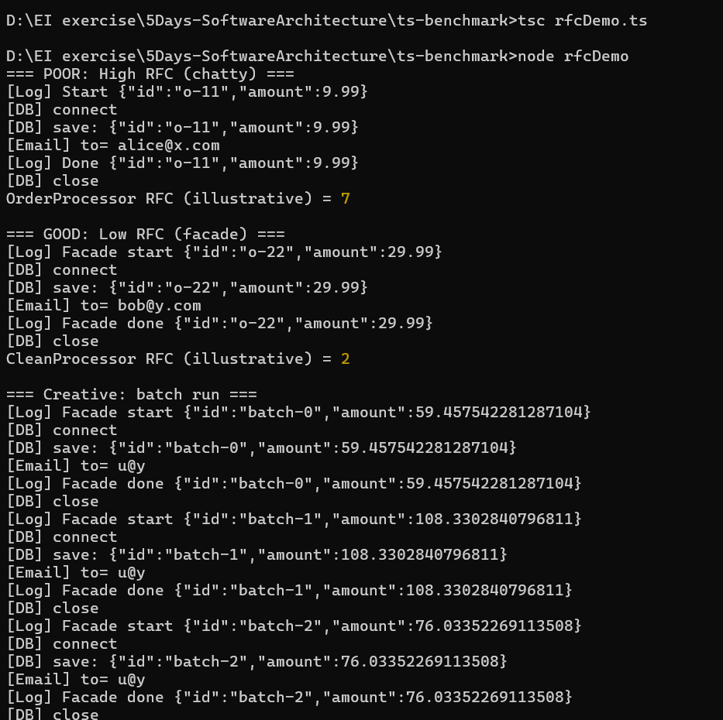

Lack of Cohesion of Methods (LCOM)?
LCOM4 counts the connected components. A score greater than 1 implies the class is trying to be two different things and should be split
In java
import java.util.*;

class LcomCalculator {
static int lcom4(List<MethodAccess> methods) {
int n = methods.size();
boolean[][] adj = new boolean[n][n];
for (int i = 0; i < n; i++) {
for (int j = i+1; j < n; j++) {
Set<String> a = methods.get(i).fields;
Set<String> b = methods.get(j).fields;
boolean intersect = false;
for (String f : a) {
if (b.contains(f)) { intersect = true; break; }
}
adj[i][j] = adj[j][i] = intersect;
}
}
boolean[] seen = new boolean[n];
int components = 0;
for (int i = 0; i < n; i++) {
if (!seen[i]) {
components++;
Deque<Integer> stack = new ArrayDeque<>();
stack.push(i);
seen[i] = true;
while (!stack.isEmpty()) {
int u = stack.pop();
for (int v = 0; v < n; v++) {
if (!seen[v] && adj[u][v]) {
seen[v] = true;
stack.push(v);
}
}
}
}
}
return components;
}

static class MethodAccess {
final String name;
final Set<String> fields;
MethodAccess(String name, String... fields) {
this.name = name;
this.fields = new HashSet<>(Arrays.asList(fields));
}
}
}

class PoorUserManager {
String name = "rithika";
String email = "rith@gmail";
String dbConfig = "db";
String auditLog = "log";
void printName() { System.out.println(name); }
void sendWelcomeEmail() { System.out.println("email->" + email); }
void connect() { System.out.println("db->" + dbConfig); }
void persistUser() { System.out.println("persisting " + name); }
void writeAudit() { System.out.println("audit:" + auditLog); }
}

class User {
String name = "rithika";
void printName() { System.out.println(name); }
}

class DbConnector {
String dbConfig = "db";
void connect() { System.out.println("db->" + dbConfig); }
void persistUser(String name) { System.out.println("persisting " + name); }
}

class Notifier {
String email = "rith@gmail";
void sendWelcomeEmail(String to) { System.out.println("email->" + to); }
}

class Auditor {
String auditLog = "log";
void writeAudit(String entry) { System.out.println("audit:" + entry); }
}

public class LcomDemo {
public static void main(String[] args) {
List<LcomCalculator.MethodAccess> poorMethods = Arrays.asList(
new LcomCalculator.MethodAccess("printName", "name"),
new LcomCalculator.MethodAccess("sendWelcomeEmail", "email"),
new LcomCalculator.MethodAccess("connect", "dbConfig"),
new LcomCalculator.MethodAccess("persistUser", "dbConfig","name"),
new LcomCalculator.MethodAccess("writeAudit", "auditLog")
);

int poorLcom = LcomCalculator.lcom4(poorMethods);
System.out.println("POOR class methods components (LCOM4) = " + poorLcom);

List<LcomCalculator.MethodAccess> userMethods = Arrays.asList(
new LcomCalculator.MethodAccess("printName", "name")
);
List<LcomCalculator.MethodAccess> dbMethods = Arrays.asList(
new LcomCalculator.MethodAccess("connect", "dbConfig"),
new LcomCalculator.MethodAccess("persistUser", "dbConfig","name")
);
List<LcomCalculator.MethodAccess> notifierMethods = Arrays.asList(
new LcomCalculator.MethodAccess("sendWelcomeEmail", "email")
);
List<LcomCalculator.MethodAccess> auditorMethods = Arrays.asList(
new LcomCalculator.MethodAccess("writeAudit", "auditLog")
);

System.out.println("GOOD class User LCOM4 = " + LcomCalculator.lcom4(userMethods));
System.out.println("GOOD class DbConnector LCOM4 = " + LcomCalculator.lcom4(dbMethods));
System.out.println("GOOD class Notifier LCOM4 = " + LcomCalculator.lcom4(notifierMethods));
System.out.println("GOOD class Auditor LCOM4 = " + LcomCalculator.lcom4(auditorMethods));

System.out.println("\nRefactored run:");
User u = new User(); u.name = "rithika"; u.printName();
DbConnector db = new DbConnector(); db.dbConfig = "db://x"; db.connect(); db.persistUser("rithika");
Notifier n = new Notifier(); n.email = "rith@gmail"; n.sendWelcomeEmail("rith@gmail");
Auditor a = new Auditor(); a.auditLog = "log01"; a.writeAudit("created user rithika");
}
}
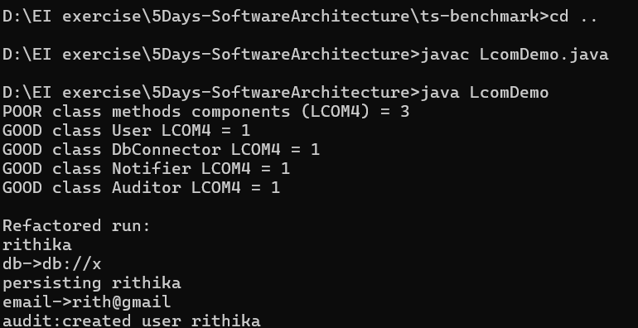
In typescript:
class LcomCalculator {
static lcom4(methods: {name: string; fields: string[]}[]): number {
var n = methods.length;
var adj: boolean[][] = [];
for (var i = 0; i < n; i++) {
adj[i] = [];
for (var j = 0; j < n; j++) adj[i][j] = false;
}
for (var i = 0; i < n; i++) {
for (var j = i + 1; j < n; j++) {
var aFields = methods[i].fields;
var bFields = methods[j].fields;
var intersect = false;
for (var ia = 0; ia < aFields.length; ia++) {
var f = aFields[ia];
for (var jb = 0; jb < bFields.length; jb++) {
if (bFields[jb] === f) { intersect = true; break; }
}
if (intersect) break;
}
adj[i][j] = adj[j][i] = intersect;
}
}
var seen: boolean[] = [];
for (var i = 0; i < n; i++) seen[i] = false;
var components = 0;
for (var i = 0; i < n; i++) {
if (!seen[i]) {
components++;
var stack = [i];
seen[i] = true;
while (stack.length) {
var u = stack.pop() as number;
for (var v = 0; v < n; v++) {
if (!seen[v] && adj[u][v]) { seen[v] = true; stack.push(v); }
}
}
}
}
return components;
}
}

class PoorUserManager {
name = "rithika";
email = "rith@gmail";
dbConfig = "db";
auditLog = "log";
printName() { console.log(this.name); }
sendWelcomeEmail() { console.log("email->", this.email); }
connect() { console.log("db->", this.dbConfig); }
persistUser() { console.log("persist", this.name); }
writeAudit() { console.log("audit", this.auditLog); }
}

class User {
name = "rithika";
printName() { console.log(this.name); }
}

class DbConnector {
dbConfig = "db";
connect() { console.log("db->", this.dbConfig); }
persistUser(name: string) { console.log("persist", name); }
}

class Notifier {
email = "rith@gmail";
sendWelcomeEmail(to: string) { console.log("email->", to); }
}

class Auditor {
auditLog = "log";
writeAudit(entry: string) { console.log("audit", entry); }
}

var poorMethods = [
{name: "printName", fields:["name"]},
{name: "sendWelcomeEmail", fields:["email"]},
{name: "connect", fields:["dbConfig"]},
{name: "persistUser", fields:["dbConfig","name"]},
{name: "writeAudit", fields:["auditLog"]}
];

console.log("POOR class methods components (LCOM4) =", LcomCalculator.lcom4(poorMethods));

var userMethods = [{name:"printName", fields:["name"]}];
var dbMethods = [
{name:"connect", fields:["dbConfig"]},
{name:"persistUser", fields:["dbConfig","name"]}
];
var notifierMethods = [{name:"sendWelcomeEmail", fields:["email"]}];
var auditorMethods = [{name:"writeAudit", fields:["auditLog"]}];

console.log("GOOD class User LCOM4 =", LcomCalculator.lcom4(userMethods));
console.log("GOOD class DbConnector LCOM4 =", LcomCalculator.lcom4(dbMethods));
console.log("GOOD class Notifier LCOM4 =", LcomCalculator.lcom4(notifierMethods));
console.log("GOOD class Auditor LCOM4 =", LcomCalculator.lcom4(auditorMethods));

console.log("\nRefactored run:");
var u = new User(); u.name = "rithika"; u.printName();
var db = new DbConnector(); db.dbConfig = "db://x"; db.connect(); db.persistUser("rithika");
var n = new Notifier(); n.email = "rith@gmail"; n.sendWelcomeEmail("rith@gmail");
var a = new Auditor(); a.auditLog = "log01"; a.writeAudit("created user rithika");
