Submitted by - Rithika
Afferent Couplings (Ca): The number of classes in other packages that depend upon classes within the package is an indicator of the package's responsibility. Afferent = incoming
- A class afferent couplings is a measure of how many other classes use the specific class.
Efferent Couplings (Ce): The number of classes in other packages that the classes in the package depend upon is an indicator of the package's dependence on externalities. Efferent = outgoing.
- A class efferent couplings is a measure of how many different classes are used by the specific class.
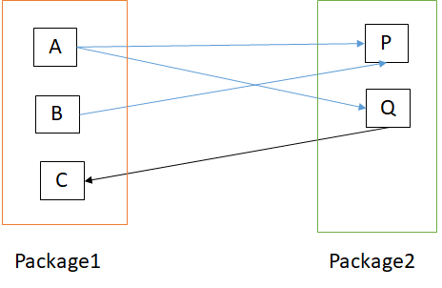
Package1,
- class A has 2 out-going edges,

- class B has 1 out-going edge,
- class C has 1 in-coming edge
- Calculation:
Ca = {} union {} union {Q}
= {Q}
= 1

Ce = {P, Q} union {P} union {}
= {P, Q,} =2
Package2,
- class P has 2 in-coming edges,
- class Q has 1 in-coming and 1 out-going edge
Ca = {A, B} union {A}
= {A, B}
= 2
Ce = {} union {C}
= {C}=1

Instability is the ratio between Efferent Coupling (Ce) and the total package coupling (Ce + Ca)
I = Ce / (Ce + Ca) =[0,1] 0-> Unstable, 1->Stable
IN Java:
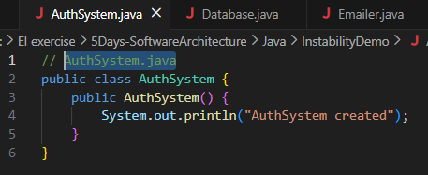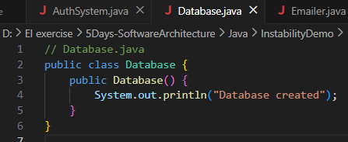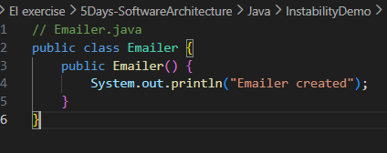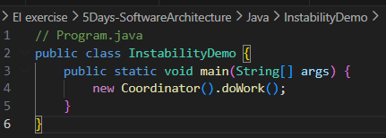
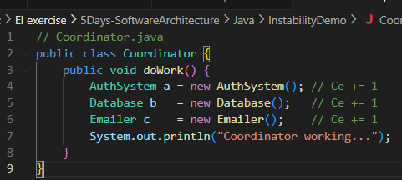
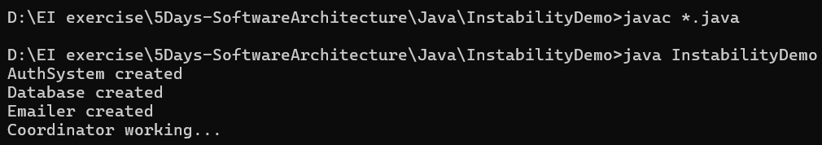
IN TYPESCRIPT:
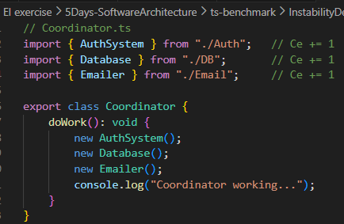
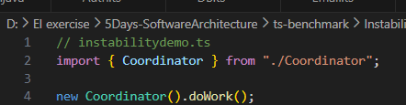
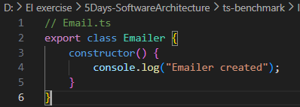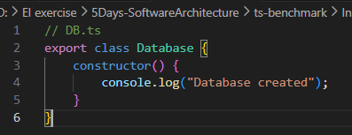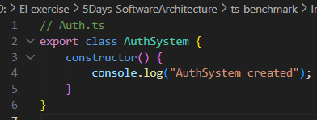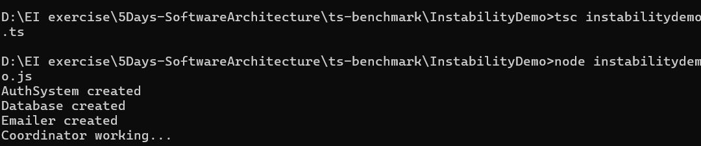
Java coupling = using the class
TypeScript coupling = importing the module
Coding assessment:
Dependency Grapher:

Ex ( A ---> B ---> C)
A.java imports B
B.java imports C
C.java imports none
O/p:
A.java -> B
B.java -> C
C.java -> (no dependencies)

In Java: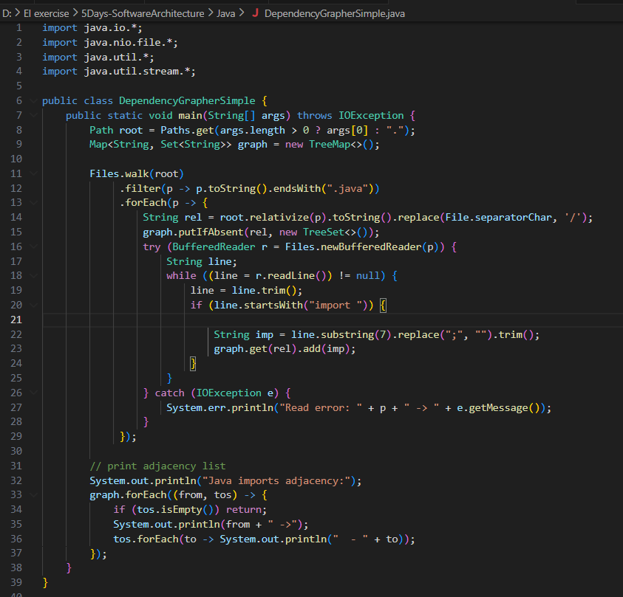 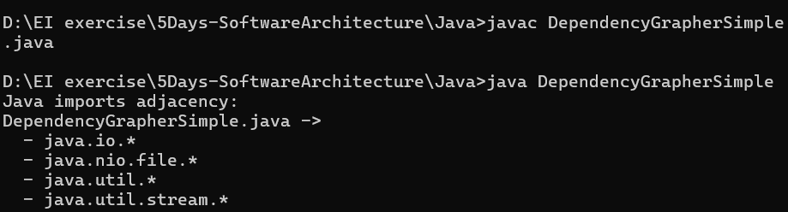

In Typescript:
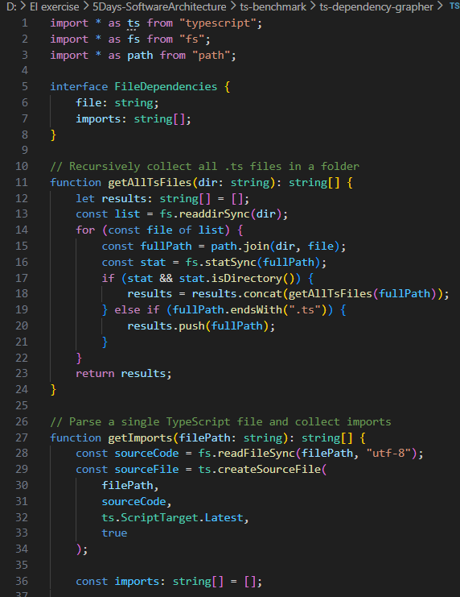
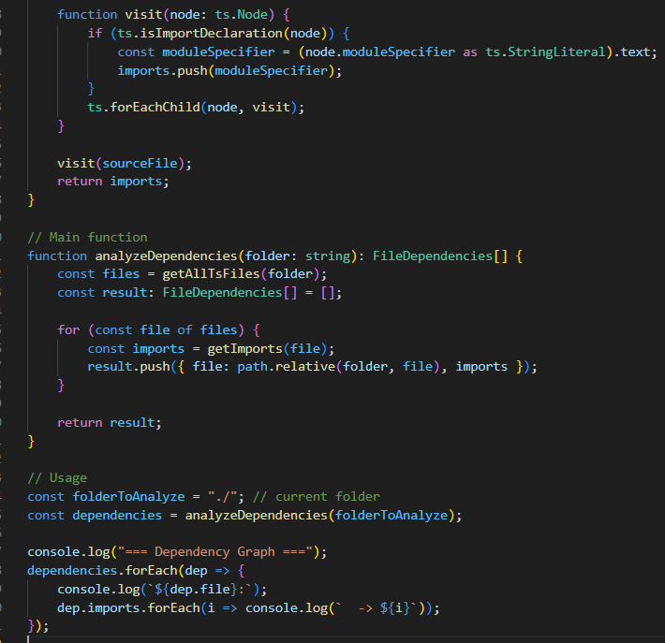
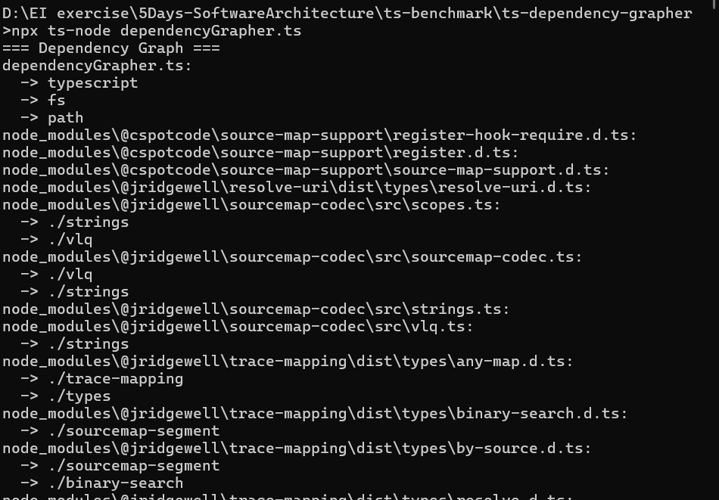

Fragility of inheritance?
A piece of code that easily breaks when you change something small somewhere else — even if the change should not logically affect it.
Why is below program fragile?
CountedList depends on the assumption that addRange() will always call add() once per item.
In java:
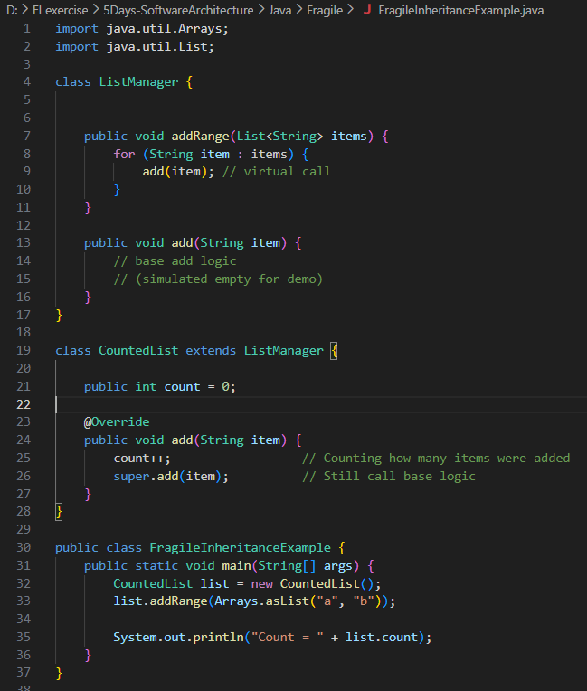
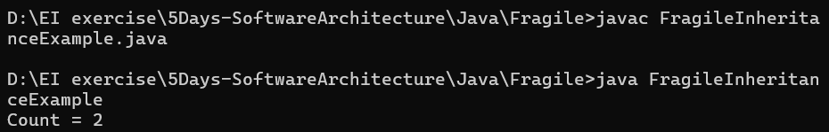
In typescript:
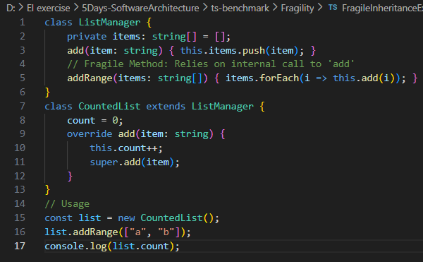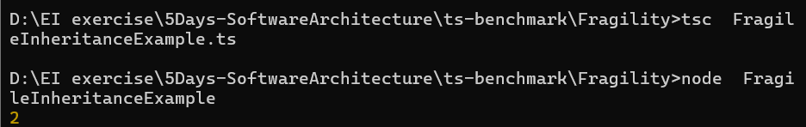

My Example:
Parent changes the car from manual to automatic
Child still expects manual → now it cannot drive
In Typescript:
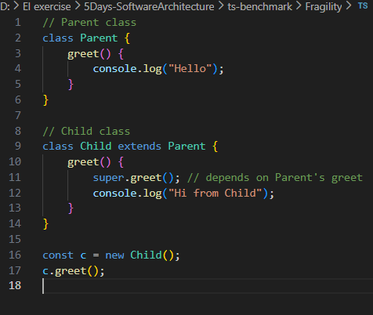
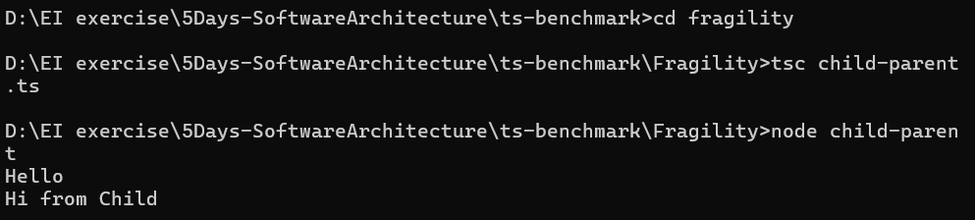
But if parent changes like :
class Parent {
greet(name: string) { // added a parameter
console.log("Hello " + name);
}
}
ERROR: greet expects 1 argument - >Fragility

In Java:
If Vehicle.drive() changes its parameters (e.g., needs two arguments), Car breaks. This is fragility of inheritance.
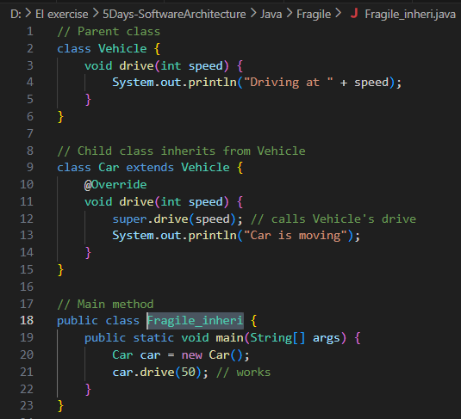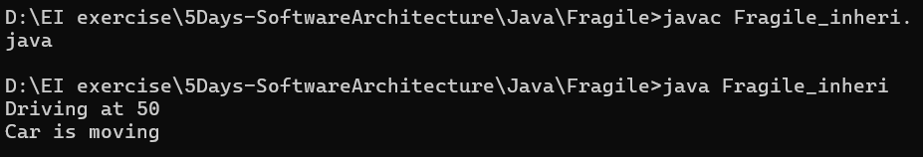
Use of composition:
“Has-a” relationship
Real-Life Example
- A Car has an Engine → Composition
The car uses the engine to run.
Engine can be replaced or upgraded without changing how the car is designed.
If inheritance were used:
- Car is-a Engine (wrong relationship)
In java:
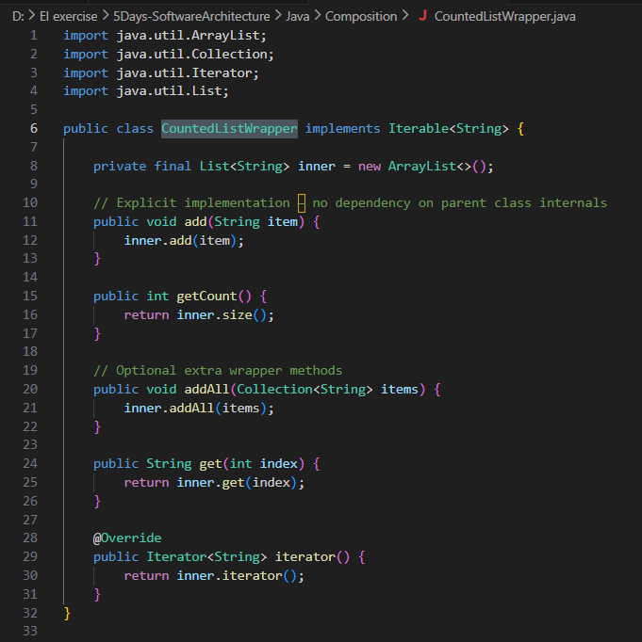
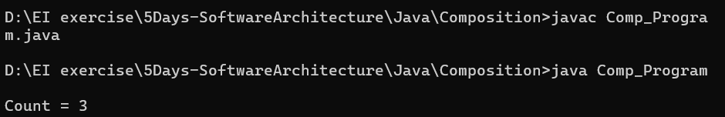

In Typescript:
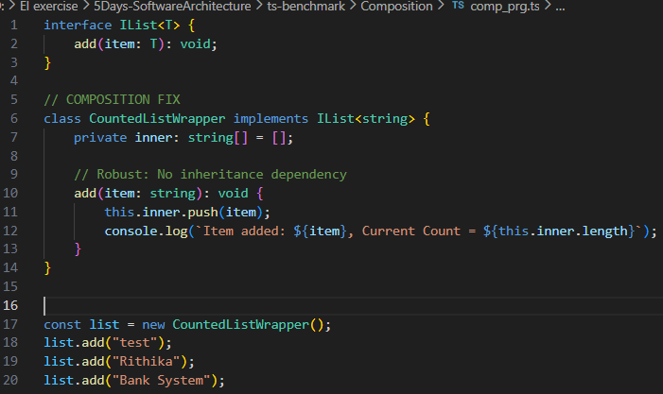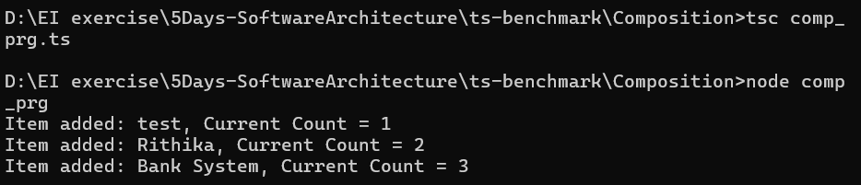

Example: “Bank”
If BankAccount changes internally (maybe extra logic or new fields), Customer will not break easily as long as deposit/withdraw methods exist.
Customer
|-- has-a --> BankAccount

In java:
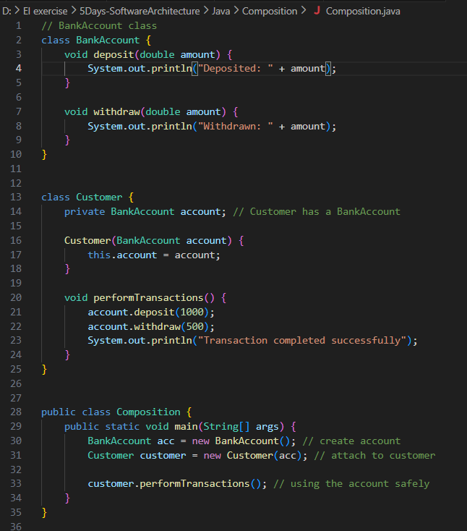
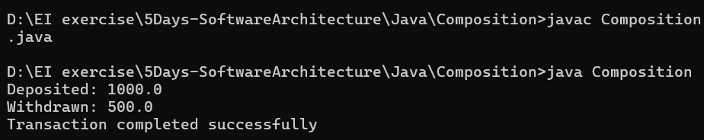

In Typescript:
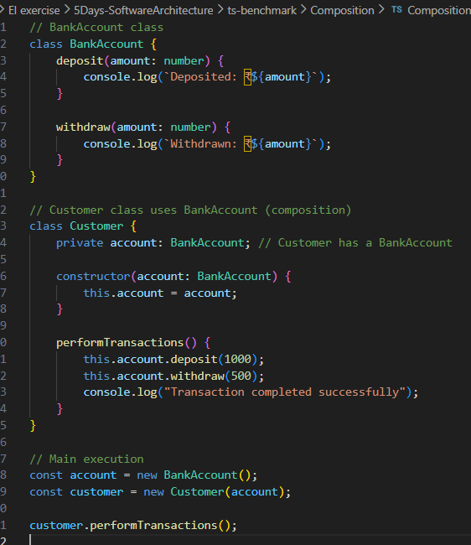
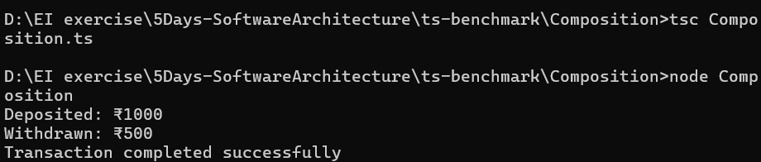

Connascence?
How strongly two pieces of code depend on each other.
Unlike CBO (Coupling Between Objects), which only tells how many couplings, Connascence explains how strong the coupling is.
Type | Meaning | Coupling Strength
CoN of Name | Must share the same name | Weak / Good
CoN of Type | Must use same parameter types | Medium
CoN of Meaning / Algorithm | Must understand hidden rules or values | Very Strong / Bad

Connascence of Name:
- If we rename deposit() to addMoney(), the customer code breaks.
- This is Connascence of Name — both components must agree on the same name.
In java:
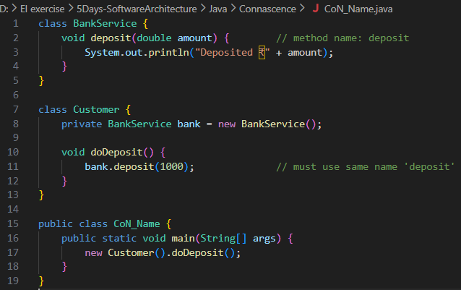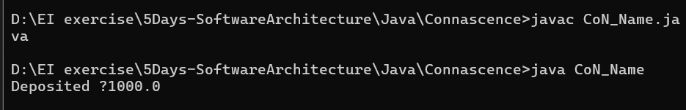

In Typescript:
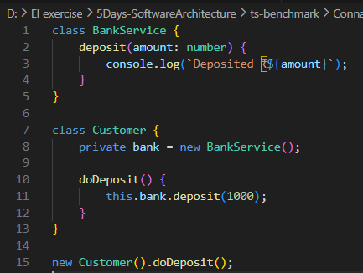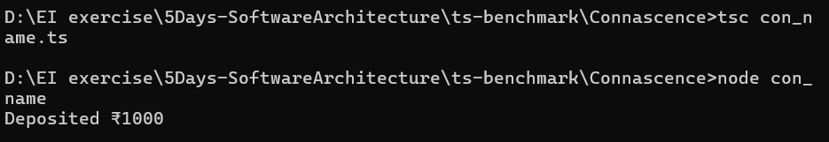
Connascence of Type
- If transfer() changes to transfer(String amount), callers break.
This is Connascence of Type.
In java:
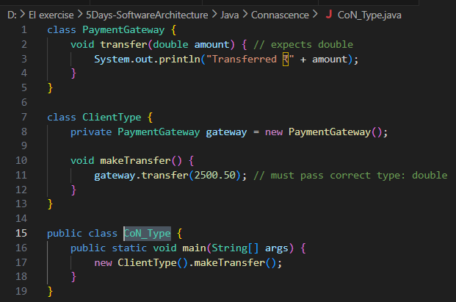
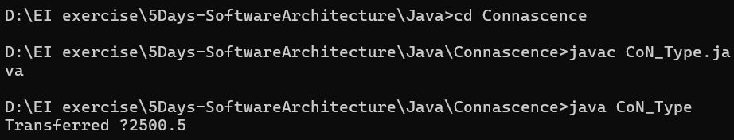
In typescript:
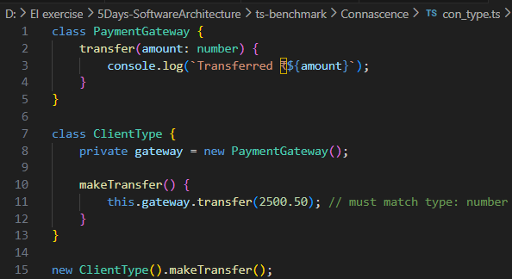
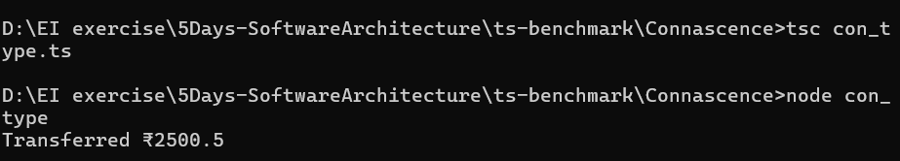
Connascence of Meaning
Strong — BAD example using magic numbers & GOOD using enum
Bad Meaning:
- -1, 0, 1 have hidden meanings.
- Caller must know secret meanings (invisible fragile contract

In java
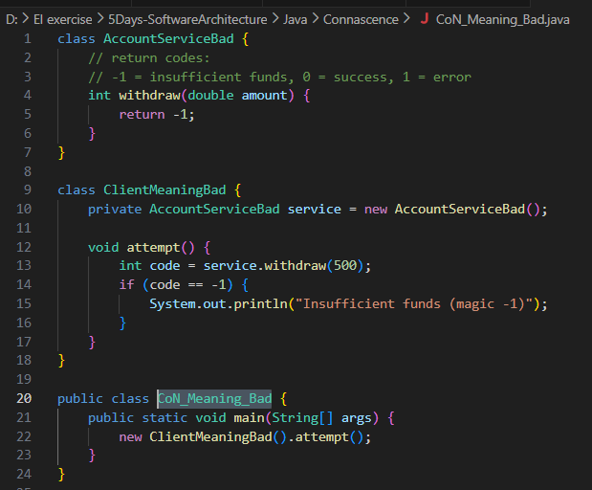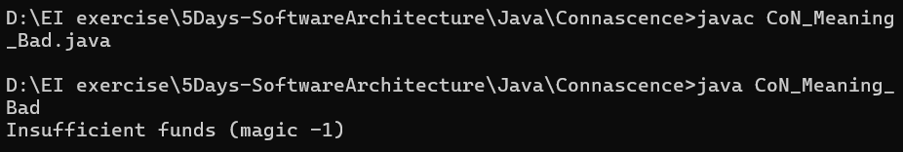

In typescript:
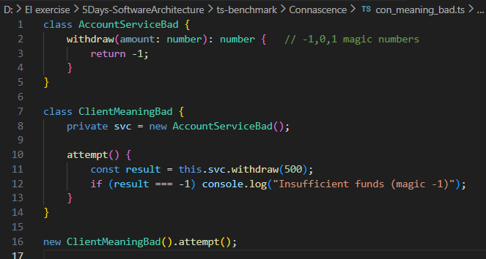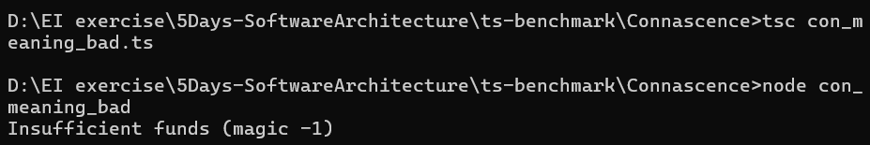
Good Meaaning: -Explicit meaning, No hidden protocol
In Java:
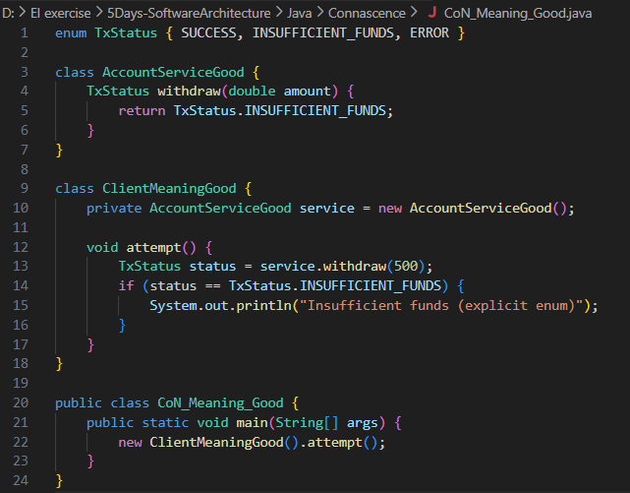

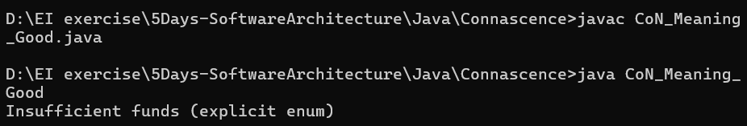

In Typescript:
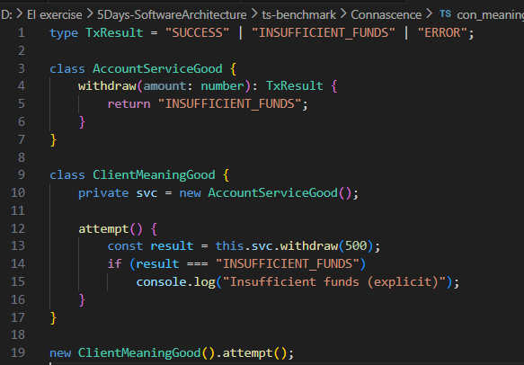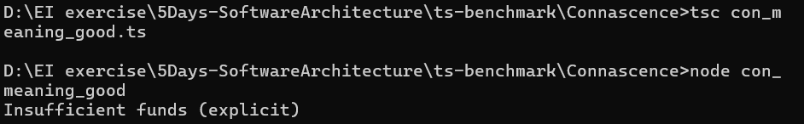

Examine the Depth of Inheritance:?
DIT = How many parent classes a class inherits from.
Example= “Bank”
Object
↑
Account (DIT = 0)
↑
SavingsAccount (DIT = 1)
↑
PremiumSavingsAccount (DIT = 2)
If we change Account.process() to remove super.process() or skip logic → all subclasses must update.
In java: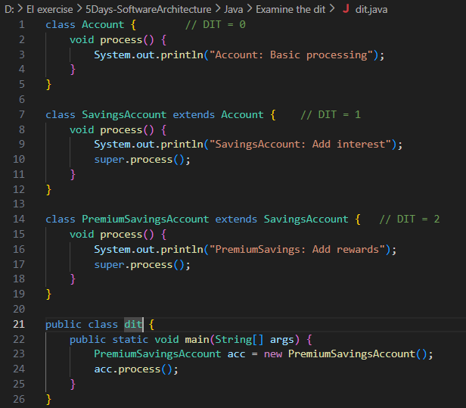
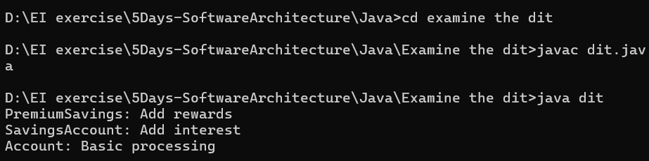
In typescript:
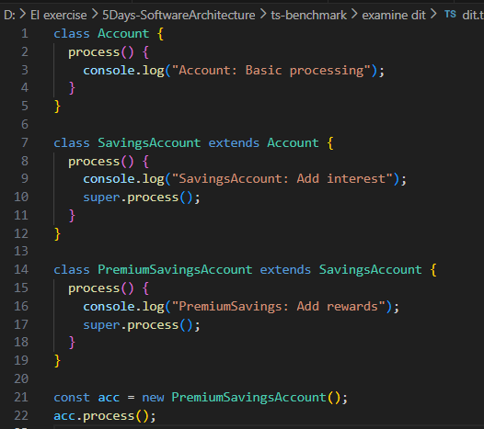
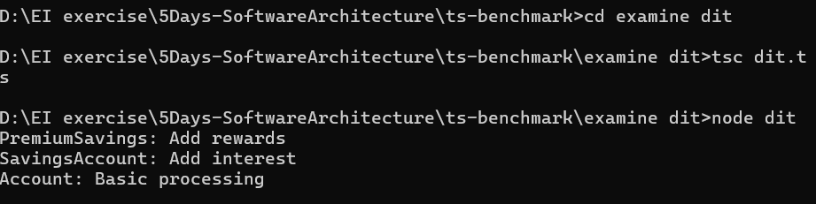

Abstractness (A)?
Abstract contains interfaces or abstract classes
A= 1 → fully abstract (all interfaces/abstract classes)
A = 0 → fully concrete (all implemented classes)
Main Sequences?:
Graph with Abstractness (A) on Y-axis and Stability (I) on X-axis.
Distance from the Main Sequence (D)
D=∣A+I−1∣
D=0 (perfect), D=1(worst design)
Minimizing D ensures stable components are abstract, unstable components are concrete
Example:
BankInterface → stable & abstract → good (on main sequence)
CustomerManager → unstable & concrete → good
TransactionProcessor → stable & concrete → bad (below main sequence, fragile)
In java:
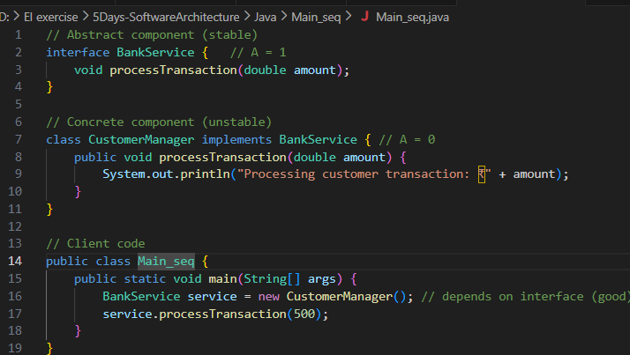
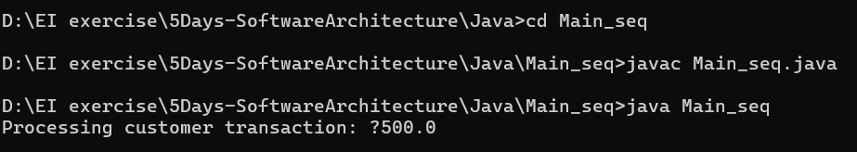
In Typescript:
