Submitted By - Rithika
Graph Theory in programs?
Program logic -> Control Flow Graph = graph where node are block of code or decision points , edges are possible flow paths
Cyclomatic Complexity (McCabe’s Formula)?
How complex your code logic is, by counting the number of independent paths through the program
Cyclomatic Complexity (CC) = E – N + 2
E-> Edges, N->Nodes
Example: Passing level of a student
If marks >= 90 → Grade A
If marks >= 75 → Grade B
Else Grade C
Each if creates an independent path
marks >= 90 → A
marks >= 75 → B
else → C
CC = number of decisions + 1 = 2 + 1 = 3
Cognitive Complexity?
Measures how difficult code is for a human to understand
Real-World ex:

If door is open
If card is valid
If PIN is correct
print "Access Granted"
If door not open → exit
If card invalid → exit
If PIN wrong → exit
print "Access Granted"

High Cognitive Complexity:
- Nested conditions
Example:
Independent Paths
- condition false at x>0
- true, then fail at x<100
- true, true, fail mod2 check
- all true → print
Start → if(x>0) → if(x<100) → if(x%2==0) → print → End
CC = Decision points + 1 = 3 + 1 = 4
Using graph:
[Start]
|
(x > 0?) -------------- No → [End]
|
Yes
|
(x < 100?) ----------- No → [End]
|
Yes
|
(x % 2 == 0?) -------- No → [End]
|
Yes
|
[Print]
|
[End]
Cyclomatic Complexity (CC) = E – N + 2
= 8 – 6 + 2
= 4

In java:
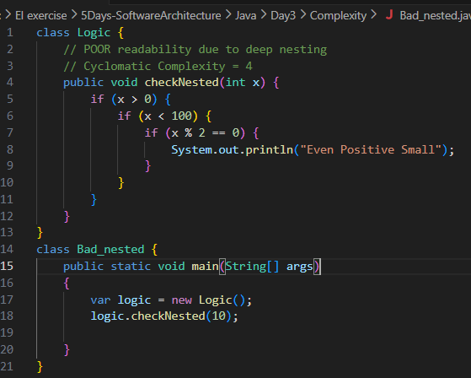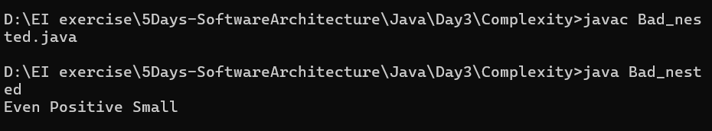
In typescript:
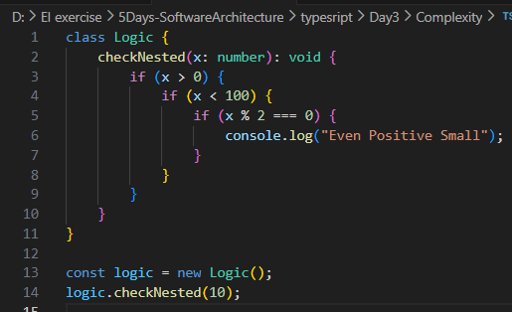
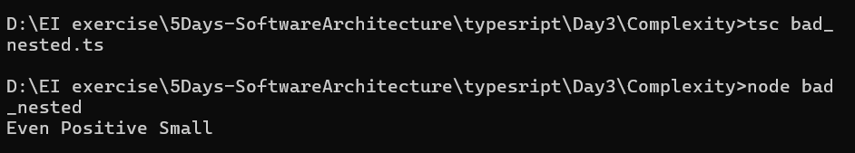
Low Cognitive complexity:
- Flat Structure
Using Graph:
Start
|
[x <= 0?] ---Yes---> End
|
No
|
[x >= 100?] ---Yes---> End
|
No
|
[x % 2 != 0?] ---Yes---> End
|
No
|
Print
|
End
CC = 3 decisions + 1 = 4

In java:
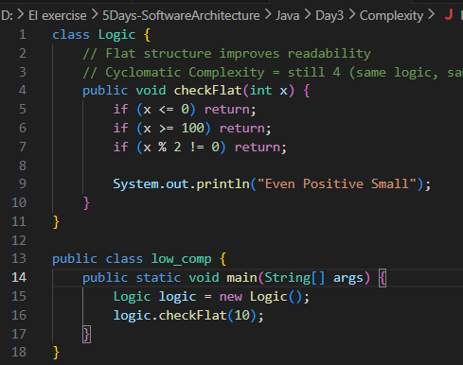
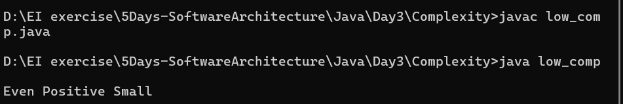

In Typescript:
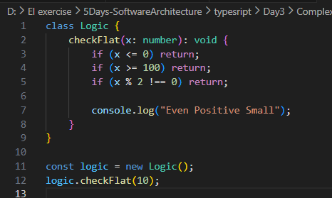
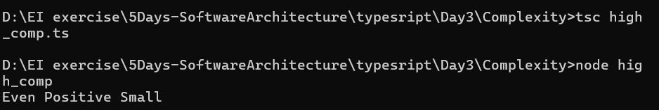
My Scenario : Bank Management
CC = E – N + 2
E = number of edges (transitions)
N = number of nodes (blocks)
(or)
CC = Number of decision points + 1
(decision - if, else if, while, for, switch-case, catch, &&, ||)

High cognitive complexity
Using graph representation:
Start
|
v
[if balance > 0] ----No----> END
|
Yes
|
[if amount <= balance] ----No----> END
|
Yes
|
[if otpVerified] ----No----> END
|
Yes
|
[if !isHoliday] ----No----> END
|
Yes
|

[switch]
/ \
SAV CUR DEF
| | |
Msg Msg Default
| | |
END
CC = E – N + 2 = 15 – 10 + 2 = 7
Element | Count
if | 4
cases | 2 additional paths
CC = 6 + 1 = 7
IN JAVA:
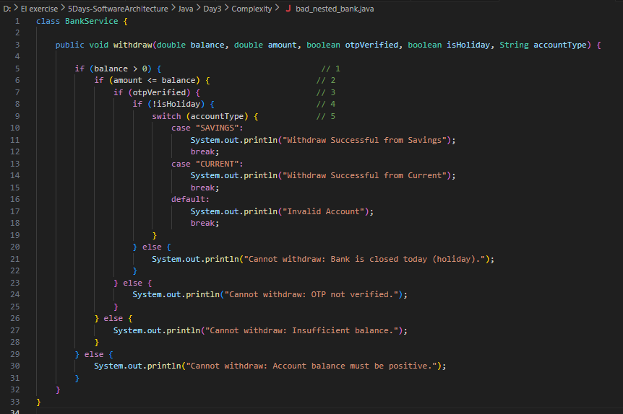
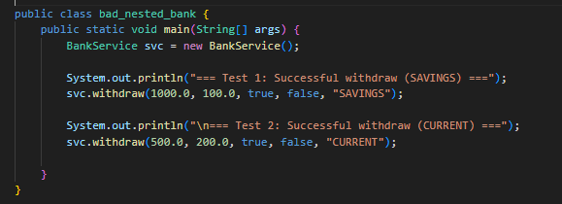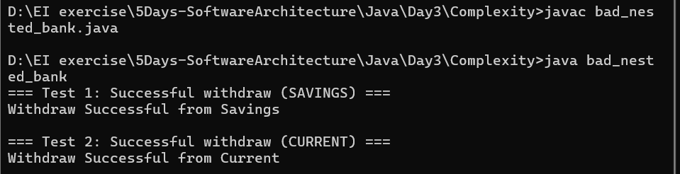
IN TYPESCRIPT:
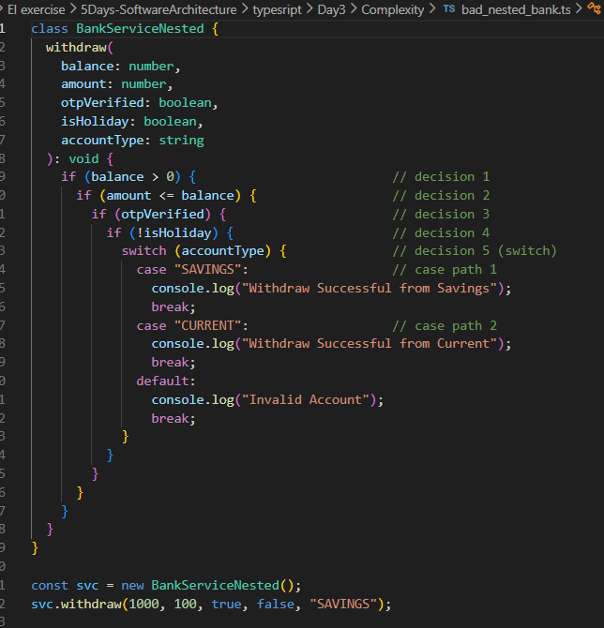

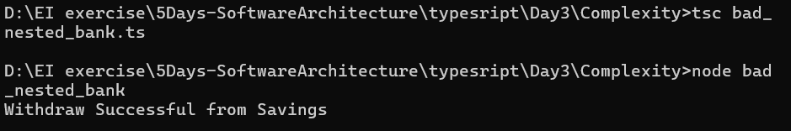
Low cognitive Complexit : Using graph Representation
[Start]
|
[if balance <= 0?] --Yes--> [End]
|
No
|
[if amount > balance?] --Yes--> [End]
|
No
|
[if !otpVerified?] --Yes--> [End]
|
No
|
[if isHoliday?] --Yes--> [End]
|
No
|
[switch]
/ \
SAV CUR DEF
| | |
Msg Msg Default
| | |
END
Decision | Count
if | 4
cases | 2
CC=6 +1= 7
IN JAVA:
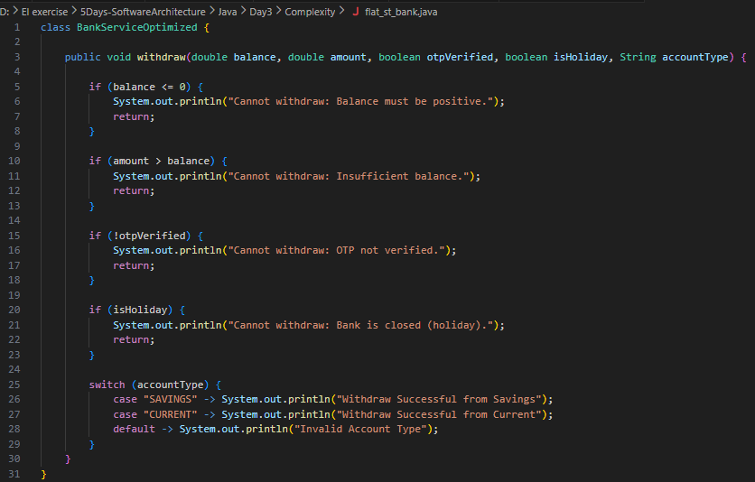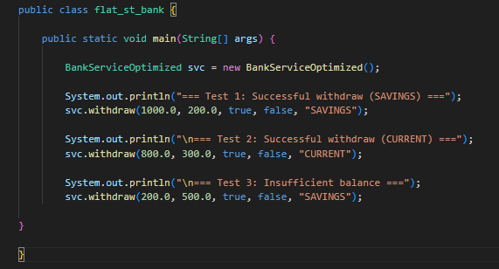
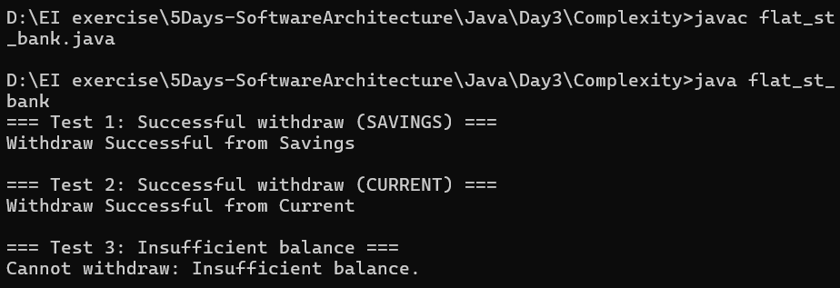
IN TYPESCRIPT:
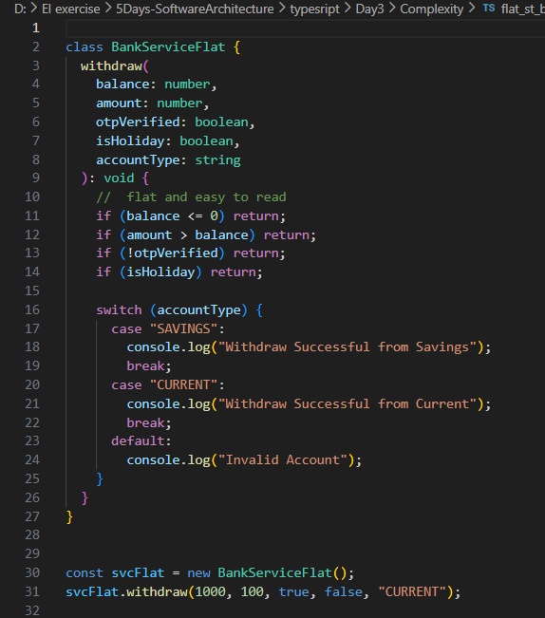
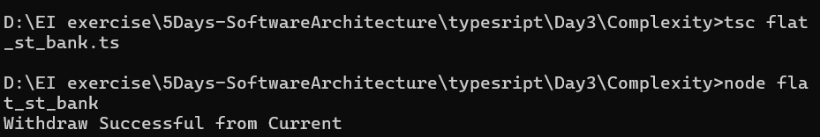
CC same but CoC reduced?
- Because CC counts logical branches, not structure.
- But Cognitive Complexity counts human effort, so structure matters
CC vs CogC:
Feature | Cyclomatic Complexity (CC) | Cognitive Complexity (CogC)
Measures | Number of independent paths | Readability & nesting
Ignores | Nesting & control flow | Does not ignore these
Goal | Testing coverage | Maintainability & understandability
Example | if-else, switch, loops | Penalizes nested if, for, recursion
Interpretation | Higher CC → more tests | Higher CogC → harder to read/maintain

White-Box Testing?:
a software testing technique where the tester looks inside the code and tests the internal logic, structure, and paths of the program.
Common White-Box Testing Techniques:
- Statement coverage – Test every line of code atleast one
- Like if , code have 10 lines -> writing testcases that execute all 10 lines
- Branch/Decision Coverage – Test every decision (T/F) of each conditions
- If ( amount >1000) then test with amount= 13000(t) , amount=200(False)
- Loop Testing – Test the loops in the code witll its iteration (0,1,…n)
- for(int r=0,r>n;r++) then test n=0,n>1
Basis Path Testing/Path coverage:
Design test cases to execute every independent path in a program at least once.
Example: Bank Management
Decisions:
- if (balance <= 0)
- else if (amount > balance)
- else if (!otpVerified)
CC= decisions +1= 3+1=4 , so 4 paths
Independent paths (Basis Paths):
- Balance ≤ 0 → "No balance"
- Balance > 0 & amount > balance → "Insufficient balance"
- Balance > 0 & amount ≤ balance & OTP not verified → "OTP not verified"
- Balance > 0 & amount ≤ balance & OTP verified → "Withdraw successful
In java:
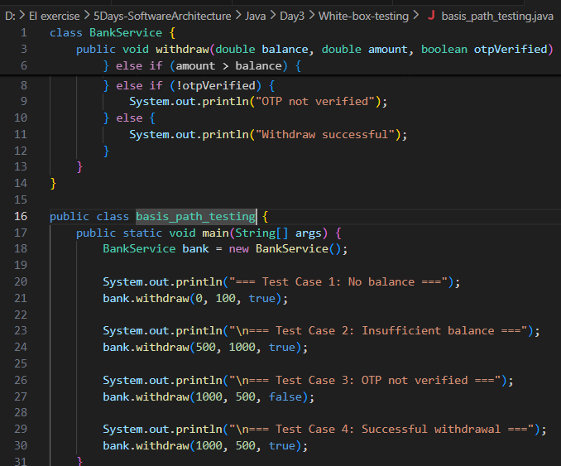
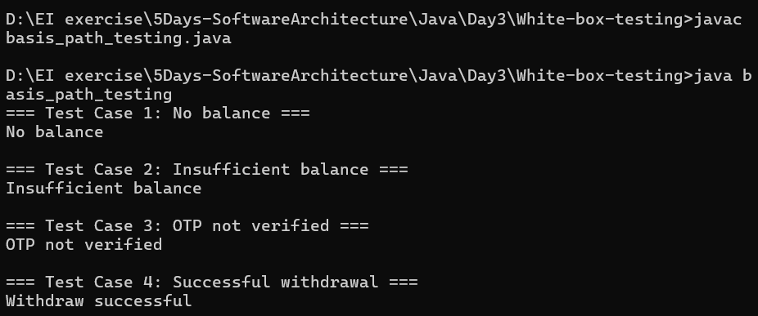In TypeScript:
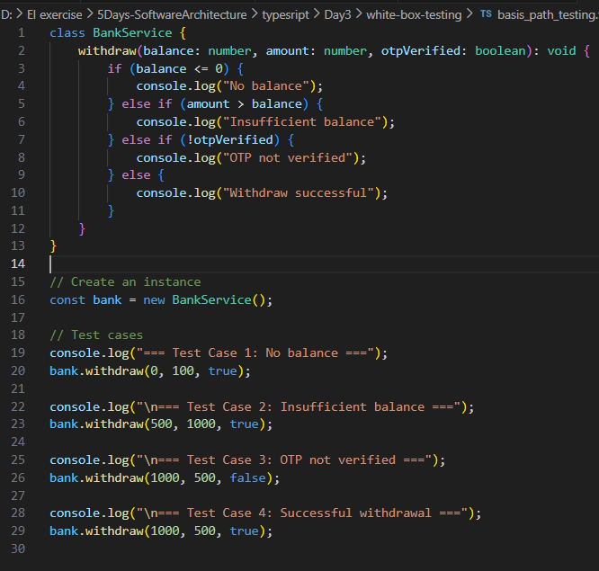
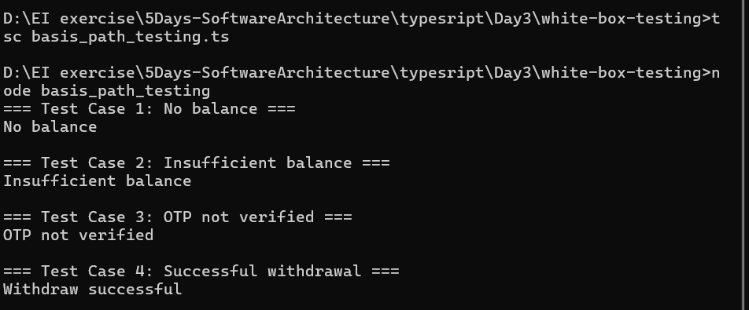
Path Sensitization?
Ensuring each path user test is actually feasible
An impossible path (also called a "dead path") should not be tested because the conditions cannot happen logically.
Example: Impossible path but CC= 2+1=3 as , (x > 5 AND x < 3) can never happen, so it is dead logic
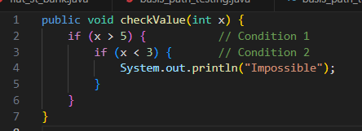
Thus, Path sensitization identify impossible paths like this and don’t waste time testing them.
Steps to do Basis Path Testing with Path Sensitization?
Draw the Control Flow Graph (CFG) Calculate Cyclomatic Complexity (CC) List all independent paths according to CC Analyze each path , if not feasible then mark as “Dead logic” Design Test case for all feasible paths
Example: Bank Management
Start
└─> if (balance <= 0)?
├─Yes: "No balance" -> End (P1)
└─No:
└─> if (amount > balance)?
├─Yes: "Insufficient" -> End (P2)
└─No:
└─> if (!otpVerified)?
├─Yes: "OTP not verified" -> End (P3)
└─No:
└─> if (isHoliday)?
├─Yes: "Bank closed" -> End (P4)
└─No: "Withdraw successful" -> End (P5)
Impossible Path (Dead Logic - P6)
└─> if (balance < 0 AND balance > 1000)?
├─Yes: "Impossible Path Reached!" -> End
└─No: (never happens)
Decisions( CC= 5+ 1 =6 , so 6 independent paths)
- if (balance <= 0) → decision 1
- else if (amount > balance) → decision 2
- else if (!otpVerified) → decision 3
- else if (isHoliday) → decision 4
- Impossible path: if (balance < 0 && balance > 1000) → decision 5
Buy use path sensitization , only 5 Paths are feasible

In java:
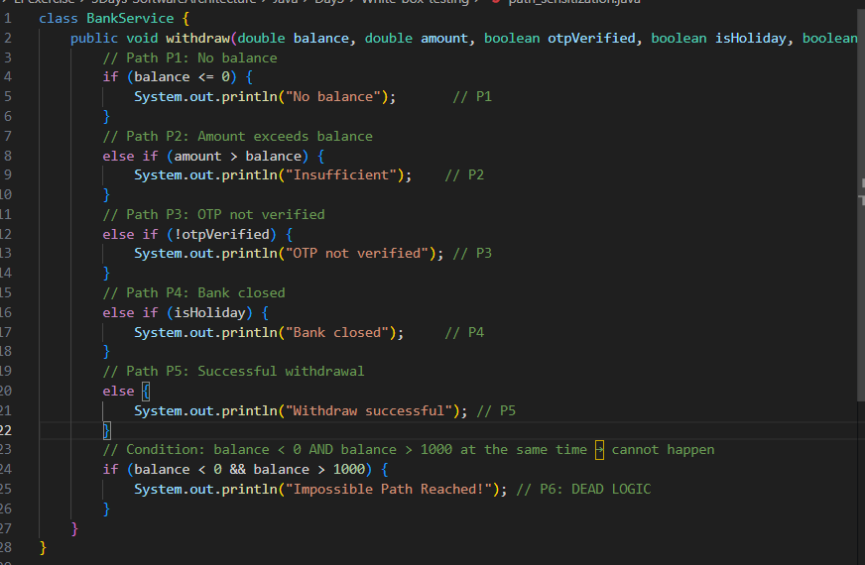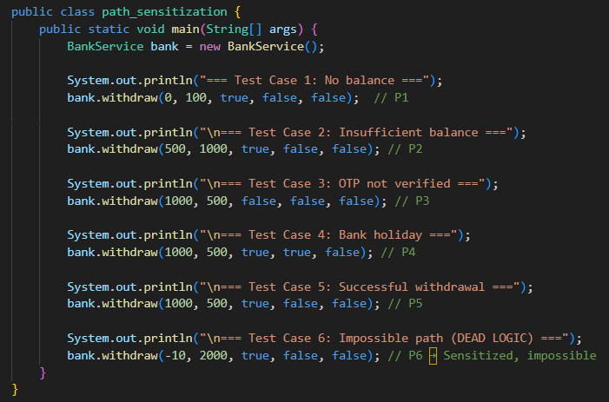
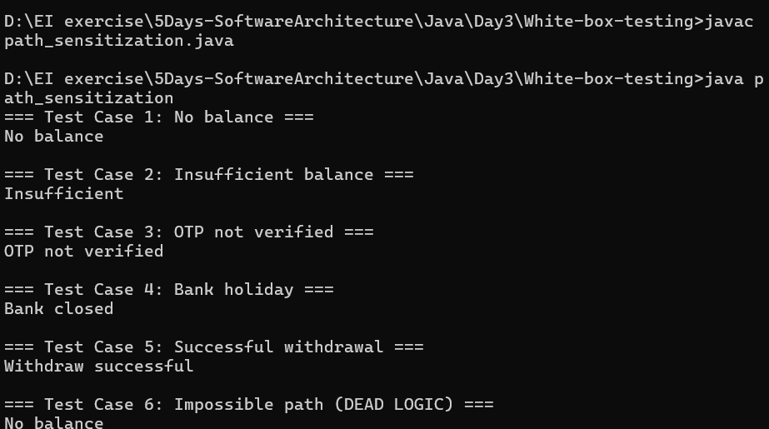
In typescript:
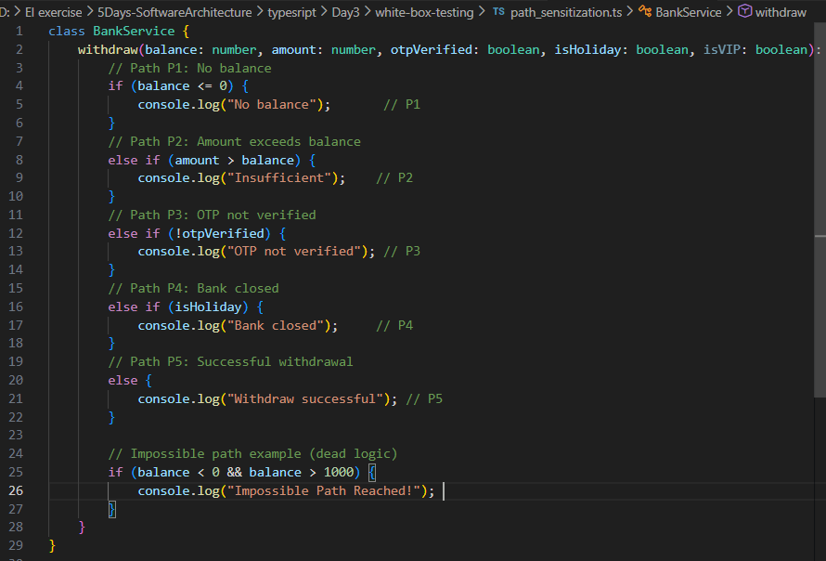
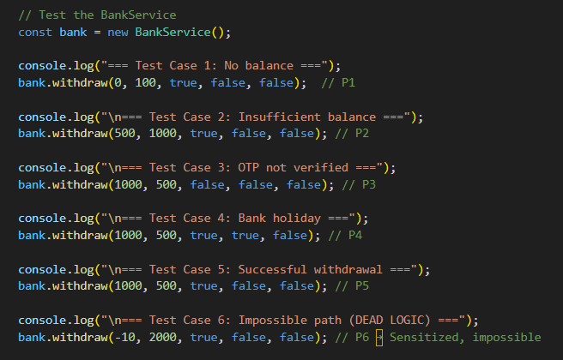
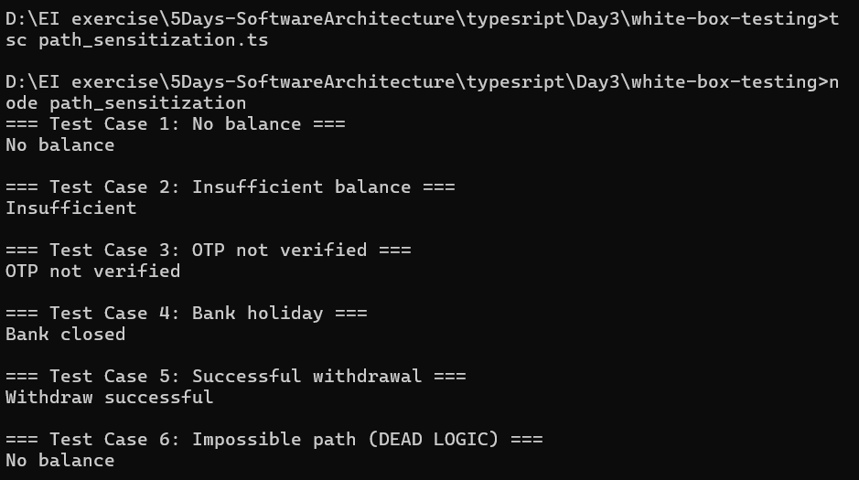
Sonarsource – company that develops tools to analyze and improce code quality
calculated using three main rules:
- +1 for each break in linear flow – e.g., if, for, while, switch, catch.
- +1 for nesting – deeper nesting increases the score more rapidly.
- Ignore shorthand constructs that improve readability, such as ternary operators or early returns.
Measure of CogC:
- Lower scores mean the code is easier to read and maintain.
- High scores indicate the need for refactoring to reduce nesting, split large methods, or simplify branching
Example:
Loop +1
If +1
Total Cognitive Complexity = 1 (loop) + 2 (if nested) = 3
In java:
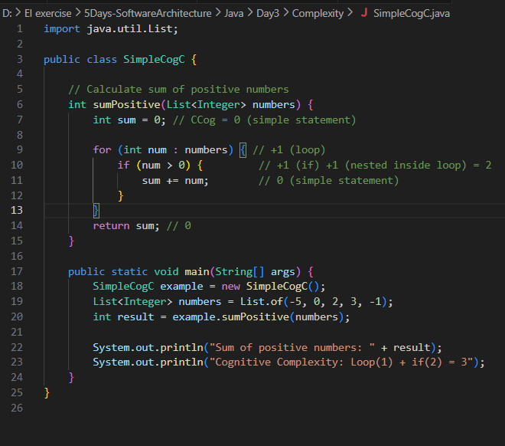
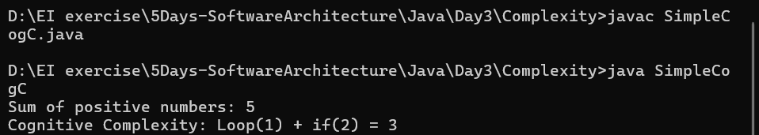

In Typescript:

