Submiited by -Rithika
Need for Merging
- Multiple developers work on different branches and later combine work.
- To combine a topic-branch (feature/fix) into the integration branch (main/develop).
- To integrate bugfixes across release lines.
- To keep branches synchronized so integration problems are discovered early.
Merge Strategies in Git
1. Three-Way Merge:
- They have 3 version – base, current, incoming
- Initially file name – “Hello World” commit
- In Feature branch –“Hello from feature a” commit
- Again in main – “Hello Git world “ commit
- On using : git merge feature , conflict occurs
- If both branches changed the SAME line differently.
2. Recursive Merge Strategy – Merge a single source branch into current branch
- Git finds the merge base (common ancestor commit) and performs a three-way merge between: merge-base, current branch tip, and other
Initialize repository -> Configure name/email -> Create initial commit on main-> Create feature branch and commit -> Switch back to main and add a new commit -> Merge feature branch into main with --no-ff = Recursive merge conflict”

Commands:
mkdir git-recursive-demo
cd git-recursive-demo
git init
git config user.name "Rithika"
git config user.email ”email”
echo "Line 1 from main" > file.txt
git add file.txt
git commit -m "Initial commit on main"
git checkout -b feature-a
echo "Feature A line 1" >> file.txt
git add file.txt
git commit -m "Feature-a: add first line"
git checkout main
echo "Main line 2" >> file.txt
git add file.txt
git commit -m "Main: add second line"
git merge --no-ff feature-a -m "Merge feature-a into main using recursive merge"
git status
Resolve the conflict
git add file.txt
git commit -m "Merge feature-a into main, resolve conflict"
git log --graph --oneline --all

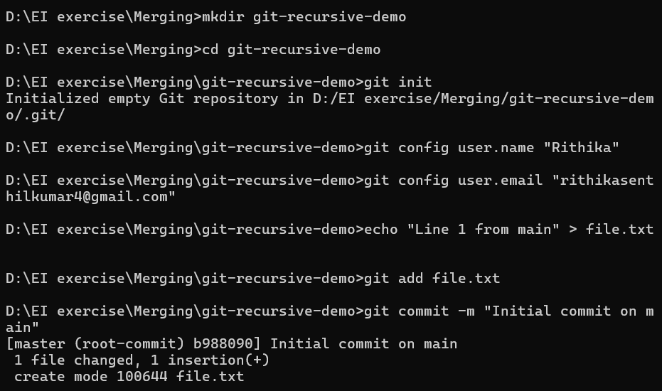
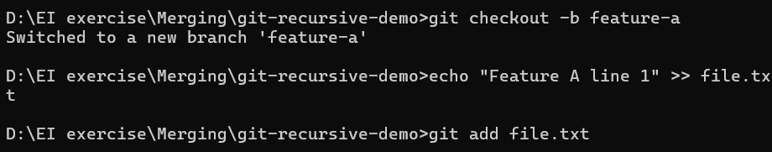
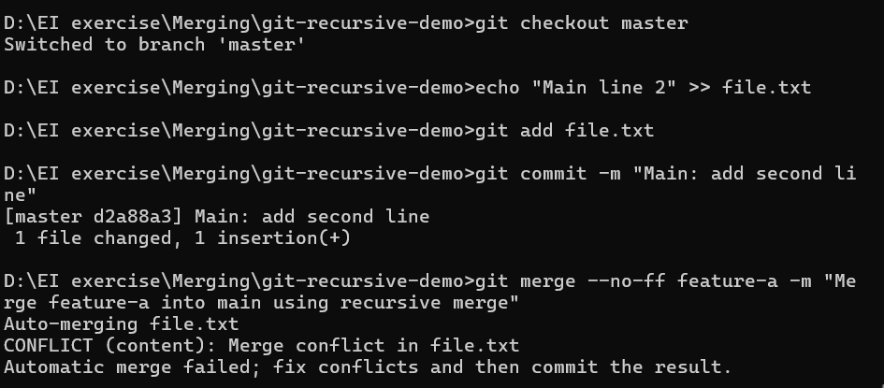
Open the conflicted file -> Conflicted markers -> remove them and save
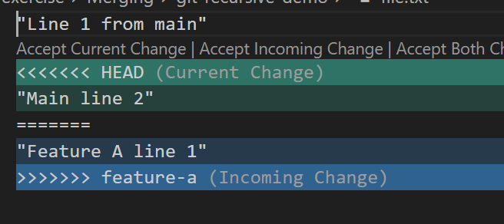
the merge commit has two parents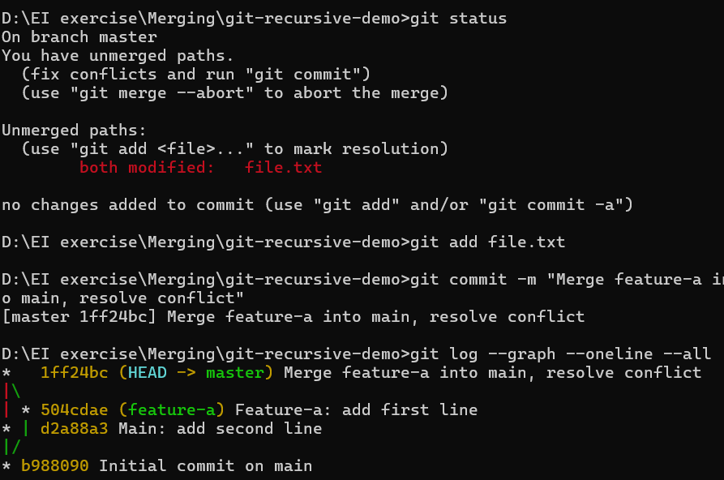
Note:
THREE-WAY MERGE = method used to combine contents
RECURSIVE MERGE = strategy used to merge branches using three-way merge repeatedly
3.) Fast Forward Merge: (Linear ) - Moves main pointer to branch head
- When the target branch has not diverged from the source branch. In this case, they simply moves the target branch pointer to the latest commit in the source branch - main had no new commits after branching
Initialize Repo -> Create first commit on main -> Create a new branch -> Make some changes in feature branch -> Now merge back into main
Git just moved the pointer forward
Before merge:
main -> a1
feature-a -> b1
After merge:
main -> b1
feature-a -> b1
Commands:

mkdir git-ff-demo
cd git-ff-demo
git init
echo "Initial Line" > file.txt
git add .
git commit -m "Initial commit"
git checkout -b feature-a
echo "Added feature A" >> file.txt
git add file.txt
git commit -m "Add feature A work"
git log --oneline --graph –all
git checkout main
git log –oneline
git merge feature-a

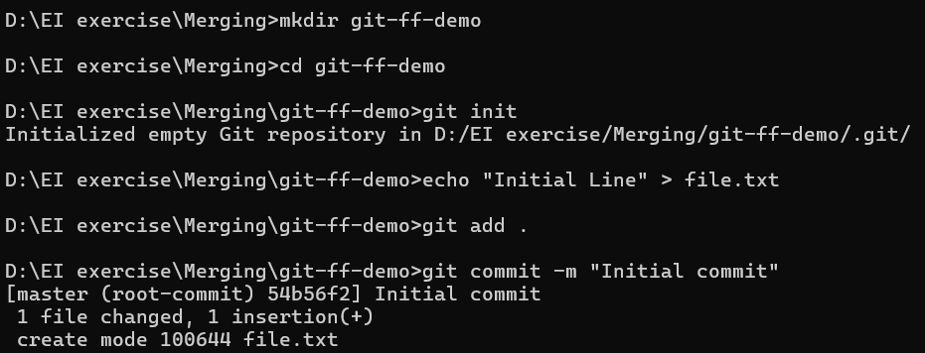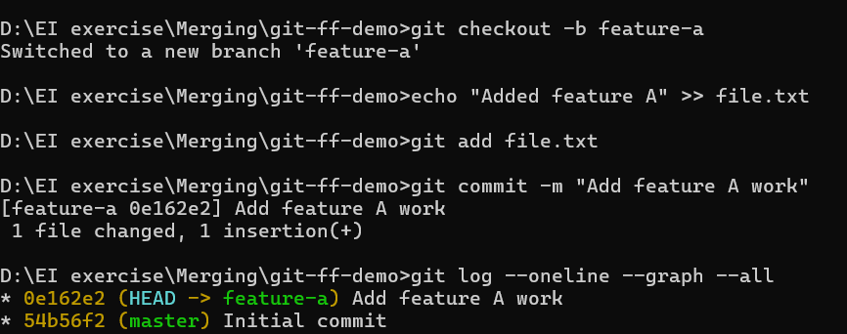
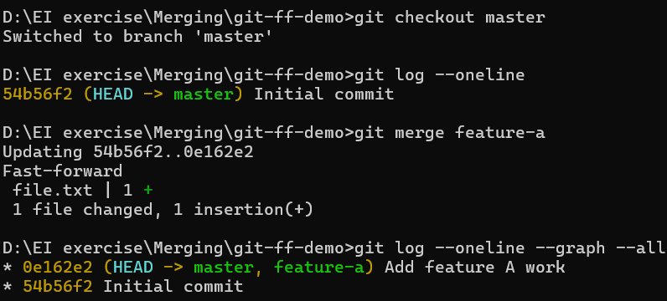

4.) Squash and Merge:
- Compress as 1 commit
- Collects all changes from the feature branch and stages them in your working tree as a single set of changes
1) Create repo and initial commit
mkdir squash-demo
cd squash-demo
git init
echo "Line 1" > file.txt
git add file.txt
git commit -m "Initial commit"
2) Create feature branch and make multiple small commits
git checkout -b feature-squash
echo "Feature line A" >> file.txt
git add file.txt
git commit -m "feat: add A"
echo "Feature line B" >> file.txt
git add file.txt
git commit -m "feat: add B"
echo "Feature line C" >> file.txt
git add file.txt
git commit -m "chore: add C"
git log --oneline --graph --decorate –all
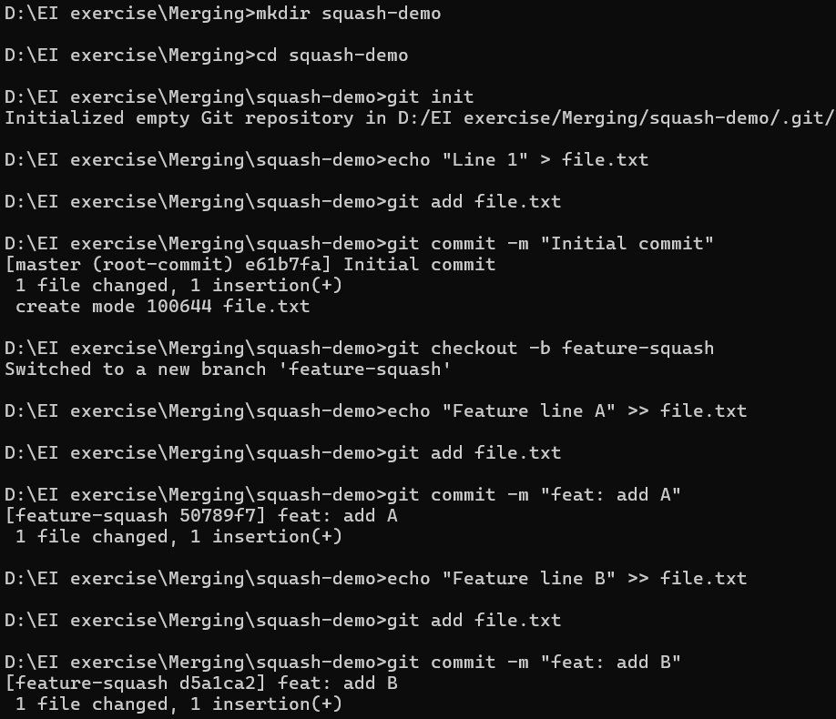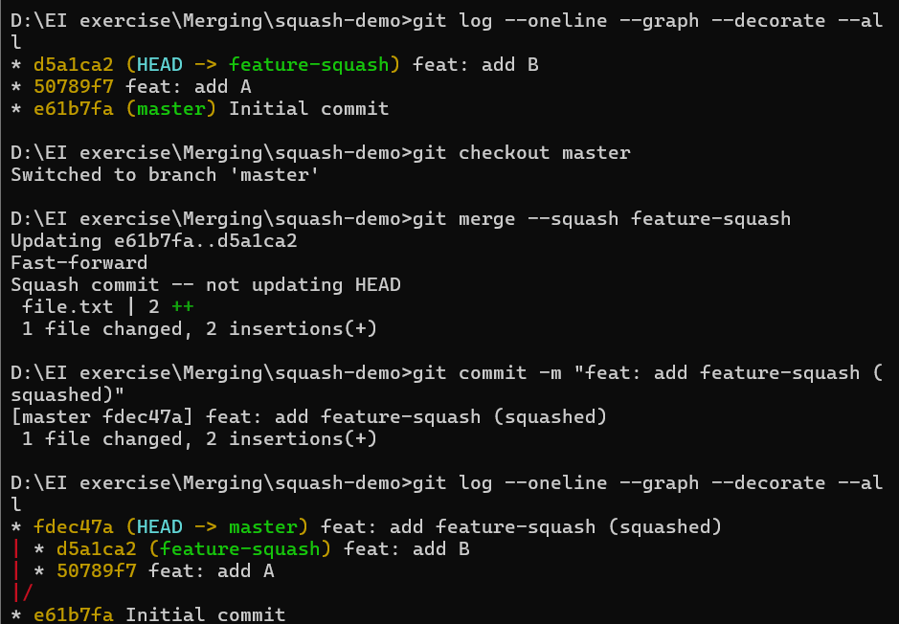

Scenario based Ex: Developing a Search Feature
All 2 development commits(add btn, debug) are now collapsed into 1 clean commit
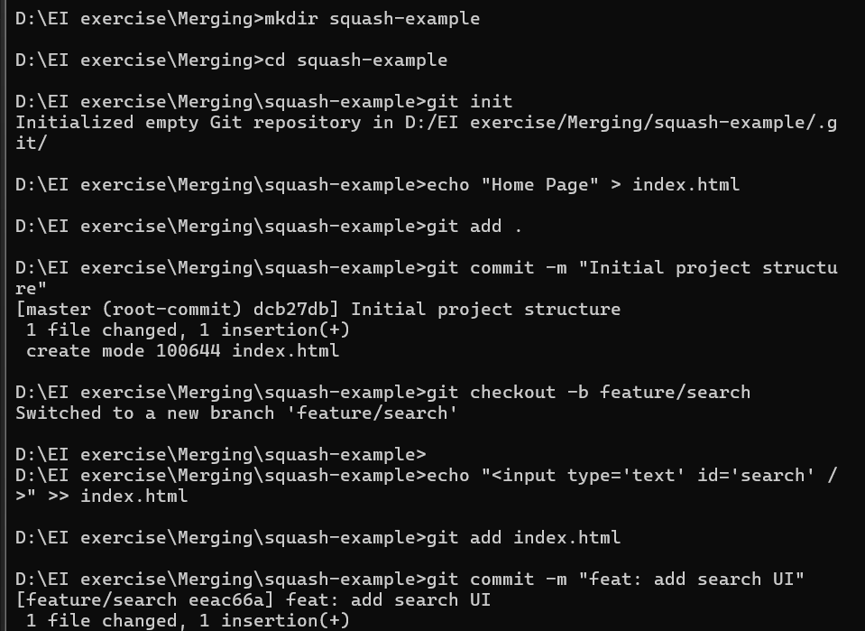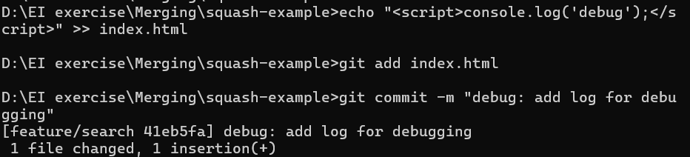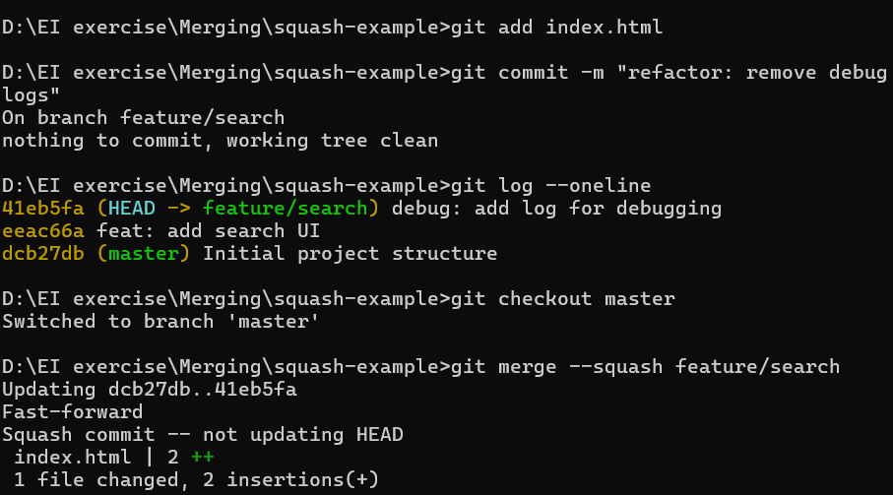
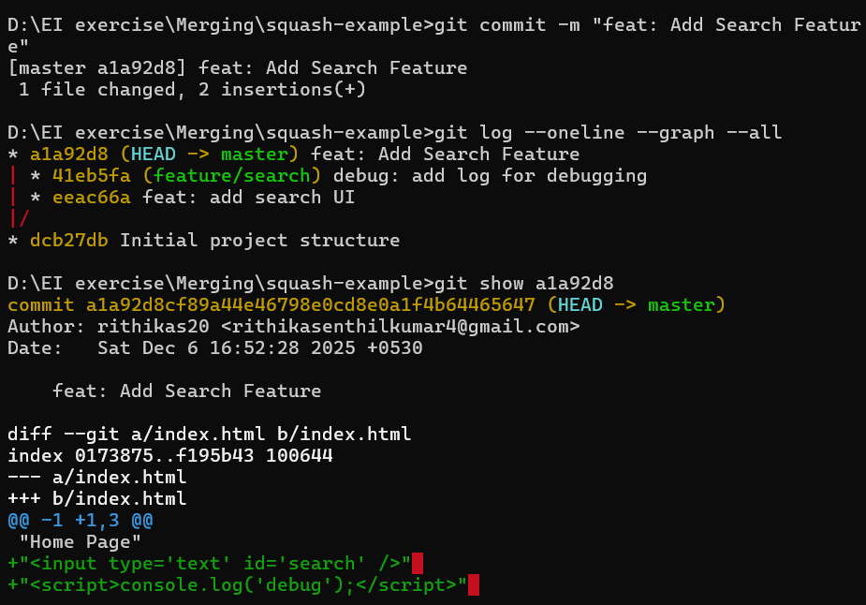

5.) Octopus Merge:
- Merging more than two branches simultaneously.
- Ex: There are three small feature branches , All features are independent and do not touch the same files, so they won’t cause conflicts
- Instead of merging them one-by-one, you want to merge them together into main using octopus merge.
Commands:
mkdir octopus-merge-example
cd octopus-merge-example
git init
echo "Home Page" > index.html
git add index.html
git commit -m "Initial home page"
git checkout -b feature/login-ui
echo "<div>Login Page UI</div>" >> index1.html
git add index1.html
git commit -m "Add login UI"
git checkout main
git checkout -b feature/banner
echo "<header>Banner Section</header>" >> index2.html
git add index2.html
git commit -m "Add banner section"
git checkout main
git merge -s octopus feature/login-ui feature/banner
git log --oneline --graph –all
feature/login-ui
\
feature/banner -- merge --> main
/
feature/footer
Suitable When | Not Suitable When
Many small independent branches | Conflicts expected
Want clean merge | Manual resolution needed
Automated integrations | Shared file changes
CI/CD pipelines | Complex feature integrations

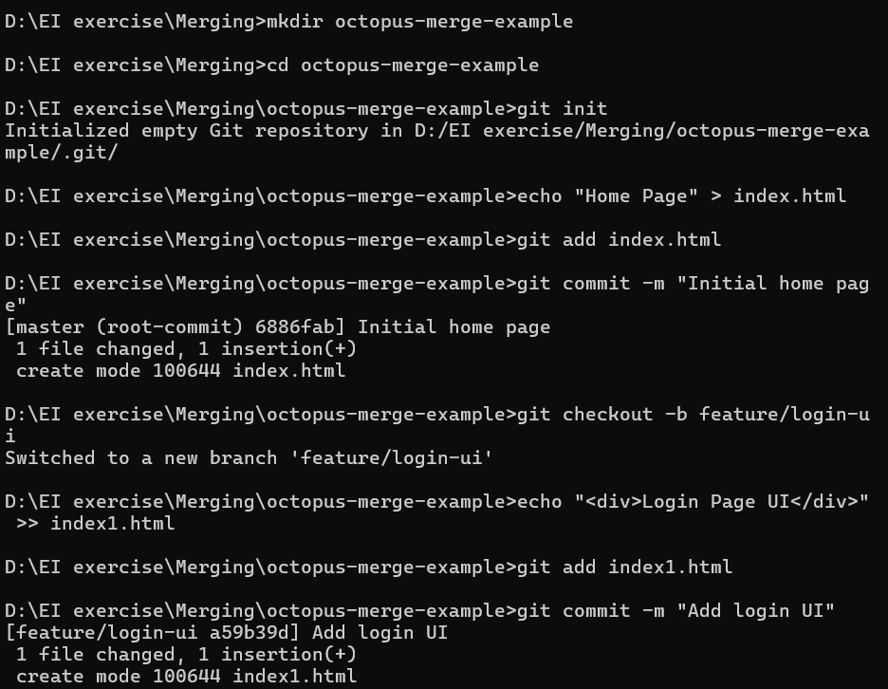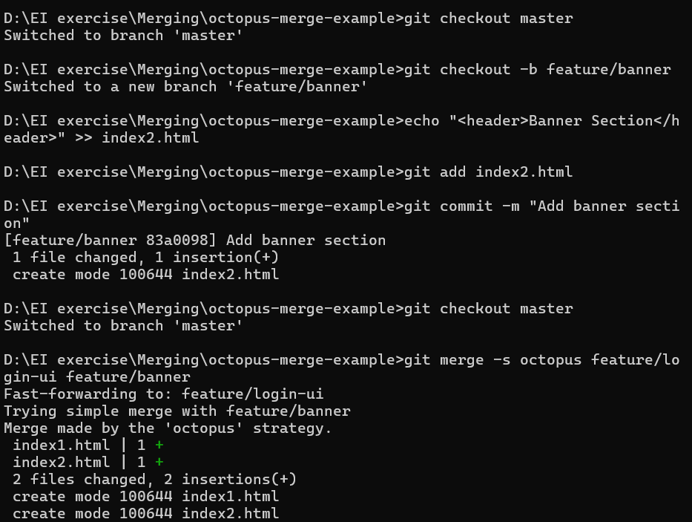
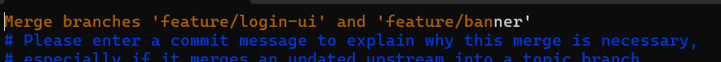
6. Subtree Merge:
- Pull another repository (or project) and merge it into a subdirectory of your current project
- Ex :

Repo1
my-app/
index.html
styles.css
Repo2:
ui-library/
button.js
input.js

To merge as : my-app/libs/ui-library/
FINAL O/P :
subtree-merge-main/
app.txt
libs/
ui-library/
button.js
Commands:
mkdir subtree-merge-main
cd subtree-merge-main
git init
echo "Main Application" > app.txt
git add .
git commit -m "Initial commit in main project"
cd ..
mkdir subtree-ui-library
cd subtree-ui-library
git init
echo "Button Component" > button.js
git add .
git commit -m "Initial library commit"
cd ../subtree-merge-main
git remote add ui_lib ../subtree-ui-library
git fetch ui_lib
git merge -s subtree --allow-unrelated-histories ui_lib/master -m "Merge UI Library into libs/ui-library folder"
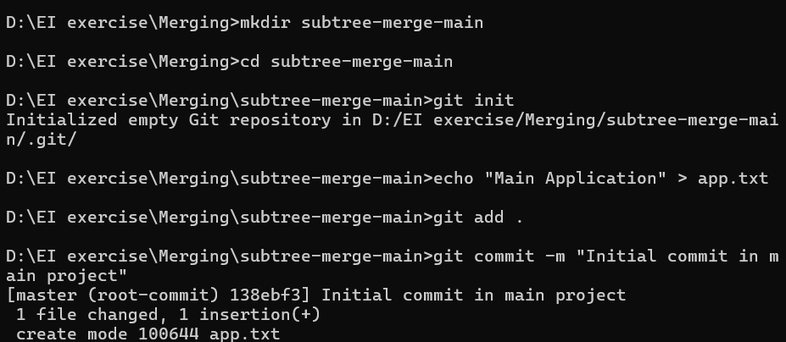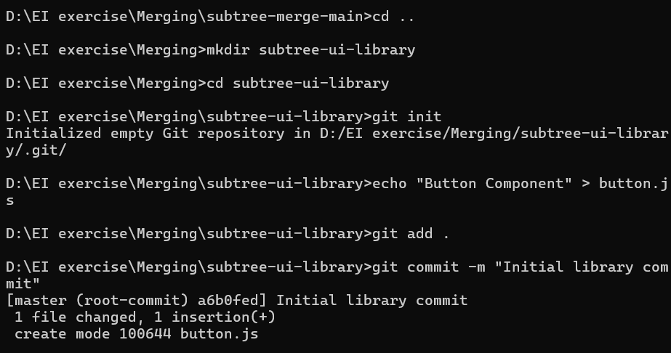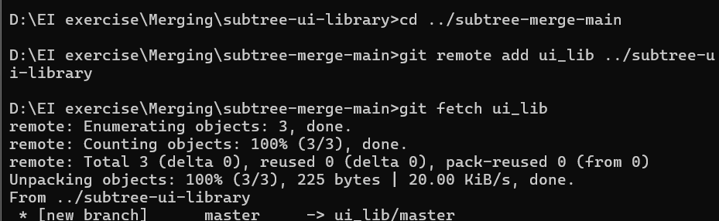
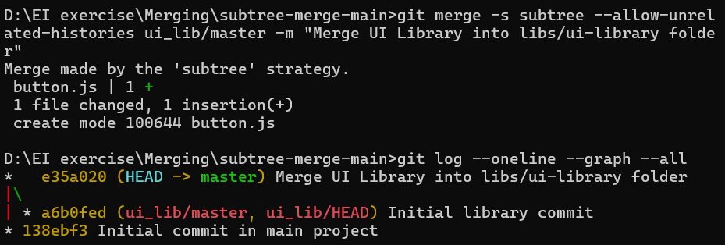
7.) Ours strategies:
- Discards all changes from the branch being merged, but still creates a merge commit so Git knows the branches are “merged.
- Keeps all changes from the current branch

Setup main branch-> Create feature branch with conflicting changes -> Go back to main branch-> Merge using ours strategy -> Check file content -> Created a merge commit, but kept only the main branch’s content.

Commands:
mkdir ours-strategy-demo
cd ours-strategy-demo
git init
echo "Line from main" > file.txt
git add .
git commit -m "Initial commit on main"
git checkout -b feature/experimental
echo "Line from feature" >> file.txt
git add .
git commit -m "Add experimental line"
git checkout main/master
git merge -s ours feature/experimental -m "Merge feature/experimental using ours"
type file.txt
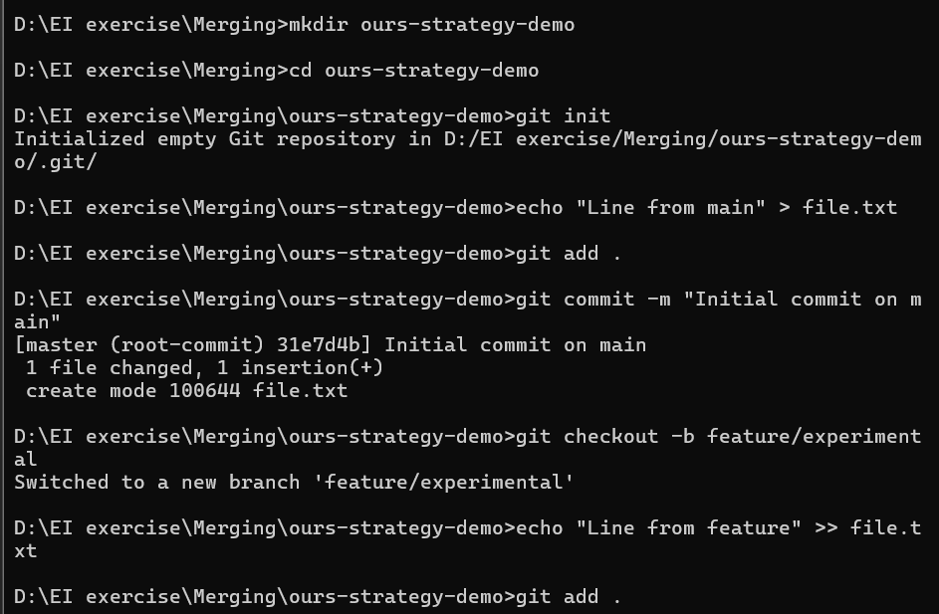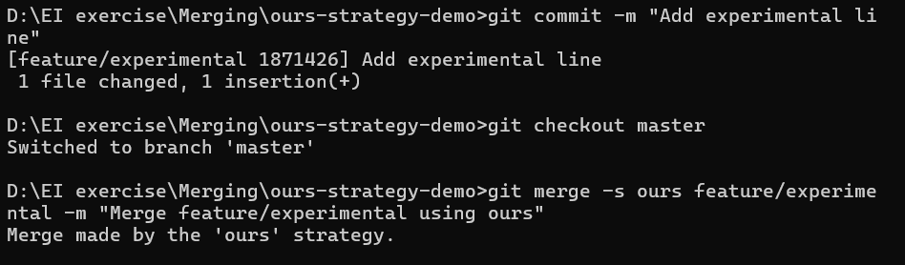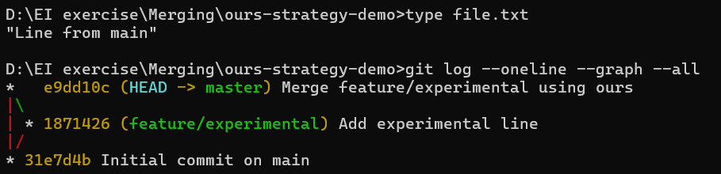
Merge Type | What happens to file content? | Commits in history | Real-life use case
Fast-forward | Adds feature content | Linear, no merge commit | Small, simple updates
Squash | Adds all feature content | Single commit | Keep main branch clean
Ours | Keeps main content, discards feature | Merge commit exists | Ignore unwanted feature changes
8.) Rebase:
- Reapplies the commit from one branch onto another ,
- No merge commit
How they Diff from merging?:
In merging:
A --- B -------- M (main)
\ /
C --- D (feature)
In Rebase:
A --- B --- C' --- D' (main after rebase)
Commands:

mkdir rebase-demo
cd rebase-demo
git init
echo "Line 1" > file.txt
git add .
git commit -m "Initial commit"
git checkout -b feature
echo "Feature line 1" >> file.txt
git add .
git commit -m "Add feature line 1"
git checkout main
echo "Main line 2" >> file.txt
git add .
git commit -m "Add main line 2"
git checkout feature
git rebase main/master
Resolve conflict manually
or use
git checkout --ours file.txt - Keep the version from the branch you're rebasing onto
git checkout --theirs file.txt - Keep the version from the commit being applied (incoming)

git add file.txt
git rebase --continue

