Enforce least-privilege access through
identity-aware, application-specific access
policies using Zscaler Private Access (ZPA).

List of teammates
S.no | Name | College | Contact
1 | Rithika TS | Pioneer College of Arts and Science | rithikasenthil176@gmail.com
2 | Priyadharshini A | Pioneer College of Arts and Science | priyadharshinianandhan.2005@gmail.com
3 | Sunitha M | Pioneer College of Arts and Science | sunithamsunitha28@gmail.com
4 | Kulanthai Samy S | Pioneer College of Arts and Science | ajaysamraj23@gmail.com

INTRODUCTION
In today's digital world, organizations rely heavily on cloud services, remote access, and distributed work environments. As a result, protecting sensitive applications and internal networks has become a critical challenge. Traditional security approaches often depend on perimeter-based defenses and Virtual Private Networks (VPNs), which grant users broad access to the entire network once authenticated. This method increases the risk of security breaches because attackers who gain access to the network can potentially reach multiple systems and resources.
To overcome these limitations, modern security strategies adopt the Zero Trust security model, which assumes that no user or device should be trusted by default. Instead, every access request must be verified and authenticated before granting permission. One of the key principles of Zero Trust is least-privilege access, where users are allowed to access only the applications or services necessary for their tasks.
Zscaler Private Access (ZPA) is a cloud-delivered security platform that enables secure remote access to private applications without exposing them to the public internet. ZPA provides identity-aware, application-specific access policies, ensuring that users are authenticated and authorized before accessing resources. Unlike traditional VPN solutions, ZPA connects users directly to applications rather than the entire network, thereby minimizing potential security risks.
This project explores how ZPA can be used to enforce least-privilege access through identity-based policies and secure connectivity. By implementing ZPA, organizations can enhance their security posture, protect sensitive data, and provide seamless access to applications for authorized users.

ABSTRACT
With the rapid growth of cloud computing and remote work environments, organizations face increasing challenges in securing access to internal applications and sensitive data. Traditional security models such as Virtual Private Networks (VPNs) often provide broad network access, which increases the risk of unauthorized access and cyber threats. To address these issues, modern security frameworks focus on implementing the least-privilege access model, ensuring that users can only access the specific applications and resources required for their role.
Zscaler Private Access (ZPA) is a cloud-based Zero Trust Network Access (ZTNA) solution designed to provide secure, identity-based access to private applications without exposing the internal network to the internet. Instead of granting full network access, ZPA establishes a secure, direct connection between authenticated users and authorized applications. This approach significantly reduces the attack surface and prevents unauthorized access.
This project focuses on enforcing least-privilege access through identity-aware and application-specific access policies using ZPA. The system verifies users based on identity, device posture, and organizational security policies before granting access to specific applications. By implementing a Zero Trust architecture, the solution ensures that every access request is continuously validated, improving overall security.
The proposed approach enhances organizational security by protecting internal applications, reducing dependency on traditional VPN solutions, and enabling secure remote access for employees and partners. Ultimately, this project demonstrates how ZPA can help organizations implement stronger access control, protect sensitive resources, and create a more secure and scalable network environment
Use Case Scenarios:
1. Secure Remote Employee Access
Scenario:
Employees working from home need to access internal company applications such as HR systems, databases, and internal portals. Traditional VPNs may expose the entire network once a user logs in.
Solution:
- Using Zscaler Private Access, organizations can provide secure, identity-based access only to specific applications required by the employee.
- ZPA verifies user identity and device posture before granting access, ensuring that employees connect securely without exposing the internal network.

2. Third-Party Vendor Access
Scenario:
External vendors or partners may need temporary access to certain company applications for maintenance or collaboration. Giving them full network access can create serious security risks.
Solution:
- With Zscaler Private Access, administrators can create application-specific access policies that allow vendors to access only the required application.
- Once the work is completed, the access can be easily revoked, ensuring secure and controlled vendor access.

3. Protection of Internal Applications
Scenario:
Many organizations host internal applications that should not be visible on the public internet. Exposing these applications increases the risk of cyber attacks.
Solution:
- Zscaler Private Access hides internal applications from the internet and connects users directly to them through a secure tunnel.
- Since the applications are not publicly exposed, attackers cannot detect or target them easily.

4. Secure Access for Multiple Locations
Scenario:
Companies with multiple branch offices need secure access to centralized applications located in data centers or cloud environments.
Solution:
- Using Zscaler Private Access, employees from different locations can securely access applications through the cloud-based Zero Trust architecture.
- The platform ensures that each user is authenticated and authorized before accessing any application.

5. BYOD (Bring Your Own Device) Security
Scenario:
Employees may use personal devices such as laptops or smartphones to access company resources, which may introduce security risks.
Solution:
- Zscaler Private Access checks device posture and security status before granting access.
- If the device does not meet the organization’s security requirements, access will be restricted.
- This ensures that only secure devices can connect to company applications.

Stage 1:
Title:
Enforce least-privilege access through identity-aware, application-specific access
policies using Zscaler Private Access (ZPA).
Overview:
Zscaler Private Access (ZPA) is a cloud-based security solution designed to provide secure access to internal applications without exposing the corporate network to the internet. It follows the least-privilege access model, meaning users are given access only to the specific applications they need, rather than full network access. This approach significantly reduces the risk of unauthorized access and cyber threats.
ZPA uses identity-aware and application-specific access policies to verify users before granting access. Authentication is based on user identity, device posture, and organizational policies, ensuring that only authorized users can connect to approved applications. Unlike traditional VPNs, ZPA creates a direct, secure connection between the user and the application, keeping applications hidden from public networks.
By adopting a Zero Trust architecture, ZPA continuously validates users and devices, ensuring secure remote access for employees, partners, and third-party users. This modern approach improves security, enhances user experience, and simplifies network management for organizations.
Overall, ZPA helps organizations protect sensitive data, reduce the attack surface, and enforce strict access control through identity-based policies while maintaining seamless and secure connectivity to private applications.

List of Vulnerability:
S.no | Vulnerability Name | CWE No.
1 | Broken Access Control | CWE-40
2 | Security Misconfiguration | CWE-16
3 | Software Supply Chain Failures | CWE-6
4 | Crytographic Failures | CWE-32
5 | Injection | CWE-37
6 | Insecure Design | CWE-39
7 | Authentication Failures | CWE-36
8 | Software or Data Integrity Failures | CWE-14
9 | Security Logging and Alerting Failures | CWE-5
10 | Mishandling of Exceptional Conditions | CWE-24

Report:
1. Vulnerability Name: Broken Access Control
CWE:40
OWASP Category: A01:2021 – Broken Access Control
Description:
Broken Access Control occurs when restrictions on what authenticated users are allowed to do are not properly enforced. Attackers can exploit these weaknesses to access unauthorized data, perform administrative actions, or modify system resources.
Business Impact:
Attackers may gain access to confidential data, modify user permissions, or perform administrative actions. This can lead to data breaches, financial losses, and damage to organizational reputation.
Vulnerability Path:
Example:
http://testfire.net/
Vulnerability Parameter:
http://testfire.net/search.jsp?query=%27%3E%3Cscript%3Ealert%28%27hacked%27%29%3C%2Fscrip t%3E
Steps
- Login as normal user and change the URL parameter or resource id
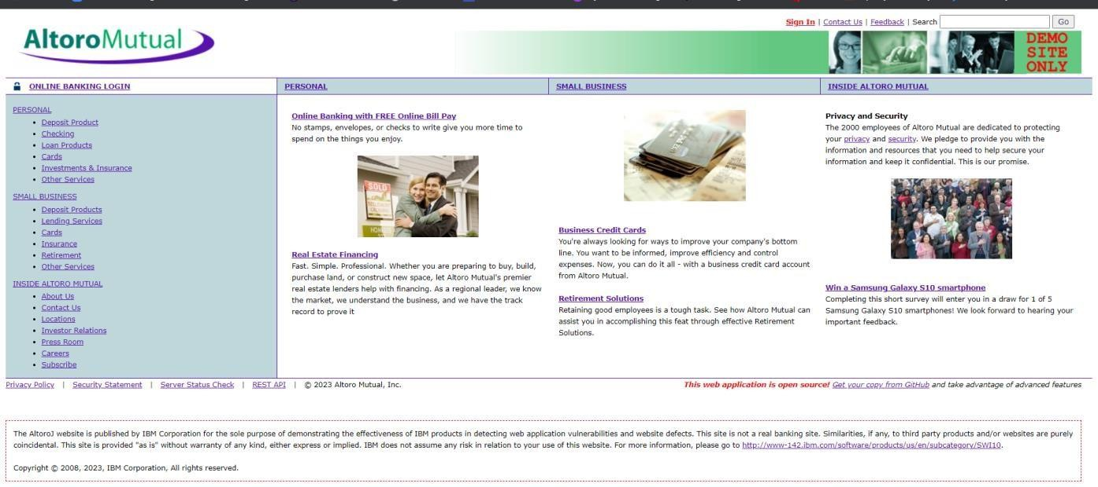
- Attempt to access restricted pages like admin panels.

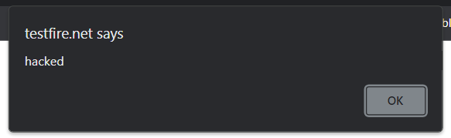
Recommendation:
• Implement proper role-based access control (RBAC).
• Validate user permissions on the server side.
• Use secure session management.

- Unauthorized access to admin page or restricted data.
2. Vulnerability Name: Security Misconfiguration
CWE: 16
OWASP Category: A05:2021 – Security Misconfiguration
Description:
Security Misconfiguration occurs when security settings are not properly implemented. This includes default credentials, unnecessary services, open cloud storage, or verbose error messages.
Business Impact:
Attackers can exploit these configurations to gain system access, retrieve sensitive information, or compromise the application.
Vulnerability Path:http://testfire.net/
Vulnerability parameter: http://testfire.net/login.jsp

Steps to Reproduce:
➢ Access application configuration pages.
➢ Check for default settings or exposed error messages.
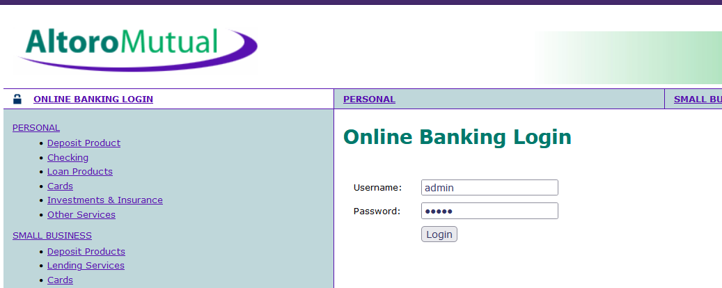

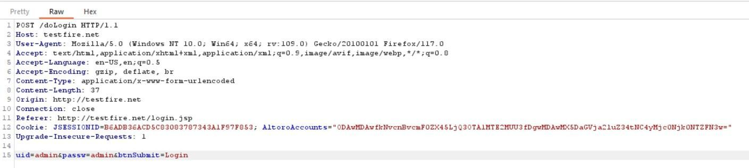

Recommendation:
• Disable default accounts and services.
• Configure security headers properly.
• Regularly update and patch systems.

3. Vulnerability Name: Software Supply Chain Failures
CWE: 6
OWASP Category: A06:2021 – Vulnerable and Outdated Components
Description:
This vulnerability occurs when applications rely on third-party libraries or components with known security flaws.
Business Impact:
Attackers may exploit vulnerabilities in outdated libraries to gain unauthorized access or execute malicious code.
Steps to Reproduce:
➢ Scan application dependencies.

➢ Identify outdated or vulnerable libraries.
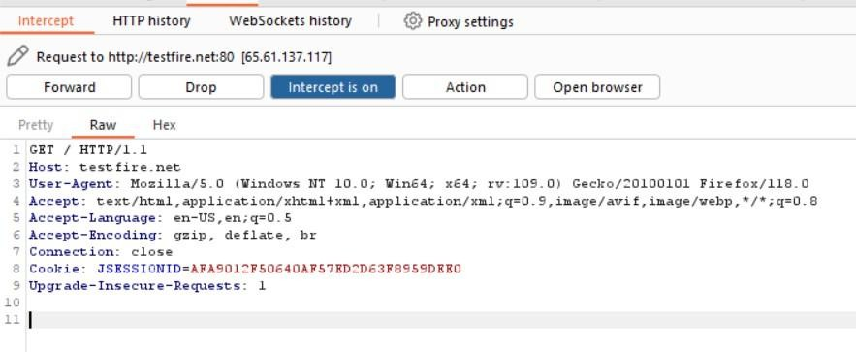
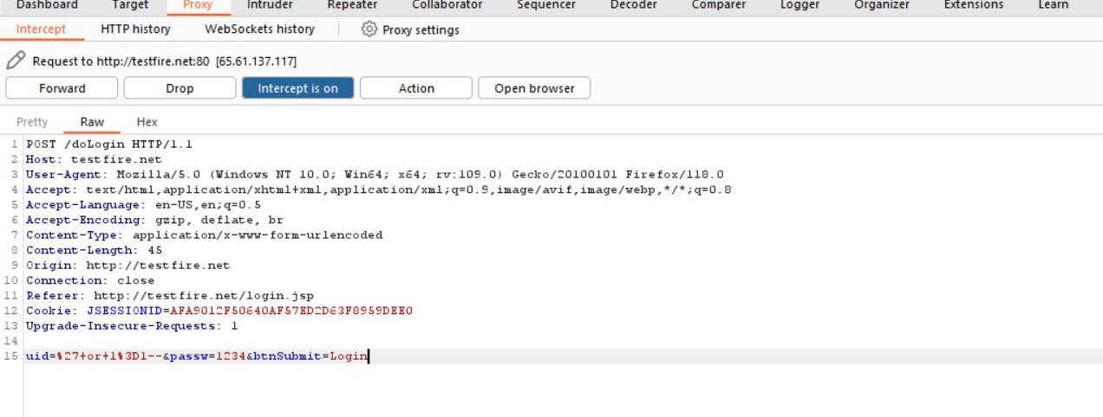
Recommendation:
• Regularly update software components.
• Use dependency vulnerability scanners.
4. Vulnerability Name: Cryptographic Failures
CWE: 32
OWASP Category: A02:2021 – Cryptographic Failures
Description:
Cryptographic failures occur when sensitive data such as passwords or financial information is not properly encrypted.
Business Impact:
Attackers can intercept sensitive data, leading to identity theft or financial fraud.
Steps to Reproduce:
➢ Intercept network traffic using tools like a proxy.
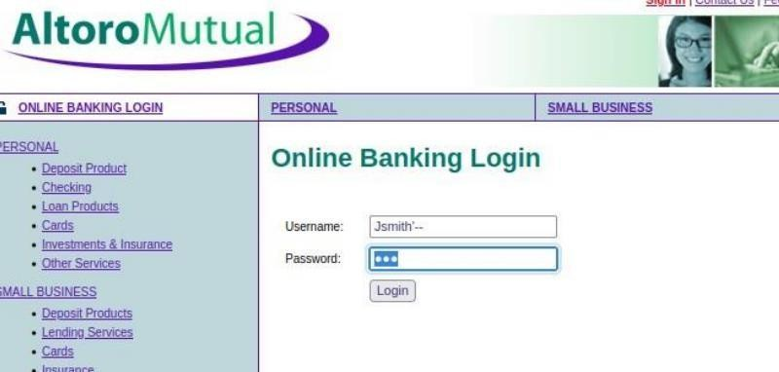
➢ Observe unencrypted sensitive data.
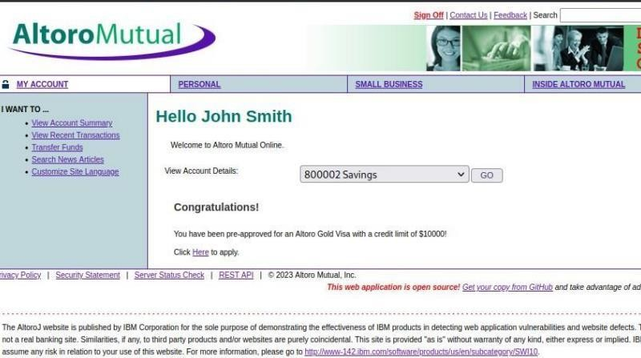
Recommendation:
• Use strong encryption algorithms.
• Enforce HTTPS and secure TLS protocols.
5. Vulnerability Name: Injection
CWE: 37
OWASP Category: A03:2021 – Injection
Description:
Injection occurs when untrusted input is sent to an interpreter as part of a command or query.
Business Impact:
Attackers can manipulate database queries to access or modify sensitive data.
Steps to Reproduce:
➢ Enter SQL payload in login or search field.
Example: ' OR '1'='1
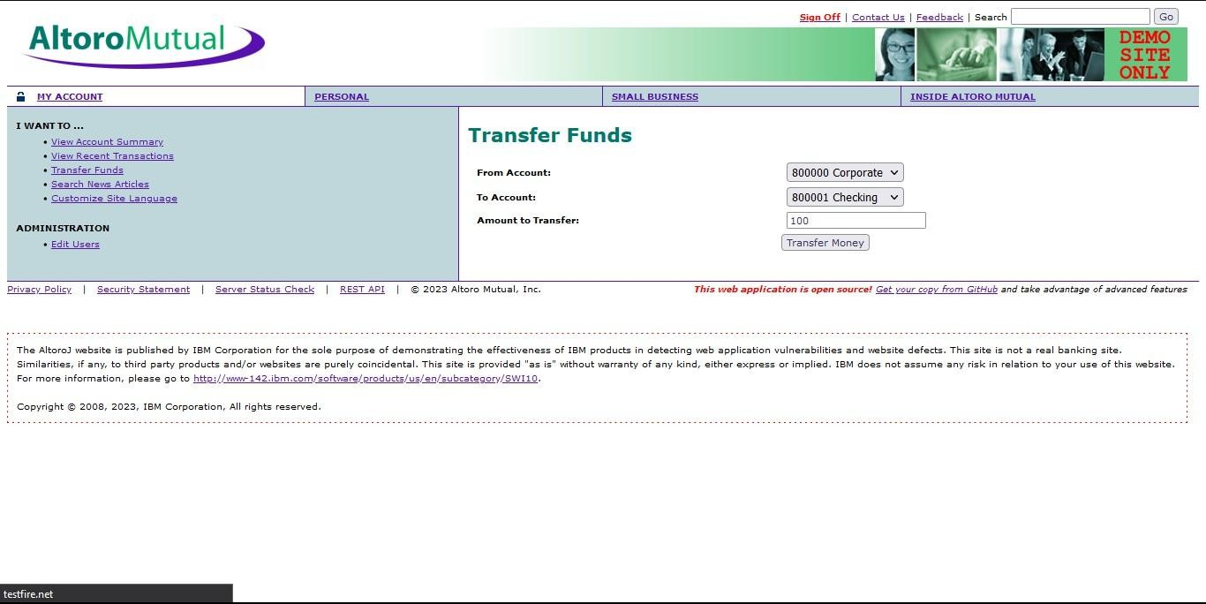

Recommendation:
• Use parameterized queries.
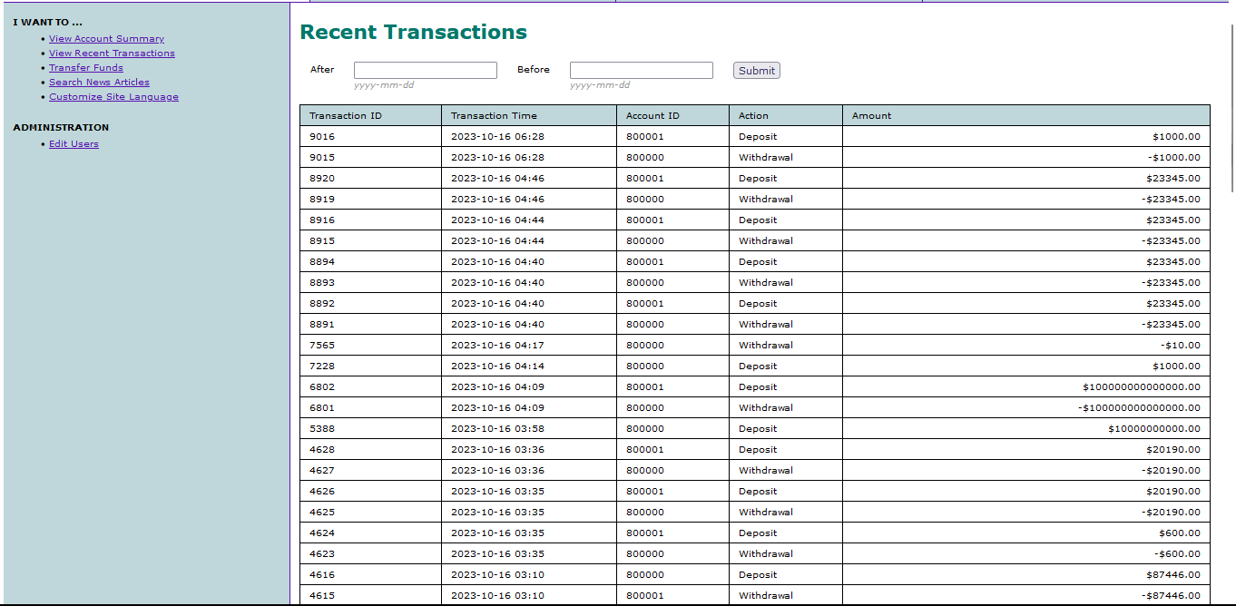
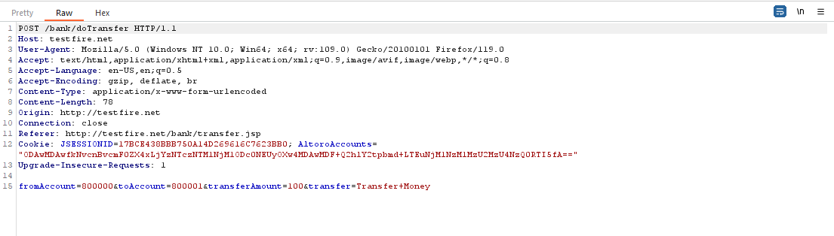
• Validate and sanitize user input.

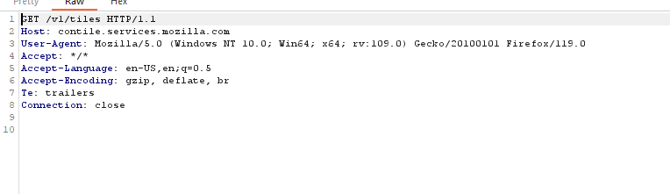

6. Vulnerability Name: Insecure Design
CWE: 39
OWASP Category: A04:2021 – Insecure Design
Description:
Insecure design refers to missing or ineffective security controls in application architecture.
Business Impact:
Attackers may bypass security mechanisms and access sensitive operations.
Steps to Reproduce:
➢ Analyze system design.

➢ Identify missing authentication or validation steps.
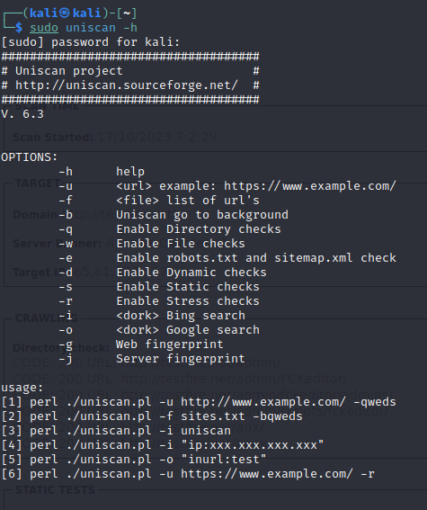

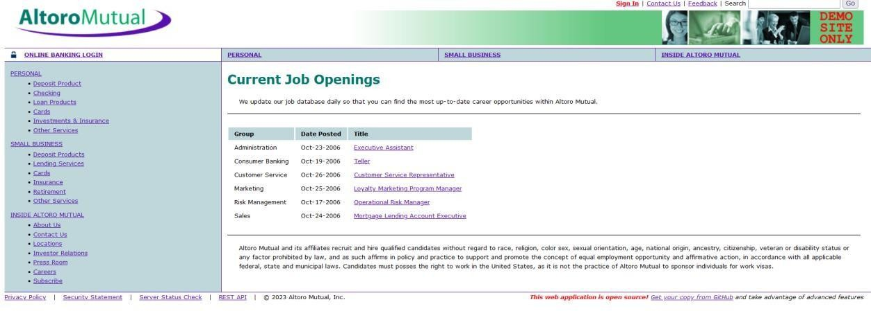
Recommendation:
• Apply secure design principles.
• Perform threat modeling during development.
7. Vulnerability Name: Authentication Failures
CWE: 36
OWASP Category: A07:2021 – Identification and Authentication Failures
Description:
Authentication failures occur when authentication mechanisms are weak or improperly implemented.
Business Impact:
Attackers may compromise accounts through brute force attacks or credential stuffing.
Steps to Reproduce:
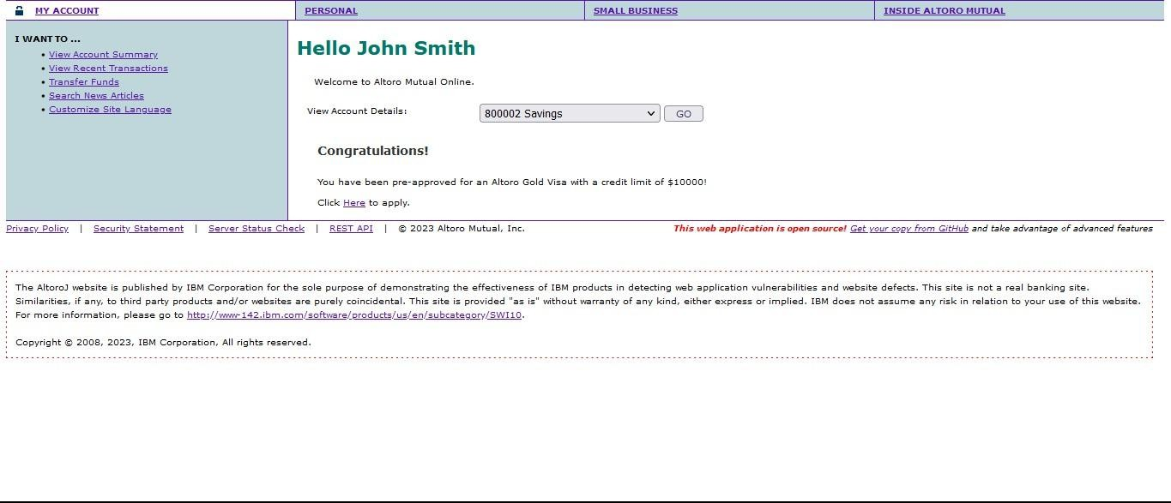
➢ Attempt multiple login attempts with weak passwords.

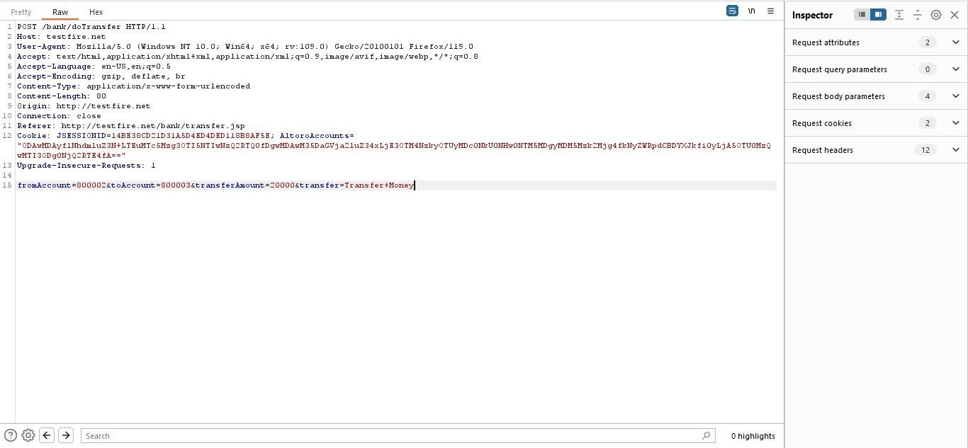
Recommendation:
• Implement strong password policies.
• Use multi-factor authentication (MFA).
8. Vulnerability Name: Software or Data Integrity Failures
CWE: 14
OWASP Category: A08:2021 – Software and Data Integrity Failures
Description:
This vulnerability occurs when applications fail to verify the integrity of software updates or data.
Business Impact:
Attackers may introduce malicious updates or modify application code.
Steps to Reproduce:

➢ Analyze update mechanisms.

➢ Check for unsigned software updates.
Recommendation:
• Implement digital signatures for updates.
• Validate data integrity.

9. Vulnerability Name: Security Logging and Monitoring Failures
CWE: 5
OWASP Category: A09:2021 – Security Logging and Monitoring Failures
Description:
Applications may fail to record important security events, preventing detection of attacks.
Business Impact:
Security incidents may go unnoticed, allowing attackers to maintain access.
Steps to Reproduce:
➢ Perform suspicious activity such as repeated login failures.
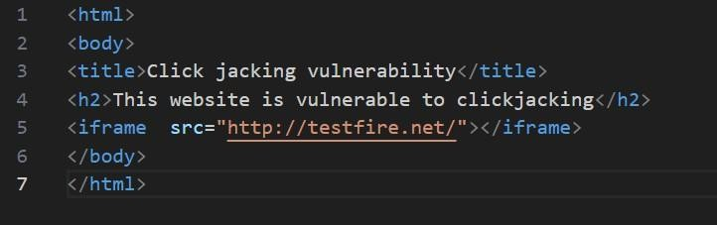
➢ Check if logs record the activity.
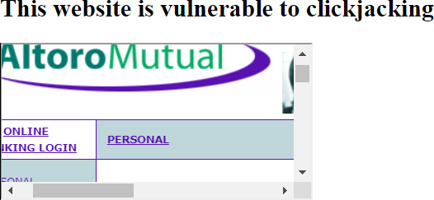
Recommendation:
• Enable detailed security logging.
• Implement monitoring and alert systems.
10. Vulnerability Name: Mishandling of Exceptional Conditions
CWE: 24
OWASP Category: Improper Error Handling
Description:
Improper handling of unexpected errors may expose system details or cause application crashes.
Business Impact:
Attackers can gather system information useful for further attacks.
Steps to Reproduce:
➢ Enter invalid input in forms.
➢ Observe error messages displayed.


Recommendation:
• Implement proper exception handling.
• Avoid displaying detailed system errors to users.
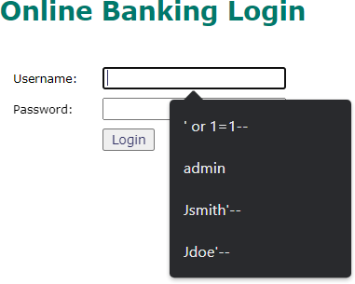

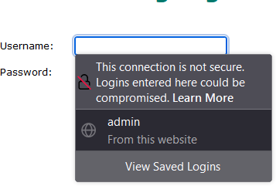

Detailed error message displayed on web page.

NESSUS SCAN REPORT:

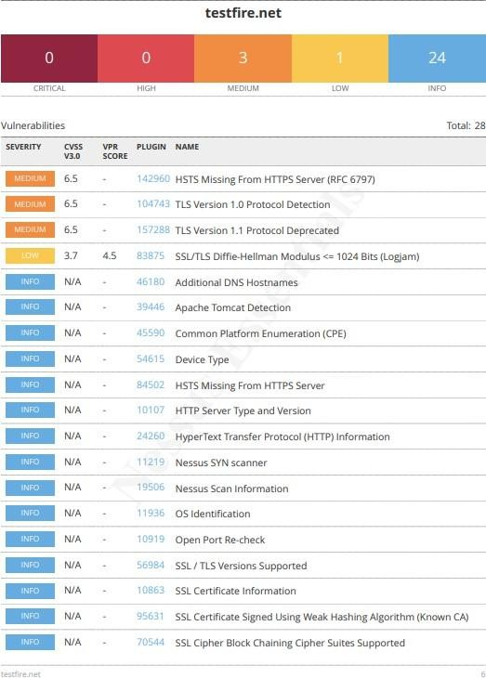
NESSUS SCAN REPORT:

Stage – 2
Overview
In this stage of the project, a vulnerability assessment was performed using the security scanning tool Tenable Nessus. The purpose of this stage is to identify potential vulnerabilities, security misconfigurations, and weak points in the target system before implementing secure access mechanisms such as Zscaler Private Access (ZPA). Vulnerability scanning is an important step in cybersecurity because it helps organizations understand the current security posture of their applications and networks.
A Nessus scan typically begins with proper preparation and planning. During this step, the objectives of the scan are defined and the scope of the assessment is determined. The security analyst must identify the systems, networks, or web applications that need to be scanned and ensure that proper authorization is obtained to perform the scan. In this project, the vulnerability scan was conducted on the practice web application Altoro Mutual Test Site (testfire.net), which is commonly used for security testing and learning purposes.
The next step involves configuration of the scanning policy. Nessus allows users to configure scan policies that define the types of vulnerabilities to detect, scanning techniques, and the level of depth for the scan. The target assets such as the website URL, IP address, or network range must also be specified during this phase. Once the policy is configured, the scan can be initiated.
During the scanning phase, Nessus systematically analyzes the target system by checking open ports, running services, software versions, encryption protocols, and system configurations. Nessus uses a large database of plugins to detect known vulnerabilities and security weaknesses. These plugins allow the tool to identify issues such as outdated protocols, insecure configurations, and potential attack vectors.
After the scan is completed, Nessus performs vulnerability identification and classification. All detected vulnerabilities are categorized based on their severity levels such as Critical, High, Medium, Low, and Informational. This classification helps security professionals prioritize the vulnerabilities that need immediate attention.
The next stage is reporting, where Nessus generates detailed vulnerability reports. These reports include information such as the vulnerability name, severity level, plugin ID, affected port, description of the issue, and recommended remediation steps. The reports can be exported in different formats such as PDF, HTML, or CSV for documentation and analysis.
Once vulnerabilities are identified, the remediation process begins. Security teams analyze the findings and take corrective actions to mitigate the risks. This may include updating software versions, applying security patches, configuring encryption protocols properly, or implementing stronger access control mechanisms.
Regular follow-up scans are also necessary to maintain a strong security posture. Continuous vulnerability scanning helps organizations detect newly discovered vulnerabilities and verify whether previously identified issues have been successfully resolved. Nessus can also be integrated with other security solutions to automate the vulnerability management process.
Overall, vulnerability scanning using Nessus is an essential component of proactive cybersecurity defense. It helps organizations detect security weaknesses early and take appropriate measures to protect their systems and data from potential cyber threats.

List of Vulnerabilities
S.No | Vulnerability Name | Severity | Plugin
1 | Cross-Site Scripting (Stored) | Low | Web Application Scanner
2 | Broken Access Control | Medium | SSH Weak HMAC Algorithms
3 | SQL Injection | Medium | N/A
4 | Broken Authentication | Low | HSTS Missing From Server
5 | Insecure Direct Object Reference | Info | Service Detection
6 | Security Misconfiguration | Low | SSL Cipher Block Chaining Suites
7 | Cross-Site Request Forgery | Low | HTTP Form-Based Authentication
8 | Cleartext Transmission of Sensitive Information | Medium | Cleartext Transmission over HTTP
9 | Clickjacking | Info | HTML Rendering Layer Vulnerability
10 | Web Server Allows Password Auto-Completion | Low | SSL/TLS Diffie-Hellman Modulus ≤1024

Target Website :testfire.net
Target IP Address:54.83.41.36

REPORT:
1. VULNERABILITY NAME: Cross site scripting (stored)
SEVERITY: Low
PLUGIN: web application scanner
PORT: N/A
DESCRIPTION: It occurs when a malicious script is injected directly into a vulnerable web application. Reflected XSS involves the reflection of a malicious script of a web application, onto a user's browser.
SOLUTION:
• When interacting with databases, use parameterized statements or prepared statements to avoid SQL injection, which can be a vector for XSS.
• Sanitize and validate all user inputs and ensure that any data displayed on the web page properly encoded. Use output encoding libraries or functions to prevent script injection.
BUSINESS IMPACT: The application stores dangerous data in a database, message forum, visitor log, or other trusted data store. Later, the dangerous data is subsequently read back into the application and included in dynamic content. From an attacker's perspective, the optimal place to inject malicious content is in an area that is displayed to either many users or particularly interesting users. Interesting users typically have elevated privileges in the application or interact with sensitive data that is valuable to the attacker. If one of these users executes malicious content, the attacker may be able to perform privileged operations on behalf of the user or gain access to sensitive data belonging to the user.
2. VULNERABILITY NAME: Broken Access Control
SEVERITY: Medium
PLUGIN: SSH weak HMAC Algorithms Supported
PORT: 22
DESCRIPTION:
Broken Access Control occurs when restrictions on what authenticated users are allowed to do are not properly enforced. Attackers can exploit these weaknesses to access unauthorized data, perform administrative actions, or modify system resources without proper permissions.
SOLUTION:
• Implement proper role-based access control (RBAC).
• Validate user permissions on the server side.
• Restrict access to sensitive resources using authentication and authorization mechanisms.
BUSINESS IMPACT:
Attackers may gain unauthorized access to confidential data or administrative functions, leading to data breaches, data modification, or service disruption.
3. VULNERABILITY NAME: SQL Injection
SEVERITY: Medium
PLUGIN: N/A
PORT: 80
DESCRIPTION:
SQL Injection occurs when an attacker inserts malicious SQL queries into input fields that interact with the database. If the application does not properly validate user inputs, the attacker can manipulate the database queries and access sensitive information.
SOLUTION:
• Use parameterized queries and prepared statements.
• Validate and sanitize all user inputs.
• Implement input filtering and database security controls.
BUSINESS IMPACT:
Attackers may retrieve sensitive information such as usernames, passwords, or financial records from the database. In severe cases, they may modify or delete data.
4. VULNERABILITY NAME: Broken Authentication
SEVERITY: Low
PLUGIN: HSTS Missing From Server
PORT: 443
DESCRIPTION:
Broken authentication occurs when authentication mechanisms are improperly implemented. This may allow attackers to compromise user accounts by exploiting weak session management or insecure authentication methods.
SOLUTION:
• Implement strong password policies.
• Use multi-factor authentication (MFA).
• Ensure secure session management and timeout mechanisms.
BUSINESS IMPACT:
Attackers may gain access to user accounts and perform unauthorized actions, potentially compromising sensitive data.
5. VULNERABILITY NAME: Insecure Direct Object Reference
SEVERITY: Informational
PLUGIN: Service Detection
PORT: 80
DESCRIPTION:
Insecure Direct Object Reference occurs when an application exposes internal objects such as files, database records, or user IDs without proper authorization checks.
SOLUTION:
• Implement proper access control checks.
• Use indirect references instead of exposing direct object identifiers.
• Validate user permissions before granting access to resources.
BUSINESS IMPACT:
Attackers may manipulate object references to access sensitive data belonging to other users.
6. VULNERABILITY NAME: Security Misconfiguration
SEVERITY: Low
PLUGIN: SSL Cipher Block Chaining Cipher Suites
PORT: 443
DESCRIPTION:
Security misconfiguration occurs when system components such as servers, frameworks, or applications are not securely configured. This may include default credentials, unnecessary services, or weak encryption settings.
SOLUTION:
• Disable unnecessary services and default accounts.
• Configure secure encryption protocols.
• Regularly update and patch systems.
BUSINESS IMPACT:
Misconfigured systems may expose sensitive information or allow attackers to exploit system weaknesses.
7. VULNERABILITY NAME: Cross-Site Request Forgery (CSRF)
SEVERITY: Low
PLUGIN: HTTP Form-Based Authentication Detected
PORT: 80
DESCRIPTION:
Cross-Site Request Forgery (CSRF) occurs when attackers trick users into performing unwanted actions on a web application where they are authenticated.
SOLUTION:
• Implement CSRF tokens in forms.
• Validate request origin using headers.
• Use secure authentication mechanisms.
BUSINESS IMPACT:
Attackers may perform unauthorized actions on behalf of the user, such as changing account settings or transferring funds.
8. VULNERABILITY NAME: Cleartext Transmission of Sensitive Information
SEVERITY: Medium
PLUGIN: Cleartext Transmission of Sensitive Information over HTTP
PORT: 80
DESCRIPTION:
Sensitive information transmitted over HTTP without encryption can be intercepted by attackers using network monitoring tools.
SOLUTION:
• Enforce HTTPS for all communications.
• Use strong TLS encryption protocols.
• Disable HTTP access for sensitive data.
BUSINESS IMPACT:
Attackers may intercept login credentials, personal information, or financial data transmitted over the network.

9. VULNERABILITY NAME: Click Jacking
SEVERITY: Informational
PLUGIN: HTML Rendering Layer Vulnerability
PORT: 80
DESCRIPTION:
ClickJacking occurs when attackers trick users into clicking hidden elements on a webpage, potentially executing unintended actions.
SOLUTION:
• Implement X-Frame-Options or Content Security Policy headers.
• Prevent pages from being embedded in external frames.
BUSINESS IMPACT:
Attackers may manipulate user actions such as clicking buttons or links without the user’s knowledge.
10. VULNERABILITY NAME: Web Server Allows Password Auto-Completion
SEVERITY: Low
PLUGIN: SSL/TLS Diffie-Hellman Modulus ≤1024 bits (Logjam)
PORT: 443
DESCRIPTION:
Password auto-completion may store user credentials in the browser, which could be accessed by unauthorized users if the system is compromised.
SOLUTION:
• Disable autocomplete for sensitive login fields.
• Implement secure password storage mechanisms.
• Use strong encryption for authentication processes.
BUSINESS IMPACT:
Stored credentials may be exposed to attackers, allowing them to access user accounts and sensitive information.
Stage – 3
Title
Enforce Least-Privilege Access Through Identity-Aware, Application-Specific Access Policies Using Zscaler Private Access (ZPA)
Zero Trust Network Access (ZTNA)
Zero Trust Network Access (ZTNA) is a modern cybersecurity approach that focuses on protecting applications rather than the entire network. The core principle of Zero Trust is “Never Trust, Always Verify.” This means that every user and device must be verified before accessing any application or resource, regardless of whether they are inside or outside the organization’s network.
Traditional network security models rely heavily on perimeter-based protection such as firewalls and VPNs. Once users are authenticated through a VPN, they often gain access to large parts of the network, which increases the risk of lateral movement attacks. In contrast, ZTNA limits access strictly to the applications a user is authorized to use.
ZTNA establishes secure connections between users and applications through encrypted tunnels. These connections are created only after verifying the user’s identity, device status, and security policies. As a result, applications remain hidden from unauthorized users and attackers on the internet. This approach significantly reduces the attack surface and improves overall security.
Zscaler Private Access (ZPA)
Zscaler Private Access (ZPA) is a cloud-delivered Zero Trust Network Access solution that enables secure access to internal applications without exposing the corporate network. Instead of providing network-level connectivity like traditional VPNs, ZPA connects users directly to specific applications based on defined access policies.
ZPA operates through a cloud-based service architecture. When a user attempts to access an internal application, the connection is first authenticated through the Zscaler cloud. The system verifies the user’s identity, device posture, and security policies before allowing access.
One of the key advantages of ZPA is that internal network infrastructure remains invisible to the internet. Users are never placed directly on the corporate network. Instead, a secure connection is created between the user and the application through Zscaler’s cloud platform.
This architecture improves security by preventing attackers from scanning internal systems or launching network-based attacks. It also simplifies remote access for employees working from different locations.
Principle of Least Privilege
The Principle of Least Privilege (PoLP) is a fundamental concept in cybersecurity. It ensures that users, devices, and applications are granted only the minimum level of access required to perform their tasks.
In traditional network environments, users often receive broad access to multiple systems once authenticated. This creates security risks because compromised accounts can be used to access other systems within the network.
By enforcing least-privilege access through ZPA, organizations ensure that users can only access specific applications assigned to them. Even if an attacker compromises a user account, the attacker cannot move laterally across the network because other systems remain inaccessible.
This approach significantly reduces the risk of insider threats, credential misuse, and unauthorized data access.

Identity-Aware Access
Identity-aware access is a security model where access decisions are based on user identity rather than network location. In this approach, access control policies rely on attributes such as:
- User identity
- Role or department
- Device security status
- Location of the user
- Time of access
ZPA integrates with identity providers such as Microsoft Active Directory, Azure AD, or Okta to authenticate users. Once a user logs in, ZPA verifies the user’s identity and evaluates the defined access policies.
For example, an employee from the finance department may be allowed to access only financial applications during working hours from a company-approved device. This ensures that access is tightly controlled and aligned with organizational roles.
Identity-aware access provides stronger security compared to traditional IP-based access control because it continuously verifies users before granting access.
Application-Specific Access Policies
Application-specific access policies allow administrators to define rules that grant users access only to certain applications rather than entire networks. These policies are configured within the ZPA administration console.
Each application is assigned its own access policy based on factors such as user identity, device posture, and security requirements. This approach enables micro-segmentation, where each application operates within its own isolated security boundary.
For example:
- HR employees may access HR management systems.
- Developers may access development servers.
- Finance staff may access accounting applications.
Users cannot see or interact with applications that are not assigned to them. This isolation prevents attackers from discovering or accessing other systems within the network.
ZPA Architecture and Components
The architecture of ZPA includes several components that work together to provide secure application access.
1. Zscaler Cloud
The Zscaler cloud platform acts as the central security gateway that verifies user identity and enforces access policies.
2. App Connectors
App Connectors are lightweight software components deployed inside the organization’s data center or cloud environment. They establish outbound connections to the Zscaler cloud and allow secure communication with internal applications.
3. ZPA Client Connector
The Client Connector is installed on user devices. It authenticates the user and establishes a secure connection to the Zscaler cloud for application access.
4. Application Segments
Application segments represent groups of internal applications that require secure access. These segments help administrators manage policies and organize applications efficiently.
Implementation Methodology
The deployment of ZPA follows a structured approach to ensure secure implementation.
Phase 1 – Discovery and Assessment
Identify internal applications and classify them based on usage and importance.
Phase 2 – Connector Deployment
Deploy ZPA App Connectors within the organization’s network or cloud environment.
Phase 3 – Application Configuration
Define application segments and configure access settings within the ZPA platform.
Phase 4 – Policy Creation
Create identity-based access policies that determine which users can access specific applications.
Phase 5 – Testing and Deployment
Test the configuration with a small group of users before deploying it across the organization.
Phase 6 – Migration from VPN
Gradually replace traditional VPN access with ZPA to improve security and simplify network access.

Conclusion :
The implementation of Zscaler Private Access represents a significant advancement in modern cybersecurity practices. By adopting a Zero Trust architecture, organizations can move away from traditional network-centric security models and implement a more secure identity-based access framework.
Through the enforcement of least-privilege access policies, users are granted access only to the applications necessary for their roles. This greatly reduces the risk of unauthorized access, lateral movement, and insider threats.
Additionally, ZPA enhances security by making internal applications invisible to the internet and ensuring that all access requests are continuously verified. The cloud-based architecture also improves scalability and simplifies remote access for employees working from different locations.
Overall, the deployment of ZPA provides a strong foundation for secure digital transformation, enabling organizations to protect sensitive resources while maintaining efficient and flexible access to applications.
Future Scope
The implementation of ZPA opens opportunities for further improvements in organizational cybersecurity.
Future enhancements may include:
• Integration with Zscaler Internet Access (ZIA) to create a unified Secure Access Service Edge (SASE) platform.
• Advanced device posture verification to ensure that only secure devices can access applications.
• AI-based threat detection systems that analyze user behavior to identify suspicious activity.
• Integration with Security Information and Event Management (SIEM) platforms such as Splunk or IBM QRadar for centralized monitoring.
• Automated identity management to instantly grant or revoke application access based on employee roles.
• Extending Zero Trust security models to IoT devices and cloud workloads.
These enhancements will further strengthen the organization’s security posture and support the adoption of modern digital infrastructures.
Topics Explored
- Zscaler
- Zero Trust Architecture
- ZPA
- VPN Security
- Threat Intelligence
- Incident Response
- Network Security
- Identity-Based Access Control
Tools Explored
• Tenable Nessus Vulnerability Scanner
• Zscaler Private Access

