- CONCLUSION

The Smart Food Saver: Channeling Surplus at Events to Orphanages and Senior Citizen Centers project provides an effective technological solution to the growing problem of food wastage. In many social events such as weddings, parties, and public gatherings, a large quantity of prepared food is often left unused and eventually discarded. At the same time, many orphanages, shelters, and senior citizen homes struggle to provide sufficient meals for their residents. This imbalance highlights the need for a structured and efficient system that can connect food donors with organizations that require food support. The Smart Food Saver system addresses this issue by creating a digital platform that enables the collection, management, and distribution of surplus food in an organized and timely manner. The system allows event organizers to report surplus food through an easy-to-use web interface by entering important details such as food type, quantity, location, and pickup time. Once the food information is submitted, the system processes the data and notifies nearby volunteers and beneficiary organizations through real-time alerts. Volunteers can then collect the surplus food and deliver it to orphanages or senior citizen centers. This process ensures that the food is distributed before it spoils, reducing wastage and helping provide meals to people in need. The Smart Food Saver system also includes several important features such as user registration and authentication, food donation posting, volunteer coordination, notification services, and donation tracking. These features help improve coordination between donors, volunteers, and beneficiary institutions. In addition, the system maintains digital records of donation activities, which improves transparency and allows administrators to monitor the entire food distribution process effectively. By using modern technologies such as web applications, Node.js backend services, and database management systems, the project demonstrates how technology can be used to solve real-world social problems. The platform not only helps reduce food wastage but also encourages social responsibility and community participation. It creates a bridge between people who have surplus food and those who need it the most.In conclusion, the Smart Food Saver system provides a sustainable and practical solution for managing surplus food from events. It promotes efficient food redistribution, reduces environmental impact caused by food waste, and supports the welfare of underprivileged communities. With further improvements and wider implementation, the system has the potential to make a significant contribution toward reducing hunger and creating a more responsible and compassionate society.
  - FUTURE ENHANCEMENTS

The Smart Food Saver system can be further improved by adding advanced features and technologies to enhance its performance, scalability, and usability. In the future, the system can be expanded into a mobile application so that event organizers, volunteers, and NGOs can easily access the platform from their smartphones. A mobile app would provide real-time notifications, faster communication, and better accessibility for users.
Another important enhancement is the integration of Artificial Intelligence (AI) to analyze food quality and freshness. AI-based image processing can help verify whether the donated food is safe for consumption by analyzing food images uploaded by organizers or volunteers. This would improve food safety and increase trust among beneficiary organizations.
The system can also be enhanced by implementing advanced route optimization and GPS tracking for volunteers. This feature would help volunteers find the shortest and fastest route to collect and deliver food, reducing transportation time and ensuring that the food reaches beneficiaries before it spoils.
In the future, the platform can be expanded to support large-scale operations across multiple cities and regions. By collaborating with government agencies, NGOs, and food safety authorities, the system can become a nationwide food redistribution network that effectively reduces food wastage and helps feed more people in need. Additional features such as donation analytics, volunteer reward systems, and automated food demand prediction can further improve the efficiency and impact of the Smart Food Saver system.

- BIBILIOGRAPHY

TEXT BOOK REFERENCES:

- Ian Sommerville, Software Engineering, 10th Edition, Pearson Education, 2016.

- Roger S. Pressman and Bruce R. Maxim, Software Engineering: A Practitioner’s Approach, 8th Edition, McGraw-Hill Education, 2015.

- Efraim Turban, David King, Jae Lee, and Deborrah C. Turban, Electronic Commerce: A Managerial and Social Networks Perspective, Springer, 2015.

- Jon Duckett, HTML and CSS: Design and Build Websites, John Wiley & Sons, 2011.

- Alex Banks and Eve Porcello, Learning React: Functional Web Development with React and Redux, O’Reilly Media, 2020.

WEBSITE REFERENCES:

- https://olioapp.com
- https://sharefood.eatrightindia.gov.in
- https://food.cloud
- https://sharethemeal.org

- APPENDICES

- DATA FLOW DIAGRAM

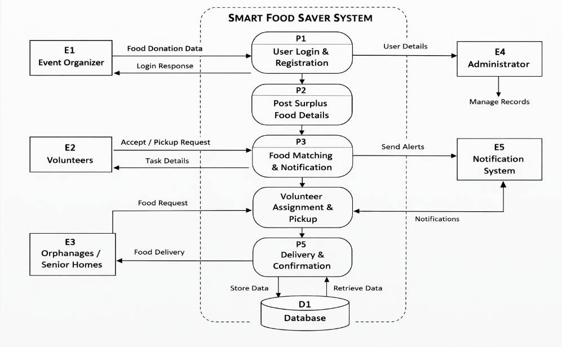

B).SAMPLE CODING

const express = require('express');
const cors = require('cors');
const bodyParser = require('body-parser');
const Database = require('better-sqlite3');

const app = express();
const db = new Database('db.sqlite');

app.use(cors());
app.use(bodyParser.json());

/* ---------------- DATABASE TABLES ---------------- */

db.prepare(`
CREATE TABLE IF NOT EXISTS users (
id INTEGER PRIMARY KEY AUTOINCREMENT,
name TEXT,
email TEXT UNIQUE,
password TEXT,
role TEXT
)
`).run();

db.prepare(`
CREATE TABLE IF NOT EXISTS donations (
id INTEGER PRIMARY KEY AUTOINCREMENT,
food_title TEXT,
quantity INTEGER,
location TEXT,
donor_name TEXT,
created_at TEXT
)
`).run();

/* ---------------- REGISTER USER ---------------- */

app.post('/register', (req,res)=>{
const {name,email,password,role} = req.body;

try{
db.prepare(`
INSERT INTO users(name,email,password,role)
VALUES(?,?,?,?)
`).run(name,email,password,role);

res.send({message:"User Registered"});
}catch(err){
res.send({error:"User already exists"});
}
});

/* ---------------- LOGIN USER ---------------- */

app.post('/login',(req,res)=>{
const {email,password} = req.body;

const user = db.prepare(`
SELECT * FROM users WHERE email=? AND password=?
`).get(email,password);

if(user){
res.send(user);
}else{
res.send({error:"Invalid login"});
}
});

/* ---------------- POST FOOD ---------------- */

app.post('/donate',(req,res)=>{

const {food_title,quantity,location,donor_name} = req.body;

db.prepare(`
INSERT INTO donations(food_title,quantity,location,donor_name,created_at)
VALUES(?,?,?,?,datetime('now'))
`).run(food_title,quantity,location,donor_name);

res.send({message:"Food Donation Added"});
});

/* ---------------- GET ALL DONATIONS ---------------- */

app.get('/donations',(req,res)=>{

const donations = db.prepare(`
SELECT * FROM donations
`).all();

res.send(donations);

});

app.listen(5000,()=>{
console.log("Server running on port 5000");
});

import React, {useState,useEffect} from "react";
import axios from "axios";

function App(){

const [food,setFood] = useState("");
const [quantity,setQuantity] = useState("");
const [location,setLocation] = useState("");
const [donor,setDonor] = useState("");
const [donations,setDonations] = useState([]);

const addDonation = async ()=>{

await axios.post("http://localhost:5000/donate",{
food_title:food,
quantity:quantity,
location:location,
donor_name:donor
});

loadDonations();
}

const loadDonations = async ()=>{
const res = await axios.get("http://localhost:5000/donations");
setDonations(res.data);
}

useEffect(()=>{
loadDonations();
},[])

return(

<div style={{padding:"20px"}}>

<h1>Smart Food Saver</h1>

<h2>Donate Surplus Food</h2>

<input
placeholder="Food Title"
onChange={(e)=>setFood(e.target.value)}
/>

<br/>

<input
placeholder="Quantity"
onChange={(e)=>setQuantity(e.target.value)}
/>

<br/>

<input
placeholder="Location"
onChange={(e)=>setLocation(e.target.value)}
/>

<br/>

<input
placeholder="Donor Name"
onChange={(e)=>setDonor(e.target.value)}
/>

<br/><br/>

<button onClick={addDonation}>
Donate Food
</button>

<h2>Available Donations</h2>

{donations.map(d =>(

<div key={d.id} style={{
border:"1px solid grey",
padding:"10px",
margin:"10px"
}}>

<h3>{d.food_title}</h3>
<p>Quantity : {d.quantity}</p>
<p>Location : {d.location}</p>
<p>Donor : {d.donor_name}</p>

</div>

))}

</div>

)
}

export default App;
C) SAMPLE OUTPUT

REGISTRATION PAGE

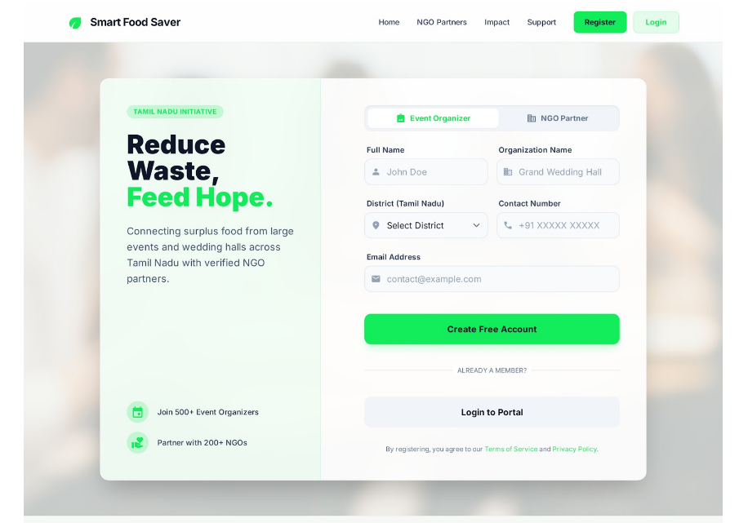

DASHBOARD PAGE

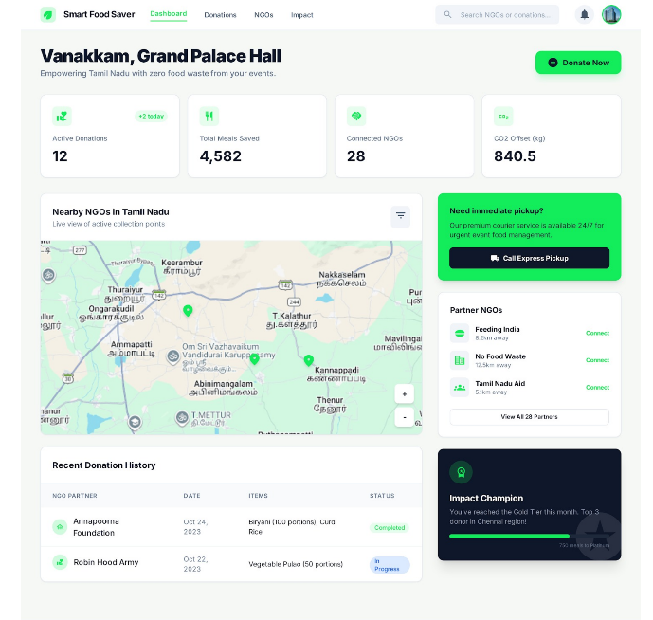

FOOD DETAILS PAGE

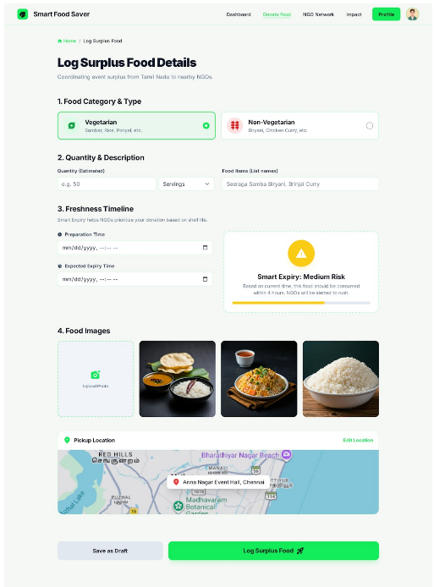

NGO NETWORK PAGE

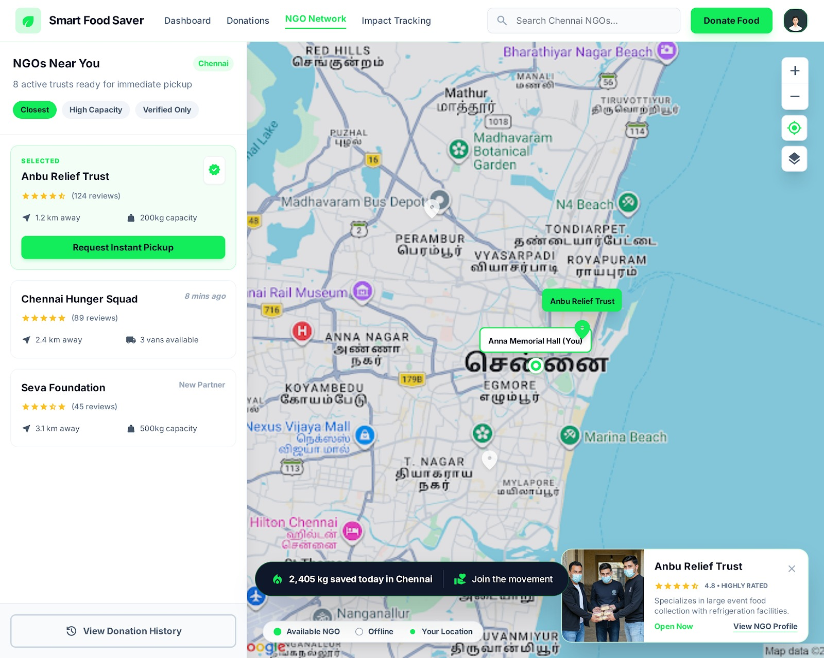

DONATION FEED PAGE

