# IoT Smart RFID Door Lock System Using NodeMCU ESP8266 and Blynk

---------------------------------------------------------------------***---------------------------------------------------------------------

**Abstract -** *The Home Door Lock Security System is a cutting-edge technological solution designed to enhance the security and convenience of residential properties. This system aims to provide homeowners with a reliable and intelligent means of protecting their homes from unauthorized access and potential security breaches.*

*The system utilizes a combination of advanced hardware and software components to create a robust and user-friendly security platform. The primary component of the system is the smart door lock, which replaces traditional mechanical locks with an electronic locking mechanism. The smart lock integrates biometric features such as fingerprint scanning and facial recognition, alongside traditional methods like key cards and PIN codes, to ensure multiple layers of authentication.*

*A key aspect of the Home Door Lock Security System is its seamless integration with a centralized control hub, accessible through a mobile application or web interface. This hub empowers homeowners to remotely manage access to their property, granting or revoking access privileges to specific individuals. It also provides real-time notifications of any unauthorized attempts or suspicious activities, offering homeowners peace of mind even when they are away from their residence.*

***Key Words*: IoT, Smart, RFID, Arduino IDE, ESP8266, *Relay Module***

1. **INTRODUCTION**

The Internet of Things (IoT) has revolutionized various aspects of our lives, and one such application is the implementation of smart door lock systems. This project proposes an innovative IoT-based smart RFID door lock system, leveraging NodeMCU ESP8266 and Blynk platform, to enhance security and convenience in residential and commercial settings.

The system architecture consists of two main components: the RFID reader module and the NodeMCU ESP8266. The RFID reader module interfaces with the NodeMCU, enabling it to detect RFID tags within its range. When an authorized RFID tag is presented, the NodeMCU initiates a real-time connection with the Blynk platform using Wi-Fi, validating the user's credentials. Through the Blynk mobile application, users can remotely unlock or lock the door, monitor access logs, and manage access permissions for individual RFID tags.

## LITERATURE SURVEY

The Blynk platform's versatility allows for easy customization and integration of additional features, such as push notifications and real-time alerts when unauthorized access attempts are made. Furthermore, it enables seamless integration with other IoT devices and platforms, enhancing the overall home or office automation experience.

## To evaluate the system's performance, the project incorporates extensive testing and security assessments, including reliability, response time, and resistance to common hacking techniques. The results demonstrate the robustness and efficacy of the IoT smart RFID door lock system in safeguarding premises and providing convenient access management.

## PROBLEM STATEMENT

## The primary objective of this project is to develop a cost effective, user-friendly, and efficient smart door lock system that incorporates Radio Frequency Identification (RFID) technology. RFID tags are assigned to authorized users, eliminating the need for traditional physical keys, and enabling seamless access control. The NodeMCU ESP8266, a popular microcontroller, serves as the central processing unit to manage data exchange and communication with the Blynk platform.

## Components Required

## NodeMCU ESP8266

## RFID MFRC-522 Module

## 12v Solenoid Door Lock

## Green LED

## Few Jumpers Wires

## Buzzer

## 3.7V Battery

## Breadboard

* Relay Module

**NodeMCU:** NodeMCU is an open source IoT platform. it includes firmware which runs on the ESP8266 Wi-Fi SoC from Expressive Systems, and hardware which is based on the ESP-12 module.

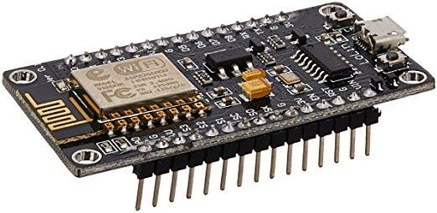

**Fig:** NodeMCU

The term "NodeMCU" by default refers to the firmware rather than the dev kits. The firmware uses the Lua scripting language. The programming code is being written for ESP8266 Wi-Fi chip using Arduino IDE, for which installation of ESP8266 library is required. We designed to make

**RFID MFRC-522 Module:** The RC522 RFID module based on the MFRC522 IC from NXP is one of the cheapest RFID options you can get online for less than four dollars. It usually comes with an RFID card tag and a key fob tag with 1KB of memory. And the best part is that it can write a tag that means you can store any message in it.

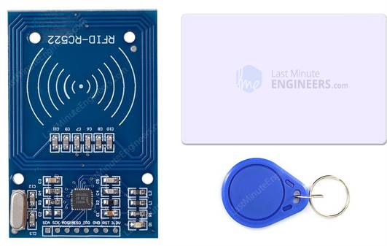

**Relay Module:** Relay modules are simply circuit boards that house one or more relays. They come in a variety of shapes and sizes, but are most commonly rectangular with 2, 4, or 8 relays mounted on them, sometimes even up to 16 relays.

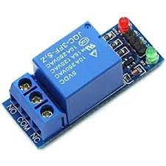

## Features of IoT based RFID smart door lock system

* Blinking LED as WIFI response.
* Buzzer for an alert system
* Authorize and Deauthorized Users from anywhere in the world.
* Over The Air Configuration Update
* Easily Reconfigure WIFI Credentials Stored in EEPROM without hardcoding.
* Live Monitor Your Door Lock From anywhere in the world.

## Proposed Structure

**IoT smart RFID door lock system** using **NodeMCU ESP8266, RFID MF-RC-522 Module, a Relay Module, Solenoid lock, and Blynk IoT platform**

This project can remotely monitor your door lock from anywhere in the world using your phone. (Both iPhone and Android Devices).

In the Blynk IoT App, two tabs are added One is for the **Remote Access Control** and the others for **Live Monitoring**.

This project also has a **Green LED**. It helps to indicate WIFI connection and Blynk IoT server connection. It blinks while data is sent successfully to the server. Similarly, a **Buzzer**is also added to alert when unauthorized access is detected. To open the door lock, permission should be granted by the admin.

This project has integrated Reconfiguring Device features. Hence, you can easily discover your device and enter your **New WIFI SSID, & Password** Wirelessly using your smartphone. Now, you can connect this device to any WIFI network without programming the board.

You can also press and hold the flash button for 10 seconds on the NodeMCU ESP8266 board to erase the WIFI credentials stored in **EEPROM**. Sometimes a condition may evolve in your project that you should intentionally erase the WIFI Credentials. Hence, In that case, you can use this button. It switches NodeMCU to **AP mode**and allows you to discover your device in **Blynk IoT**. Where you can configure your **WIFI SSID & Password**.

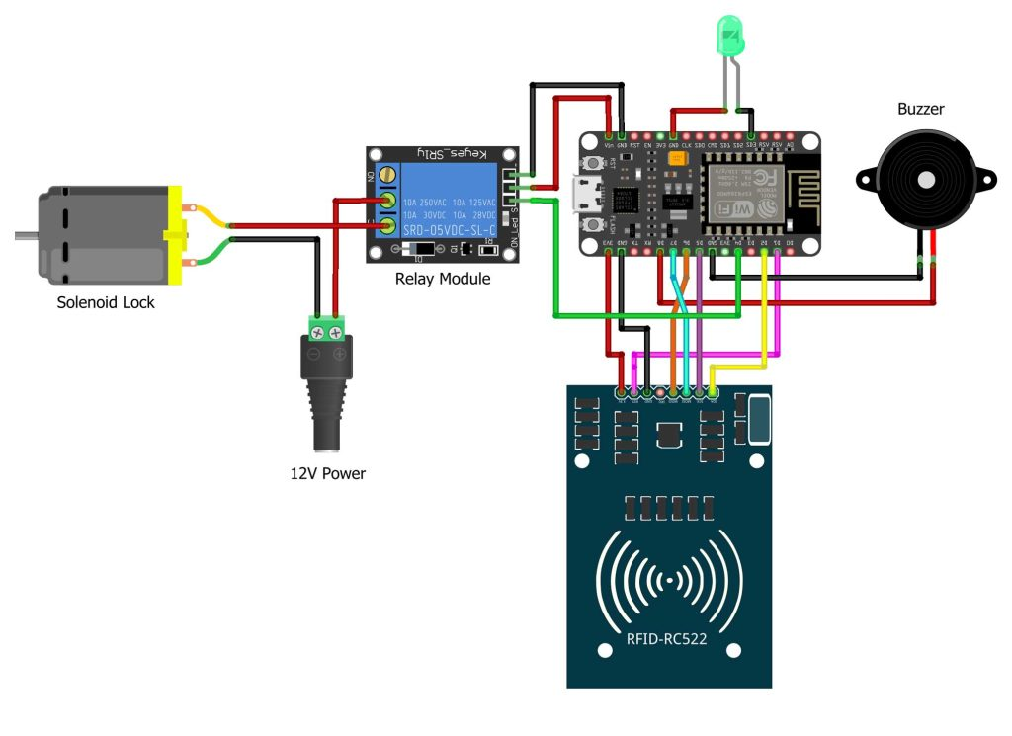

## KEY OBJECTIVES

## RFID Access Control: Implement a robust RFID-based access control mechanism that can authenticate users through RFID cards or tags. Each authorized user will have a unique RFID card associated with their identity.

## Mobile Application Interface: Develop a user-friendly mobile application using Blynk platform, which allows users to remotely interact with the door lock system. Through the app, users should be able to grant access to others, view access logs, and receive real-time notifications about door activity.

## Remote Door Locking/Unlocking: Enable the mobile application to remotely control the door lock system. Authorized users should be able to lock or unlock the door from anywhere with an internet connection.

## Secure Communication: Ensure all communication between the NodeMCU ESP8266 module and the mobile application is encrypted and secured to prevent unauthorized access and tampering.

## Access Logs: Implement a logging system that records the access events, including successful and unsuccessful attempts. The log data should be accessible through the mobile application.

## Offline Mode Handling: Implement a mechanism to handle connectivity issues between the NodeMCU ESP8266 and the Blynk server. The system should still allow local RFID-based access control even when the internet is unavailable.

## Power Management: Optimize power consumption on the NodeMCU ESP8266 module to ensure energy efficiency and prolong the device's operational lifespan.

## Scalability and Flexibility: Design the system to be easily scalable for multiple doors and users. It should also be flexible enough to accommodate future enhancements or integration with other IoT devices.

## EXPERIMENTAL SNIPPETS

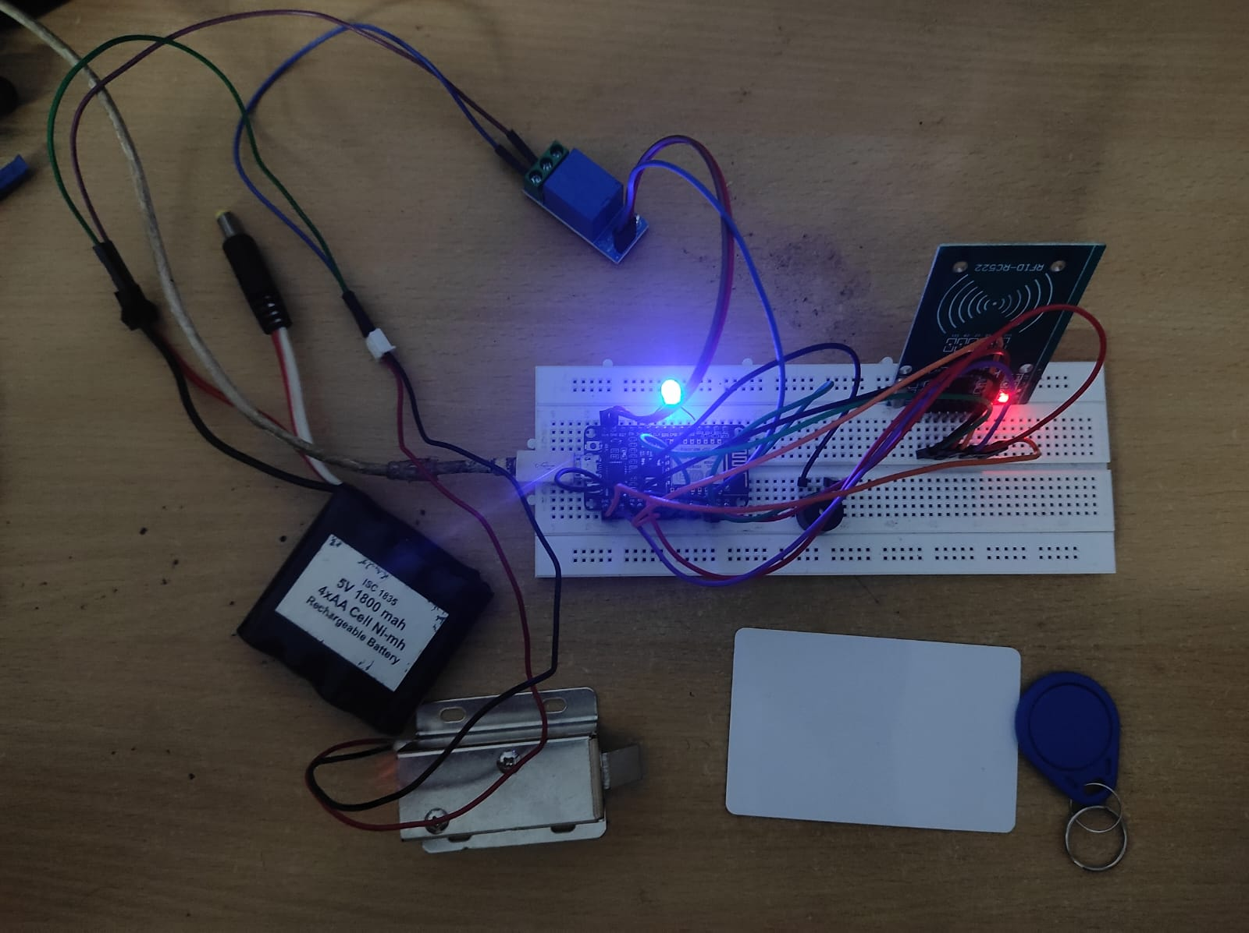

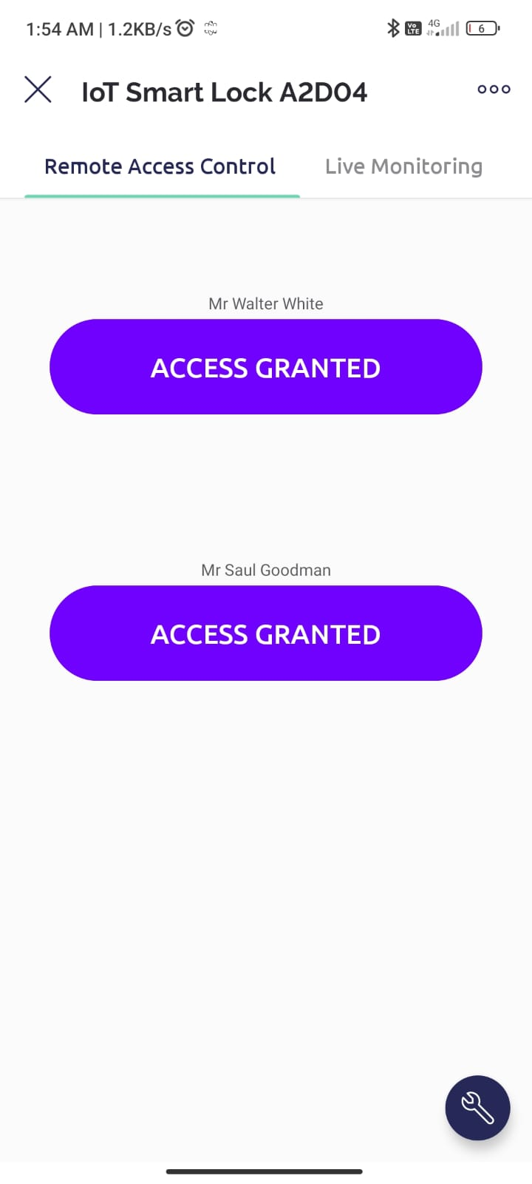 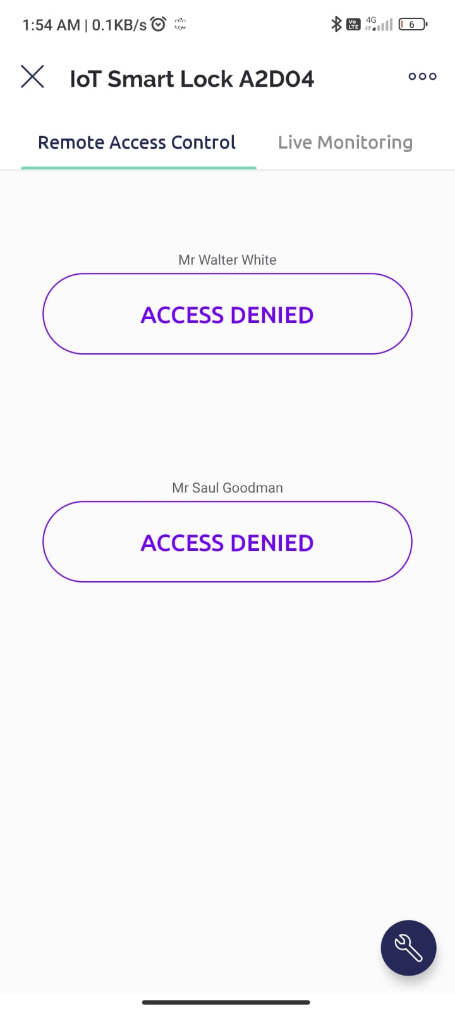 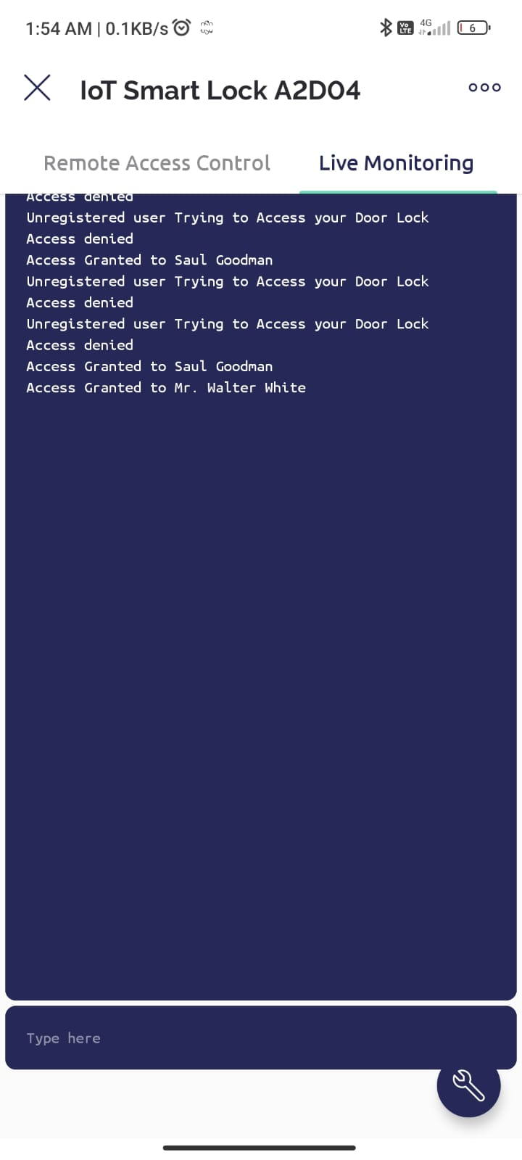

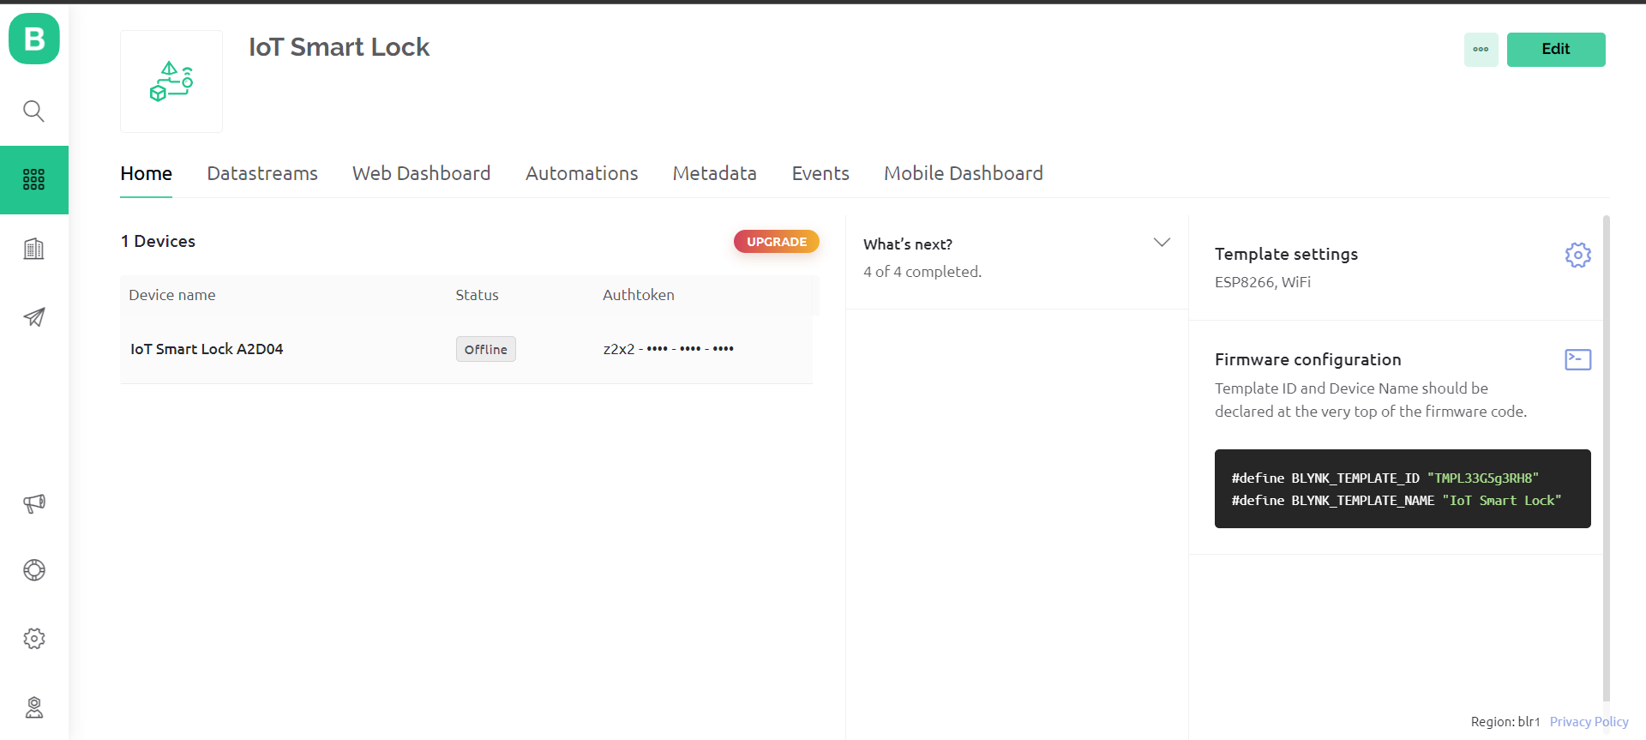

## CONCLUSION

## The experimental results indicate that the IoT smart RFID door lock system using NodeMCU ESP8266 and Blynk has achieved its intended objectives. The integration of RFID technology with Blynk's mobile application provided an efficient and secure access control solution. The system's ability to handle offline scenarios, along with its power management capabilities, enhances its practicality and usability. The project demonstrates a successful implementation of IoT-based access control with potential for further expansion and application in various scenarios.