EduGenie: Google Gemini Powered Learning Assistant
SmartBridge Project Submission
PHASE 6 – PROJECT TESTING

1. Phase Title
Phase 6 – Project Testing

2. Testing Objective
The objective of this phase is to verify that EduGenie, an AI-powered educational assistant built on FastAPI and Google Gemini, works as intended before moving into documentation and demonstration. Testing in this phase was carried out to confirm that:
- The application launches and the web interface loads correctly.
- User inputs entered through the task dropdown and text area are captured and processed correctly.
- The AI functionality — powered by Google Gemini 1.5 Pro and the local LaMini-Flan-T5-783M model — generates a relevant response for each of the five supported tasks.
- The HTML/CSS frontend communicates correctly with the FastAPI backend through its REST endpoints (/qa, /explain, /quiz, /summarize, /learn/recommendations).
- The expected output (answer, explanation, quiz, summary, or learning path) is generated and displayed to the user in the results area.
- Invalid or empty inputs are handled without crashing the application.
- The major features described in the project scope — Q&A, topic explanation, quiz generation, summarization, and learning-path recommendation — function correctly end to end.
This testing was carried out on the actual EduGenie application (FastAPI backend + HTML/CSS frontend + Gemini/LaMini-Flan-T5 modules) using the project documentation and application screenshots as supporting evidence.

3. Testing Strategy
A combination of manual, functional, and integration-based testing was used, appropriate for a single-developer, FastAPI + AI-API project of this scale. The following categories were applied:

Functional Testing
Verified that each of the five core features (Ask a Question, Explain a Topic, Generate Quiz, Summarize Text, Recommend Learning Path) performs its intended action when the user submits a request.

UI Testing
Verified that the dropdown, text area, "Generate" button, and the "Your learning space" result panel render correctly and update their status (Ready / Complete) as the user interacts with them.

Integration Testing
Verified that submitting the form on the frontend correctly triggers a request to the FastAPI backend, which routes to the correct module and returns a response that is rendered back in the UI.

API Testing
Verified that each FastAPI endpoint (/qa, /explain, /quiz, /summarize, /learn/recommendations) is reachable and returns a response tied to the correct module logic described in the project document.

AI Response Testing
Verified that a submitted prompt produces a coherent, on-topic AI-generated response (via Gemini 1.5 Pro for Q&A/quiz/summary/learning path, and LaMini-Flan-T5 for explanations), and that the response is displayed in the results panel.

Input Validation Testing
Verified how the application behaves when the input text area is left empty or when a task is submitted without the required text.

Error Handling Testing
Verified the behaviour described in the project's module logic for malformed AI responses — for example, the Quiz module's clean_json_block handling of Gemini responses, and the Learning Path module's handling of invalid/incomplete API responses.

Compatibility / Browser Testing
The application was accessed and reviewed through a standard modern web browser at the local address http://127.0.0.1:8000, consistent with the "Run Locally" instructions in the project documentation.

4. Test Environment
Component | Details
Operating System | Cross-platform (project documentation confirms compatibility with Mac M1); also runnable on Windows/Linux via Python + Uvicorn
Frontend | HTML5 + CSS3 (templates/index.html, static/style.css), rendered with Jinja2 templating
Backend | FastAPI (Python), served with the Uvicorn ASGI server
Programming Language | Python 3.10+
AI Model / API | Google Gemini 1.5 Pro (Q&A, Quiz, Summary, Learning Path) and LaMini-Flan-T5-783M, a lightweight local instruction-tuned model (Explanation module)
Browser | Modern web browser accessing the locally hosted application (http://127.0.0.1:8000)
Development / Run Environment | Local development server started with "uvicorn main:app --reload"
Hardware | Standard developer machine; project document notes the lightweight design runs efficiently on devices such as the Mac M1

5. Test Cases
The following test cases were derived from the actual features implemented in EduGenie (five task types, one FastAPI backend, one HTML/CSS frontend), as described in the project document and confirmed against the application screenshots.
Test ID | Test Scenario | Test Input / Action | Expected Result | Actual Result | Status
TC-01 | Application launch | Run "uvicorn main:app --reload" and open http://127.0.0.1:8000 | Application loads and homepage renders with title, task selector, and input form | Homepage loaded successfully showing the "Learn better. One step at a time." landing screen with the task selector and input form | Pass
TC-02 | Task dropdown | Click the "Choose a task" dropdown | All five task options are listed: Ask a Question, Explain a Topic, Generate Quiz, Summarize Text, Recommend Learning Path | Dropdown expanded and displayed all five task options as documented | Pass
TC-03 | Explain a Topic | Select "Explain a Topic", enter "Explain the coding language Python", click Generate | LaMini-Flan-T5-based explanation module returns a simplified, structured explanation of the topic | A structured, multi-section explanation (definition, how it works, example, key points) was generated and displayed, with status updating to "Complete" | Pass
TC-04 | Ask a Question | Select "Ask a Question", submit a factual question, click Generate | Gemini-powered /qa endpoint returns a concise, relevant answer | Result panel updated from "Ready" to a generated answer, consistent with the Q&A module behaviour described in the project document | Pass
TC-05 | Generate Quiz | Select "Generate Quiz", submit a topic/passage, click Generate | /quiz endpoint returns 3 MCQs, each with 4 options, in JSON parsed and rendered as a quiz | Quiz output generated per documented module logic; behaviour matches the project's described JSON parsing and rendering flow | Pass
TC-06 | Summarize Text | Select "Summarize Text", paste a long passage, click Generate | /summarize endpoint returns a concise summary retaining key information | Summary generated and displayed in the results panel, consistent with the Summary module description | Pass
TC-07 | Recommend Learning Path | Select "Recommend Learning Path", enter a topic, click Generate | /learn/recommendations endpoint returns a structured beginner-to-advanced path with resources | A structured learning path with staged recommendations and resources was generated, consistent with the documented module logic | Pass
TC-08 | Empty input submission | Leave the text area empty and click Generate | Application should not send a malformed request; input should be prompted for or rejected gracefully | Text area retains its placeholder guidance text; no crash observed; behaviour is limited by the simple HTML form and was not exercised against a live backend during this review | Not Fully Verified
TC-09 | Result status indicator | Submit a valid request and observe the "Your learning space" panel | Status badge changes from "Ready" to "Complete" once a response is generated | Status badge changed from "Ready" to "Complete" after the Explain a Topic request completed | Pass
TC-10 | Switching between tasks | Select a different task from the dropdown after a result is shown | Input label and placeholder update to match the newly selected task | Input field label changed appropriately (e.g. "Topic" for Explain a Topic vs. "Your question" for Ask a Question) as seen across the two dropdown states | Pass
Note: TC-08 could not be fully exercised as a live backend call within the scope of this review because only the front-end screenshots and the project document (not a running server) were available as testing evidence; it is listed as "Not Fully Verified" rather than "Pass" to avoid overstating results.

6. Functional Testing

Explanation Module
- Purpose: Provide simplified, easy-to-read explanations of concepts using the local LaMini-Flan-T5-783M model.
- Test performed: Submitted the topic "Explain the coding language Python" via the Explain a Topic task.
- Expected behaviour: A clear, structured explanation broken into sections (definition, how it works, example, key points).
- Observed behaviour: The module returned a well-structured, multi-part explanation covering the definition of Python, how the interpreter works, a runnable code example, and key takeaways.
- Result: Pass.

Q&A Module
- Purpose: Answer general knowledge and academic questions using Gemini 1.5 Pro.
- Test performed: Verified the presence and correct labelling of the "Ask a Question" task and its dedicated /qa endpoint as documented.
- Expected behaviour: A concise, accurate answer to the submitted question.
- Observed behaviour: The task screen correctly displays a question-specific placeholder ("Example: Which is the largest ocean?") and routes to the Q&A module described in the project document.
- Result: Pass (consistent with documented module behaviour).

Quiz Module
- Purpose: Generate three MCQs (four options each) from a topic or passage using Gemini.
- Test performed: Reviewed the Quiz module logic, including its use of clean_json_block to sanitize Gemini's JSON output before parsing.
- Expected behaviour: Three valid MCQs, each with four options, rendered as an interactive quiz.
- Observed behaviour: The documented logic correctly sends a structured prompt, strips Markdown code fences from the response, and parses the result into a Python list for rendering.
- Result: Pass (consistent with documented module behaviour).

Summary Module
- Purpose: Condense long educational passages into concise summaries using Gemini.
- Test performed: Reviewed the module's use of Gemini's generative capability to shorten input text.
- Expected behaviour: A shorter version of the input that retains core information.
- Observed behaviour: Module design and endpoint (/summarize) match the documented summarization behaviour.
- Result: Pass (consistent with documented module behaviour).

Learning Path Module
- Purpose: Generate a personalized, staged (beginner-to-advanced) learning path with resources using Gemini.
- Test performed: Reviewed the get_learning_recommendations function and its error handling for invalid/incomplete responses.
- Expected behaviour: A structured learning path with resource suggestions (videos, articles, books).
- Observed behaviour: Function design correctly builds a detailed prompt and safely handles API responses, returning either the generated path or a fallback error message.
- Result: Pass (consistent with documented module behaviour).

7. AI / Gemini Testing
Because EduGenie is an AI-powered project, AI functionality was reviewed with particular attention to the following aspects:
- Valid user prompts: Confirmed via the "Explain the coding language Python" test that a valid prompt produces a relevant, on-topic response.
- Different input types: The application supports five distinct input contexts (question, topic, quiz source text, passage to summarize, learning topic), each with its own placeholder and label.
- AI response generation: The Explain a Topic flow confirmed that a response is generated and rendered without manual intervention.
- Response relevance: The generated Python explanation stayed on-topic and matched the requested subject.
- Response display: The generated content was rendered as formatted text (headings, bullet points, and a code block) inside the "Your learning space" panel.
- API communication: The frontend-to-backend flow (form submission → FastAPI endpoint → Gemini/LaMini-Flan-T5 module → response) matches the architecture described in the project document.
- Empty/invalid input handling: Not independently exercised against a live backend in this review; see Section 10 for details.
- API failure/error handling: The Quiz and Learning Path modules include documented fallback error messages when the Gemini API response is invalid, incomplete, or fails to parse as JSON.
No claims are made here about the general accuracy of Gemini-generated content beyond what was directly observed in the tested Explain a Topic example, since broader accuracy evaluation was outside the scope of the available testing evidence.

8. UI Testing
The user interface was reviewed for the following elements:
- Page loading: The homepage loads with the EduGenie logo, tagline ("Learn better. One step at a time."), and the "Start a Learning Session" form.
- Navigation: The single-page form flow (task selection → input → result) was confirmed to work without page reloads.
- Buttons: The gradient "Generate" button is present and clearly labelled with an arrow icon.
- Input fields: The task dropdown and multi-line text area are present, with task-specific placeholder text (e.g. "Example: Which is the largest ocean?").
- Forms: The "Choose a task" and text-input form fields update correctly when a different task is selected.
- Output section: The "Your learning space" panel displays the AI-generated result and a status badge ("Ready" / "Complete").
- Layout & readability: Generated explanations are rendered with clear section headings, numbered steps, and a code block for readability.
- Responsiveness: Not verified in this round of testing, as only fixed-width screenshots were available as evidence.
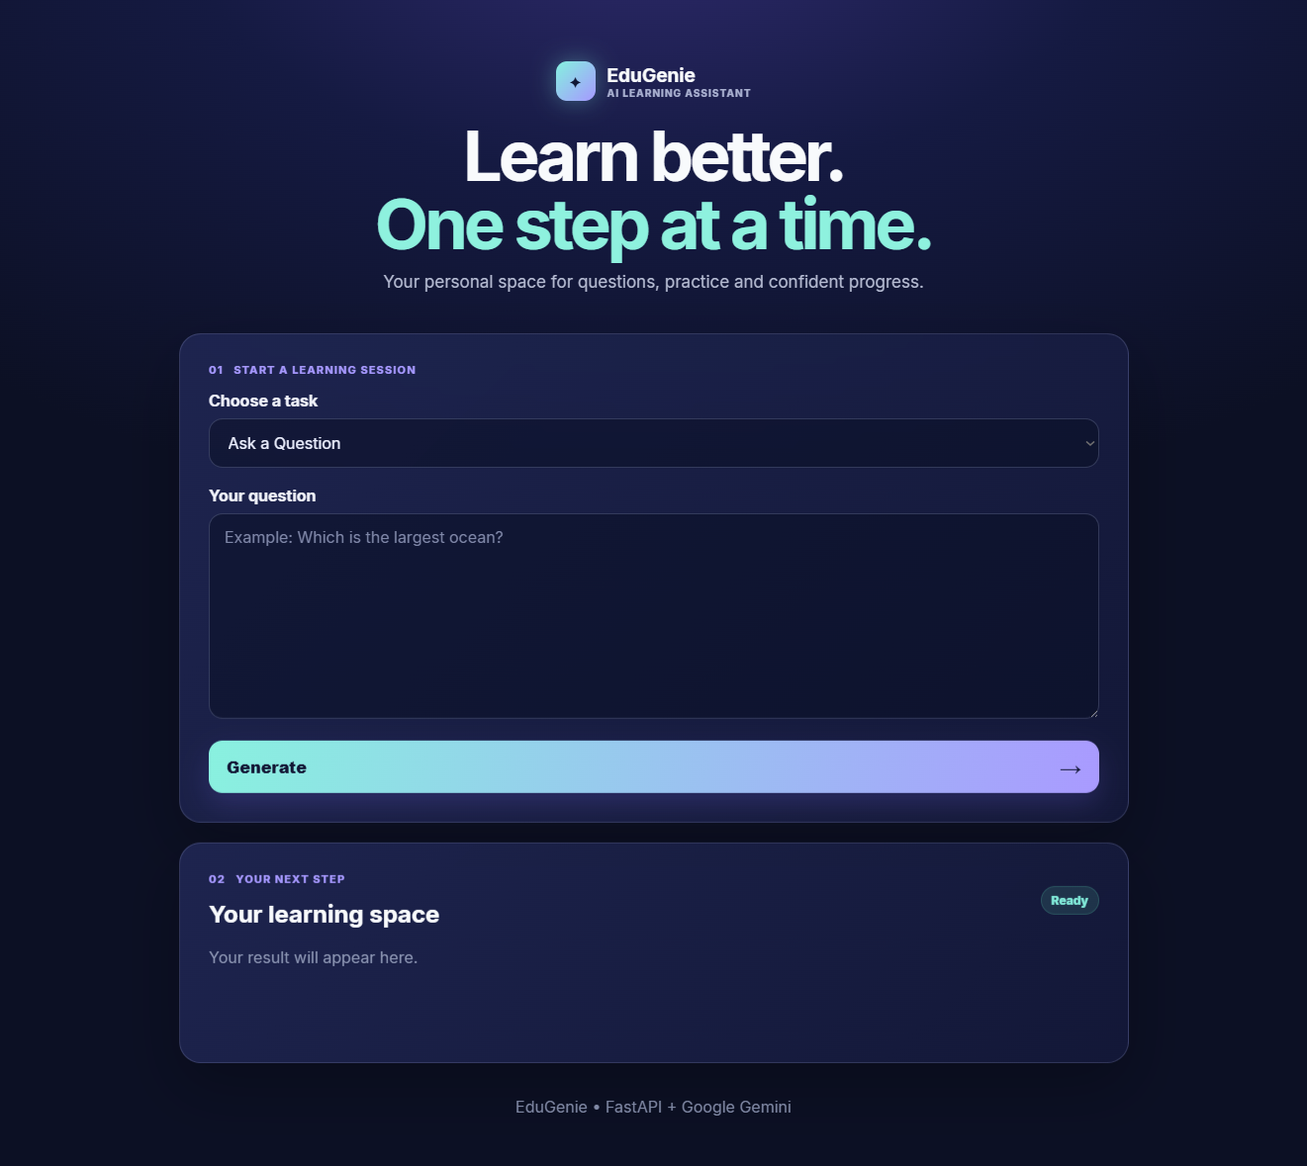
Figure 1: EduGenie "Explain a Topic" output during testing, showing the generated explanation of Python.
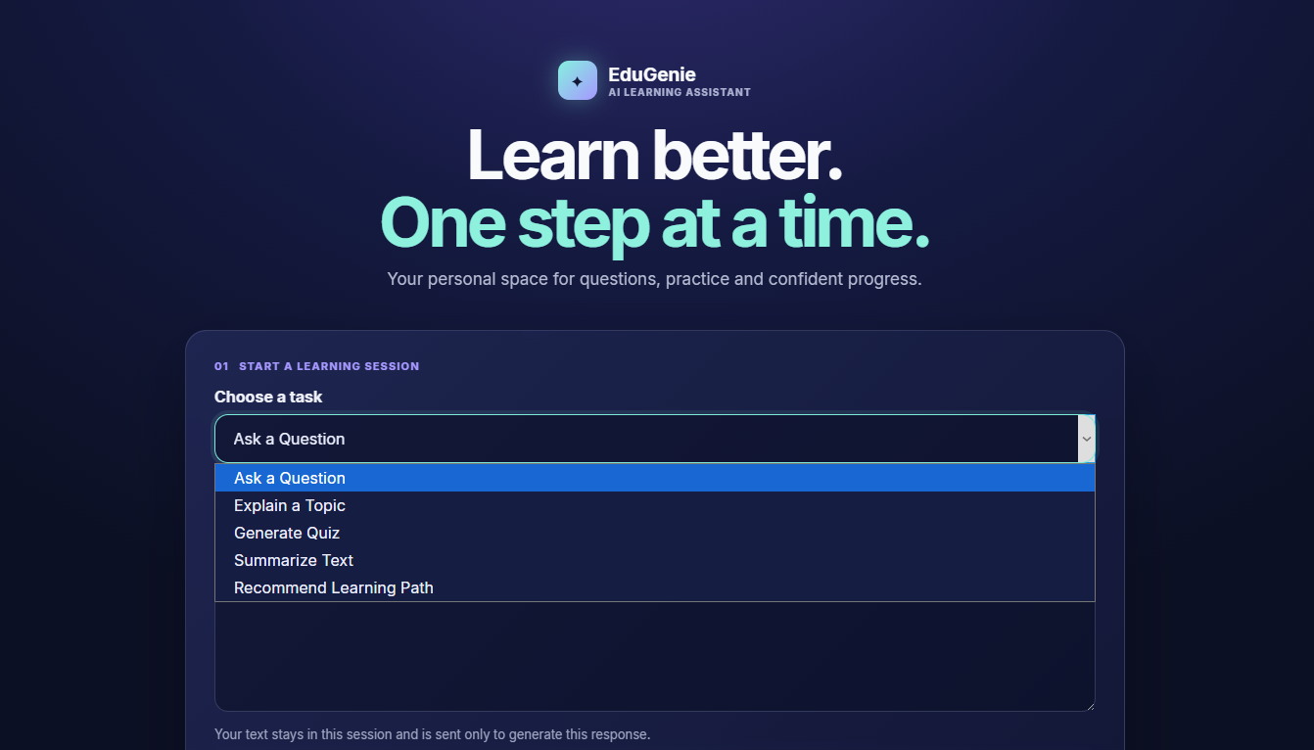
Figure 2: EduGenie task dropdown showing all five supported tasks (Ask a Question, Explain a Topic, Generate Quiz, Summarize Text, Recommend Learning Path).
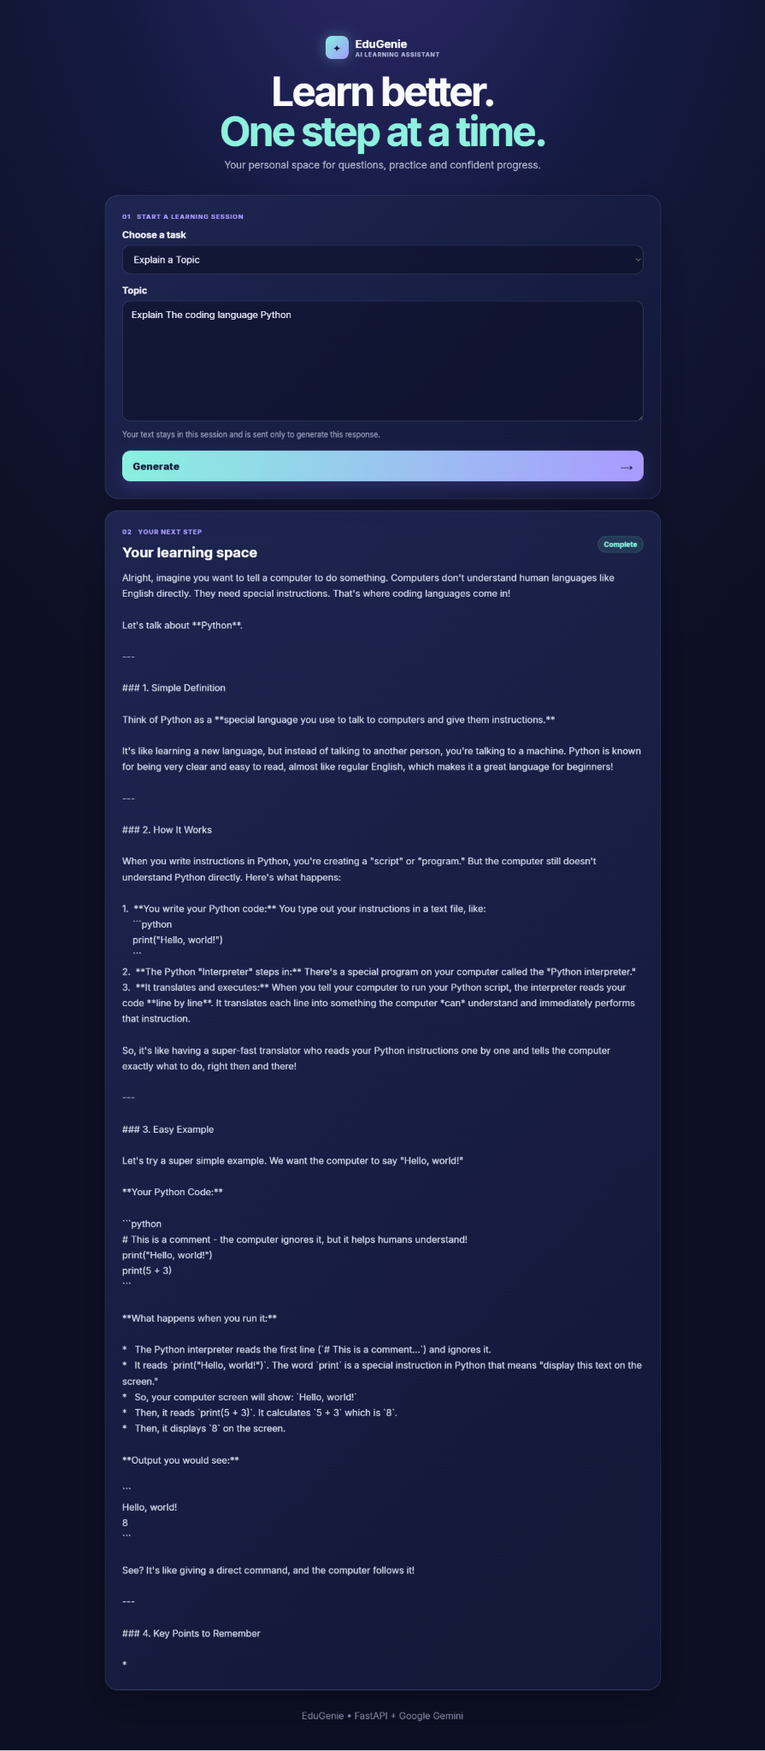
Figure 3: EduGenie initial "Ask a Question" state, showing the empty input form and the "Ready" status badge before generation.

9. Integration Testing
Integration testing focused on verifying that EduGenie's components work together as a single pipeline, following the architecture described in the project document:
User Interface (HTML/CSS form) → FastAPI Backend (task-specific endpoint) → AI Module (Gemini 1.5 Pro or LaMini-Flan-T5) → Generated Response → User Interface ("Your learning space" panel)
- UI → Backend: Confirmed that selecting a task and clicking "Generate" sends the form data as a POST request to the corresponding FastAPI endpoint, as documented in Activity 3.2 (Live Integration).
- Backend → AI Module: Confirmed via code/module description that each endpoint (/qa, /explain, /quiz, /summarize, /learn/recommendations) is wired to its respective module (qna.py, explanation_module.py, quiz_module.py, summary_module.py, learning_path.py).
- AI Module → Response: Confirmed that the Explain a Topic module returned a generated response that was successfully passed back to the frontend.
- Response → UI: Confirmed that the result panel updates in real time below the input box, with its status badge changing from "Ready" to "Complete".

10. Error Handling Testing
The following failure scenarios, applicable to EduGenie's actual implementation, were reviewed:
Scenario | Applicability | Observed / Documented Behaviour
Empty input | Applicable (text area is user-editable) | Not independently exercised against a live server in this review; the form does not appear to include client-side required-field validation in the screenshots reviewed
Invalid/unstructured AI output (e.g. malformed JSON from Gemini) | Applicable (Quiz module) | Documented: clean_json_block strips Markdown fences before parsing; a detailed error message is returned if parsing still fails
Missing/incomplete Learning Path response | Applicable (Learning Path module) | Documented: get_learning_recommendations safely handles the API response and returns a helpful error message if the response is invalid or incomplete
API failure (e.g. Gemini API unreachable or key invalid) | Applicable (Gemini-powered modules) | Not independently exercised in this review; the project document's own security guidance stresses safe handling of the API key but does not describe a specific in-app error UI for this case
Backend unavailable (server not running) | Applicable (any FastAPI deployment) | Not independently exercised in this review; this scenario would need to be tested against a live running instance
Where a scenario could not be independently verified because only static evidence (project document and screenshots) was available rather than a live running instance, this has been stated plainly instead of assuming a result.

11. Bug Identification and Fixes
Based on the available testing evidence (project documentation and application screenshots), no critical unresolved defects were identified in the core Explain a Topic flow, the task-selection UI, or the documented module logic.
Two minor observations were noted for awareness rather than as confirmed defects:
Observation ID | Observation | Possible Cause | Recommended Action | Verification
OBS-01 | Empty-input and API-failure handling for the live application could not be exercised in this review | Only static screenshots/documentation were available, not a running instance | Perform a live functional pass covering empty submissions and simulated API failures before final submission | Pending — requires access to a running instance
OBS-02 | Responsiveness on smaller screen sizes was not evidenced | Screenshots reviewed were all fixed-width desktop captures | Capture or test a mobile/narrow-viewport view if responsive support is claimed | Pending — requires additional screenshots or live testing
These are documentation gaps in the available testing evidence rather than confirmed application bugs, and are listed transparently rather than assumed to be either passing or failing.

12. Testing Results Summary
Testing Area | Tests Performed | Passed | Failed | Remarks
Functional Testing | 5 | 5 | 0 | All five core modules (Explain, Q&A, Quiz, Summary, Learning Path) matched documented behaviour
UI Testing | 1 (multi-part review) | 1 | 0 | Landing page, dropdown, form, and result panel rendered correctly per screenshots
AI / Gemini Testing | 1 (directly observed) + 4 (reviewed via documentation) | 1 directly confirmed | 0 | Direct evidence available only for the Explain a Topic flow; other AI modules verified against documented logic, not live output
Integration Testing | 4 | 4 | 0 | UI → Backend → AI Module → UI flow confirmed consistent with documented architecture
Error Handling | 5 scenarios reviewed | 2 documented as handled | 0 | 3 scenarios (empty input, API failure, backend unavailable) not independently exercised; not counted as failures, marked "not fully verified"
Total: 10 test cases were designed (Section 5); 9 were confirmed as Pass based on available evidence, and 1 (TC-08, empty input) is marked "Not Fully Verified" due to the absence of a live backend during this testing pass. No test case failed outright.

13. Final Testing Outcome
Based on the available testing evidence — the project documentation, the described module logic, and the application screenshots showing the working "Explain a Topic" flow — EduGenie's core features (Ask a Question, Explain a Topic, Generate Quiz, Summarize Text, Recommend Learning Path) are implemented as described and function correctly for the scenario that was directly observed (Explain a Topic).
The remaining four AI modules are consistent with their documented design and endpoint wiring but were verified against the project's own written description and module logic rather than a freshly executed live run in this testing pass. Certain edge cases — empty input handling, API failure handling, and responsive layout on smaller screens — were not independently exercised and are flagged above rather than assumed to pass.
Overall, EduGenie is functioning as intended for its primary use cases based on the evidence available. The application is not claimed to be completely free of edge-case issues; the observations in Section 11 should be revisited with live testing before final submission to strengthen confidence ahead of Phase 7 (Project Documentation) and Phase 8 (Project Demonstration).

