Name: Rithikun Sen

ID: 103800533

Email: [103800533@student.swin.edu.au](mailto:103800533@student.swin.edu.au)

# Project 1 URL

* Register Page: <https://mercury.swin.edu.au/cos80021/s103800533/Project1/register.php>
* Login Page: <https://mercury.swin.edu.au/cos80021/s103800533/Project1/login.php>
* Booking Page: <https://mercury.swin.edu.au/cos80021/s103800533/Project1/booking.php?email=xxx@xxx.com>
* Admin Page: <https://mercury.swin.edu.au/cos80021/s103800533/Project1/admin.php>

# Introduction on how to use the system

* Navigate to the mercury server via this link: <https://mercury.swin.edu.au/cos80021/s103800533/Project1>

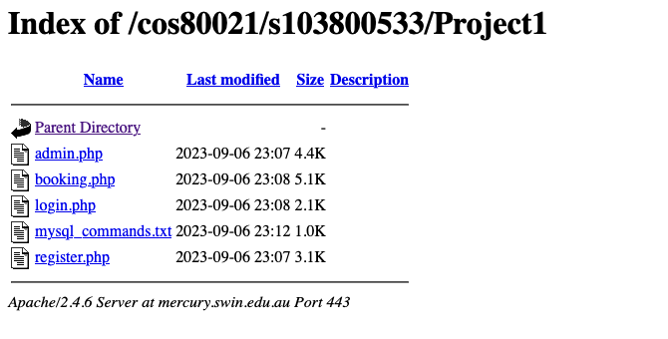

* If the user doesn’t have an account yet, they need to navigate to the register page and register their account with the following information:
  + Customer name
  + Password
  + Confirm password
  + Phone number
  + Email address

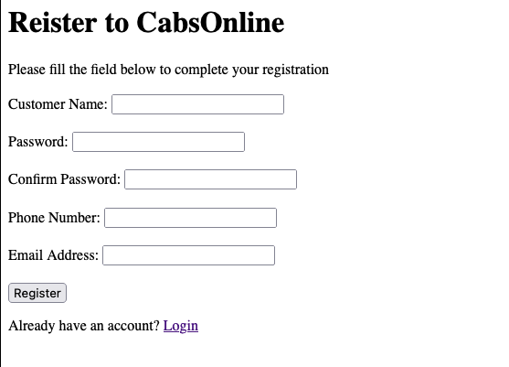

* If the user already has an account, they can log in with their email and password.

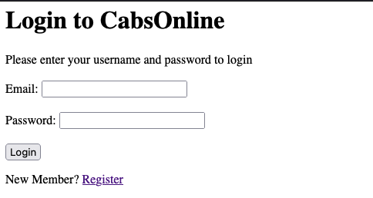

* After logging in, the user can book a taxi with the following information.
  + Passenger email
  + Passenger name
  + Contact phone number
  + Pick-up address (unit number, street number, street name, suburb, and destination suburb)
  + Pick-up date and time

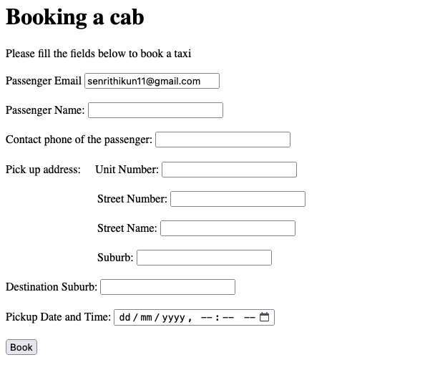

* The admin can view all the booking information and filter the unassigned booking information by pick-up date and time (within 3 hours from now).
* The admin can update the status of the booking information to assigned.

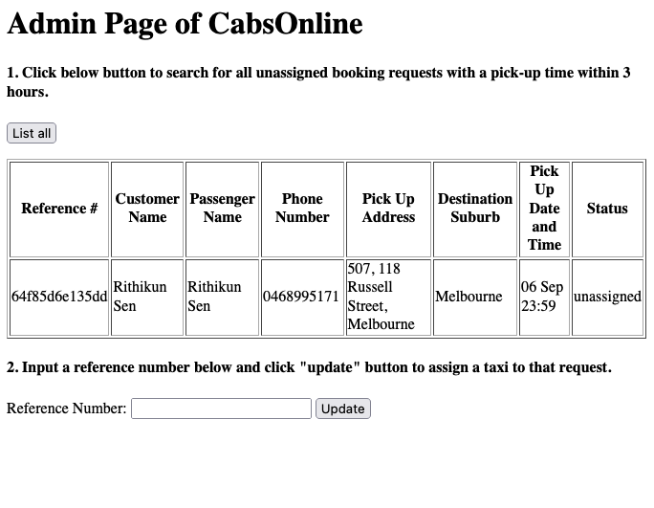

# a list of all the files in the system.

* Register.php
* Login.php
* Booking.php
* Admin.php
* README.md
* Mysql_commands.txt

# References

* [PHP: Generate Unique ID] (<https://www.geeksforgeeks.org/php-uniqid-function/>)
* [PHP: Date and Time] (https://www.w3schools.com/php/php_date.asp)