Name: Rithikun Sen

ID: 103800533

Email: [103800533@student.swin.edu.au](mailto:103800533@student.swin.edu.au)

# Project 2 URL

* Register Page: <https://mercury.swin.edu.au/cos80021/s103800533/Project1/register.php>
* Login Page: <https://mercury.swin.edu.au/cos80021/s103800533/Project1/login.php>
* Home Page: <https://mercury.swin.edu.au/cos80021/s103800533/Project1/admin.php>
* Listing Page:
* Bidding Page:
* Maintenance Page:

# Introduction on how to use the system

* Navigate to the mercury server via this link:

<https://mercury.swin.edu.au/cos80021/s103800533/Project2/>

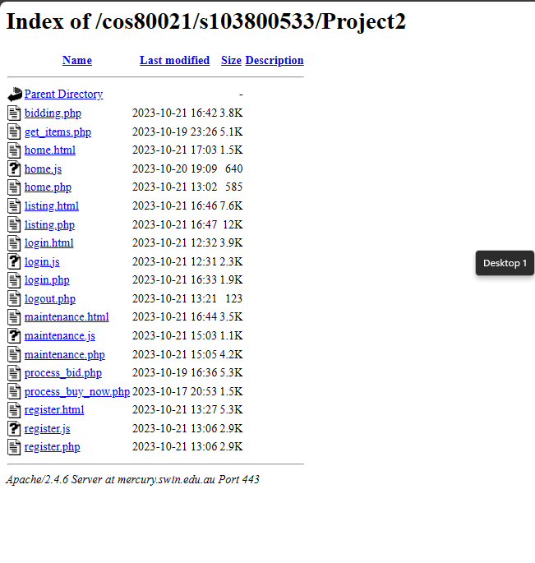

* Navigate to Home Page:

<https://mercury.swin.edu.au/cos80021/s103800533/Project2/home.html>

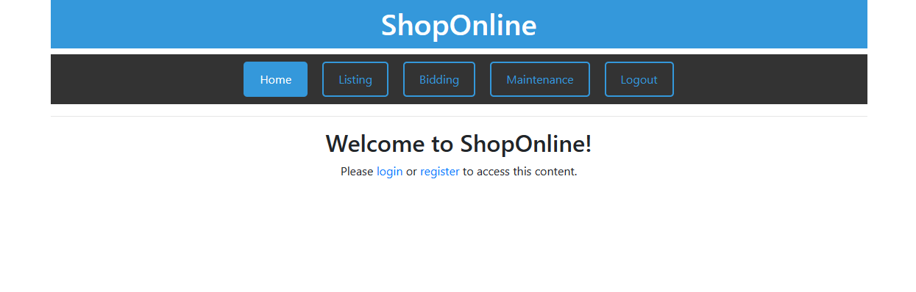

* If the user doesn’t have an account yet, they need to click on the register button and register their account with the following information:
  + First name
  + Surname
  + Email
  + Password
  + Confirm Password

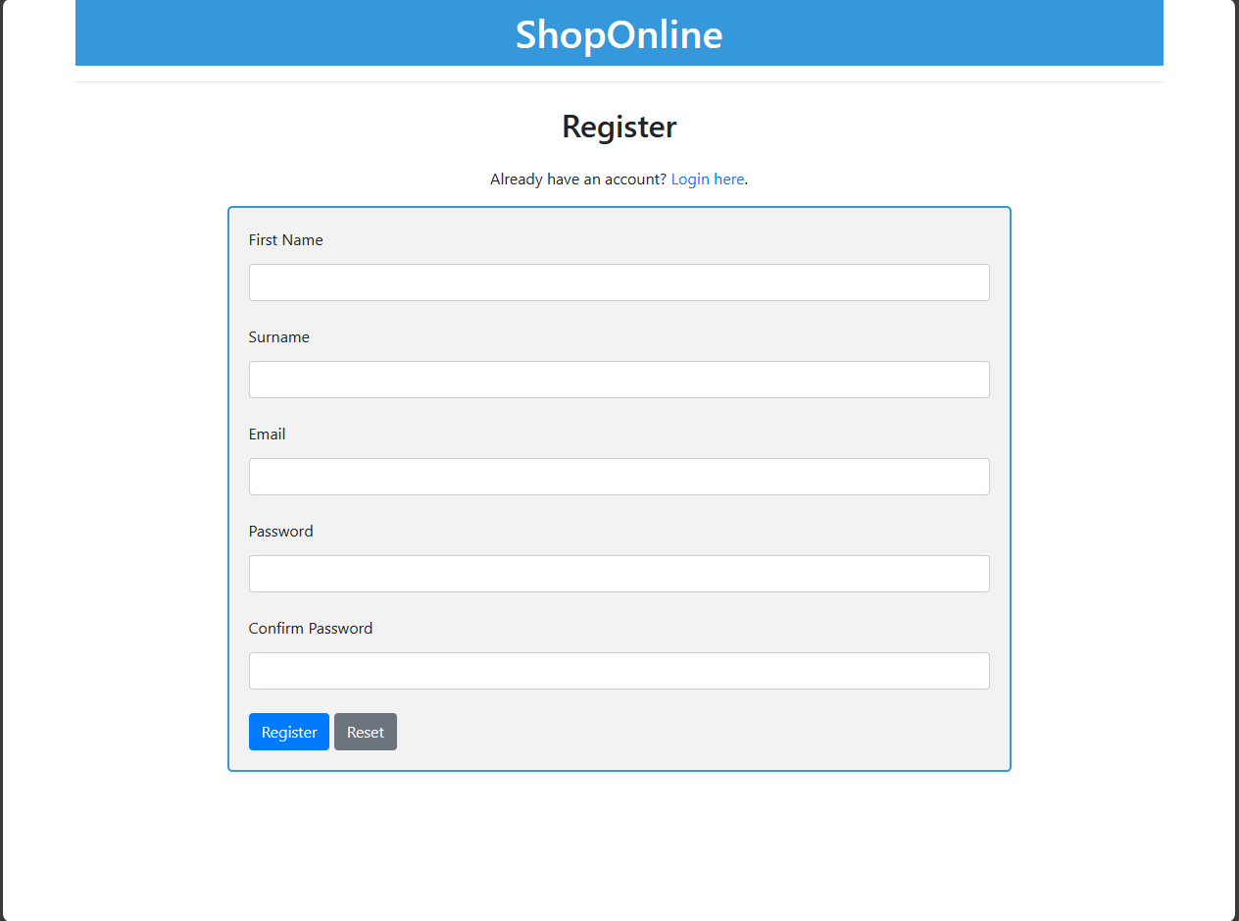

* If the user already has an account, they can log in with their email and password.

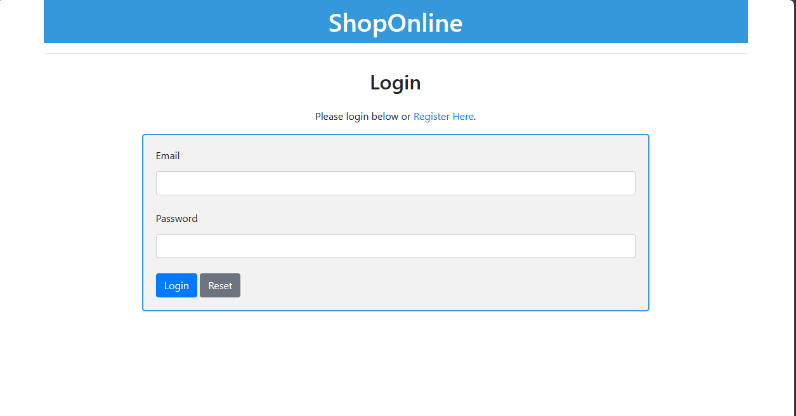

* After logging in, the user can list the items for bidding with the following information.
  + Item Name
  + Category
  + Description
  + Start Price
  + Reserve Price
  + Buy it now price
  + Duration
    - Days
    - Hours
    - Minutes

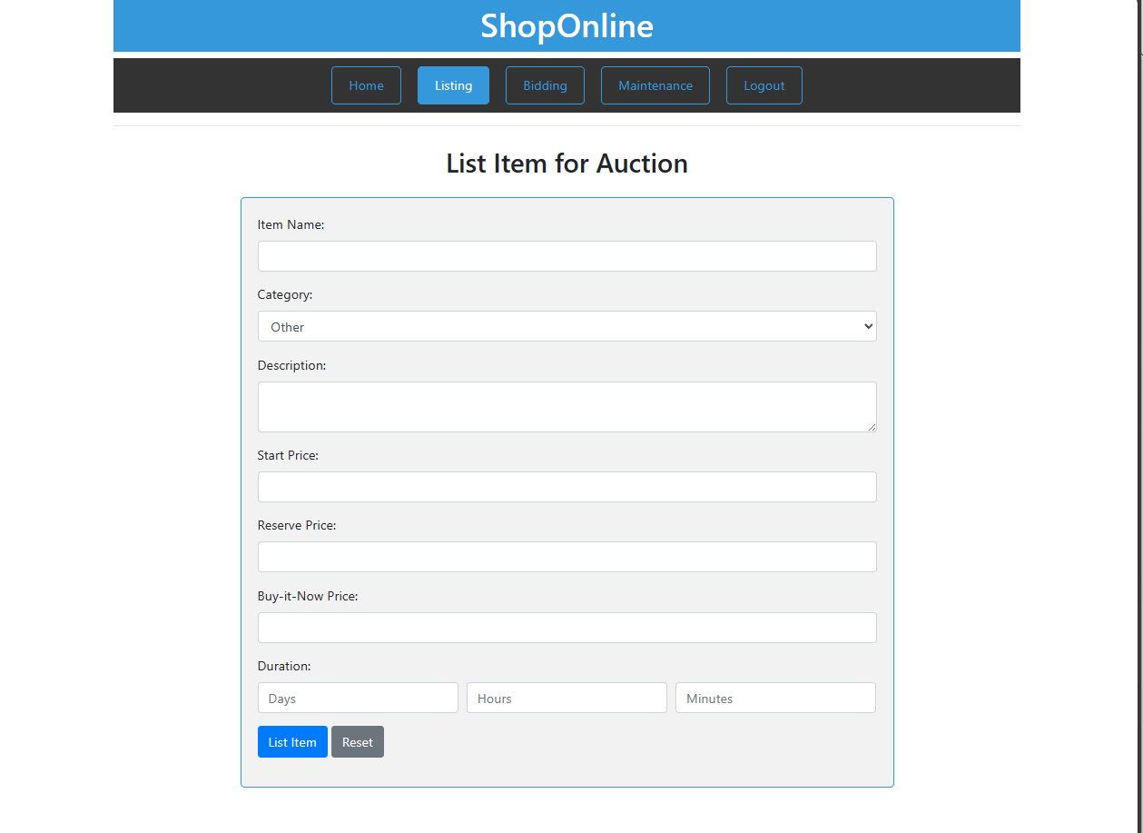

* After the user list items for bidding, they can navigate to bidding page to view the items that are available for bidding:
  + Place bid
  + Buy it now

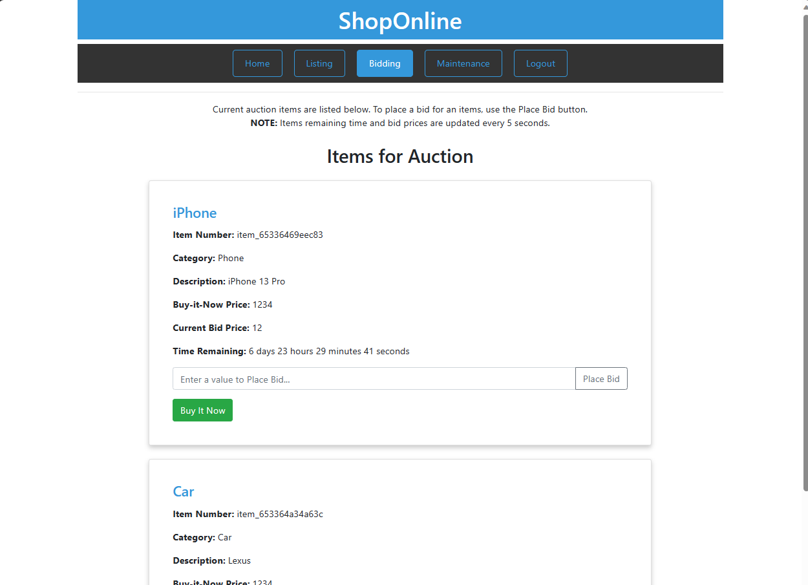

* After the user choose to Place bid or Buy the items the user can go in to maintenance page to process auction items and generate report

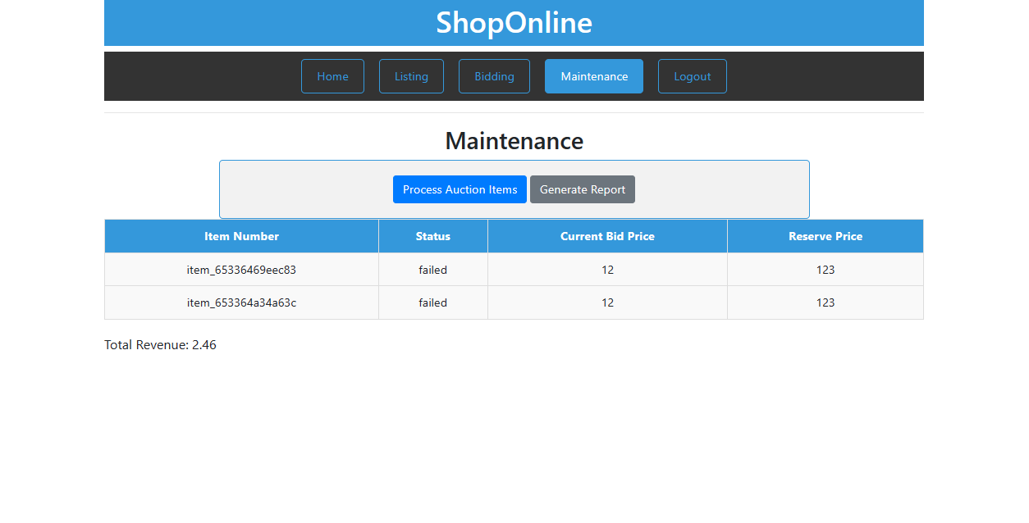

# a list of all the files in the system.

* home.html
* home.php
* home.js
* login.html
* login.php
* login.js
* logout.php
* register.html
* register.php
* register.js
* listing.php
* bidding.php
* maintenance.html
* maintenance.php
* maintenance.js
* process_bid.php
* process_buy_now.php
* get_items.php