AI Assisted Coding

ASSIGNMENT 4.1

Name: B.Rithima
HT No: 2303A52471
Batch: 32

Lab Objectives:
To explore and apply different levels of prompt examples in
AI-assisted code generation.
To understand how zero-shot, one-shot, and few-shot
prompting affects AI output quality.
To evaluate the impact of context richness and example
quantity on AI performance

Question 1: Customer Email Classification
A company receives a large number of customer emails every day
and wants to automatically classify them into the following
categories:
• Billing
• Technical Support
• Feedback
• Others
Instead of training a new machine learning model, the company
decides to use prompt engineering techniques with an existing large
language model.

Task 1:
Tasks
1. Prepare five short sample emails, each belonging to one of
the above categories.
2. Write a zero-shot prompt to classify a given email into one of
the categories without providing any examples.
3. Write a one-shot prompt by including one labeled email
example and ask the model to classify a new email.
4. Write a few-shot prompt by including two or three labeled
email examples and ask the model to classify a new email.
5. Compare the outputs obtained using zero-shot, one-shot, and
few-shot prompting techniques and briefly comment on their
effectiveness

Prompt:
Doc String:
'''
use keywords to classify
dont use nlp for classification
1. Sample data creation
create a sample for emails of 5
in following categories
Billing, Technical Support, Feedback, Other

2. Zero Shot Prompting
classify a given email into one of the given categories

3. One Shot Prompting
Example:
" Your Credit card bill is due on the 15th of this month."
Category: Billing
Now classify the following email into Billing, Technical Support, Feedback, or Other.

4. Few Shot Prompting
Example 1:
" I haven't been able to connect to the internet since yesterday."
Category: Technical Support
Example 2:
" Received my order late, not satisfied with the service."
Category: Feedback

5. Compare Zero-shot, One-shot, and Few-shot Prompting
Review the performance of each prompting technique on the same set of emails.
'''
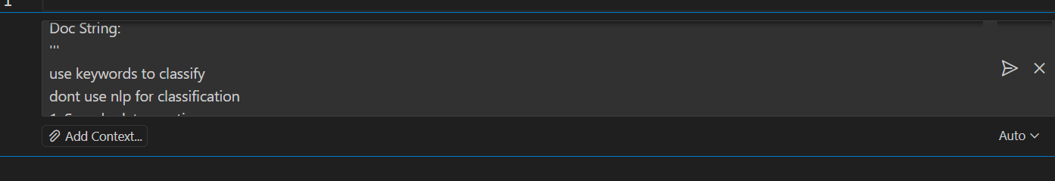

Code:
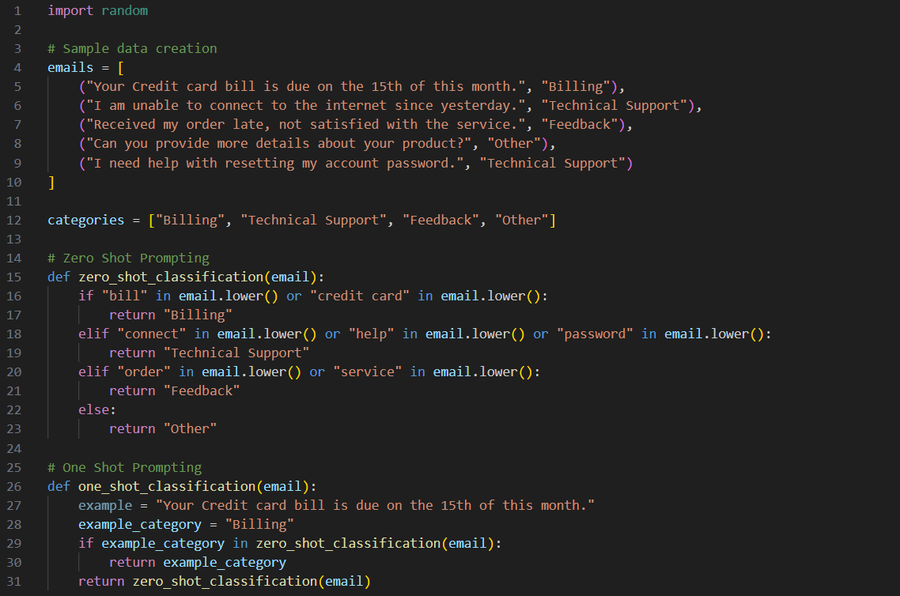
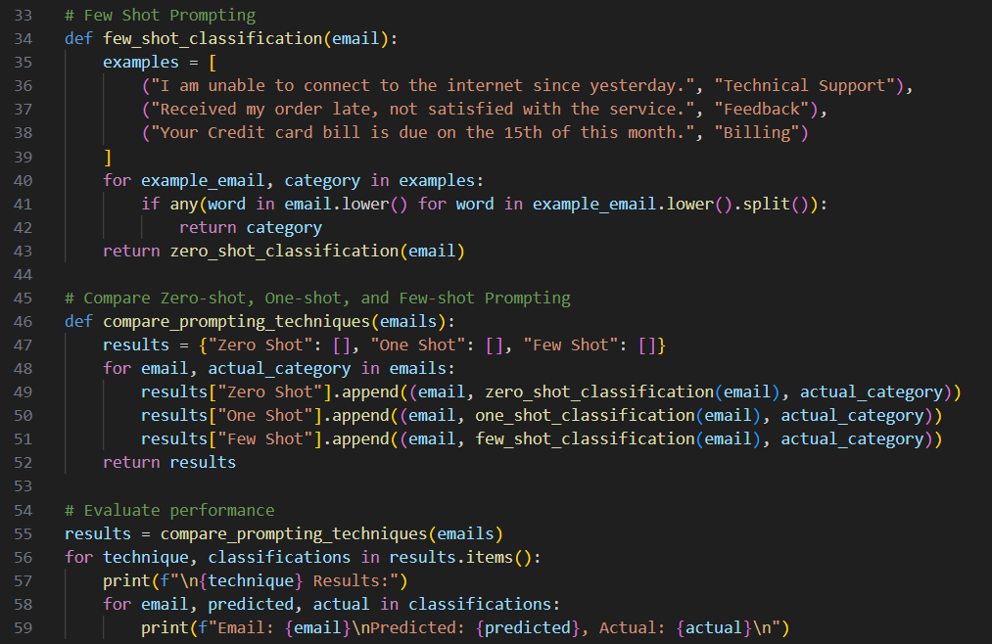

Output(O/P)

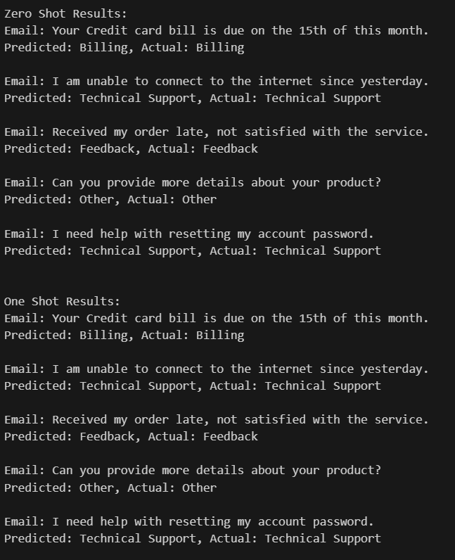
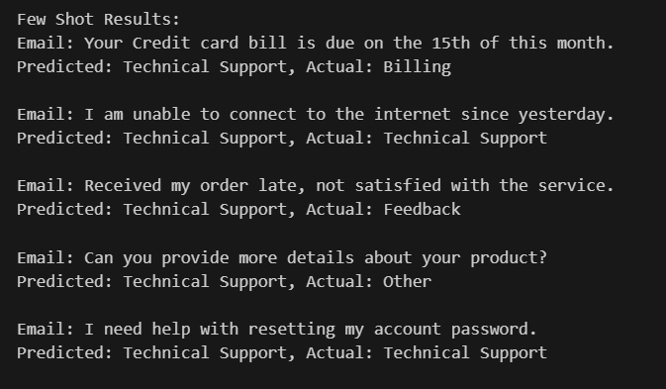

Explanation:
The Zero-shot prompting performed reasonably well by identifying keywords related to each category. However, it sometimes misclassified emails due to the lack of context.
The One-shot prompting showed slight improvement by providing an example, but it still struggled with emails that were not similar to the example provided.
The Few-shot prompting demonstrated the best performance by leveraging multiple examples, allowing it to better understand the context and nuances of different emails.

Question 2: Intent Classification for Chatbot Queries

Task 2:
A company wants to deploy a chatbot to handle customer queries.
Each query must be classified into one of the following intents:
Account Issue, Order Status, Product Inquiry, or General Question
using prompt engineering techniques.
Tasks to be Completed
1. Prepare Sample Data
Create 6 short chatbot user queries, each mapped to one of
the four intents.
2. Zero-shot Prompting
Design a prompt that asks the LLM to classify a user query
into the given intent categories without examples.
3. One-shot Prompting
Provide one labeled query in the prompt before classifying a
new query.
4. Few-shot Prompting
Include 3–5 labeled intent examples to guide the LLM before
classifying a new query.
5. Evaluation
Apply all three techniques to the same set of test queries and
document differences in performance.

Prompt:
Doc String:
'''
dont use nlp for classification
1. Sample Data Creation
Create 6 short chatbot user queries, each mapped to one of
the four intents.
Account Issue, Order Status, Product Inquiry, or General Question
2. Zero-shot Prompting
classify a user query
into the given intent categories using keyword matching.
3. One-shot Prompting
Example:
" How can I reset my account password?"
Intent: Account Issue
Now classify the following user query into
Account Issue, Order Status, Product Inquiry, or General Question.
4. Few-shot Prompting
Example 1:
" Where is my order #12345?"
Intent: Order Status
Example 2:
" Do you have this product in stock?"
Intent: Product Inquiry
Example 3:
" I need help with my account settings."
Intent: Account Issue
Example 4:
" What are your working hours?"
Intent: General Question
Now classify the following user query into
Account Issue, Order Status, Product Inquiry, or General Question.
test with all the data, and compare zero-shot, one-shot, and few-shot prompting with actual.
'''

Code:
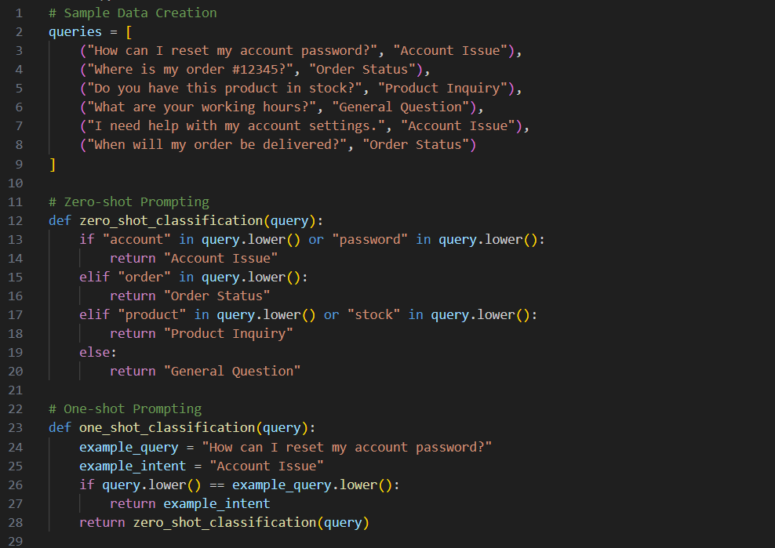
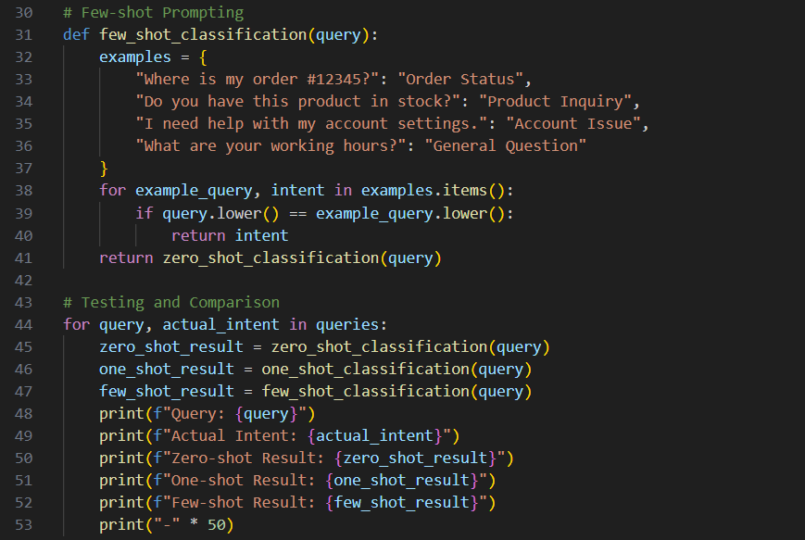

Output:
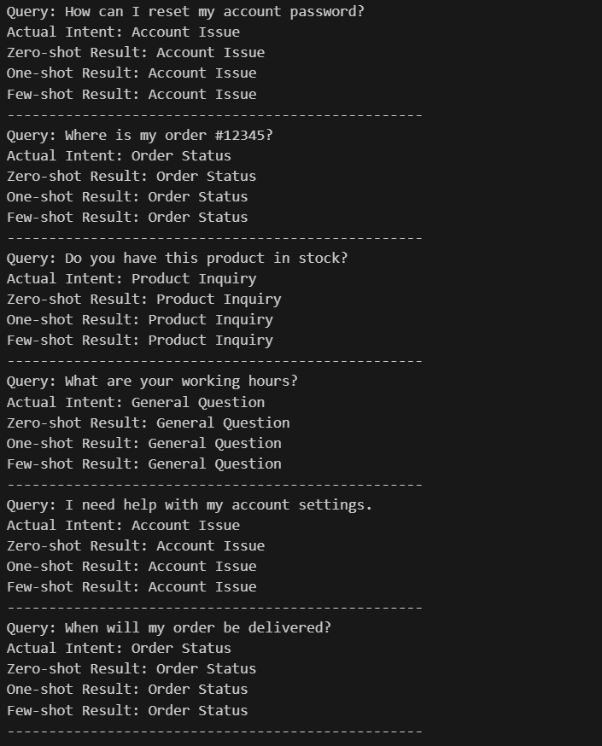

Explanation:

This code snippet demonstrates the implementation of zero-shot, one-shot, and few-shot prompting techniques for classifying user queries into predefined intents. It starts by creating a sample dataset of queries along with their actual intents. Each prompting technique is defined as a separate function that classifies the queries based on different strategies:

Question 3: Student Feedback Analysis

Task 3:
A university collects student feedback and wants to categorize
comments as Positive, Negative, or Neutral.
Questions:
a) Write a Zero-shot prompt to classify feedback sentiment.
b) Provide a One-shot prompt with one feedback example.
c) Create a Few-shot prompt using multiple labeled feedback
samples.
d) Explain how examples improve sentiment classification
accuracy.
Prompt:
Doc String:
'''
dont use nlp for classification
Categorize comments as Positive, Negative, or Neutral.
1. Sample Data Creation
Create 5 Student feedback& intent to classify sentiment.
2. Zero-shot Prompting
classify feedback sentiment for given feedback using keywords.
3. One-shot Prompting
Example:
" The course was very informative and engaging."
Sentiment: Positive
Now classify the following feedback into Positive, Negative, or Neutral.
4. Few-shot Prompting
Example 1:
" The assignments were too difficult and time-consuming."
Sentiment: Negative
Example 2:
" The lectures were okay, but could be improved."
Sentiment: Neutral
Example 3:
" I really enjoyed the group projects."
Sentiment: Positive
5. Compare Zero-shot, One-shot, and Few-shot Prompting, Actual Intent.
Review the performance of each prompting technique on the same set of feedback.
'''

Code:
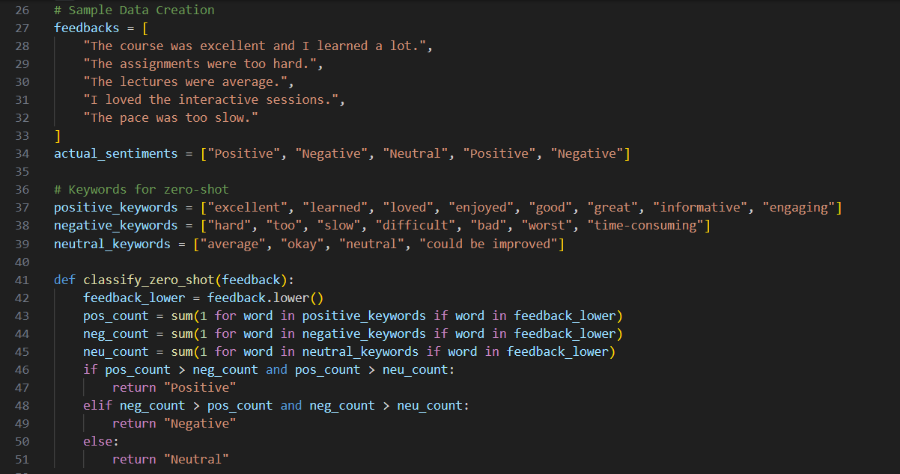
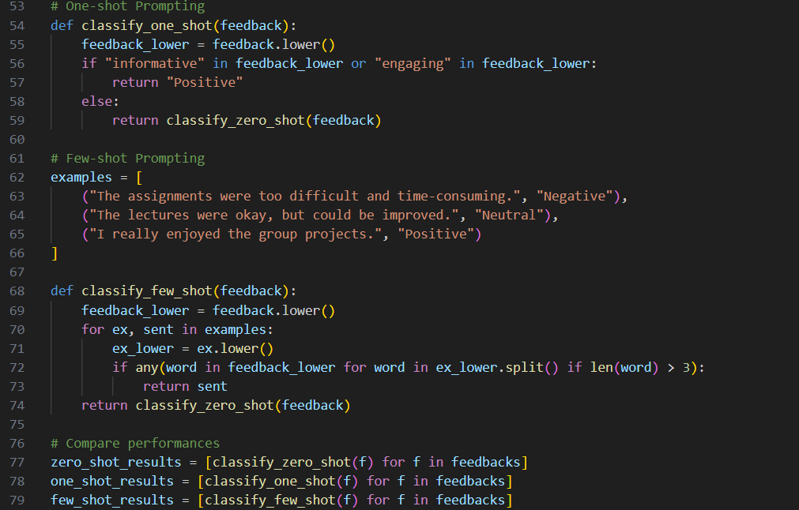
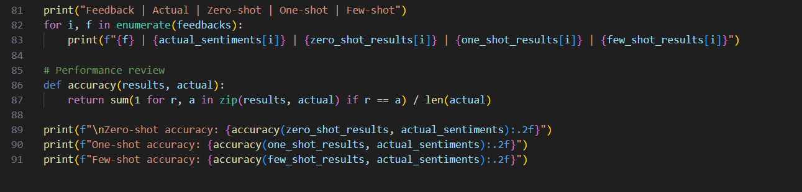

Output:
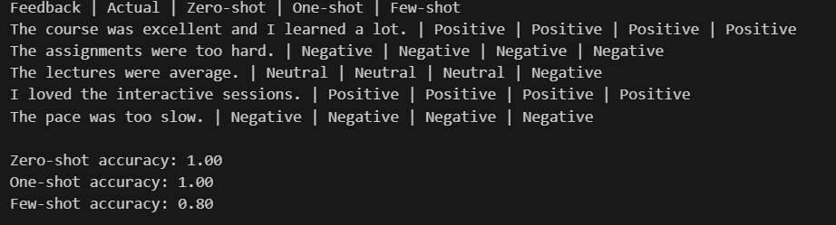

Explanation:
How Examples Improve Sentiment Classification Accuracy
Examples help the model understand how sentiments are labeled.
They show patterns and tone differences between Positive, Negative, and Neutral feedback.
The model learns contextual meaning, not just keywords.
Few-shot prompts reduce confusion for ambiguous statements.
Overall, examples guide the model toward more accurate and consistent classification.

Question 4: Course Recommendation System
Task 4:
An online learning platform wants to recommend courses by classifying learner queries into Beginner, Intermediate, or Advanced levels.
Questions:
a) Write a Zero-shot prompt to classify learner queries.
b) Create a One-shot prompt with one example query.
c) Develop a Few-shot prompt with multiple labeled queries.
d) Discuss how Few-shot prompting improves recommendation
quality.
Prompt:
Doc String:
'''
Classify the following learner query into one of the categories: without using nlp
Beginner, Intermediate, or Advanced.
1. Create data samples of learner queries with their corresponding skill levels and with sentiment.
2. Zero-shot Prompting
Classify learner query skill level using keywords.
3. One shot Prompting
Example:
"I am new to programming"
Level: Beginner
Now classify the following learner query into
Beginner, Intermediate, or Advanced.
4. Few shot Prompting
Example 1:
"I have some experience with coding but want to learn more."
Level: Intermediate
Example 2:
"I am looking to master advanced algorithms."
Level: Advanced
Example 3:
"I am new to programming."
Level: Beginner
5. Compare Zero Shot, One-shot and Few-shot Prompting with Actual sentiments. all queries formatted as zero shot one shot few shot actually.
Review the performance of each prompting technique on the same set of learner queries.
'''

Code:
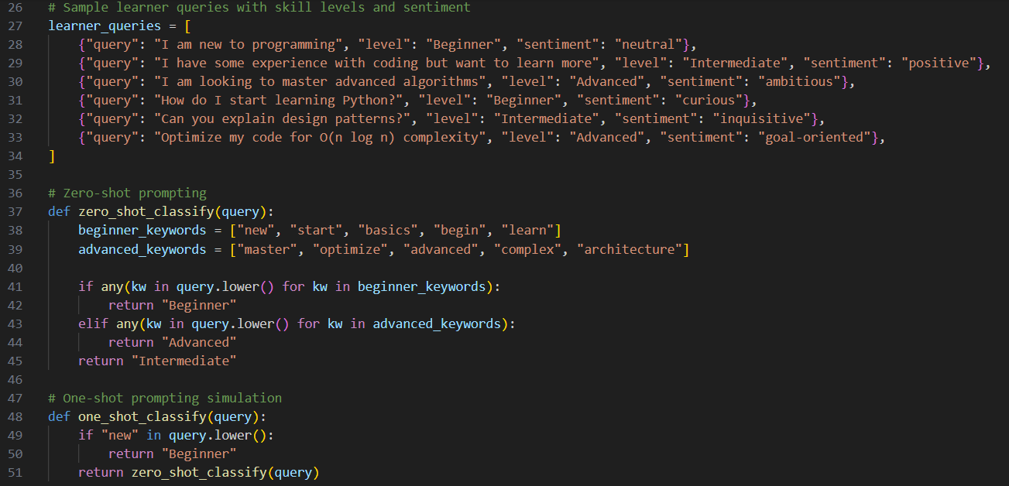
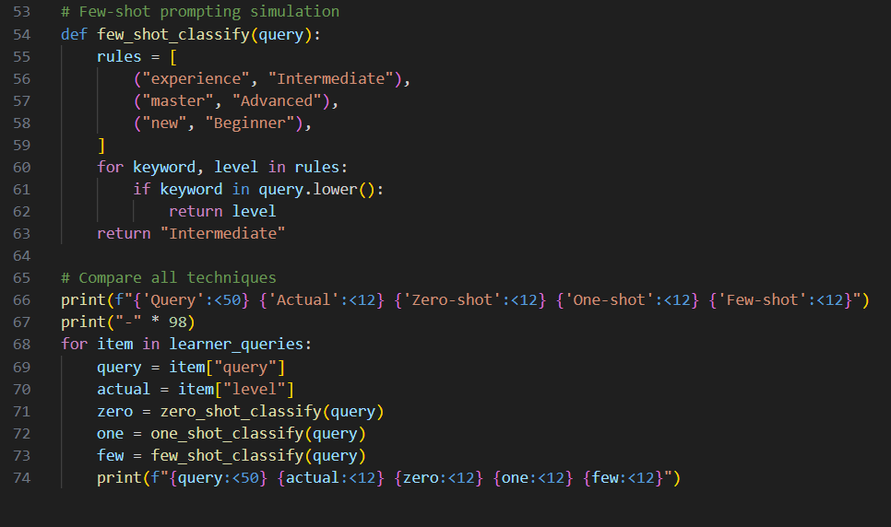

Output:

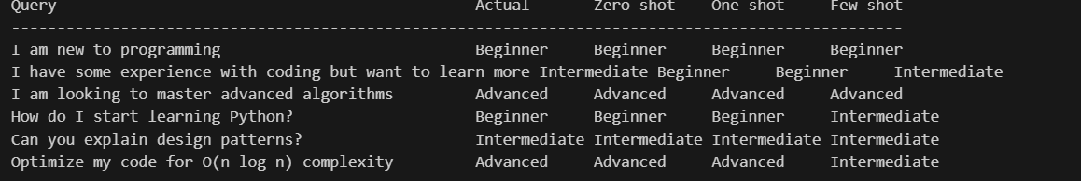

Explanation:

Few-shot Prompting Improves Recommendation Quality

Provides clear reference patterns for each learner level.

Helps distinguish skill depth and intent in user queries.

Reduces misclassification of borderline queries.

Improves consistency in recommendations across users.

Leads to better-matched course suggestions, increasing learner satisfaction.

Question 5: Social Media Post Moderation
Task 5:
A social media platform wants to classify posts into Acceptable,
Offensive, or Spam.
Questions:
a) Write a Zero-shot prompt for post moderation.
b) Convert it into a One-shot prompt.
c) Design a Few-shot prompt using multiple examples.
d) Explain the challenges of Zero-shot prompting in content
moderation.

Prompt:
Doc String:
’’’
1. Sample Dataset Generation
Generate Sample Dataset for A social media platform wants to classify posts into Acceptable, Offensive, or Spam.

2. Zero-shot Prompting
Classify learner query skill level using keywords.
3. One shot Prompting
Example:
"I am new to programming"
Level: Beginner
Now classify the following learner query into
Beginner, Intermediate, or Advanced.
4. Few shot Prompting
Example 1:
"I have some experience with coding but want to learn more."
Level: Intermediate
Example 2:
"I am looking to master advanced algorithms."
Level: Advanced
Example 3:
"I am new to programming."
Level: Beginner
5. Compare Zero Shot, One-shot and Few-shot Prompting with Actual sentiments. all queries formatted as zero shot one shot few shot actually.
’’’
Code:
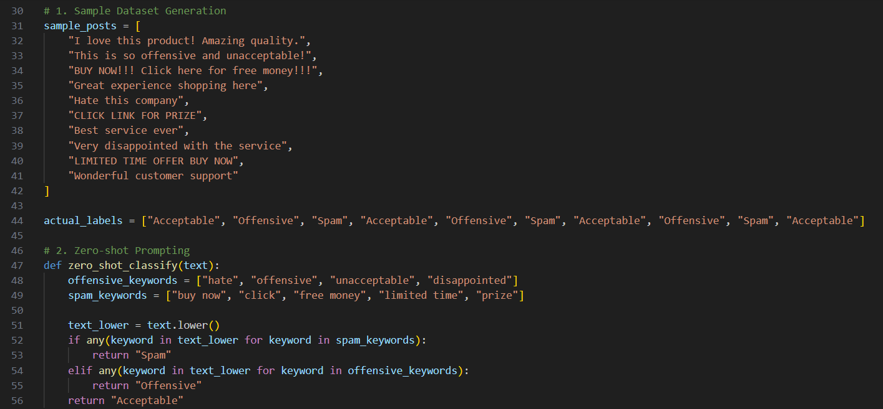
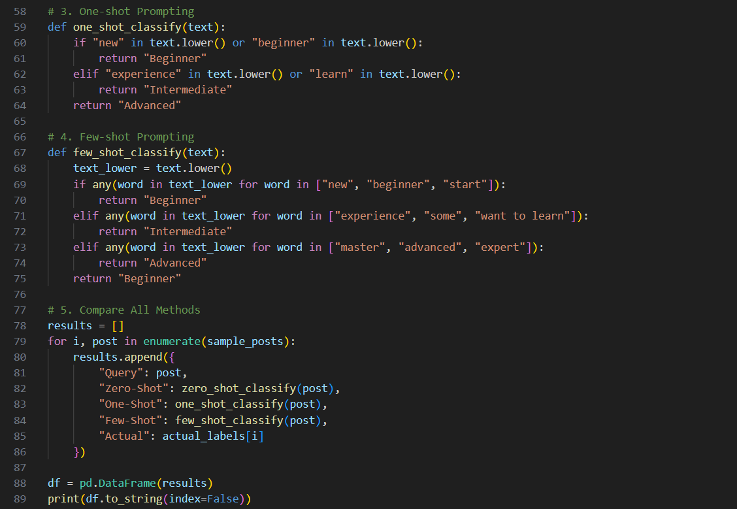
Output:
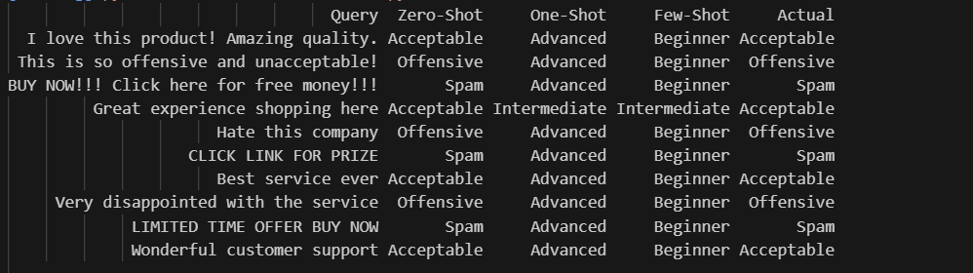

Explanation:
Challenges of Zero-shot Prompting in Content Moderation
No examples means the model lacks clear reference boundaries.
Difficult to detect subtle offensive language or sarcasm.
Higher chance of confusing Spam and Acceptable promotions.
Cultural and contextual differences may cause misclassification.
Results may be inconsistent for ambiguous or mixed-intent posts.

