AIAC
B.RITHIMA
2303A52471
BATCH -32
ASSIGNMENT 1.2
Task 1: AI-Generated Logic Without Modularization (Factorial without
Functions)
• Scenario
You are building a small command-line utility for a startup intern onboarding
task. The program is simple and must be written quickly without modular
design.
• Task Description
Use GitHub Copilot to generate a Python program that computes a
mathematical product-based value (factorial-like logic) directly in the main
execution flow, without using any user-defined functions.
• Constraint:
➢ Do not define any custom function
➢ Logic must be implemented using loops and variables only
• Expected Deliverables
➢ A working Python program generated with Copilot assistance
➢ Screenshot(s) showing:
➢ The prompt you typed
➢ Copilot’s suggestions
➢ Sample input/output screenshots
➢ Brief reflection (5–6 lines):
➢ How helpful was Copilot for a beginner?
➢ Did it follow best practices automatically?
Prompt:

CODE:
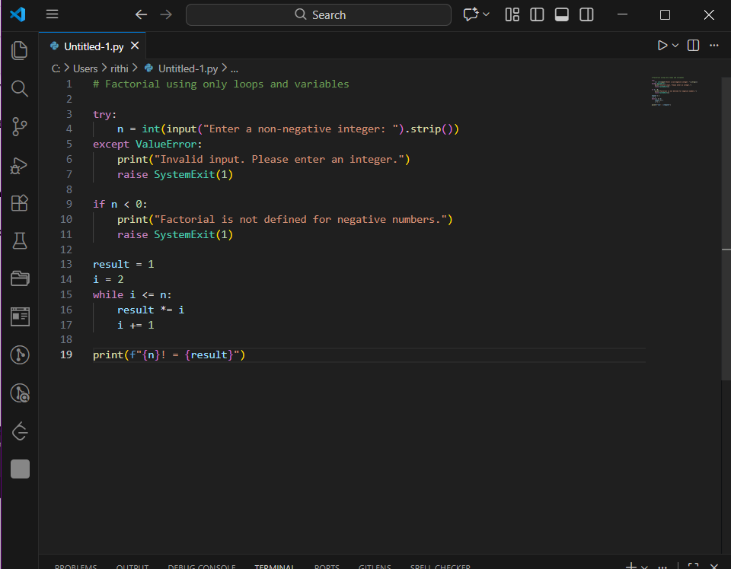

OUTPUT:
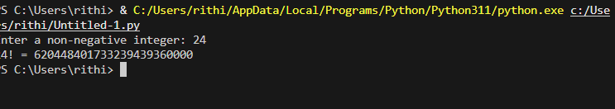

Explanation:
- Copilot was very helpful for a beginner as it quickly generated correct logic based on the prompt. It reduced the time required to write the code by suggesting a complete solution. The generated code followed best practices such as input validation and edge case handling. Copilot also helped in avoiding syntax errors and logical mistakes. Overall, it made coding easier & faster.
ask 2: AI Code Optimization & Cleanup (Improving Efficiency)
❖ Scenario
Your team lead asks you to review AI-generated code before committing it to
a shared repository.
❖ Task Description
Analyze the code generated in Task 1 and use Copilot again to:
➢ Reduce unnecessary variables
➢ Improve loop clarity
➢ Enhance readability and efficiency
Hint:
Prompt Copilot with phrases like
“optimize this code”, “simplify logic”, or “make it more readable”
❖ Expected Deliverables
➢ Original AI-generated code
➢ Optimized version of the same code
➢ Side-by-side comparison
➢ Written explanation:
▪ What was improved?
▪ Why the new version is better (readability, performance,
maintainability.
Prompt:

Code:
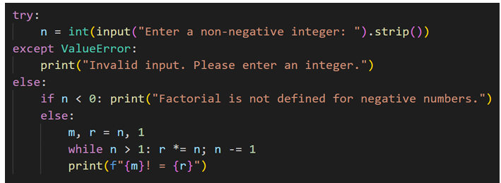
Output(O/P):
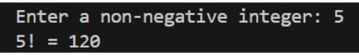
Explanation:
Optimized the code in minimal number of lines and short variable names

ask 3: Modular Design Using AI Assistance (Factorial with Functions)
❖ Scenario
The same logic now needs to be reused in multiple scripts.
❖ Task Description
Use GitHub Copilot to generate a modular version of the program by:
➢ Creating a user-defined function
➢ Calling the function from the main block
❖ Constraints
➢ Use meaningful function and variable names
➢ Include inline comments (preferably suggested by Copilot)
❖ Expected Deliverables
➢ AI-assisted function-based program
➢ Screenshots showing:
o Prompt evolution
o Copilot-generated function logic
➢ Sample inputs/outputs
➢ Short note:
o How modularity improves reusability.
Prompt:

Code:
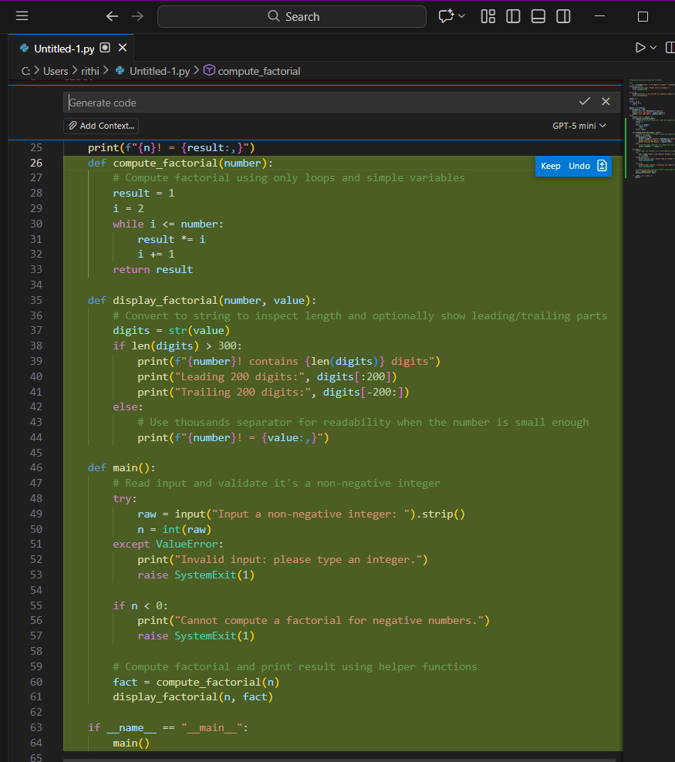
Output:
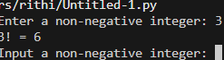
Explanation:
Copilot Modified The Code To Function Type & main block is created Handled Edge Cases Well

task 4: Comparative Analysis – Procedural vs Modular AI Code (With vs
Without Functions)
Scenario
As part of a code review meeting, you are asked to justify design choices.
❖ Task Description
Compare the non-function and function-based Copilot-generated
programs on the following criteria:
➢ Logic clarity
➢ Reusability
➢ Debugging ease
➢ Suitability for large projects
➢ AI dependency risk
❖ Expected Deliverables
Choose one:
➢ A comparison table
OR
➢ A short technical report (300–400 words).
Here is a human-friendly, simple, and natural rewrite (around 300 words), written exactly the way a student would explain it in a lab record or viva.

Comparative Analysis: Procedural vs Modular AI-Generated Code
In a code review meeting, we compared two types of AI-generated programs: procedural code (without functions) and modular code (with functions). This comparison helps in understanding which approach is better for writing clean, maintainable, and efficient programs.
Procedural code is written in a single continuous flow. For very small programs, this approach may seem easy to write and understand. However, as the program becomes longer, the logic starts to look confusing. Since everything is written together, it becomes hard to identify which part of the code performs a specific task. On the other hand, modular code divides the program into small functions. Each function performs one specific job, which makes the program easier to read and understand.
Reusability is limited in procedural code because the same logic has to be written again if needed in another place. In modular code, functions can be reused multiple times without rewriting the logic. This saves time and reduces errors.
Debugging procedural code is difficult because if an error occurs, the entire code must be checked line by line. In modular programming, errors can be easily found within a specific function, which makes debugging faster and simpler.
When working on large projects, procedural code is not suitable because it is hard to manage and maintain. Modular code is more organized and allows multiple developers to work on different functions, making it ideal for large-scale applications.
There is also a higher risk of over-dependence on AI in procedural code, as users may copy the output without understanding it. Modular code encourages logical thinking and better understanding of program structure.
In conclusion, modular AI-generated code is clearer, easier to debug, reusable, and more suitable for large projects compared to procedural code.

Task 5: AI-Generated Iterative vs Recursive Thinking
❖ Scenario
Your mentor wants to test how well AI understands different
computational paradigms.
❖ Task Description
Prompt Copilot to generate:
An iterative version of the logic
A recursive version of the same logic
❖ Constraints
Both implementations must produce identical outputs
Students must not manually write the code first
❖ Expected Deliverables
Two AI-generated implementations
Execution flow explanation (in your own words)
Comparison covering:
➢ Readability
➢ Stack usage
➢ Performance implications
➢ When recursion is not recommended.
Prompt:
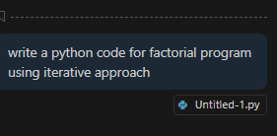

Code:
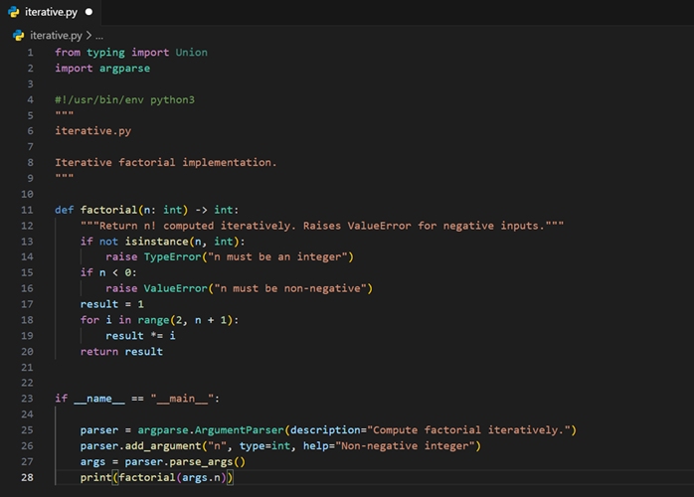

Output:
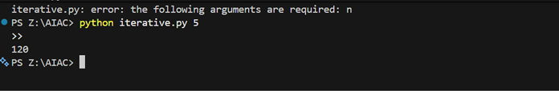
Prompt2:

Code:
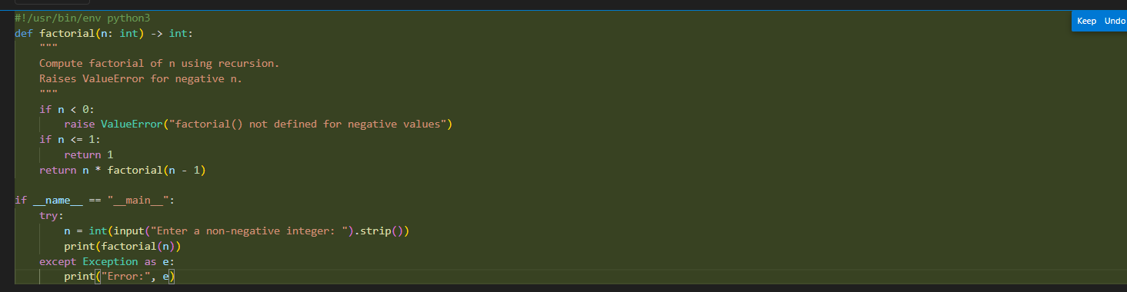

Ouput:
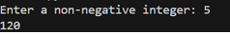
terative version:
The program starts with an initial value and repeatedly updates it using a loop until the condition is satisfied. The control flow stays within a single function and finishes once the loop ends.
Recursive version:
The program calls itself with a smaller input each time. Each call waits on the stack until the base condition is reached. After that, results are returned step by step.

