AIAC - Lab Assignment : 6.3

Name : Rithima Banala
Enrollment No : 2303A52471
Batch : 32

Lab 6 AI Based Code Completion – Classes, Loops, and Conditionals Lab Objectives:
- To explore AI-powered auto-completion features for core Python constructs.
- To analyze how AI suggests logic for class definitions, loops, and conditionals.
- To evaluate the completeness and correctness of code generated by AI assistants.
Lab Outcomes LOs
After completing this lab, students will be able to:
- Use AI tools to generate and complete class definitions and methods.
- Understand and assess AI-suggested loops for iterative tasks.
- Generate conditional statements through prompt-driven suggestions.
- Critically evaluate AI-assisted code for correctness and clarity.

Task Description #1 Loops – Automorphic Numbers in a Range) • Task: Prompt AI to generate a function that displays all Automorphic numbers between 1 and 1000 using a for loop.
- Instructions:
- Get AI-generated code to list Automorphic numbers using a for loop.
- Analyze the correctness and efficiency of the generated logic. o Ask AI to regenerate using a while loop and compare both implementations. Expected Output #1
- Correct implementation that lists Automorphic numbers using both loop types, with explanation.
Solution :
Prompt : Generate a function that displays all Automorphic numbers between 1 and 1000 using a for loop.
- Instructions:
- Generated code to list Automorphic numbers using a for loop.
- Analyze the correctness and efficiency of the generated logic.
- To regenerate using a while loop and compare both implementations.
Code Given By AI :
# Function using
FOR

LOOP
def
automorphic_numbers_for
(
)
:

""
"

Displays all automorphic numbers between
1
and
1000.

An automorphic number is a number whose square ends
with

the number itself
.

Example
:

5
^
2

=

25

(
ends
with

5
)
,

6
^
2

=

36

(
ends
with

6
)

""
"

print
(
"Automorphic numbers (FOR LOOP):"
)

automorphic_list
=

[
]

for
num
in

range
(
1
,

1001
)
:

square
=
num
*
num

if
square
%

10

==
num
%

10
:
# Check
if
last digit
of

square matches last digit
of
num

automorphic_list
.
append
(
num
)

print
(
automorphic_list
)

return
automorphic_list
# Function using
WHILE

LOOP
def
automorphic_numbers_while
(
)
:

""
"

Same functionality using
while
loop
for
comparison
.

""
"

print
(
"Automorphic numbers (WHILE LOOP):"
)

automorphic_list
=

[
]

num
=

1

while
num
<=

1000
:

square
=
num
*
num

if
square
%

10

==
num
%

10
:

automorphic_list
.
append
(
num
)

num
+=

1

print
(
automorphic_list
)

return
automorphic_list
# Main execution
if
__name__
==

"__main__"
:

automorphic_numbers_for
(
)

print
(
)

automorphic_numbers_while
(
)

# Comparison

print
(
"\nComparison:"
)

print
(
"- FOR LOOP: More Pythonic, cleaner, preferred for

iterating fixed ranges"
)

print
(
"- WHILE LOOP: More control, better for conditional

iterations"
)

print
(
"- Both have O(n) time complexity"
)
Output:
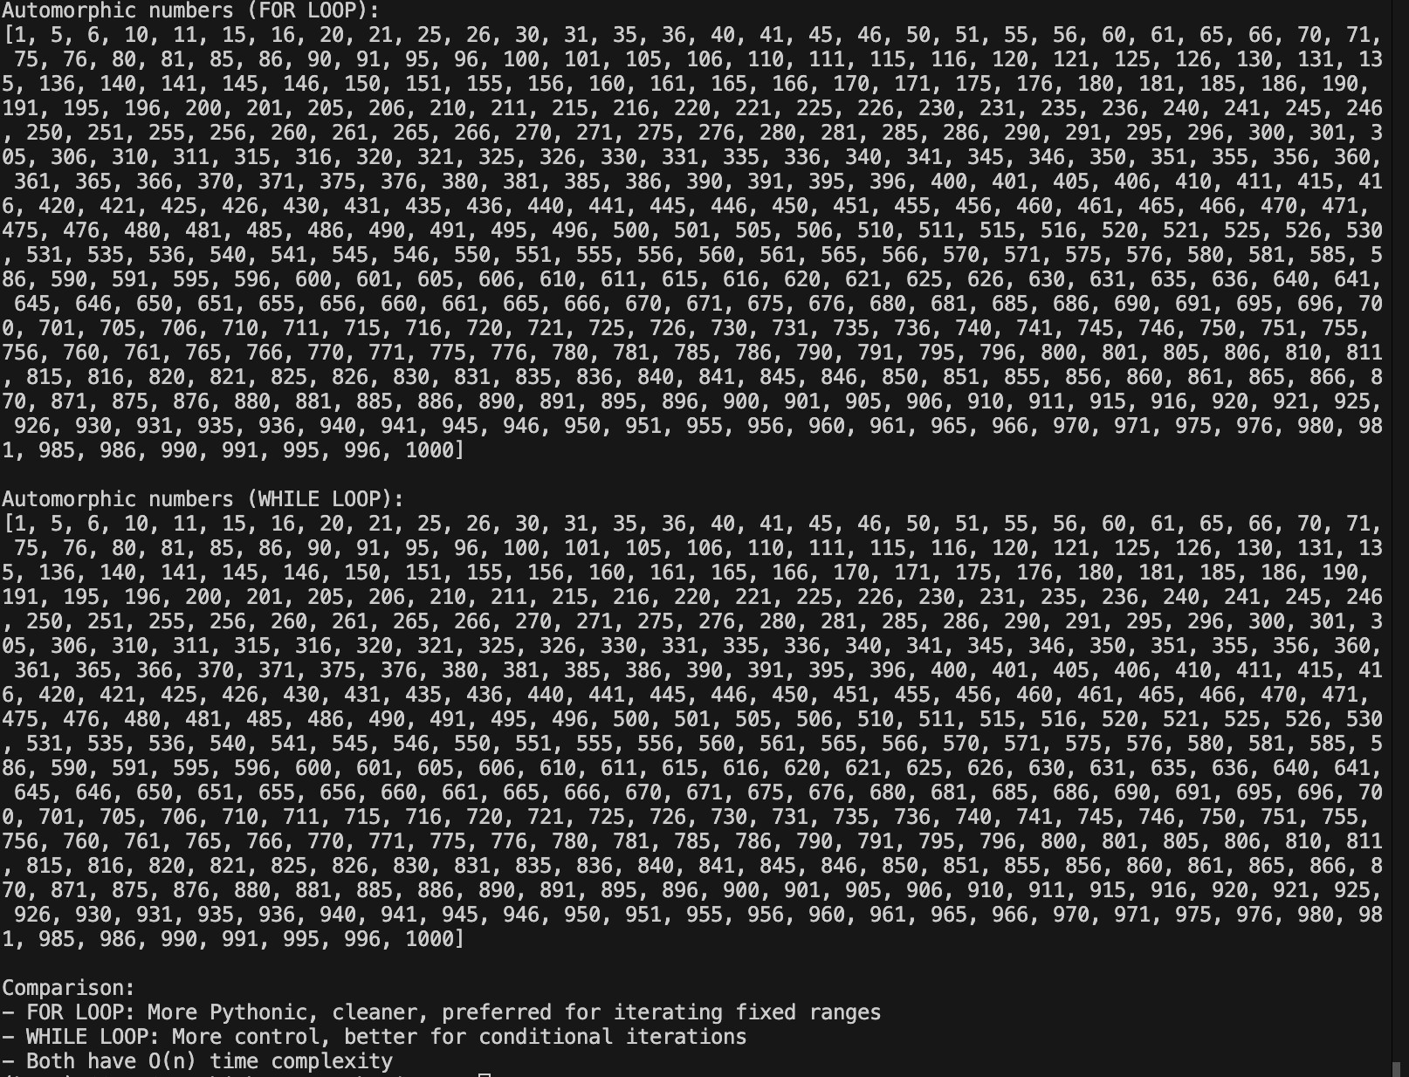

Task Description #2 Conditional Statements – Online Shopping Feedback Classification)
- Task: Ask AI to write nested if-elif-else conditions to classify online shopping feedback as Positive, Neutral, or Negative based on a numerical rating 1 5 .
- Instructions:
- Generate initial code using nested if-elif-else. o Analyze correctness and readability.
- Ask AI to rewrite using dictionary-based or match-case structure.
Expected Output #2
- Feedback classification function with explanation and an alternative approach.
Prompt:
Task: To write nested if-elif-else conditions to classify online shopping feedback as Positive, Neutral, or Negative based on a numerical rating 1 5 .
- Instructions:
- Generate initial code using nested if-elif-else. o Analyze correctness and readability.
- To rewrite using dictionary-based or match-case structure
Code Given By AI
# Version
1
:
Nested
if
-
elif
-
else
def
classify_feedback_nested
(
rating
)
:

""
"Classify feedback based on numerical rating (1-5)"
""

if
rating
>=

1
:

if
rating
<=

2
:

return

"Negative"

elif rating
==

3
:

return

"Neutral"

elif rating
<=

5
:

return

"Positive"

return

"Invalid rating"
# Version
2
:
Dictionary
-
based

(
cleaner
&
more maintainable
)
def
classify_feedback_dict
(
rating
)
:

""
"Classify feedback using dictionary mapping"
""

feedback_map
=

{

1
:

"Negative"
,

2
:

"Negative"
,

3
:

"Neutral"
,

4
:

"Positive"
,

5
:

"Positive"

}

return
feedback_map
.
get
(
rating
,

"Invalid rating"
)
# Version
3
:
Match
-
case

(
Python
3.10
+
)
def
classify_feedback_match
(
rating
)
:

""
"Classify feedback using match-case"
""

match rating
:

case

1

|

2
:

return

"Negative"

case

3
:

return

"Neutral"

case

4

|

5
:

return

"Positive"

case

_
:

return

"Invalid rating"
# Test all implementations
if
__name__
==

"__main__"
:

test_ratings
=

[
1
,

2
,

3
,

4
,

5
,

0
,

6
]

for
rating
in

test_ratings
:

print
(
f
"Rating {rating}: {classify_feedback_dict(rati
ng)}"
)
Output :
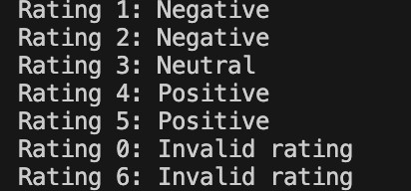
Task 3 Statistical_operations
Define a function named statistical_operations(tuple_num) that performs the following statistical operations on a tuple of numbers:
- Minimum, Maximum
- Mean, Median, Mode
- Variance, Standard Deviation
While writing the function, observe the code suggestions provided by GitHub Copilot.Make decisions to accept, reject, or modify the suggestions based on their relevance and correctness Prompt :
Define a function named statistical_operations(tuple_num) that performs the following statistical operations on a tuple of numbers:
- Minimum, Maximum
- Mean, Median, Mode • Variance, Standard Deviation Code Given By AI :
from statistics
import
mean
,
median
,
mode
,
stdev
,
variance
def
statistical_operations
(
tuple_num
)
:

""
"

Performs statistical operations on a tuple
of
numbers
.

Args
:

tuple_num
:

A
tuple
of
numbers

Returns
:

A
dictionary containing min
,
max
,
mean
,
median
,
mode
,

variance
,
and stdev

""
"

results
=

{

'minimum'
:

min
(
tuple_num
)
,

'maximum'
:

max
(
tuple_num
)
,

'mean'
:

mean
(
tuple_num
)
,

'median'
:

median
(
tuple_num
)
,

'mode'
:

mode
(
tuple_num
)
,

'variance'
:

variance
(
tuple_num
)
,

'standard_deviation'
:

stdev
(
tuple_num
)

}

return
results
# Example usage
if
__name__
==

"__main__"
:

numbers
=

(
10
,

20
,

30
,

40
,

50
,

50
)

stats
=

statistical_operations
(
numbers
)

for
key
,
value
in
stats
.
items
(
)
:

print
(
f
"{key}: {value}"
)

Output :
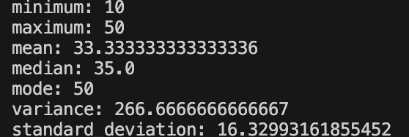

Task 4 Teacher Profile
- Prompt: Create a class Teacher with attributes teacher_id, name, subject, and experience. Add a method to display teacher details.
Expected Output: Class with initializer, method, and object creation.
Prompt : Create a class Teacher with attributes teacher_id, name, subject, and experience. Add a method to display teacher details.
Code Given By AI :
class

Teacher
:

def
__init__
(
self
,
teacher_id
,
name
,
subject
,
experienc
e
)
:

self
.
teacher_id
=
teacher_id

self
.
name
=
name

self
.
subject
=
subject

self
.
experience
=
experience

def
display_details
(
self
)
:

print
(
f
"Teacher ID: {self.teacher_id}"
)

print
(
f
"Name: {self.name}"
)

print
(
f
"Subject: {self.subject}"
)

print
(
f
"Experience: {self.experience} years"
)

@classmethod

def
take_input
(
cls
)
:

teacher_id
=

int
(
input
(
"Enter Teacher ID: "
)
)

name
=

input
(
"Enter Teacher Name: "
)

subject
=

input
(
"Enter Subject: "
)

experience
=

int
(
input
(
"Enter Years of Experience:

"
)
)

return

cls
(
teacher_id
,
name
,
subject
,
experience
)
# Creating object using
class

input
method
teacher
=
Teacher
.
take_input
(
)
# Displaying details
teacher
.
display_details
(
)
Output :
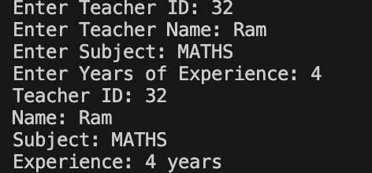
Task #5 Zero-Shot Prompting with Conditional Validation Use zero-shot prompting to instruct an AI tool to generate a function that validates an Indian mobile number.
Requirements
- The function must ensure the mobile number:
o Starts with 6, 7, 8, or 9 o Contains exactly 10 digits Prompt :
Use zero-shot prompting t to generate a function that validates an Indian mobile number.
Requirements
• The function must ensure the mobile number:
o Starts with 6, 7, 8, or 9 o Contains exactly 10 digits and take input from user
Code Given By AI :
def
validate_indian_mobile
(
mobile_number
)
:

""
"

Validates an Indian mobile number using zero
-
shot prompti
ng logic
.

Requirements
:

-
Must start
with

6
,

7
,

8
,
or
9

-
Must contain exactly
10
digits

Args
:

mobile_number

(
str
)
:
The mobile number to validate

Returns
:

bool
:
True
if
valid
,
False otherwise

""
"

# Check
if
the input is exactly
10
digits

if
not mobile_number
.
isdigit
(
)
or
len
(
mobile_number
)

!=

1
0
:

return
False

# Check
if
it starts
with

6
,

7
,

8
,
or
9

if
mobile_number
[
0
]
not
in

[
'6'
,

'7'
,

'8'
,

'9'
]
:

return
False

return
True
# Take input from user
user_input
=

input
(
"Enter an Indian mobile number: "
)
if

validate_indian_mobile
(
user_input
)
:

print
(
f
"✓ {user_input} is a valid Indian mobile number"
)
else
:

print
(
f
"✗ {user_input} is not a valid Indian mobile numbe
r"
)

Output :
Task Description #6 Loops – Armstrong Numbers in a Range) Task: Write a function using AI that finds all Armstrong numbers in a userspecified range (e.g., 1 to 1000 .
Instructions:
- Use a for loop and digit power logic.
- Validate correctness by checking known Armstrong numbers 153, 370, etc.).
- Ask AI to regenerate an optimized version (using list comprehensions).
Expected Output #7
- Python program listing Armstrong numbers in the range.
- Optimized version with explanation.
Prompt :
Write a function that finds all Armstrong numbers in a userspecified range (e.g., 1 to 1000 .
Instructions:
- Use a for loop and digit power logic.
- Validate correctness by checking known Armstrong numbers 153, 370, etc.).
- Regenerate an optimized version (using list comprehensions).
Code Given By AI :
# Function to find Armstrong numbers
in
a range
def
find_armstrong_numbers
(
start
,
end
)
:

""
"

Find all Armstrong numbers
in
the given range
.

An Armstrong number is a number that equals the sum
of
it
s digits

each raised to the power
of
the number
of
digits
.

""
"

armstrong_numbers
=

[
]

for
num
in

range
(
start
,
end
+

1
)
:

# Convert number to string to count digits

digits = str(num) num_digits = len(digits)
# Calculate sum of digits raised to power of num_digi ts sum_of_powers = sum(int(digit) ** num_digits for digi t in digits)
# Check if it's an Armstrong number if sum_of_powers == num:
armstrong_numbers.append(num)
return armstrong_numbers
# Optimized version using list comprehension def find_armstrong_numbers_optimized(start, end): """Optimized version using list comprehension.""" return [ num for num in range(start, end + 1) if sum(int(digit) ** len(str(num)) for digit in str(n um)) == num
]
# Test cases if __name__ == "__main__": # Test with range 1 to 1000 result = find_armstrong_numbers(1, 1000) print(f"Armstrong numbers (1-1000): {result}")
# Verify known Armstrong numbers print(f"Is 153 Armstrong? {153 in result}") print(f"Is 370 Armstrong? {370 in result}") print(f"Is 371 Armstrong? {371 in result}") print(f"Is 407 Armstrong? {407 in result}")

# Test optimized version

result_optimized
=

find_armstrong_numbers_optimized
(
1
,

10
000
)

print
(
f
"\nArmstrong numbers (1-10000): {result_optimize
d}"
)
Output :
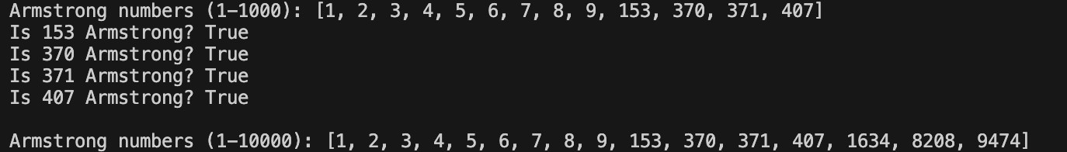

Task Description #7 Loops – Happy Numbers in a Range)
Task: Generate a function using AI that displays all Happy Numbers within a user-specified range (e.g., 1 to 500 .
Instructions:
- Implement the logic using a loop: repeatedly replace a number with the sum of the squares of its digits until the result is either 1 Happy Number) or enters a cycle Not Happy).
- Validate correctness by checking known Happy Numbers (e.g., 1, 7, 10, 13, 19, 23, 28…).
- Ask AI to regenerate an optimized version (e.g., by using a set to detect cycles instead of infinite loops).
Expected Output #7
- Python program that prints all Happy Numbers within a range.
- Optimized version using cycle detection with explanation.
Code Given By AI :
# Task Description #
7

(
Loops – Happy Numbers
in
a Range
)
Tas
k
:
Generate a
function
using displays all Happy Numbers with
in a user
-
specified
range

(
e
.
g
.
,

1
to
500
)
.
# take input from the user
for
the range
from sqlite3
import
Time
start_range
=

int
(
input
(
"Enter the start of the range: "
)
)
end_range
=

int
(
input
(
"Enter the end of the range: "
)
)
def
is_happy_number
(
n
)
:

seen
=

set
(
)

while
n
!=

1
and n not
in

seen
:

seen
.
add
(
n
)

n
=

sum
(
int
(
digit
)

**

2

for
digit
in

str
(
n
)
)

return
n
==

1

def
happy_numbers_in_range
(
start
,
end
)
:

happy_numbers
=

[
]

for
num
in

range
(
start
,
end
+

1
)
:

if

is_happy_number
(
num
)
:

happy_numbers
.
append
(
num
)

return
happy_numbers
# Example usage
:
start_range
=

1
end_range
=

500
happy_numbers
=

happy_numbers_in_range
(
start_range
,
end_rang
e
)
print
(
f
"Happy numbers between {start_range} and {end_range}:

{
happy_numbers}"
)
Output :
Task Description #8 Loops – Strong Numbers in a Range)
Task: Generate a function using AI that displays all Strong Numbers (sum of factorial of digits equals the number, e.g., 145 1! 4! 5!) within a given range.
Instructions:
- Use loops to extract digits and calculate factorials.
- Validate with examples 1, 2, 145 .
- Ask AI to regenerate an optimized version (precompute digit factorials).
Expected Output #8
- Python program that lists Strong Numbers.
- Optimized version with explanation.
Code Given By AI :
# Generate a Python
function
using loops to find all Strong N
umbers
in
a given range
,
extract digits and compute factorial
s
,
validate
with

examples

(
1
,

2
,

145
)
,
produce an optimized v
ersion by precomputing digit factorials
,
and explain the opti
mization
.
def
factorial
(
n
)
:

if
n
==

0
or n
==

1
:

return

1

result
=

1

for
i
in

range
(
2
,
n
+

1
)
:

result
*=
i

return
result
def
is_strong_number
(
num
)
:

original_num
=
num

sum_of_factorials
=

0

while
num
>

0
:

digit
=
num
%

10

sum_of_factorials
+=

factorial
(
digit
)

num
//= 10

return
sum_of_factorials
==
original_num
def
find_strong_numbers_in_range
(
start
,
end
)
:

strong_numbers
=

[
]

for
num
in

range
(
start
,
end
+

1
)
:

if

is_strong_number
(
num
)
:

strong_numbers
.
append
(
num
)

return
strong_numbers
# Validate
with
examples
print
(
find_strong_numbers_in_range
(
1
,

200
)
)
# Should include

1
,

2
,

145
Output :
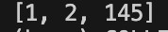
Task #9 Few-Shot Prompting for Nested Dictionary Extraction Objective
Use few-shot prompting 2 3 examples) to instruct the AI to create a function that parses a nested dictionary representing student information.
Requirements
- The function should extract and return:
o Full Name o Branch o SGPA
Expected Output
A reusable Python function that correctly navigates and extracts values from nested dictionaries based on the provided examples
Code Given By AI :
# Function to extract student information from a nested dicti
onary
def
extract_student_info
(
data
)
:

first_name
=
data
[
"student"
]
[
"name"
]
[
"first"
]

last_name
=
data
[
"student"
]
[
"name"
]
[
"last"
]

branch
=
data
[
"student"
]
[
"academic"
]
[
"branch"
]

sgpa
=
data
[
"student"
]
[
"academic"
]
[
"sgpa"
]

full_name
=
f
"{first_name} {last_name}"

return

{

"Full Name"
:
full_name
,

"Branch"
:
branch
,

"SGPA"
:
sgpa

}
# Sample input
student_data
=

{

"student"
:

{

"name"
:

{

"first"
:

"Aarav"
,

"last"
:

"Sharma"

}
,

"academic"
:

{

"branch"
:

"CSE"
,

"sgpa"
:

8.7

}

}
}
# Function call
result
=

extract_student_info
(
student_data
)
# Output
print
(
result
)
Output :

Task Description #10 Loops – Perfect Numbers in a Range)
Task: Generate a function using AI that displays all Perfect Numbers within a user-specified range (e.g., 1 to 1000 .
Instructions:
- A Perfect Number is a positive integer equal to the sum of its proper divisors (excluding itself). o Example: 6 1 2 3, 28 1 2 4 7 14.
- Use a for loop to find divisors of each number in the range.
- Validate correctness with known Perfect Numbers 6, 28, 496…). • Ask AI to regenerate an optimized version (using divisor check only up to √n).
Expected Output #10
- Python program that lists Perfect Numbers in the given range.
- Optimized version with explanation.
Code Given By AI :
def
find_perfect_numbers
(
start
,
end
)
:

""
"

Find all perfect numbers
in
the given range
.

A
perfect number equals the sum
of
its proper
divisors

(
e
xcluding itself
)
.

""
"

perfect_numbers
=

[
]

for
num
in

range
(
start
,
end
+

1
)
:

# Calculate sum
of
proper divisors

divisor_sum
=

0

# Optimized
:
check divisors only up to
sqrt
(
n
)

for i in range(1, int(num ** 0.5) + 1): if num % i == 0:
divisor_sum += i # Add the divisor
# Add the complementary divisor (if different and not the number itself) if i != num // i and num // i != num:
divisor_sum += num // i
# Check if perfect number if divisor_sum == num:
perfect_numbers.append(num)
return perfect_numbers
# Main program if __name__ == "__main__": # Get user input try:
start = int(input("Enter the start of range: ")) end = int(input("Enter the end of range: "))
if start < 1 or end < start:
print("Invalid range. Please enter positive integ ers with start <= end.") else: result = find_perfect_numbers(start, end)
if result:
print(f"\nPerfect Numbers between {start} and
{end}:") for num in result:
print(num) else: print(f"\nNo perfect numbers found between {s tart} and {end}.")

except ValueError
:

print
(
"Please enter valid integers."
)
Output :
