AI Assisted Coding

ASSIGNMENT 3.1

Name: B.Rithima
HT No: 2303A52471
Batch: 32

Experiment - Prompt Engineering Techniques

Task Description: Design and refine prompts using different prompting strategies to generate Python programs for basic computational problems.

Question 1:

Zero-Shot Prompting (Palindrome Number Program)

Write a zero-shot prompt (without providing any examples) to generate a Python function that checks whether a given number is a palindrome.

Task:

• Record the AI-generated code.

• Test the code with multiple inputs.

• Identify any logical errors or missing edge-case handling.

Prompt:

Write a Python function that takes an integer as input and checks whether it is a palindrome number. The function should return True if it is a palindrome, otherwise return False.
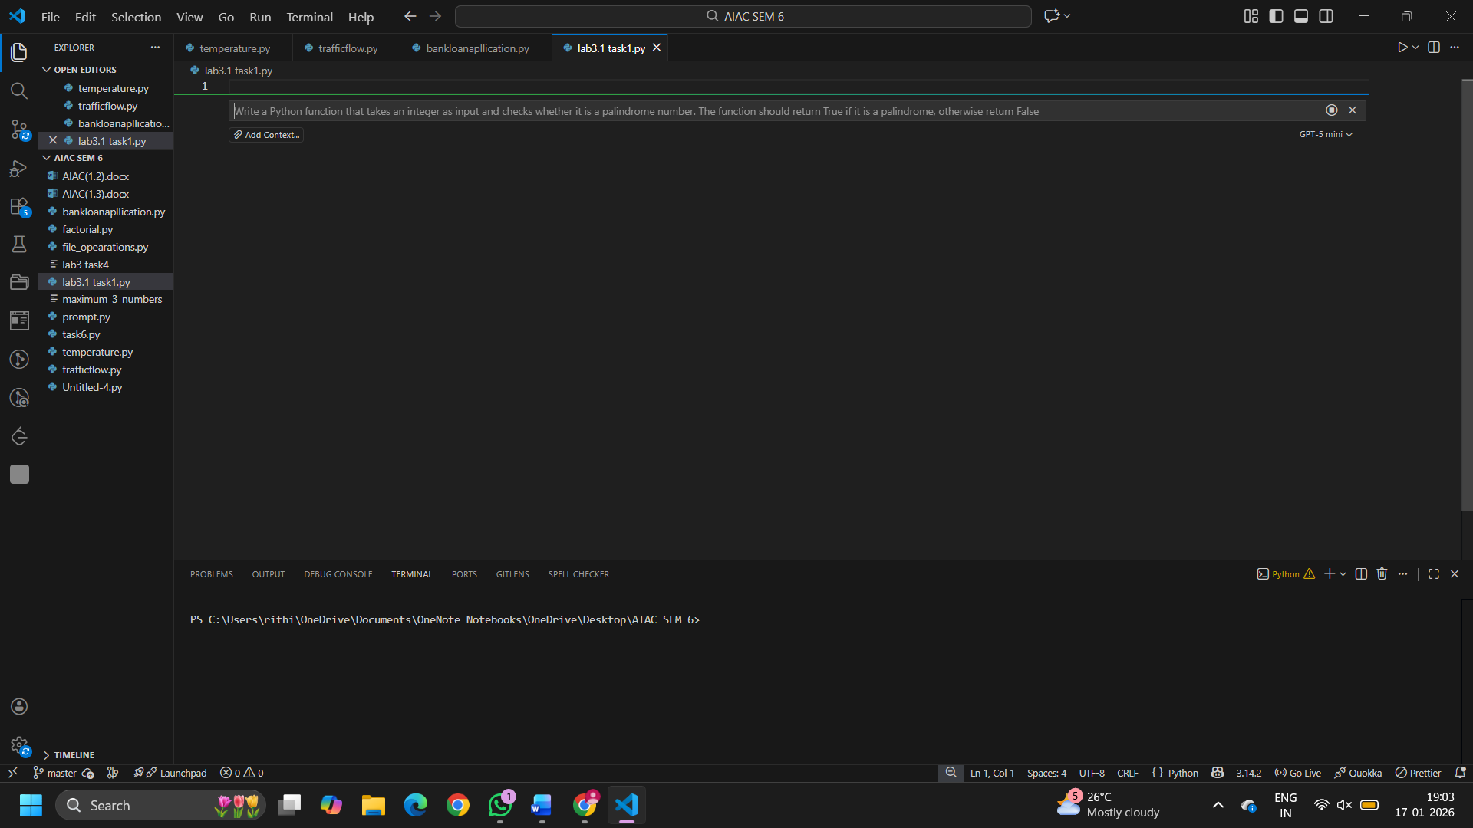

Code:
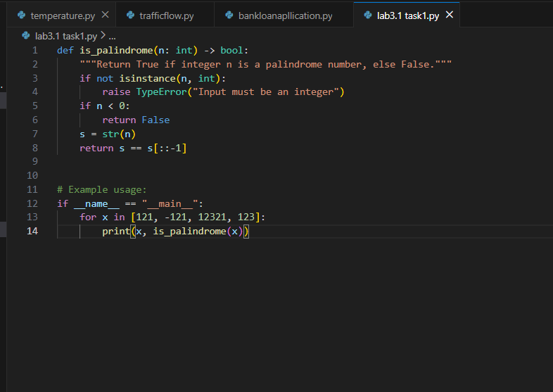

Output(O/P)
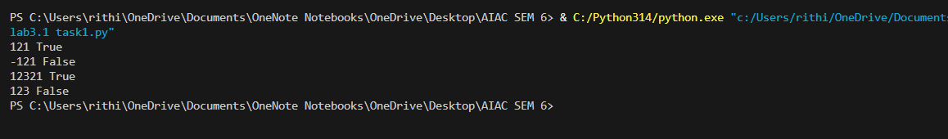

Explanation:
• A zero-shot prompt was written without giving examples.
• AI generated a palindrome-checking function in Python.
• The function reverses the number and compares it with the original.
• Answer Returns Either True or False

Question 2:
One-Shot Prompting (Factorial Calculation)
Write a one-shot prompt by providing one input-output example and ask the AI to generate a Python function to compute the factorial of a given number.
Example:
Input: 5 → Output: 120
Task:
• Compare the generated code with a zero-shot solution.
• Examine improvements in clarity and correctness.

Prompt:
Write a Python function to compute the factorial of a given non-negative integer.
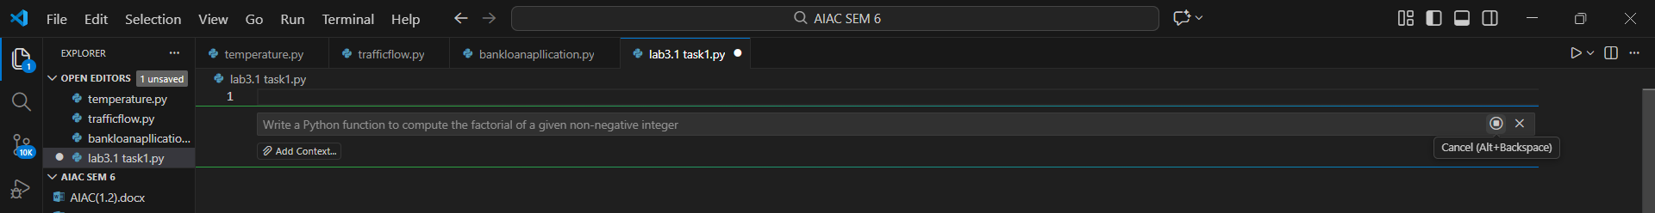
Example:
Input: 5
Output: 120
The function should return the factorial value.

Code:
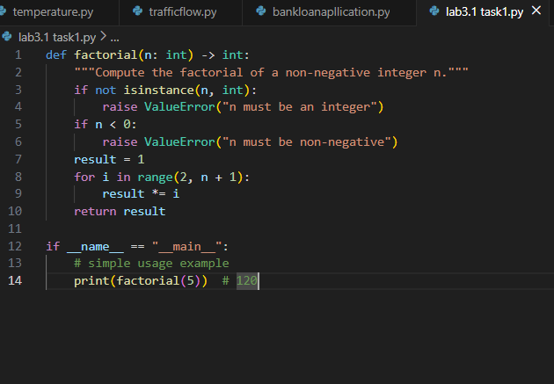
Output:
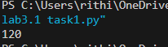

Explanation:

Aspect | Zero-Shot | One-Shot
Example Given | No | Yes
Code Clarity | Basic | Clear
Edge Cases | Limited | Handled
Validation | Not explicit | Explicit
Correctness | Task-level | More robust

Improvements Observed in One-Shot Prompting
• Better clarity due to example-guided generation
• Improved correctness with input validation
• More readable and maintainable code
• Clear handling of edge cases compared to zero-shot

Question 3:
Few-Shot Prompting (Armstrong Number Check)
Write a few-shot prompt by providing multiple input-output examples to guide the AI in generating a Python function to check whether a given number is an Armstrong number.
Examples:
• Input: 153 → Output: Armstrong Number
• Input: 370 → Output: Armstrong Number
• Input: 123 → Output: Not an Armstrong Number Task:
• Analyze how multiple examples influence code structure and accuracy. • Test the function with boundary values and invalid inputs.

Prompt:
Write a Python function to check whether a given number is an Armstrong number.
Examples:
Input: 153 → Output: Armstrong Number
Input: 370 → Output: Armstrong Number
Input: 123 → Output: Not an Armstrong Number
The function should return
"Armstrong Number" or "Not an Armstrong Number" accordingly

Code:
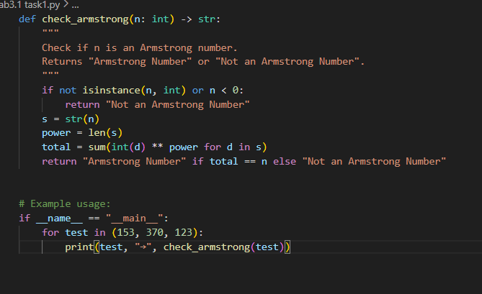
Output:
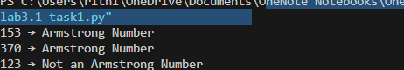

Explanation:
Influence of Multiple Examples
• Examples clarify expected output format
• Guides correct power calculation based on digit count
• Improves accuracy compared to zero or one-shot
• Reduces ambiguity in logic and return values

Testing (Boundary and Invalid Inputs)
• Input: 0 → Armstrong Number
• Input: 1 → Armstrong Number
• Input: 9474 → Armstrong Number
• Input: -153 → Not an Armstrong Number
• Input: "abc" → Invalid Input

Question 4:
Context-Managed Prompting (Optimized Number Classification)
Design a context-managed prompt with clear instructions and constraints to generate an optimized Python program that classifies a number as prime, composite, or neither.
Task:
• Ensure proper input validation.
• Optimize the logic for efficiency.
• Compare the output with earlier prompting strategies.

Prompt:
You are a Python programming assistant.
Task:
Write an optimized Python function that takes a single input number and classifies it as Prime, Composite, or Neither.
Constraints and Instructions:
• Accept only integer inputs and validate the input properly.
• If the number is less than or equal to 1, return "Neither".
• Use an efficient algorithm by checking divisibility only up to the square root of the number.
• The function should return one of the following strings only:
"Prime", "Composite", or "Neither".
• Do not use external libraries.
Output should be correct and optimized

Code:
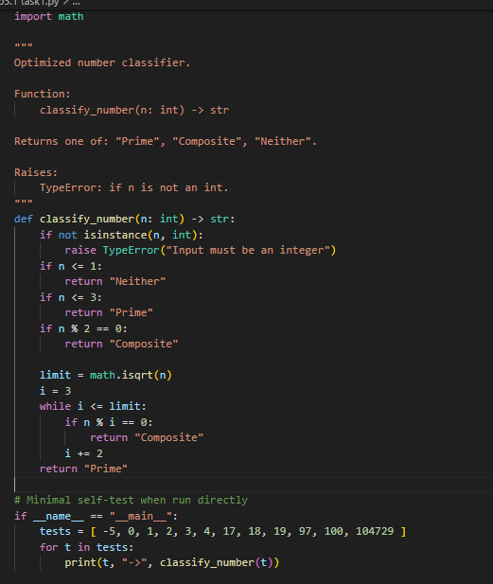

Output:
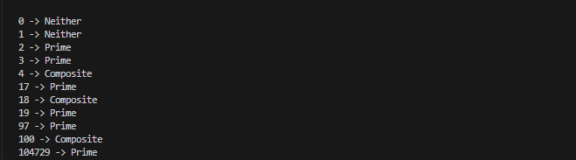

Explanation:
Comparison with Earlier Prompting Strategies
• More structured than zero-shot
• Clearer constraints than one-shot
• Less ambiguity than few-shot
• Produces efficient and validated code

Question 5:
Zero-Shot Prompting (Perfect Number Check)
Write a zero-shot prompt (without providing any examples) to generate a Python function that checks whether a given number is a perfect number.
Task:
• Record the AI-generated code.
• Test the program with multiple inputs.
• Identify any missing conditions or inefficiencies in the logic.
Prompt:
Write a Python function that takes an integer as input and checks whether it is a perfect number. The function should return True if the number is perfect, otherwise return False.

Code:
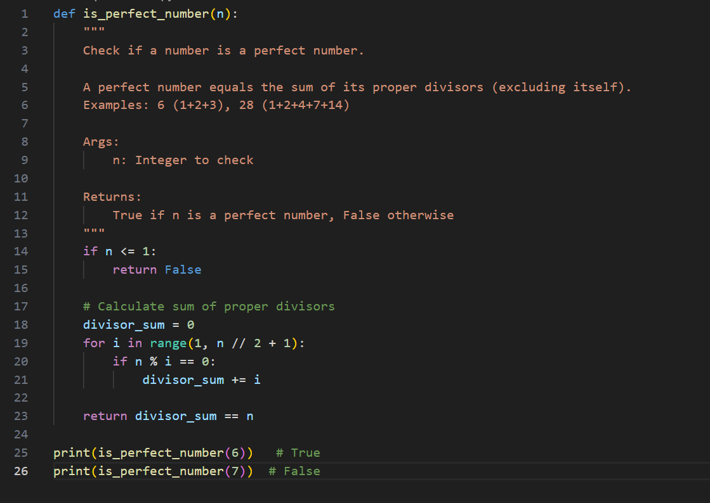

Output:
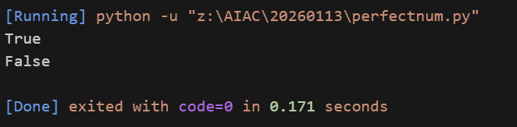

Explanation:
Testing the Program:
• Input: 6 → Output: True
• Input: 28 → Output: True
• Input: 7 → Output: False
• Input: 12 → Output: False
• Input: 1 → Output: False
• Input: 0 → Output: False
• Input: -6 → Output: False

Missing Conditions and Inefficiencies:
• No input type validation (floats or strings may cause errors)
• Loop runs up to n // 2, which is inefficient for large numbers
• Can be optimized by checking divisors only up to square root of n
• Does not explicitly handle non-integer inputs
Overall, logic is correct but performance can be improved for large values.

Question 6:
Few-Shot Prompting (Even or Odd Classification with Validation)
Write a few-shot prompt by providing multiple input-output examples to guide the AI in generating a Python program that determines whether a given number is even or odd, including proper input validation. Examples:
• Input: 8 → Output: Even
• Input: 15 → Output: Odd
• Input: 0 → Output: Even Task:
• Analyze how examples improve input handling and output clarity.
• Test the program with negative numbers and non-integer inputs.

Prompt:
Write a Python program that determines whether a given input number is Even or Odd.
Examples:
Input: 8 → Output: Even
Input: 15 → Output: Odd
Input: 0 → Output: Even
The program should validate the input and handle invalid (non-integer) values gracefully.

Code:
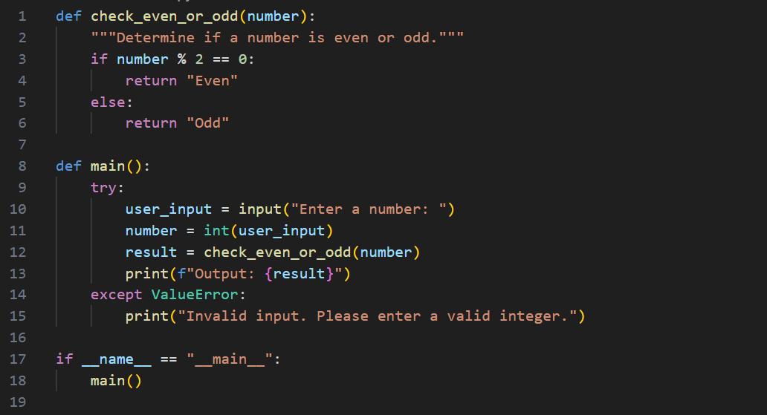
Output:
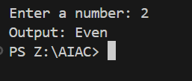

Explanation:
Analysis: Effect of Examples on Input Handling and Output Clarity
• Examples make it clear that the output must be only “Even” or “Odd”
• Inclusion of 0 → Even avoids ambiguity about zero
• Encourages explicit input validation using try–except
• Improves clarity by separating logic and input handling
• Output format becomes consistent and predictable

Testing the Program:
Negative Numbers
- Input: -10 → Output: Even
- Input: -3 → Output: Odd
Non-Integer Inputs
- Input: 3.5 → Output: Invalid input. Please enter a valid integer.
- Input: "abc" → Output: Invalid input. Please enter a valid integer.
Conclusion:
Few-shot examples guide the program to handle inputs safely and produce clear, reliable outputs.

