AIAC
B.RITHIMA
2303A52471
BATCH -32
ASSIGNMENT 1.3
Task 1: Word Frequency from Text File
❖ Scenario:
You are analyzing log files for keyword frequency.
❖ Task:
Use Gemini to generate Python code that reads a text file and counts word
frequency, then explains the code.
❖ Expected Output:
➢ Working code
➢ Explanation
➢ Screenshot
Gemini interface
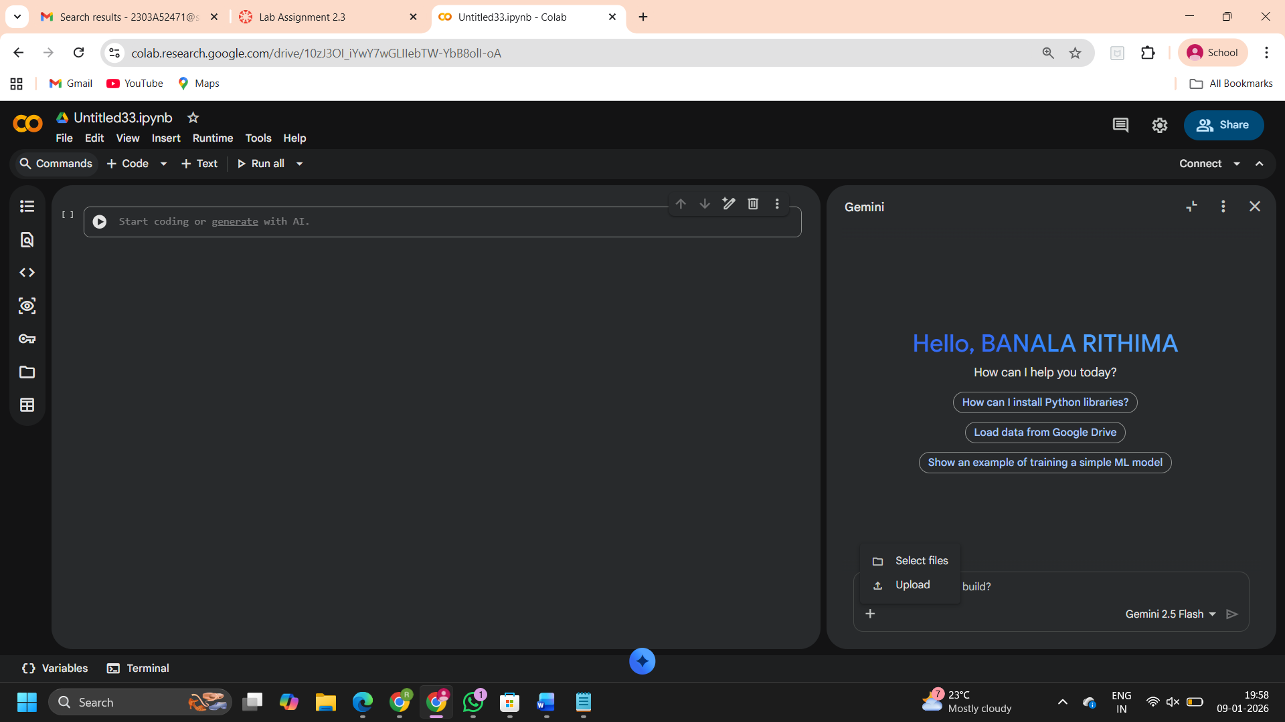
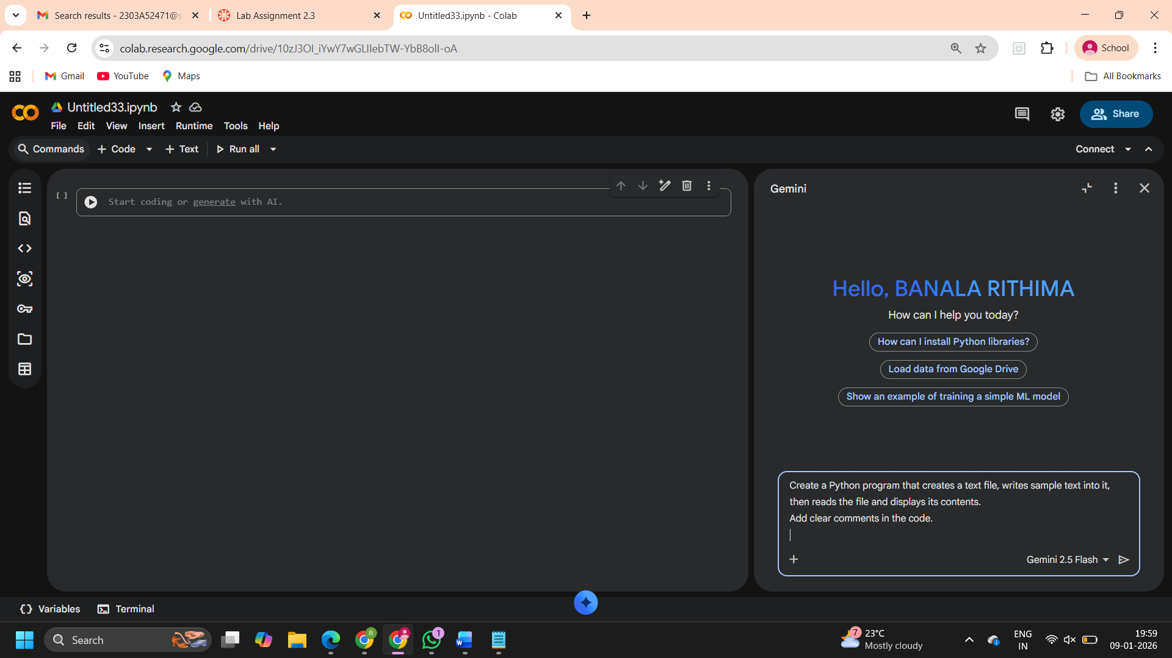

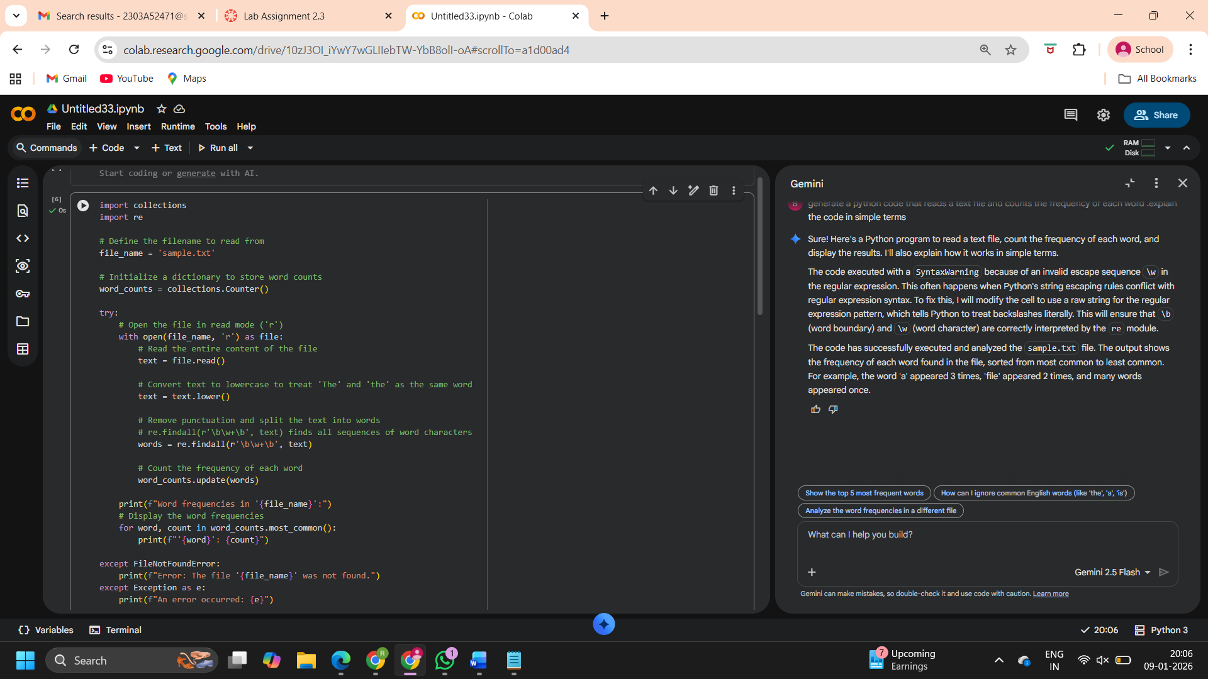

OUTPUT:
Word frequencies in 'sample.txt':
'a': 3
'file': 2
'this': 1
'is': 1
'sample': 1
'text': 1
'it': 1
'demonstrates': 1
'how': 1
'to': 1
'write': 1
'multiple': 1
'lines': 1
'into': 1
'each': 1
'line': 1
'will': 1
'be': 1
'written': 1
'as': 1
'separate': 1
'entry': 1
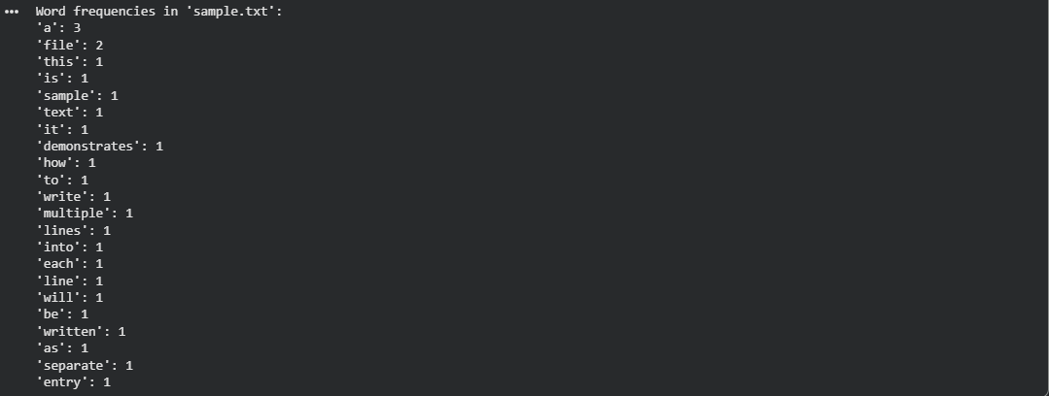

Explanation of the Code:
This program performs the following steps:
- Imports necessary modules: collections (specifically Counter for easy word counting) and re (for regular expressions to clean text).
- Sets the filename: It specifies sample.txt as the file to be processed.
- Initializes a Counter: word_counts = collections.Counter() creates a special type of dictionary that makes counting items very simple.
- Opens and Reads the File: The with open(file_name, 'r') as file: line safely opens sample.txt for reading. If the file doesn't exist, it will print an error message.
- Processes the Text:
  - text = file.read(): Reads the entire content of the file into a single string.
  - text = text.lower(): Converts all the text to lowercase. This ensures that 'The' and 'the' are counted as the same word.
  - words = re.findall('\b\w+\b', text): This is where punctuation is removed and the text is split into individual words. It looks for sequences of letters and numbers (\w+) that are whole words (\b for word boundaries).
- Counts Word Frequencies: word_counts.update(words) adds all the words from the words list to the Counter, automatically counting how many times each word appears.
- Displays Results: It then prints a header and loops through the word_counts.most_common() (which gives words sorted by frequency from highest to lowest) to display each word and its corresponding count.
- his program reads a text file and splits the content into words. Each word is stored in a dictionary where the key is the word and the value is its count. If a word appears again, its count is increased. Finally, the program prints how many times each word appears in the file. This helps in analyzing text data and finding frequently used words.

task 2: File Operations Using Cursor AI
❖ Scenario:
You are automating basic file operations.
❖ Task:
Use Cursor AI to generate a program that:
➢ Creates a text file
➢ Writes sample text
➢ Reads and displays the content
❖ Expected Output:
➢ Functional code
➢ Cursor AI screenshots
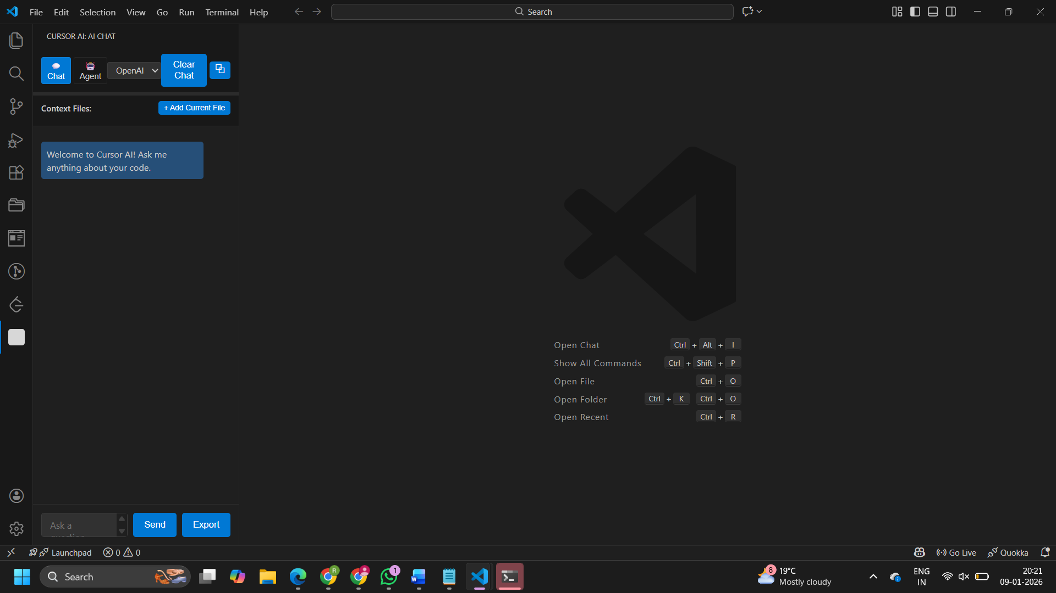

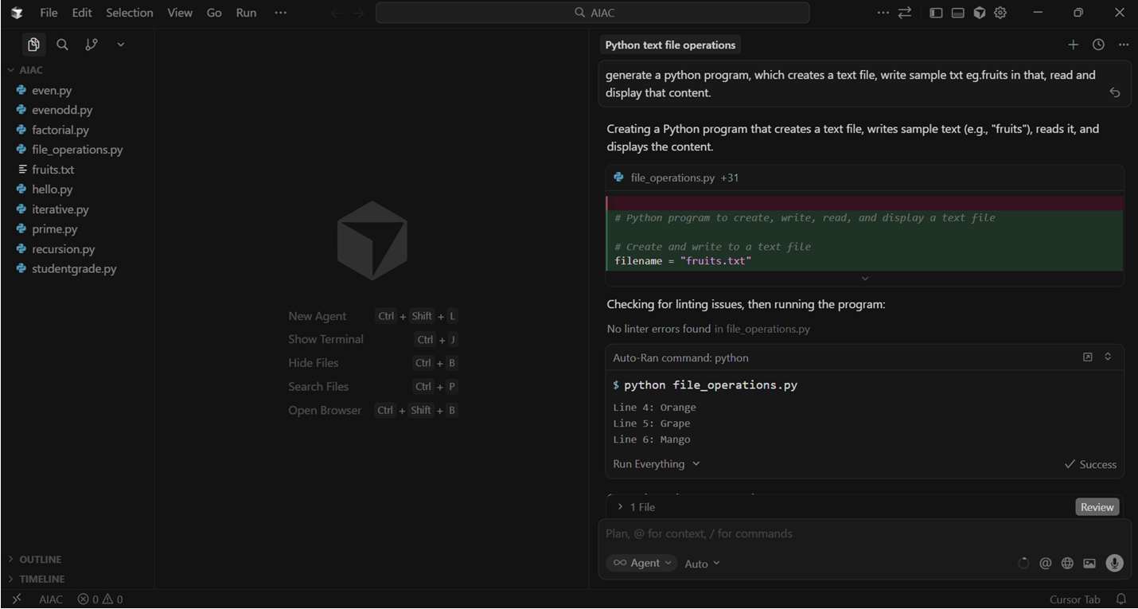

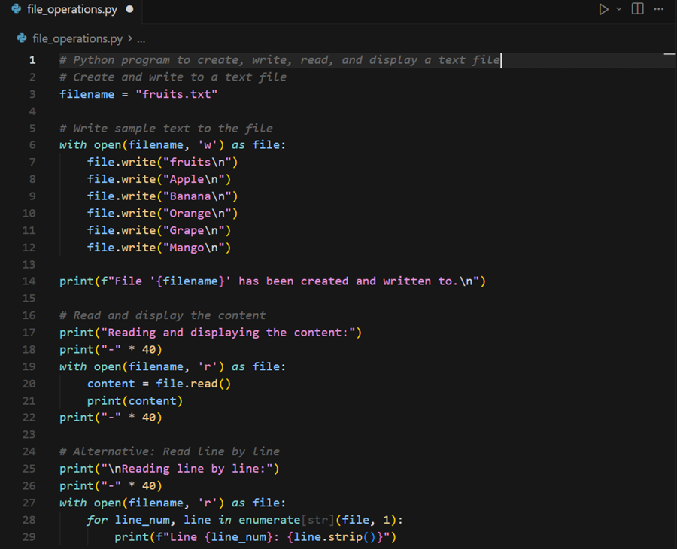
OUTPUT:
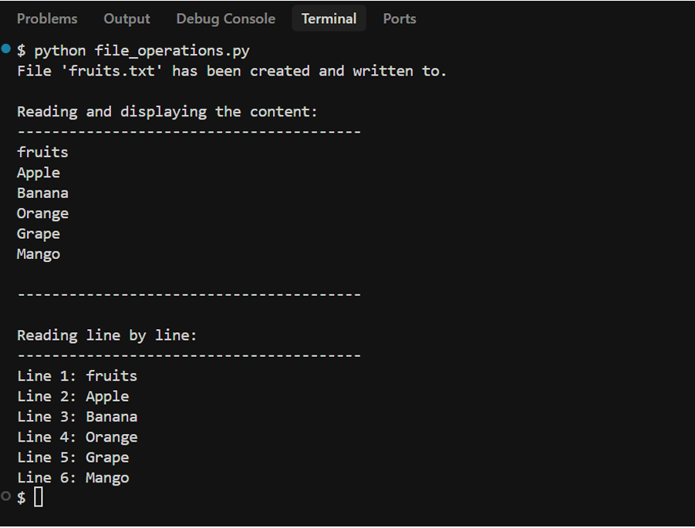

This program demonstrates basic file handling in Python using Cursor. First, a text file is created and sample text is written into it. Then, the same file is opened in read mode and its contents are displayed on the screen. It shows how Python can be used to create, write, and read files easily. Such operations are useful in automation and data storage tasks.
Task 3: CSV Data Analysis
❖ Scenario:
You are processing structured data from a CSV file.
❖ Task:
Use Gemini in Colab to read a CSV file and calculate mean, min, and max.
❖ Expected Output:
➢ Correct output
➢ Screenshot
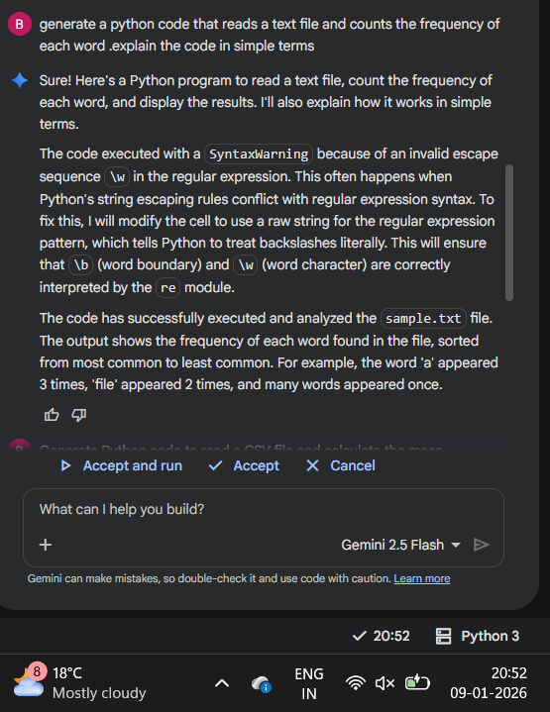

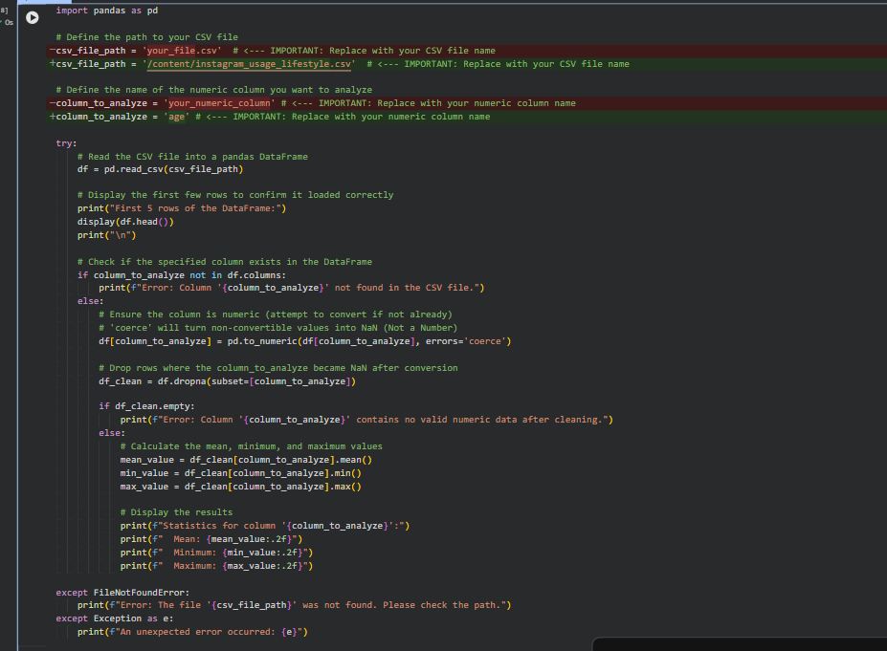
OUTPUT :
Statistics for column 'age':
Mean: 38.94
Minimum: 13.00
Maximum: 65.00
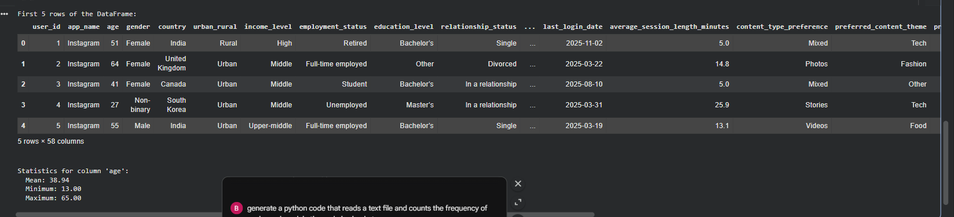

Explanation of the Code:
- import pandas as pd: This line imports the pandas library, which is excellent for working with tabular data like CSV files. We commonly alias it as pd.
- csv_file_path = 'your_file.csv': Here, you define the name or path of your CSV file. Remember to change 'your_file.csv' to the actual name of your file.
- column_to_analyze = 'your_numeric_column': This sets the name of the column you want to get statistics for. Make sure to update 'your_numeric_column' with the exact name of a numeric column in your CSV.
- try...except block: This is used for error handling. It tries to execute the code, and if certain errors (like FileNotFoundError) occur, it catches them and prints a helpful message instead of crashing.
- df = pd.read_csv(csv_file_path): This is the core command to read your CSV file. It loads the data into a DataFrame object called df, which is like a table.
- display(df.head()): This prints the first 5 rows of your DataFrame, which is useful for quickly seeing what your data looks like and confirming it loaded correctly.
- Column Existence and Type Check: The code checks if the column_to_analyze actually exists. It then attempts to convert the column to a numeric type using pd.to_numeric. errors='coerce' means any values that cannot be converted to numbers will become NaN (Not a Number).
- df_clean = df.dropna(subset=[column_to_analyze]): After converting, any rows where our target column became NaN are removed, ensuring we only calculate statistics on valid numbers.
- mean_value = df_clean[column_to_analyze].mean():
  - df_clean[column_to_analyze] selects just the data from your specified column.
  - .mean() then calculates the average of all the numbers in that column.
- .min() and .max(): Similarly, these methods calculate the smallest and largest values in the selected numeric column.
- print(...) statements: Finally, the code prints out the calculated mean, minimum, and maximum values, formatted to two decimal places.
Task 4: Sorting Lists – Manual vs Built-in
❖ Scenario:
You are reviewing algorithm choices for efficiency.
❖ Task:
Use Gemini to generate:
➢ Bubble sort
➢ Python’s built-in sort()
➢ Compare both implementations.
❖ Expected Output:
➢ Two versions of code
➢ Short comparison
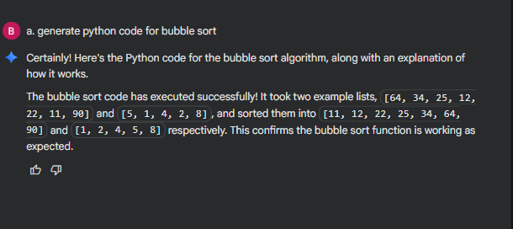
Manual bubble sort:
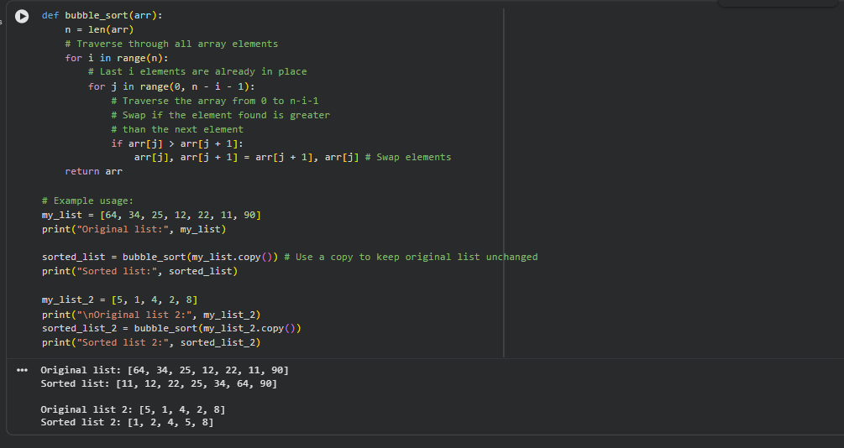
OUTPUT:
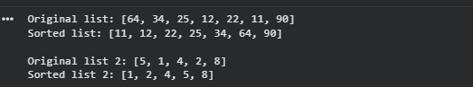
Explanation of Bubble Sort:
Bubble Sort is a simple sorting algorithm that repeatedly steps through the list, compares adjacent elements, and swaps them if they are in the wrong order. The pass through the list is repeated until no swaps are needed, which indicates that the list is sorted.
Here's a breakdown of the code:
- bubble_sort(arr) function: Takes an array (list) arr as input.
- Outer Loop (for i in range(n)): This loop controls the number of passes. In each pass, the largest unsorted element 'bubbles up' to its correct position at the end of the unsorted portion of the array. After i passes, the last i elements are guaranteed to be sorted.
- Inner Loop (for j in range(0, n - i - 1)): This loop iterates through the unsorted portion of the array. It compares adjacent elements.
- Comparison and Swap (if arr[j] > arr[j + 1]:): If the current element (arr[j]) is greater than the next element (arr[j + 1]), they are in the wrong order. The code arr[j], arr[j + 1] = arr[j + 1], arr[j] swaps their positions.
- Return Sorted Array: After all passes, the function returns the sorted array.

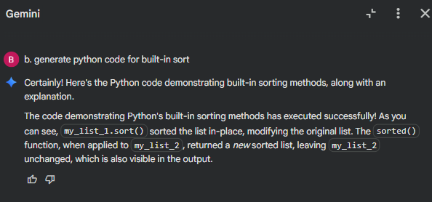

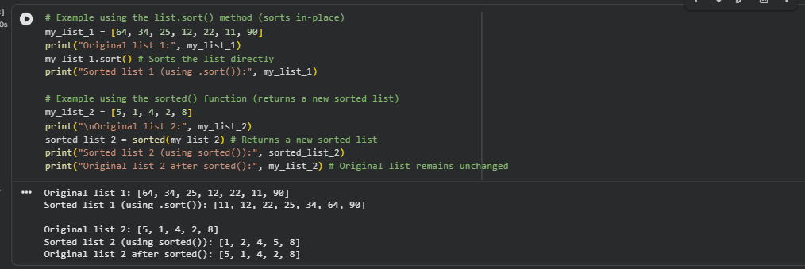
OUTPUT:
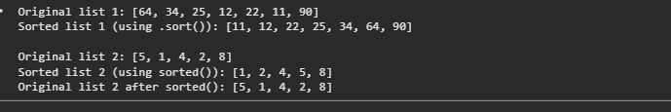
Explanation of Python's Built-in Sorting:
Python provides convenient and highly optimized built-in ways to sort lists:
- list.sort() method:
  - This is a method of the list object itself (e.g., my_list.sort()).
  - It sorts the list in-place, meaning it modifies the original list directly and does not return a new list.
  - It returns None.
  - It is generally more efficient for sorting lists you no longer need in their original order.
- sorted() function:
  - This is a built-in function that can take any iterable (like a list, tuple, or string) as input (e.g., sorted(my_list)).
  - It returns a new sorted list, leaving the original iterable unchanged.
  - This is useful when you need to keep the original data intact and work with a sorted copy.
Both methods support optional arguments like reverse=True for descending order and key for custom sorting criteria.
Comparison :
- Bubble Sort (Manual Implementation): Slow (O(n^2)), mainly for learning how sorting works. Not suitable for large datasets due to poor performance.
- Python's Built-in Sorts (.sort() and sorted()): Fast (O(n log n)), highly optimized, and used for practical applications. Prefer these for real-world tasks.
  - .sort() modifies the list directly.
  - sorted() returns a new sorted list.

