1. Create table employee(empid int,emponame varchar(20),dept varchar(20),salary float);

table EMPLOYEE created.

2

insert into employee values(1,'Amal','Sales',2500);

insert into employee values(2,'Roop','Production',2500);

insert into employee values(3,'Romal','Marketing',2500);

insert into employee values(4,'Rithin','Sales',7500);

insert into employee values(5,'Jose','Marketing',100000);

insert into employee values(6,'Marria','Sales',75000);

insert into employee values(7,'Jenny','Sales',10000);

insert into employee values(8,'Thresiama','Marketing',150000);

insert into employee values(9,'Rinu','Sales',100000);

insert into employee values(10,'Anoop','Sales',100000);

1 rows inserted.

1 rows inserted.

1 rows inserted.

1 rows inserted.

1 rows inserted.

1 rows inserted.

1 rows inserted.

1 rows inserted.

1 rows inserted.

1 rows inserted.

1 rows inserted.

1 rows inserted.

3

select empid,empname from employee;

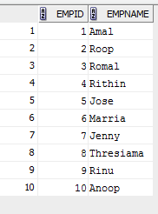

4

delete from employee where empid = 10;

1 rows deleted.

5

insert into employee values(11,'Lissy','Production',NULL);

1 rows inserted.

6

select \* from employee where dept = 'Marketing';

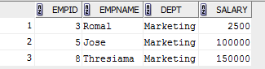

7

update employee

set salary = 4800

where empid =11;

1 rows updated.

8

update employee

set salary = 1900

where empname = 'Rithin';

1 rows updated.

9

select \* from employee where dept = 'Marketing' and salary > 2000;

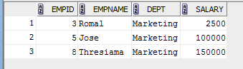

10

select \* from employee where dept='Sales' or dept='Marketing'; 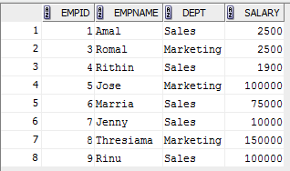

11

select empid,empname from employee where salary>2300 and salary<3000;

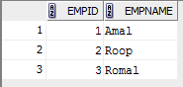

12

update employee

set salary = (salary+(salary\*0.12))

where dept='Production';

2 rows updated.

13

select empname from employee where salary<2000 or dept = 'Sales';

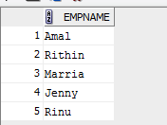

14

select empid as employeeid,empname as employeename from employee where dept = 'Marketing' or Salary>10000;

