**1**

set serveroutput on;

DECLARE

a number;

c number;

i number;

q number;

FUNCTION fact(x IN number)

RETURN number

IS

z number;

BEGIN

z:=1;

q:=1;

for i in 1..x LOOP

z:= (z*q);

q:=q+1;

END LOOP;

return z;

END;

BEGIN

a:= &a;

c := fact(a);

dbms_output.put_line('Factorial is ' || c);

END;

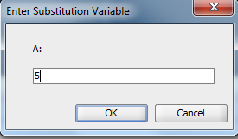

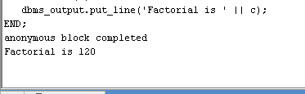

set serveroutput on;

DECLARE

ROLL integer;

names varchar(20);

M1 integer;

M2 INTEGER;

M3 INTEGER;

total INTEGER;

GRADE VARCHAR(20);

FUNCTION f(x IN INTEGER)

RETURN varchar

IS

z varchar(20);

BEGIN

IF x > 40 THEN

z:= 'pass';

ELSE

z:= 'fail';

END IF;

return z;

END;

PROCEDURE up(ROLL in integer,names in varchar,M1 in integer,M2 in integer,M3 in integer,total in integer,grade in varchar) IS

BEGIN

insert into student_grade values(ROLL,names,M1,M2,M3,total,grade);

END;

BEGIN

ROLL:=&ROLL;

names:= '&names';

M1:= &M1;

M2:= &M2;

M3:= &M3;

total:=(M1+M2+M3);

GRADE:= f(total);

up(ROLL,names,M1,M2,M3,total,GRADE);

END;

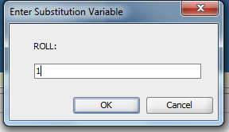

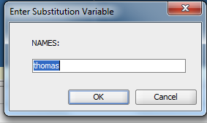

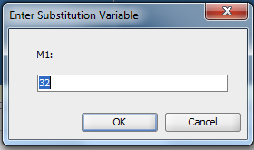

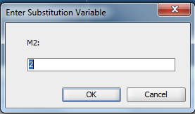

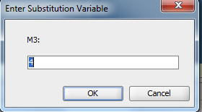

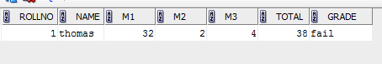

SET SERVEROUTPUT ON;

CREATE OR REPLACE PACKAGE PK1 AS

PROCEDURE PROC1(A IN INT, B IN INT);

PROCEDURE PROC2(A IN INT);

FUNCTION FN11(A IN INT) RETURN VARCHAR2;

FUNCTION FN22(A IN INT,B IN INT,C IN INT) RETURN INT;

END PK1;

/

CREATE OR REPLACE PACKAGE BODY PK1 AS

PROCEDURE PROC1(A IN INT,B IN INT) IS

BEGIN

DBMS_OUTPUT.PUT_LINE('SUM:'||(A+B));

DBMS_OUTPUT.PUT_LINE('AVG:'||(A+B)/2);

DBMS_OUTPUT.PUT_LINE('PRODUCT:'||(A*B));

END;

PROCEDURE PROC2(A INT) AS

BEGIN

DBMS_OUTPUT.PUT_LINE('SQUARE ROOT OF '||A||' IS '||SQRT(A));

END;

FUNCTION FN11(A IN INT) RETURN VARCHAR2 IS B VARCHAR2(4);

BEGIN

IF(MOD(A,2)=0) THEN

RETURN 'EVEN';

ELSE

RETURN 'ODD';

END IF;

END;

FUNCTION FN22(A IN INT,B IN INT,C IN INT)

RETURN INT IS D INT;

BEGIN

D := A+B+C;

RETURN D;

END;

END PK1;

/

DECLARE

P INT;

Q INT;

R INT;

S INT;

RT VARCHAR2(4);

SUM1 INT;

BEGIN

P:=&P;

Q:=&Q;

R:=&R;

S:=&S;

PK1.PROC1(P,Q);

PK1.PROC2(R);

RT:=PK1.FN11(S);

SUM1:=PK1.FN22(P,Q,S);

DBMS_OUTPUT.PUT_LINE(S ||' IS '||RT);

DBMS_OUTPUT.PUT_LINE('SUM OF '||P||','||Q||' AND '||S||' IS '||SUM1);

END;

CREATE TABLE CUST_DETAIL(CUST_ID INTEGER PRIMARY KEY, NAME VARCHAR(20),ADDRESS VARCHAR(20));

CREATE OR REPLACE TRIGGER RITHIN

AFTER INSERT ON cust_detail

BEGIN

dbms_output.put_line('row inserted');

END;

/

insert into cust_detail values(1,'rithin','adkfjasdljk');

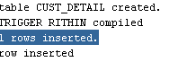

CREATE TABLE CUST_DETAIL(CUST_ID INTEGER PRIMARY KEY, NAME VARCHAR(20),ADDRESS VARCHAR(20));

create table employee_details(emp_id int primary key,name varchar(20),salary integer);

CREATE OR REPLACE TRIGGER RITHIN

AFTER INSERT ON cust_detail

BEGIN

dbms_output.put_line('row inserted');

END;

/

CREATE OR REPLACE TRIGGER RITHIN1

AFTER INSERT ON employee_details

for each row when(new.salary>20000)

BEGIN

dbms_output.put_line('salary is great');

END;

/

insert into cust_detail values(1,'rithin','adkfjasdljk');

insert into employee_details values(6,'prakash1',30000);