create table Student(

rollno int,

name varchar(20),

physics int,

cyhemistry int,

maths int,

total int,

result varchar(20)

);

table STUDENT created.

insert into student values(1,'Justin',20,22,45,NULL,NULL);

insert into student values(2,'Kennith',18,20,40,NULL,NULL);

insert into student values(3,'Leion',25,22,45,NULL,NULL);

insert into student values(4,'Nibin',20,22,45,NULL,NULL);

insert into student values(5,'Richu',23,22,45,NULL,NULL);

insert into student values(6,'Rithin',25,25,49,NULL,NULL);

insert into student values(7,'Rohan',20,22,45,NULL,NULL);

insert into student values(8,'Romal',5,21,40,NULL,NULL);

insert into student values(9,'Roop',4,5,45,NULL,NULL);

insert into student values(10,'Roni',2,2,5,NULL,NULL);

1 rows inserted.

1 rows inserted.

1 rows inserted.

1 rows inserted.

1 rows inserted.

1 rows inserted.

1 rows inserted.

1 rows inserted.

1 rows inserted.

1 rows inserted.

1

select avg(Physics) from student;



2

select max(Maths) as Highest_marks_math from student;



3

select min(Chemistry) as Least_marks_Chemistry from student;



4

select count(*) from student where physics<12;



5

select * from student where physics>12 and chemistry >12 and maths>25;

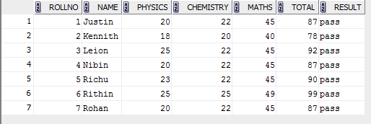

6

select * from student order by total desc;

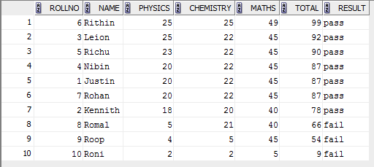

7

select count(*)*10 as pass_percentage_of_maths from student where maths >25;



8

select count(*)*10 as passpercentage from student where maths>25 and chemistry>12 and physics>12;



9

select avg(total) from student;



10

select count(*) from student where result='pass';



11

select branch,count(*) from student where result='pass' group by branch;

