create table accountd(

accountno varchar(9),

branch varchar(20),

name varchar(20),

phoneno varchar(20)

);



insert into accountd values('A12345679','New York','Elizabeth','9988776655');

insert into accountd values('B12937861','New York','liz','9128377665');

insert into accountd values('D08934784','New delhi','Don','7760980655');

insert into accountd values('C74873458','New York','Deam Elizabeth','9584671289');

insert into accountd values('C74873468','New York','Debruyne','9984671289');

insert into accountd values('A12345676','New York','ron','9988776655');

insert into accountd values('B12937865','New York','lizza','9128377665');

insert into accountd values('D08934783','New delhi','rose','7760980655');

insert into accountd values('C74873438','New York','ana','9584671289');

insert into accountd values('C74873469','New York','autamondy','9984671289');

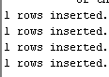

1

Select name from accountd where instr(name,'D')=1;



2

Select distinct branch from accountd where instr(branch,'New')=1;



3

Select upper(name) from accountd;

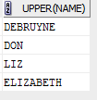

4

select name from accountd where instr(name,'n')=4 and instr(name,'n')=length(name);



5

Select name from accountd where instr(name,'D')=1 and instr(name,'a')=3 and instr(name,'Eli')!=0;



6

select name from accountd where instr(accountno,'6')=9;



7

update accountd

set name =upper(name);



8

select name from accountd where instr(name,'T')=length(name);



9

select reverse(name) from accountd;

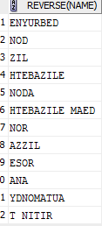

10

select concat('+91',phoneno) from accountd;

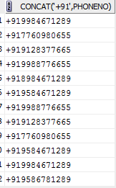

11

select ltrim(accountno,'ABCD') from accountd;

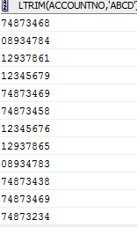

12

Select accountno from accountd where instr(accountno,'4')=2;



13

Select accountno,name from accountd where instr(accountno,'4')=2 and instr(name,'william')=1;



1

select reverse('nmutuA etedO ehT') from dual;



2

select ltrim('123231xyzTECH','123231xyz') from dual;



3

select rtrim('computer\*\*\*','\*\*\*') from dual;



4

select rpad('computer',11,'x') from dual;



5

select INSTR('welcome to kerala','e',1,1)from dual;



6

select initcap('mARKcALAWAY') from dual;



7

select length('relational database management systems')from dual;



8

select CONCAT('julius','ceaser')from dual;



9

select SUBSTR('india is my country', 7, 2) from dual;



10

select INSTR('making of a king','k',-1,2)from dual;

