create table ite(itemid int primary key,itemname varchar(50),category varchar(20),price int,instock int check(instock>=0));

create table cus(custid int primary key, cusname varchar(20),address varchar(20),state varchar(20));

create table ors(orderid int primary key,custID int,itemid int,quantity int , orderdate date);

create table dey(deliveryid int primary key,custID int, orderid int);

insert into ite values(1,'iphone 11','mobile', 100000,45);

insert into ite values(2,'asus tuf','laptop',56000,20);

insert into ite values(3,'hp pencil','stationary',20,60);

insert into ite values(4,'galaxy s4','mobile', 20000,75);

insert into ite values(5,'joker','toys', 450,150);

select \* from ite;

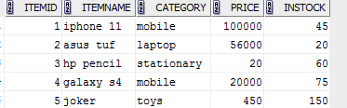

insert into cus values(211,'amal','jaipur','rajasthan');

insert into cus values(212,'bijesh','pala','kerala');

insert into cus values(213,'jobson','kollam','kerala');

insert into cus values(214,'pinky','dadar','mumbai');

select \* from cus;

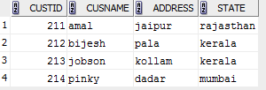

insert into ors values(111,211,2,1,'11-09-2015');

insert into ors values(112,213,4,5,'21-05-2017');

insert into ors values(113,214,1,1,'15-10-2018');

insert into ors values(114,212,5,25,'15-10-2013');

select \* from ors;

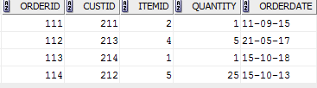

insert into dey values(987,214,113);

insert into dey values(654,213,112);

insert into dey values(321,211,111);

select \* from dey;

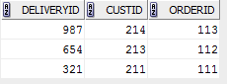

select \* from cus where custid IN(select custid from ors); --Q1

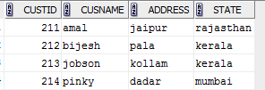

select \* from cus where custid IN (select custid from dey); --Q2

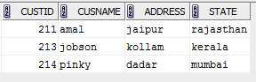

select orderdate from ors where custid in (select custid from cus where cusname LIKE'j%'); --Q3



select itemname, price from ite where itemid in (select itemid from ors where custID in(select custid from cus where cusname='Pinky'));



select \* from cus where custid in (select custid from ors where orderdate >'31-01-2013'and orderid not in (select orderid from dey)); --Q5

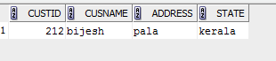

select itemid from ors union select itemid from ors where custid in (select custid from dey); --Q6

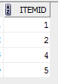

select cusname from cus where custid in (select custid from ors) intersect select cusname from cus where custid in (select custid from dey); --Q7

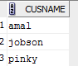

select cusname from cus where custid in (select custid from ors) minus select cusname from cus where custid in (select custid from dey); --Q8



select \* from cus where custid in (select custid from ors where quantity=(select max(quantity) from ors)); --Q9



select \* from cus where custid in (select custid from ors where itemid in(select itemid from ite where price>5000 )); --Q10

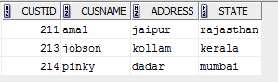

select cusname, address from cus where custid not in (select custid from ors where itemid in (select itemid from ite where itemname='galaxy s4')); q-11

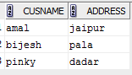

select \* from cus left join ors on cus.custid=ors.custid; --Q12

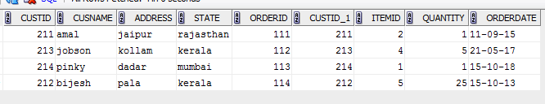

select \* from cus order by state; --Q13

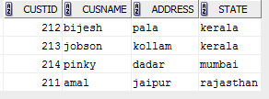

select \* from ite where price>(select avg(price) from ite ) order by category; --Q14

