**0**

set serveroutput on;

declare

a integer;

b integer;

c integer;

begin

dbms_output.put_line('Enter two nos');

a:= &a;

b:= &b;

c:= (a+b);

dbms_output.put_line('Sum is ' || c);

end;

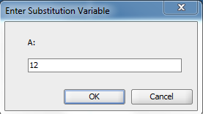

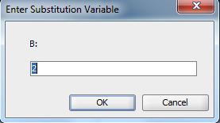



1

set serveroutput on;

declare

a integer;

b integer;

c integer;

begin

dbms_output.put_line('Enter two nos');

a:= &a;

b:= &b;

c:= (a+b);

dbms_output.put_line('Sum is ' || c);

c:= (a-b);

dbms_output.put_line('Difference is ' || c);

c:= (a*b);

dbms_output.put_line('Product is ' || c);

c:= (a/b);

dbms_output.put_line('Quotient is ' || c);

end;





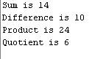

2

set serveroutput on;

declare

a integer;

b integer;

c integer;

begin

dbms_output.put_line('Enter two nos');

a:= &a;

b:= &b;

if a>b then

dbms_output.put_line('Smaller digit is ' || b);

else

dbms_output.put_line('Smaller digit is ' || a);

end if;

end;







3

set serveroutput on;

declare

a integer;

b integer;

begin

dbms_output.put_line('Enter the no');

a:= &a;

b:= 1;

WHILE a > 0 LOOP

b:= (b*a);

a := a - 1;

END LOOP;

dbms_output.put_line('Factorial is'||b);

end;

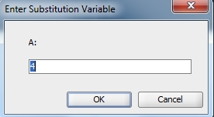



4

set serveroutput on;

declare

a integer;

b integer;

c integer;

n integer;

begin

dbms_output.put_line('Enter the no');

n:=&n;

a:= 0;

b:= 1;

dbms_output.put_line(a);

dbms_output.put_line(b);

WHILE n > 2 LOOP

c:= (a+b);

a:= b;

b:= c;

dbms_output.put_line(c);

n:=n-1;

END LOOP;

end;



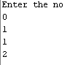

5

set serveroutput on;

declare

n number;

i number;

begin

n := &n;

i := 2;

for i in 2..n/2

loop

if mod(n, i) = 0

then

dbms_output.put_line(n);

end if;

end loop;

end;

1

create table student_grade( rollno int,name varchar(10),mark1 int,mark2 int,mark3 int,grade varchar(10));

set serveroutput on;

declare

begin

insert into student_grade values(1,'rithin',100,100,100,'');

insert into student_grade values(2,'roop',40,39,30,'');

insert into student_grade values(3,'romal',34,78,100,'');

insert into student_grade values(4,'rohan',50,100,100,'');

update student_grade set grade='Pass' where ((mark1+mark2+mark3)/3)>40;

update student_grade set grade='fail' where ((mark1+mark2+mark3)/3)<40;

commit;

end;

select * from student_grade;