**1)**

**a)**

Pi = Number of full-time workers working in three shifts (8am - 4pm), (noon – 8pm), (4pm – 8pm) where i = 1,2,3.

Qj = Number of part-time workers working in four shifts (8am - noon), (noon – 4pm), (4pm – 8pm), (8pm - midnight) where j = 1,2,3,4.

Amount paid for full time = $14/hr

Amount paid for part time = $12/hr

Zmin = Minimum cost.

**Zmin = 8*14*(P1 + P2 + P3) + 4*12*(Q1 + Q2 + Q3 + Q4).**

**Constraints:**

P1 + Q1 ≥ 4

P1 + P2 + Q2≥ 8

P2 + P3 + Q3 ≥ 10

P3 + Q4 ≥ 6

P1 ≥ Q1

P1 + P2 ≥ Q2

P2 + P3 ≥ Q3

P3 ≥ Q4

Pi ≥ 0, Qj ≥ 0.

Q1 = 2, Q2 = 4, Q3 = 5, Q4 = 3 and P1 = 2, P2 = 2, P3 = 3

**Zmin = 112*(7) + 48*(14) = 1456.**

Full time workers are = 7

Part time workers = 14

**b)**

We need to give 1 hr break to full time workers and no break to part time workers.

So, we must remove 1 hr cost of full timers in three shifts from the above cost function.

Therefore, minimum cost function:

**Zm1 = 8*14*(P1 + P2 + P3) – 14*(P1 + P2 + P3) + 4*12*(Q1 + Q2 + Q3 + Q4).**

Constraints remain same as above.

Zm1 = 112*(7) – 14*(7) + 48*(14) = 1358.

Zmin – Zm1 = 1456 – 1358

= 98.

**2)**

X axis represented as collegiate

Y axis represents Mini

The shaded part below is the optimal solution.

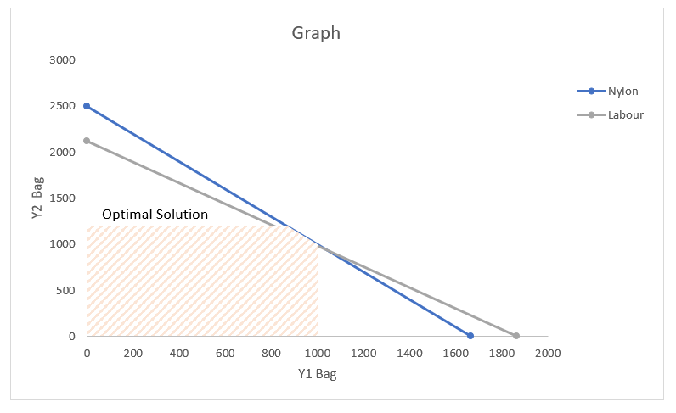

**3)**

**a) Decision variables**:

Yij , where I is the plants 1,2,3 and j is the sizes l, m, s.

Y1l, Y1m, Y1s variables for plant 1

Y2l, Y2m, Y2s variables for plant 2

Y3l, Y3m, Y3s variables for plant 3

**b) Linear programming model:**

Zmax  is the maximum profit

**Zmax =420*(Y1l + Y2l + Y3l) + 360*(Y1m + Y2m + Y3m) + 300*(Y1s + Y2s + Y3s)**

Constraints for Max capacity:

Y1l + Y1m + Y1s ≤ 750

Y2l + Y2m + Y2s ≤ 900

Y3l + Y3m + Y3s ≤ 450

Storage space:

20*Y1l + 15*Y1m + 12*Y1s ≤ 13000

20*Y2l + 15*Y2m + 12*Y2s ≤ 12000

20*Y3l + 15*Y3m + 12*Y3s ≤ 5000

Same percentage of capacity:

900*(Y1l + Y1m + Y1s) – 750*(Y2l + Y2m + Y2s) = 0

450*(Y2l + Y2m + Y2s) – 900*(Y3l + Y3m + Y3s) = 0

450*(Y1l + Y1m + Y1s) – 750*(Y3l + Y3m + Y3s) = 0

Y1l+Y2l+Y3l<=900

Y1m+y2m+y3m<=1200

Y1s+Y2s+Y3s<=750

And Yij ≥ 0 where i = 1, 2, 3 and j = l, m, s

**c)**

library(lpSolveAPI)  
b <- make.lp(0,3,verbose = "neutral")  
b  
add.constraint(b, c(1,1,1), "<=", 750 )  
add.constraint(b, c(1,1,1), "<=", 900)  
add.constraint(b, c(1,1,1), "<=", 450)  
add.constraint(b, c(20,15,12), "<=", 13000)  
add.constraint(b, c(20,15,12), "<=", 12000)  
add.constraint(b, c(20,15,12), "<=", 5000)  
add.constraint(b, c(1,1,1), "<=", 900)  
add.constraint(b, c(1,1,1), "<=", 1200)  
add.constraint(b, c(1,1,1), "<=", 750)  
  
  
b.col <- c("P 1","P 2","P 3")   
b.row <- c("Y1l","Y1m","Y1s","Y2l", "Y2m","Y2s","Y3l","Y3m","Y3s")   
dimnames(b) <- list(b.row,b.col)  
  
b  
solve(b)