PRODUCT REQUIREMENTS DOCUMENT
Creative Production Tracker
Internal usage analytics for creatives produced on the Hawky platform
Field | Value
Owner | Surender Selvaraj (Co-Founder, Hawky.ai)
Audience | Engineering / Dev team
Status | Draft v1.0 — for dev handover
Date | 10 June 2026
Companion asset | creative-tracker-mockup.html (clickable mockup of both screens)

1. Background & Problem
Creatives are produced on the Hawky platform through three entry points — Co-Pilot, the Production Table, and the Creative Production Agent. Today there is no single view that tells us how many creatives are being produced per brand, who is producing them (the brand's own users vs. the Hawky team), and which entry point they are using.
Without this, we cannot answer basic adoption questions: Is a brand actually self-serving, or is the Hawky team doing the work for them? Which production surface is getting traction? Which users at a brand are power users, and which have never logged in?
This PRD specifies an internal web dashboard — the Creative Production Tracker — that answers these questions at two levels: a cross-brand overview, and a per-brand, per-user drill-down.

2. Goals & Non-Goals

Goals
- For every brand, show the total number of creatives produced, split by production source (Co-Pilot / Production Table / Creative Production Agent).
- For every brand, show the split between creatives made by brand users vs. creatives made by Hawky team members.
- On clicking a brand, show a user-level breakdown: each user, their creative count per source, and direct links to the production tables they created.
- Enable the team to assess per-brand and per-user adoption and self-serve usage at a glance.

Non-Goals (v1)
- Creative performance metrics (CTR, ROAS, spend) — this dashboard tracks production volume, not ad performance.
- Alerting / scheduled reports (Phase 2 candidate).
- Exposing this dashboard to brands — it is internal-only in v1.

3. Definitions & Classification Rules
Term | Definition
Creative | Any creative asset generated and saved on the platform via one of the three sources. Open question: whether drafts/unsaved generations count — see §12.
Source | The surface a creative was created from. Enum: COPILOT, PRODUCTION_TABLE, CREATIVE_AGENT. Every creative must carry exactly one source value.
Hawky user | Any user whose login email contains the substring hawky (case-insensitive), e.g. rahul@hawky.ai. Classification is computed at query time from the email — no manual tagging needed.
Brand user | Any user whose email does not contain “hawky”. Attributed to the brand whose workspace the creative was made in.
Brand | The brand/workspace the creative belongs to (the brand it was made for), regardless of who made it.
Classification rule (pseudo-logic): creator_type = email.lower().contains("hawky") ? HAWKY : BRAND
Note: this is a heuristic. If a brand ever has a legitimate user with “hawky” in their email, or Hawky staff use non-hawky emails, counts will be wrong. v1 accepts this; Phase 2 can add an explicit internal-user flag that overrides the email rule.

4. Users & Access
- Primary users: Hawky founders, customer success, and growth — to track adoption and account health.
- Access: Restricted to Hawky team members only (auth gate: hawky email domain or existing internal admin role). Brands must not be able to reach this page.
- Entry point: Standalone internal webpage (e.g. /internal/creative-tracker) or a tab inside the existing admin panel — dev team's call based on what is fastest.

5. Functional Requirements

5.1 Screen 1 — Overview (all brands)
The landing screen. One row per brand, with global summary cards on top.

Summary cards (top of page)
- Total creatives — all brands, current filter window, with % change vs. the previous equal-length period.
- By brand users — count + % of total + number of distinct active brand users.
- By Hawky users — count + % of total + number of distinct active Hawky users.
- Top source — the source with the highest creative count in the window.

Brand table — one row per brand, columns:
Column | Spec
Brand | Brand/workspace name. Row click navigates to Screen 2 for that brand.
Total | Total creatives in the filter window (all sources, all creator types).
Co-Pilot / Prod. Table / Creative Agent | Per-source creative counts. The three must sum to Total.
Brand-made | Creatives by brand users.
Hawky-made | Creatives by Hawky users. Brand-made + Hawky-made = Total.
Brand vs Hawky | Horizontal ratio bar visualizing the split.
Last activity | Relative timestamp of the most recent creative for this brand.
- Default sort: Total descending. All numeric columns sortable.
- Search box filters brands by name.
- Brands with zero creatives in the window still appear (with zeros) — inactivity is signal, not noise.

5.2 Screen 2 — Brand detail (user-level drill-down)
Reached by clicking any brand row. Shows the same summary pattern scoped to the brand, plus a user-level table.

Brand summary cards
- Total creatives (with period-over-period change), Brand-made (count, %, distinct users), Hawky-made (count, %, distinct users), and the source split (CP / PT / CA counts).

User table — one row per user who created ≥1 creative for this brand:
Column | Spec
User | Login email of the creator.
Type | Badge: BRAND or HAWKY (per §3 classification rule).
Total | Creatives by this user for this brand in the window.
Co-Pilot / Prod. Table / Creative Agent | Per-source counts for this user. Must sum to the user's Total.
Production tables | Link: “View N tables →”. Opens the list of production tables created by this user for this brand, each item deep-linking to the live production table in the product. This is the key feature for auditing how a user actually works.
Last active | Timestamp of the user's most recent creative for this brand.
- Default sort: Total descending. Search filters by email.
- Breadcrumb (“← All brands”) returns to Screen 1 preserving filters.

5.3 Global filters (both screens)
- Date range — presets: Last 7 / 30 / 90 days, This month, Custom range. Default: Last 30 days. All counts, cards, and tables respect it.
- Source — All / Co-Pilot / Production Table / Creative Agent.
- Creator type — All / Brand users / Hawky users.
- Filters persist when navigating Overview ↔ Brand detail, and are encoded in the URL (shareable links).

5.4 Deep links
- Each brand detail screen has a stable URL: /internal/creative-tracker/brand/{brand_id}.
- Each “View N tables” entry links to the production table's canonical product URL: /brand/{brand_id}/production-table/{table_id} (or equivalent existing route).

6. Data & Tracking Specification
Every creative record (or a creative_created event, if we go event-based) must carry the following fields. If existing creative records already store these, this is a query/aggregation task; any missing field must be added at creation time across all three sources.
Field | Type | Notes
creative_id | string | Unique ID of the creative.
brand_id | string | Workspace/brand the creative was created in.
created_by_email | string | Login email of the creating user. Basis for HAWKY/BRAND classification.
source | enum | COPILOT | PRODUCTION_TABLE | CREATIVE_AGENT. Mandatory, exactly one.
production_table_id | string? | Set when source = PRODUCTION_TABLE; null otherwise. Powers the “View N tables” links.
created_at | timestamp | UTC creation time. Basis for all date filtering.
Backfill: historical creatives should be backfilled with these fields where derivable, so the dashboard is useful on day one. If source cannot be derived for old records, bucket them as UNKNOWN and display an “Unknown” column only when non-zero.
Consistency invariants (must hold on every screen): Σ source counts = Total, and Brand-made + Hawky-made = Total. If an invariant breaks, it is a data bug, not a display option.

7. Suggested API Endpoints
Indicative shape — dev team free to restructure as long as the screens in §5 are served.
Endpoint | Returns
GET /api/internal/creative-stats/overview?from&to&source&creator_type | Global summary cards + array of per-brand rows (totals, per-source counts, brand/hawky split, last_activity).
GET /api/internal/creative-stats/brand/{brand_id}?from&to&source&creator_type | Brand summary cards + array of per-user rows (per-source counts, type, last_active, production_table count).
GET /api/internal/creative-stats/brand/{brand_id}/user/{email}/tables | List of production tables created by that user for that brand: {table_id, name, creative_count, created_at, url}.
Counts should be computed via aggregate queries (or a small materialized rollup if volumes demand it) — see §9 for performance targets.

8. Visual Design
The dashboard follows the Hawky internal design language: warm near-black canvas (#0A0A0B), warm cream text (#F5F1EB), Inter for UI text, JetBrains Mono for labels, single warm-orange accent (#FF6B3D) reserved for the headline metric. A clickable HTML mockup of both screens accompanies this PRD (creative-tracker-mockup.html) — click any brand row to see the drill-down. Screens below.
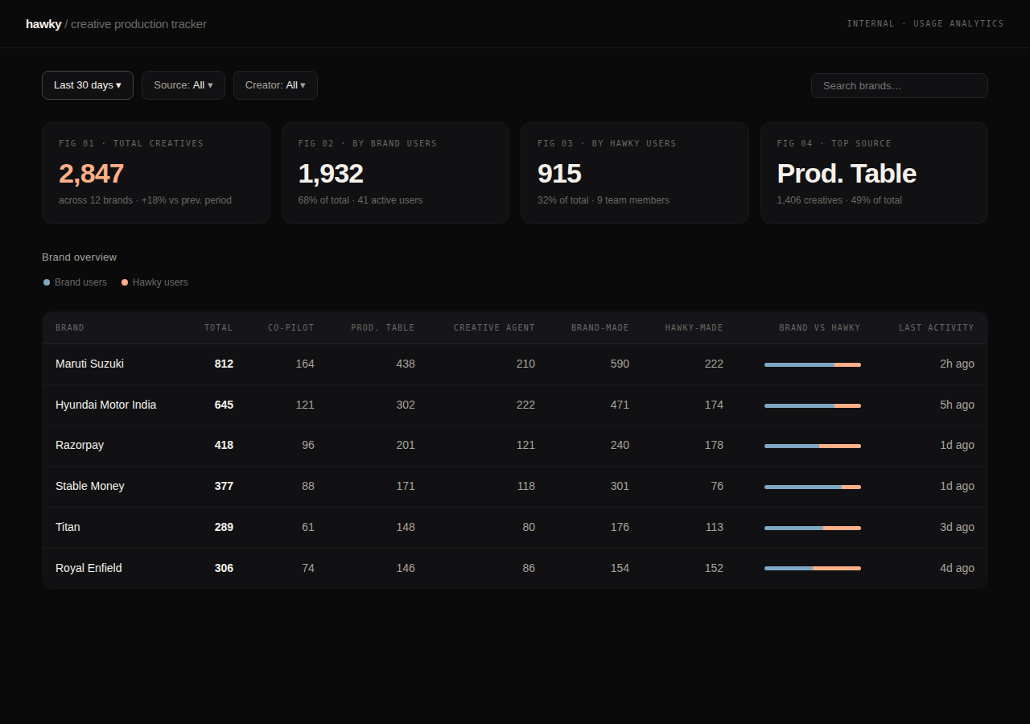
Fig 1 — Screen 1: Overview. Global cards, per-brand table with source split, brand-vs-hawky ratio bar, last activity.
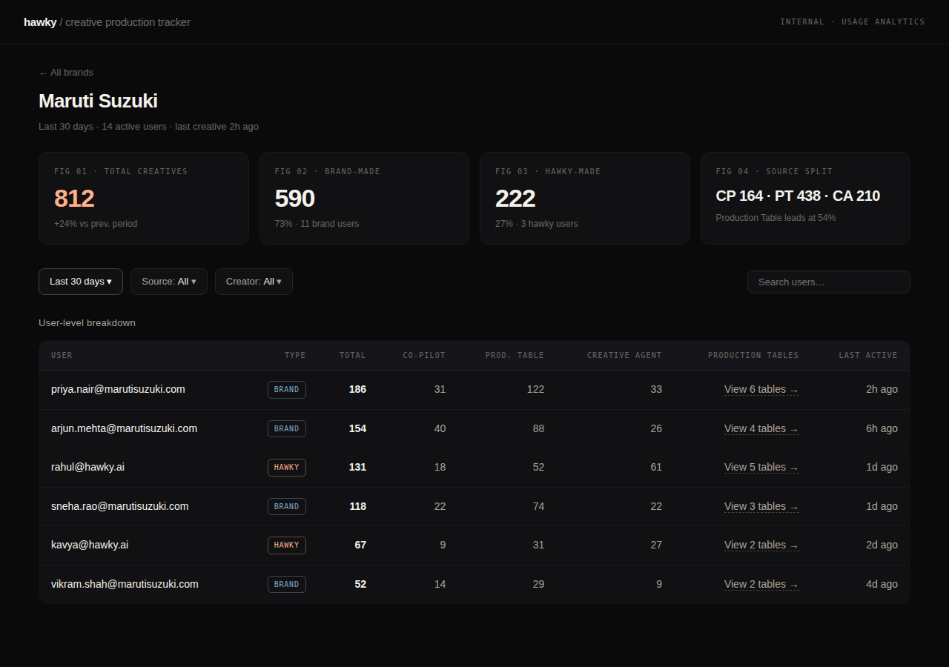
Fig 2 — Screen 2: Brand detail (Maruti Suzuki example). Brand-scoped cards and the user-level table with type badges and production-table links.

9. Non-Functional Requirements
- Performance: Overview loads in < 2s for 50 brands / 100k creatives; brand detail < 1.5s. Pre-aggregate if needed.
- Freshness: Near-real-time preferred; up to 1 hour of lag acceptable in v1 if a rollup job is used. Show a “data as of” timestamp if lagged.
- Security: Internal-only; gate by Hawky email/admin role. No PII beyond user emails, which the team already has access to.
- Responsiveness: Desktop-first; must remain readable on a laptop at 1280px. Mobile is nice-to-have.

10. Edge Cases
- A user creates creatives for multiple brands → they appear in each brand's user table, counted separately per brand.
- A creative is deleted → decide whether counts are “ever created” (immutable event log) or “currently existing”. Recommendation: count ever-created (event-based) since the goal is usage tracking, not inventory.
- Co-Pilot or the Creative Agent generates multiple variants in one action → each saved variant counts as one creative. Confirm against current behavior (see §12).
- Agent-scheduled creatives with no human in the loop → attribute to the user who configured the agent; if a system identity is used, classify as HAWKY and label “agent (auto)”.
- Email casing/aliases (Rahul@Hawky.ai, rahul+test@hawky.ai) → normalize to lowercase; treat plus-aliases as the same user.
- Zero-activity brands and zero-table users → show with zeros / “No tables”, never hide.

11. Out of Scope / Phase 2 Candidates
- Weekly adoption digest emailed to the team (re-using the Agents infra).
- Trend charts: creatives per week per brand; brand-vs-hawky ratio over time (the self-serve adoption curve).
- Linking production volume to performance (which source produces winning creatives).
- CSV export of both tables.
- Explicit internal-user flag replacing the email heuristic.

12. Open Questions (for Surender / dev kickoff)
- Does a “creative” mean every generated variant, or only saved/exported ones? (Defines the count.)
- Do all three sources currently write creator email + source onto the creative record, or does tracking need to be added at creation time?
- Should Co-Pilot and Creative Agent outputs also link back to a session/run (like production tables do), or are table links the only drill-through needed in v1?
- Is there an existing internal admin panel to host this, or should it be a standalone page?
- How far back should the backfill go?

